**BOOKLET GENERATOR**

Project Scope of Work , Questions & Quotation

**Booklet Scope of Work.**

I have divided whole scope of project into three sections/areas. Section 1 & 2 has layout and backend management . Section 3 has only layout management .

1) Maintain/Save Booklet Records to db .  
2) Maintain/Save Table of Contents related to each Booklet to db.  
3) Generate Single pdf file from all selected files of currently selected booklet folder with main heading page having name of table of content as main heading with list of all files attach to it.  
  
**Booklet User Story:**  
  
User have only these two main screens.  
  
**Screen 1:**

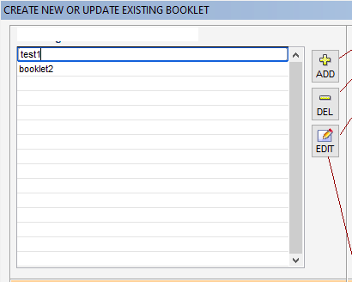

From this screen ,   
  
1) User can create, delete and update booklet names. Basically from this screen user will generate multiple booklets name. These booklet records will be save to db.  
  
After click on edit from selected booklet name, Screen 2 will be show to user.

**Screen 2:**

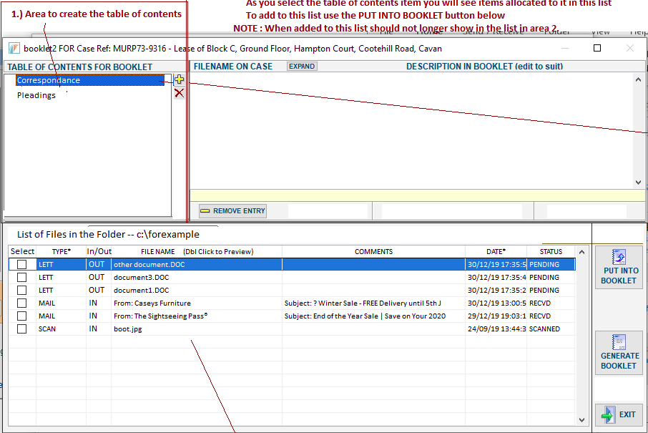  
  
 From this screen ,  
  
1) User will be able to create and delete multiple Table of Contents for selected booklet. The table of content record will also save to db .   
  
  
2) User can select multiple files for each table of content from single predefined folder by click on “PUT INTO BOOKLET.”  
  
3) After click on “Generate Booklet” btn, a single pdf file will be generate from all selected files of each table of content with main page having which contain the list of all Table of Contents names with selected files names.

**Special NOTE:**   
  
According to my understanding, this is the whole User Story of booklet generator, which I build after throughly review the update requirement snap. Please share your feedback on my understating about the latest scope of project and correct me , if I am wrong.

**Questions:**

1) Should I build the layout of above two screens(Screen 1 and Screen 2) with simple bootstrap or you will provide a proper theme to me for these two screens.?  
  
2) Should I only save the records of Booklets and Table of Contents to db Or you consider any other data , which should also supposed to be saved into db .?  
  
3) Is our booklet app have only one page layout or we should build seperate routes for each screen. Please share your thoughts.?  
  
Like: /booklets, /booklets/1/generator.  
  
The above routes are dummy. Its just for your understanding.  
  
  
**Quotation.**  
  
  
Bid Cost: $300  
Estimated Completion Duration: 1.5 Weeks approx/  
  
  
**Special Note:**   
  
The above mentioned cost and duration is calculated after throughly review the scope of project and effort.   
  
If you need cost and duration estimation breakdown w.r.t project scope of work, then I can also provide that.   
  
If the above mentioned cost and duration is not suitable for you, then you can discuss it with me . I will adjust it as much as I can .  
  
Looking forward to your response.  
  
Thanks.  
  
Regards,

Yaseen Iqbal