Order Line Items Table Alignment Design Issues (After Adding Infinity Scroll )

Current Approach for Table Alignment

Right now, table alignment is adjust with two separate tables. Buy using this approach , table header section is adjust with line items but table bottom adjustment section is affected and not aligned with upper section properly.

Table-1 use for order line items section

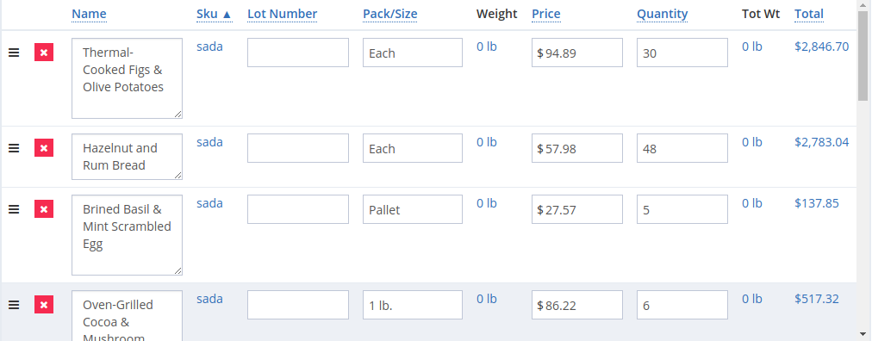

Table 2 – use for Orders Adjustment Section

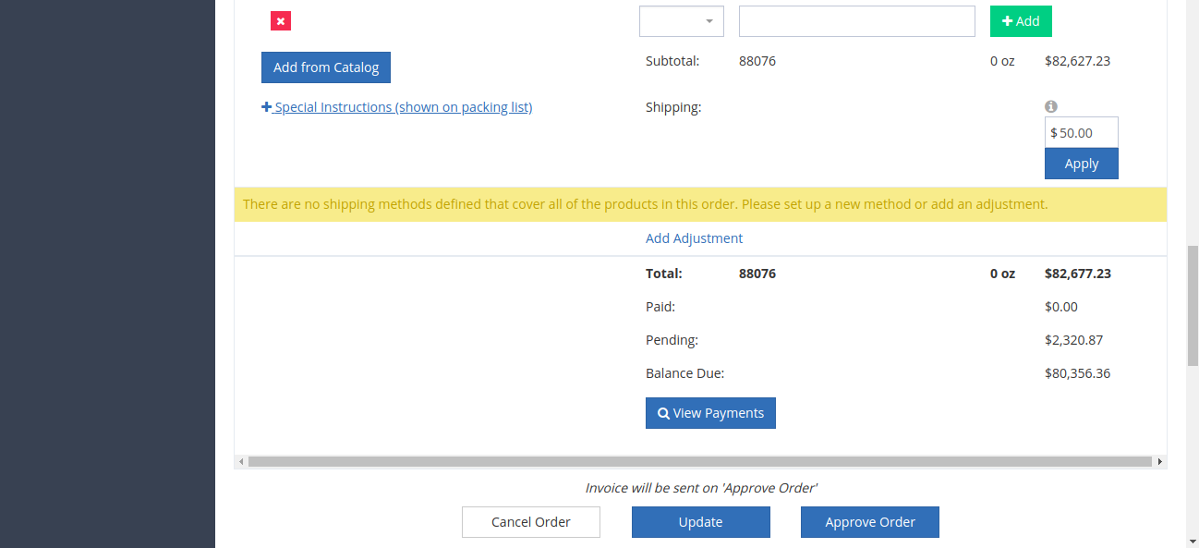

Other Approaches To Resolve the Table Alignment Issue.

Approach-1

I try to adjust both sections (orders line item and adjustment) in one table and try to add scroll bar to table tbody having line items . But when I try to add scrollbar property to table tbody, table design get disturbed. Please see the screen shot

To make the tbody scrollable, I add the following Css props to table tbody.

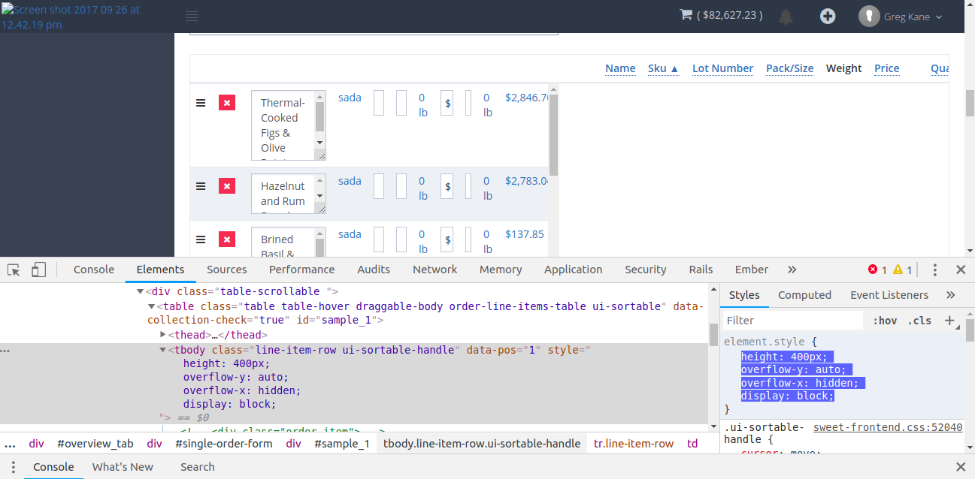

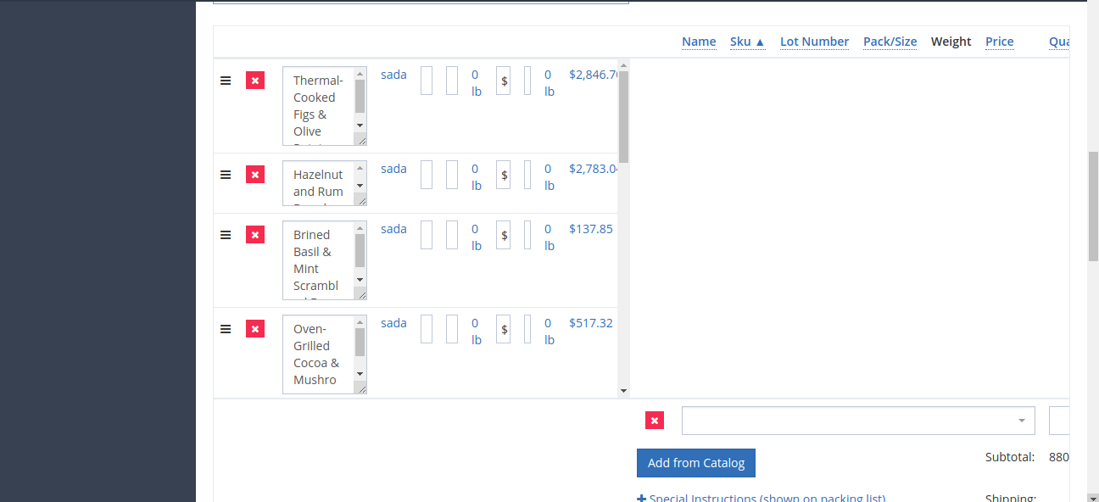

After add the following Css properties , table alignment is totally disturbed. In ideal way, by using these css properties, table tbody should be scrollable. But it shows strange behavior.

Approach -2

In this approach , I try to wrap up the tbody in a div and add to scrollable props to this div, but we can not do this. Its against html standards. We can not wrap one block element to another .

I try this,

<div>

<tbody></tbody>

</div>

but browser shift this div upto table element.

After that, to wrap the tbody in div , I try this table html structure.

<tbody>

<tr>

<td>

<div>

<table>

<tbody></tbody>

</table>

</div>

</td>

</tr>

</tbody>

Buy using this structure, tbody wraps into div , but buy this approach , line items design was totally affected. If I carry this approach , then I have to adjust the line item section design for each table. So I leave this approach .

Approach -3

I carry the two table approach , One for (line items sections and adjustment section ). For second table , I put a empty tbody with single tr with multiple td’s elements and give a manual width to each td according to header element th element width. Buy using this approach , table bottom section perfectly allign with upper section but the design affected for mobile views . Its only work for wider width devices.

I use this html structure.

Table 1 HTML STRUCTURE

<table >

<thead>

<tr>

<th></th>

<th></th>

<th></th>

</tr>

</thead>

</table>

Table 2 HTML STRUCTURE

<table class="table table-hover draggable-body ">

<tbody>

<tr class="hidden-row"><td style="width: 20px; padding-right: 0px;"></td>

<td style="width: 6%;">

</td>

<td style="

width: 18%;

">

</td>

<td style="

width: 3%;

">

</td>

<td style="

width: 15%;

">

</td>

<td style="

width: 11%;

">

</td>

<td style="

width: 15%;

">

</td>

<td style="

width: 13%;

">

</td>

<td style="

width: 16%;

">

</td>

<td style="

width: 4%;

">

</td>

<td>

</td>

</tr>

</tbody>

<tbody id='variant-quick-add' >

</tbody>

<tbody></tbody>

</table>

Approach-4

I carry the two table approach , One for (line items sections and adjustment section ). For second table , I put a empty tbody with single tr with multiple td’s elements and give a manual width to each td according to header element th element width and use colspan for bottom tr elements. Buy using this approach , table bottom section perfectly allign with upper section but the design affected for mobile views . Its only work for wider width devices.

I use this html structure.

<table>

<thead >

<tr >

<th></th>

<th></th>

</tr>

</thead>

<tbody>

</tbody>

<tbody>

</tbody>

<tbody>

</tbody>

</table>

<table>

<thead >

<tr >

<th style="

width: 21px;

"></th>

<th style="

width: 53px;

"></th>

<th class="resize-col ui-resizable" style="

width: 173px;

"></th>

<th class="resize-col ui-resizable" style="

width: 68px;

"></th>

<th class="resize-col ui-resizable" style="

width: 145px;

"></th>

<th class="resize-col ui-resizable" style="

width: 143px;

"></th>

<th class="resize-col ui-resizable" style="

width: 64px;

">"

width: 136px;

">></th>

<th class="resize-col ui-resizable" style="

width: 127px;

">

</th>

<th class="resize-col ui-resizable" style="

width: 60px;

"></th>

<th class="resize-col ui-resizable" style="

width: 95px !important;

/\* box-shadow: 0 0 black; \*/

">

</th>

</tr>

</thead>

<tbody >

<tr >

<td></td>

<td>

</td>

<td colspan="6"></td>

<td colspan='1'>

</td>

<td colspan='100%'>

</td>

</tr>

</tbody>

<tbody>

</tbody>

</table>