**RESTful Web Service – Library**

1. **List of all Books**

URL : <http://localhost:8080/books>

Screenshot1:

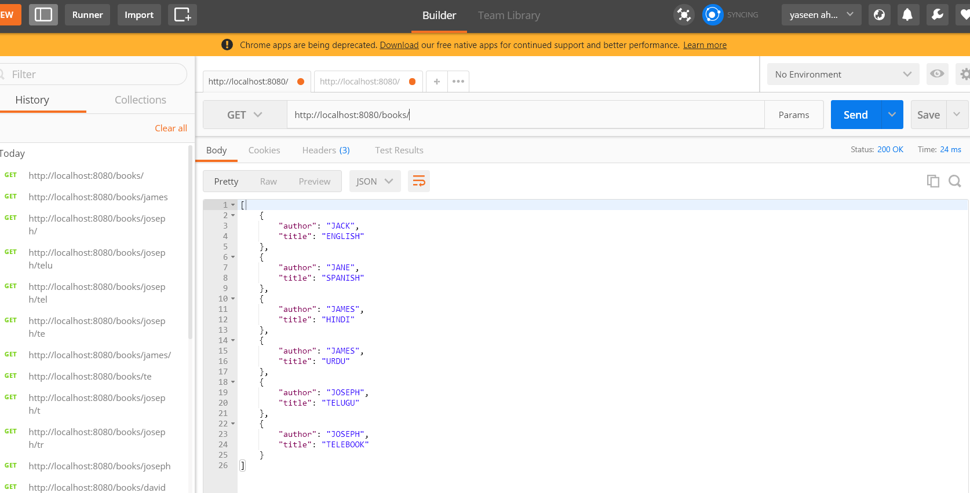

1. **List of books by Author**

**url:** <http://localhost:8080/books/james>

**Screenshot:**

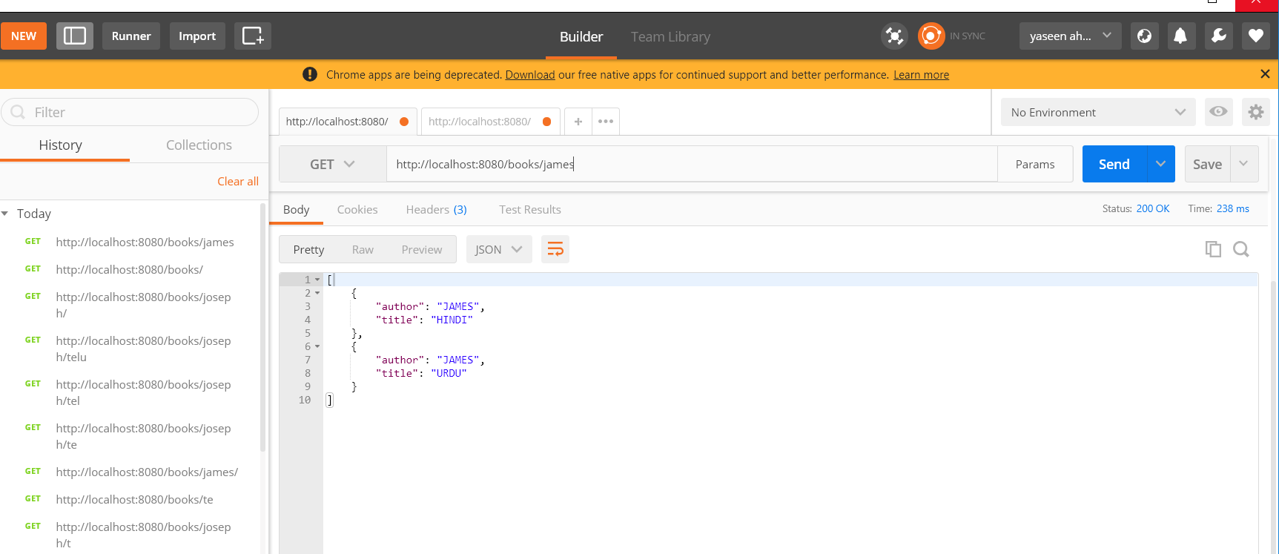

1. **List of books by partial Title match**

**url:** <http://localhost:8080/books/Joseph/te>

**Screenhsot:**

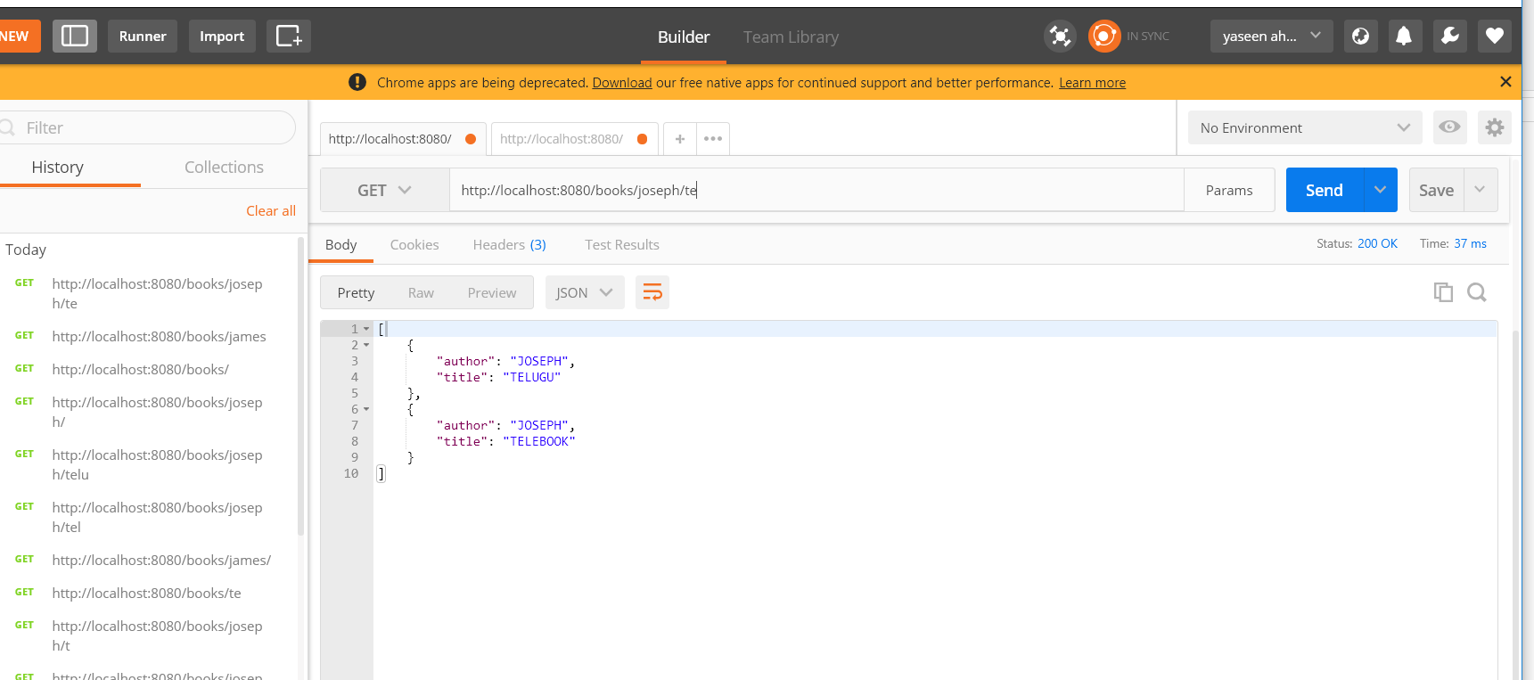

1. **Add a book to the list (POST)**

**url:** http://localhost:8080/book

**body:**

{

"author": "JAMES",

"title": "TAMIL"

}

**Screenshot:** 