**Final Year Project Report**

**Online Event Management System**



**Project Advisor:** Sir Owaise

**Submitted By:**

|  |  |
| --- | --- |
| Umair Habib Khan | 2422-115003 |
| Mohammed Yaseen Khan | 2421-314032 |
| Moiz Ahmed | 2422-115002 |
| Mohammed Saim Ali | 2421-115009 |

**Session**

**2015-2018**

**Preston University**

**North Nazimabad Campus**



**Dedication**

A final year project report presented to the Preston University North Nazimabad campus Karachi in partial fulfillment of the requirements of the degree of Bachelor of Science in Computer Science. Our Application is dedicated to our parents and especially we would also like to dedicate this project to our Project advisors because they guided us in a right direction and gave their valuable time to us in the completion of this project. We discussed our project with them and they gave better suggestions to improve our project.

**Final Approval**

**Panel of Examiners**

**Head of Department**

Department of Computer Science

Preston University Karachi

______________________

**Program Director ( Final Year Projects)**

Department of Computer Science

Preston University Karachi

______________________

**Supervisor** ______________________

Department of Computer Science

Preston University Karachi

**Acknowledgment**

In the name of Allah, the Most Beneficent and the Most Merciful Alhamdulillah, all praises to Allah for the strengths and His blessing in completing this application. Special thanks go to my supervisor, Sir Owaise, for his supervision and constant support. His dynamic help of useful comments and suggestions during the cautious and application works have added to the success of this inquiry. Not forgotten. We would like to express my gratefulness to the Department of Computer Science Head, Mr. Owaise for their support and help towards my Bachelor affairs. My acknowledgment also goes to all the technicians and office staffs of the university for their co-operation. Heartfelt thanks to all my friends and to those who secondarily donated in this research, your kindness means a lot to me. Thank you very much.

**Project Title**

**Online Event Management System**

**Objective**

Making a web-based system which will help event management company to organize and manage their event more professionally and easily.

**Undertaken by**

**Supervised by**

**Starting Date**

**Sir Owaise,**

**14-03-2017**

**Completion Date**

**23-01-2019**

**Tools Used**

**Operating System**

**Documentation**

HTML5, CSS3, M.D Bootstrap, JavaScript, JQuery, Node.js, Express.js and MongoDB

**Plagiarism Report**

**Abstract**

It is an online event management system software project that serves as an event manager. This project consists of 2 targets 1.***Client*** 2.***User***. The system allows the Clients to register, log in so that the client could update its occasion profile and as well as new Users are allowed to register and log in on the application to send a request to the Client. The system helps in the management of events, users, clients and the aspects related to them. This project is based on a web application. The project provides most of the basic functionality required for an event type e.g. [Marriage, Birthday party, School & College Festival, etc.], the system then allows the user to select date and time of event, place and the event equipment as required. All the data is logged in the database and the user is given a receipt number for his booking. The data is then sent to the Client and administrator (website owner) so that the client could follow up with the User as soon as possible. Keywords- User, Admin, Events, Book, Event Management, Database.

1. This application manages the festivals, events by providing as much as information on both sides as per required.
2. It can be used to identify the target of the budget & cost of the event.
3. It will reduce the efforts of the user as well as time-saving
4. Events searching can be done as per the required date and time.
5. Client and User identification is possible.
6. Registration and Sign In form available for both Client and User
7. Languages which will be used are HTML5, CSS3, M.D Bootstrap, JQuery, JavaScript, Node.js, Express.js, and MongoDB

REVISION CHART



This chart covers a history of this document’s reviews. The accesses below are providing just for design drives. Those accesses should be removed until the review/s they refer to have actually been formed.

The document itself should be kept in review regulator, and a short-term report of each type should have arrived in the Revision Control System. A brief report can be recurrent in this unit. Appraisals need not to be defined away in the text unless they clarify the document.

|  |  |  |  |
| --- | --- | --- | --- |
| **Version** | **Primary Author(s)** | **Description of Version** | **Date** |
|  |  |  | **Completed** |
|  |  |  |  |
| Draft | Umair Habib Khan  Mohamed Yaseen Khan | Original draft created for delivery | 08-08-2018 |
|  |  | and evaluation comments |  |
|  |  |  |  |
| Preliminary | Moiz Ahmed  Mohamed Saim Ali | Following draft including initial | 25-09-2018 |
|  |  | review notes spread for |  |
|  |  | final evaluation |  |
|  |  |  |  |
| Final | Mohammed Yaseen Khan | First whole draft, which is placed | 01-10-2018 |
|  |  | under alteration regulator |  |
|  |  |  |  |
| Revision 1 | Umair Habib Khan | Reviewed draft, studied according to | 05-11-2018 |
|  |  | the alteration regulator process and |  |
|  |  | continued under alteration controller |  |
|  |  |  |  |
| Revision 2 | Mohammed Saim Ali | Studied draft, reviewed giving to | 15-12-2018 |
|  |  | the alteration regulator process and |  |
|  |  | continued below alteration control |  |
|  |  |  |  |
| Revision 3 | Moiz Ahmed | Studied draft, reviewed giving to | 10-01-2019 |
|  |  | the alteration switch process and |  |
|  |  | continued under modification control |  |
|  |  |  |  |

CONTENTS



|  |  |  |  |  |  |  |
| --- | --- | --- | --- | --- | --- | --- |
| **CONTENTS** | | | **.................................................................................................................................................** | |  | **1** |
|  | LIST OF FIGURES: ........................................................................................................................................ | | | |  | 3 |
|  | LIST OF TABLES: ......................................................................................................................................... | | | |  | 4 |
|  | DEFINITIONS AND ACRONYMS .................................................................................................................. | | | |  | 5 |
| **1.** | **INTRODUCTION .............................................................................................................................** | | | |  | **6** |
|  | 1.1 | MOTIVATIONS .................................................................................................................................. | | |  | 6 |
|  | 1.2 | PROJECT OVERVIEW ......................................................................................................................... | | |  | 6 |
|  | 1.4 | OBJECTIVES .......................................................................................................................................... | | |  | 7 |
| **2.** | **DOMAIN ANALYSIS ......................................................................................................................** | | | |  | **8** |
|  | 2.1 | CUSTOMER ....................................................................................................................................... | | |  | 8 |
|  | 2.2 | STAKEHOLDERS................................................................................................................................ | | |  | 8 |
|  | 2.3 | AFFECTED GROUPS WITH SOCIAL OR ECONOMIC IMPACT | | | ............................................................. | 10 |
|  | 2.4 | DEPENDENCIES/ EXTERNAL SYSTEMS ........................................................................................... | | | | 11 |
|  | 2.5 | REFERENCE DOCUMENTS ............................................................................................................... | | |  | 11 |
|  | *2.5.1* | | *Related Projects ........................................................................................................* | |  | *11* |
|  | *2.5.2* | | *Feature Comparison .................................................................................................* | | | *12* |
| **3.** | **REQUIREMENTS ANALYSIS .......................................................................................................** | | | | | **12** |
|  | 3.1 | REQUIREMENTS ............................................................................................................................... | | |  | 13 |
|  | 3.2 | LIST OF ACTORS ............................................................................................................................... | | |  | 15 |
|  | 3.3 | LIST OF USE CASES ........................................................................................................................... | | |  | 16 |
|  | 3.4 SYSTEM USE CASE DIAGRAM ............................................................................................................... | | | |  | 17 |
|  | 3.5 | EXTENDED USE CASES ..................................................................................................................... | | |  | 18 |
|  | 3.6 | USER INTERFACES (MOCK SCREENS) ............................................................................................... | | | | 19 |
| **4.** | **DATA FLOW DIAGRAM ...............................................................................................................** | | | |  | **23** |
|  | 4.1 | DATA FLOW DIAGRAM LEVEL 0 .................................................................................................... | | | | 23 |
|  | 4.2 | DATA FLOW DIAGRAM LEVEL 1 .................................................................................................... | | | | 23 |
|  | 4.3 | DATA FLOW DIAGRAM LEVEL 2 .................................................................................................... | | | | 24 |
| **5.** | **SYSTEM DESIGN ............................................................................................................................** | | | |  | **25** |
|  | 5.1 | SYSTEM ARCHITECTURE DIAGRAM ................................................................................................ | | | | 25 |
|  | 5.2 | CLASS DIAGRAM............................................................................................................................. | | |  | 26 |
|  | ............................................................................................................. | |  |  | **ERROR! BOOKMARK NOT DEFINED.** | |
|  | 5.3 | SEQUENCE DIAGRAMS .................................................................................................................... | | |  | 27 |
|  | 5.4 | OTHER UMLS ........................................................................... | | | **ERROR! BOOKMARK NOT DEFINED.** | |
|  | 5.5 | ERD(ENTITY RELATIONSHIP DIAGRAM) ....................................................................................... | | | | 30 |
|  | 5.6 | DATA DICTIONARY......................................................................................................................... | | |  | 30 |
| **6.** | **IMPLEMENTATION DETAILS ....................................................................................................** | | | | | **32** |
|  | 6.1 | DEVELOPMENT SETUP ...................................................................................................................... | | |  | 32 |
|  | 6.2 | DEPLOYMENT SETUP ........................................................................................................................ | | |  | 32 |
|  | 6.3 | ALGORITHMS ............................................................................ | | | **ERROR! BOOKMARK NOT DEFINED.** | |
|  | 6.4 | CONSTRAINTS ................................................................................................................................. | | |  | 33 |
|  | *6.4.1* | | *Assumptions ..............................................................................................................* | |  | *33* |
|  | *6.4.2* | | *System constraints ....................................................................................................* | |  | *33* |
|  | *6.4.3* | | *Restrictions ...............................................................................................................* | |  | *33* |

|  |  |  |  |  |
| --- | --- | --- | --- | --- |
|  | *6.4.4* | | *Limitations ..................................................................* | ***Error! Bookmark not defined.*** |
| **7.** | **TESTING ............................................................................................................................................** | | | **34** |
|  | 7.1 | EXTENDED TEST CASES .................................................................................................................. | | 34 |
|  | 7.2 | TRACEABILITY MATRIX .................................................................................................................. | | 37 |
|  | *7.2.1* | | *RID vs UCID (requirements vs use cases)................................................................* | *37* |
|  | *7.2.2* | | *Prototypes (RID vs PID) ...........................................................................................* | *37* |
|  | *7.2.3* | | *Test Cases (RID vs TID) ...........................................................................................* | *38* |
|  | *7.2.4* | | *Coverage (UCID vs TID)............................................* | ***Error! Bookmark not defined.*** |
| **8.** | **RESULTS/OUTPUT/STATISTICS ................................................................................................** | | | **39** |
|  | 8.1 | %COMPLETION................................................................................................................................ | | 39 |
|  | 8.2 | %ACCURACY ................................................................................................................................... | | 39 |
|  | 8.3 | %CORRECTNESS .............................................................................................................................. | | 39 |
| **9.** | **CONCLUSION..................................................................................................................................** | | | **40** |
| **10.** | | **FUTURE WORK ..........................................................................................................................** | | **41** |
| **11.** | | **BIBLIOGRAPHY .........................................................................................................................** | | **42** |
|  | 11.1 |  | BOOKS ........................................................................................................................................ | 42 |

1. *Partha kuchana. 2011. “Software Architecture Design Patterns in Java”****Error! Bookmark not defined.***

11.2 ARTICLES 42

11.3 RESEARCH PAPERS **ERROR! BOOKMARK NOT DEFINED.**

1. *“Developing a car maintenance service concept for business” – Theseus****Error! Bookmark not defined.***

11.4 OTHER REFERENCES 42

**12.** **APPENDIX****43**

12.1 GLOSSARY OF TERMS 43

12.2 PRE-REQUISITES 43

**List of Figures:**

Figure 1 Use case diagram 17

Figure 2 Android prototype 1 **Error! Bookmark not defined.**

Figure 3 Android prototype 2 **Error! Bookmark not defined.**

Figure 4 Android prototype 3 **Error! Bookmark not defined.**

Figure 5 Android prototype 4 **Error! Bookmark not defined.**

Figure 6 Android prototype 5 **Error! Bookmark not defined.**

Figure 7 Web prototype 1 **Error! Bookmark not defined.**

Figure 8 Web prototype 2 22

Figure 9 Web prototype 3 **Error! Bookmark not defined.**

Figure 10 Web prototype 4 **Error! Bookmark not defined.**

Figure 11 DFD Level 0 23

Figure 12 DFD Level 1 23

Figure 13 DFD Level 2 24

Figure 14 System Architecture 25

Figure 15 Class Diagram 26

Figure 16 Sequence Diagram 27

Figure 17 ERD 30

Figure 18 Data Base **Error! Bookmark not defined.**

Figure 19Login Controller **Error! Bookmark not defined.**

Figure 20Login **Error! Bookmark not defined.**

Figure 21Location 1 **Error! Bookmark not defined.**

Figure 22 Location 2 **Error! Bookmark not defined.**

Figure 23Location 3 **Error! Bookmark not defined.**

Figure 24Helper **Error! Bookmark not defined.**

Figure 25Helper 1 **Error! Bookmark not defined.**

Figure 26Helper 2 **Error! Bookmark not defined.**

Figure 27Helper 3 **Error! Bookmark not defined.**

Figure 28 Helper 4 **Error! Bookmark not defined.**

Figure 29 Helper 5 **Error! Bookmark not defined.**

Figure 30 Helper 6 **Error! Bookmark not defined.**

Figure 31 Helper 7 **Error! Bookmark not defined.**

Figure 32 Helper 8 **Error! Bookmark not defined.**

|  |  |  |
| --- | --- | --- |
| Figure 33 | Helper 9 .......................................................................... | **Error! Bookmark not defined.** |
| Figure 34 | Helper 10 ........................................................................ | **Error! Bookmark not defined.** |
| Figure 35 | Helper 11 ........................................................................ | **Error! Bookmark not defined.** |

**List of Tables:**

Table 1: Table of acronyms and definitions 5

Table 2 problem statement **Error! Bookmark not defined.**

Table 3 List of stakeholders **Error! Bookmark not defined.**

Table 4 Feature Comparison 12

Table 5 Data Dictionary 1 30

Table 6 Data Dictionary 2 **Error! Bookmark not defined.**

Table 7 Data Dictionary 3 31

Table 8 Data Dictionary 4 31

Table 9 Data Dictionary 5 31

Table 10 Data Dictionary 6 **Error! Bookmark not defined.**

Table 11 Data Dictionary 7 **Error! Bookmark not defined.**

Table 12 Test case 1 34

Table 13 Test case 2 34

Table 14 Test case 3 35

Table 15 Test case 4 35

Table 16 Test case 5 36

Table 17 Test case 6 36

Table 18 Test case 7 **Error! Bookmark not defined.**

Table 19 Test case 8 **Error! Bookmark not defined.**

Table 20 Test case 9 **Error! Bookmark not defined.**

Table 21 Test case 10 **Error! Bookmark not defined.**

**Definitions and Acronyms**

Provide definitions to all the meanings of the unusual languages and abbreviations used within this document

|  |  |
| --- | --- |
| **Acronym** | **Definition** |
|  |  |
| EMS | Event Management System |
|  |  |
| GPS | Global positioning system |
|  |  |
| DFD | Data flow diagram |
|  |  |
| ERD | Entity relationship diagram |
|  |  |
| RID | Requirements ID |
|  |  |
| UCID | Use case ID |
|  |  |
| TID | Test ID |
|  |  |
| Web-based application | AnapplicationthatrunsontheInternet |
|  |  |
| Login | A user identification number to enter the system |
|  |  |
| Mock Screens | These are the dummy prototypes |
|  |  |

**Table 1: Table of acronyms and definitions**

1. INTRODUCTION



*.*

**1.1** **Motivations**

This system is used to accomplish all the action linked to the event. In any event, many service suppliers work concurrently and it is very hard to achieve these suppliers. It is also significant for occasion organizer that he has all the links particulars of these service suppliers so that he can advocate them any time to plot an event at a given time. To accomplish all these actions we have developed this software. To get achievement in the event management business, the user should have solid system associates of the service provider. These associates are basically suppliers of exact services who can be organized rapidly to contribute in any given event. To make an event effective event manager needs altered service supplier like Sound systems services, Lighting providers, Canteen services, stage construction and so on. In the current system, Event Company has to do all organization work physically. They keep all expense data on documents. There is no arrangement to form the past costs on any event. To do this they have to check the expense record and this job is very time overwhelming and annoying. Keeping this whole difficulty in the notice we have established this system. This system helps the event management company to accomplish their paperwork online and they can also recover report of the last event they have completed.

**1.2** **Project Overview**

Event management is the web-based application of [project management](https://en.wikipedia.org/wiki/Project_management) to the Construction and Expansion of huge scale events such as Wedding formalities, formal gatherings. People that need to find or book online event halls or ready to see the bundles online about mansions. They will able to get all this data complete this system. To get achievement in the event management professional, the user should have strong link associates of the service provider. These contacts are basically providers of exact services who can be organized fast to contribute in any given event. To make an event effective event Manager needs changed service provider like Sound systems services, Lighting providers, Canteen services, stage creation and so on.

**1.3 Problems Statement**

In any event, many service providers work concurrently and it is very hard to manage these suppliers. It is also significant for event organizer that he has all the associates particulars of these service providers so that he can interaction them any time to plan an event at a given time. In the current system, Event Company has to do all organization work physically. They keep all expense information on documents. There is no arrangement to check the past costs on any event. To do this they have to check the expense register and this task is very time overwhelming and annoying.

**1.4 Objectives**

This system spontaneously produces the certificate and issue it/mail it. System very professionally stores, keep and recover data from its database and can be used for additional inquiry. This system offers the latest announcement to its user.Time-saving movement. The data in a central way which is obtainable to all the event managers. Easy to manage old data in the database. Members can register for any trendy event from anyplace. The event manager can keep records of members.

1. DOMAIN ANALYSIS



**2.1** **Customer**

Common people Admin

**2.2** **Stakeholders**

|  |  |  |  |  |  |  |
| --- | --- | --- | --- | --- | --- | --- |
|  | **Stakeholder** | **Role in system** | |  |  |  |
|  |  |  |  |  |  |  |
|  | ❖ **Event** |  | The event organizer is accountable for |  |  |  |
|  | **Organizer/Manager** |  | preparation events and confirming that they run as | |  |  |
|  |  |  | easily as imaginable; |  |  |  |
|  |  |  | Produce detailed suggestions for events; | |  |  |
|  |  |  | Study venues, suppliers and contractors, and | |  |  |
|  |  |  | then negotiate prices, hire and etc. |  |  |  |
|  | ❖ **Event** | Key accountabilities are | |  |  |  |
|  | **Administrator** |  | Dispensation discussion and events reservations | |  |  |
|  |  |  |  |
|  |  |  | Rushing up calls |  |  |  |
|  |  |  | Linking with other sections about the client | |  |  |
|  |  |  | Necessities |  |  |  |
|  |  |  | Preparing flyers for reviews |  |  |  |
|  |  |  | Selling meetings and events over the | |  |  |
|  |  |  | Phone |  |  |  |
|  |  |  | | |  |  |
|  | ❖ **Sponsors** | sponsors (monetary or in-kind support in return for | | |  |  |
|  |  | byline and contact to spectators) | |  |  |  |
|  |  |  | | |  |  |
|  | ❖ **Employees and** | Following are the responsibilities of worker and | | |  |  |
|  | **volunteers.** | helper. | |  |  |  |
|  |  |  | Be prompt and dependable |  |  |  |
|  |  |  | Esteem privacy |  |  |  |
|  |  |  | Transmit out the responsibilities listed in your helper | |  |  |
|  |  |  | location report |  |  |  |
|  |  |  | Be answerable |  |  |  |
|  |  |  | Give sign if your obtainability changes or you | |  |  |

|  |  |  |  |
| --- | --- | --- | --- |
|  |  | are leaving the body |  |
|  |  | Account any damages or risks that you notice in |  |
|  |  | the workplace |  |
|  |  | Follow to the organization’s policies and |  |
|  |  | Events |  |
|  |  | Deal with criticisms in a suitable manner |  |
|  |  | Assume exercise as demanded |  |
|  |  | Ask for backing when needed |  |
|  |  | Provision of other team members. |  |
|  |  | |  |
| ❖ **Service and** | The service and agreement worker may perform them | |  |
| **Contract** | duties in following classes | |  |
| **provider** |  | Catering |  |
|  |  |
|  |  | Merchandise |  |
|  |  | Amusement structure and equipment |  |
| ❖ **Regulator** | The regulator is responsible for the switch and management of a specific activity or event related public interest area. | |
|  |  | |
|  |  | |
| ❖ **Social Media** | As this is a web application so Social media can | |
|  | includes the following facilities | |
|  | Event time | |
|  | Get prompt Massage about any alteration or | |
|  |  | informs simply |
|  |  | Online event packages |
|  |  | Online event booking |
|  |  | Online payment |
|  | Extent network of people | |
|  | Word of entrance/biological spread | |
|  | Nonstop appointment before, during and after | |
|  |  | the event. |
|  |  | Hunt Engine Perceptibility |
|  | Market research and feedback | |
|  |  | More... |
|  |  | |
| ❖ **Members of the** | Members of the public who attend the event. | |
| **public** |  |  |

**2.3** **Affected Groups with a social or economic impact**

Events do not take place in space – they touch almost every feature of exists, whether the social, cultural, economic, ecological or radical aspects. The welfares rising from such confident influences are a great part of the motive for the approval and backing of events. Plans are being established to improve event results and improve their assistance. Some exaggerated Groups are following

Participants and spectators

* + Supporting the event and being rewarded with entertaining; Co-workers
  + Who provides labor and support in return for the expense and other prizes?

The host group

* + Mutual contribution and support; The host private
  + Impacts and context; Sponsors
  + Financial or in-kind support in return for credit and contact to viewers;

Media organizations

* + Endorsing the event in return for publicity income.

**2.4** **Dependencies/ External Systems**

Following are the tools/skills, on which our system depends for its accomplishment, **Programming language**: JavaScript

**Front-End**: HTML5, CSS3, and JQUERY

**Hardware interface:** 512 MB RAM, WINDOWS 7/8

**Database:** MongoDB

**Tools:** Vs code, GIT

**2.5** **Reference Documents**

**2.5.1** **Related Projects**

We took some examples of related features project that are following

Hotel management system(HMS)

|  |  |  |  |  |  |  |  |  |
| --- | --- | --- | --- | --- | --- | --- | --- | --- |
|  | **2.5.1** | **Feature Comparison** | | | | |  |  |
|  |  | |  |  |  |  |  | |
|  |  | |  |  |  |  |  | |
| Sr. | Feature comparison | |  | HMS |  |  | Remarks | |
| No |  |  |  |  |  |  |  |  |
|  |  |  |  |  |  |  |  |  |
| 1. | Registration |  |  | For | whole |  |  | Using registration |
|  |  |  |  | online | entrée |  |  | article from |
|  |  |  |  | the user must have to | |  |  | HMS can |
|  |  |  |  | register |  |  |  | development the |
|  |  |  |  | himself/herself | |  |  | productivity of the |
|  |  |  |  |  |  |  |  | system. |
|  |  |  |  |  |  |  |  |  |
|  |  |  |  |  |  |  |  |  |
|  |  |  |  |  |  |  |  |  |
| 2. | Notification/updates | |  | Any update can | |  |  | Update through |
|  |  |  |  | get request | |  |  |  |
|  |  |  |  | Installed. | |  |  | through e-mail |
|  |  |  |  |  |  |  |  | both can be |
|  |  |  |  |  |  |  |  | considered |
|  |  |  |  |  |  |  |  | increasing the |
|  |  |  |  |  |  |  |  | connectivity of our |
|  |  |  |  |  |  |  |  | system. |
| 3. | Online Packages |  |  | Unregistered | |  |  | Using Online |
|  |  |  |  | users will able to | |  |  | Packages story of |
|  |  |  |  | see posts | |  |  | HMS will increase |
|  |  |  |  | online. |  |  |  | the user |
|  |  |  |  |  |  |  |  | consummation. |
|  |  |  |  |  | |  |  |  |
| 4. | Time Slots |  |  | Timing slots for | |  |  | Using Time Slots |
|  |  |  |  | breakfast, lunch | |  |  | feature of both |
|  |  |  |  | supper and | |  |  | HMS |
|  |  |  |  | dinner or etc. | |  |  | will increase our |
|  |  |  |  |  |  |  |  | system’s |
|  |  |  |  |  |  |  |  | competence. |
|  |  | |  |  |  |  |  |  |
|  | Table 2Feature Comparison | | |  |  |  |  |  |

**References:**

<http://www.slideshare.net/DYogendraRao/event-management-system-24592836>

<http://www.slideshare.net/FNISHA/online-event-mngmnt-system>

1. REQUIREMENTS ANALYSIS



**3.1** **Requirements**

**3.1.1 Functional Requirement**

1. **Registration:**

To arrive into this site user has to record himself first. Necessities of registering are first name, last name, user name, email-id, password, confirm password etc.

1. **User Login:**

The System offers the ability to login into the system. Enter username and password

User Profile page

1. **Select the Event:**

The user can select the event.

1. **Forgot Password**

The user can send rearrange link to the mail id to reset the password. Input: Email id

Output: Reset link send to Email id.

1. **Logout:**

The system delivers the ability to log out from the site

Input: Select logout choice

Output: Logout from the system

Processing: User will log out

1. **Online packages:**

Online several payment posts will obtainable to see.

1. **Time Slots:**

Time slots for obtainability of a venue on which event going too apprehended.

1. **Notification/updates:**

The user will get to know any announcement, recent update or significant massages through e-mail.

**3.1.2 Non-Functional Requirement:**

1. **Performance Requirements:**

The system needs to be dependable

If powerless to procedure the demand then a suitable errormessage

Web pages are loaded within a few seconds

1. **Safety Requirements:**

The particulars need to be retained properly Users must be authentic

The database must be kept supported up

1. **Security Requirements:**

After arriving the password and user id the user can admission his profile

The details of the user must be safe and protected Sharing of particulars

**3.1.3 Data Requirements:**

Minimum 1GB needed to store our database.

512MB RAM is also needed to install our whole system.

**3.1.4 External Requirements:**

How will our system attach to other software?

External requirements are the following;

To get a significant announcement through E-mail, the user must have to provide an email address.

**3.2** **List of Actors:**

Following are the actors;

1. **Event organizer/manager:**

The event manager is accountable for development events and safeguarding that they run as easily as promising.

1. **Event Administrator:**

Processing meeting and events reservations; Dashing up calls.

1. **Sponsor:**

Financial or in-kind support in return for heading and contact to spectators

1. **Employees and volunteers:**
2. **Service and contract provider:**

Catering;

1. **Regulator:**

The controller is responsible for control and management of a specific activity or event connected public interest.

1. **Social media:**

Word of mouth/viral broadcast;

Nonstop appointment before, during and after the event; Search Engine Perceptibility;

Market research and feedback.

**3.3** **Constraints:**

The constraints are;

Only listed users will able to book online event sites.

The user will get an immediate message through an e-mail address.

Every user will have its own isolated password of his/her account.

To get a significant announcement through E-mail, the user must have to deliver and email address.

Online conferences with event organizer/manager are not accessible.

Online photos will accessible of event venues but to examine the event venue a client must have to walk up actually at the area where the event is going to hold.

**3.4** **List of use cases**

Following are the use cases;

**Registration**:

To arrive into this site user has to list himself first. Necessities of registering are first name, last name, user name, email-id, password, confirm password etc.

**Login**:

The System delivers the ability to login into the system. Enter username and password. User profile page.

**Event selection:**

the user will select an event by seeing at time slots available and appropriate packages.

**Manager Profile:**

Produce comprehensive suggestions for events (for example, timelines, venues, suppliers, legal obligations, staffing, and budgets).

**Add volunteer: Payment:**

Appropriate charges for an event.

**Add winner: Logout:**

The system delivers the ability to log out from the site Input: Select logout option

Output: Logout from the system

Processing: User will log out

**3.5** **System use case diagram**

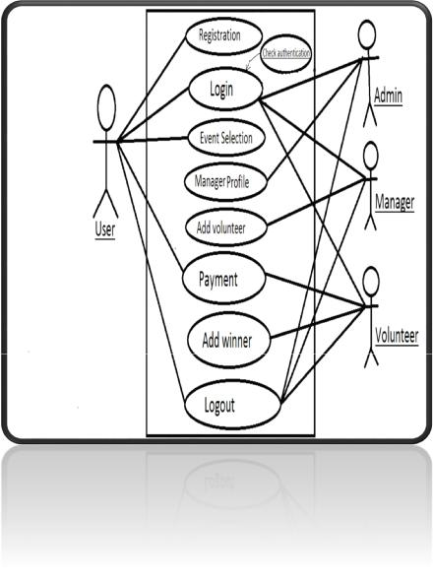

**Figure 1 Use case diagram**

**3.5** **Extended use cases:**

**1) Sign up**

**Section: Main**

Name:

Actors:

Purpose:

Description:

Cross References:

Pre-Conditions

Positive Post-

Situations

Sign up

Public

Sign up to the system

The user enters his connection particulars to sign up to the

system.

NONE

NONE

Sign Up Positive

Disappointment Post-

Situations

Sign Up Unsuccessful. Enter right particulars.

**Alternative Course**

Step 1:

Step 2:

The user enters inacceptable login data

The system shows a mistake and asks the user to re-

Arrive the data.

**2) Login**

**Section: Main**

Name:

Actors:

Purpose:

Description:

Login

Manager, Public.

Log in to the system

The user arrives the username and password to login to

the system.

|  |  |
| --- | --- |
| Cross References: | NONE |
| **Pre-Conditions** | NONE |
| **Positive Post-** | The user is recorded into the system |
| **Situations** |  |
|  |  |
| **Failure Post-** | Login Failed |
| **Conditions** |  |
|  |  |

**Typical Course of Events**

|  |  |  |  |  |  |  |  |  |  |
| --- | --- | --- | --- | --- | --- | --- | --- | --- | --- |
|  |  |  | **Actor Action** |  |  |  | **System Response** | |  |
|  |  |  | | |  |  |  |  |  |
| 1 | | This use case starts when a user | | | 2 | The | system | validates | the |
|  |  | enters | The username | and |  | data and records the user into | | | |
|  |  | password on the login screen | |  |  | the system | |  |  |
|  |  |  | |  |  |  |  |  |  |
|  | **Alternative Course** | | |  |  |  |  |  |  |
|  | Step 1: | | The user enters inacceptable login data | | | | | |  |
|  | Step 2: | | The system shows an error and asks the user to | | | | | | |
|  |  |  | re-enter the data | | | | |  |  |

**3.6** **Screen Shots**

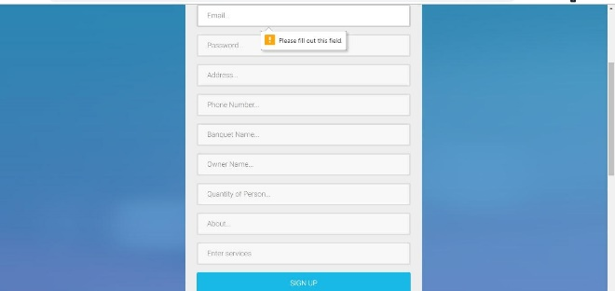

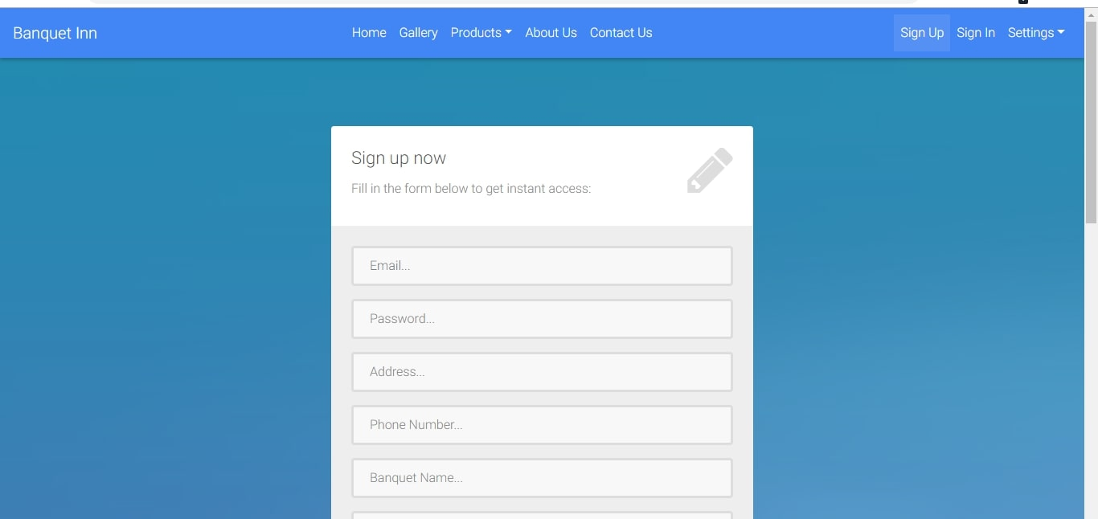Empty input Field

Sign Up Page

Sign in Page

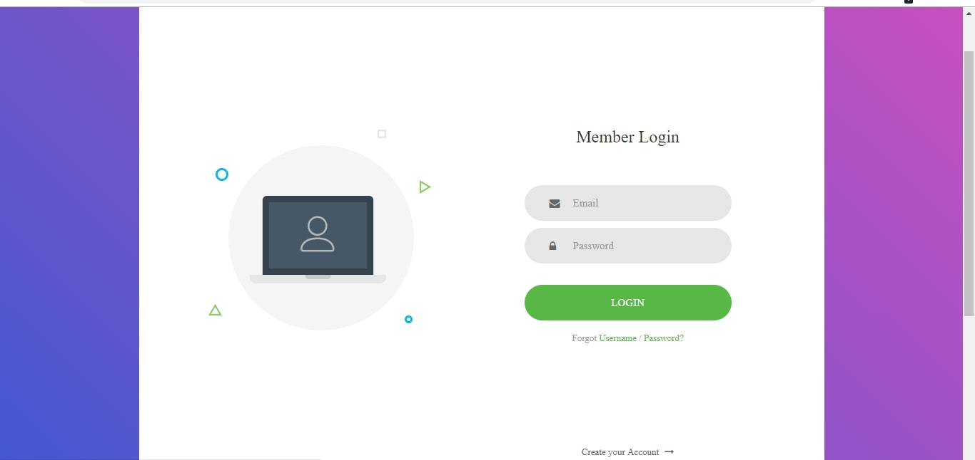

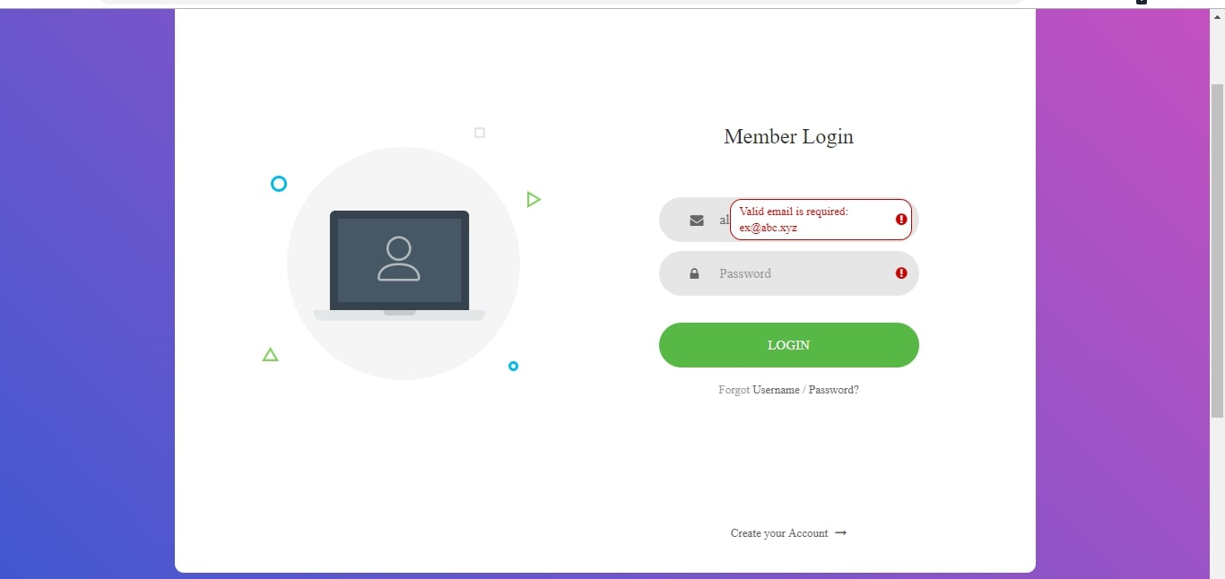

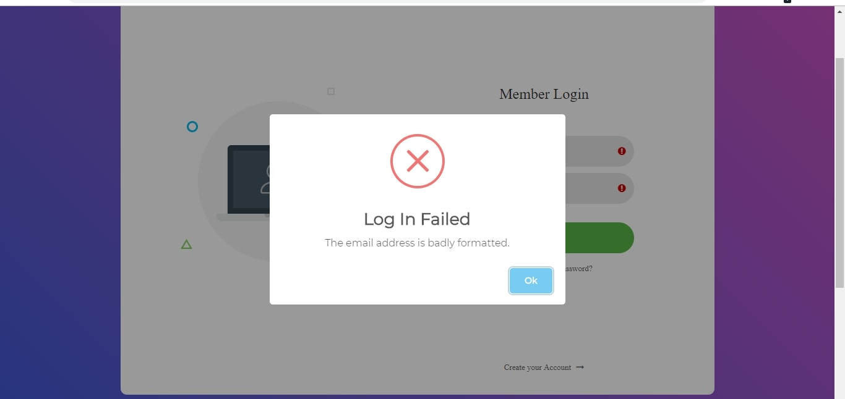Login Invalid Input

Login Fail

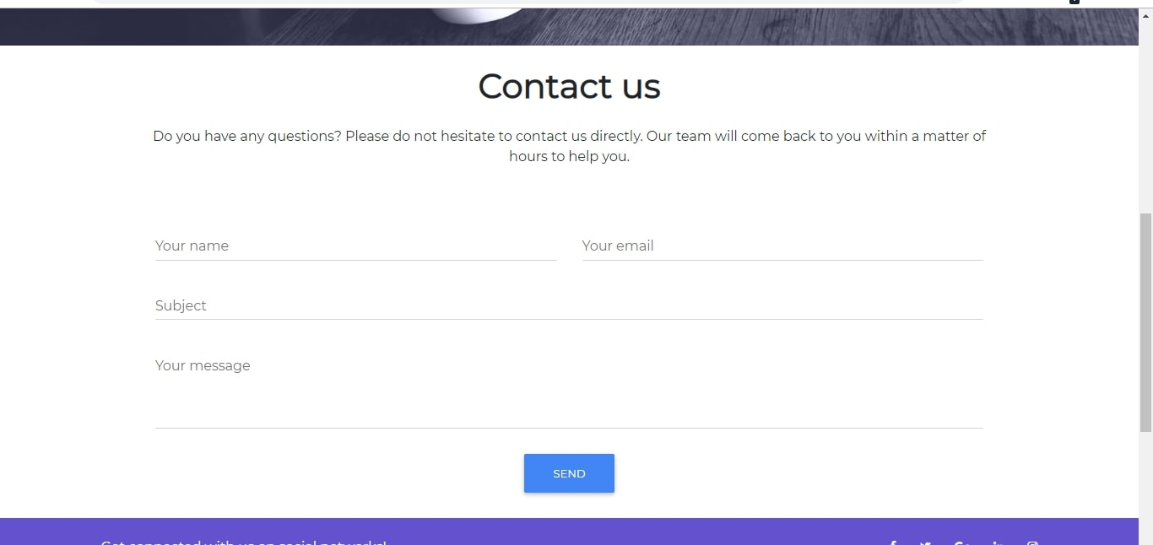

Contact Page

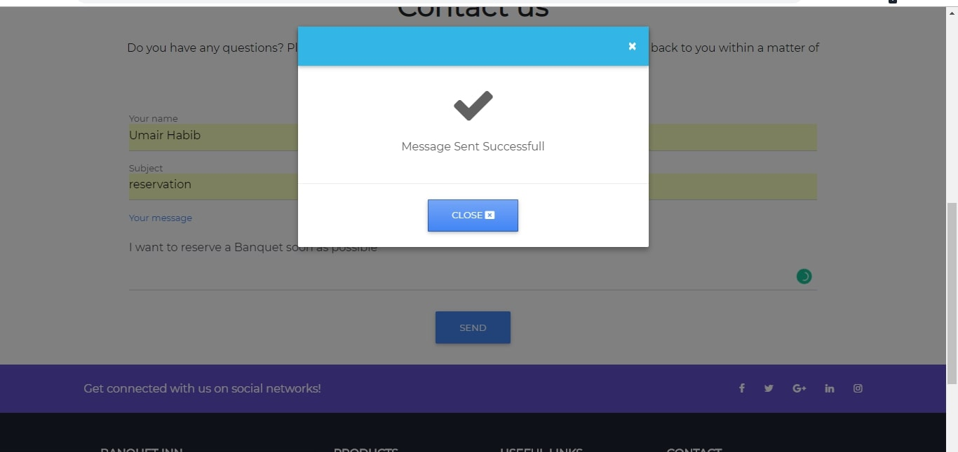

Contact Page Message Sent

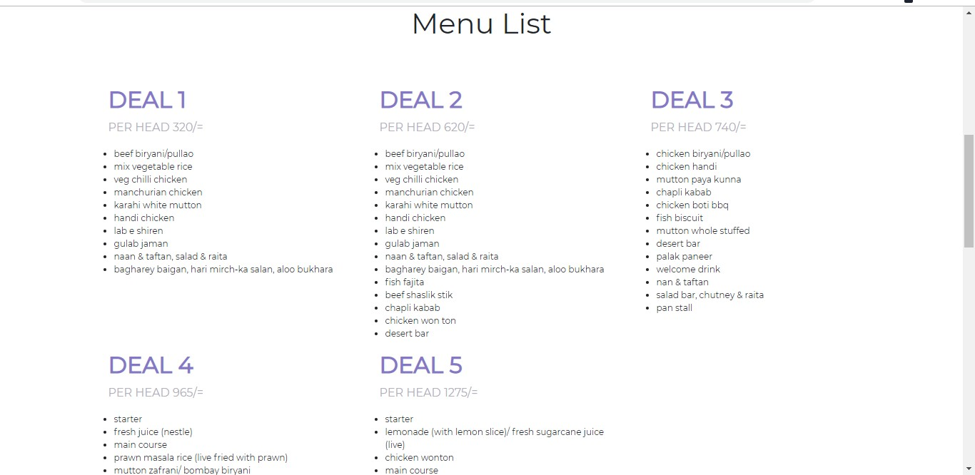

Catering Page

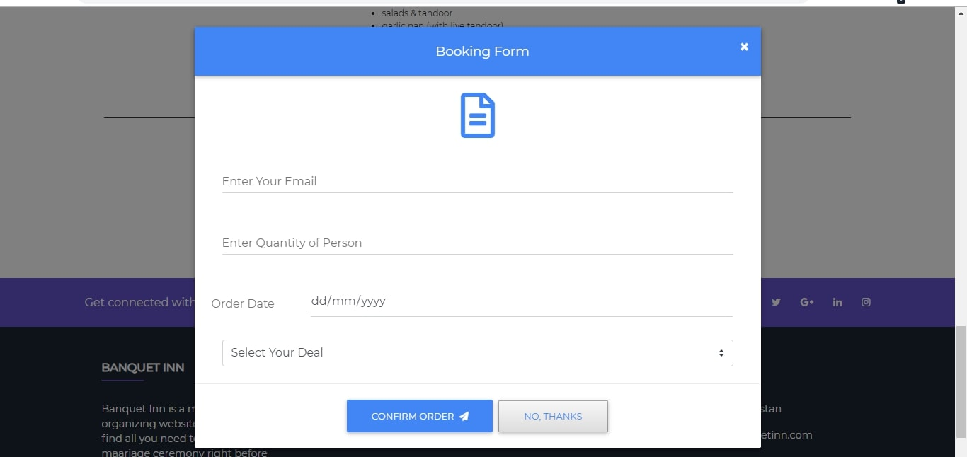

Catering Booking Form

Banquet Reservation Dates List

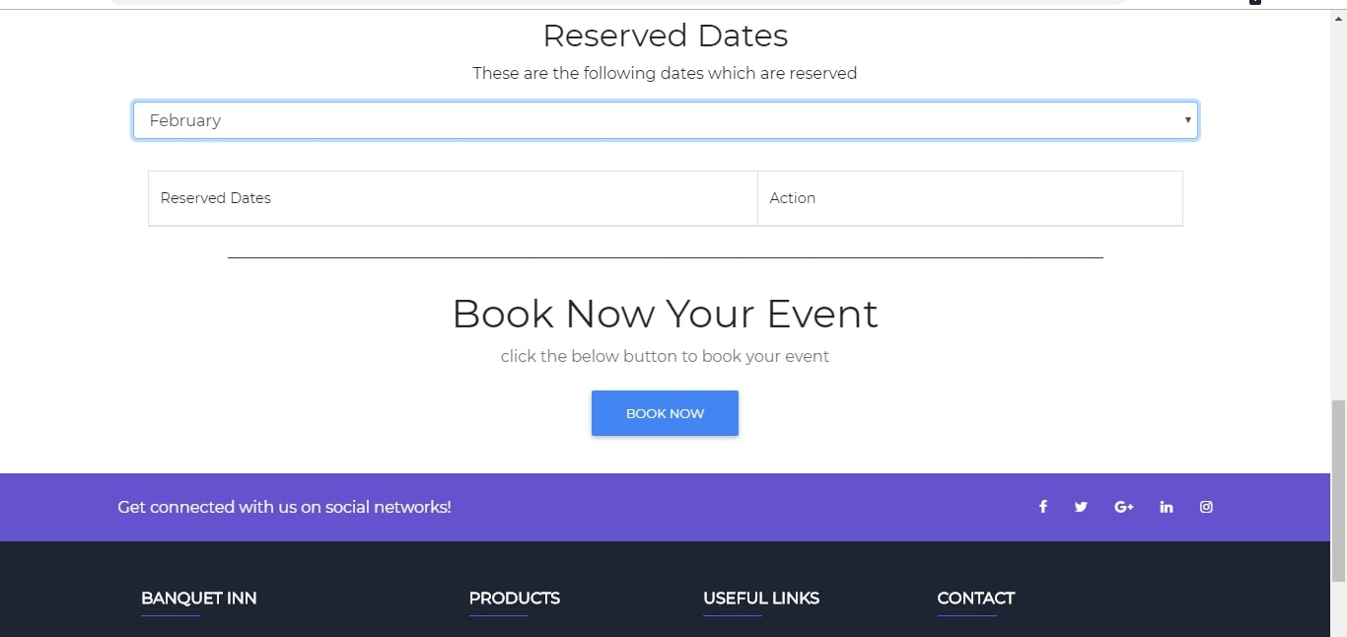

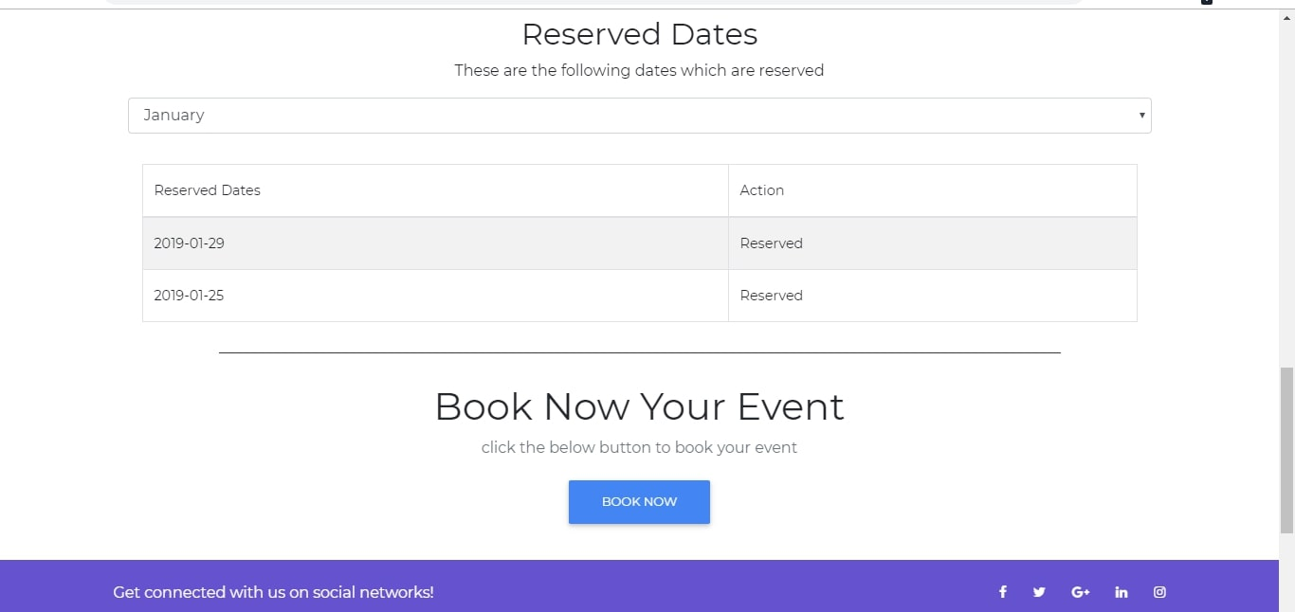

Banquet Reservation Dates List

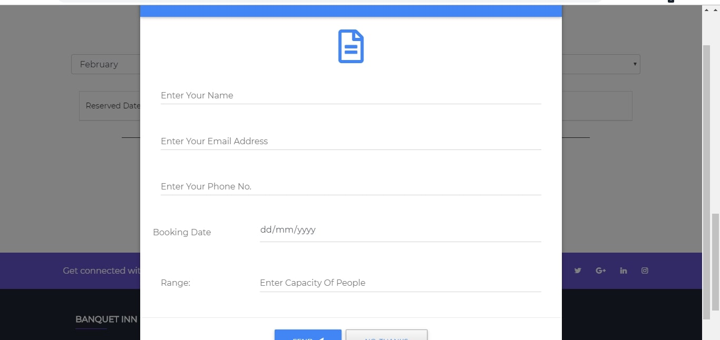

Banquet Booking Form

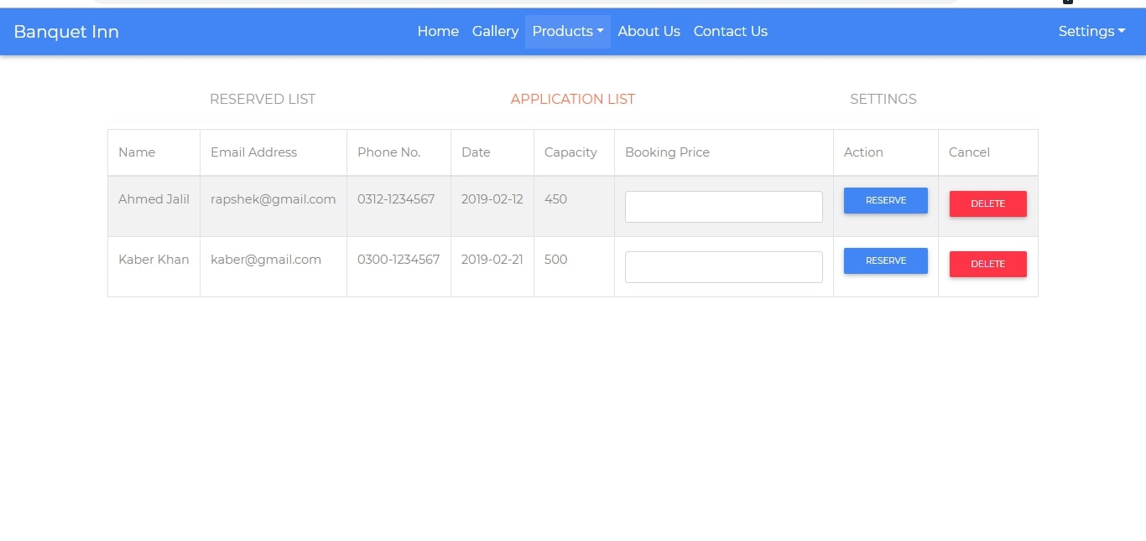

Banquet Registration Applicant List

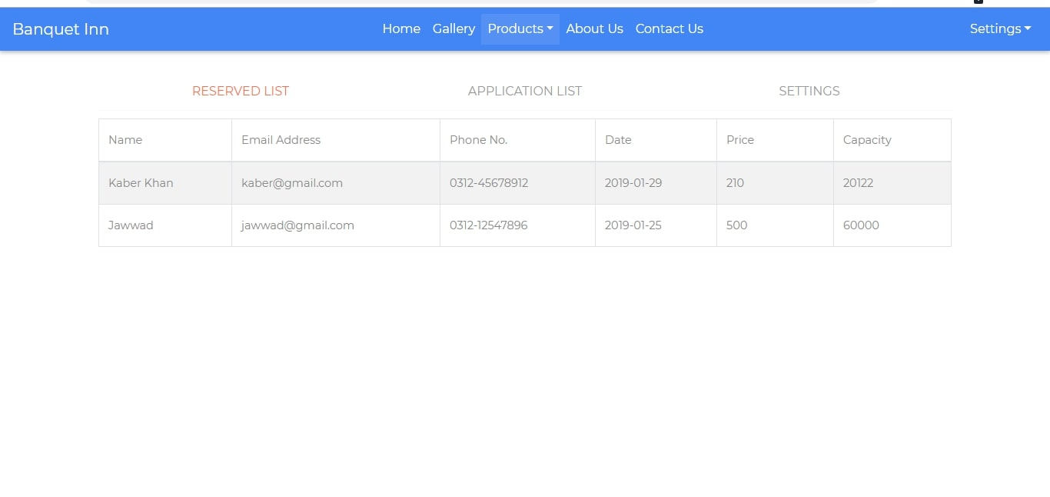

Reserved Banquet Dates List

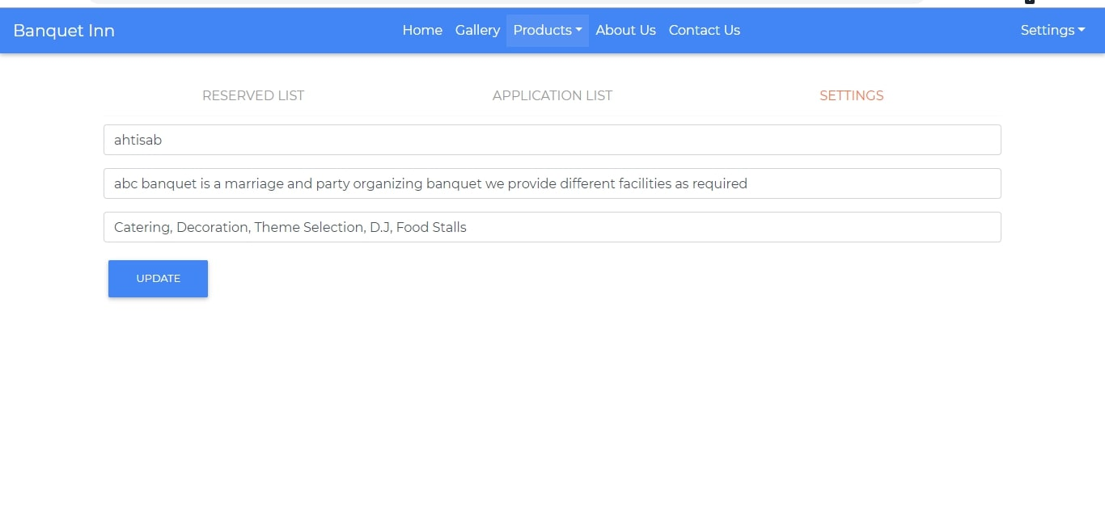

Banquet Setting Page

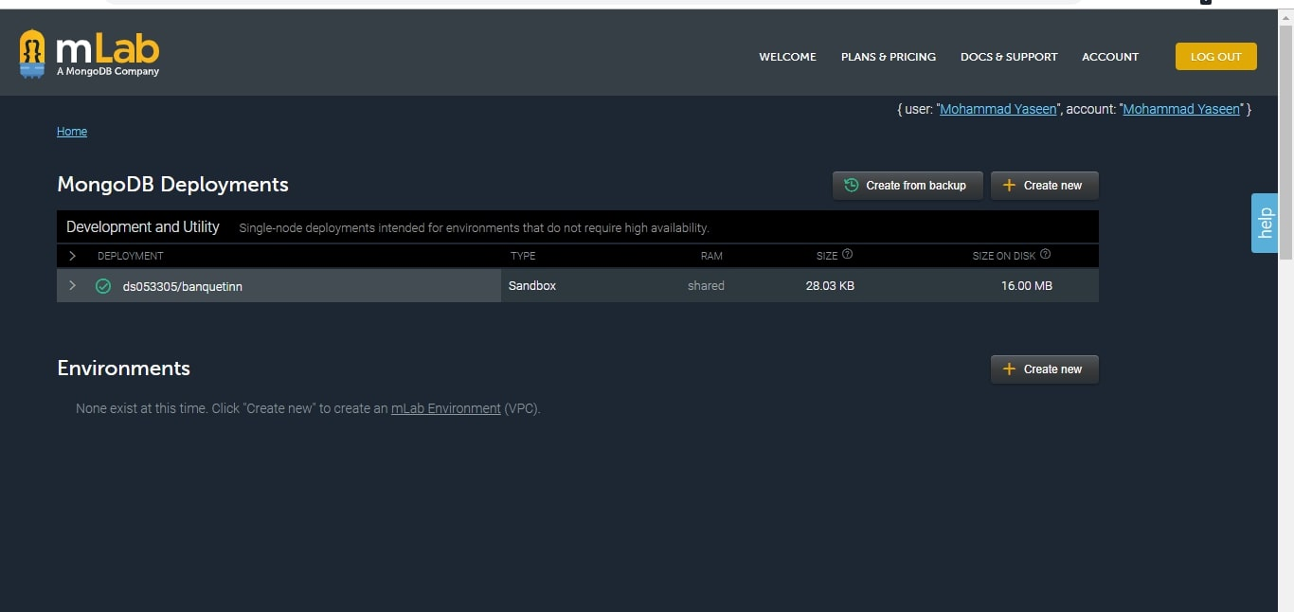

Banquet Database Entry

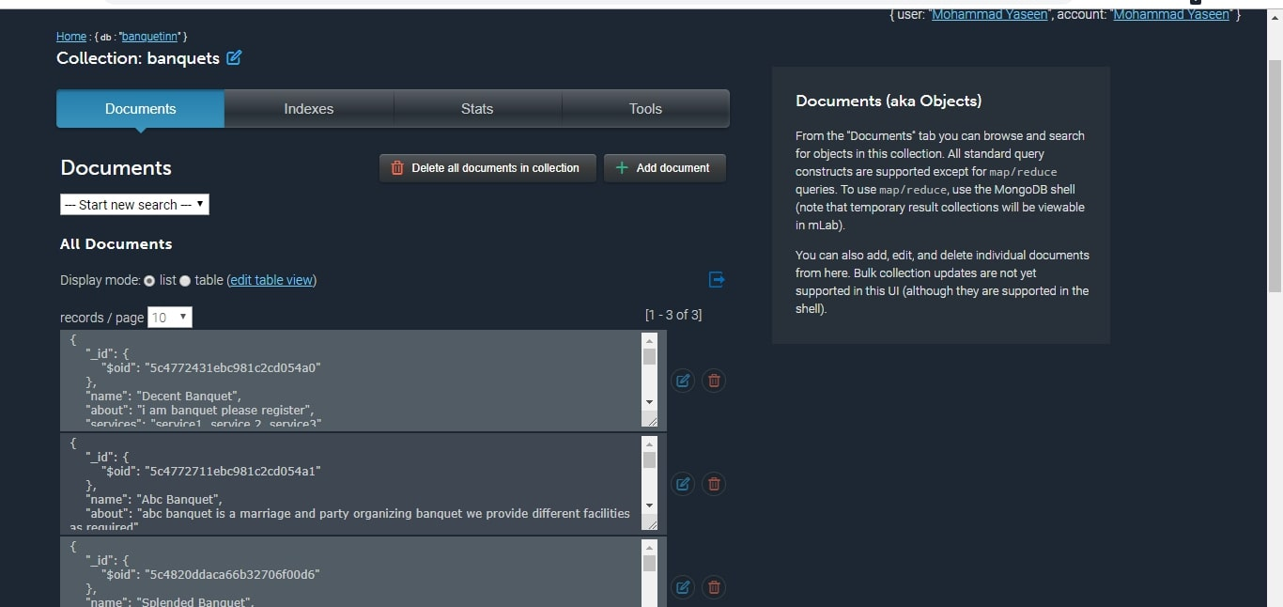

Banquet Database Entry List

1. **DATA FLOW DIAGRAM**



**4.1** **Data Flow Diagram Level 0**

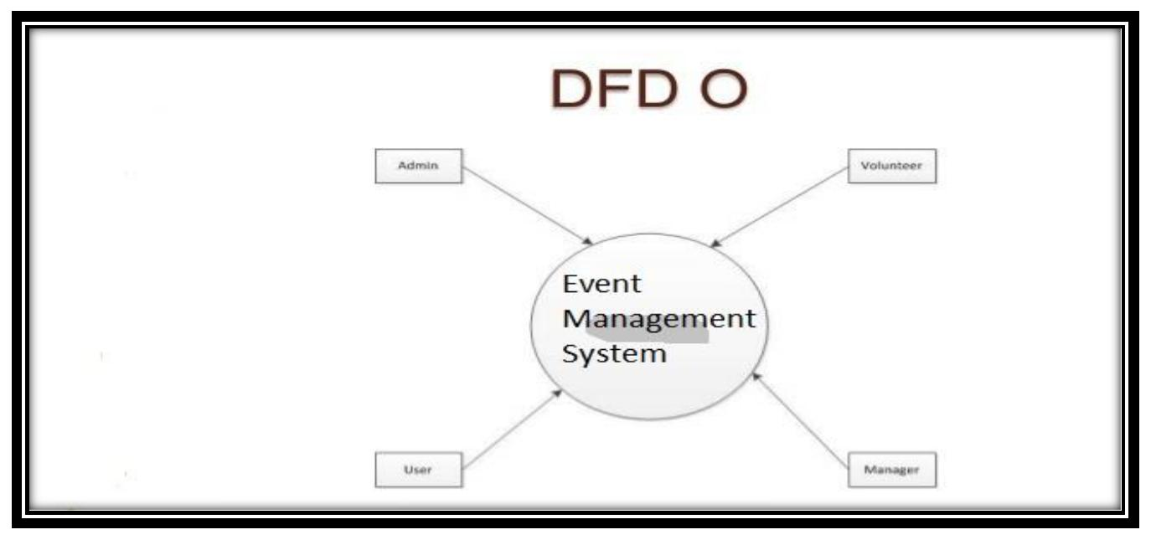

**Figure 3 DFD Level 0**

**4.2** **Data Flow Diagram Level 1**

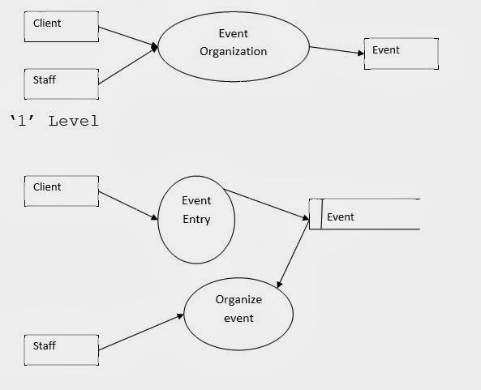

**Figure 4 DFD Level 1**

**4.3** **Data Flow Diagram Level 2**

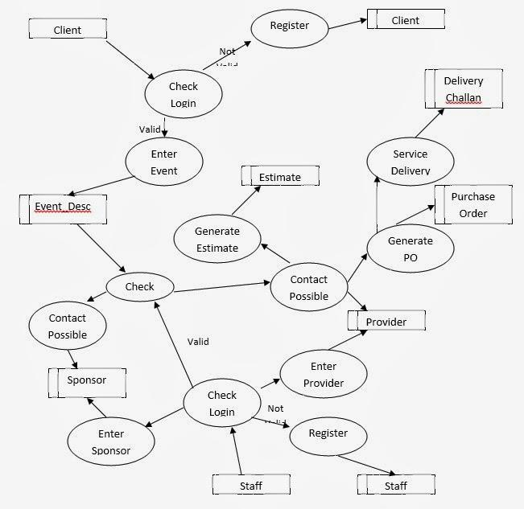

**Figure 5 DFD Level 2**

1. SYSTEM DESIGN



Define the system construction, or purely deliver the construction figure. For the School system, it may include web-based front end, web server, database etc. Don’t concern too much about it just give a modest illustration of a distinctive web-based plan?

**5.1** **System Architecture Diagram**

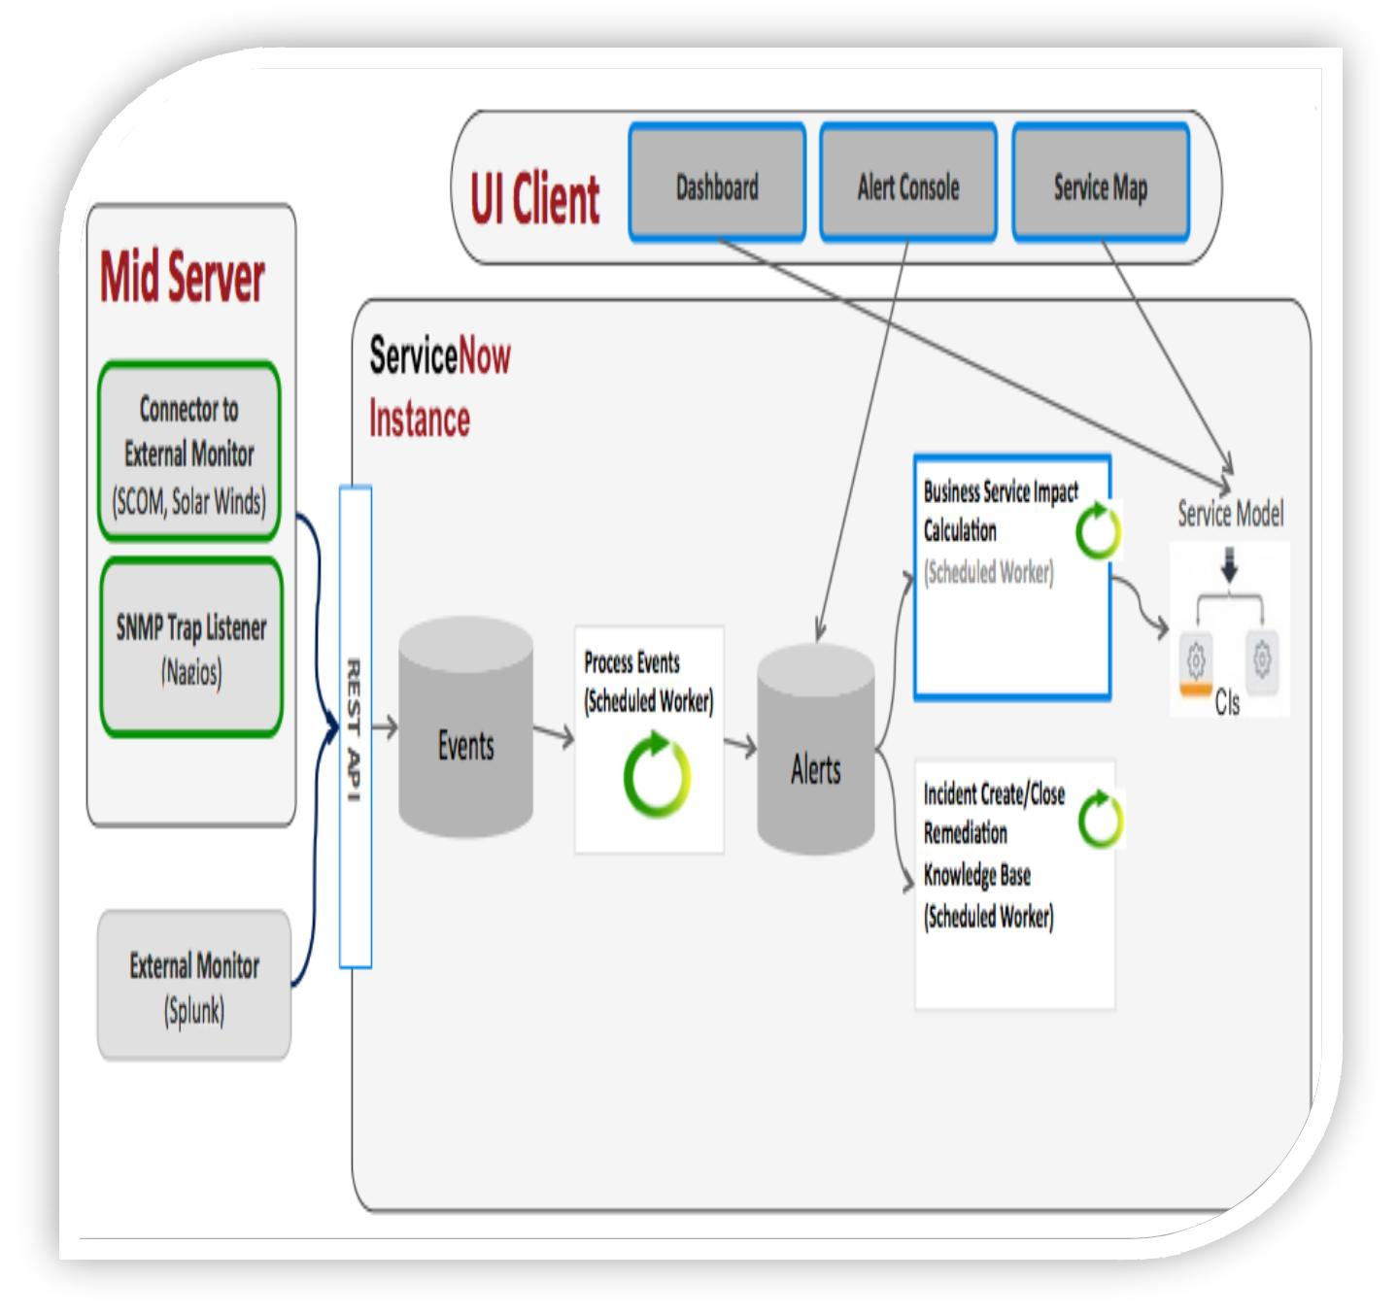

**Figure 6 System Architecture**

**5.2** **Class Diagram**

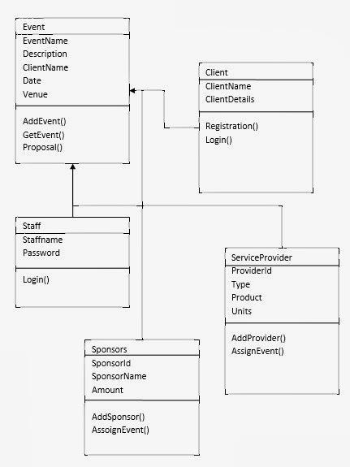

**Figure 7 Class Diagram**

**5.3** **Sequence Diagrams**

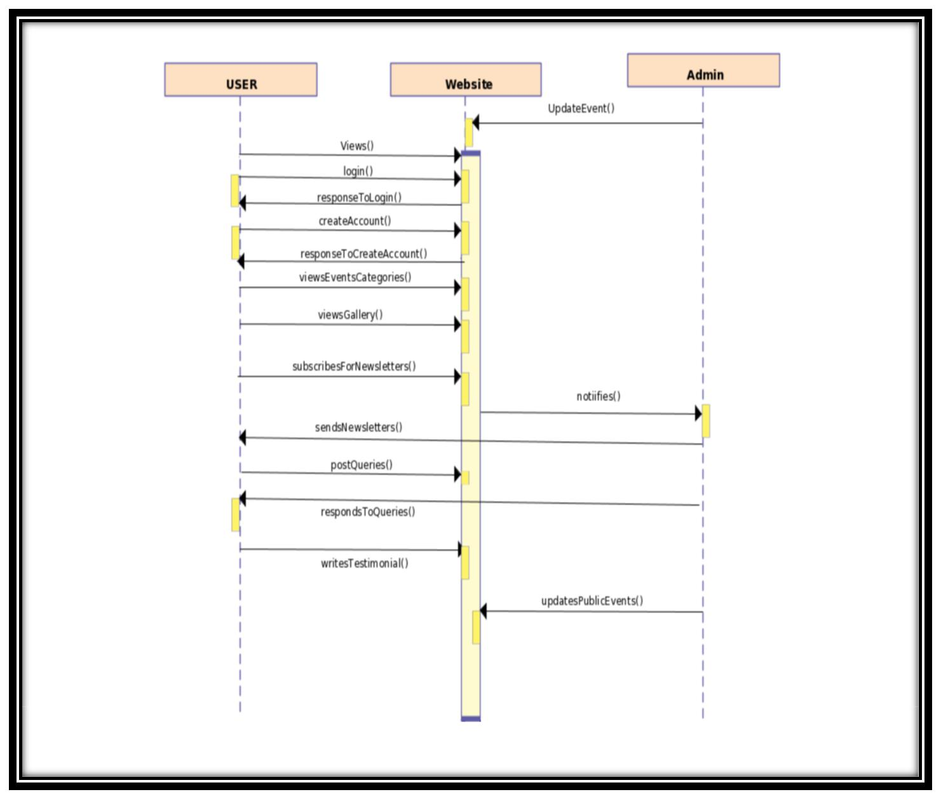

**Figure 8 Sequence Diagram**

**5.4** **Activity Diagram**

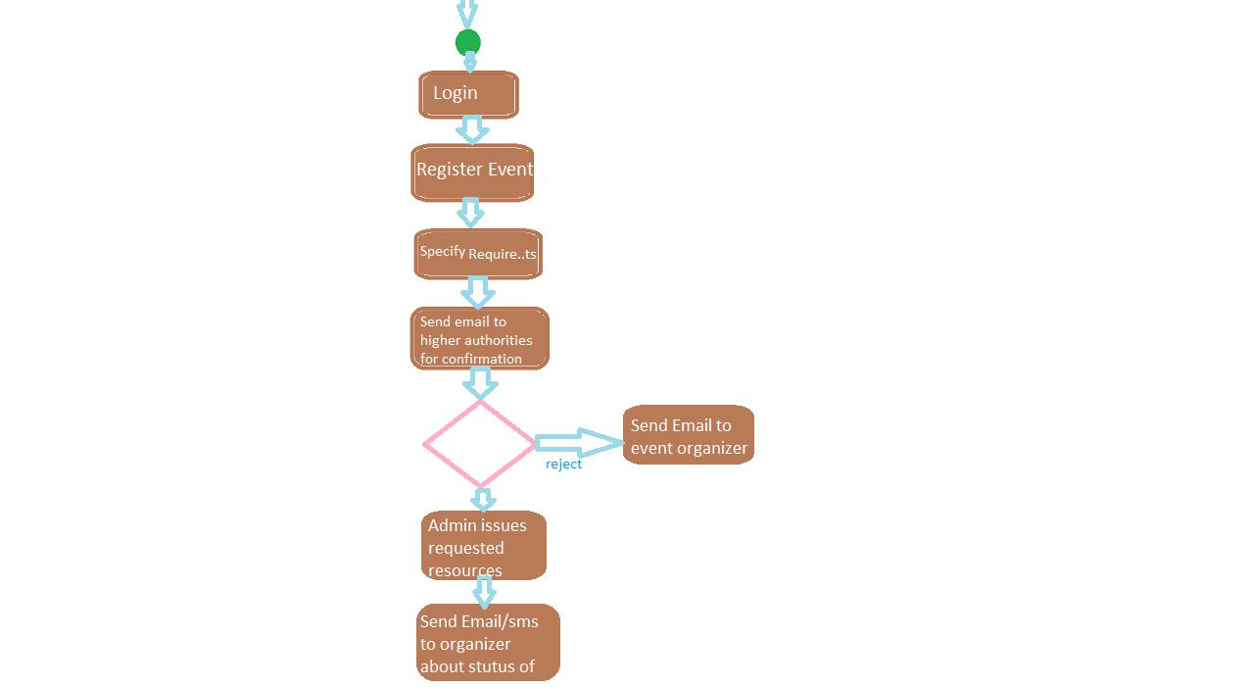

**Figure 9 Activity Diagram**

**5.5** **Component Diagram**

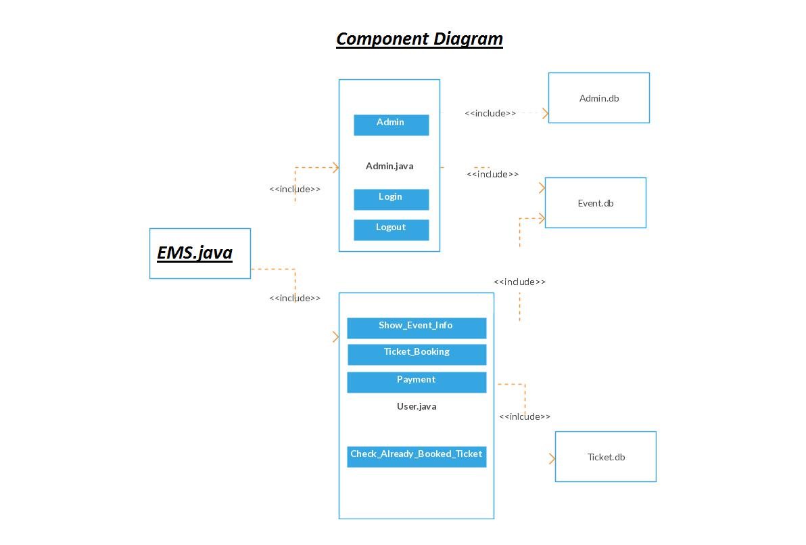

**Figure 18 Component Diagram**

**5.6** **ERD(Entity Relationship Diagram)**

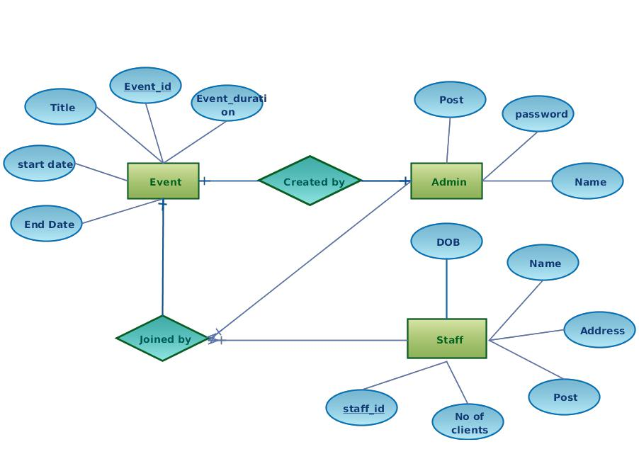

**Figure 10 ERD**

**5.7** **Data Dictionary**

1) User:

|  |  |  |  |
| --- | --- | --- | --- |
| Name | Type | Size | Description |
|  |  |  |  |
| ID | Integer | 1 | Id of the User |
|  |  |  |  |
| Name | String | 30 | Name of the User |
|  |  |  |  |
| Contact | Integer | 50 | Contact No of the User |
|  |  |  |  |
| Location | String | 12 | Location of the User |
|  |  |  |  |
| Email | String | 20 | Email of the User |
|  |  |  |  |

**Table 3 Data Dictionary 1**

2) User Request:

|  |  |  |  |
| --- | --- | --- | --- |
| Name | Type | Size | Description |
|  |  |  |  |
| Categories | String | 3 | Type of the event |
|  |  |  |  |
| Service | String | 10 | Type of service |
|  |  |  |  |
| Location | String | 25 | Location of venue |
|  |  |  |  |
| **Table 4Data Dictionary 2** | |  |  |

3) Account:

|  |  |  |  |
| --- | --- | --- | --- |
| Name | Type | Size | Description |
|  |  |  |  |
| ID | Integer | 4 | Id of the User |
|  |  |  |  |
| Password | String | 30 | Password of the User |
|  |  |  |  |
| Email | String | 20 | Email of the User |
|  |  |  |  |
| **Table 5Data Dictionary 3** | |  |  |

4) Admin:

|  |  |  |  |
| --- | --- | --- | --- |
| Name | Type | Size | Description |
|  |  |  |  |
| ID | Integer | 5 | Id of the Amin |
|  |  |  |  |
| Name | String | 30 | Name of the Admin |
|  |  |  |  |
| Password | String | 25 | Password of the Admin |
|  |  |  |  |

**Table 6Data Dictionary 4**

1. IMPLEMENTATION DETAILS



This section includes all the implementation details.

**6.1** **Development Setup**

**Programming language:** JavaScript

**Frontend:** HTML5, CSS3, JQUERY

**Hardware interface:** windows 7/8

**Database:** MongoDB

**Tools: vs code**

MongoDB is an open source database management system (DBMS) that uses a document-oriented database model which ropes many forms of data. It is one of the frequent nonrelation database tools which ascended in the mid-2000s under the NoSQL notable for use in big data submissions and other dispensation jobs involving data that doesn't fit well in an inflexible relational model. Instead of using tables and rows as in relational databases, the MongoDB construction is made up of groups and forms.

**6.2** **Deployment setup**

As this development is an online web-based application so we must be followed the following five steps during deployment steps:

**Step1: Preparation**

The three universal ideas for this website request placement are;

The client has **nothing** (i.e. this is their first website)

The client **previously has to host** and you will be organizing the site on **their**

**server**

The client **previously has to host** but you will be **poignant to a new server**

**Step2: Setup DNS records**

**Step 3: Set Up a Live Testing Site**

**Step 4: Set Up Email Accounts**

Developers organizing a website often supervise email, but it will be important to the client. Does your customer have mail hosted on their longstanding server? Are you moving their email?

**Step 5: Backup and Go Live**

Deployment checklist:

Have entree to DNS record organization or know the people to communication

Set up the DNS archives and make sure that all the locations are right Set up and test the website on the manufacturing server (where it will live) Set up email

Back up the longstanding site and organize the new one

**6.3** **Constraints**

**6.3.1 Assumptions**

1. The client will able to see existing time slots for an event online.
2. Most of the people will have internet linking to approach our web.
3. Most of the people will visit our web which is involved to see an event.
4. The online operator will able to get the info like timing slots, packages etc. of altered halls.
5. The user will able to search any wedding lawn by name and have full admission to info of applicable marriage hall/wedding lawn.
6. The user may be enabled for payment.
7. If a user follows the outline of a wedding lawn or a marriage hall he/she may get the new notices through their E-mail.

**6.3.2 System constraints**

1. PC or Laptop
2. Smart Phone
3. Internet
4. Database
5. User

**6.3.3 Restrictions:**

To book a wedding lawn user must sign up for the system.

A user is not allowable to contact or see the personal particulars of another user.

1. TESTING



**7.1** **Extended Test Cases**

**Table 7 Test case 1**

|  |  |  |  |  |  |  |  |  |  |  |
| --- | --- | --- | --- | --- | --- | --- | --- | --- | --- | --- |
| Test | Test | Test Steps: | |  | Test Data: | Expected | | Actual | Pass/Fai |  |
| case | Scenario: |  |  |  |  | results: | | results: | l |  |
| id: |  |  |  |  |  |  |  |  |  |  |
|  |  |  |  | |  |  |  |  |  |  |
| TCID | Check | 1. | Go to site | | User id: 123 | User | should | As expected | Pass |  |
| 1 | customer | 2. | Enter | user | User | login | into |  |  |  |
|  | login with |  | id |  | application. | |  |  |  |
|  |  |  | password: |  |  |  |
|  | legal data | 3. | Enter | user |  |  |  |  |  |
|  | R6524 |  |  |  |  |  |
|  |  |  | password | |  |  |  |  |  |
|  |  | 4. | Check |  |  |  |  |  |  |  |
|  |  |  | submit |  |  |  |  |  |  |  |

**Table 8Test case 2**

|  |  |  |  |  |  |  |  |  |  |
| --- | --- | --- | --- | --- | --- | --- | --- | --- | --- |
| Test | Test | Test Steps: | |  | Test Data: | Expected | Actual | Pass/Fail |  |
| case | Scenario: |  |  |  |  | results: | results: |  |  |
| id: |  |  |  |  |  |  |  |  |  |
|  |  |  |  | |  |  |  |  |  |
| TCID2 | Check | 1. | Go to site | | User id: | User should | As expected | pass |  |
|  | customer | 2. | Enter | user | User | not login into |  |  |  |
|  | login with |  | id |  | application. |  |  |  |
|  |  |  | password: |  |  |  |
|  | invalid data | 3. | Enter | user |  |  |  |  |
|  | 567h |  |  |  |  |
|  |  |  | password | |  |  |  |  |
|  |  | 4. | Check |  |  |  |  |  |  |
|  |  |  | submit |  |  |  |  |  |  |
|  |  |  |  |  |  |  |  |  |  |

**Table 9Test case 3**

|  |  |  |  |  |  |  |  |  |  |  |
| --- | --- | --- | --- | --- | --- | --- | --- | --- | --- | --- |
| Test | Test | Test Steps: | |  | Test | Expected | | Actual | Pass/Fa |  |
| case | Scenario: |  |  |  | Data: | results: | | results: | il |  |
| id: |  |  |  |  |  |  |  |  |  |  |
|  |  |  |  | |  |  |  |  |  |  |
| TCI | Test User | 1. | Go to the site | | User id: | User | should | As expected | Pass |  |
| D3 | forgot | 2. | Enter | user | 3456 | not | login |  |  |  |
|  | password |  | id |  | User | into |  |  |  |  |
|  |  | 3. | Enter | user | application. | |  |  |  |
|  |  | password |  |  |  |
|  |  |  | password: | |  |  |  |  |  |
|  |  |  | : |  |  |  |  |  |
|  |  |  | “password | |  |  |  |  |  |
|  |  |  | “Empty” |  |  |  |  |  |
|  |  |  | forgot” |  |  |  |  |  |  |
|  |  | 4. | Enter |  | Verification |  |  |  |  |  |
|  |  |  | verification | | on code: |  |  |  |  |  |
|  |  |  | code |  | 8899 |  |  |  |  |  |
|  |  | 5. | Enter | new |  |  |  |  |  |
|  |  |  |  |  |  |  |  |
|  |  |  | password. | | Enter |  |  |  |  |  |
|  |  | 6. | Check |  | new |  |  |  |  |  |
|  |  |  | submit |  | password |  |  |  |  |  |
|  |  |  |  |  | : chili |  |  |  |  |  |
|  |  |  |  |  |  |  |  |  |  |  |

**Table 10 Test case 4**

|  |  |  |  |  |  |  |  |  |  |  |  |  |  |  |
| --- | --- | --- | --- | --- | --- | --- | --- | --- | --- | --- | --- | --- | --- | --- |
| Test | Test | Test Steps: | |  |  | Test Data: | |  |  | Expected | | Actual | Pass |  |
| Case | Scenario: |  |  |  |  |  |  |  |  | results: |  | results: | /Fail |  |
| id: |  |  |  |  |  |  |  |  |  |  |  |  |  |  |
|  |  |  |  |  |  |  | |  | |  |  |  |  |  |
| TCID4 | Test the | 1. | Go to site |  |  | User | | name: | | The | user | As | pass |  |
|  | Submit | 2. | Navigate | to |  | NOMAN Akhter | | | | can make | | expected |  |  |
|  |  | login/signup | |  |  |  |  |  | new |  |  |  |  |
|  | button. |  |  | Email: | |  |  |  |  |  |  |
|  |  | page. |  |  |  |  | account | on |  |  |  |
|  |  |  |  |  | [13005065023@u](mailto:13005065023@umt.edu.pk) | | |  |  |  |  |
|  |  | 3. | Fill the form | |  |  | this | web |  |  |  |
|  |  | [mt.edu.pk](mailto:13005065023@umt.edu.pk) |  | |  |  |  |
|  |  |  | according | to |  |  |  |  | application | |  |  |  |
|  |  |  |  |  |  |  |  |  |
|  |  |  | the format. |  |  | Password: 345yt | | | |  |  |  |  |  |
|  |  | 4. | Click submit. | |  |  |  |  |  |  |  |  |  |  |
|  |  |  |  |  |  |  |  |  |  |  |  |  |  |  |

**Table 11Test case 5**

|  |  |  |  |  |  |  |  |  |  |  |
| --- | --- | --- | --- | --- | --- | --- | --- | --- | --- | --- |
| Test | Test Scenario: | | Test Steps: | |  | Test Data: | Expected | | Actual | Pass/ |
| case id: |  |  |  |  |  |  | results: | | results: | Fail |
|  |  |  |  |  | |  |  | |  |  |
| TCID5 | To view the |  | 1. | Go to the site | |  | User can see | | As | pass |
|  | timing slots of |  | 2. | Click | on hall |  | the | timing | expected |  |
|  | venue. |  |  | name. |  |  | slots | of |  |  |
|  |  |  | 3. | Check | timing |  | venue. |  |  |  |
|  |  |  |  | slots |  |  |  |  |  |  |
|  |  |  |  |  |  |  |  |  |  |  |

**Table 12Test case 6**

|  |  |  |  |  |  |  |  |  |
| --- | --- | --- | --- | --- | --- | --- | --- | --- |
| Test | Test Scenario: | Test Steps: | | Expected results: | | | Actual | Pass/Fail |
| case id: |  |  |  |  |  |  | results: |  |
|  |  |  |  |  |  |  |  |  |
| TCID6 | To view the | 1. | Go to the site | User can | See |  | As | pass |
|  | packages venue. | 2. | Click on hall | packages | Of |  | expected |  |
|  |  |  | name. | entire venue/hall. | |  |  |  |
|  |  | 3. | Check packages |  |  |  |  |  |

**7.2** **Traceability Matrix**

**7.2.1** **RID vs UCID (requirements vs use cases)**

|  |  |  |  |  |  |  |  |  |  |  |  |
| --- | --- | --- | --- | --- | --- | --- | --- | --- | --- | --- | --- |
| **UCID/RID** | **R** | **R** | **R** | **R** | **R** | **R** | **R** | **R** | **R** | **R** |  |
|  | **1** | **2** | **3** | **4** | **5** | **6** | **7** | **8** | **9** | **10** |  |
|  |  |  |  |  |  |  |  |  |  |  |  |
| UC 1 | ✓ |  |  |  |  |  |  |  |  |  |  |
|  |  |  |  |  |  |  |  |  |  |  |
|  |  |  |  |  |  |  |  |  |  |  |  |
| UC 2 | ✓ | ✓ |  |  |  |  |  |  |  |  |  |
|  |  |  |  |  |  |  |  |  |  |  |
|  |  |  |  |  |  |  |  |  |  |  |  |
| UC 3 |  |  | ✓ |  |  |  |  |  |  |  |  |
|  |  |  |  |  |  |  |  |  |  |  |
|  |  |  |  |  |  |  |  |  |  |  |  |
| UC 4 |  | ✓ | ✓ | ✓ | ✓ |  |  |  |  |  |  |
|  |  |  |  |  |  |  |  |  |  |  |
|  |  |  |  |  |  |  |  |  |  |  |  |
| UC 5 |  |  | ✓ |  |  |  | ✓ |  |  |  |  |
|  |  |  |  |  |  |  |  |  |  |  |
|  |  |  |  |  |  |  |  |  |  |  |  |
| UC 6 |  |  |  |  |  |  |  |  | ✓ | ✓ |  |
|  |  |  |  |  |  |  |  |  |  |  |
|  |  |  |  |  |  |  |  |  |  |  |  |

**7.2.2** **Prototypes (RID vs PID)**

|  |  |  |  |  |  |  |  |  |  |  |
| --- | --- | --- | --- | --- | --- | --- | --- | --- | --- | --- |
| **RID/PID** | **PID** | **PID** | **PID** | **PID** | **PID** | **PID** | **PID** | **PID** | **PID** |  |
|  | **1** | **2** | **3** | **4** | **5** | **6** | **7** | **8** | **9** |  |
|  |  |  |  |  |  |  |  |  |  |  |
| RID 1 | ✓ |  |  |  |  |  |  |  |  |  |
|  |  |  |  |  |  |  |  |  |  |
|  |  |  |  |  |  |  |  |  |  |  |
| RID 2 |  | ✓ |  |  |  |  |  |  |  |  |
|  |  |  |  |  |  |  |  |  |  |
|  |  |  |  |  |  |  |  |  |  |  |
| RID 3 |  | ✓ |  | ✓ |  |  |  |  |  |  |
|  |  |  |  |  |  |  |  |  |  |
|  |  |  |  |  |  |  |  |  |  |  |
| RID 4 |  |  |  | ✓ | ✓ |  |  |  |  |  |
|  |  |  |  |  |  |  |  |  |  |
|  |  |  |  |  |  |  |  |  |  |  |
| RID 5 |  |  | ✓ |  |  |  |  |  |  |  |
|  |  |  |  |  |  |  |  |  |  |
|  |  |  |  |  |  |  |  |  |  |  |
| RID 6 |  |  |  |  | ✓ |  |  | ✓ |  |  |
|  |  |  |  |  |  |  |  |  |  |
|  |  |  |  |  |  |  |  |  |  |  |
| RID7 |  |  |  |  |  | ✓ |  |  |  |  |
|  |  |  |  |  |  |  |  |  |  |
|  |  |  |  |  |  |  |  |  |  |  |
| RID8 |  |  |  |  |  |  |  |  |  |  |
|  |  |  |  |  |  |  |  |  |  |  |
| RID9 |  |  |  |  |  |  | ✓ | ✓ |  |  |
|  |  |  |  |  |  |  |  |  |  |
|  |  |  |  |  |  |  |  |  |  |  |
| RID10 |  |  |  |  |  |  |  |  | ✓ |  |
|  |  |  |  |  |  |  |  |  |  |
|  |  |  |  |  |  |  |  |  |  |  |

**7.2.3** **Test Cases (RID vs TID)**

|  |  |  |  |  |  |  |  |  |  |  |
| --- | --- | --- | --- | --- | --- | --- | --- | --- | --- | --- |
| **RID/PID** | **RID** | **RID** | **RID** | **RID** | **RID** | **RID** | **RID** | **RID** | **RID** |  |
|  | **1** | **2** | **3** | **4** | **5** | **6** | **7** | **8** | **9** |  |
|  |  |  |  |  |  |  |  |  |  |  |
| TID 1 | ✓ |  |  |  |  |  |  |  |  |  |
|  |  |  |  |  |  |  |  |  |  |
|  |  |  |  |  |  |  |  |  |  |  |
| TID 2 |  | ✓ |  |  |  |  |  |  |  |  |
|  |  |  |  |  |  |  |  |  |  |
|  |  |  |  |  |  |  |  |  |  |  |
| TID 3 |  | ✓ |  |  |  |  |  |  |  |  |
|  |  |  |  |  |  |  |  |  |  |
|  |  |  |  |  |  |  |  |  |  |  |
| TID 4 |  |  |  |  |  |  |  |  |  |  |
|  |  |  |  |  |  |  |  |  |  |  |
| TID 5 |  |  | ✓ | ✓ |  |  |  |  |  |  |
|  |  |  |  |  |  |  |  |  |  |
|  |  |  |  |  |  |  |  |  |  |  |
| TID 6 |  |  |  |  | ✓ |  |  |  |  |  |
|  |  |  |  |  |  |  |  |  |  |
|  |  |  |  |  |  |  |  |  |  |  |
| TID7 |  |  |  |  |  | ✓ |  |  |  |  |
|  |  |  |  |  |  |  |  |  |  |
|  |  |  |  |  |  |  |  |  |  |  |
| TID8 |  |  |  |  |  |  |  |  |  |  |
|  |  |  |  |  |  |  |  |  |  |  |
| TID9 |  |  |  | ✓ |  |  | ✓ | ✓ |  |  |
|  |  |  |  |  |  |  |  |  |  |
|  |  |  |  |  |  |  |  |  |  |  |
| TID10 |  |  |  |  |  | ✓ |  |  | ✓ |  |
|  |  |  |  |  |  |  |  |  |  |
|  |  |  |  |  |  |  |  |  |  |  |

1. RESULTS/OUTPUT/STATISTICS



This section includes the results of the above comparison.

**8.1** %completion.

We have finished our development 100%. We have encountered all the use ful requirements that we debated.

**8.2** **%accuracy**

Our development is working 100% correct. It fulfills all the useful and nonfunctional necessities as we assured.

**8.3** **%correctness**

As we have verified all the necessities and made their test cases stated and clear all the errors so now our project is 100% accurate.

1. CONCLUSION



Our project is only a modest project to fulfill the needs to manage their project work. Some user-friendly coding has also implemented. This platform shall prove to be a commanding package to satisfying all necessities of the user. The impartial of software planning is to deliver a border effort that enables the manager to make sensible estimation made within a partial time frame at the start of the software project and should be updated frequently as the project frequently.

In the end, it is determined that we have made exertion on following points…

An explanation of contextual and background of the project and its relative to work already done in the area.

Made declaration of the purposes and aims of the project. The report of the determination, choice, and applicability.

We describe the project on which we are working on the project.

We define the condition terms of the system and actions that can be done on these things.

We intended user edge and safety issues related to the system.

Finally, the system is applied and verified conferring to the test cases.

1. FUTURE WORK



It can be brief that the upcoming opportunity of the project circles around keeping data concerning:

We can add progress software for event management system including more services.

We will congregation the stage on online servers to make it available worldwide Participate multiple load balancers to allocate loads of the system.

Create the master and slave database assembly to lessen the excess of the database inquiries.

Applying the backup instrument for taking backup on codebase and database on the even basis on different servers.

The above-revealed points are the improvements which can be done to rise applicability and usage of the project.

Here we can keep the records of event and booking. Also, it can be seen that nowadays the players are multipurpose, i.e. so there is a scope for presenting a method to uphold the event management system. Improvement can be done to keep all the event, booking, customer, employee, and inquiry.

1. BIBLIOGRAPHY



**11.1 Books**

1. <https://www.scribd.com/document/342098952/Synopsis-of-Event-Management-System>
2. <https://solutiondots.com/blog/event-management-system-comprehensive-solution-events-management.html>
3. [http://www.academia.edu/4593395/Project_Report_On_Event_manag](http://www.academia.edu/4593395/Project_Report_On_Event_management) [ement.](http://www.academia.edu/4593395/Project_Report_On_Event_management)

**11.2 Articles**

1. Event Management System by D Yogendra Rao: <http://www.slideshare.net/DYogendraRao/event-management-system-24592836>
2. **Web-based event management system by FakhrunNisha**

**11.3 Other References**

1. <http://www.w3schools.com/>
2. <http://stackoverflow.com/>
3. <https://www.tutorialspoint.com/web_development_tutorials.htm>
4. <http://github.com/>
5. <http://www.vogella.com/tutorials/dotnet/artcle.html>
6. APPENDIX



**12.1 Glossary of terms**

None

**12.2 Pre-requisites**

One should have information about Web Technologies and database before developing this web-based application.