Evaluation Report
Comparative Optimisation of the Travelling Salesman Problem Using Iterated Local Search and Genetic Algorithms
Module: AI for Search and Optimisation
Author: Yaseen Sharaf

Table of Contents
Table of Contents 1
1. Evaluation Methodology 1
2. Results Summary 1
3. Convergence Analysis 1
4. Statistical Significance Testing 1
5. Visualisations 1
5.1 Solution Quality vs. Problem Size 1
5.2 Runtime vs. Problem Size 1
5.3 Distribution of 50-City Results 1
5.4 Best Observed Routes at 50 Cities 1
6. Discussion 1
7. Limitations 1
8. Conclusion 1
9. Legal and Ethical Considerations 1
10. References 1

1. Evaluation Methodology
Both algorithms were compared on a symmetric Euclidean Travelling Salesman Problem built from a 50-city dataset. Five problem instances were constructed from the first 10, 20, 30, 40 and 50 rows of the dataset in their original order, so both algorithms always faced identical coordinates and distance matrices.
A pilot study using the 50-city instance and seeds 142–144 was used to choose a fair evaluation budget shared by both algorithms. Increasing the budget from 50,000 to 100,000 evaluations reduced ILS's mean distance by approximately 5.91%, while GA's mean distance was essentially unchanged over the same interval. A budget of 100,000 route evaluations was therefore selected for the main experiment, as it was large enough for ILS to complete its initial local search and perform further exploration in every pilot run.
The main experiment ran both algorithms across all five problem sizes using ten seeds each (42–51), producing 100 runs in total. Algorithm execution order was alternated to avoid a systematic order effect. One evaluation was defined as a complete route-distance calculation; both algorithms stopped at exactly 100,000 evaluations in every run. Runtime was measured with time.perf_counter() and included search operations only — distance-matrix construction, validation, plotting and file saving were excluded.
Final distances at each problem size were compared using two-sided Welch and Mann–Whitney tests, alongside an exact paired permutation sensitivity check. Holm correction was applied across the 15 planned comparisons at a significance threshold of α = 0.05. Because ILS and GA reused the same seeds, the independent-sample tests (Welch, Mann–Whitney) were treated as exploratory, with the paired permutation test relied on as the primary safeguard against that shared randomness.

2. Results Summary
City count | GA mean dist. | ILS mean dist. | ILS reduction vs GA (%) | GA mean runtime (s) | ILS mean runtime (s) | GA / ILS runtime ratio
10 | 290.3068 | 290.3068 | 0 | 10.333 | 1.081 | 9.563
20 | 391.7211 | 386.4297 | 1.3508 | 13.929 | 2.669 | 5.218
30 | 459.1461 | 451.767 | 1.6071 | 14.776 | 3.392 | 4.357
40 | 523.8433 | 500.2963 | 4.495 | 14.986 | 3.585 | 4.18
50 | 594.5714 | 579.7012 | 2.501 | 15.358 | 4.198 | 3.658
Table 1: Mean best distance and mean runtime for GA and ILS across all tested problem sizes (10 seeded runs per cell).
Both algorithms reached the same distance on the 10-city instance. From 20 cities onward, ILS produced lower mean distances than GA at every problem size, with reductions of 1.35%, 1.61%, 4.50% and 2.50% at 20, 30, 40 and 50 cities respectively. ILS was also consistently faster, with GA taking between roughly 3.7 and 9.6 times longer on average despite both algorithms using an identical number of route evaluations — reflecting the additional per-evaluation overhead of GA's population-based operators rather than a difference in search effort.

3. Convergence Analysis
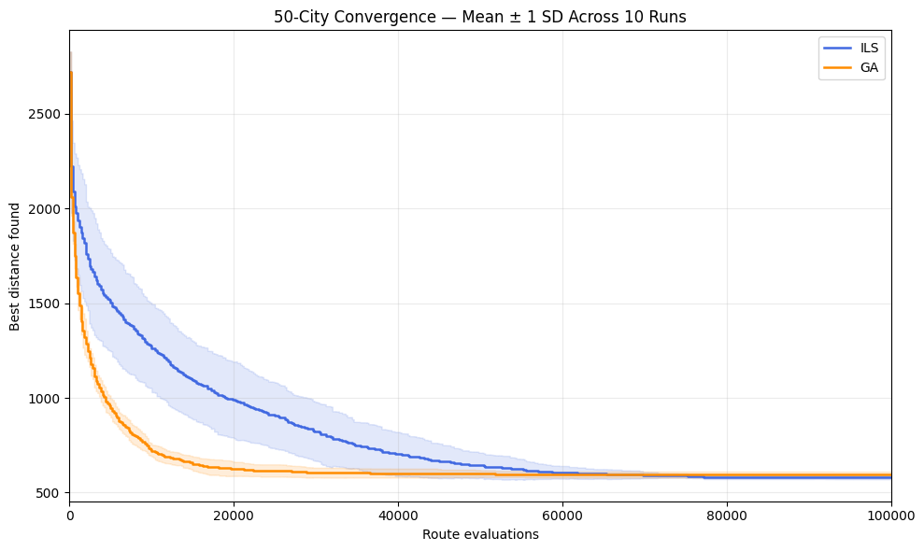
Figure 1: Mean best distance (± 1 SD across 10 runs) versus route evaluations for the 50-city instance.
The convergence results reveal a clear trade-off. GA improved more quickly during the early part of the evaluation budget, benefiting from its population exploring many candidate routes in parallel. ILS improved more gradually, but its 2-opt local search ultimately reached a lower final mean distance once the full budget was used. This means the relative ranking of the two algorithms depends on when the search is stopped: an early-stopped run would favour GA, while the full 100,000-evaluation budget favours ILS.

4. Statistical Significance Testing
Welch's t-test, the Mann–Whitney U test and an exact paired permutation test were each applied at every problem size, giving 15 comparisons in total. Holm correction was applied across all 15 to control the family-wise error rate. Table 2 reports the Holm-adjusted p-value for each test and problem size; values below 0.05 (marked *) indicate rejection of the null hypothesis of no difference between algorithms.
City count | Welch (Holm p) | Mann-Whitney (Holm p) | Paired permutation (Holm p)
10 | Undefined | 1.0000 | 1.0000
20 | 1.0000 | 0.0274* | 0.1719
30 | 0.2480 | 0.0303* | 0.1719
40 | 0.2480 | 0.3466 | 0.2578
50 | 0.2043 | 0.1682 | 0.1270
Table 2: Holm-adjusted p-values for each statistical test, by problem size.
Only the Mann–Whitney comparisons at 20 and 30 cities fall below the 0.05 threshold after correction (adjusted p = 0.0274 and 0.0303 respectively). No Welch or paired permutation comparison rejects its null hypothesis at any problem size, and the 10-city Welch test is undefined because both samples had zero variance. Because the Mann–Whitney findings rely on an asymptotic approximation and the samples reused seeds, they are treated as exploratory rather than confirmatory. Overall, the descriptive results in Table 1 favour ILS, but the inferential statistical evidence is limited and depends on which test is used.

5. Visualisations

5.1 Solution Quality vs. Problem Size
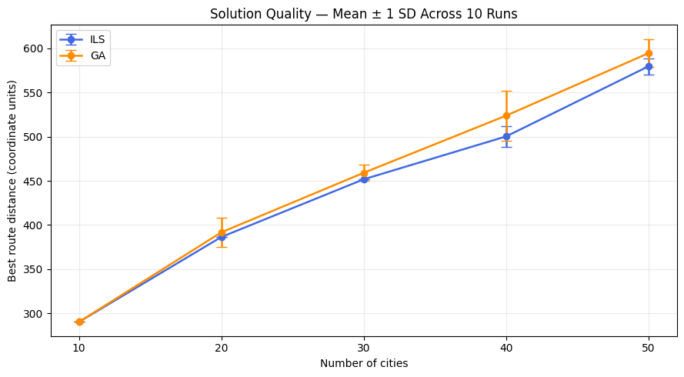
Figure 2: Mean best distance (± 1 SD) versus number of cities.
ILS and GA are indistinguishable at 10 cities but diverge as problem size increases, with ILS's mean distance consistently at or below GA's from 20 cities onward. The gap is largest at 40 cities, where ILS achieves roughly a 4.5% lower mean distance.

5.2 Runtime vs. Problem Size
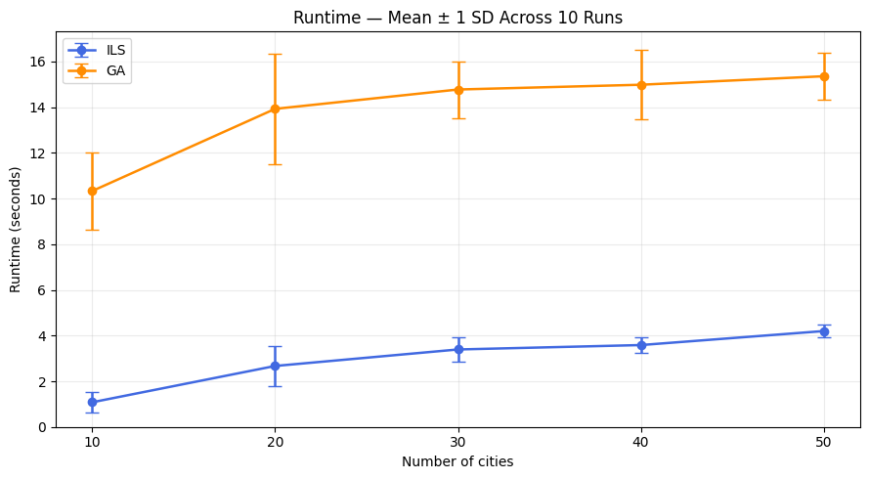
Figure 3: Mean runtime in seconds (± 1 SD) versus number of cities.
GA's runtime is substantially higher than ILS's at every problem size and grows more steeply, despite both algorithms performing exactly 100,000 route evaluations. This reflects the additional bookkeeping GA performs per evaluation — maintaining a population, performing tournament selection, crossover and mutation — compared with ILS's simpler perturb-and-locally-search loop.

5.3 Distribution of 50-City Results
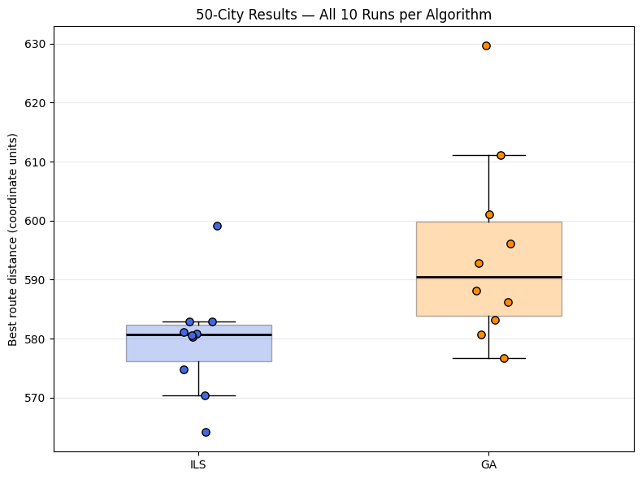
Figure 4: Best distance for all 10 seeded runs at 50 cities, shown as a boxplot with individual run values overlaid.
ILS's 10 runs are tightly clustered, indicating consistent performance across seeds. GA's runs are more spread out and centred on a higher distance, with its worst run exceeding ILS's worst run by a wide margin. This supports the earlier observation that ILS is not only more accurate on average at 50 cities but also more reliable from run to run.

5.4 Best Observed Routes at 50 Cities
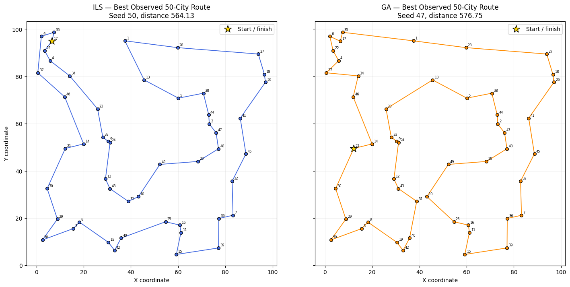
Figure 5: Best route found by each algorithm across all 10 seeds at 50 cities.
Both best-observed routes are free of obvious long crossing edges, consistent with the smoothing effect of 2-opt local search (used directly by ILS, and indirectly benefiting from GA's own search dynamics). The ILS route achieved a distance of 564.13 versus 576.75 for the GA route shown.

6. Discussion
The experiment compared Iterated Local Search (ILS) and a Genetic Algorithm (GA) on five fixed Travelling Salesman Problem instances containing 10–50 cities. Each algorithm received 100,000 route evaluations per run and was repeated using ten seeds.
Both algorithms achieved the same distance on the 10-city instance. ILS produced lower mean distances on the remaining instances, with reductions relative to GA of 1.35%, 1.61%, 4.50%, and 2.50% for 20, 30, 40, and 50 cities respectively. ILS also showed lower variation across seeds on these instances. Repeatedly finding the same distance at smaller sizes indicates consistency, but does not prove global optimality.
The convergence results reveal a trade-off. On the 50-city instance, GA improved more quickly during the early evaluation budget, whereas ILS improved more gradually and achieved a lower final mean distance. The relative performance therefore depended on when the search was stopped.
ILS had lower measured mean runtime at every problem size. GA took approximately 3.66–9.56 times longer on average. Although both algorithms used the same number of complete route evaluations, their additional operations differed. These timings describe the implementations and execution environment used in this experiment.
After Holm correction across 15 comparisons, the Mann–Whitney tests rejected their null hypotheses at 20 and 30 cities, with adjusted p-values of 0.0274 and 0.0303. No Welch or paired permutation comparison rejected its null hypothesis. The Mann–Whitney findings are exploratory because the samples reused seeds and the p-values used an asymptotic approximation with ties. Overall, the descriptive results favour ILS, while the inferential evidence is limited and depends on the test used.

7. Limitations
Several limitations restrict the conclusions:
- Each problem size used one fixed subset of the same dataset. Repeated seeds measure algorithm variability on those instances, not performance across a broad collection of TSP instances.
- Ten runs per algorithm and size provide limited information about the result distributions, particularly when distances contain many ties or occasional poor runs.
- Seeds were reused across algorithms, creating shared initial randomness. The paired permutation analysis addresses seed pairing but still relies on exchangeability under its null hypothesis.
- The evaluation budget and algorithm configurations influence the comparison. The pilot demonstrated that the relative ranking could change with the budget. Neither algorithm received extensive parameter tuning.
- Equal evaluation counts do not guarantee equal computational effort. Runtime also depends on implementation details, hardware, and background system activity.
- No exact solver or certified optimum was used. Consequently, the study reports best observed distances rather than optimality gaps.
Future work could use more independent problem instances and runs, examine several evaluation and time budgets, and compare results against exact solutions where feasible.

8. Conclusion
Under the tested configurations and a budget of 100,000 route evaluations, ILS matched GA's mean solution quality at 10 cities and produced lower mean distances at 20–50 cities. It also showed greater consistency on the larger instances and lower measured runtime at every size.
GA improved more quickly early in the 50-city search, while ILS achieved a better final mean distance. This demonstrates that convergence behaviour and the available search budget matter alongside final solution quality.
The results favour this ILS implementation for the tested instances and budget. However, the adjusted statistical comparisons do not establish a consistent difference across tests, and the limited instance set prevents a general claim that ILS is superior to GA for the TSP.

9. Legal and Ethical Considerations
Both algorithms were implemented independently for this project. The general algorithmic techniques used — 2-opt local search, Iterated Local Search, and Genetic Algorithms — are drawn from the published academic literature cited in the References section, and no third-party source code was copied. If any AI assistance tools were used at any stage of development, analysis, or the drafting of this report, that use should be disclosed here in line with the module's academic integrity policy.
The dataset used (cities.csv) contains synthetic coordinate data and raises no personal data or licensing concerns.

10. References
Croes, G. A. (1958). A Method for Solving Traveling-Salesman Problems. Operations Research, 6(6), 791–812. https://pubsonline.informs.org/doi/10.1287/opre.6.6.791
Holland, J. H. (1992). Adaptation in Natural and Artificial Systems. MIT Press. https://mitpress.mit.edu/9780262581110/adaptation-in-natural-and-artificial-systems/
Lourenço, H. R., Martin, O. C. and Stützle, T. (2001). Iterated Local Search. arXiv:math/0102188. https://arxiv.org/abs/math/0102188
SciPy documentation. Welch's t-test from descriptive statistics. https://docs.scipy.org/doc/scipy/reference/generated/scipy.stats.ttest_ind_from_stats.html
SciPy documentation. Mann–Whitney U test. https://docs.scipy.org/doc/scipy/reference/generated/scipy.stats.mannwhitneyu.html
SciPy documentation. Permutation tests. https://docs.scipy.org/doc/scipy/reference/generated/scipy.stats.permutation_test.html
Statsmodels documentation. Multiple-testing corrections, including Holm. https://www.statsmodels.org/v0.11.1/generated/statsmodels.stats.multitest.multipletests.html

