Farah Origin 🧶 | Project Documentation
Welcome to the official documentation for Farah Origin, an Aesthetic Crochet & Henna Atelier platform. This document outlines the architecture, features, and deployment pipeline for the Next.js web application and Android APK.

1. Project Overview
Farah Origin is a modern e-commerce and portfolio application designed to showcase and sell handcrafted crochet and henna products. It features a stunning, premium user interface (UI) and a fully functional Admin Dashboard for managing inventory and orders.

Core Features:
- Aesthetic UI/UX: Clean glassmorphism design, smooth framer-motion micro-animations, and a premium typography pair (Inter for UI, Playfair Display for headings).
- E-Commerce Checkout: Cart management, dynamic stock validation, and Razorpay integration (with UPI, Card, and Netbanking support).
- Admin Dashboard (/admin): Real-time order tracking, comprehensive analytics, order details modals, and search/filtering capabilities.
- Cross-Platform: Available as a responsive web app and a native Android APK (built via Capacitor).
- Automated Notifications: Live email order confirmations sent to customers via Nodemailer.

2. Tech Stack 🛠️
- Frontend: Next.js 16 (React 19)
- Styling: Tailwind CSS + Framer Motion
- Backend / API: Next.js API Routes (Serverless)
- Database: Supabase (PostgreSQL)
- Mobile App: Capacitor & Android Studio (Native APK)
- Email: Nodemailer

3. Visual Gallery & Screenshots 📸
Here is a visual overview of the application:

Homepage Hero Section
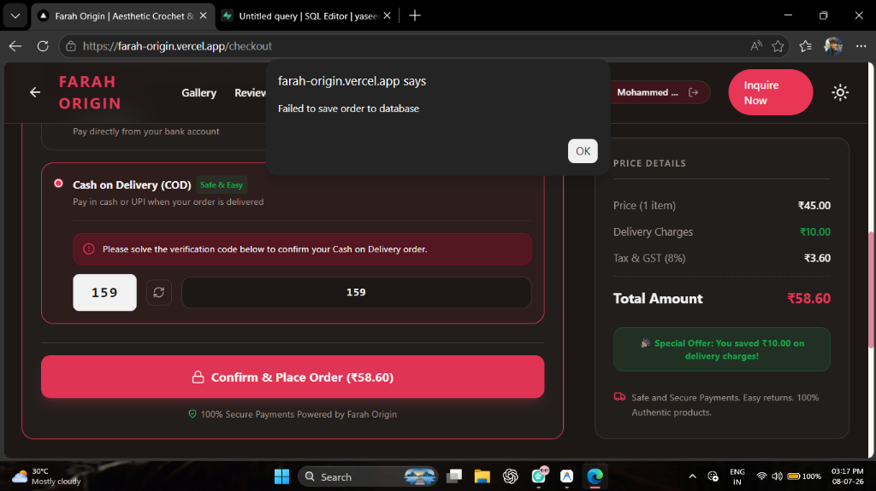
Homepage Hero Section

Admin Dashboard & Analytics
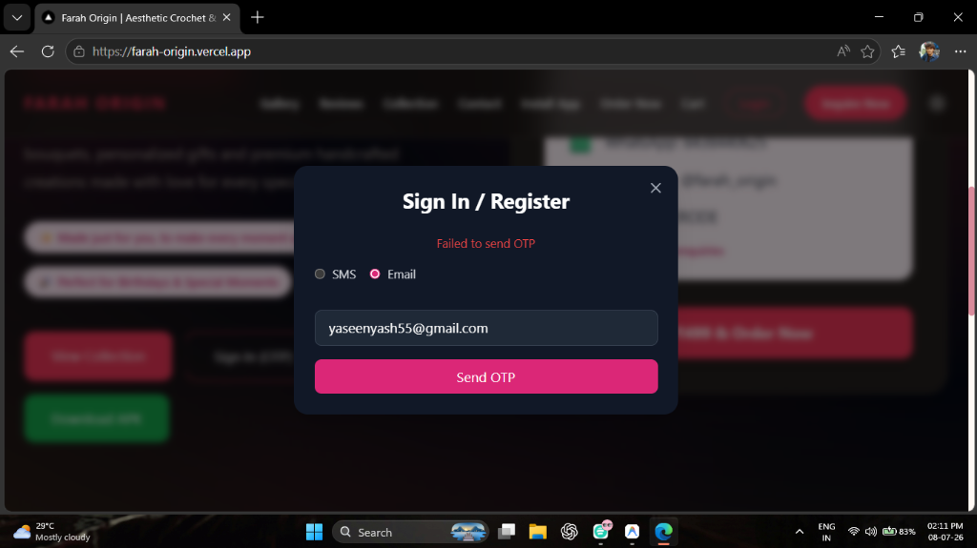
Admin Dashboard & Analytics

Product Collection
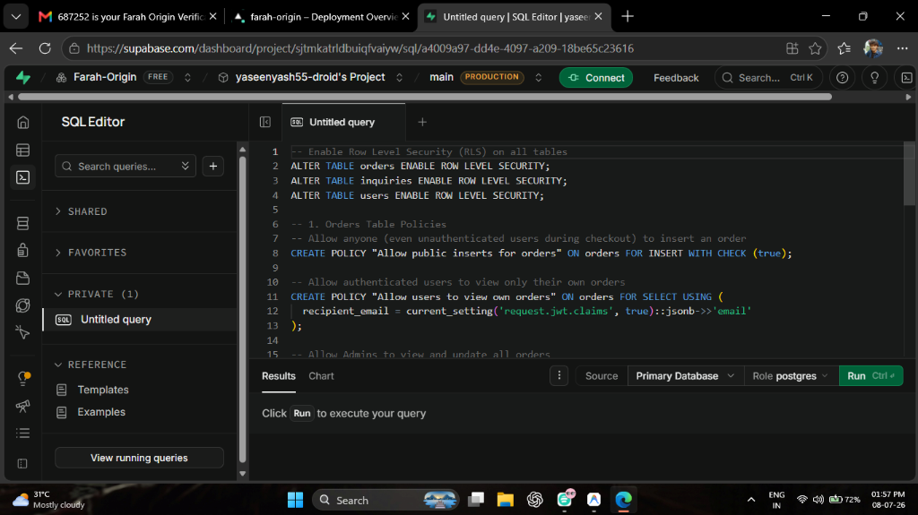
Product Collection

Secure Checkout
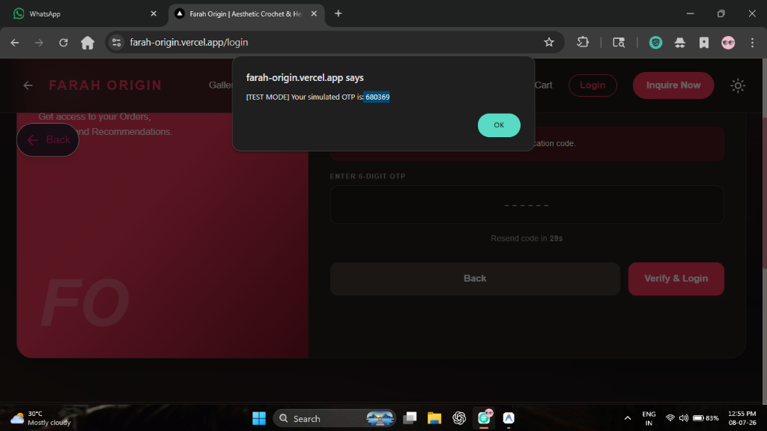
Secure Checkout
(Note: Since the site is now live on your phone via the APK, you can also take screenshots directly from your device!)

4. Application Architecture

API Routes (app/api/)
- POST /api/checkout/create-order: Initializes a Razorpay payment order.
- GET/POST/PUT /api/orders: Fetches orders, places a new order (validates stock), and updates order status (Admin only).
- POST /api/auth/register: Upserts a user in Supabase and returns an encrypted JWT cookie.
- POST /api/auth/send-otp: Sends a login verification code via SMS (Fast2SMS/Twilio) and Email (Nodemailer).

Key Pages (app/)
- /: The hero landing page showcasing the brand.
- /view-collection: The shop page where users can browse and add items to the cart.
- /checkout: A multi-step secure checkout process (Login -> Address -> Summary -> Payment).
- /admin: A protected dashboard for the store owner to view revenue, filter orders, and check stock.

5. Deployment & Build Pipeline 🚀

Web Deployment (Vercel)
The web application is continuously deployed to Vercel. - Production URL: https://farah-origin.vercel.app - Environment Variables: All secrets (Supabase keys, Email passwords) are securely injected via Vercel’s Environment settings.

Android APK Build Process
To generate a new Android app update, the project uses a custom Node script (scripts/build-apk.js) executed via: npm run apk:export
What this script does: 1. Temporarily hides server-side API routes (since the APK must be fully static). 2. Runs next build to generate static HTML/JS in the out/ folder. 3. Syncs the static assets to the Android folder using @capacitor/android. 4. Compiles the native Android project via gradlew assembleRelease. 5. Restores the API routes and outputs farah-origin.apk into the public/ folder so it can be downloaded at /download.

