Evaluation Warning: The document was created with Spire.Doc for .NET.



•

TECHNOLOGIES AND SOLUTIONS

**Halal**



**Qiymət**

**təklifi**

**Company**

**Customer**

diqqətinə

**ProductName təklifi**

No: **ProposalNumber**

Təklifin hazırlanma tarixi:

##### BeginDate

Qüvvədə olduğu son tarix:

##### EndDate

Məsul menecer:

##### ManagerPosition

##### ManageName

ManagerPhone

[ManagerEmail](mailto:amina.adilzade@halal.az)

•

ONS

• • •

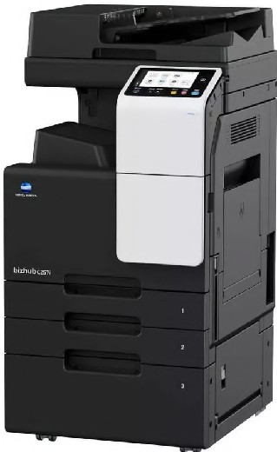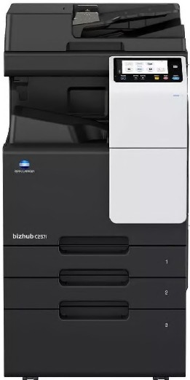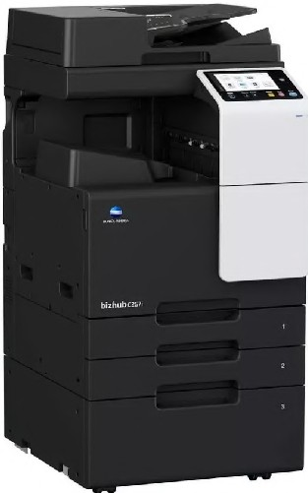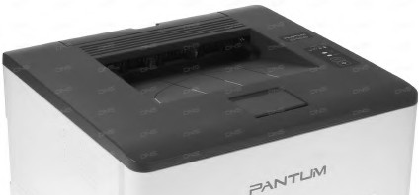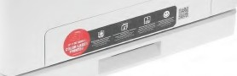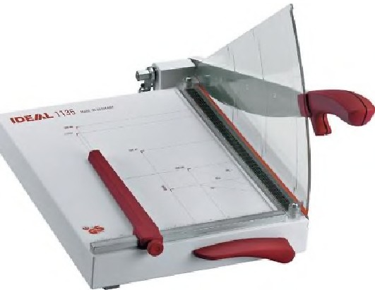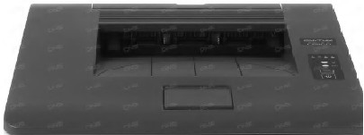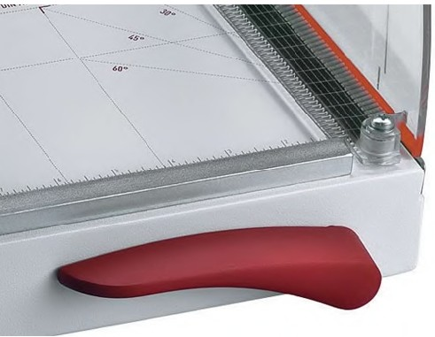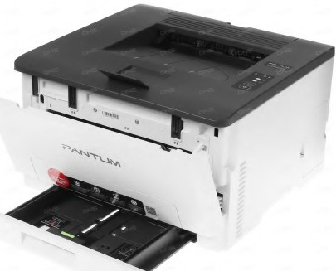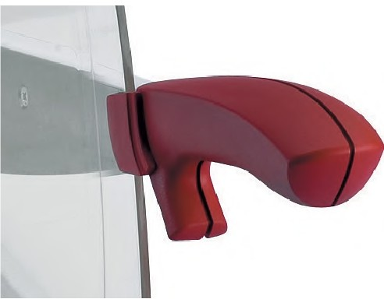

## Matbaa taklifi

**l ONICA MINOLTA**

♦ ♦

•

**Qiymat taklifi**

#### Konica Minolta c257i

###### Texniki xususiyat

* Yuksak mahsuldarl1q
* c;ap mexanizminin etibarl1 konstruksiyas1
* Sarf materiallarin1n va ehtiyat hissalarinin yuksak davaml1l191
* Oz va arxa c;apin inanllmaz daqiqliyi
* Sarf materiallarin1n va ehtiyat hissalarinin yuksak davaml1l191

**?ANTUM**

Qura$d1nl1b: AA matbaasi, Max Print MMC, BB na$riyyat1

#### Pantum CPll00ADN

###### Texniki xususiyat

* Yuksak mahsuldarl1q
* c;ap mexanizminin etibarl1 konstruksiyas1
* Sarf materiallarin1n va ehtiyat hissalarinin yuksak davaml1l191
* Oz va arxa c;ap1n inan1lmaz daqiqliyi
* Sarf materiallarin1n va ehtiyat hissalarinin yuksak davaml1l191

1. **IDEAL 1135**

###### Texniki xususiyat

* Yuksak mahsuldarl1q
* c;ap mexanizminin etibarl1 konstruksiyas1
* Sarf materiallarin1n va ehtiyat hissalarinin yuksak davaml1l191
* Oz va arxa c;apin inan1lmaz daqiqliyi
* Sarf materiallarin1n va ehtiyat hissalarinin yuksak davaml1l191

**.=>ANTLIM**

Qura$dlrll1b: Holcim MMC, Bank of Baku

Qura$d1rll1b: Milli Elmlar Akademiyas1, RabitaBank, Yap1kredi Bank

• • •

# Halal

TECHNOLOGIES AND SOLUTIONS

♦ ♦

•

**Qiymat taklifi**



•

## Qiymat cadvali

|  |  |  |  |  |  |
| --- | --- | --- | --- | --- | --- |
| N9 | **Mahsullar** | **Qiymat (1 adad)** | **Miqdar** | **Cami (USD)** | **Cami (AZN)** |
| II | **Konica Minolta c257i** | **3000 USD** | **1** | **3000 USD** | **5100 AZN** |
| II II | **Pantum CPllOOADN**  **IDEAL 1135** | **500 USD**  **500 USD** | **1**  **1** | **500 USD**  **430 USD** | **850AZN**  **731 AZN** |
|  | | | | **Cami** | **6681 AZN** |
| **aov** | **100 AZN** |
| **Omumi** | **6781 AZN** |

***Qeyd:***

* YOksak mahsuldarl1q
* <:=ap mexanizminin etibarl1 konstruksiyas1
* Sarf materiallarinin va ehtiyat hissalarinin yuksak davaml1l191
* Oz va arxa c;:ap1n inanilmaz daqiqliyi
* Sarf materiallarin1n va ehtiyat hissalarinin yuksak davaml1l191



• • •

Halal

TECHNOLOGIES AND SOLUTIONS

• •♦ ♦

Qiymat **taklifi**

"HALAL-P" MMC olaraq Azarbaycan bazannda 1996-ci ildan etibaran faaliyyat gostaririk va dunyaca ma hur ticarat markalann1n Azarbaycanda rasmi tamsilc;isiyik.

Matbaa, bank, korporativ va arxiv hallari uzra boyuk tacruba va biliklara, elaca da boyuk va professional servis markazina sahibik.

### Faaliyyat sahalarimiz

•

**ODD *fcj':***

**ODD 'v**

**DD** --

**DD .aDDaDa**

**DDD**

-

....,_-

......-

....,_-

Metbee



25 ildir bazarda



5000-den <;ox layihe te$kili



Muxtelif <;e$idde mehsullann anbarda movcudlugu

**om**

Ofis Bank

### Farqimiz



Bir <;ox dunya brendlerin resmi distribyutoru



Sertifikatla$dInlm1$ muhendisler



Olke uzre xidmetlerin gosterilmesi

Arxiv



Professional texniki dastak



Temennas1z

<;atd1nlma xidmeti



Mehsullara zemanet

Bak1 ah., Binaqadi ray., S.S.Axundov SF

+994 12 436 26/27 21

+994 50 265 85 15

[www.halal.az](http://www.halal.az/) [office@halal.az](mailto:office@halal.az)