Yasemin KOÇ
Computer Engineer
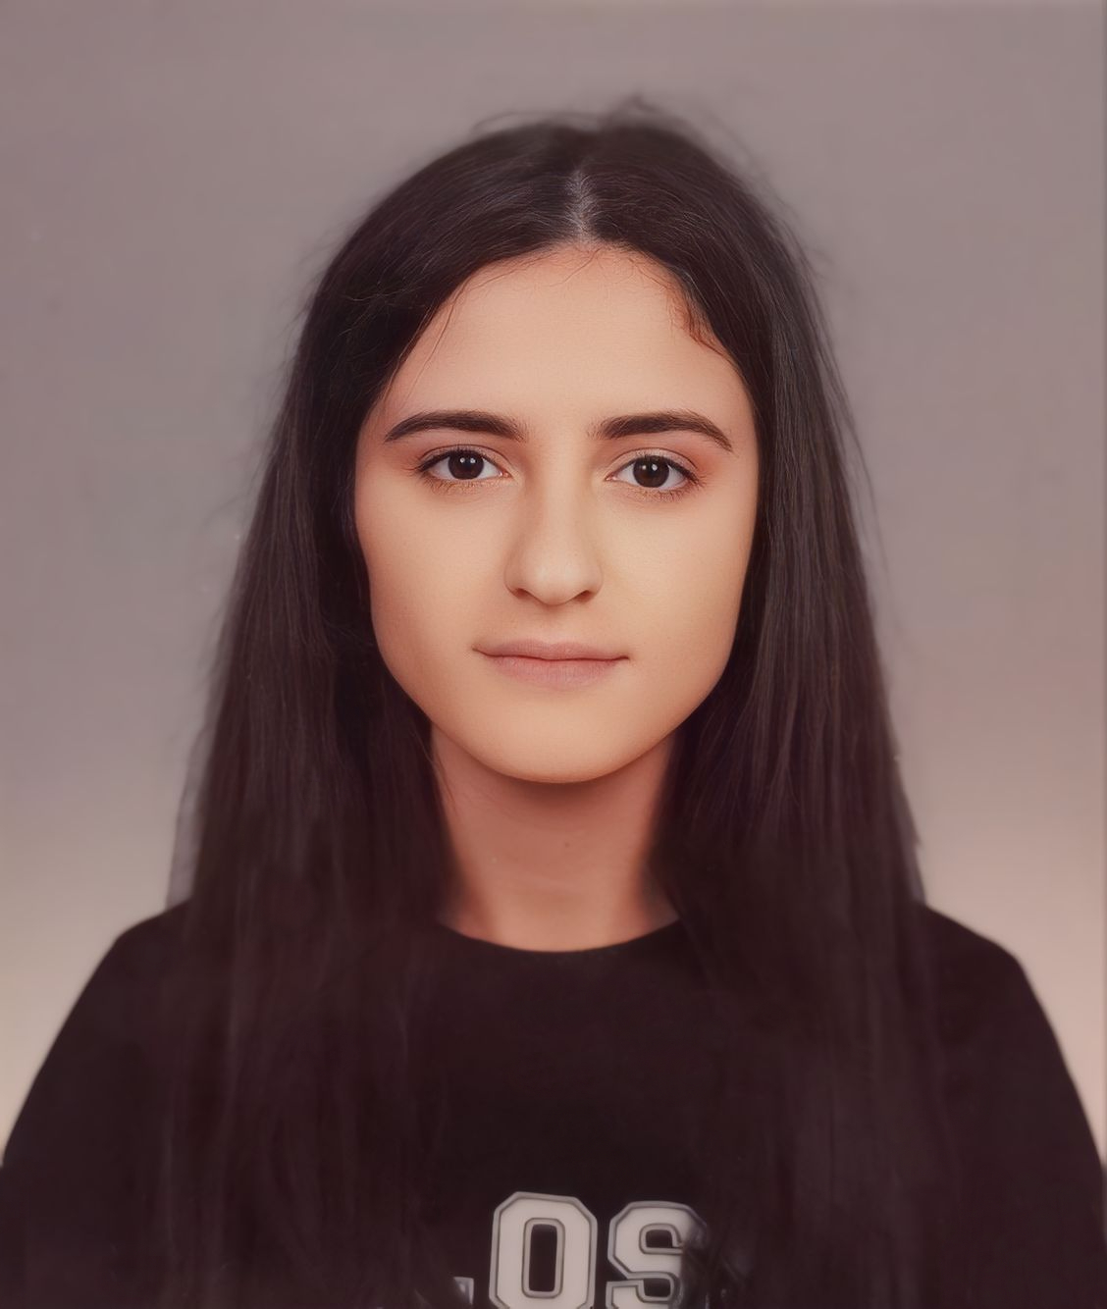
Github: yaseminkoc
https://www.linkedin.com/in/kocyasemin/
yaseminkocc37@gmail.com

Personal Profile

Date of birth: 02/12/2000
Marital status: Single
Non-Smoker

Education

2019 – 2024 Comp. Sci. Eng. Manisa Celal Bayar University
Grade achieved: 3,51 / 4
2015 – 2019 Technical IT Turgut Reis Technical and Vocational
High School (The school ended with
the first position.)
Grade achieved: 96,35 / 100

Working Experiences

Datasoft Software Company

Frontend Developer September 2022 – Present

Intern May 2022 – August 2022

I have done my volunteer and summer internship in this company. In this process, I took part in the project to solve the frontend and backend coding bugs on the pre-accounting program.

Skills

Technical: C#, .Net Framework, DevExpress, Entity Framework, Python 3 (for Machine Learning (Beginner)), Java (OOP), React Native, HTML, CSS, Bootstrap, JavaScript, SQL, React, Redux, Deployment, Rest API, Adobe Photoshop (intermediate) and for using backend I am improving myself about .Net Core and Node js now.

Language: English (Professional reading, Intermediate speaking and Intermediate writing)

Achievement

- METAHack Challenge 2024 : First Place – Medipol University TTO
We came 1st in the "Artificial Intelligence" category of the METAHack Challenge 2024 competition held by Medipol University TTO.

- HAVELSAN Ekspres Hackathon’24 : Third Place – HAVELSAN
We came 3rd in the "Natural Language Processing" category of the HAVELSAN Ekspres’24 Hackathon competition held by HAVELSAN.

- Innovative Software Competition (Y³)’22 – GAN : Second Place - Presidency of Defense Industries
As part of Team "Laval" with teammate, secured an second place in the Y³ 3rd Term Competition for Generating Competitive Networks and Synthetic Data conducted by the Presidency of Defense Industries.

Projects

- Wind Energy Forecasting with Artificial Intelligence – TÜBİTAK 2209 – B (private on Github for privacy, not yet live)
- Technology Maturity Assessment System – TUSAŞ
- Manisa Celal Bayar University Ethical Board Website
- Gutenberg Library Project
- e-Commerce Website

