Muğla Sıtkı Koçman University

Department of Computer Engineering

Senior Design Project I

Analysis & Design Report

Yasemin Toraman

Supervisor: Zeynep Filiz Eren

January 17, 2024

**Contents**

1 Introduction 3

2 Motivation 3

3 Similar Existing Applications 3

4 Proposed System 3

4.1 Overview 3

4.2 Functional Requirements 3

4.3 User Interface Design 3

4.4 Entity Relationship Diagram 3

4.5 Technologies and Tools 3

5 Future Work 3

6 References 3

Mobile Application

# Introduction

My application is a community-driven platform for sharing announcements, listings, and connecting with others. Unlike traditional marketplaces, my app focuses on communication without direct transactions. Share your updates, discover local opportunities, and connect with like-minded individuals effortlessly.

# Motivation

Inspired by the simplicity and usefulness of Craigslist, I am motivated to create a mobile app with a sleek interface, tailored for the Turkish community. Fueled by the absence of a dedicated solution, my goal is to offer a native platform for seamless local communication and announcements.

# Similar Existing Applications

1. **CragList:** Craigslist is a classified advertisements website where users can find various categories, including items for sale, jobs, services, housing, and events. It primarily facilitates local transactions, and users communicate independently of the platform.
2. **NextDoor:** Focuses on local communities, allowing users to post about items for sale, events, and local services.
3. **Letgo:** Users can buy and sell used goods, chat with potential buyers or sellers, and browse local listings.
4. **OfferUp:** Similar to Letgo, users can buy and sell items locally and communicate with potential buyers or sellers.
5. **Facebook Marketplace:** Users can buy and sell items, list services, and discover local events.
6. **eBay:** eBay is a global online marketplace that allows users to buy and sell a wide range of products through auctions or fixed-price listings. Users can communicate through messaging, and transactions are facilitated directly on the platform.
7. **CPlus Classified:** Users can post classified ads for various categories, including items for sale, jobs, services, housing, and events.

My application distinguishes itself by offering a multifunctional platform. It will combine the local community aspect of Craigslist with the ability to communicate and share information about various topics beyond buying and selling, such as events and services, providing a more versatile and dynamic experience.

| **Feature** | **My Application** | **Craigslist** | **Facebook Marketplace** | **Nextdoor** | **Letgo** | **OfferUp** | **eBay** | **CPlus Classified** |
| --- | --- | --- | --- | --- | --- | --- | --- | --- |
| Buy/Sell Functionality | No | Yes | Yes | Yes | Yes | Yes | Yes | Yes |
| Communication for Announcements | Yes | Limited | Limited | Limited | Limited | Limited | Yes | Limited |
| Event Announcements | Yes | Yes | Yes | Yes | No | No | No | Yes |
| Service Listings | Yes | Limited | Limited | Yes | No | No | No | Limited |

# Proposed System

## Overview

## Functional Requirements

taslak, çizim, diyagram, çizgi içeren bir resim

Açıklama otomatik olarak oluşturuldu

## User Interface Design

metin, ekran görüntüsü, mobil telefon, sayı, numara içeren bir resim

Açıklama otomatik olarak oluşturuldu

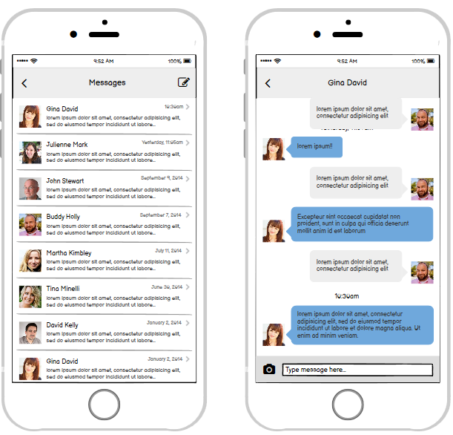

metin, ekran görüntüsü, sayı, numara, mobil telefon içeren bir resim

Açıklama otomatik olarak oluşturuldumetin, ekran görüntüsü, mobil telefon, küçük alet içeren bir resim

Açıklama otomatik olarak oluşturuldu

## Class Diagram, Sequence Diagrams, Activity Diagrams

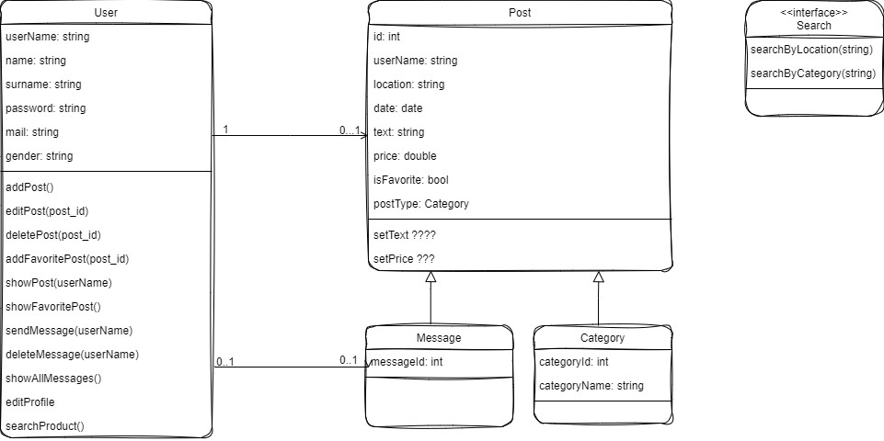

**Sequence Diagram:**

metin, diyagram, plan, paralel içeren bir resim

Açıklama otomatik olarak oluşturuldu

metin, diyagram, paralel, plan içeren bir resim

Açıklama otomatik olarak oluşturuldu

**Activity Diagram:**

diyagram, plan, teknik çizim, metin içeren bir resim

Açıklama otomatik olarak oluşturuldu

diyagram, taslak, teknik çizim, çizim içeren bir resim

Açıklama otomatik olarak oluşturuldu

diyagram, teknik çizim, plan, taslak içeren bir resim

Açıklama otomatik olarak oluşturuldu

## Technologies and Tools

I will develop my mobile application with React Native and I will use Firebase for the database. In addition to these two basic components, the list of tools I will use:

* Node.js
* Expo
* Expo Go (Ios application)
* Android Studio Emulator
* Visual Studio Code
* UI Libraries/Components(React Nativation etc.)

# Future Work

In the second semester, I will code the remaining screens of my application and add multiple views for the posts to appear (for example, sometimes it will be in the form of a list, sometimes it will be in the form of a photo).

I also plan to add product sorting according to increasing and decreasing prices, the option to filter as newly added, old added, and the share option so that it can be shared with people.

At the same time, I want to code a screen that shows the number of products from the map in the application.

# References

<https://boston.craigslist.org/>

<https://nextdoor.com/>

<https://offerup.com/>

<https://www.ebay.com/>

<https://apps.apple.com/us/app/cplus-classifieds/id955286870>

<https://apps.apple.com/tr/app/letgo-i-kinci-el-al-ve-sat/id986339882?l=tr>