# Practical Project: Guess A Number

This is an additional practical project, and **it is not mandatory and it is not included in the final score**. The main purpose is to use gained knowledge in different types of problems and to improve your portfolio and GitHub skills.

We will make the console game "Guess A Number". "Guess A Number" is a game in which your opponent, "**the computer**", chooses a **random** number between "1 and 100", and your task is to **guess** this number. After each number you enter, the computer will give you a **hint** of whether the number is **greater** or **less** than the number you selected until you guess the **correct** number.

## Create GitHub Repository

We already have a GitHub account, so we're moving directly to creating a new repository.

Create a **new repository** from: <https://github.com/new>. Choose a **meaningful name**, e. g. "GuessANumberByUsername" add a **short description** and make your repo **public**:

|  |  |
| --- | --- |
|  | Please choose **your own original and unique name** for your project!  Your GitHub profile should be **unique**.  You can follow this tutorial, but you can also **make changes** and **implement your project differently**. |

Also, **add a** README.md file and .gitignore **for Python**, as shown below:

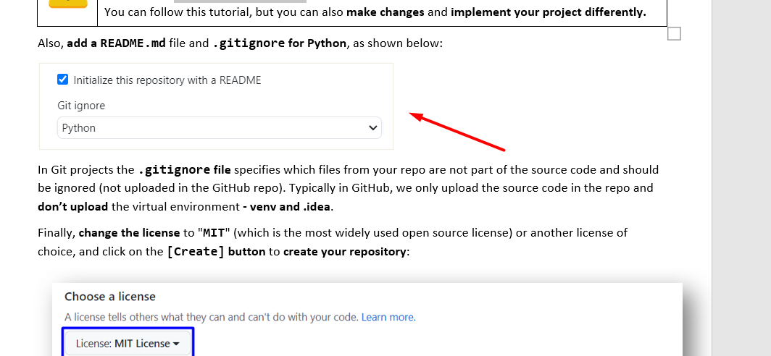

In Git projects the .gitignore **file** specifies which files from your repo are not part of the source code and should be ignored (not uploaded in the GitHub repo). Typically in GitHub, we only upload the source code in the repo and **don't upload** the virtual environment **- venv and .idea**.

Finally, **change the license** to "MIT" (which is the most widely used open source license) or another license of choice, and click on the [Create] **button** to **create your repository**:

Now your **repository is created** and looks like this:

Now let's see how to **write the code** of our game.

## Write the Game's Code

Let's create the game and play with it.

### Create a PyCharm Project

First, we should **start PyCharm** and **create a new project**. Then, **choose an appropriate name** and a **place to save the project**. Our project should be created and should look like this:

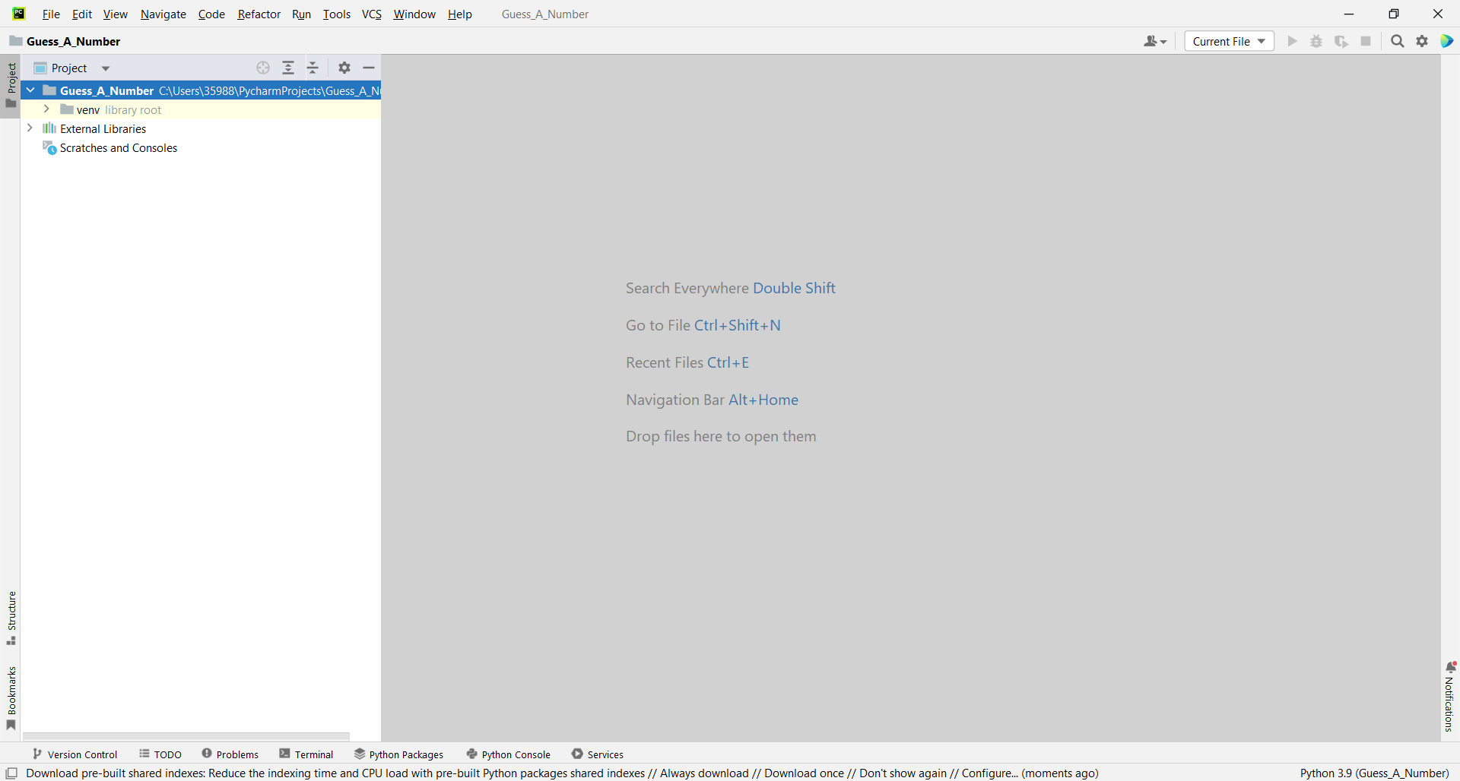

We should create a **new Python file** with the name of the game:

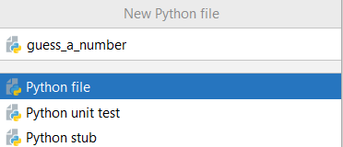

### Implement the Game Logic

Now let's start working on our project.

#### Read Player's Move

First import the library **"random"**, then create a variable in which the random number will be stored:

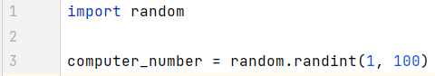

**A little more information about "random.randint()":** [**https://www.w3schools.com/python/ref_random_randint.asp**](https://www.w3schools.com/python/ref_random_randint.asp)

Now write a while-loop to **iterate** until the player guesses the computer's **random** number. Write on the console what the player should do and **read** his **input** **data**. You already know how to do that.



Now let's run the **app** in the console and check whether our current code **works** properly:

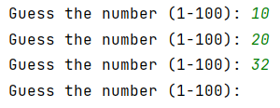

We can see that we have our text **written** on the console and we should be able to **read** the player’s input **repeatedly** because of our while-loop.

#### Check the Player's Input

Now **check** the player's input using the ".isdigit()" method. It will review the input data and return us "True" or "False" depending on the data **submitted** by the player. If It's a **number** (**what we expect**) the method will return "True" otherwise "False". If "**False**", print a message and let the player type a number again.

Do it as follow:

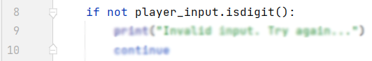

If data is valid parse the player input to **int type** and write an if-else statement in which we will check all **three** possible cases.

First, if the player's number is **equal** to the computer's number that means the player **guessed** the computer's number, so you should **write** a message, and **stop** the application by using the keyword "break". Do it like this:

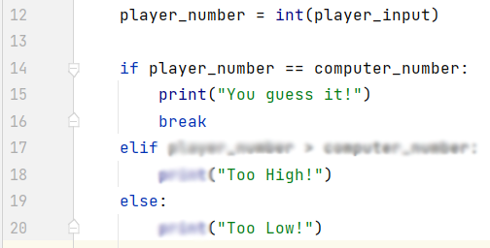

The other **two** cases are if the player's number is **higher** than the computer's number and the player's number is **less** than the computer's number. Write the rest of the else-if statement by yourself:



Now let's run the **app** in the console and check whether our current code **works** properly, the game should look like this:

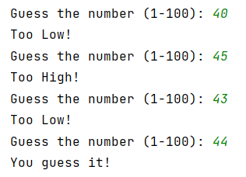

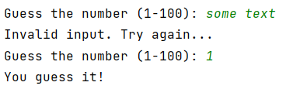

## Upload Your Project to Github

We already know how to clone our repository by using **Git** **Bash** or **GitHub Desktop**.

### Use GitBash (Option 1)

Go to the desired **directory**, right-click on a blank space **anywhere** in the folder, and select "**Git Bash Here**" to open the Git command line console. If the "**Git Bash Here**" menu is missing, you should first install Git.

Type the **"**gitclone**"** command followed by the link to your **repository**:

gitclone



The result should be something like this:

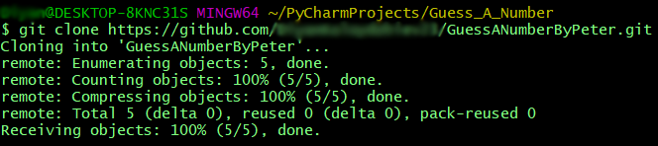

Your files from your GitHub repo will be downloaded to a **sub-folder** called as your project in GitHub, "**GuessANumberByPeter**" in our case.

When we open the cloned **repository sub-folder**, it should look like this:

The next thing to do is to **add** your **project files** to your **cloned** **repository folder**. It should look like this: 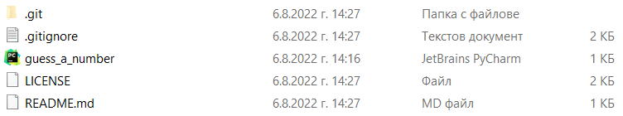

Now we are ready to upload our changes from "**Git Bash clone**". Go to the desired **folder**, right-click on a blank space anywhere in the folder, select "GitBashHere" and run the following **commands**.

Type the following command:

|  |
| --- |
| git status |

The **git status** command displays the state of the working directory and the **staging area**.

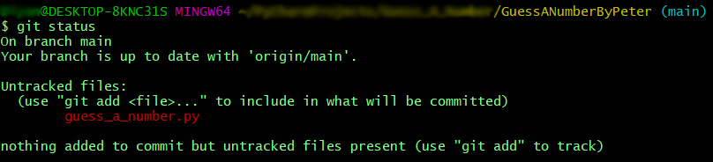Now type:

|  |
| --- |
| git add . |

This command **adds** all modified files.

Next type:

|  |
| --- |
| git commit -m "Your message here" |

This command**commits** your changes. We also should **add** an appropriate **message**.

Second to the last type.

|  |
| --- |
| git pull |

This command **updates** your local **repository**.

Now the last thing that we should do is to **push** our changes by using the command:

|  |
| --- |
| git push |

This command **pushes** your changes to our local **repository**.

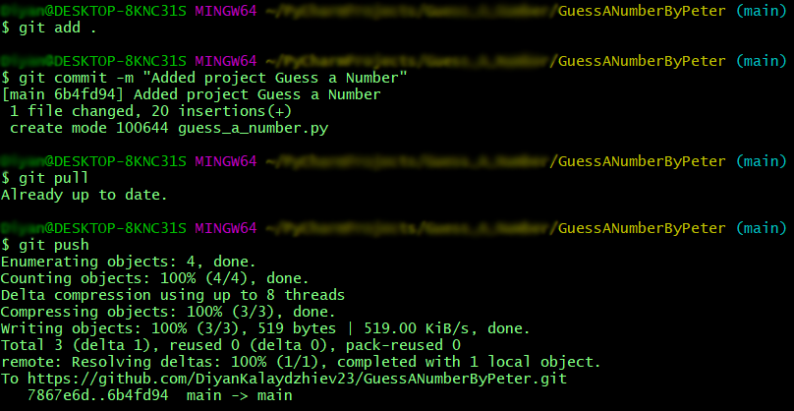

This is all you need to **update** your **repository** with **Git Bash**.

A little more information about it is here: <https://git-scm.com/about>.

### Use GitHub Desktop (Option 2)

If you don't have GitHub Desktop on your computer, download and install it from here: <https://desktop.github.com/>

Go to **"File"** and chose **"Clone repository".**

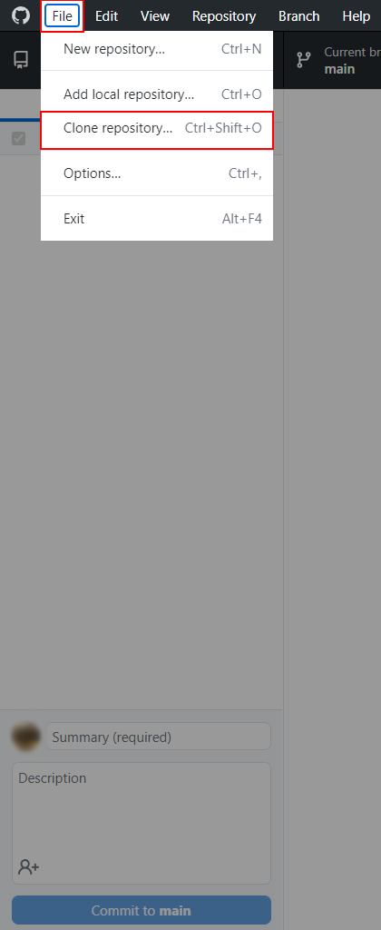

**Chose the repository** for the project, in our case "GuessANumberByPetar" and hit the **"Clone"** button**.** 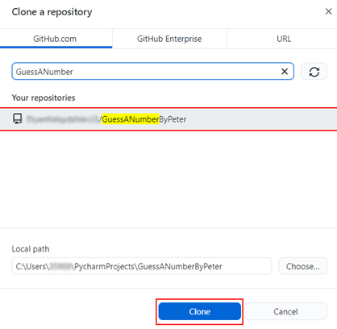

Your files from your GitHub repo will be downloaded to a **sub-folder** called as your project in GitHub, "**GuessANumberByPeter**" in our case.

The next thing to do is to **add** your **project files** to your **cloned** **repository folder**. It should look like this:



After that go to GitHub Desktop and **create a commit**, just like this.

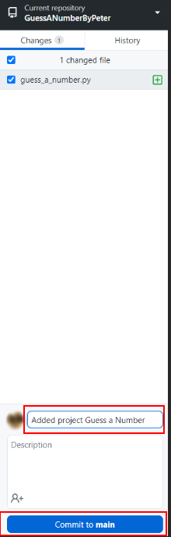

Then **push the commit** to the repository.

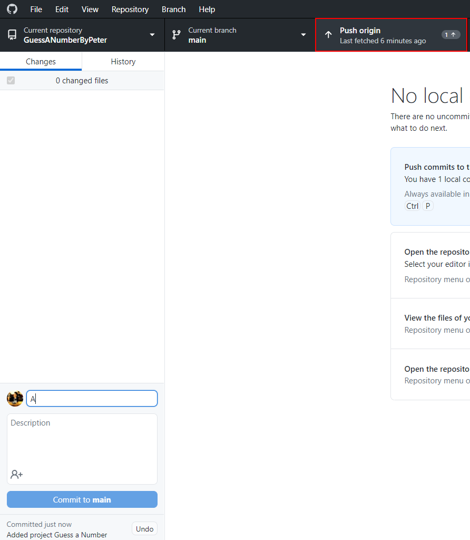

This is all you need to **update** your **repository** usingGit**Hub Desktop.**

## * Modify the Code, Write Your Own Features

Now, it's time to **play with the code** and **modify it**.

|  |  |
| --- | --- |
|  | This is your own project. **Be unique**. Don't be a copy/paster!   * Implement your **own features**. * **Implement the code yourself**, using your own coding style, code formatting, comments, etc. * Make the project **more interesting**. Learn by playing with the code and adding your own changes. |

Below are a few **ideas** of what you can implement or modify as an addition to your code.

### Add Difficulty

You can add logic for difficulty, so the player can have **only a few tries** to guess the number.

### Restart the Game

You can automatically **restart the game** after it is finished (or ask the player to play again).

### Additional Ideas

* You can **add levels** so every time when the player guesses the number, the range between the minimum and maximum number gets bigger e. g. **Level 1 (1 - 100)**, **Level 2 (1-200),** etc.
* You can add anything else to your code, based on your own ideas?

### Commit to GitHub

Now **commit and push your code changes** to your GitHub repo!

|  |  |
| --- | --- |
|  | It is very important to **commit frequently** your code to GitHub. This way you create a **rich commit history** for your project and your GitHub contribution graph is growing: |

## 5. Create a README.md File

It's highly recommended to provide documentation as part of your project on GitHub to describe what the project is doing. So, let's make one for this **project**. Let's start by editing the README.md file from our repo on GitHub:

Add a project name.

You can **view** the current progress by pressing the [Preview] button:

### Documentation Sections

Add **information** about your project in your README.md file: project goals, technologies used, screenshots, live demo, etc. Typically, you should have the following **sections**:

* **Project title** (should answer the question "What's inside this project)
* **Project goals** (what problem we solve, e. g. we implement a certain game)
* **Solution** (should describe how we solve the problem 🡪 algorithms, technologies, libraries, frameworks, tools, etc.)
* **Source code link** (give a direct link to your source code)
* **Screenshots** (add screenshots from your project in different scenarios of its usage)
* **Live demo** (add a one-click live demo of your code)

### Use Markdown

Note that the GitHub README.md file is written in the **Markdown language**. Markdown combines text and special formatting tags to describe formatted text documents.

You can learn more about **Markdown** here: <https://docs.github.com/en/get-started/writing-on-github/getting-started-with-writing-and-formatting-on-github/basic-writing-and-formatting-syntax>.

### Project Goals

Start your documentation by describing your **project goals**. What problem does your project solve?

### Sample Documentation

This is an **example** of how you can document your project. Don't copy-paste it! 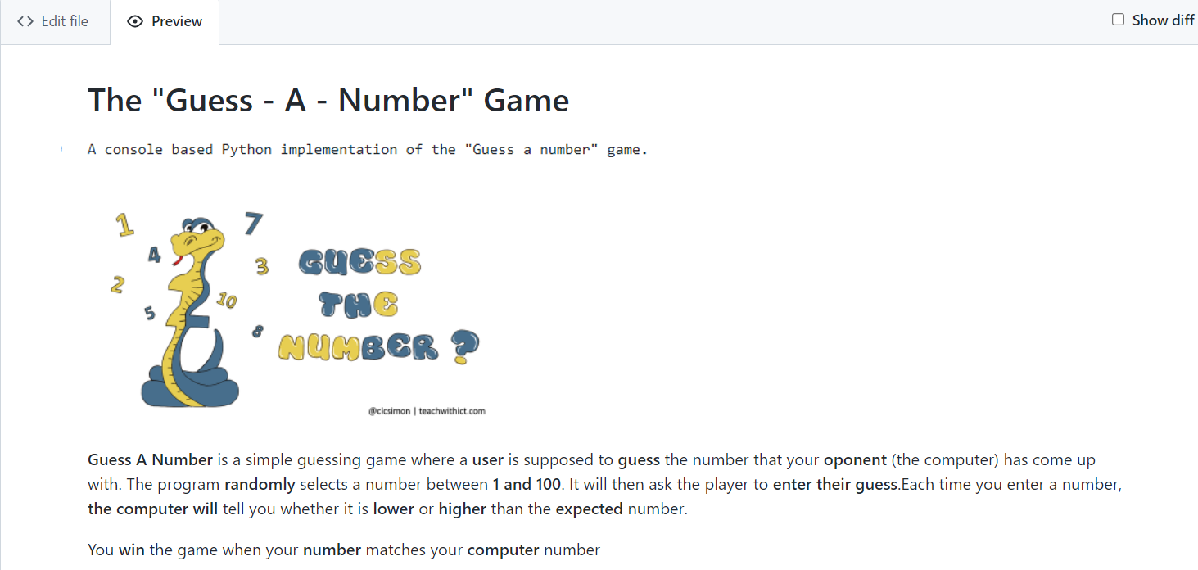

|  |  |
| --- | --- |
|  | **Write the project documentation yourself**. Don't copy/paste it!  This is your **unique GitHub profile** and your own unique project. **Be different** from others. |

Find an **appropriate** **image** and add it. You can add **images** as follows:



You can add information about the **inputs** and **outputs** of the project:

### Your Solution

Describe how you **solve the problem**: algorithms, technologies, libraries, frameworks, tools, etc.

### Link to the Source Code

[Source Code](guess_a_number.py)

### Screenshots

Add **screenshots** of your project:

1. **Take a screenshot** with your favorite tool (e.g. the [Snipping Tool](https://support.microsoft.com/en-us/windows/open-snipping-tool-and-take-a-screenshot-a35ac9ff-4a58-24c9-3253-f12bac9f9d44) in Windows).
2. **Paste** the screenshot in the GitHub Markdown editor, using [Ctrl+V]:

Example screenshots for the "Guess a Number" game:





## 6. Upload Your App to Replit

You already should have a **Replit** profile. Now let's add our **project** there so we can share it with our **friends** and add it to our **GitHub** profile. You already should know how to do that.

Open the **menu** in the upper **left corner**. Click "**Create**", then select the **language** in which your project is **written**, select a name, and **create** the project. Choose Python.

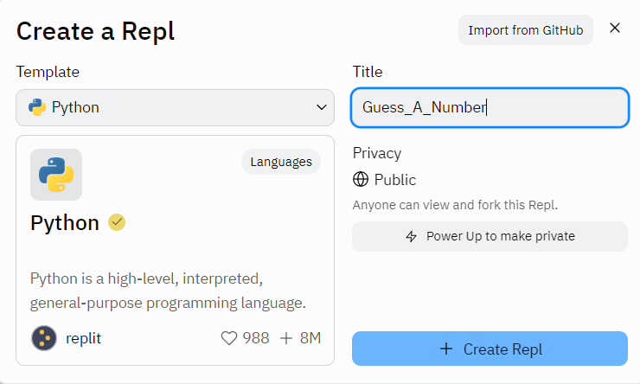

**Paste your code** in the "main.py" file:

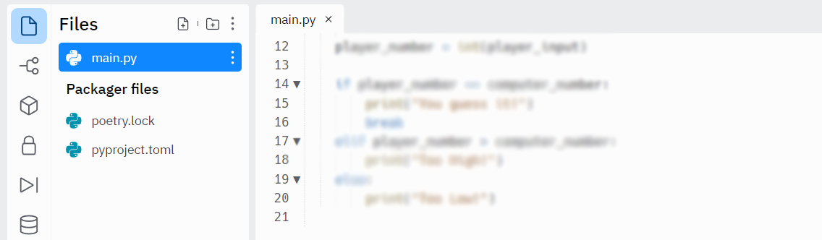

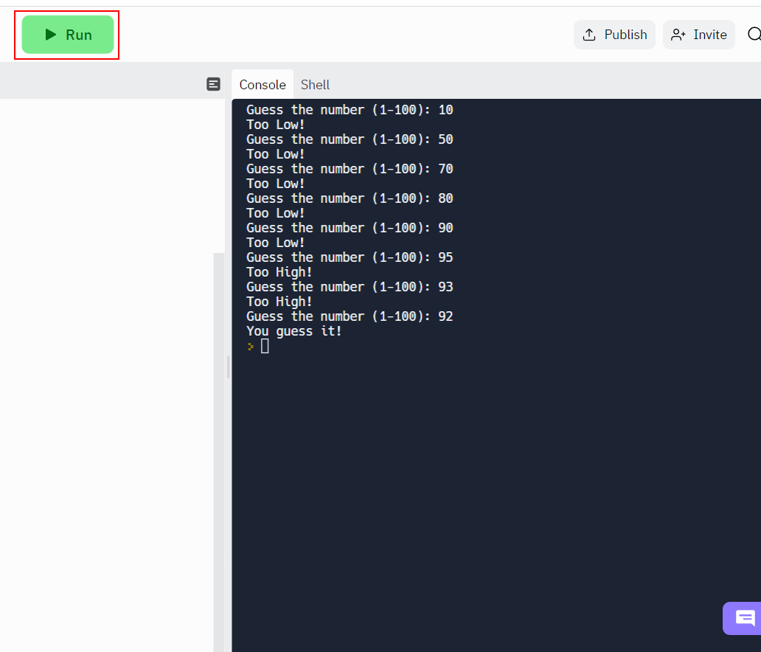

You can now **share** your app with your friends.

## 7. Add Replit Link to Your README.md

Now add a "**one-click live demo**" of your project from your GitHub project documentation. You can do it as follows:

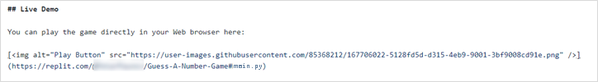

You can take a **screenshot** from Replit.com and **paste it** into the GitHub documentation editor directly with **[Ctrl+V]**.

Now we have completed our **second console game** and we have our second **project** in our GitHub portfolio.