MyJasperReport
20 Sep 2025 13:13:44

 | Purpose
 | This is also used to show in HTML Report
 | MyJasperReport | 2 | / 9

 | Views
 | Application Landscape
 | No viewpoint
 | 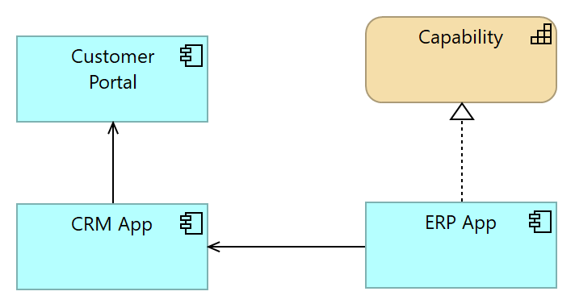
 | Elements
 | Element | Type
 | Capability | Capability
 | CRM App | Application Component
 | Customer Portal | Application Component
 | ERP App | Application Component
 | MyJasperReport |  | 3 | / 9

 | Ref View
 | No viewpoint
 | 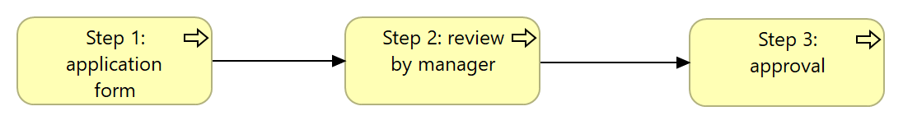
 | Elements
 | Element | Type
 | Step 1: application form | Business Process
 | Step 2: review by manager | Business Process
 | Step 3: approval | Business Process
 | MyJasperReport |  | 4 | / 9

 | Strategy View
 | No viewpoint
 | 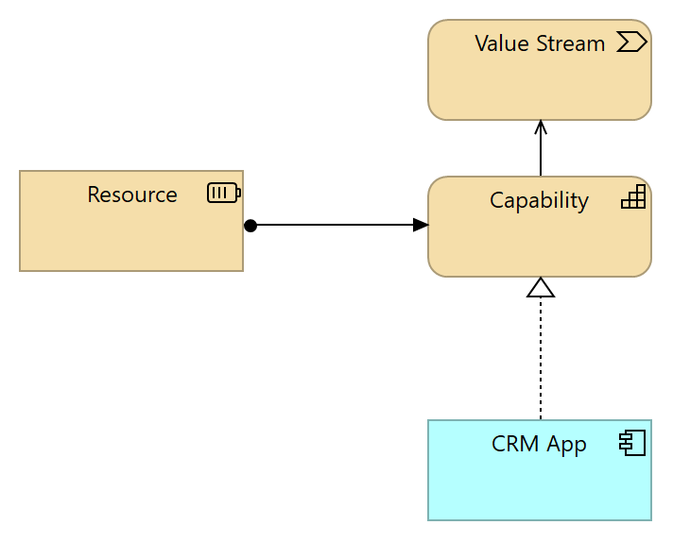
 | Elements
 | Element | Type
 | Capability | Capability
 | CRM App | Application Component
 | Resource | Resource
 | Value Stream | Value Stream
 | MyJasperReport |  | 5 | / 9

 | Strategy Layer
 | Capability
 | Type | Capability
 | Capability
 | Type | Capability
 | Resource
 | Type | Resource
 | Value Stream
 | Type | Value Stream
 | MyJasperReport |  | 6 | / 9

 | Business Layer
 | new step
 | Type | Business Process
 | Step 1: application form
 | Type | Business Process
 | Step 2: review by manager
 | Type | Business Process
 | Step 3: approval
 | Type | Business Process
 | MyJasperReport |  | 7 | / 9

 | Application Layer
 | CRM App
 | Type | Application Component
 | Customer Portal
 | Type | Application Component
 | ERP App
 | Type | Application Component
 | _hide_from_export_ true
 | MyJasperReport |  | 8 | / 9

 | Relations
 | Serving relation
 | Type | Serving relation
 | Source | Capability
 | Target | Value Stream
 | Assignment relation
 | Type | Assignment relation
 | Source | Resource
 | Target | Capability
 | Serving relation
 | Type | Serving relation
 | Source | CRM App
 | Target | Customer Portal
 | Serving relation
 | Type | Serving relation
 | Source | ERP App
 | Target | CRM App
 | Realization relation
 | Type | Realization relation
 | Source | ERP App
 | Target | Capability
 | Triggering relation
 | Type | Triggering relation
 | Source | Step 1: application form
 | Target | Step 2: review by manager
 | Triggering relation
 | Type | Triggering relation
 | Source | Step 2: review by manager
 | Target | Step 3: approval
 | Realization relation
 | Type | Realization relation
 | Source | CRM App
 | Target | Capability
 | MyJasperReport |  | 9 | / 9

