
MyJasperReport
20 Sep 2025 13:13:44
This is also used to show in HTML Report
Purpose
MyJasperReport
2
/ 9
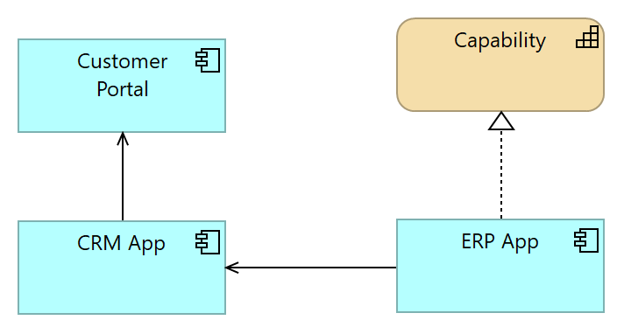
Views
Application Landscape
No viewpoint
Elements
Element
Type
Capability
Capability
CRM App
Application Component
Customer Portal
Application Component
ERP App
Application Component
MyJasperReport
3
/ 9
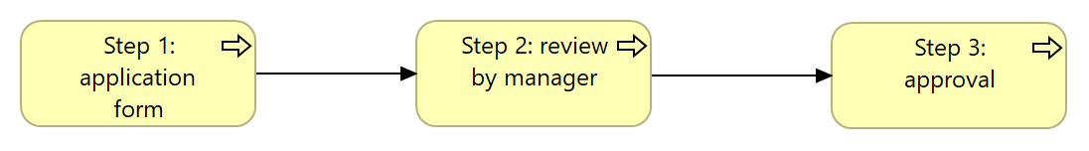
Ref View
No viewpoint
Elements
Element
Type
Step 1: application form
Business Process
Step 2: review by manager
Business Process
Step 3: approval
Business Process
MyJasperReport
4
/ 9
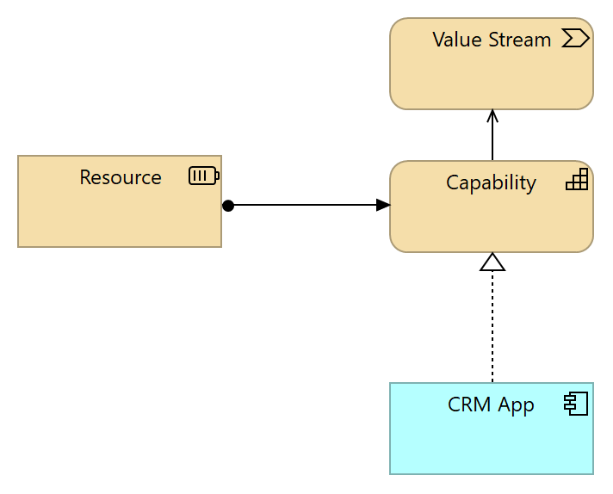
Strategy View
No viewpoint
Elements
Element
Type
Capability
Capability
CRM App
Application Component
Resource
Resource
Value Stream
Value Stream
MyJasperReport
5
/ 9
Capability
Type
Capability
Capability
Type
Capability
Resource
Type
Resource
Value Stream
Type
Value Stream
Strategy Layer
MyJasperReport
6
/ 9
new step
Type
Business Process
Step 1: application form
Type
Business Process
Step 2: review by manager
Type
Business Process
Step 3: approval
Type
Business Process
Business Layer
MyJasperReport
7
/ 9
CRM App
Type
Application Component
Customer Portal
Type
Application Component
ERP App
Type
Application Component
_hide_from_export_
true
Application Layer
MyJasperReport
8
/ 9
Serving relation
Type
Serving relation
Capability
Value Stream
Source
Target
Assignment relation
Type
Assignment relation
Resource
Capability
Source
Target
Serving relation
Type
Serving relation
CRM App
Customer Portal
Source
Target
Serving relation
Type
Serving relation
ERP App
CRM App
Source
Target
Realization relation
Type
Realization relation
ERP App
Capability
Source
Target
Triggering relation
Type
Triggering relation
Step 1: application form
Step 2: review by manager
Source
Target
Triggering relation
Type
Triggering relation
Step 2: review by manager
Step 3: approval
Source
Target
Realization relation
Type
Realization relation
CRM App
Capability
Source
Target
Relations
MyJasperReport
9
/ 9

