Normal & Sketch
21 Sep 2025 09:06:27

 | Purpose
 | Normal & Sketch | 2 | / 8

 | Views
 | Capbility Model
 | No viewpoint
 | 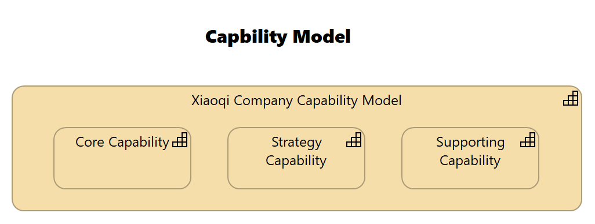
 | Elements
 | Element | Type
 | Core Capability | Capability
 | Strategy Capability | Capability
 | Supporting Capability | Capability
 | Xiaoqi Company Capability Model | Capability
 | Normal & Sketch |  | 3 | / 8

 | Processing Sketch
 | 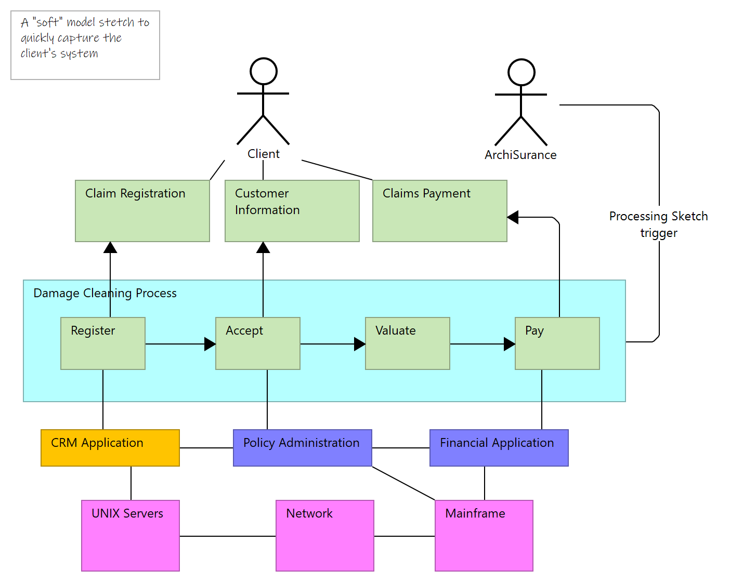
 | Documentation
 | Sketch Sample
 | Normal & Sketch | 4 | / 8

 | Strategy Layer
 | Core Capability
 | Type | Capability
 | Strategy Capability
 | Type | Capability
 | Supporting Capability
 | Type | Capability
 | Xiaoqi Company Capability Model
 | Type | Capability
 | Normal & Sketch |  | 5 | / 8

 | Application Layer
 | App 001
 | Type | Application Component
 | App 002
 | Type | Application Component
 | Normal & Sketch |  | 6 | / 8

 | Technology & Physical Layer
 | AWS Cloud
 | Type | Communication Network
 | Azure Cloud
 | Type | Communication Network
 | Normal & Sketch |  | 7 | / 8

 | Relations
 | Composition relation
 | Type | Composition relation
 | Source | Xiaoqi Company Capability Model
 | Target | Strategy Capability
 | Composition relation
 | Type | Composition relation
 | Source | Xiaoqi Company Capability Model
 | Target | Supporting Capability
 | Composition relation
 | Type | Composition relation
 | Source | Xiaoqi Company Capability Model
 | Target | Core Capability
 | Normal & Sketch |  | 8 | / 8

