
Normal & Sketch
21 Sep 2025 09:06:27

Purpose
Normal & Sketch
2
/ 8
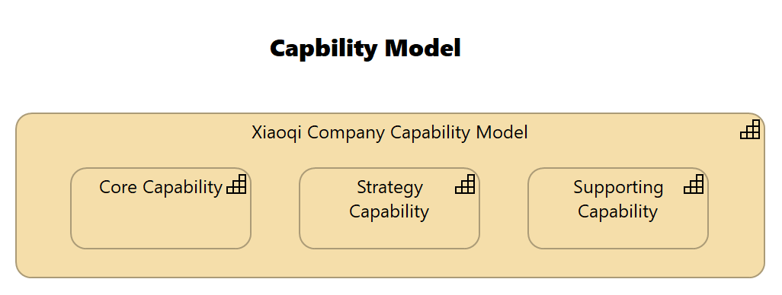
Views
Capbility Model
No viewpoint
Elements
Element
Type
Core Capability
Capability
Strategy Capability
Capability
Supporting Capability
Capability
Xiaoqi Company Capability Model
Capability
Normal & Sketch
3
/ 8
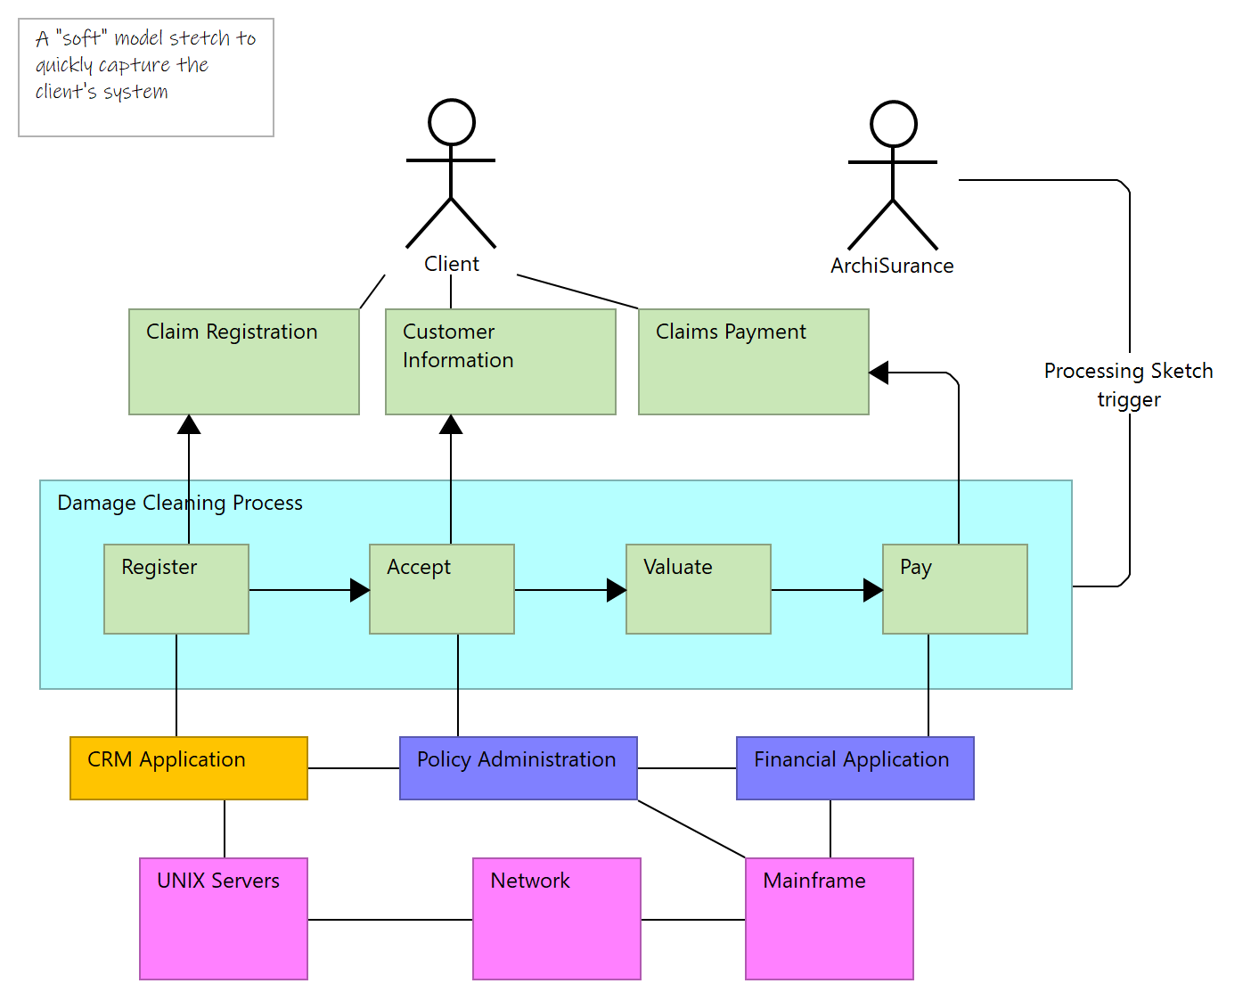
Processing Sketch
Documentation
Sketch Sample
Normal & Sketch
4
/ 8
Core Capability
Type
Capability
Strategy Capability
Type
Capability
Supporting Capability
Type
Capability
Xiaoqi Company Capability Model
Type
Capability
Strategy Layer
Normal & Sketch
5
/ 8
App 001
Type
Application Component
App 002
Type
Application Component
Application Layer
Normal & Sketch
6
/ 8
AWS Cloud
Type
Communication Network
Azure Cloud
Type
Communication Network
Technology & Physical Layer
Normal & Sketch
7
/ 8
Composition relation
Type
Composition relation
Xiaoqi Company Capability Model
Strategy Capability
Source
Target
Composition relation
Type
Composition relation
Xiaoqi Company Capability Model
Supporting Capability
Source
Target
Composition relation
Type
Composition relation
Xiaoqi Company Capability Model
Core Capability
Source
Target
Relations
Normal & Sketch
8
/ 8

