BIZBOK10.0

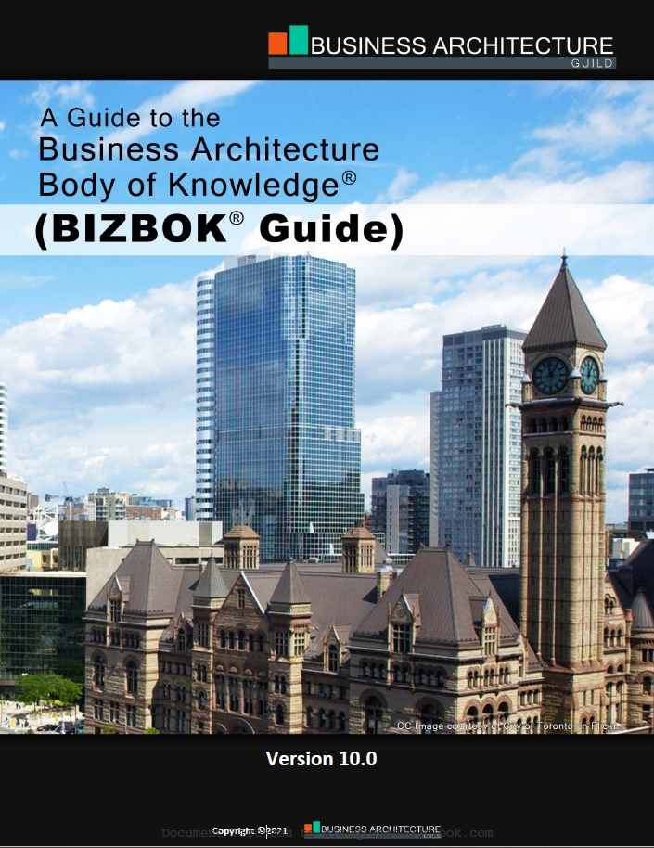

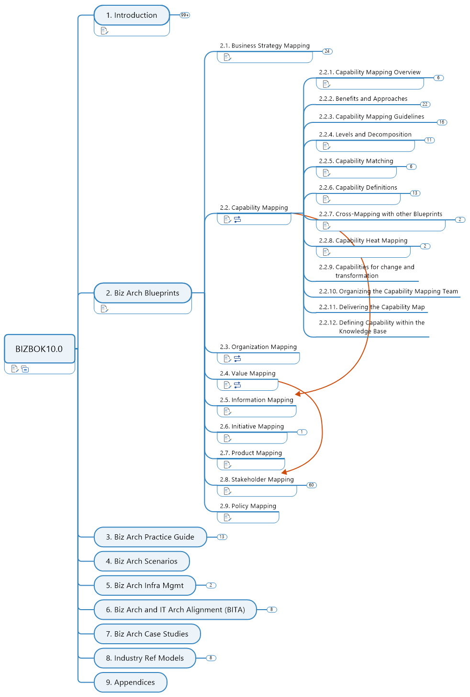

1. Introduction 13

1.1. Positioning of BIZBOK Guide 13

1.1.1. Provides an industry standard framework for biz arch practitioners and individuals who wish to use biz arch to address biz challenges 13

1.1.2. Benefits organizations at every stage of the biz arch practice. 13

1.1.3. Provides a complete picture of biz arch, trying together various concepts, disciplines, principles, and best practices into an overall framework. 13

· Capable to incorporate and leverage a wide range of biz practices and emerging disciplines. 13

· Establishes the standard for building, deploying, and leveraging biz arch within an organization. 13

1.2. Definition of Biz Arch 13

1.2.1. Architecture is not an inspirational business, it's a rational procedure to do sensible and hopefully beautiful things; that's all. (Harry Siedler) 13

1.2.2. Dating back to 2008 through 2016, Biz Arch was defined as "a blueprint of the enterprise that provides a common understanding of the organization and is used to align strategic objectives and tactical demands". 13

1.2.3. In January 2017, BA Guild and numbers of associations / organizations rectified new definitions for business and related architecture disciplines 13

· "Biz Arch represents holistic, multidimensional business views of: capabilities, end-to-end value delivery, information, and organizational structure; and the relationships among these business views and strategies, products, policies, initiatives, and stakeholders". 13

1.2.4. Biz Arch value proposition 13

· The value of Biz Arch is to provide an abstract representation of an enterprise and the business ecosystem in which it operates. By doing so, Biz Arch delivers value as an effective communication and analytical framework for translating strategy into actionable initiatives. The framework also enhances the enterprise's capacity to enact transformational change, navigate complexity, reduce risk, make more informed decisions, align diverse stakeholders to a shared vision of the future, and leverage technology more effectively. 13

· A business ecosystem is defined as "one or more legal entities, in whole or in part, that exist as an integrated community of individuals and assets, or aggregations thereof, interacting as a cohesive whole toward a common mission or purpose." 14

1.2.5. **Blueprints** are abstract representations of reality that represent a wide variety of viewpoints. 14

· The different types of Business Blueprints, along with numerous others, enable organizations to visualize their business from a variety of perspectives, providing management with information about a given domain or domains within a specific context. 14

1.2.6. Biz Arch focuses on the essence, structure, and overall transparency of the business, not on financial performance 14

· Biz Arch Characteristics 14

· - Stakeholder Value-Driven 14

· - Capability-Centric 14

· - Strategically Oriented 14

· - Business Silo Agnostic 14

· - External & Internal Transparency 14

· - Enables Business Model Realization 14

· Operating Model Characteristics 14

· - Depicts how business operates 14

· - Business process, people and IT architecture focused 14

· - Focus on efficiency gains, cost reductions and imporvement 14

1.3. Biz Arch Framework 14

1.3.1. Business Blueprints 14

· Deliver business transparency that enables and streamlines business transformation across business units, capabilities, and stakeholders 14

1.3.2. Business Architecture Scenarios 14

· Provide business transparency on specific business initiatives. 14

· Biz Arch is applied differently based on the type of scenario at hand. 14

· Sample Scenarios Topics 14

· Investment Analysis 14

· Shift to Customer Centric Business Model 15

· Merger and Acquisition Analysis 15

· New Product / Service Rollout 15

· Globalization 15

· Business Capability Outsourcing 15

· Supply Chain Streamlining 15

· Divestiture 15

· Regulatory Compliance 15

· Change Management 15

· Operational Cost Reduction 15

· Joint Venture Deployment 15

· IT Portfolio Investment Analysis 15

· Digital Transformation 15

· Digital Twin Deployment 15

1.3.3. Business Architecture Knowledgebase 15

· Used to store the information about the business and is organized in concise ways that are customized to a given organization's environment 15

1.4. Biz Arch Principles 15

1.4.1. A principle is an agreed upon truth that can guide one's reasoning. 15

1.4.2. Core principles apply to Biz Arch 15

· Biz Arch is about the business 15

· Biz Arch's scope is the scope of the business 15

· Biz Arch is not prescriptive (规定性的) 15

· Biz Arch is iterative (反复的) 15

· Biz Arch is reusable 15

· Biz Arch is not about the deliverables 15

1.4.3. Business Role 15

· Macro Level 15

· establishes principles and governing policies over interaction with suppliers, partners, and all types of outsourcing 15

· Strategic Level 15

· supplements the vision with target capabilities, supporting principles and policies and a current state environmental assessment to provide contextual rationale 15

· Program Level 15

· strategic initiatives into delivery-focused change initiatives 15

· Lowest Level 15

· is usually replaced by a role of product owner, business analyst who engages with the project with the main purpose of communicating architecture and promoting project's alignment with it 15

1.5. Video: Business Architecture Overview 16

1.5.1. Defining Business Architecture 16

· Definition: Biz Arch is a blueprint of the enterprise that provides a common understanding of the organization and is used to align strategic objectives and tactical demands. 16

· first it's blueprint 16

· common understanding, common language 16

· align strategic objective and tactic demands 16

· Purpose: Biz Arch provides a common, enterprise-level business language and framework for documenting how the biz is structured, what it does and what it needs to do to meet its goals 16

· Consideration 16

· Blueprints provide a variety of ways to view the business, offering a shared perspective on business vocabulary, stakeholder views and value delivery 16

· Shared viewpoints expedite situation and issue analysis, problem resolution and deployment planning and execution 16

1.5.2. Biz Arch Value Proposition 16

· Biz Arch provides a representations of 16

· What a business does - capability 16

· How it delivers stakeholder value - value stream 16

· The vocabulary it uses to communicate - information 16

· Business structure - organization 16

· These perspectives are augmented by representations of strategy, stakeholders, initiatives, products/services, policy, decisions/events and analytics 16

· Why Leverage Biz Arch 16

· Common Biz Issues 16

· Obscured customer and other stakeholder engagement perspective 16

· No shared understanding of business capabilities or vocabulary 16

· Biz unit silos mask customer engagement and value delivery 16

· Overall lack of transparency across biz units 16

· Results in these biz challenges 16

· Innovation and planning teams lack critical perspectives 16

· Inability to trace strategy through initiatives and solutions 16

· Investment decisions are risky and ill-informed 16

· Siloed initiatives are often misdirected or in conflict 16

· Requirements scope is unclear, leading to failed projects 16

· Ineffective cross-busienss unit coordination creates risk, drives up costs 16

· IT investments are ill-conceived, lack clear ROI 16

1.5.3. Biz Arch Framework Overview 16

· Core 16

· Capabilities - What? 16

· Information - What? 16

· Value Streams - How? 16

· Organization - Who? & Where? 16

· Extended 16

· Stakeholders - Who? & Where? 17

· Vision, Strategies & Tactics - Why? 17

· Initiatives & Projects - How? 17

· Decisions & Events - When? & Where? 17

· Metrics & Measures - How Well? 17

· Products & Services - What? 17

· Policies, rules, Regulations - Why? 17

1.5.4. Using Biz Arch to move from Strategy to Actionable Solutions 17

1.5.5. Biz Arch's rols in IT Arch and IT Solution Deployment 17

· Enterprise Architecture 17

· Business Architecture - Business View 17

· Application Architecture - Business Automation & Services View 17

· Data Architecture - Data View 17

· Technical Architecture - Platform & Enabling Technology View 17

· Solution Architecture - Initiative or Portfolio View 17

1.5.6. Dispelling 10 common myths of Biz Arch 17

· A Biz Arch can be built with limited Biz Engagement and Commitment 17

· The Biz Arch capability is the deliverable 17

· Biz Arch is complicated 17

· There is no commonly defined approach to Biz Arch 17

· Biz Arch is program, project or biz unit specific 17

· Biz Arch can be licensed or acquired 17

· Biz Arch is an IT discipline 17

· Biz Arch is expensive 17

· Biz do not need Biz Arch because they already understand all they need to know about the business 17

· Biz Arch is fancy team for business analysis 17

1.5.7. Biz Arch Governance 17

· Charter 17

· What does the business architecture team do? 17

· Governance Structure 17

· How is the business architecture team structured? 17

· Roadmap 17

· How will the biz arch team mature? 17

· Engagement Model 17

· How does the biz arch team interact with others? 17

1.5.8. Building Biz Arch Expertise 17

2. Biz Arch Blueprints 17

2.1. Business Strategy Mapping 17

2.1.1. Defining Biz Strategy Mapping 17

· Strategy: The pattern or plan that integrates an organization's major goals, policies, and action sequences into a cohesive whole. 18

2.1.2. Using Biz Arch for Strategy Justification and Interpretation 18

2.1.3. Strategy and Organization Structure 18

2.1.4. Planning vs. Design Approach 18

2.1.5. Benefits of Strategy Mapping 18

2.1.6. Principles of Strategy Mapping 18

2.1.7. Strategy Mapping Frameworks 18

· Ansoff Product/Market Grid 18

· Strength/Weakness/Opportunity/Threat (SWOT) analysis 18

· Five Forces Model (Michael Porter) 18

· Norton Kaplan Strategy Map 18

· Business Motivation Model (BMM) 18

· Hoshin Kanri 18

2.1.8. Strategy Mapping and Interpretation: Distillation and Interpretation 18

· Distilling Strategy via Objective Mapping 18

· Linking Objectives to Capability and Value Perspective 18

· Linking Objectives to the Environment 18

2.1.9. Approach to Strategy Mapping 18

· Strategy Mapping Template 18

· Strategy Mapping Guidelines 18

2.1.10. Business Strategy Impact Analysis Mapping Template 18

2.1.11. Business Strategy Imapact Analysis Guidelines 18

2.1.12. Define Strategy within Biz Arch Knowledgebase 18

2.2. Capability Mapping 19

2.2.1. Capability Mapping Overview 19

· A business capability, or simply a "capability", defines what a business does. Specifically, the business capability is "a particular ability or capacity that a business may possess or change to achieve a specific purpose or outcome." 20

· Capabilities are based on WHAT a business does. 20

· Future state capabilities represent capabilities the business has no ability to current perform. Future capabilities should be included in capability map if identified as part of the strategy. 20

· Capabilities are based on business objects. 20

· Capabilities do not stand alone 20

· Needs to consider the real scope of the business, not just the legally defined enterprise. 20

2.2.2. Benefits and Approaches 20

· A capability instance is defined as "a specific realization of a capability, as it exists or is envisioned to exist, in the context of a given business unit, value stream, or other situational context." 20

· Benefits of Using Biz Cap 21

· A common vocabulary 21

· A way to see what is common across a business. 21

· Enable laser-like business investment focus. 21

· Baseline for planning, change management, & impact analysis. 21

· The basis for transformational design and deployment. 21

· A clear link from strategy to execution. 21

· Approaches 21

· Top-down enterprise approach 22

· The top-down approach to capability mapping strives to create a single map for the business 22

· This includes all capabilities that enable the organization to viably fulfill its mission 22

· This map would ultimately encompass a complete and fully rationalized view of the business 22

· Bottom-up business unit centric approach 22

· If the capability map is to be used within the confines of that business unit, only enabling root cause analysis, issue resolution, and transformation planning within the confines of that business unit is perfectly fine. 22

· When each business unit capability map is created in isolation, there is little visible commonality across maps. 22

· Derivative capability map approach 22

· Similar to the business unit approach only it begins from a top-down view and derives detailed maps from a single, high-level perspective 22

· The concept involves created a common, umbrella capability map for the biz that defines capabilities down to at least a level 2 view and ideally a level 3 view 22

· Mapping with conglomerates/partners 22

· A shared level 1 capability map across the conglomerate can be useful as a baseline, at least for strategic and supporting tiers 22

· Capability mapping teams are encouraged to consider the upsides and downsides of various enterprise, BU, and project mapping approaches as they move forward and align their work accordingly to avoid some of the downside challenges. 23

2.2.3. Capability Mapping Guidelines 23

· How to do Capability Mapping 23

· The capability map is the commonly used business blueprint for depicting a set of capabilities for a business 23

· It presents a logically grouped set of capabilities that are independent of organizational structures, processes, IT assets, or product offerings. 23

· The map itself is a complete view of the business and relies on two basic concepts: leveling and stratification (调平和分层) 23

· Guidelines 23

· Focus on business objectives 23

· Determine if it is a capability because it describes what the business does. 23

· Consider it in terms of outcomes 23

· Verify that is isn't a process or value stream 23

· Unique in terms of intent 23

· Unique based on the information they require 23

· Validate by roles and resources 24

· Eliminate redundancies 24

· Ignore 80/20 rule 24

· Don't overgeneralize the business 24

· If it is planned, its a capability 24

2.2.4. Levels and Decomposition 24

· Drafting a Level 1 Capability Map 25

· Establish a candidate list of capabilities 25

· Refine the starter list 25

· Validate the starter list against the organization chart and industry perspectives 25

· Draft Level 1 capability map 25

· Decomposing the Capability Map 25

· Prioritize the capability decomposition approach 25

· Draft the level 2 capability map 25

· Decompose capabilities into lower level based on core business views 25

· Frame capabilities in terms of their parent capabilities 25

· Refine through iteration 25

2.2.5. Capability Matching 25

· The "controlling" object (e.g. agreement) serves as the Logical Focal Point for the Match. The controlling object initiates and is listed first in Level 3 matching capability 25

· The Controlling Object is Typically the More Volatile Object. 25

· Matching Capabilities should not be Duplicated within a Capability Map when another controlling object has established the association. 25

· Parent/Child Object Matching is not Required because objects defined in Child Capabilities are already associated with the Parent through Decomposition. 26

· Object Matching within a Level 1 is dictated (指示) by the Same Level unless where traditional Level 1 boundary scope is pushed to Level 2 Capability or Lower. 26

· Three-way Matches may be Applied as well where such an association is required by a given business scenarios. 26

2.2.6. Capability Definitions 26

· Capability Definition Template 26

· Building Capability Definitions - Guidelines 26

· Define each capability using a single sentence that defines what it is but not why, when, or how it occurs 26

· Do not reuse the terms used within the capability name as a part of the definition 27

· Define parent capabilities before decomposing children capabilities 27

· Define all capabilities prior to full rollout of the map 27

· Refine and test definitions through socialization and validation cycles 27

· Capabilities Grammatical Practices 27

· Capability names are shown with the first level of each word in the name capitalized. 27

· For lists within a capability definition, use the Oxford Comma. 27

· Do not use the "and/or" combination in a definition 27

· For capability definitions, keep them to one sentence and end them with a period. 27

· Use the "/" (hash) to represent a matching capability, object-to-object relationship 27

2.2.7. Cross-Mapping with other Blueprints 27

· Capability/Organization Mapping 27

· Value Stream / Capability Cross-Mapping Blueprint 28

2.2.8. Capability Heat Mapping 28

· General Heatmap 29

· Assign Criticality Attribute to Heat Mapping 29

2.2.9. Capabilities for change and transformation 30

2.2.10. Organizing the Capability Mapping Team 30

2.2.11. Delivering the Capability Map 30

2.2.12. Defining Capability within the Knowledge Base 30

2.3. Organization Mapping 30

2.4. Value Mapping 30

2.5. Information Mapping 30

2.6. Initiative Mapping 30

2.6.1. Definition: An Initiative is A Course of Action that is being executed or has been selected for execution. 31

2.7. Product Mapping 31

2.8. Stakeholder Mapping 31

2.8.1. Stakeholder: an internal or external individual or organization with a vested interest in achieving value through a particular outcome. 31

2.8.2. Stakeholder v.s. Role 31

· Role is non-architectural concept 31

· Stakeholders may be reflected as certain roles within the context of related disciplines such as business design and business process management. 31

· The Role concept typically incorporates a broad set of more granular categories that change frequently, while Stakeholder is defined as a higher level, is less volatile, and evolves to be used in more strategic or deliberate ways. 31

2.8.3. Sample Stakeholders 31

· Customer, Constituent, Patient, Member, Client 31

· Partner, Supplier, Agent, Distributor, Reseller, Vendor 31

· Sales Person, Technical Support, Underwriter, Claims Agent, Help Desk Personnel 31

· Legal Representative, Contract Officer, Network Manager 31

· Pilot, Engineer, Shift Supervisor, Gate Agent, Security Guard, Compliance Officer 31

· Regulator, Auditor, Tax Authority 31

· Competitor 31

2.8.4. Purpose of Stakeholder Mapping 31

· Central Goal: to further the understanding and improvement of the business based on various business scenarios associated with value-seeking stakeholders as well as those stakeholders who contribute to value delivery. 31

· Provides an overview as well as a detailed understanding as to how the business delivers values to customers, partners, and other 3rd party. 31

· Offers insight into the stakeholders who are critical to the business' bottom line. 31

· Delivers a deeper perspective into the importance of value streams, and, in turn, capabilities and related business concepts. 31

2.8.5. Benefits of Stakeholder Mapping 31

· Provides a context for determining how to achieve and deliver customer value 31

· Identifies 3rd-party partners, suppliers, agents, and related stakeholders within the context of stakeholder value delivery 31

· Offers a perspective on how to organize various value streams based on the stakeholders benefiting from those value streams. 31

· Highlights stakeholder commonalities across business units and 3rd parties as a basis for centralizing analysis and streamline investments in how those stakeholders receive and contribute to business value propositions 32

· Establishes a context for externalized resource enablement for certain capabilities 32

· Provides a basis for identifying the role of stakeholders that participate in various value stream stages 32

· Highlights specific areas of focus of various internal stakeholders and how they deliver externally and internally focused value to the business 32

· Offers business executives a concrete set of stakeholder-oriented focal points as input to strategic planning work 32

2.8.6. Principles of Stakeholder Mapping 32

· A stakeholder is an individual or an organization that has a substantive (实质性) impact on business 32

· A stakeholder can be internal or external to the enterprise 32

· A stakeholder covers a variety of individual and organizational categories 32

· A stakeholder is represented as an information concept within the information map 32

· A stakeholder triggers and participates in value streams, either as a recipient of value or as a participant that enables value delivery. 32

· A stakeholder serves as a resource to implement a capability 32

· A stakeholder can be the target of a give strategy 32

2.8.7. type of Stakeholder 32

· Triggering Stakeholder 32

· Defined as a stakeholder that initiates a value stream for purpose of achieving a stated value proposition 32

· e.g. a customer seeking a product 32

· e.g. a partners seeking a relationship 32

· e.g. a manager seeking a new hire 32

· This is the Stakeholder who is seeking the end state value proposition 32

· Participating Stakeholder 32

· Defined as a role or responsibility within a value stream stage and, therefore, contributes to capabilities with outcomes that achieve the value item(s) for that stage. 32

· This is the Stakeholder who contribute along the way to achieving the value preposition that initiated by "Triggering Stakeholder" 32

2.8.8. Content in Stakeholder Mapping 32

· Stakeholder Type 32

· internal or external party 32

· customers, partners, and regulatory bodies are associated with external stakeholder types 32

· Stakeholder Category 32

· Link with Level 1 Capabilities 32

· Stakeholder 32

· Stakeholder Description 32

2.8.9. Stakeholder Knowledgebase Relationships 32

· Stakeholder belongs to business unit, which may be a partner, provides stakeholder context, and highlights role commonalities or inconsistencies across an ecosystem 32

· Stakeholder triggers value stream, highlighting where a stakeholder is seeking a value proposition or serving as a proxy for a stakeholder seeking a value proposition 32

· Stakeholder participates in value stream stage highlights where any number of stakeholders contribute to the value delivered by that stage 32

· Stakeholder contributes to a capability outcome, which should be viewed in context of a value stream stage where capabilities and stakeholders interest 32

· Stakeholder defines an information concept, where, for concepts such as customer, partner, and human resource, this relationship aligns unique stakeholders defined in the stakeholder map with the information concept types 33

· Strategy impacts a stakeholder is a relationship that is particularly useful when an organization wants to target a customer, partner, or human resource as part of a strategy 33

2.9. Policy Mapping 33

3. Biz Arch Practice Guide 34

3.1. Common Approaches for Getting Started 34

3.2. Biz Arch Governance 34

3.3. Biz Arch and Biz Models 34

3.4. Biz Arch and Biz Process Modeling and Mgmt 34

3.5. Biz Archi and Case Mgmt 34

3.6. Biz Arch and Lean Six Sigma 34

3.7. Biz Arch and Biz Performance Mgmt 34

3.8. Biz Arch and Requirement Alignment 34

3.9. Biz Arch Maturity Model 34

3.10. The Role of the Biz Architect 34

3.11. Biz Arch and Strategy Execution 34

3.12. Biz Arch and Operating Models 34

3.13. Biz Arch and Customer Experience Design 34

4. Biz Arch Scenarios 34

5. Biz Arch Infra Mgmt 34

5.1. The Biz Arch Knowledgebase 34

5.2. Biz Arch Tooling Options 34

6. Biz Arch and IT Arch Alignment (BITA) 34

6.1. Biz Arch and IT Arch Alignment Overview 34

6.2. Biz Arch and EA Framework Alignment 34

6.3. Biz Arch and System Development Lifecycle (SDLC) 34

6.4. Biz Arch and Application Portfolio Mgmt 34

6.5. Biz Arch and SOA Alignment 34

6.6. Biz Information and Data Arch Alignment 34

6.7. Biz Arch and Solution Arch 35

6.8. Biz Arch and IT Arch Transformation 35

7. Biz Arch Case Studies 35

8. Industry Ref Models 35

8.1. Financial Services Industry Ref Model 35

8.2. Manufacturing Industry Ref Model 35

8.3. Healthcare Industry Ref Model 35

8.4. Member-Based Association Industry Ref Model 35

8.5. Insurance Industry Ref Model 35

8.6. Common Ref Model 35

8.7. Transportation Industry Ref Model 35

8.8. Government Industry Ref Model 35

9. Appendices 35

1. Introduction

Overview of the BIZBOK Guide.

* 1. Positioning of BIZBOK Guide

BIZBOK Guide - A Guide to the Business Architecture Body of Knowledge

* + 1. Provides an industry standard framework for biz arch practitioners and individuals who wish to use biz arch to address biz challenges
    2. Benefits organizations at every stage of the biz arch practice.
    3. Provides a complete picture of biz arch, trying together various concepts, disciplines, principles, and best practices into an overall framework.
       - Capable to incorporate and leverage a wide range of biz practices and emerging disciplines.
       - Establishes the standard for building, deploying, and leveraging biz arch within an organization.
  1. Definition of Biz Arch
     1. Architecture is not an inspirational business, it's a rational procedure to do sensible and hopefully beautiful things; that's all. (Harry Siedler)
     2. Dating back to 2008 through 2016, Biz Arch was defined as "a blueprint of the enterprise that provides a common understanding of the organization and is used to align strategic objectives and tactical demands".
     3. In January 2017, BA Guild and numbers of associations / organizations rectified new definitions for business and related architecture disciplines
        + "Biz Arch represents holistic, multidimensional business views of: capabilities, end-to-end value delivery, information, and organizational structure; and the relationships among these business views and strategies, products, policies, initiatives, and stakeholders".
     4. Biz Arch value proposition
        + The value of Biz Arch is to provide an abstract representation of an enterprise and the business ecosystem in which it operates. By doing so, Biz Arch delivers value as an effective communication and analytical framework for translating strategy into actionable initiatives. The framework also enhances the enterprise's capacity to enact transformational change, navigate complexity, reduce risk, make more informed decisions, align diverse stakeholders to a shared vision of the future, and leverage technology more effectively.
        + A business ecosystem is defined as "one or more legal entities, in whole or in part, that exist as an integrated community of individuals and assets, or aggregations thereof, interacting as a cohesive whole toward a common mission or purpose."
     5. **Blueprints** are abstract representations of reality that represent a wide variety of viewpoints.
        + The different types of Business Blueprints, along with numerous others, enable organizations to visualize their business from a variety of perspectives, providing management with information about a given domain or domains within a specific context.
     6. Biz Arch focuses on the essence, structure, and overall transparency of the business, not on financial performance
        + Biz Arch Characteristics
          - - Stakeholder Value-Driven
          - - Capability-Centric
          - - Strategically Oriented
          - - Business Silo Agnostic
          - - External & Internal Transparency
          - - Enables Business Model Realization
        + Operating Model Characteristics
          - - Depicts how business operates
          - - Business process, people and IT architecture focused
          - - Focus on efficiency gains, cost reductions and imporvement
  2. Biz Arch Framework

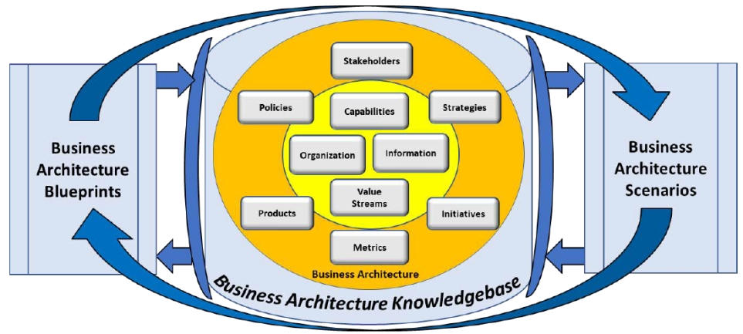

* + 1. Business Blueprints
       - Deliver business transparency that enables and streamlines business transformation across business units, capabilities, and stakeholders
    2. Business Architecture Scenarios
       - Provide business transparency on specific business initiatives.
       - Biz Arch is applied differently based on the type of scenario at hand.
       - Sample Scenarios Topics
         * Investment Analysis
         * Shift to Customer Centric Business Model
         * Merger and Acquisition Analysis
         * New Product / Service Rollout
         * Globalization
         * Business Capability Outsourcing
         * Supply Chain Streamlining
         * Divestiture
         * Regulatory Compliance
         * Change Management
         * Operational Cost Reduction
         * Joint Venture Deployment
         * IT Portfolio Investment Analysis
         * Digital Transformation
         * Digital Twin Deployment

Digital twin deployment in factories, warehouses Mid sized companies in the Asia Pacific and South Africa regions need handholding to deploy new generation solutions in order to gain a competitive advantage in a fast changing and new normal world. Indoor tracking & monitoring – consulting, deployment

* + 1. Business Architecture Knowledgebase
       - Used to store the information about the business and is organized in concise ways that are customized to a given organization's environment
  1. Biz Arch Principles
     1. A principle is an agreed upon truth that can guide one's reasoning.
     2. Core principles apply to Biz Arch
        + Biz Arch is about the business
        + Biz Arch's scope is the scope of the business
        + Biz Arch is not prescriptive (规定性的)
        + Biz Arch is iterative (反复的)
        + Biz Arch is reusable
        + Biz Arch is not about the deliverables
     3. Business Role
        + Macro Level
          - establishes principles and governing policies over interaction with suppliers, partners, and all types of outsourcing
        + Strategic Level
          - supplements the vision with target capabilities, supporting principles and policies and a current state environmental assessment to provide contextual rationale
        + Program Level
          - strategic initiatives into delivery-focused change initiatives
        + Lowest Level
          - is usually replaced by a role of product owner, business analyst who engages with the project with the main purpose of communicating architecture and promoting project's alignment with it
  2. Video: Business Architecture Overview

|  |  |
| --- | --- |
| See also | [Special Guild Webinar on Vimeo](https://vimeo.com/157787273) |

* + 1. Defining Business Architecture
       - Definition: Biz Arch is a blueprint of the enterprise that provides a common understanding of the organization and is used to align strategic objectives and tactical demands.
         * first it's blueprint
         * common understanding, common language
         * align strategic objective and tactic demands
       - Purpose: Biz Arch provides a common, enterprise-level business language and framework for documenting how the biz is structured, what it does and what it needs to do to meet its goals
       - Consideration
         * Blueprints provide a variety of ways to view the business, offering a shared perspective on business vocabulary, stakeholder views and value delivery
         * Shared viewpoints expedite situation and issue analysis, problem resolution and deployment planning and execution
    2. Biz Arch Value Proposition
       - Biz Arch provides a representations of
         * What a business does - capability
         * How it delivers stakeholder value - value stream
         * The vocabulary it uses to communicate - information
         * Business structure - organization
         * These perspectives are augmented by representations of strategy, stakeholders, initiatives, products/services, policy, decisions/events and analytics
       - Why Leverage Biz Arch
         * Common Biz Issues

Obscured customer and other stakeholder engagement perspective

No shared understanding of business capabilities or vocabulary

Biz unit silos mask customer engagement and value delivery

Overall lack of transparency across biz units

* + - * + Results in these biz challenges

Innovation and planning teams lack critical perspectives

Inability to trace strategy through initiatives and solutions

Investment decisions are risky and ill-informed

Siloed initiatives are often misdirected or in conflict

Requirements scope is unclear, leading to failed projects

Ineffective cross-busienss unit coordination creates risk, drives up costs

IT investments are ill-conceived, lack clear ROI

* + 1. Biz Arch Framework Overview
       - Core
         * Capabilities - What?
         * Information - What?
         * Value Streams - How?
         * Organization - Who? & Where?
       - Extended
         * Stakeholders - Who? & Where?
         * Vision, Strategies & Tactics - Why?
         * Initiatives & Projects - How?
         * Decisions & Events - When? & Where?
         * Metrics & Measures - How Well?
         * Products & Services - What?
         * Policies, rules, Regulations - Why?
    2. Using Biz Arch to move from Strategy to Actionable Solutions
    3. Biz Arch's rols in IT Arch and IT Solution Deployment
       - Enterprise Architecture
         * Business Architecture - Business View
         * Application Architecture - Business Automation & Services View
         * Data Architecture - Data View
         * Technical Architecture - Platform & Enabling Technology View
         * Solution Architecture - Initiative or Portfolio View
    4. Dispelling 10 common myths of Biz Arch
       - A Biz Arch can be built with limited Biz Engagement and Commitment
       - The Biz Arch capability is the deliverable
       - Biz Arch is complicated
       - There is no commonly defined approach to Biz Arch
       - Biz Arch is program, project or biz unit specific
       - Biz Arch can be licensed or acquired
       - Biz Arch is an IT discipline
       - Biz Arch is expensive
       - Biz do not need Biz Arch because they already understand all they need to know about the business
       - Biz Arch is fancy team for business analysis
    5. Biz Arch Governance
       - Charter
         * What does the business architecture team do?
       - Governance Structure
         * How is the business architecture team structured?
       - Roadmap
         * How will the biz arch team mature?
       - Engagement Model
         * How does the biz arch team interact with others?
    6. Building Biz Arch Expertise

1. Biz Arch Blueprints

Includes detailed mapping discussion of common business blueprints along with guidelines for how to use these blueprints in practice

* 1. Business Strategy Mapping

How business strategy and objectives play a role within business architecture.

* + 1. Defining Biz Strategy Mapping
       - Strategy: The pattern or plan that integrates an organization's major goals, policies, and action sequences into a cohesive whole.
    2. Using Biz Arch for Strategy Justification and Interpretation
    3. Strategy and Organization Structure

|  |  |
| --- | --- |
| Relationship | begins at Organization Mapping |

* + 1. Planning vs. Design Approach
    2. Benefits of Strategy Mapping
    3. Principles of Strategy Mapping
    4. Strategy Mapping Frameworks
       - Ansoff Product/Market Grid
       - Strength/Weakness/Opportunity/Threat (SWOT) analysis
       - Five Forces Model (Michael Porter)
       - Norton Kaplan Strategy Map
       - Business Motivation Model (BMM)
       - Hoshin Kanri
    5. Strategy Mapping and Interpretation: Distillation and Interpretation
       - Distilling Strategy via Objective Mapping
       - Linking Objectives to Capability and Value Perspective

|  |  |
| --- | --- |
| Relationship | begins at Value Mapping |
| Relationship | begins at Capability Mapping |

* + - * Linking Objectives to the Environment
    1. Approach to Strategy Mapping
       - Strategy Mapping Template
       - Strategy Mapping Guidelines
    2. Business Strategy Impact Analysis Mapping Template
    3. Business Strategy Imapact Analysis Guidelines
    4. Define Strategy within Biz Arch Knowledgebase

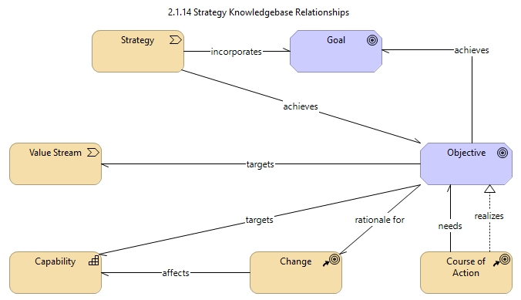

* 1. Capability Mapping

|  |  |
| --- | --- |
| Relationship | points to Linking Objectives to Capability and Value Perspective |
| Relationship | points to Information Mapping |

Details the definition, benefits, development, and use of business capabilities in planning and other business areas.

Also includes information about building the capability map and cross-mapping of capabilities to other business architecture domains.

"Science is facts; just as houses are mad of stone, so is science made of facts; but a pile of stones is not a house, and a collection of facts is not necessarily science."

-- Jules Henri Poincere (1854-1912), French mathematician

* + 1. Capability Mapping Overview

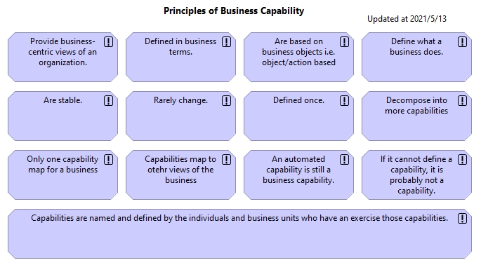

* + - * A business capability, or simply a "capability", defines what a business does. Specifically, the business capability is "a particular ability or capacity that a business may possess or change to achieve a specific purpose or outcome."

Capability: the power or ability to do something.

Business Capability is A Representation of What the Business Does! (not how, now why)

Each box has specific feature.

* + - * Capabilities are based on WHAT a business does.
      * Future state capabilities represent capabilities the business has no ability to current perform. Future capabilities should be included in capability map if identified as part of the strategy.
      * Capabilities are based on business objects.
      * Capabilities do not stand alone
      * Needs to consider the real scope of the business, not just the legally defined enterprise.
    1. Benefits and Approaches
       - A capability instance is defined as "a specific realization of a capability, as it exists or is envisioned to exist, in the context of a given business unit, value stream, or other situational context."

A moment in time where a capability is being used for a specific purpose

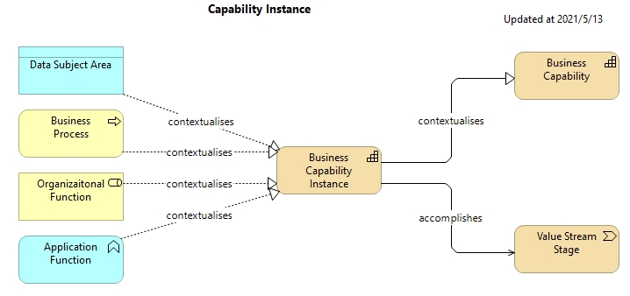

* + - * Benefits of Using Biz Cap
        + A common vocabulary
        + A way to see what is common across a business.
        + Enable laser-like business investment focus.
        + Baseline for planning, change management, & impact analysis.
        + The basis for transformational design and deployment.
        + A clear link from strategy to execution.
      * Approaches

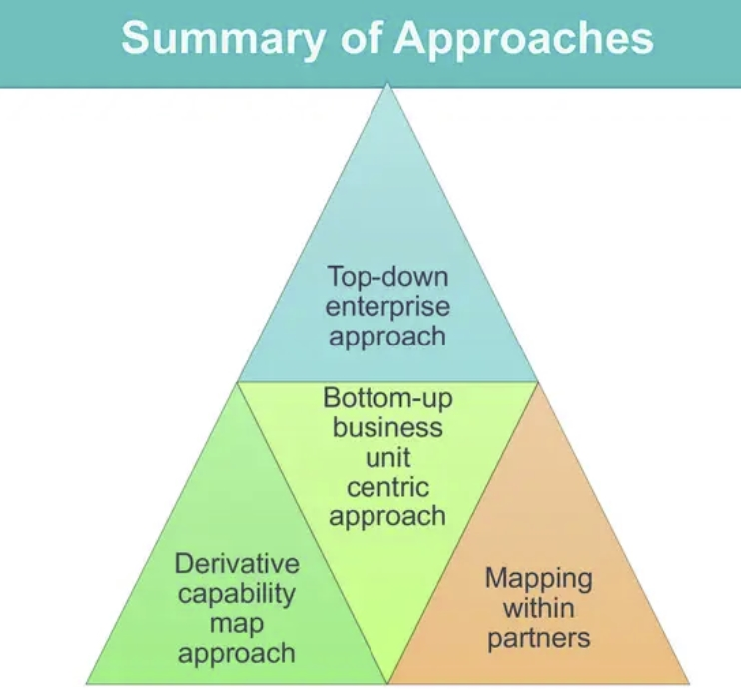

* + - * + Top-down enterprise approach

The top-down approach to capability mapping strives to create a single map for the business

This includes all capabilities that enable the organization to viably fulfill its mission

This map would ultimately encompass a complete and fully rationalized view of the business

* + - * + Bottom-up business unit centric approach

If the capability map is to be used within the confines of that business unit, only enabling root cause analysis, issue resolution, and transformation planning within the confines of that business unit is perfectly fine.

When each business unit capability map is created in isolation, there is little visible commonality across maps.

* + - * + Derivative capability map approach

Similar to the business unit approach only it begins from a top-down view and derives detailed maps from a single, high-level perspective

The concept involves created a common, umbrella capability map for the biz that defines capabilities down to at least a level 2 view and ideally a level 3 view

* + - * + Mapping with conglomerates/partners

A shared level 1 capability map across the conglomerate can be useful as a baseline, at least for strategic and supporting tiers

Capability mapping teams are encouraged to consider the upsides and downsides of various enterprise, BU, and project mapping approaches as they move forward and align their work accordingly to avoid some of the downside challenges.

* + 1. Capability Mapping Guidelines
       - How to do Capability Mapping
         * The capability map is the commonly used business blueprint for depicting a set of capabilities for a business
         * It presents a logically grouped set of capabilities that are independent of organizational structures, processes, IT assets, or product offerings.
         * The map itself is a complete view of the business and relies on two basic concepts: leveling and stratification (调平和分层)

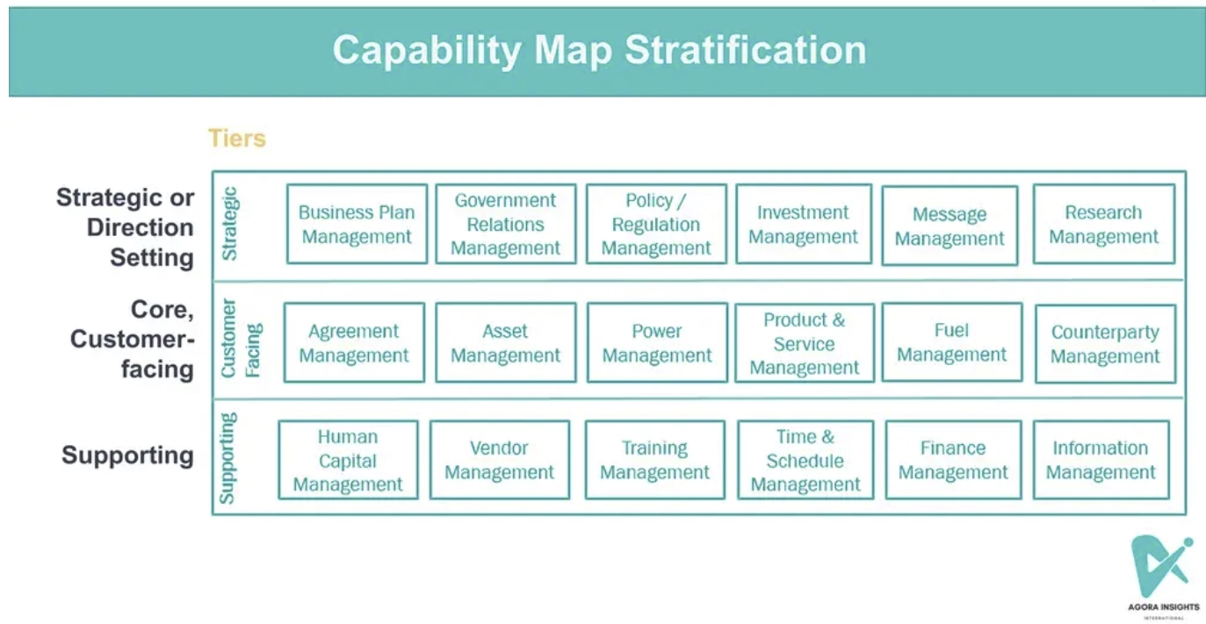

* + - * Guidelines
        + Focus on business objectives

Business objects are tangible tings commonly recognized by the business

* + - * + Determine if it is a capability because it describes what the business does.
        + Consider it in terms of outcomes
        + Verify that is isn't a process or value stream

Topics that require a stakeholder, such as authorizing, validating, or otherwise engaging in a sequence of activities, are not capabilities because they describe how something is being done. A capability must be a self-contained concept that is not procedural in nature and is built around a defined business object.

* + - * + Unique in terms of intent

If two capabilities seem alike, question their intent.

* + - * + Unique based on the information they require

Capabilities rely on and impact business information and, therefore, can be segregated based on that information.

* + - * + Validate by roles and resources

Certain capabilities are unique to certain roles and skills, however, which allows mapping teams to differentiate between two capabilities that sound similar but, in reality, are two unique capabilities.

A question to ask is this: if two people switched jobs, would they still perform as well performing two similar capabilities?

* + - * + Eliminate redundancies

The rule is to consolidate as tightly as possible and reuse capabilities across business units, product lines, and international boundaries.

The how and where factors within business architecture are addressed organizationally and through value streams and IT deployments.

* + - * + Ignore 80/20 rule

It does not matter if a SME states that "we rarely if ever have to do that".

There is no 80/20 rule with capabilities.

If there is a capability, define it, even if it is rarely done.

Leaving out such a capability will leave a hole in the picture of the business.

* + - * + Don't overgeneralize the business

The various pieces of the business need to be documented at the right level of detail so that everyone can see and share a common mental model of what the business does.

The use of a capability map for analysis becomes much less useful when it is over abstracted or overgeneralized.

As a rule, it takes time to settle into the right level of generalization based on capability reviews and use in practice.

* + - * + If it is planned, its a capability

If management plans to do something, identify it as a capability.

A desire to have a new capability that does not exist raises the topic of current vesus target state.

The capability map is the rare architectural view that allows creating of a single view of the current state and the target state of the business.

Target state capabilities, if there are any, can be identified using a color-coding scheme.

* + 1. Levels and Decomposition

Establish candidates form level capability first.

When decomposing capabilities we end up with lower-levels of capabilities which provide more details regarding the capability and core business views.

Remember the naming conventions of levelling.

* + - * Drafting a Level 1 Capability Map
        + Establish a candidate list of capabilities
        + Refine the starter list
        + Validate the starter list against the organization chart and industry perspectives
        + Draft Level 1 capability map
      * Decomposing the Capability Map
        + Prioritize the capability decomposition approach
        + Draft the level 2 capability map
        + Decompose capabilities into lower level based on core business views
        + Frame capabilities in terms of their parent capabilities
        + Refine through iteration
    1. Capability Matching

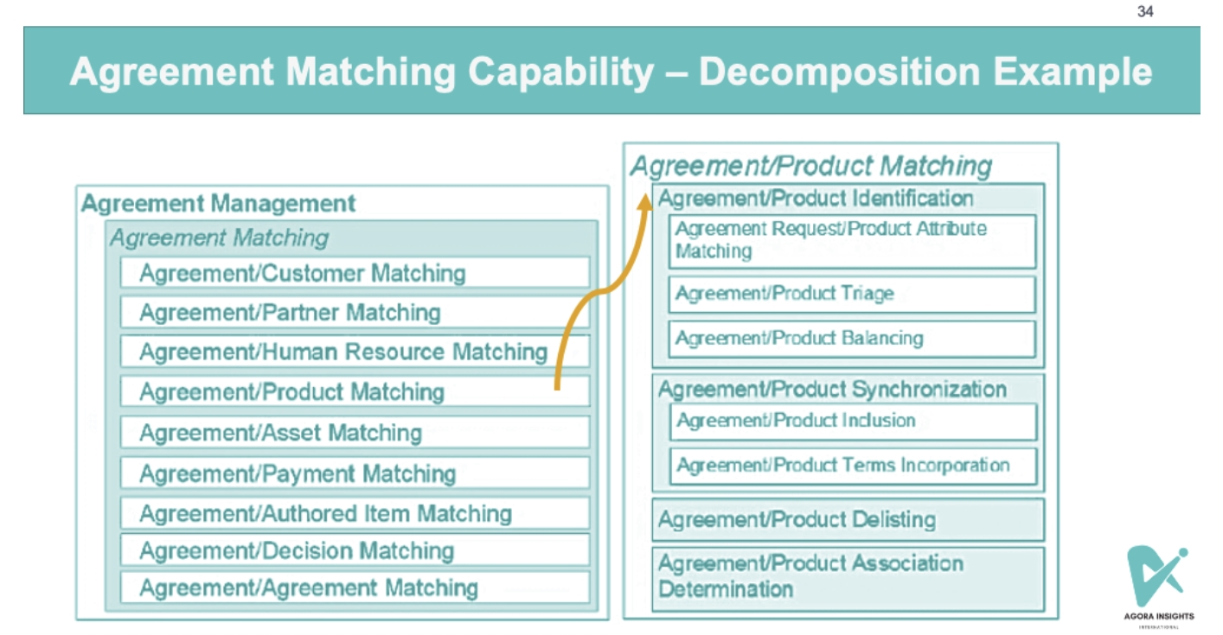

* + - * The "controlling" object (e.g. agreement) serves as the Logical Focal Point for the Match. The controlling object initiates and is listed first in Level 3 matching capability
      * The Controlling Object is Typically the More Volatile Object.

volatile: happens more frequently

e.g. where a single customer may have many agreements over time, the agreement is the controlling object, so the match is made via an Agreement/Customer Matching capability.

* + - * Matching Capabilities should not be Duplicated within a Capability Map when another controlling object has established the association.

e.g. If Agreement Matching has a capability for Agreement/Product Matching, there is no need for Product Matching to have a capability for Product/Agreement Matching.

* + - * Parent/Child Object Matching is not Required because objects defined in Child Capabilities are already associated with the Parent through Decomposition.

e.g. when Agreement Order Management is defined as a Level 2 capability under Agreement Management, there is no need to match Order to Agreement.

* + - * Object Matching within a Level 1 is dictated (指示) by the Same Level unless where traditional Level 1 boundary scope is pushed to Level 2 Capability or Lower.
      * Three-way Matches may be Applied as well where such an association is required by a given business scenarios.
    1. Capability Definitions

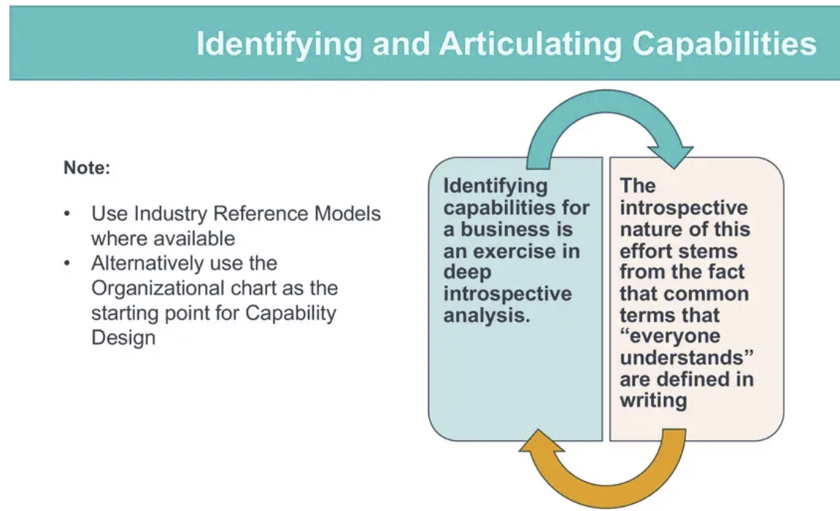

introspective: 内省的

* + - * Capability Definition Template

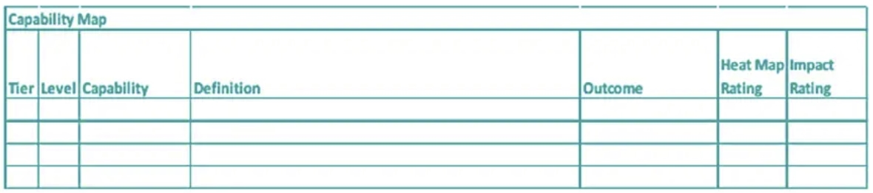

* + - * Building Capability Definitions - Guidelines
        + Define each capability using a single sentence that defines what it is but not why, when, or how it occurs
        + Do not reuse the terms used within the capability name as a part of the definition
        + Define parent capabilities before decomposing children capabilities
        + Define all capabilities prior to full rollout of the map
        + Refine and test definitions through socialization and validation cycles
      * Capabilities Grammatical Practices
        + Capability names are shown with the first level of each word in the name capitalized.

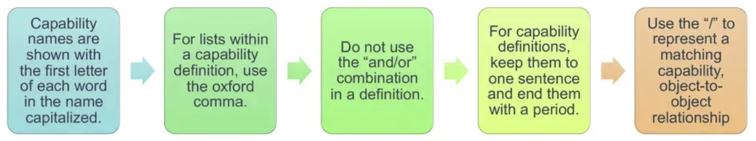

* + - * + For lists within a capability definition, use the Oxford Comma.

|  |  |
| --- | --- |
| See also | [What is the Oxford Comma (or Serial Comma)? | Grammarly](https://www.grammarly.com/blog/what-is-the-oxford-comma-and-why-do-people-care-so-much-about-it/) |

* + - * + Do not use the "and/or" combination in a definition
        + For capability definitions, keep them to one sentence and end them with a period.
        + Use the "/" (hash) to represent a matching capability, object-to-object relationship
    1. Cross-Mapping with other Blueprints
* **Capabilities** are often used to cross-map with **Value Streams** when there is a change in an organization.
* **Organizational mapping** often uses **Capability Mapping** as its foundational building block.
* **Capabilities** can be used to cross-map with **Business Units** to ensure that no operational impact is had.
  + - * Capability/Organization Mapping

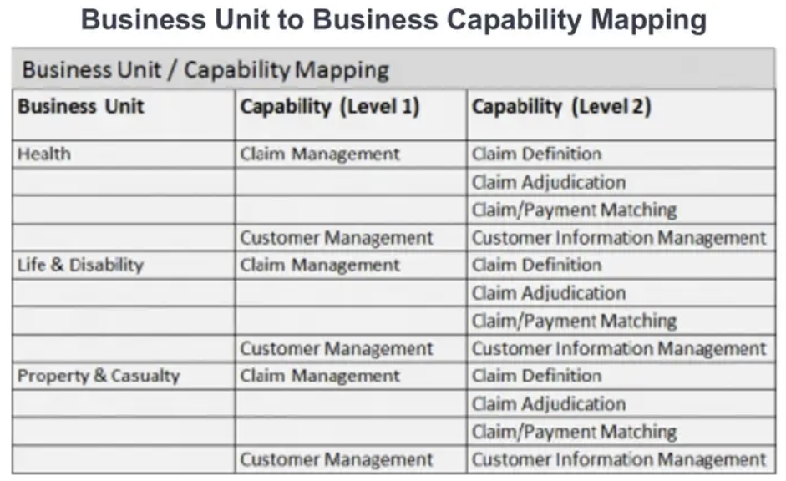

* + - * Value Stream / Capability Cross-Mapping Blueprint

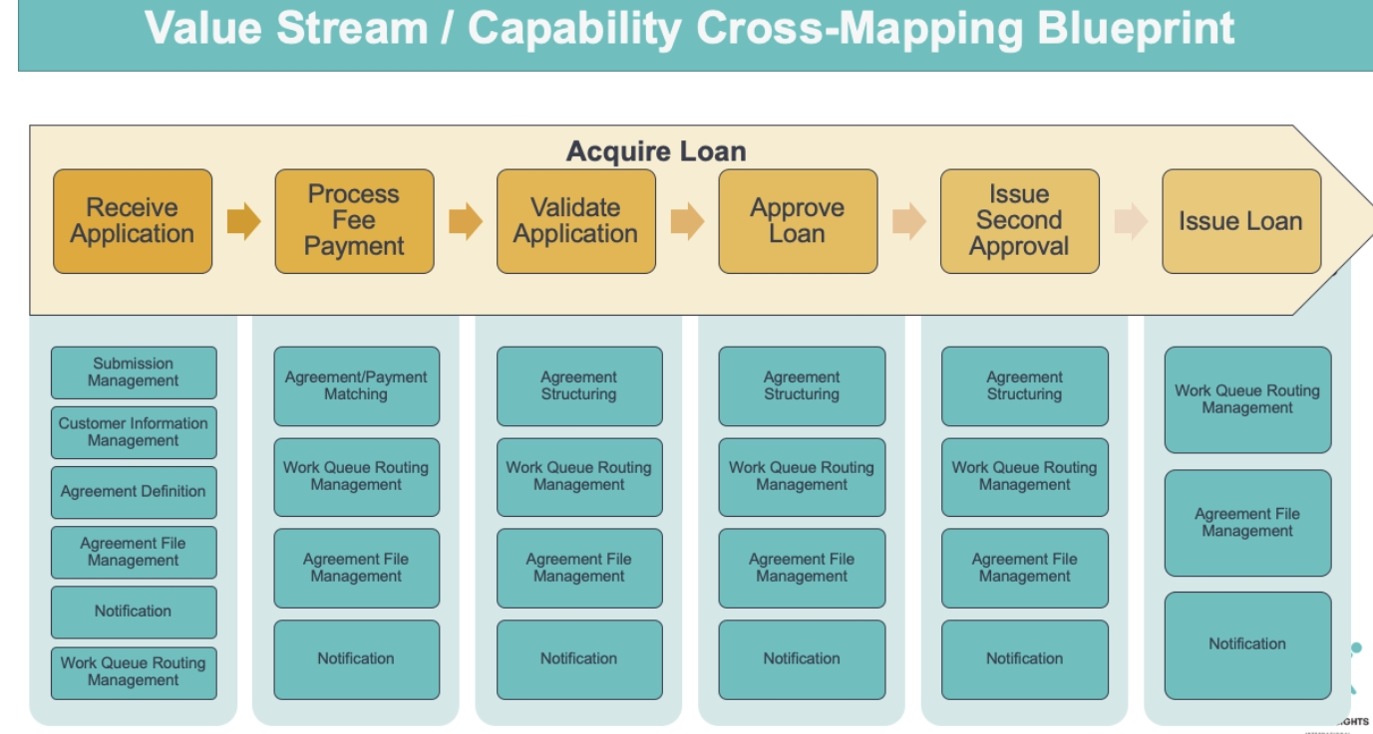

* + 1. Capability Heat Mapping

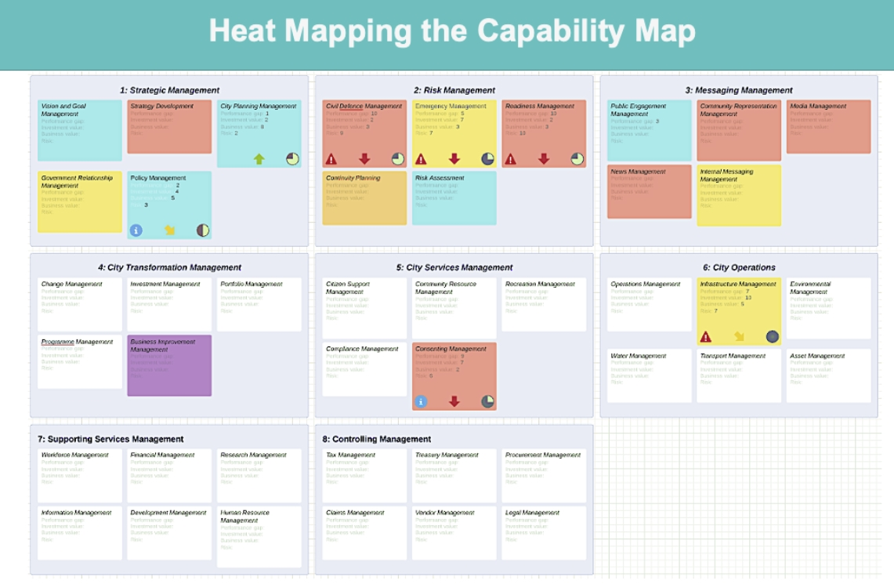

* Capabilities not yet evaluate do not have a colour associated to it
* New/Proposed capabilities are represented in purple on a heat map
* Impact or criticality rating of the capability shows us how important a capability is to the business

* + - * General Heatmap

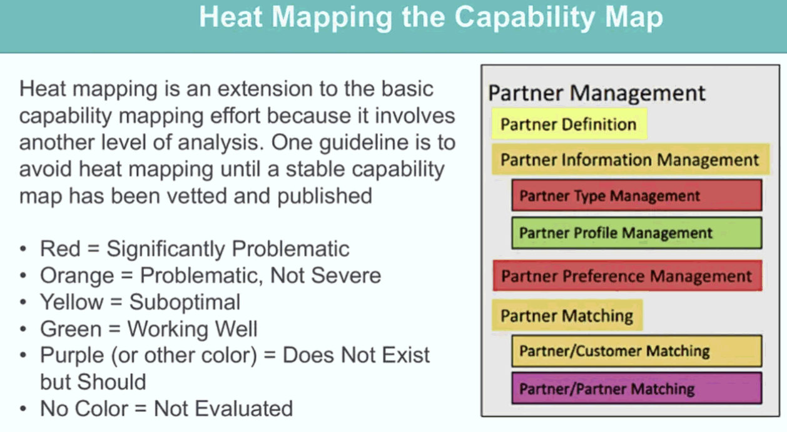

* + - * Assign Criticality Attribute to Heat Mapping

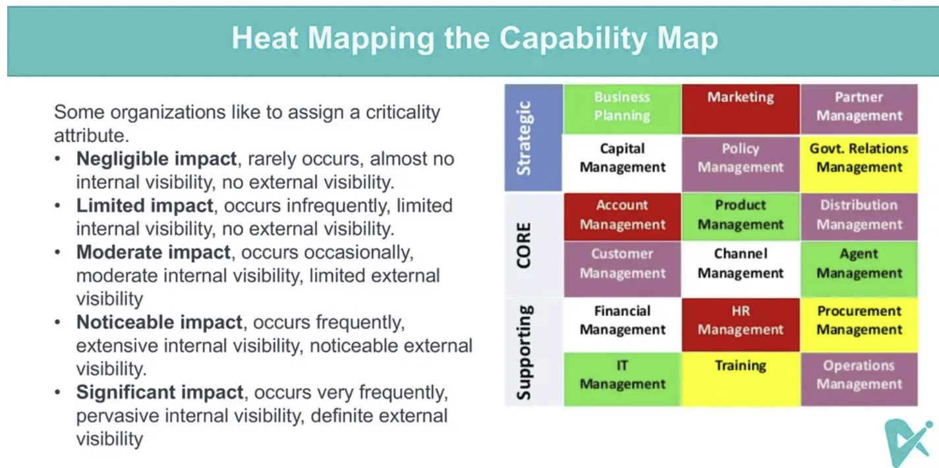

* + 1. Capabilities for change and transformation
    2. Organizing the Capability Mapping Team
    3. Delivering the Capability Map
    4. Defining Capability within the Knowledge Base
  1. Organization Mapping

|  |  |
| --- | --- |
| Relationship | points to Strategy and Organization Structure |

Mapping organizational structures into the business architecture and covers business unit mapping and inclusion of various stakeholders into the business architecture.

* 1. Value Mapping

|  |  |
| --- | --- |
| Relationship | points to Stakeholder Mapping |
| Relationship | points to Linking Objectives to Capability and Value Perspective |

Outlines the definition, benefits, development, and detailed value stream mapping approaches and their use in context of business planning, transformation, and related initiatives.

* 1. Information Mapping

|  |  |
| --- | --- |
| Relationship | begins at Capability Mapping |

Provides a business perspective of information and its role in business architecture and delivering business value.

* 1. Initiative Mapping

The approaches for visualizing business initiatives within the context of business architecture, including viewing initiatives in light of the impact on capabilities, value streams, and delivering business objectives.

* + 1. Definition: An Initiative is A Course of Action that is being executed or has been selected for execution.
  1. Product Mapping

Maps a business' products and cross-maps them to other business architecture domains, including the capabilities that enable those products.

* 1. Stakeholder Mapping

|  |  |
| --- | --- |
| Relationship | begins at Value Mapping |

Identifies stakeholder definition, business criticality, role in business planning and value determination, and formal mapping to value streams.

* + 1. Stakeholder: an internal or external individual or organization with a vested interest in achieving value through a particular outcome.
    2. Stakeholder v.s. Role
       - Role is non-architectural concept
       - Stakeholders may be reflected as certain roles within the context of related disciplines such as business design and business process management.
       - The Role concept typically incorporates a broad set of more granular categories that change frequently, while Stakeholder is defined as a higher level, is less volatile, and evolves to be used in more strategic or deliberate ways.
    3. Sample Stakeholders
       - Customer, Constituent, Patient, Member, Client
       - Partner, Supplier, Agent, Distributor, Reseller, Vendor
       - Sales Person, Technical Support, Underwriter, Claims Agent, Help Desk Personnel
       - Legal Representative, Contract Officer, Network Manager
       - Pilot, Engineer, Shift Supervisor, Gate Agent, Security Guard, Compliance Officer
       - Regulator, Auditor, Tax Authority
       - Competitor
    4. Purpose of Stakeholder Mapping
       - Central Goal: to further the understanding and improvement of the business based on various business scenarios associated with value-seeking stakeholders as well as those stakeholders who contribute to value delivery.
       - Provides an overview as well as a detailed understanding as to how the business delivers values to customers, partners, and other 3rd party.
       - Offers insight into the stakeholders who are critical to the business' bottom line.
       - Delivers a deeper perspective into the importance of value streams, and, in turn, capabilities and related business concepts.
    5. Benefits of Stakeholder Mapping
       - Provides a context for determining how to achieve and deliver customer value
       - Identifies 3rd-party partners, suppliers, agents, and related stakeholders within the context of stakeholder value delivery
       - Offers a perspective on how to organize various value streams based on the stakeholders benefiting from those value streams.
       - Highlights stakeholder commonalities across business units and 3rd parties as a basis for centralizing analysis and streamline investments in how those stakeholders receive and contribute to business value propositions
       - Establishes a context for externalized resource enablement for certain capabilities
       - Provides a basis for identifying the role of stakeholders that participate in various value stream stages
       - Highlights specific areas of focus of various internal stakeholders and how they deliver externally and internally focused value to the business
       - Offers business executives a concrete set of stakeholder-oriented focal points as input to strategic planning work
    6. Principles of Stakeholder Mapping
       - A stakeholder is an individual or an organization that has a substantive (实质性) impact on business
       - A stakeholder can be internal or external to the enterprise
       - A stakeholder covers a variety of individual and organizational categories
       - A stakeholder is represented as an information concept within the information map
       - A stakeholder triggers and participates in value streams, either as a recipient of value or as a participant that enables value delivery.
       - A stakeholder serves as a resource to implement a capability
       - A stakeholder can be the target of a give strategy
    7. type of Stakeholder
       - Triggering Stakeholder
         * Defined as a stakeholder that initiates a value stream for purpose of achieving a stated value proposition

e.g. a customer seeking a product

e.g. a partners seeking a relationship

e.g. a manager seeking a new hire

* + - * + This is the Stakeholder who is seeking the end state value proposition
      * Participating Stakeholder
        + Defined as a role or responsibility within a value stream stage and, therefore, contributes to capabilities with outcomes that achieve the value item(s) for that stage.
        + This is the Stakeholder who contribute along the way to achieving the value preposition that initiated by "Triggering Stakeholder"
    1. Content in Stakeholder Mapping
       - Stakeholder Type
         * internal or external party
         * customers, partners, and regulatory bodies are associated with external stakeholder types
       - Stakeholder Category
         * Link with Level 1 Capabilities
       - Stakeholder
       - Stakeholder Description
    2. Stakeholder Knowledgebase Relationships
       - Stakeholder belongs to business unit, which may be a partner, provides stakeholder context, and highlights role commonalities or inconsistencies across an ecosystem
       - Stakeholder triggers value stream, highlighting where a stakeholder is seeking a value proposition or serving as a proxy for a stakeholder seeking a value proposition
       - Stakeholder participates in value stream stage highlights where any number of stakeholders contribute to the value delivered by that stage
       - Stakeholder contributes to a capability outcome, which should be viewed in context of a value stream stage where capabilities and stakeholders interest
       - Stakeholder defines an information concept, where, for concepts such as customer, partner, and human resource, this relationship aligns unique stakeholders defined in the stakeholder map with the information concept types
       - Strategy impacts a stakeholder is a relationship that is particularly useful when an organization wants to target a customer, partner, or human resource as part of a strategy
  1. Policy Mapping

Outlines approaches to organizing and aligning business policies, a critical business perspective in heavily regulated corporate sectors and government agencies.

1. Biz Arch Practice Guide
   1. Common Approaches for Getting Started
   2. Biz Arch Governance
   3. Biz Arch and Biz Models
   4. Biz Arch and Biz Process Modeling and Mgmt
   5. Biz Archi and Case Mgmt
   6. Biz Arch and Lean Six Sigma
   7. Biz Arch and Biz Performance Mgmt
   8. Biz Arch and Requirement Alignment
   9. Biz Arch Maturity Model
   10. The Role of the Biz Architect
   11. Biz Arch and Strategy Execution
   12. Biz Arch and Operating Models
   13. Biz Arch and Customer Experience Design
2. Biz Arch Scenarios
3. Biz Arch Infra Mgmt
   1. The Biz Arch Knowledgebase
   2. Biz Arch Tooling Options
4. Biz Arch and IT Arch Alignment (BITA)
   1. Biz Arch and IT Arch Alignment Overview
   2. Biz Arch and EA Framework Alignment
   3. Biz Arch and System Development Lifecycle (SDLC)
   4. Biz Arch and Application Portfolio Mgmt
   5. Biz Arch and SOA Alignment
   6. Biz Information and Data Arch Alignment
   7. Biz Arch and Solution Arch
   8. Biz Arch and IT Arch Transformation
5. Biz Arch Case Studies
6. Industry Ref Models
   1. Financial Services Industry Ref Model
   2. Manufacturing Industry Ref Model
   3. Healthcare Industry Ref Model
   4. Member-Based Association Industry Ref Model
   5. Insurance Industry Ref Model
   6. Common Ref Model
   7. Transportation Industry Ref Model
   8. Government Industry Ref Model
7. Appendices