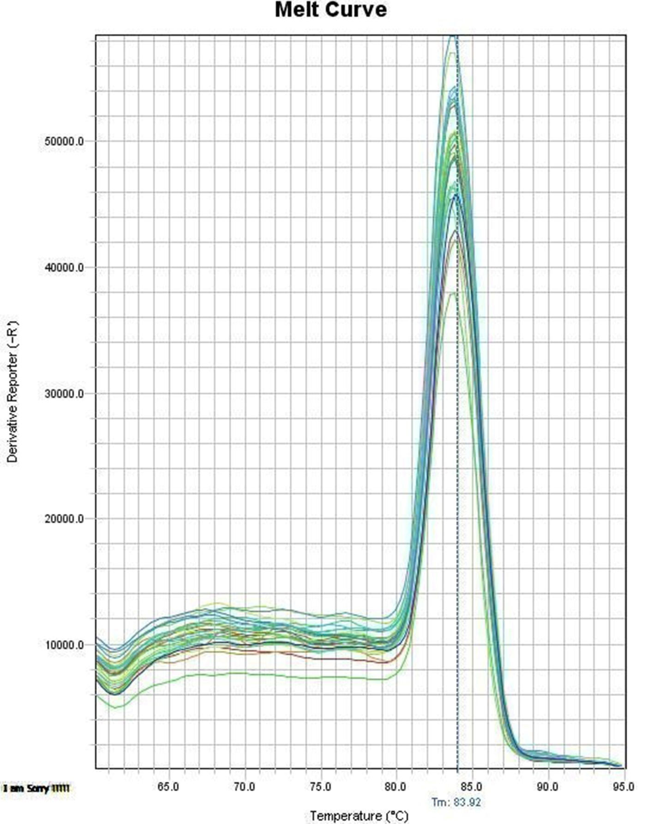

A

B

C

D

**Fig. S1:** shows the melting curve of A: SIRT1, B: Smad3, C: miRNA-141, D: TGF-β

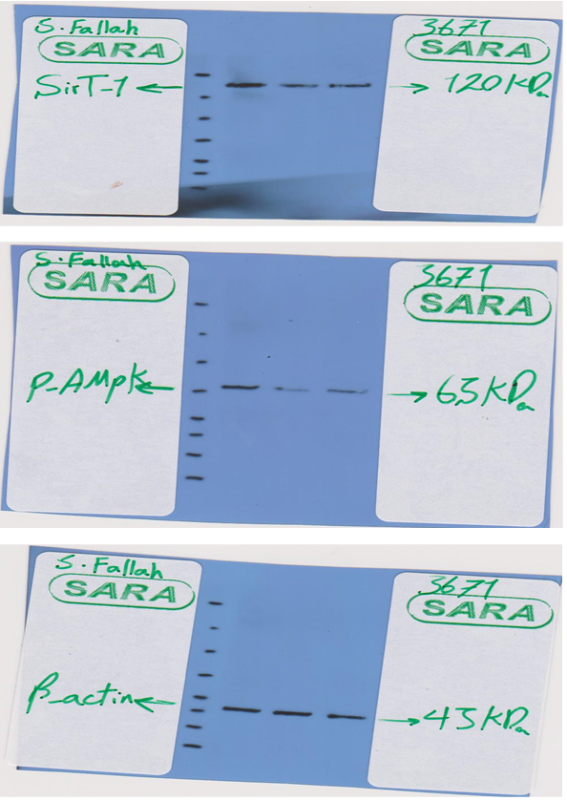

**Fig. S2:** Represents images of major Western blot bands.