Title

Multi-Subject Analysis of Hair Cycle Dynamics: A Subcompartmentalized SIR-Based ODE Modeling

Contributors:
- Liladhar Paudel
- Yoseph Asfaw

Objectives

1. Quantitative Analysis of Multi-Subject Follicle Dynamics
- Baseline Trends: Establish fundamental population trends for multiple subjects by analyzing mean follicle counts across Anagen (A), Catagen (C), and Telogen (T) phases, utilizing a simulated population of 10,000 follicles.
- Standardization: Normalize raw data into proportional distributions to allow for consistent comparison of cycle dynamics across subjects with varying hair densities ($N$).

2. Implementation of Subcompartmentalized ODE Models
- Advanced Framework: Develop and implement a Subcompartment ODE model to move beyond standard linear transitions.
- Stochastic Realism: Capture the "non-exponential" nature of hair phase durations, ensuring follicles remain in a phase for a biologically realistic duration.
- Optimization: Identify subject-specific transition rates ($α,β,γ$) using non-linear least squares regression.

3. Model Validation and Residual Diagnostics
- Visual Verification: Evaluate the accuracy of subcompartment fits using comparative phase plots and multi-subject grid visualizations.
- Error Analysis: Utilize Residual Scatter/Line plots and Autocorrelation (ACF) analysis to ensure the model captures transient dynamics without systematic bias.

4. Predictive Simulation of Biological Perturbations
- Inhibition Modeling: Simulate hormonal or clinical inhibition by analyzing the effect of reducing transition rates, such as Alpha (A→C) and Gamma (T→A).
- Activation Modeling: Simulate biochemical treatment effects by increasing transition rates, such as Beta (C→T), to model accelerated phase recycling and recovery.

Body of the Investigation
import base64
from IPython.display import HTML, display
import numpy as np
import matplotlib.pyplot as plt
from scipy.integrate import solve_ivp
from scipy.optimize import least_squares
from tabulate import tabulate
from statsmodels.stats.diagnostic import het_arch
from statsmodels.graphics.tsaplots import plot_acf
def draw_mermaid_centered(graph_code):
graphbytes = graph_code.encode("ascii")
base64_string = base64.b64encode(graphbytes).decode("ascii")
url = "https://mermaid.ink/img/" + base64_string
# Use the legacy <center> tag which Jupyter usually respects
display(HTML(f'<center><img src="{url}"></center>'))
def print_styled(text, color="black"):
# Centers, bolds, and colors the text in one line
display(HTML(f'<div style="text-align:center; color:{color}; font-weight:bold; font-size:14px;">{text}</div>'))
my_graph = """
graph TD
A((A)) --> C((C))
C --> T((T))
T --> A
"""
draw_mermaid_centered(my_graph)
print_styled("A State Machine Representation of the Human Hair Follicular Transition")
# # --- Saving Mermaid graph ---
# import requests
# def save_mermaid_image(graph_code, filename):
# graphbytes = graph_code.encode("ascii")
# base64_string = base64.b64encode(graphbytes).decode("ascii")
# url = "https://mermaid.ink/img/" + base64_string
# response = requests.get(url)
# if response.status_code == 200:
# with open(filename, 'wb') as f:
# f.write(response.content)
# print(f"Saved Mermaid diagram to {filename}")
# # Call this before or after your Matplotlib logic
# F1 = "."
# save_mermaid_image(my_graph, f"{F1}/01a_hair_cycle_diagram_TD.png")
<IPython.core.display.HTML object>
<IPython.core.display.HTML object>
'\n# --- Saving Mermaid graph ---\nimport requests\n\ndef save_mermaid_image(graph_code, filename):\n graphbytes = graph_code.encode("ascii")\n base64_string = base64.b64encode(graphbytes).decode("ascii")\n url = "https://mermaid.ink/img/" + base64_string\n \n response = requests.get(url)\n if response.status_code == 200:\n with open(filename, \'wb\') as f:\n f.write(response.content)\n print(f"Saved Mermaid diagram to {filename}")\n\n# Call this before or after your Matplotlib logic\nF1 = "."\nsave_mermaid_image(my_graph, f"{F1}/01a_hair_cycle_diagram_TD.png")\n\n'

Extended SIR model for the follicle life cycle
The graph above is a state machine representation of the life cycle of a follicle where:
- A Anagen is a growing state
- C Catagen is a transition stage
- T Talogen is a resting state
We propose SIR-like modeling:
$$\frac{dA}{dt}=k_{wake}(\frac{w_{nt}^{n}}{w_{nt}^{n}+k_{wnt}^{n}})T−A(β_{base}+β_{max}(\frac{FGF5^{n}}{FGF5^{n}+K_{FGF5}^{n}}.\frac{DHT^{m}}{DHT^{m}+K_{DHT}^{m}}))$$
$$\frac{dC}{dt}=A(β_{base}+β_{max}(\frac{FGF5^{n}}{FGF5^{n}+K_{FGF5}^{n}}.\frac{DHT^{m}}{DHT^{m}+K_{DHT}^{m}}))−γC$$
$$\frac{dT}{dt}=γC−k_{wake}(\frac{w_{nt}^{n}}{w_{nt}^{n}+k_{wnt}^{n}})T$$
where:
- $k_{wake}$ is the maximum fraction of T that converts to A at a time
- $w_{nt}$ is a protein signaling awakening of follicles (converting from Talogen to Anagen)
- FGF5 is a protein that signals the transition from Anagen to Catagen. It is a growth inhibitor.
- DHT is a hormone that accelerates the FGF5 effect.
- $γ$ is the C to T conversion rate. It solely depends on the biological clock, not on hormones or proteins.
Treatments like minoxidal lowers the $k_{wnt}$ and Finosteride reduces DHT
Parameter variations:
- $K_{FGF5}$ and $K_{DHT}$ vary from person to person as they have strong genetic dependency
- DHT varies depending on age and health condition. More DHT at older ages.
- FGF5 and $W_{nt}$ can be assumed among people as they are produced at the same rate and quantity.
- $K_{wnt}$ also depends on genetics but can be assumed constant for people of similar age and health condition.

Nonlinear regression to determine the parameters in the extended-SIR model.
There are no publicly available clinical datasets on hair loss or hair treatment that are directly relevant to this project. In particular, longitudinal measurements—such as follicle counts in the anagen (A) and telogen (T) phases, average follicle diameter, and related metrics—would be highly valuable. Such data could be used in a regression framework to estimate the parameters of an SIR-type model describing follicle state dynamics.
In the absence of suitable public datasets, we relied on Halloy et al. to generate synthetic data. Their work models the transition times between follicle states using log-normal distributions parameterized by experimentally derived values. Building on this framework, we conducted an agent-based simulation to produce longitudinal data, specifically tracking the number of follicles in the anagen (A), catagen (C), and telogen (T) states over time. We then fit the extended SIR model to the mean trajectories obtained by averaging across multiple simulation runs.
The duration of each follicular phase is modeled using a log-normal distribution:
$$f(x; μ,σ)=\frac{1}{x σ\sqrt{2π}}exp​\left(−\frac{(logx−μ)^{2}}{2σ^{2}}\right), x>0$$
The mean ($m$) and variance ($v$) of these durations are derived from experimental data. Using the moment-generating function, the parameters for the log-normal distribution are calculated as:
$$σ_{log}^{2}=ln​\left(1+\frac{v}{m^{2}}\right)$$
$$μ_{log}=ln(m)−\frac{1}{2}σ_{log}^{2}$$

I. Generate Synthetic Data
#---------------------------------------------------------
# 1. Log-normal duration sampler
# (Phase durations drawn from empirical distributions)
#---------------------------------------------------------
def sample_duration(mu, sigma):
"""Sample a phase duration from the log-normal distribution in Eq. (1)."""
return np.random.lognormal(mean=mu, sigma=sigma)
#---------------------------------------------------------
# 2. Probability of transition into pathological state M
# (Slowly increasing probability as cycles accumulate)
#---------------------------------------------------------
def p_to_M(cycles):
"""Slowly increasing probability of transitioning to M."""
return min(0.01 * (1 + 0.1 * cycles), 0.2)
#---------------------------------------------------------
# 3. Baseline follicle-cycle structure (A → C → T → A)
#---------------------------------------------------------
next_phase = {
"A": "C",
"C": "T",
"T": "A"
}
#-----------------------------------------------------------
# 4. Phase-duration parameters for A, T, L, and optional M
#-----------------------------------------------------------
def convert_to_lognormal_params(mean, variance):
sigma2_log = np.log(1 + variance / (mean**2))
sigma_log = np.sqrt(sigma2_log)
mu_log = np.log(mean) - 0.5 * sigma2_log
return mu_log, sigma_log
#---------------------------------------------------------
# 5. Phase-transition rule
# (Normal cycling or optional transition into M)
#---------------------------------------------------------
def choose_next_phase(phase, cycles, include_M=False):
"""
Determine the next phase in the follicle cycle.
If include_M=True, allow a slow-probability transition to M.
"""
# If follicle is already in M, it stays there
if phase == "M":
return "M"
# Normal cycle transitions
next_phase_map = {"A": "C", "C": "T", "T": "A"}
# If M transitions are disabled
if not include_M:
return next_phase_map[phase]
# Otherwise include slow probability to M
pM = p_to_M(cycles)
if np.random.rand() < pM:
return "M"
else:
return next_phase_map[phase]
#---------------------------------------------------------
# 6. Simulate a single follicle over T_end months
#---------------------------------------------------------
def simulate_follicle(T_end, initial_phase, include_M=False):
phase = initial_phase
cycles = 0
time_to_transition = sample_duration(*phase_params[phase])
phases = []
cycle_counts = []
for t in range(T_end):
# If already in M, stay in M
if phase == "M":
phases.append("M")
cycle_counts.append(cycles)
continue
phases.append(phase)
cycle_counts.append(cycles)
time_to_transition -= 1
if time_to_transition <= 0:
# Use the new choice function
phase = choose_next_phase(phase, cycles, include_M=include_M)
# If moved to M, no new duration needed
if phase == "M":
continue
# Otherwise sample new duration
time_to_transition = sample_duration(*phase_params[phase])
# Count cycles when entering A
if phase == "A":
cycles += 1
return phases, cycle_counts
#---------------------------------------------------------
# 7. Simulate a population of independent follicles
#---------------------------------------------------------
def simulate_population(N_follicles, T_end, initial_phase, include_M=False, cooling=3):
all_phases = []
all_cycles = []
for i in range(N_follicles):
phases, cycles = simulate_follicle(T_end, initial_phase, include_M=include_M)
all_phases.append(phases)
all_cycles.append(cycles)
# Convert both to numpy arrays for easier slicing/math
return np.array(all_phases), np.array(all_cycles)
#---------------------------------------------------------
# 8. Population-level statistics at a given time t
#---------------------------------------------------------
def population_statistics(all_phases, all_cycles, t=None):
"""
Compute counts for A, C, and T.
Include M only if it exists in the data.
"""
# Slice the data based on whether a specific time t is provided
if t is not None:
target_data = all_phases[:, t]
axis = None # Summing a 1D slice
else:
target_data = all_phases
axis = 0 # Summing across follicles for each time step
# Standard phases
stats = {
"A": np.sum(target_data == "A", axis=axis),
"C": np.sum(target_data == "C", axis=axis),
"T": np.sum(target_data == "T", axis=axis),
}
# Add M only if it is present in the data
if np.any(target_data == "M"):
stats["M"] = np.sum(target_data == "M", axis=axis)
return stats
#---------------------------------------------------------
# 9. Paired simulations: with-M vs without-M transitions
#---------------------------------------------------------
def run_two_simulations(N, T_end):
# With M transitions
phases_M, cycles_M = simulate_population(N, T_end, include_M=True, cooling =3)
# Without M transitions
phases_noM, cycles_noM = simulate_population(N, T_end, include_M=False, cooling =3)
return (phases_M, cycles_M), (phases_noM, cycles_noM)
#---------------------------------------------------------
# 10. Multi-Subject Population Simulation
#---------------------------------------------------------
def run_subject_populations(params, N=1000, T_end=200, n_simulation=25, include_M=False):
global phase_params
phase_params = params
A, C, T, M = [], [], [], []
for i in range(n_simulation):
rnd = np.random.rand()
if rnd < 0.50:
initial_phase = 'A'
elif rnd < 0.80:
initial_phase = 'T'
else:
initial_phase = 'C'
# Pass include_M into the simulation
all_phases, all_cycles = simulate_population(N, T_end, initial_phase=initial_phase, include_M=include_M)
data = population_statistics(all_phases, all_cycles)
A.append(data['A'])
C.append(data['C'])
T.append(data['T'])
if 'M' in data:
M.append(data['M'])
# Conditional return
if include_M and len(M) > 0:
return np.array(A), np.array(C), np.array(T), np.array(M)
else:
return np.array(A), np.array(C), np.array(T)
#----------------------------------------------------------
# 11. Generate follicle-cycle Data for baseline structure
# (A → C → T → A)
#----------------------------------------------------------
mu_M = 3.0 # example mean duration of M
var_M = 2.0 # example variance of M
# Subject 1:
phase_params1 = {
"A": convert_to_lognormal_params(16.91, 19.49**2),
"C": convert_to_lognormal_params(1.79, 0.82**2),
"T": convert_to_lognormal_params(5.23, 5.18**2),
}
# Subject 2:
phase_params2 = {
"A": convert_to_lognormal_params(5.16, 4.50**2),
"C": convert_to_lognormal_params(2.09, 1.06**2),
"T": convert_to_lognormal_params(3.53, 5.43**2),
}
# Subject 3
phase_params3 = {
"A": convert_to_lognormal_params(6.49, 10.16**2),
"C": convert_to_lognormal_params(2.17, 1.11**2),
"T": convert_to_lognormal_params(4.56, 9.57**2),
}
N_value = 10_000
T_end_value=200
n_sim_value=25
# Running simulation for subjects 1 & 2 only:
A1, C1, T1 = run_subject_populations(phase_params1, N=N_value, T_end=T_end_value, n_simulation=n_sim_value)
A2, C2, T2 = run_subject_populations(phase_params2, N=N_value, T_end=T_end_value, n_simulation=n_sim_value)
#-------------------------------------------------------
# Plotting follicle-cycle Data for baseline structure
#-------------------------------------------------------
colors = ['#1f77b4', '#d62728', '#000000'] # Blue (A), Red (C), Black (T)
labels = ['Anagen (A)', 'Catagen (C)', 'Telogen (T)']
fig, axes = plt.subplots(1, 2, figsize=(15, 6))
plot_setup = [
{"name": "Subject 1", "data": [A1, C1, T1], "ax": axes[0]},
{"name": "Subject 2", "data": [A2, C2, T2], "ax": axes[1]}
]
for setup in plot_setup:
ax = setup["ax"]
# A, C, T are shape (25, 200)
A_mean = np.mean(setup["data"][0], axis=0)
C_mean = np.mean(setup["data"][1], axis=0)
T_mean = np.mean(setup["data"][2], axis=0)
means = [A_mean, C_mean, T_mean]
for i in range(3):
ax.plot(range(T_end_value), means[i], color=colors[i], label=labels[i], linewidth=2.5)
# Formatting
ax.set_title(f"{setup['name']}: Population Dynamics", fontweight='bold')
ax.set_xlabel('Time (Months)')
ax.set_ylabel('Follicle Count')
ax.set_ylim(0, N_value + 50) # Set limit based on N
ax.legend(loc='upper right')
ax.grid(alpha=0.3)
plt.tight_layout()
plt.show()
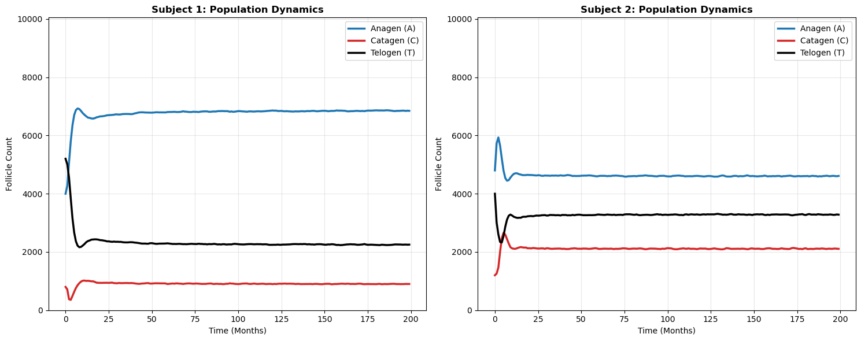
#--------------------------------------------------------------------
# Generate follicle-cycle Data with Pathological state (M) included
#--------------------------------------------------------------------
# This code never runs
if False:
# Define New Dictionaries for M-simulations
phase_params1_M = phase_params1.copy()
phase_params1_M["M"] = convert_to_lognormal_params(mu_M, var_M**2)
phase_params2_M = phase_params2.copy()
phase_params2_M["M"] = convert_to_lognormal_params(mu_M, var_M**2)
phase_params3_M = phase_params3.copy()
phase_params3_M["M"] = convert_to_lognormal_params(mu_M, var_M**2)
# Run with 4 return variables
A1_M, C1_M, T1_M, M1 = run_subject_populations(phase_params1_M, N=1000, include_M=True)
A2_M, C2_M, T2_M, M2 = run_subject_populations(phase_params2_M, N=1000, include_M=True)
A3_M, C3_M, T3_M, M3 = run_subject_populations(phase_params3_M, N=1000, include_M=True)

II. Normalize and Apply Nonlinear Regression
Normalized ODEs:
$$\frac{dA}{dt}=k_{wake}(\frac{w_{nt}^{n}}{w_{nt}^{n}+k_{wnt}^{n}})T−A(β_{base}+β_{max}(\frac{FGF5^{n}}{FGF5^{n}+K_{FGF5}^{n}}.\frac{DHT^{m}}{DHT^{m}+K_{DHT}^{m}}))$$
$$\frac{dC}{dt}=A(β_{base}+β_{max}(\frac{FGF5^{n}}{FGF5^{n}+K_{FGF5}^{n}}.\frac{DHT^{m}}{DHT^{m}+K_{DHT}^{m}}))−γC$$
$$\frac{dT}{dt}=γC−k_{wake}(\frac{w_{nt}^{n}}{w_{nt}^{n}+k_{wnt}^{n}})T$$
Define:
- N = A + T + C
- a = $\frac{A}{N}$
- c = $\frac{C}{N}$
- r = $\frac{T}{N}$
- $α$ = $k_{wake}(\frac{w_{nt}^{n}}{w_{nt}^{n}+k_{wnt}^{n}})$
- $β$ = $(\beta_{base} + \beta_{max}(\frac{FGF5^n}{FGF5^n + K_{FGF5}^n}.\frac{DHT^m}{DHT^m + K_{DHT}^m} )) $
The equation simplifies to:
$$\frac{da}{dt}=αr−βa$$
$$\frac{dc}{dt}=βa−γc$$
$$\frac{dr}{dt}=γc−αr$$
# ---------------------------------------------------
# Normalizing Subject Follicle Data (baseline cycle)
# ---------------------------------------------------
# Assemble subject data together
subjects_data = [
{"name": "Subject 1", "data": [A1, C1, T1]},
{"name": "Subject 2", "data": [A2, C2, T2]},
# Add Subject 3 here if you ran it: {"name": "Subject 3", "data": [A3, C3, T3]}
]
# Process and Normalize data for each subject
t_data = np.arange(T_end_value)
results = {}
for sub in subjects_data:
# sub["data"] => [A, C, T] => along (axis=1)
# then transpose and divide by N to get proportions (0 to 1)
avg_counts = np.mean(sub["data"], axis=1).T
norm_data = avg_counts / N_value # N = N_value
results[sub["name"]] = {
"norm_data": norm_data,
"x0": norm_data[0] # Initial proportions for solve_ivp
}
# Check shape of normalized data
print(f"Shape for Subject 1: {results['Subject 1']['norm_data'].shape}")
print(f"Shape for Subject 2: {results['Subject 2']['norm_data'].shape}")
Shape for Subject 1: (200, 3)
Shape for Subject 2: (200, 3)
# -------------------------------------------------------------------
# Comparative Analysis of Subject Follicle Dynamics (baseline cycle)
# -------------------------------------------------------------------
# Create subplots
fig, axes = plt.subplots(1, 2, figsize=(15, 6))
labels = ['Anagen (a)', 'Catagen (c)', 'Telogen (r)']
colors = ['teal', 'orange', 'salmon']
# Plot Subject 1 (Left)
for i in range(3):
axes[0].plot(results['Subject 1']['norm_data'][:, i], label=labels[i], color=colors[i])
axes[0].set_title('Subject 1: Population Proportions (Simulated)', fontweight='bold')
axes[0].set_xlabel('Time (Months)')
axes[0].set_ylabel('Proportion of Follicles')
axes[0].set_ylim(0, 1)
axes[0].legend()
axes[0].grid(alpha=0.3)
# Plot Subject 2 (Right)
for i in range(3):
axes[1].plot(results['Subject 2']['norm_data'][:, i], label=labels[i], color=colors[i])
axes[1].set_title('Subject 2: Population Proportions (Simulated)', fontweight='bold')
axes[1].set_xlabel('Time (Months)')
axes[1].set_ylabel('Proportion of Follicles')
axes[1].set_ylim(0, 1)
axes[1].legend()
axes[1].grid(alpha=0.3)
plt.tight_layout()
plt.show()
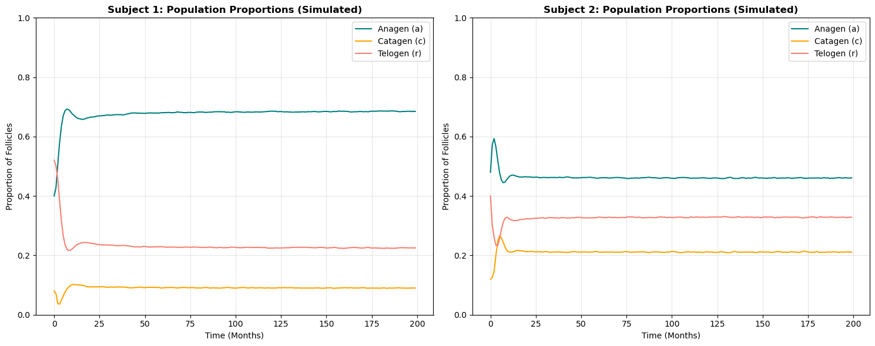
# Define variables to use in plottings below
subjects = ["Subject 1", "Subject 2"]
phase_labels = ['Phase A', 'Phase C', 'Phase T']
labels_titles = ['Phase A', 'Phase C', 'Phase T']
labels = ['A', 'C', 'T']
labels_keys = ['A', 'C', 'T']
# ----------------------------------------------------------
# Non-linear Regression of Hair Cycle Data (baseline cycle)
# Parameter Estimation & ODE Integration
# ----------------------------------------------------------
def system(t, x, alpha, beta, gamma):
a, c, r = x
da = alpha * r - beta * a
dc = beta * a - gamma * c
dr = gamma * c - alpha * r
return [da, dc, dr]
def simulate(theta, t_eval, x0):
alpha, beta, gamma = theta
sol = solve_ivp(
lambda t, x: system(t, x, alpha, beta, gamma),
(t_eval[0], t_eval[-1]),
x0,
t_eval=t_eval
)
return sol.y.T
def residuals(theta, t_eval, data, x0):
pred = simulate(theta, t_eval, x0)
return (data - pred).ravel()
# Initial guess for [alpha, beta, gamma]
theta0 = [0.1, 0.1, 0.1]
for sub_name in subjects:
# Retrieve the pre-processed normalized data and initial state
norm_data = results[sub_name]['norm_data']
x0 = results[sub_name]['x0']
# Run the nonlinear regression to find best-fit parameters
res = least_squares(
residuals, # The function name
theta0, # The first argument
args=(t_data, norm_data, x0), # The remaining arguments
bounds=(0, np.inf), # Ensures biological rates stay positive
method='trf' # Trust Region Reflective (TRF) method of optimization
)
# Store full object, optimized parameters and the fitted simulations
results[sub_name]['res_object'] = res
results[sub_name]['params'] = res.x
results[sub_name]['Y_hat'] = simulate(res.x, t_data, x0)
print(f"Finished fitting {sub_name}. Params: {res.x}")
Finished fitting Subject 1. Params: [0.23642475 0.07894899 0.59080753]
Finished fitting Subject 2. Params: [0.31756458 0.22377499 0.48626187]
#----------------------------------------------------
# ODE fit plots for Hair Cycle Data (baseline cycle)
#----------------------------------------------------
colors = ['#1f77b4', '#d62728', '#000000'] # Blue (A/a), Red (C/c), Green (T/r)
fig, axes = plt.subplots(1, 2, figsize=(15, 6))
for idx, sub_name in enumerate(subjects):
ax = axes[idx]
# Extract the fitted ODE data only
fitted = results[sub_name]['Y_hat']
for i in range(3):
# Plot the fitted ODE
ax.plot(t_data, fitted[:, i], color=colors[i], label=labels[i], linewidth=3)
# Formatting
ax.set_title(f'{sub_name}: Population Proportions (ODE fit)', fontsize=14, fontweight='bold')
ax.set_xlabel('Time (Months)', fontsize=12)
ax.set_ylabel('Proportion of Follicles', fontsize=12)
# Consistent scale
ax.set_ylim(-0.02, 1.02)
ax.legend(loc='upper right', frameon=True)
ax.grid(True, alpha=0.3, linestyle='--')
plt.tight_layout()
plt.show()
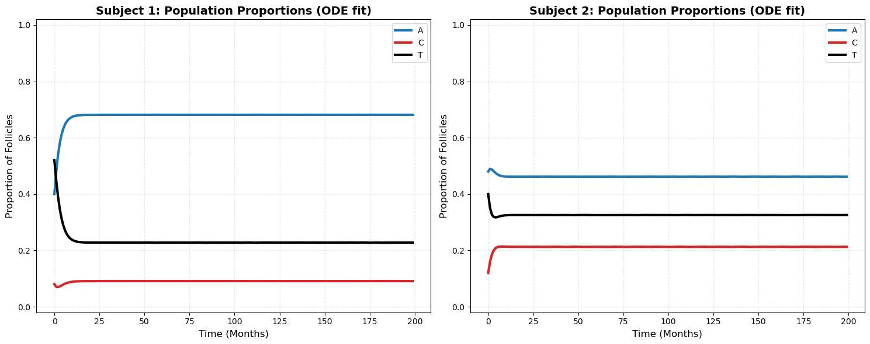
#------------------------------------------------------------------------------
# Hair Cycle Model: Parameter Estimation and Validation Plots (baseline cycle)
#------------------------------------------------------------------------------
colors = ['#0072B2', '#D55E00', '#009E73'] # Blue (A/a), Orange (C/c), Green (T/r)
fig, axes = plt.subplots(1, 2, figsize=(15, 6))
for idx, sub_name in enumerate(subjects):
ax = axes[idx]
orig = results[sub_name]['norm_data'] # Simulated data
fitted = results[sub_name]['Y_hat'] # ODE Fit
for i in range(3):
# Simulated Data (Dashed Line)
ax.plot(t_data, orig[:, i], color=colors[i], linestyle='--', linewidth=1.5, alpha=0.9)
# ODE Fitted Results (Solid Line)
ax.plot(t_data, fitted[:, i], color=colors[i], label=labels[i], linewidth=3)
# Formatting
ax.set_title(f'{sub_name}: Simulation vs. ODE Fit', fontsize=14, fontweight='bold')
ax.set_xlabel('Time (Months)', fontsize=12)
ax.set_ylabel('Proportion of Follicles', fontsize=12)
ax.set_ylim(-0.02, 1.02)
ax.legend(loc='upper right', framealpha=1)
ax.grid(True, linestyle=':', alpha=0.5)
plt.tight_layout()
plt.show()
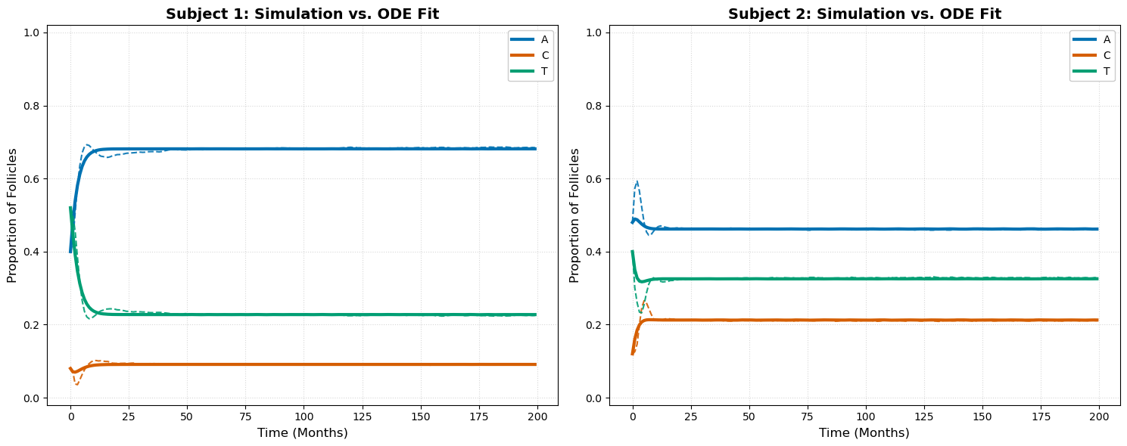
#---------------------------------------------------------------------------
# Fitting ODE Models to Simulated Hair Cycle Data (baseline cycle dynamics)
#---------------------------------------------------------------------------
fig, axs = plt.subplots(2, 3, figsize=(12, 7.5))
for row, sub_name in enumerate(subjects):
orig = results[sub_name]['norm_data']
fitted = results[sub_name]['Y_hat']
for col in range(3):
ax = axs[row, col]
# Plotting
l1, = ax.plot(t_data, orig[:, col] * N_value, '-', color='black', alpha=0.9, label='Data')
l2, = ax.plot(t_data, fitted[:, col] * N_value, '--', color='red', linewidth=2, label='Fit')
ax.set_title(f"{sub_name}: {labels[col]}", fontsize=10, fontweight='bold', pad=10)
ax.set_xlabel('Time', fontsize=9)
ax.set_ylabel('Count', fontsize=9)
ax.grid(alpha=0.2)
# Placement of legend
fig.legend(handles=[l1, l2],
loc='center',
bbox_to_anchor=(0.5, 0.5),
ncol=2,
frameon=True,
facecolor='white',
edgecolor='none')
# Tighten the layout
plt.tight_layout()
plt.subplots_adjust(hspace=0.6)
plt.show()
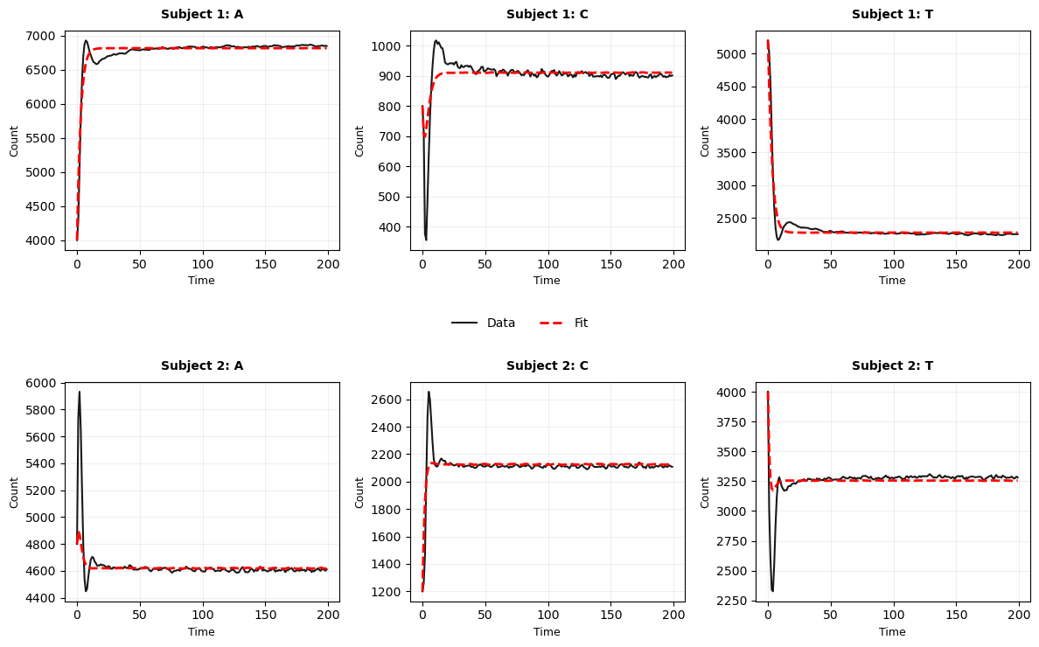
#-----------------------------------------
# Compute RMSE (baseline cycle dynamics)
#-----------------------------------------
rmse_table = []
for sub_name in subjects:
data = results[sub_name]['norm_data']
pred = results[sub_name]['Y_hat']
res = data - pred
# Compute RMSE per phase and scale by N
rmse_per_phase = np.sqrt(np.mean(res**2, axis=0)) * N_value
rmse_table.append([sub_name, *rmse_per_phase])
# Display results
headers = ["Subject", "RMSE Phase A", "RMSE Phase C", "RMSE Phase T"]
print(tabulate(rmse_table, headers=headers, tablefmt="grid", floatfmt=".2f"))
+-----------+----------------+----------------+----------------+
| Subject | RMSE Phase A | RMSE Phase C | RMSE Phase T |
+===========+================+================+================+
| Subject 1 | 87.83 | 48.23 | 89.33 |
+-----------+----------------+----------------+----------------+
| Subject 2 | 120.23 | 74.45 | 118.86 |
+-----------+----------------+----------------+----------------+
The model fits the data very well. The RMSE indicates that predictions are typically within an error bound of approximately 15 follicles for each follicle state. To further assess the appropriateness of the model, we analyze the residuals to examine any remaining structure or systematic patterns not captured by the model.
#----------------------------------------------------
# Compute Standard Errors (baseline cycle dynamics)
#----------------------------------------------------
uncertainty_table = []
for sub_name in subjects:
res = results[sub_name]['res_object']
rr = res.fun # Residuals
J = res.jac # Jacobian matrix
n = len(rr) # Number of data points (200 * 3)
p = len(res.x) # Number of parameters (3)
sigma2 = (rr @ rr) / (n - p)
cov = sigma2 * np.linalg.inv(J.T @ J)
se = np.sqrt(np.diag(cov))
uncertainty_table.append([sub_name, se[0], se[1], se[2]])
# Display the results
headers = ["Subject", "SE (Alpha)", "SE (Beta)", "SE (Gamma)"]
print(f"\nParameter Uncertainty (Standard Errors):")
print(tabulate(uncertainty_table, headers=headers, tablefmt="grid", floatfmt=".6f"))
Parameter Uncertainty (Standard Errors):
+-----------+--------------+-------------+--------------+
| Subject | SE (Alpha) | SE (Beta) | SE (Gamma) |
+===========+==============+=============+==============+
| Subject 1 | 0.004521 | 0.001532 | 0.011392 |
+-----------+--------------+-------------+--------------+
| Subject 2 | 0.009701 | 0.006815 | 0.014884 |
+-----------+--------------+-------------+--------------+
The standard error of parameters estimate is in the order of 0.01 which is acceptable.
#-------------------------------------------------
# Residue scatter plots (baseline cycle dynamics)
#-------------------------------------------------
fig, axs = plt.subplots(2, 3, figsize=(12, 7))
for row, sub_name in enumerate(subjects):
# Retrieve norm-data and ODE fit
data = results[sub_name]['norm_data']
pred = results[sub_name]['Y_hat']
res = (data - pred) * N_value
for col in range(3):
ax = axs[row, col]
ax.scatter(t_data, res[:, col], s=10, alpha=0.5, color='purple', label='Residual')
ax.axhline(0, color='black', linestyle='--', linewidth=1)
ax.set_title(f"{sub_name}: {phase_labels[col]}", fontweight='bold')
ax.set_xlabel('Time')
ax.set_ylabel('Residual (Count)')
ax.set_ylim(-500, 500)
ax.grid(alpha=0.2)
ax.legend(loc='upper right')
plt.tight_layout()
plt.show()
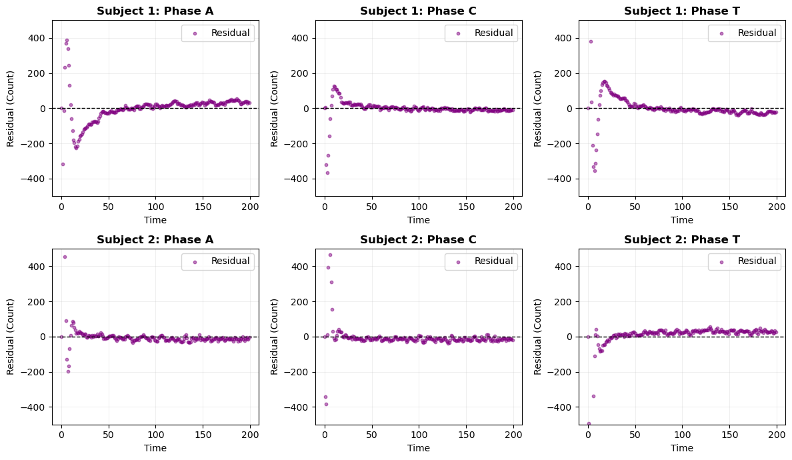
#-------------------------------------------------
# Residue Line Plots
#-------------------------------------------------
# 2 rows for subjects, 3 columns for phases
fig, axs = plt.subplots(2, 3, figsize=(12, 7))
for row, sub_name in enumerate(subjects):
# 1. Retrieve the ORIGINAL residuals (not the subcomp ones)
# Usually stored in 'res_object' from your first fitting
rr = results[sub_name]['res_object'].fun
# 2. Reshape to (Time, 3)
# Use len(t_data) or your T_end_value to match the original fit length
res_matrix = rr.reshape((len(t_data), 3))
for col in range(3):
ax = axs[row, col]
# 3. Plotting with your N_value scaling
ax.plot(t_data, res_matrix[:, col] * N_value, '--',
linewidth=1.5, color='purple', label='Residual')
# Zero line reference
ax.axhline(0, color='black', linestyle='-', alpha=0.3)
ax.set_title(f"{sub_name}: {labels[col]}")
ax.set_xlabel('time')
ax.set_ylabel('Scaled Residual')
ax.legend(loc='lower right', fontsize='small')
ax.grid(alpha=0.2)
plt.tight_layout()
plt.show()
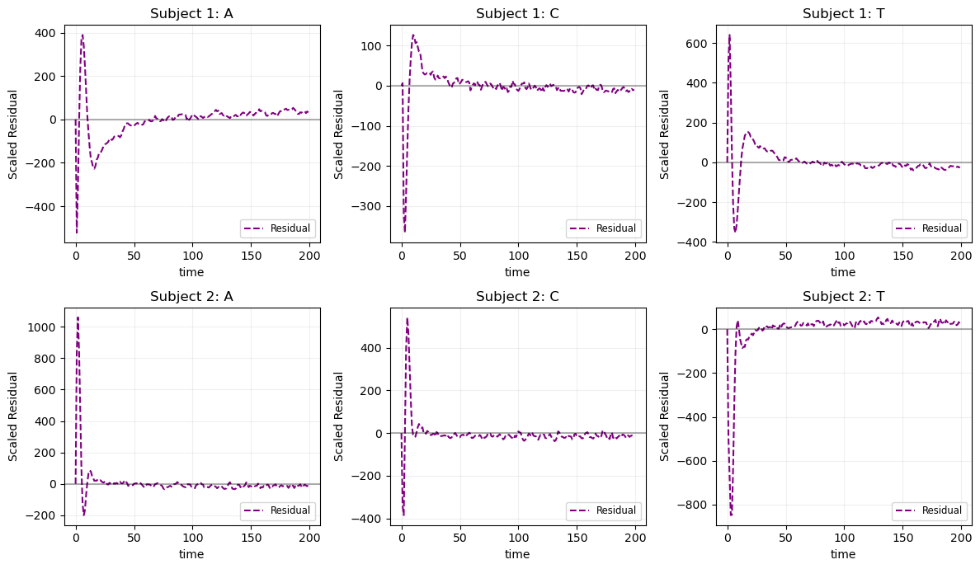
#----------------------------------------------------------------------
# Perform Engle's ARCH test on the residuals (baseline cycle dynamics)
#----------------------------------------------------------------------
arch_results = []
for sub_name in ["Subject 1", "Subject 2"]:
rr = results[sub_name]['res_object'].fun
res_matrix = rr.reshape((200, 3))
subject_row = [sub_name]
for i in range(3):
f_arch, p_arch = het_arch(res_matrix[:, i])[-2:]
subject_row.append(f"{f_arch:.2f} / {p_arch:.2e}")
arch_results.append(subject_row)
headers = ["Subject", "Phase A (F/p)", "Phase C (F/p)", "Phase T (F/p)"]
print(tabulate(arch_results, headers=headers, tablefmt="grid"))
+-----------+---------------------+---------------------+---------------------+
| Subject | Phase A (F/p) | Phase C (F/p) | Phase T (F/p) |
+===========+=====================+=====================+=====================+
| Subject 1 | 1474.53 / 3.32e-166 | 2552.91 / 2.47e-187 | 1821.92 / 2.46e-174 |
+-----------+---------------------+---------------------+---------------------+
| Subject 2 | 236.46 / 1.56e-97 | 15.51 / 8.10e-20 | 72.56 / 1.33e-57 |
+-----------+---------------------+---------------------+---------------------+
#---------------------------------------
# Residual Autocorrelation Analysis
#---------------------------------------
# 2 rows (one per subject), 3 columns (one per phase)
fig, axs = plt.subplots(2, 3, figsize=(15, 8))
for row, sub_name in enumerate(subjects):
# 1. Retrieve and reshape residuals to (T_end_value, 3)
rr = results[sub_name]['res_object'].fun
res_matrix = rr.reshape((T_end_value, 3))
for col in range(3):
ax = axs[row, col]
# 2. Plot ACF for the specific phase on the correct subplot axis
# Suppress double-plotting by assigning to '_'
_ = plot_acf(res_matrix[:, col], lags=40, ax=ax, title=f"{sub_name}: {labels[col]} (ACF)")
# Formatting for readability
ax.set_xlabel("Lags")
ax.set_ylabel("Autocorrelation")
ax.grid(alpha=0.2)
# Global title and adjustment
fig.suptitle("Residual Autocorrelation Analysis", fontsize=16, fontweight='bold', y=1.02)
plt.tight_layout()
plt.show()
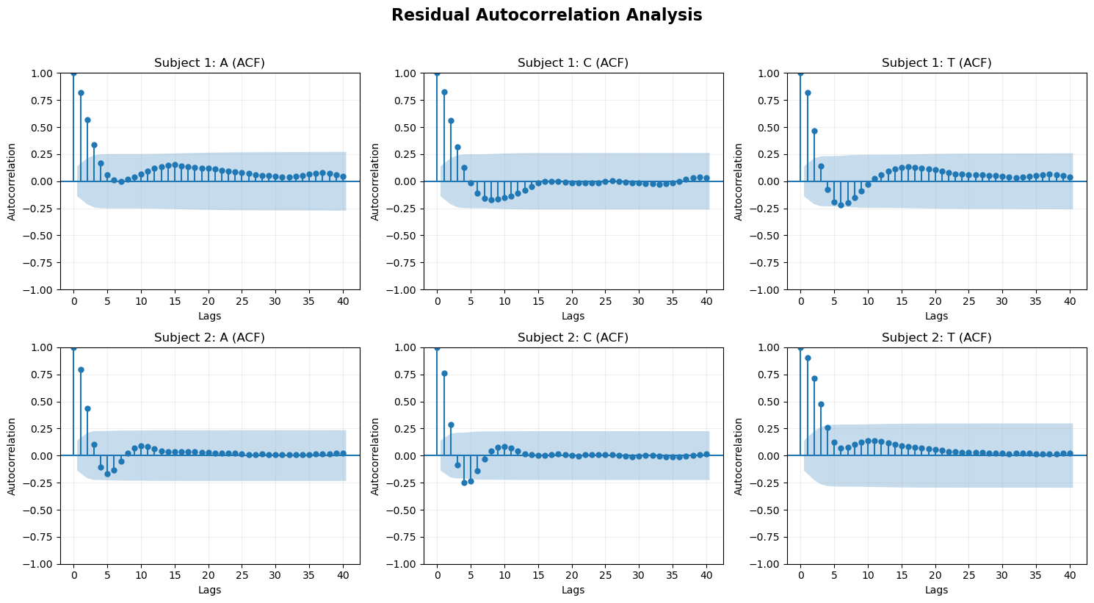
The residuals are not random; instead, they exhibit a clear exponentially decaying pattern. This indicates that the model fails to fully capture the underlying dynamics of the follicle cycle. The primary limitation arises from the linear SIR-type formulation, which assumes memoryless transitions between states. Such an assumption is not appropriate for biological systems like hair follicles, where the duration spent in each phase influences transition behavior.
Further evidence of model inadequacy is seen in the autocorrelation function (ACF), which shows that the residuals are not white noise and retain temporal structure. This confirms that important dynamics are missing from the model.
To address these issues, we introduced subcompartments within the anagen and telogen states. This modification allows the model to approximate non-exponential (non-memoryless) dwell-time distributions, thereby incorporating implicit memory into the system and improving its ability to capture the observed follicle dynamics.

III. Sub-compartmentalization
my_graph_final = """
graph TD
%% The Top Corner
C((C)) --> T1((T1))
%% The Right Side
T1 --> T2((T2))
%% The Bottom Corner
T2 --> A1((A1))
%% The Left Side
A1 --> A2((A2))
%% Closing the loop (Back to Top)
A2 --> C
%% Styling
style A1 fill:#f9f,stroke:#333,stroke-width:2px
style A2 fill:#f9f,stroke:#333,stroke-width:2px
style C fill:#fff,stroke:#333,stroke-width:2px
style T1 fill:#bbf,stroke:#333,stroke-width:2px
style T2 fill:#bbf,stroke:#333,stroke-width:2px
"""
draw_mermaid_centered(my_graph_final)
print_styled("A State Machine Representation of the Sub-compartmentalized Follicular Transition")
# # --- Saving Mermaid graph ---
# import requests
# def save_mermaid_image(graph_code, filename):
# graphbytes = graph_code.encode("ascii")
# base64_string = base64.b64encode(graphbytes).decode("ascii")
# url = "https://mermaid.ink/img/" + base64_string
# response = requests.get(url)
# if response.status_code == 200:
# with open(filename, 'wb') as f:
# f.write(response.content)
# print(f"Saved Mermaid diagram to {filename}")
# # Call this before or after your Matplotlib logic
# F1 = "."
# save_mermaid_image(my_graph_final, f"{F1}/02a_hair_cycle_diagram_final_TD.png")
<IPython.core.display.HTML object>
<IPython.core.display.HTML object>
import numpy as np
from scipy.integrate import solve_ivp
from scipy.optimize import least_squares
# --------------------------------------------------------------
# Subcompartment ODE System
# --------------------------------------------------------------
def follicle_subcomp_model(t, y, alpha, beta, gamma):
"""
ODE System with 2 subcompartments for Telogen and Anagen.
Transitions: C -> T1 -> T2 -> A1 -> A2 -> C
"""
t1, t2, a1, a2, c = y
# Rates: alpha (T), beta (A), gamma (C)
dt1 = gamma * c - alpha * t1
dt2 = alpha * t1 - alpha * t2
da1 = alpha * t2 - beta * a1
da2 = beta * a1 - beta * a2
dc = beta * a2 - gamma * c
return [dt1, dt2, da1, da2, dc]
# --------------------------------------------------------------
# Initial State Helper
# --------------------------------------------------------------
def build_initial_state(A0, C0, T0):
"""
Splits the observed initial population counts into sub-compartments.
Assumes an even distribution (50/50) at t=0.
Input: A0, C0, T0 (Aggregated initial counts/proportions)
Return: [T01, T02, A01, A02, C0] (Initial state vector for ODE)
"""
return [T0/2, T0/2, A0/2, A0/2, C0]
# --------------------------------------------------------------
# Simulation Wrapper
# --------------------------------------------------------------
def solve_model(times, params, A0, C0, T0):
"""
Runs the ODE solver and aggregates subcompartments back into
A, C, and T for comparison with observed data.
"""
alpha, beta, gamma = params
y0 = build_initial_state(A0, C0, T0)
sol = solve_ivp(
fun=lambda t, y: follicle_subcomp_model(t, y, alpha, beta, gamma),
t_span=(times[0], times[-1]),
y0=y0,
t_eval=times,
method="RK45",
rtol=1e-7,
atol=1e-9
)
t1, t2, a1, a2, c = sol.y
# Aggregate sub-states back into the 3 main phases
T_pred = t1 + t2
A_pred = a1 + a2
C_pred = c
return {
"t1": t1, "t2": t2, "a1": a1, "a2": a2, "c": c,
"A_pred": A_pred, "C_pred": C_pred, "T_pred": T_pred
}
# --------------------------------------------------------------
# Residuals Function (for least_squares)
# --------------------------------------------------------------
def residuals_subcomp(params, times, A_obs, C_obs, T_obs):
"""
Computes the difference between simulated data and ODE predictions.
"""
# Extract initial conditions from the first index of observed data
A0, C0, T0 = A_obs[0], C_obs[0], T_obs[0]
# Run the model
out = solve_model(times, params, A0, C0, T0)
# Calculate errors across all three phases
resA = out["A_pred"] - A_obs
resC = out["C_pred"] - C_obs
resT = out["T_pred"] - T_obs
# Flatten into a 1D array for least_squares
return np.concatenate([resA, resC, resT])
# Using same subjects definition and Initial guess for [alpha, beta, gamma]
p0 = [0.1, 0.1, 0.1]
for sub_name in subjects:
# Retrieve the pre-processed normalized data
norm_data = results[sub_name]['norm_data']
a_obs, c_obs, t_obs = norm_data[:, 0], norm_data[:, 1], norm_data[:, 2]
# 2. Run the nonlinear regression using the SUBCOMPARTMENT functions
res = least_squares(
residuals_subcomp, # New residuals function
p0, # Initial guess
args=(t_data, a_obs, c_obs, t_obs),
bounds=(0, np.inf), # Rates must be positive
method='trf',
# verbose=2
)
# Store full object, optimized parameters, and the aggregated fitted curves
results[sub_name]['subcomp_res_object'] = res
results[sub_name]['subcomp_params'] = res.x
results[sub_name]['subcomp_out'] = solve_model(t_data, res.x, a_obs[0], c_obs[0], t_obs[0])
print(f"\nFinished subcomp fitting {sub_name}. Params: {res.x}")
Finished subcomp fitting Subject 1. Params: [0.36160271 0.12208128 0.45376359]
Finished subcomp fitting Subject 2. Params: [0.43199306 0.30512427 0.33087477]
print(f"Finished subcomp fitting {sub_name}. Params: {res.x}")
Finished subcomp fitting Subject 2. Params: [0.43199306 0.30512427 0.33087477]
#---------------------------------------------------------------------------
# Plotting Multi-Subject Subcompartment Results
#---------------------------------------------------------------------------
fig, axs = plt.subplots(2, 3, figsize=(12, 7.5))
for row, sub_name in enumerate(subjects):
orig = results[sub_name]['norm_data']
out = results[sub_name]['subcomp_out']
for col in range(3):
ax = axs[row, col]
# Plotting original data (NumPy array)
l1, = ax.plot(t_data, orig[:, col] * N_value, '-', color='black', alpha=0.9, label='Data')
# Plotting fitted data (from Dictionary using the key)
current_key = f'{labels[col]}_pred'
l2, = ax.plot(t_data, out[current_key] * N_value, '--', color='red', linewidth=2, label='Fit')
ax.set_title(f"{sub_name}: {labels[col]}", fontsize=10, fontweight='bold', pad=10)
ax.set_xlabel('Time', fontsize=9)
ax.set_ylabel('Count', fontsize=9)
ax.grid(alpha=0.2)
# Placement of legend
fig.legend(handles=[l1, l2],
loc='center',
bbox_to_anchor=(0.5, 0.5),
ncol=2,
frameon=True,
facecolor='white',
edgecolor='none')
plt.tight_layout()
plt.subplots_adjust(hspace=0.6)
plt.show()
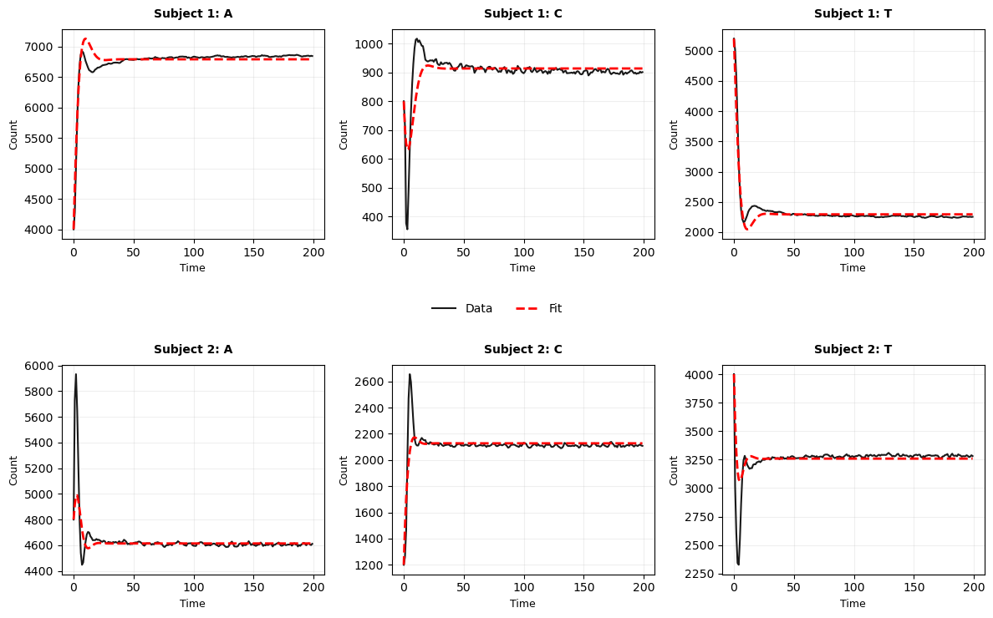
Demonistarted better transient response.??
#-------------------------------------------------
# Residue scatter plots (Subcompartment results)
#-------------------------------------------------
fig, axs = plt.subplots(2, 3, figsize=(12, 7))
for row, sub_name in enumerate(subjects):
# Retrieve data
data = results[sub_name]['norm_data']
out = results[sub_name]['subcomp_out']
# Reconstruct the prediction array from the dictionary keys
pred = np.column_stack([out[f'{k}_pred'] for k in labels_keys])
# Calculate residuals
res = (data - pred) * N_value
for col in range(3):
ax = axs[row, col]
ax.scatter(t_data, res[:, col], s=10, alpha=0.5, color='purple', label='Residual')
ax.axhline(0, color='black', linestyle='--', linewidth=1)
ax.set_title(f"{sub_name}: {labels_titles[col]}", fontweight='bold')
ax.set_xlabel('Time')
ax.set_ylabel('Residual (Count)')
# Adjusting ylim
ax.set_ylim(-500, 500)
ax.grid(alpha=0.2)
ax.legend(loc='upper right', fontsize='small')
plt.tight_layout()
plt.show()
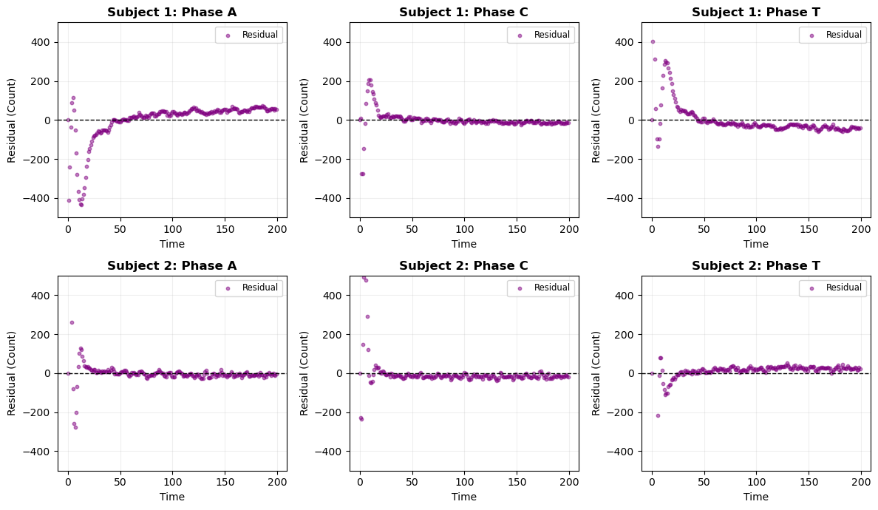
#-------------------------------------------------
# Multi-Subject Residue Line Plots
#-------------------------------------------------
fig, axs = plt.subplots(2, 3, figsize=(12, 7))
for row, sub_name in enumerate(subjects):
# Retrieve residuals from the specific subject's result object
# .fun contains the vector of residuals
rr = results[sub_name]['subcomp_res_object'].fun
# Reshape to (Number of time points, 3 phases)
res_matrix = rr.reshape((len(t_data), 3))
for col in range(3):
ax = axs[row, col]
# Plotting with scaling by N_value
ax.plot(t_data, res_matrix[:, col] * N_value, '--',
linewidth=1.5, color='purple', label='Residual')
# Zero line setting
ax.axhline(0, color='black', linestyle='-', alpha=0.3)
ax.set_title(f"{sub_name}: {labels[col]}")
ax.set_xlabel('time')
ax.set_ylabel('Scaled Residual')
ax.legend(loc='lower right', fontsize='small')
ax.grid(alpha=0.2)
plt.tight_layout()
plt.show()
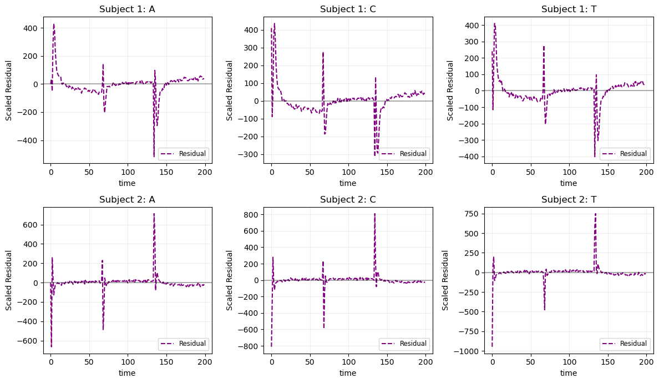
#----------------------------------------------------
# Residual Autocorrelation Analysis (Subcompartment)
#---------------------------------------------------
fig, axs = plt.subplots(2, 3, figsize=(15, 8))
for row, sub_name in enumerate(subjects):
# Retrieve residuals
rr = results[sub_name]['subcomp_res_object'].fun
# Reshape back to (Time, 3)
res_matrix = rr.reshape((len(t_data), 3))
for col in range(3):
ax = axs[row, col]
# Plot ACF for the specific phase
_ = plot_acf(res_matrix[:, col], lags=40, ax=ax,
title=f"{sub_name}: {phase_labels[col]} (ACF)")
ax.set_xlabel("Lags")
ax.set_ylabel("Autocorrelation")
ax.grid(alpha=0.2)
fig.suptitle("Residual Autocorrelation Analysis", fontsize=16, fontweight='bold', y=1.02)
plt.tight_layout()
plt.show()
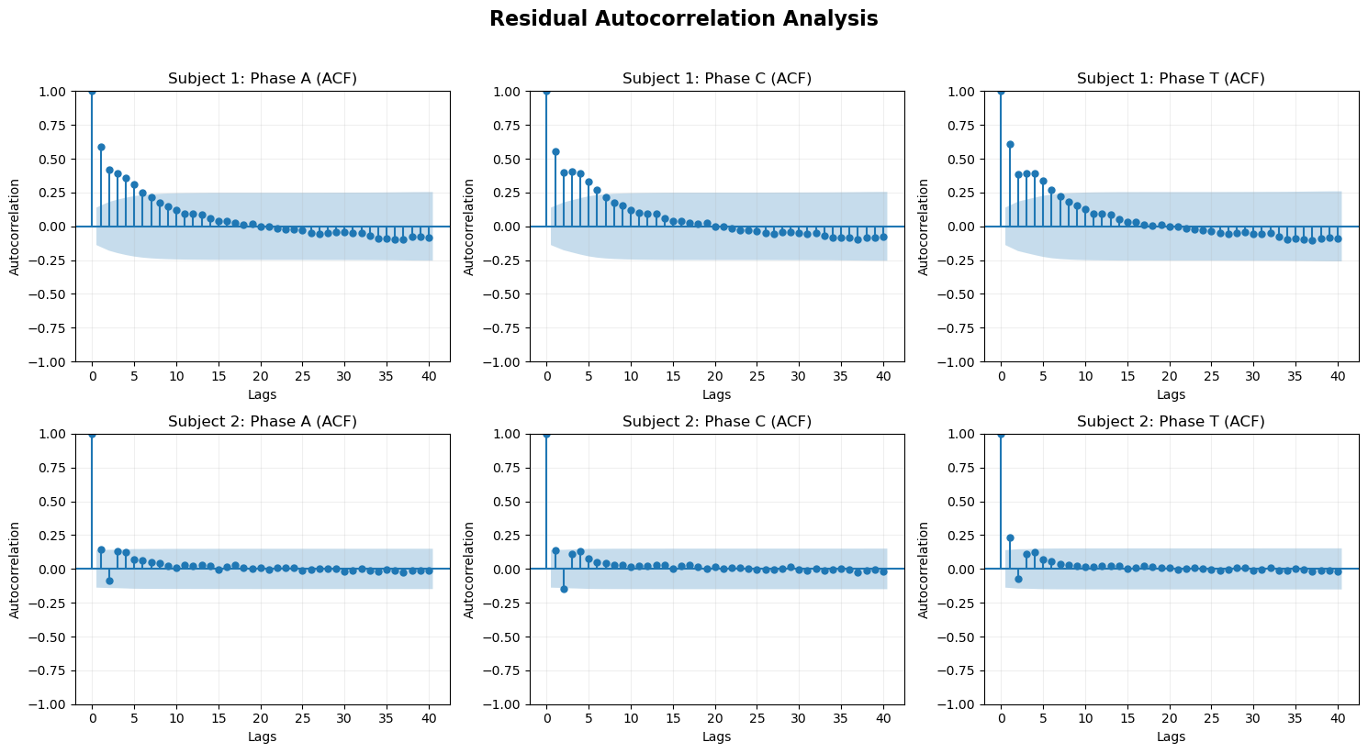
The scatter plot doesn't show any pattern. The autoregression shows that the residue is white noise. So the model assumptions are ppropariate and the model is able to capture the dynamics of the follicle cycle. ???

IV. Parameter Sensitivity and Hair Treatment
for sub_name in subjects:
res = results[sub_name]['subcomp_res_object']
print(f"--- Summary for {sub_name} ---")
print(f"Termination: {res.message}")
print(f"Function evaluations: {res.nfev}")
print(f"Initial cost: {res.cost:.4e}") # Note: res.cost is the final cost
print(f"Optimality: {res.optimality:.2e}")
print(f"Optimized Params: {res.x}")
print("-" * 30)
--- Summary for Subject 1 ---
Termination: `xtol` termination condition is satisfied.
Function evaluations: 61
Initial cost: 2.0037e-02
Optimality: 6.10e-03
Optimized Params: [0.36160271 0.12208128 0.45376359]
------------------------------
--- Summary for Subject 2 ---
Termination: `xtol` termination condition is satisfied.
Function evaluations: 255
Initial cost: 3.0014e-02
Optimality: 3.25e-03
Optimized Params: [0.43199306 0.30512427 0.33087477]
------------------------------
#-------------------------------------------------------------
# ODE fit plots for Hair Cycle Data (subcompartmentalization)
#-------------------------------------------------------------
labels = ['A', 'C', 'T']
colors = ['#1f77b4', '#ff7f0e', '#2ca02c'] # Blue, Orange, Green
fig, axs = plt.subplots(1, 2, figsize=(14, 5), sharey=True)
for i, sub_name in enumerate(subjects):
ax = axs[i]
out = results[sub_name]['subcomp_out']
# Plot all 3 phases (A, C, T) on the same subplot
for j in range(3):
key = f'{labels[j]}_pred'
ax.plot(t_data, out[key] * N_value, label=labels[j], color=colors[j], linewidth=2)
ax.set_title(f"Subcompartment Population Proportions (ODE fit): {sub_name}", fontweight='bold')
ax.set_xlabel("Time")
if i == 0:
ax.set_ylabel("Count")
ax.grid(alpha=0.3)
ax.legend()
plt.tight_layout()
plt.show()
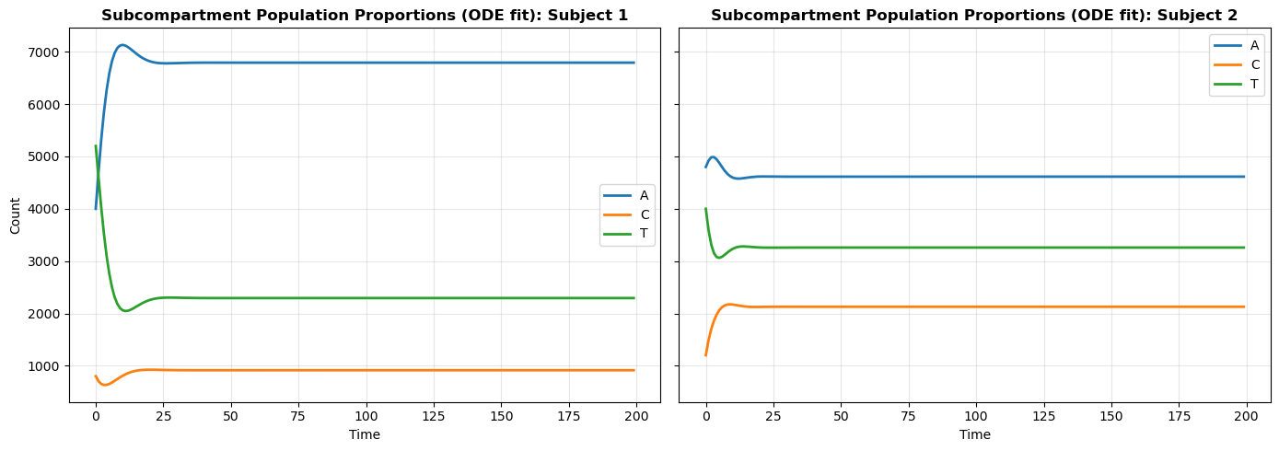
#-------------------------------------------------------------
# Impact of recuction in alpha (subcompartmentalization)
# Transition: A -> C)
#-------------------------------------------------------------
fig, axs = plt.subplots(1, 2, figsize=(14, 5), sharey=True)
for i, sub_name in enumerate(subjects):
ax = axs[i]
# Retrieve original optimized parameters and initial conditions
theta = results[sub_name]['subcomp_params'].copy()
norm_data = results[sub_name]['norm_data']
a0, c0, t0 = norm_data[0]
# Apply the simulation change: reduce alpha (index 0) by half
theta[0] = theta[0] / 4
# Re-solve the model with the modified parameters
sim_out = solve_model(t_data, theta, a0, c0, t0)
# Plot all three phases
for j in range(3):
key = f'{labels[j]}_pred'
ax.plot(t_data, sim_out[key] * N_value, label=labels[j], linewidth=2)
ax.set_title(f"Impact of 75% Reduction in Alpha: {sub_name} (ODE fit)", fontweight='bold')
ax.set_xlabel("Time")
if i == 0: ax.set_ylabel("Count")
ax.grid(alpha=0.3)
ax.legend()
plt.tight_layout()
plt.show()
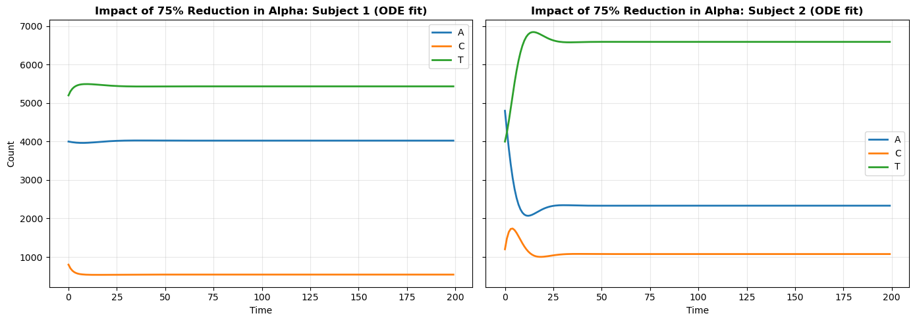
We observe that when alpha is reduced—corresponding to an increased Wnt activation threshold—the transition into the anagen phase decreases. As a result, the proportion of follicles in anagen becomes lower than that in catagen. This shift indicates reduced hair growth activity and suggests a higher susceptibility to hair loss (baldness). Results show that the impact is much higher in Subject 2.
#-------------------------------------------------------------
# Impact of doubling Beta (subcompartmentalization)
# Transition: C -> T)
#-------------------------------------------------------------
fig, axs = plt.subplots(1, 2, figsize=(14, 5), sharey=True)
for i, sub_name in enumerate(subjects):
ax = axs[i]
# Retrieve parameters
theta = results[sub_name]['subcomp_params'].copy()
norm_data = results[sub_name]['norm_data']
a0, c0, t0 = norm_data[0]
# Doubling Beta (Transition C -> T)
theta[1] = theta[1] * 2
sim_out = solve_model(t_data, theta, a0, c0, t0)
for j in range(3):
key = f'{labels[j]}_pred'
ax.plot(t_data, sim_out[key] * N_value, label=labels[j], linewidth=2)
# Title
ax.set_title(f"Impact of Doubling Beta (100% Increase): {sub_name} (ODE fit)", fontweight='bold')
ax.set_xlabel("Time")
if i == 0: ax.set_ylabel("Count")
ax.grid(alpha=0.3)
ax.legend()
plt.tight_layout()
plt.show()
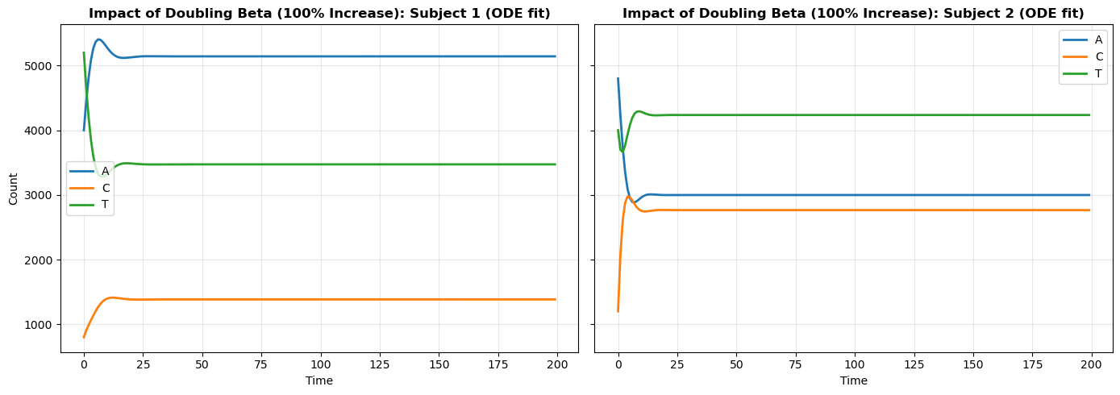
#-------------------------------------------------------------
# Impact of 75% Reduction in Gamma (subcompartmentalization)
# Transition: T -> A
#-------------------------------------------------------------
fig, axs = plt.subplots(1, 2, figsize=(14, 5), sharey=True)
for i, sub_name in enumerate(subjects):
ax = axs[i]
# Retrieve parameters
theta = results[sub_name]['subcomp_params'].copy()
norm_data = results[sub_name]['norm_data']
a0, c0, t0 = norm_data[0]
# Reduce Gamma (Transition T -> A) by 75%
theta[2] = theta[2] / 4
# Re-solve the model
sim_out = solve_model(t_data, theta, a0, c0, t0)
# Plot all three phases
for j in range(3):
key = f'{labels[j]}_pred'
ax.plot(t_data, sim_out[key] * N_value, label=labels[j], linewidth=2)
# Title
ax.set_title(f"Impact of 75% Reduction in Gamma: {sub_name} (ODE fit)", fontweight='bold')
ax.set_xlabel("Time")
if i == 0: ax.set_ylabel("Count")
ax.grid(alpha=0.3)
ax.legend()
plt.tight_layout()
plt.show()
