Title: Multi-Subject Analysis of Hair Cycle Dynamics: A Sub-compartmentalized SIR-Based ODE Modeling.

Contributors:

Asfaw, Yoseph
Paudel, Liladhar

Abstract

- Introduction
Hair loss is a highly prevalent condition that affects individuals across a wide range of ages and both genders. Beyond its physiological aspects, hair loss has significant psychological and social implications, often impacting self-confidence, mental well-being, and even professional opportunities. As a result, understanding and predicting hair loss progression has become an important problem in both clinical and research settings.
Currently, many clinical procedures for evaluating hair loss and forecasting its future severity rely heavily on manual assessment and expert judgment. These approaches, while valuable, are often subjective and may lack consistency and scalability. This limitation has motivated substantial research into quantitative and computational models that can systematically describe hair follicle behavior over time.
Hair follicles undergo a cyclic process consisting of three primary phases: anagen (growth phase), catagen (transition phase), and telogen (resting phase). Transitions between these phases are regulated by complex interactions of biochemical signals, including proteins such as Wnt and various hormones. Over the years, several studies have proposed mathematical models—particularly systems of ordinary differential equations (ODEs)—to capture these dynamics. For example, Al-Nuaimi et al. (2012) introduced a compartment-based model demonstrating oscillatory switching between growth and resting states, while Wang et al. (2017) developed a multi-scale framework to model spatial propagation of follicle activation. More recently, Alzubadi (2024) incorporated immune system interactions to better explain pathological conditions such as alopecia.
Despite differences in biological detail, these models share a common structural feature: they describe populations of follicles transitioning between discrete states. This structure closely resembles compartmental models widely used in epidemiology, particularly the SIR model, where individuals transition between susceptible, infected, and recovered states.
Motivated by this analogy, this work formulates hair follicle dynamics within an SIR-inspired framework. By leveraging the mathematical simplicity and interpretability of compartmental models, we aim to provide a tractable yet insightful representation of follicle state transitions, enabling deeper analysis of hair growth dynamics and potential progression toward hair loss.
Due to the lack of accessible longitudinal clinical data, we estimated the parameters of the proposed ODE system using nonlinear regression on synthetically generated data. Specifically, we leveraged the stochastic framework presented in Halloy et al. (2026), which provides statistical characteristics for both alopecic and non-alopecic populations. Using this framework, we implemented an agent-based simulation to generate realistic time-series data for follicle state transitions.
The proposed model demonstrates a strong fit to the generated data, yielding parameter values that are consistent with known biological interpretations of hair follicle dynamics. However, initial analysis of the residuals indicated that a simple three-compartment formulation fails to capture the full temporal structure of the system, particularly its non-memoryless behavior.
To address this limitation, we extended the model by introducing sub-compartments within the primary states of anagen and telogen. This refinement allows the system to better represent delayed transitions and internal phase heterogeneity, resulting in improved alignment with observed follicle dynamics.

- Model Description

The compartmental structure of the hair follicle life cycle—comprising the anagen, catagen, and telogen phases—is illustrated in the figure below.
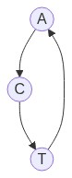

The SIR-like model equation is:
$$\frac{dA}{dt}=αT-βA$$
$$\frac{dC}{dt}=βA-γC$$
$$\frac{dT}{dt}=γC-αT$$

Where:
- A is number of follicles at anagen state.
- C is number of follicles at catagen state.
- T is number of follicles at telogen state.

The total number of follicles N = A + C + T is assumed constant.

Matrix representation and steady state analysis:
Define a = A/N, c = C/N and r = T/N. The matric representation of the model becomes
$$\left[\begin{matrix}\dot{a} \\ \dot{c} \\ \dot{r}\end{matrix}\right]=\left[\begin{matrix}-β & 0 & α \\ β & -γ & 0 \\ 0 & γ & -α\end{matrix}\right]\left[\begin{matrix}a \\ c \\ r\end{matrix}\right]= \dot{x}=Mx$$
The steady states values can be obtained from:
$\dot{x}= Mx=0$

$$a^{*}=\frac{αγ}{αβ+βγ+αγ}$$
$$c^{*}=\frac{αβ}{αβ+βγ+αγ}$$
$$r^{*}=\frac{βγ}{αβ+βγ+αγ}$$

Trace(M) <0 and det(M) = $-β*\left(γ*α\right)+ α*β*γ=0$ and $a+c+r=1$ leads that one of eigen value is 0 and the rest are negative. Therefore, the stationary point is stable.

Biochemical interpretation of the parameters.

- $β$: Exit from growth rate: is related to the Fibroblast Growth Factor F (FGF5) protein concentration. When the concentration reaches a specific threshold, it triggers the transition to catagen. It also measures the influence of DHT hormones. High concentration of DHT increases the value of the parameter.
- $γ$ : is largely a fixed biological timer derived by programmed cell death.
- $α$: is an activation rate related to the wake-up signal. It is related to Wnt protein and high concentration of Wnt increases the parameter.

Biochemical parameter ranges and descriptions.
The following table summarizes the ranges of biochemical parameters relevant to the hair follicle life cycle. These ranges are used to assess the validity of the parameters estimated from the nonlinear regression of the ODE model.

Metrics | Symbol | Description | Typical range (per month)
gamma | $$γ$$ | Catagen to Telogen transit rate | 1.3 to 1.5
Telogen base rate | $$k_{wake}$$ | Telogen to Anagen transfer rate | 0.25 to 0.33
Anagen base rate | $$β_{base}$$ | Anagen to Catagen transfer rate | 0.027
Wnt/FGF5/DHT |  | Signal strength | Normalized to 1
Biological Threshold | $$K_{wnt}, K_{FGF5}$$ | - | 0.4 to 0.6 normalized
Biological Threshold | $$K_{DHT}$$ | - | 0.2 to 0.8 normalized

Large value of $K_{wnt}$ results in blocking the hair follicle to leave telogen phase and enter anagen phase. $K_{FGF5} and K_{DHT}$ dictates the exit of the follicle from growing phase. These values are directly related to the parameters of compartment model.

Nonlinear regression:
We attempted to estimate the value the model parameters through nonlinear regression. Due to the lack of accessible longitudinal clinical data, we generated synthetic data. Specifically, we leveraged the stochastic framework presented in Halloy et al. (2026), which provides statistical characteristics for both alopecic and non-alopecic populations. Using this framework, we implemented an agent-based simulation to generate realistic time-series data for follicle state transitions.
One of the challenges we faced during nonlinear fitting on ODE to the synthetic data is that, the ODE is a memoryless system while biological systems in general and the synthetic data in particular are not memoryless.
To address this limitation, we extended the model by introducing sub-compartments within the primary states of anagen and telogen.
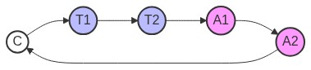

The residence time in each sub-compartment is assumed to follow an exponential distribution. Consequently, the total time spent within a state—being the sum of multiple exponential stages—follows an Erlang distribution. This removes the memoryless property of the system.

$$t= \sum_{i=1}^{k}{t_{i,}} , t_{i} \sim expon(λ)$$
$$f\left(t;k, λ\right)= \frac{λ^{k}t^{k-1}e^{-λt}}{k-1}$$

- Results & Discussion

< Figure 6. Subject Level Population Dynamics (Simulated vs. ODE fit)>
< Table 2: Parameter Uncertainty (Standard Errors)>
< Figure 8. Residuals (Line Plots), Subject Level Population Dynamics>
< Figure 9. Residuals (Autocorrelation), Subject Level Population Dynamics>
<>

Figure xx.

Sensitivity to K₀A.
The sensitivity of the box model to changes in mass-transfer capacity K₀A is illustrated in Figure 3. These plots show how the concentration difference $∆\left(x\right)$ evolves along the fiber axis for both CO and CC flow when K₀A is varied. Changing K₀A effectively mimics the behavior of solutes with different diffusivities: lower K₀A values resemble larger (slower diffusive) solutes such as phosphate (PO₄²⁻), mid-range values correspond to solutes like creatinine, and high K₀A values reflect small (fast diffusing) solutes such as urea. By comparing these three representative cases, the figure highlights how strongly the predicted CO and CC gradients depend on the underlying mass-transfer capacity of the system. This interpretation is consistent with in vivo measurements reported in the HEMO Study (Depner et al., 2004 [5]).

At low K₀A (400 mL/min) (Figure 3a), both CO and CC flows show a slow, gradual decline in $∆\left(x\right)$. CC maintains a slightly higher gradient, but the difference between the two configurations is small. This behavior is typical of larger or slower-diffusing solutes, where membrane transport is the limiting step and equilibration occurs slowly.

At moderate K₀A (800 mL/min) (Figure 3b), the gradients decay more quickly. The CO curve collapses early, reaching near-equilibrium within the first half of the fiber, while CC still preserves a meaningful gradient over a longer distance. This pattern resembles mid-range solutes like creatinine, where the membrane is more effective and the advantage of CC becomes more noticeable.

At high K₀A (Figure 3c), equilibrium happens rapidly. The CO gradient drops almost immediately near the inlet, leaving little driving force downstream. CC also decays faster than before, but it still maintains a larger gradient across most of the fiber. This behavior mirrors small, fast-diffusing solutes like urea, where the membrane is highly effective and CC flow shows a clear performance advantage.

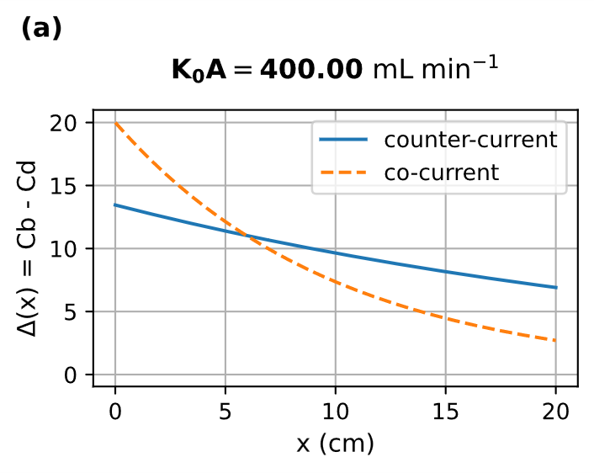 | 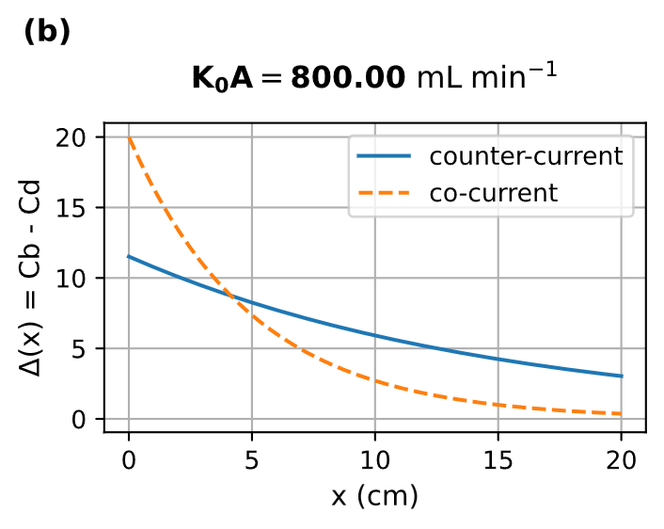
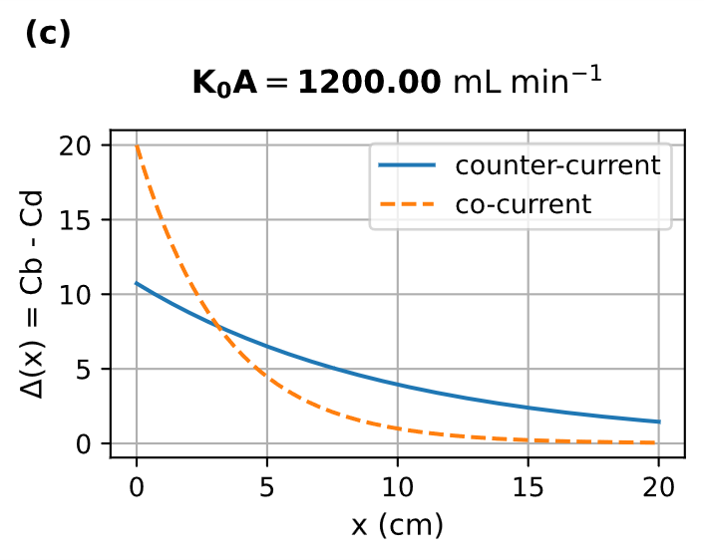
Figure 3. Sensitivity of the box model predicted spatial concentration profiles to changes in mass-transfer capacity K₀A during co-current and counter-current kidney dialysis.

Sensitivity to Dialysate Flow Rate Q_{d}.
The influence of dialysate flow rate Q_{d} on the axial concentration profiles is shown in Figure 4. As Q_{d} is altered, the model predicts clear changes in how the concentration difference $∆\left(x\right)$ develops along the fiber for both CO and CC operation. Higher Q_{d} supplies cleaner dialysate more rapidly, limiting solute buildup on the dialysate side and helping maintain a stronger driving force for diffusion. Comparing the predictions at the high, intermediate, and low Q_{d} reveals how dialysate flow redistributes the available driving force along the device and how the performance gap between CC and CO shifts with flow rate.

Figures 4a-4c show a clear progression in the axial concentration profiles as the dialysate flow rate is reduced from 1000 to 400 mL/min. At the highest flow, the dialysate remains close to its inlet concentration, causing both CO and CC gradients to fall sharply and leaving CO with very little driving force beyond the inlet region. As the flow is lowered to 700 mL/min, the decay of $∆\left(x\right)$ becomes less abrupt, and the distinction between CO and CC becomes more evident as CC maintains a usable gradient over a larger portion of the fiber. At the lowest flow of 400 mL/min, dialysate-side solute accumulation slows the decline of $∆\left(x\right)$, producing more gradual profiles in both configurations and revealing a regime where dialysate flow increasingly limits transport. Across the three figures, CC consistently preserves a higher driving force than CO, and its relative advantage becomes more pronounced as Q_{d} decreases.

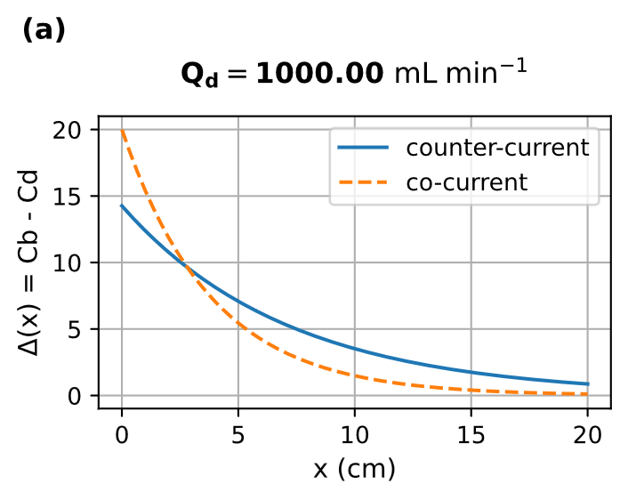 | 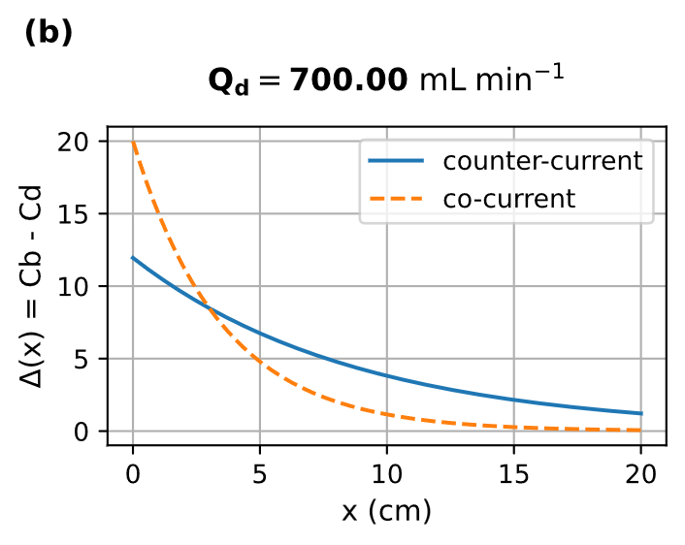
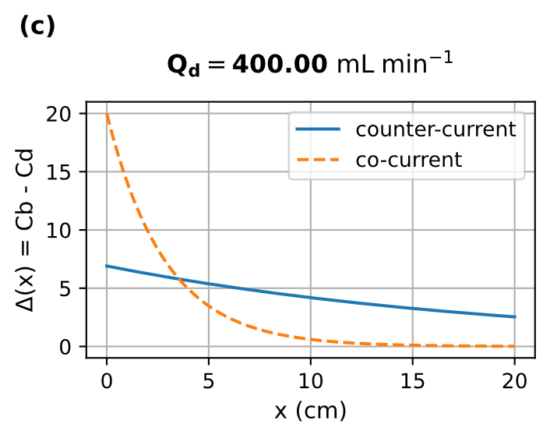
Figure 4. Influence of dialysate flow rate Q_{d} on model predicted spatial concentration profile during co-current and counter-current kidney dialysis.

In this model, K₀A is held constant while we examine how changes in dialysate flow rate Q_{d} reshape the axial concentration difference $∆\left(x\right)$ for CO and CC configurations. This isolates the geometric and convective effects of Q_{d} on the transmembrane driving force for the solute transport. In clinical dialyzers, however, the effective mass-transfer area coefficient K₀A can itself increase with dialysate flow, particularly for small solutes such as urea, so the present simulations likely underestimate the full impact of higher Q_{d} on solute removal (Leypoldt et al., HEMO Study [6]).

Temporal Concentration C(t).
Figure 5 shows the model-predicted time course of the normalized solute concentration in the patient’s blood compartment, $C\left(t\right)$, during dialysis for CO and CC flow. Because at $C\left(0\right)=1$ the curves represent the fraction of the initial solute load remaining in the body as treatment progresses, consistent with standard single-pool mass-balance formulations used in dialysis kinetics. Both configurations exhibit a monotonic decline in $C\left(t\right)$, reflecting net solute removal driven by the transmembrane concentration difference $∆\left(x\right)$ established within the dialyzer (Sargent et al. Biophysics of Dialysis [7]).

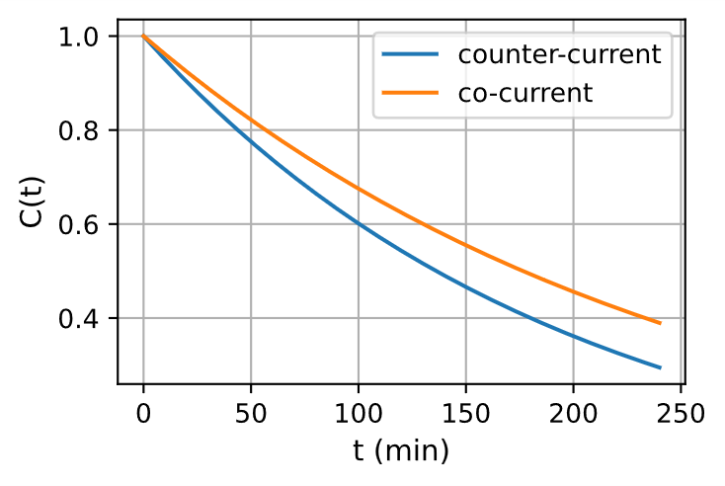
Figure 5. Model predicted temporal concentration profile during co-current and counter-current kidney dialysis.

The two curves diverge because the flow configuration determines how effectively the dialyzer maintains a driving force for diffusion. In the CC arrangement, the blood is continually exposed to dialysate that is closer to its inlet concentration, preserving a larger $∆\left(x\right)$ along the entire fiber. This sustained gradient produces a higher effective clearance at each moment in time, causing the CC curve to fall more rapidly and remains consistently below the CO curve. In contrast, the CO configuration experiences early equilibration between blood and dialysate, leading to a faster collapse of the driving force and a correspondingly slower decline in $∆\left(x\right)$, a behavior long recognized in CC vs. CO mass-transfer comparisons in hemodialysis [7].

Comparison with Experimental Results.
The experimental results (Eloot, 2005 [8]) show that CC operation provides a consistent and meaningful improvement in solute-removal efficiency. For the low-molecular-weight solute LMW-AB, clearance increases from 184 mL/min in CO flow to 215 mL/min in CC, corresponding to a 17% increase. For the mid-molecular-weight Na₃PO₄, clearance rises from 145 mL/min to 176 mL/min, representing a 21% improvement. These experimentally observed gains align with our model’s predicted enhancement of 30%. The modest difference between theoretical and experimental results is expected, given real-world factors such as non-uniform mixing, membrane heterogeneity and axial dispersion. Importantly, the experimental trends confirm the model’s mechanistic prediction that CC operation sustains a larger effective concentration gradient than CO, thereby enabling superior solute-removal performance.

- Conclusions

In this work we describe a lumped two compartment box model for kidney dialysis and compare the performance efficiency of co- and counter-current flow. We propose mathematical ODEs for both spatial and temporal models and solve them analytically. Simulations are conducted using parameter values chosen to fall within the physiological range of clinical hemodialysis.

The combined spatial-temporal analysis reveals a coherent mechanistic picture: counter-current operation consistently sustains a larger and more uniformly distributed concentration gradient across the dialyzer, whereas co-current flow rapidly approaches local equilibrium and loses driving force early in the device. This difference in gradient explains the higher solute-removal efficiency observed in counter-current systems. The temporal patient model further shows that this sustained gradient translates into lower systemic solute concentrations over the course of treatment.

Sensitivity studies highlight the dominant influence of the mass-transfer area coefficient K₀A, which governs the steepness of axial gradients and amplifies the performance gap between the flow configurations. Variation in dialysate flow rate Q_{d} produces complementary effects by redistributing the available driving force and shifting the system between membrane-limited and dialysate-limited regimes. Across all parameter ranges, counter-current flow maintains a higher effective gradient and therefore superior clearance.

Overall, the model provides a compact analytical framework that links axial transport phenomena to whole-body solute kinetics. It offers a transparent explanation for the well-established counter-current dialyzer design and clarifies how flow direction shapes axial concentration gradient and, in turn, the resulting solute-removal efficiency.

- References

[1] Michaelas, A. S. (1966). Operating Parameters and Performance Criteria for Hemodialyzers and Other Membrane-separation Devices. Trans. Am. Soc. Artif. Inter. Organs, 12, 387–381.

[2] Loney, N. W. (2009). Analysis on a Counter-Current Flow Hemodialyzer, Chemical Product and Process Modeling, vol. 4, no. 5.

[3] Gotch, F. A., Sargent, J. A. (1985). A mechanistic analysis of the National Cooperative Dialysis Study (NCDS). Kidney International, 28, 3, 526–534, ISSN 0085-2538.

[4] Chang, K. Y., Kim, S.-H., Kim, Y. O., Jin, D. C., Song, H. C., Choi, E. J., Kim, Y.-L., Kim, Y.-S., Kang, S.-W., Kim, N.-H., Yang, C. W., & Kim, Y. K. (2016). The impact of blood flow rate during hemodialysis on all-cause mortality. The Korean Journal of Internal Medicine, 31(6), 1131–1139.

[5] Depner T. A., Greene T., Daugirdas J. T., Cheung A. K., Gotch F. A., Leypoldt J. K. (2004). Dialyzer Performance in the HEMO Study: In Vivo K₀A and True Blood Flow Determined from a Model of Cross-Dialyzer Urea Extraction. ASAIO Journal, 50, 1, 85–93.

[6] Leypoldt, J. k., Cheung, A. K., Agodoa, L. Y., Daugirdas, J. T., Greene, T., Keshaviah, P. R. (1997). Hemodialyzer mass transfer-area coefficients for urea increase at high dialysate flow rates. Kidney International, 51, 2013–2017.

[7] Sargent, J.A., Gotch, F.A. (1983). Principles and Biophysics of Dialysis. In: Drukker, W., Parsons, F.M., Maher, J.F. (eds) Replacement of Renal Function by Dialysis. Springer, Dordrecht.

[8] Eloot, S. (2005). Experimental and Numerical Modeling of Dialysis. PhD Thesis. Ghent University
Faculty of Engineering, Civil Engineering Department, Hydraulics Laboratory.

- Appendices

Appendix A: Derivation of the initial condition of counter-current configuration

Start with equations (4), (6)
$$\frac{{dC}_{d}}{dx}= \frac{K_{0} a\left(C_{b} - C_{d}\right)}{Q_{d}}$$

$∆\left(x\right)= ∆(0)e^{-γx}$

Substituting $∆\left(x\right)$, for $C_{b} - C_{d}$, we have a separable differential equation.

$\frac{{dC}_{d}}{dx}= \frac{K_{0} aσ∆(0)e^{-γx}}{Q_{d}}$ (13)

Rearranging the like terms and integrating both sides,

$\int_{c_{d0}}^{c_{di}}{{dc}_{d}}= \int_{0}^{l}{\frac{K_{0} aσ∆(0)e^{-γx}}{Q_{d}}}dx$

$c_{di}- c_{do}= \frac{K_{0} aσ∆(0)}{Q_{d}}*\frac{(1-e^{-γl})}{γ}$ (14)

The initial condition $∆(0)$ is defined as
$$∆\left(0\right)= c_{bi}- c_{do}$$

$$c_{do}= c_{bi}- ∆(0)$$

Substituting above equation into (13) and solving for $∆\left(0\right)$,

$$c_{bi}- c_{di}=\left(1- \frac{K_{0}aσ}{Q_{d}}*\frac{\left(1-e^{-γl}\right)}{γ} \right)∆(0)$$

$$∆\left(0\right)= \frac{c_{bi}- c_{di}}{\left(1- \frac{K_{0}aσ}{Q_{d}}*\frac{\left(1-e^{-γl}\right)}{γ} \right)}$$

Appendix B: Proportionality of blood outlet concentration to inlet concentration

Equation (7) and (8) states that, the initial condition for concentration gradient is a linear combination of the inlet concentration of the blood and dialysate $c_{bi}, and c_{di}$.

$∆\left(0\right)= αc_{bi}+ βc_{di}$ (15)
Where:
$α and β are some constant$s.

Equation (14) indicates that the difference between the inlet and outlet concentrations of the dialysate is proportional to the initial concentration gradient. By conservation of solute, the same reasoning applies to the blood stream. Therefore, the difference between the inlet and outlet blood concentrations can be written as
$c_{bi}- c_{bo}= θc_{bi}+ μc_{di}$ (16)

where $μ and θ are some constant$s.
Rearranging equation (16), the outlet blood concentration can be expressed as a linear combination of the inlet concentrations:
$c_{bo}= ϑc_{bi}+ μc_{di}$ (17)
where μ and $ϑ$ are some constants.
In most dialysis setting $c_{di}≪ c_{bi}$. So, for the sake of simplicity, we can safely set it to zero.
That reduces equation (17), to
$$c_{bo}= ϑc_{bi}$$
This result establishes the proportional relationship between the outlet and inlet blood concentrations assumed in the model.

