ScholarPlan: An LLM-Powered Planning Agent for Academic Research and Information Gathering
Design Proposal Report
Module: Intelligent Agents

Group A

September 2026

1. Introduction
Academic literature searching is repetitive yet error-prone when delegated to a single large language model (LLM), because unaided LLMs plan unreliably and fabricate citations (Ji et al., 2023; Kambhampati et al., 2024). This proposal presents ScholarPlan, a multi-agent system in which an LLM Planner decomposes a research goal, cooperating agents retrieve, summarise, and verify evidence from open scholarly sources, and an Archivist stores the results offline.

2. System Requirements and Assumptions

2.1 Requirements
• Instruction-tuned LLMs for three roles. The Planner and Processor must return schema-valid JSON (a subtask graph and a claim list) and are ranked on the Berkeley Function-Calling Leaderboard (BFCL, 2026); the Critic performs entailment classification and is ranked on LLM-AggreFact (Tang, Laban and Durrett, 2024).
• Keyless scholarly APIs (arXiv, OpenAlex, Crossref) that return stable identifiers (DOI, arXiv ID), so every claim is traceable to a source (Priem, Piwowar and Orr, 2022).
• Local sentence embeddings (Reimers and Gurevych, 2019) for deduplication, relevance ranking, and vector indexing at zero cost.
• A bounded ReAct reasoning loop (Yao et al., 2023) capped at 20 steps per run, controlling both Azure credit and API rate limits.
• Offline outputs: a report, BibTeX bibliography, vector index, and execution trace, satisfying the retrieval, processing, and storage success criteria.

2.2 Assumptions
• Sources are mainly English; full text exists only for open-access works, with abstracts as fallback.
• Single user, single run, single machine; no authentication, multi-tenancy, or distributed deployment.
• Free-tier quotas and the one-off Azure student credit suffice for demonstration scale.

3. Design Decisions
• Hybrid agent architecture. A single deliberative LLM Planner reasons over the goal while role-specialised reactive agents (Retriever, Processor, Critic, Archivist) act only when their input appears. Hybrid layering combines deliberative goal-direction with reactive robustness (Wooldridge, 2009) and keeps retrieval, processing, and critique as separate failure surfaces, so an irrelevant source is never confused with an unsupported claim (Guo et al., 2024).
• Blackboard coordination. Agents never invoke one another; they read and write shared state (Figures 2 and 3). The blackboard model offers decoupled, opportunistic control among heterogeneous knowledge sources (Hayes-Roth, 1985) and has recently outperformed centralised orchestration for LLM agents in information discovery (Salemi et al., 2025). Implementing it in SQLite3 makes every intermediate artefact persistent and inspectable.
• ReAct planning with Reflexion-style re-planning. The Planner interleaves Thought, Action, and Observation (Yao et al., 2023). A rejected summary produces a written Feedback record that the Planner reads before its next thought, then narrows the query, seeks another source, or abandons the claim, mirroring verbal self-reflection (Shinn et al., 2023).
• Independent verification. The Critic, a separate model, tests whether each claim is entailed by its cited source, following the LLM-Modulo argument that LLM plans need an external verifier (Kambhampati et al., 2024) and grounding outputs in retrieved text (Lewis et al., 2020).
• Benchmark-driven model selection. GPT-5-mini serves the Planner and Processor: it scores 55.46% on BFCL V4, and Azure's $100 student credit funds well over a hundred runs at Global Standard prices (BFCL, 2026; Microsoft, 2026), with GPT-5-nano as fallback. Llama-3.3-70B-Instruct (Dubey et al., 2024) serves as the Critic: it outscores gpt-4o-mini on LLM-AggreFact (Tang, Laban and Durrett, 2024), is not deprecated in Azure, and, being open-weight, can run locally via Ollama for reproducibility.
• Plain-Python orchestration. LangChain and LangGraph were rejected because their abstractions obscure the ReAct loop under assessment and add dependency churn.
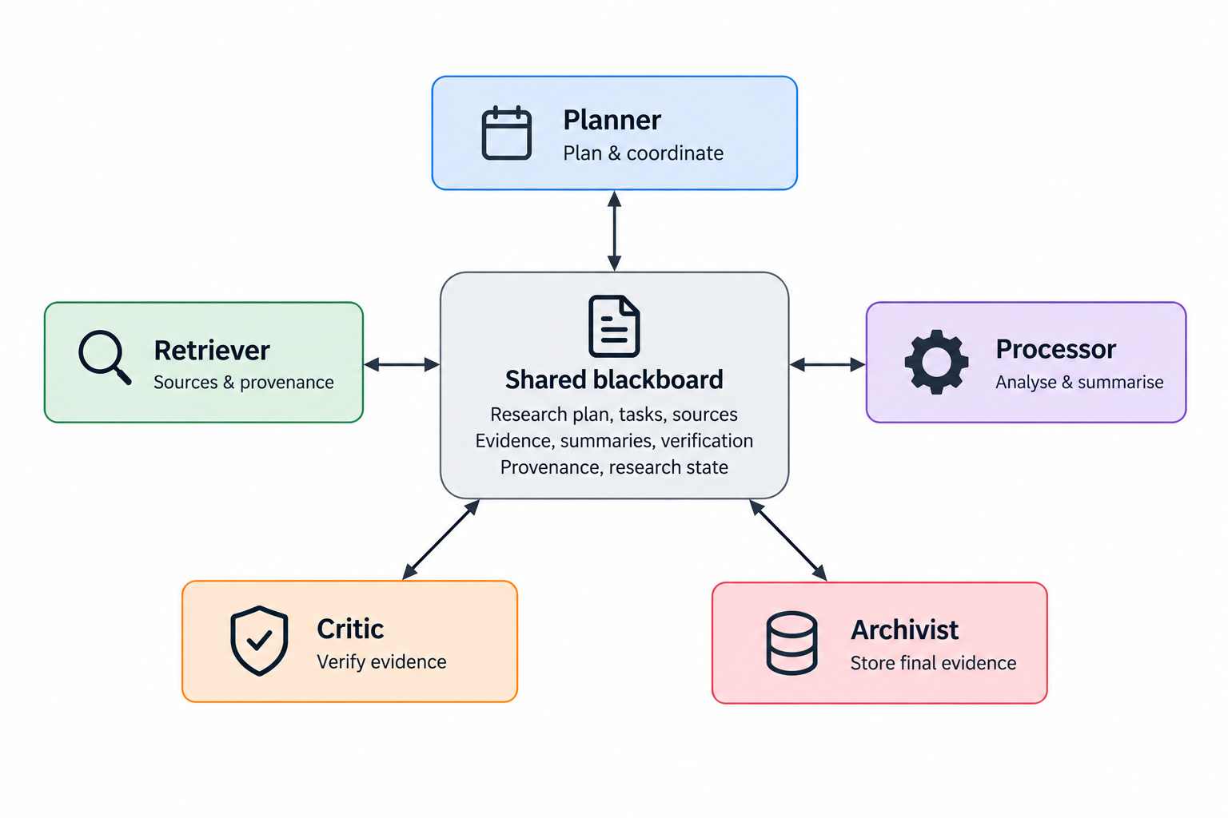
Figure 1. Architectural view: five role-specialised agents coordinating through the shared blackboard.

4. Development Approach
• Scrum with weekly sprints (Schwaber and Sutherland, 2020). LLM behaviour is empirically uncertain, so requirements emerge through experimentation; plan-driven methods presuppose stable, specifiable requirements (Sommerville, 2016). Sprint reviews double as prompt-evaluation checkpoints.
• Role-based agent-oriented analysis. Following the Gaia methodology, each agent is specified as a role with responsibilities, permissions (blackboard read and write rights), and protocols (Wooldridge, Jennings and Kinny, 2000); the five roles map onto per-member work packages, supporting virtual teamwork.
• Testing by agent type. Deterministic agents (Retriever, Archivist) receive pytest unit tests; the Critic is unit-tested against bespoke-minicheck:7b; the Planner and Processor use an evaluation harness of fixed research questions with known relevant sources, measuring source recall and Critic pass rate.

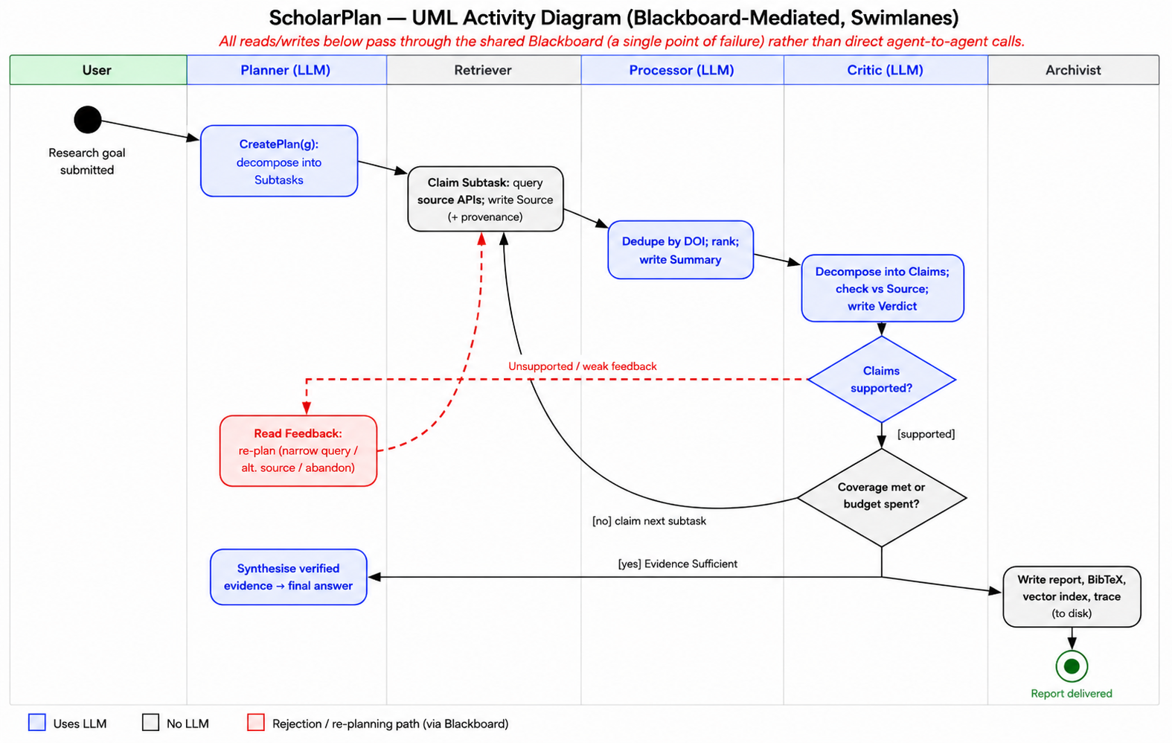
Figure 2. Activity view: end-to-end flow by agent, with the Critic-rejection re-planning loop dashed.

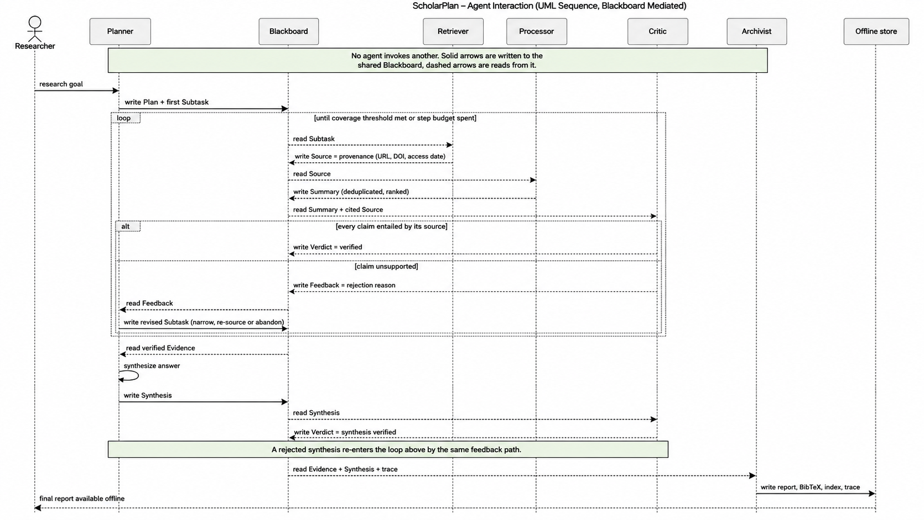
Figure 3. Sequence view: agents interacting through the blackboard; only the Archivist writes to disk.

5. Anticipated Challenges
• Task decomposition. LLM planners over- or under-decompose goals (Huang et al., 2024). Mitigation: JSON-schema-constrained subtasks, one subtask issued per ReAct step, and a coverage threshold that terminates the loop, keeping plan validity under external control (Kambhampati et al., 2024).
• Unreliable or noisy online data. Irrelevant context degrades LLM reasoning (Shi et al., 2023). Mitigation: DOI deduplication, embedding-based relevance ranking (Reimers and Gurevych, 2019), and provenance captured at fetch time (Priem, Piwowar and Orr, 2022).
• Hallucinated claims. Summaries may assert content absent from the source (Ji et al., 2023). Mitigation: claim-level entailment checking by the Critic (Tang, Laban and Durrett, 2024); unsupported summaries never reach the report.
• Explainability of LLM decisions. Mitigation: every Thought, Verdict, and Feedback is persisted to the blackboard and exported as a trace, making the reasoning chain auditable in the manner of chain-of-thought (Wei et al., 2022).
• Agent cooperation and single point of failure. The blackboard decouples agents but concentrates risk (Salemi et al., 2025). Mitigation: SQLite transactions for atomic claims and the step budget to prevent runaway loops.
• Cost and rate limits. Azure credit is non-renewable, and arXiv permits one request every three seconds. Mitigation: the 20-step budget, source caching, and an early sprint measuring real per-run cost, since benchmark costs cannot simply be summed.
• Non-deterministic behaviour. Mitigation: the evaluation harness in Section 4 and low-temperature sampling.

6. Tools, Libraries, Models and Environments
• Language and environment: Python 3.11; uv for virtual environments and dependencies; VS Code; Git and GitHub for source control and code review.
• Models: GPT-5-mini (Planner, Processor; fallback GPT-5-nano) and Llama-3.3-70B-Instruct (Critic) on Azure for Students; bespoke-minicheck:7b via Ollama for testing; sentence-transformers for embeddings.
• Data sources: arXiv API, OpenAlex API, and Crossref REST API.
• Storage: sqlite3 (blackboard, metadata) and sqlite-vec (vector index).
• Testing: pytest and a bespoke evaluation harness.
• Hosting: Azure for Students ($100 credit) was selected over Hugging Face inference credits ($0.10 per month, too small for repeated evaluation) and Ollama (hardware the team cannot guarantee).

7. Conclusion
ScholarPlan combines a deliberative ReAct planner, reactive specialists, and blackboard coordination to meet the three success criteria within free-tier constraints: retrieval by the Retriever, processing by the Processor and Critic, storage by the Archivist. Its principal risks (decomposition quality, noisy data and cost) are addressed through schema-constrained planning, independent verification and a bounded step budget.

References
Dubey, A. et al. (2024) ‘The Llama 3 herd of models’, arXiv preprint arXiv:2407.21783. Available at: https://arxiv.org/abs/2407.21783 (Accessed: 2 September 2026).
Guo, T., Chen, X., Wang, Y., Chang, R., Pei, S., Chawla, N.V., Wiest, O. and Zhang, X. (2024) ‘Large language model based multi-agents: A survey of progress and challenges’, in Proceedings of the Thirty-Third International Joint Conference on Artificial Intelligence (IJCAI-24). Jeju: IJCAI, pp. 8048–8057. Available at: https://doi.org/10.24963/ijcai.2024/890 (Accessed: 2 September 2026).
Hayes-Roth, B. (1985) ‘A blackboard architecture for control’, Artificial Intelligence, 26(3), pp. 251–321. Available at: https://doi.org/10.1016/0004-3702(85)90063-3 (Accessed: 2 September 2026).
Huang, X., Liu, W., Chen, X., Wang, X., Wang, H., Lian, D., Wang, Y., Tang, R. and Chen, E. (2024) ‘Understanding the planning of LLM agents: A survey’, arXiv preprint arXiv:2402.02716. Available at: https://arxiv.org/abs/2402.02716 (Accessed: 2 September 2026).
Ji, Z., Lee, N., Frieske, R., Yu, T., Su, D., Xu, Y., Ishii, E., Bang, Y.J., Madotto, A. and Fung, P. (2023) ‘Survey of hallucination in natural language generation’, ACM Computing Surveys, 55(12), Article 248, pp. 1–38. Available at: https://doi.org/10.1145/3571730 (Accessed: 2 September 2026).
Kambhampati, S., Valmeekam, K., Guan, L., Verma, M., Stechly, K., Bhambri, S., Saldyt, L. and Murthy, A. (2024) ‘Position: LLMs can’t plan, but can help planning in LLM-Modulo frameworks’, in Proceedings of the 41st International Conference on Machine Learning (ICML 2024). Vienna: PMLR 235. Available at: https://arxiv.org/abs/2402.01817 (Accessed: 2 September 2026).
Lewis, P. et al. (2020) ‘Retrieval-augmented generation for knowledge-intensive NLP tasks’, in Advances in Neural Information Processing Systems 33 (NeurIPS 2020), pp. 9459–9474. Available at: https://arxiv.org/abs/2005.11401 (Accessed: 2 September 2026).
Patil, S.G., Zhang, T., Wang, X. and Gonzalez, J.E. (2023) ‘Gorilla: Large language model connected with massive APIs’, arXiv preprint arXiv:2305.15334. Available at: https://arxiv.org/abs/2305.15334 (Accessed: 2 September 2026).
Priem, J., Piwowar, H. and Orr, R. (2022) ‘OpenAlex: A fully-open index of scholarly works, authors, venues, institutions, and concepts’, arXiv preprint arXiv:2205.01833. Available at: https://arxiv.org/abs/2205.01833 (Accessed: 2 September 2026).
Reimers, N. and Gurevych, I. (2019) ‘Sentence-BERT: Sentence embeddings using Siamese BERT-networks’, in Proceedings of the 2019 Conference on Empirical Methods in Natural Language Processing and the 9th International Joint Conference on Natural Language Processing (EMNLP-IJCNLP). Hong Kong: Association for Computational Linguistics, pp. 3982–3992.
Salemi, A., Parmar, M., Goyal, P., Song, Y., Yoon, J., Zamani, H., Palangi, H. and Pfister, T. (2025) ‘LLM-based multi-agent blackboard system for information discovery in data science’, arXiv preprint arXiv:2510.01285. Available at: https://arxiv.org/abs/2510.01285 (Accessed: 2 September 2026).
Schwaber, K. and Sutherland, J. (2020) The Scrum Guide. Available at: https://scrumguides.org (Accessed: 2 September 2026).
Shi, F., Chen, X., Misra, K., Scales, N., Dohan, D., Chi, E.H., Schärli, N. and Zhou, D. (2023) ‘Large language models can be easily distracted by irrelevant context’, in Proceedings of the 40th International Conference on Machine Learning (ICML 2023). Honolulu: PMLR 202, pp. 31210–31227.
Shinn, N., Cassano, F., Gopinath, A., Narasimhan, K. and Yao, S. (2023) ‘Reflexion: Language agents with verbal reinforcement learning’, in Advances in Neural Information Processing Systems 36 (NeurIPS 2023). Available at: https://arxiv.org/abs/2303.11366 (Accessed: 2 September 2026).
Sommerville, I. (2016) Software Engineering. 10th edn. Harlow: Pearson.
Tang, L., Laban, P. and Durrett, G. (2024) ‘MiniCheck: Efficient fact-checking of LLMs on grounding documents’, in Proceedings of the 2024 Conference on Empirical Methods in Natural Language Processing (EMNLP 2024). Miami: Association for Computational Linguistics. Available at: https://doi.org/10.18653/v1/2024.emnlp-main.499 (Accessed: 2 September 2026).
Wei, J., Wang, X., Schuurmans, D., Bosma, M., Ichter, B., Xia, F., Chi, E., Le, Q.V. and Zhou, D. (2022) ‘Chain-of-thought prompting elicits reasoning in large language models’, in Advances in Neural Information Processing Systems 35 (NeurIPS 2022), pp. 24824–24837. Available at: https://arxiv.org/abs/2201.11903 (Accessed: 2 September 2026).
Wooldridge, M. (2009) An Introduction to MultiAgent Systems. 2nd edn. Chichester: John Wiley & Sons.
Wooldridge, M., Jennings, N.R. and Kinny, D. (2000) ‘The Gaia methodology for agent-oriented analysis and design’, Autonomous Agents and Multi-Agent Systems, 3(3), pp. 285–312. Available at: https://doi.org/10.1023/A:1010071910869 (Accessed: 2 September 2026).
Yao, S., Zhao, J., Yu, D., Du, N., Shafran, I., Narasimhan, K. and Cao, Y. (2023) ‘ReAct: Synergizing reasoning and acting in language models’, in Proceedings of the Eleventh International Conference on Learning Representations (ICLR 2023). Available at: https://arxiv.org/abs/2210.03629 (Accessed: 2 September 2026).
Berkeley Function-Calling Leaderboard (2026) Berkeley Function-Calling Leaderboard V4. Berkeley, CA: UC Berkeley Sky Computing Lab. Available at: https://gorilla.cs.berkeley.edu/leaderboard.html (Accessed: 16 Aug 2026).
Microsoft (2026) Azure Retail Prices API. Available at: https://learn.microsoft.com/en-us/rest/api/cost-management/retail-prices/azure-retail-prices (Accessed: 16 August 2026).

