Codebase-Aware RAG
A Complete Guide — Concepts, Architecture, Working, and Interview Preparation
A Retrieval-Augmented Generation system that answers natural-language questions
about a Python codebase by parsing real function/class structure and using the
call graph between functions to pull in relevant context automatically.

Table of Contents
1. Project Overview — What This Is and Why It's Different
2. Full Architecture (7 Phases)
3. Key Concepts & Terminology (Glossary)
4. Deep Dive: Phase 1 — AST Parser
5. Deep Dive: Phase 2 — Call Graph Builder
6. Deep Dive: Phase 3 — Embeddings + Storage
7. Deep Dive: Phase 4 — Graph-Expanded Retrieval
8. Deep Dive: Phase 5 — Answer Generation + API
9. Deep Dive: Phase 6 & 6b — Evaluation Harness
10. Deep Dive: Phase 7 — MCP Server
11. Important Design Decisions & Trade-offs
12. Known Limitations
13. Interview Questions & Answers (40 Q&A)

1. Project Overview
Most simple “chat with your code” tools work by cutting every file into fixed-size text blocks (for example, every 500 characters) and then doing a plain vector search over those blocks. This breaks in two predictable ways:
- A long function gets cut in half in the middle of its logic, because the splitter doesn't know where a function starts or ends.
- Retrieval returns one isolated snippet with no surrounding context — you get the matched piece, but not the function that calls it or the function it calls.
This project, Codebase-Aware RAG, is built to avoid both problems. It does three things differently:
- Parses .py files and Python code cells inside .ipynb notebooks using Python's own ast (Abstract Syntax Tree) module, so every chunk is a whole function or method — never cut mid-logic.
- Builds a resolved call graph (who calls whom) between all the functions in the repo, filtering out noise from library calls and built-ins.
- Expands retrieval one hop across that call graph at query time, so the AI answering a question sees a function AND its immediate caller/callee, not an isolated snippet.
Example (the project's own flagship case):
Question: "where is class imbalance handled?"
Plain vector search finds: undersample()
Graph-expanded retrieval ALSO finds: prepare_training_data()
(because it is the function that CALLS undersample())
The result is that the AI answering the question can explain not just WHAT balances the data, but WHEN and WHY it gets called — because both pieces of code are shown to it together.
Every part of the pipeline is provider-agnostic — meaning you can swap out pieces without rewriting anything else:
- Embeddings: sentence-transformers (local, free) is the primary choice, with automatic fallback to TF-IDF if the model can't be downloaded.
- Answer generation: swap between stub (no setup needed), ollama (local, free LLM), or anthropic (paid Claude API) with a single line of config.

2. Full Architecture (7 Phases)
The whole project is organized as 7 sequential phases. Each phase is a separate, flat Python file (no package structure) that imports directly from the one before it. This keeps the layering very clear: Phase 4 cannot work without Phase 3's stored data, and Phase 3 cannot work without Phase 2's resolved call graph.
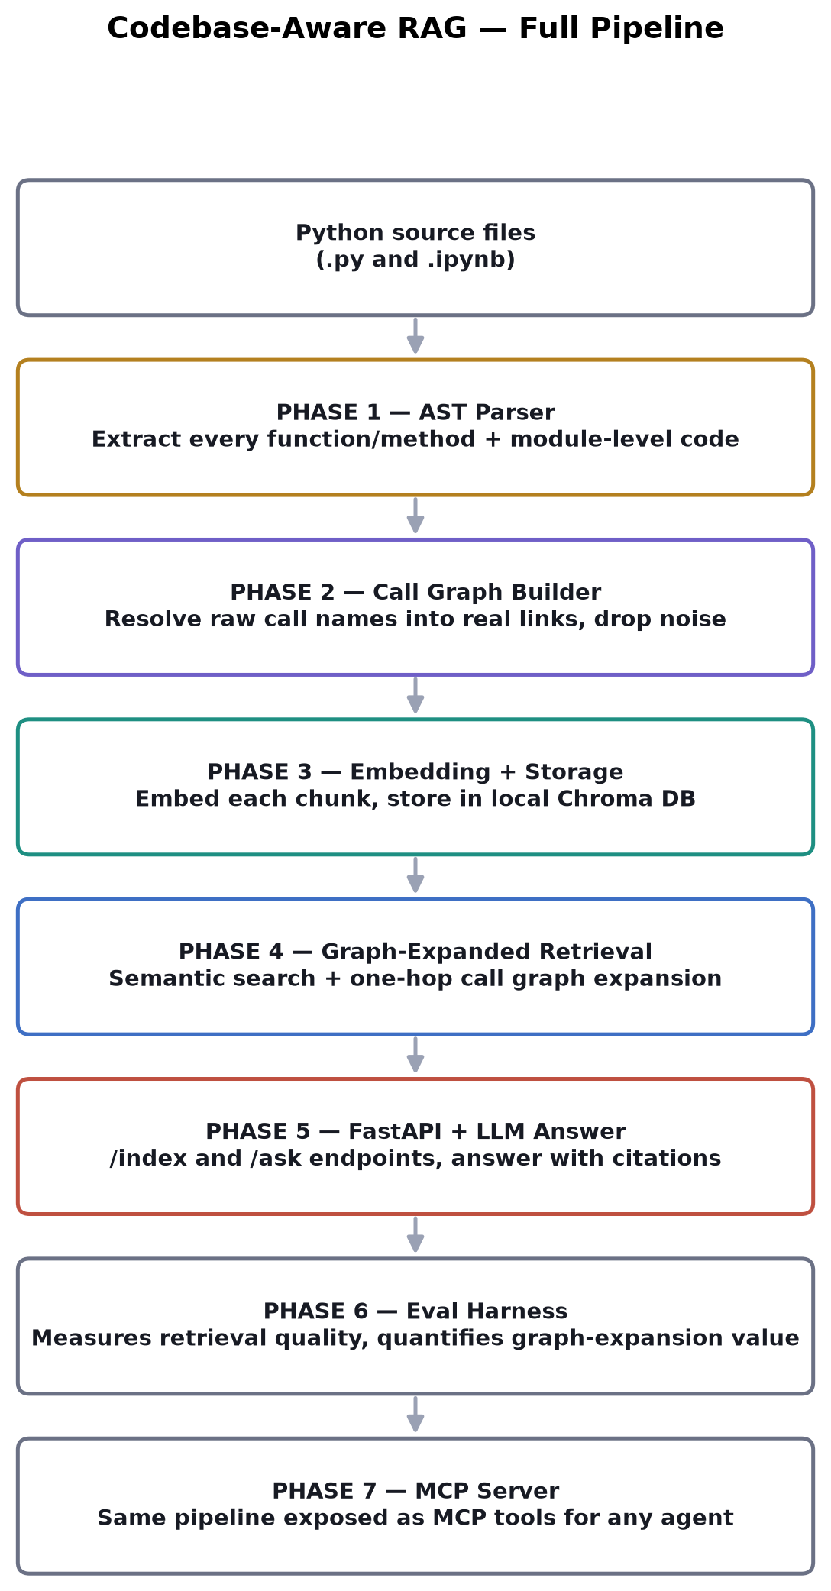
File-to-phase map:
File | Responsibility
phase1_ast_parser.py | AST parsing, function/module chunk extraction
phase2_call_graph.py | Call graph resolution (calls / called_by)
phase3_embedding_providers.py | Pluggable embedding backends
phase3_code_store.py | Chroma storage + semantic search
phase4_retriever.py | Graph-expanded retrieval
phase5_answer_providers.py | Pluggable LLM backends (stub / ollama / anthropic)
phase5_api.py | FastAPI app (browser UI, /index, /ask)
phase6_eval.py | Retrieval eval harness (recall metrics, top_k/hop A/B)
phase6b_answer_eval.py | Answer-quality eval (does the final answer text name the right function?)
phase7_mcp_server.py | MCP server exposing the pipeline as agent tools

Two separate flows run through this pipeline. Understanding this split is the single most important thing to remember about how the project works:
- INDEXING — runs once per repo, or again whenever the code changes. Phases 1 → 2 → 3.
- ASKING A QUESTION — runs every single time someone asks something. Phase 3 (embed the question) → Phase 4 → Phase 5.

2.1 Indexing Flow
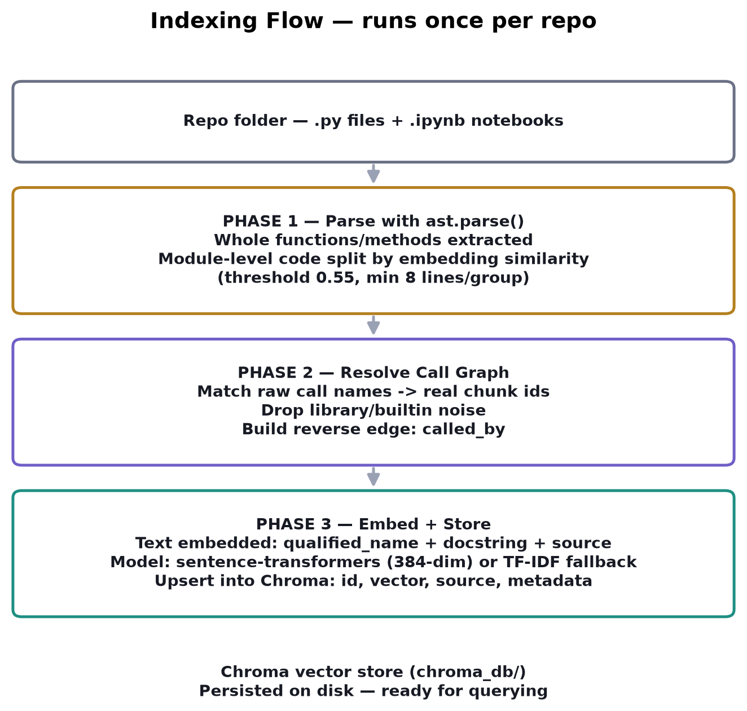

2.2 Query (Ask) Flow
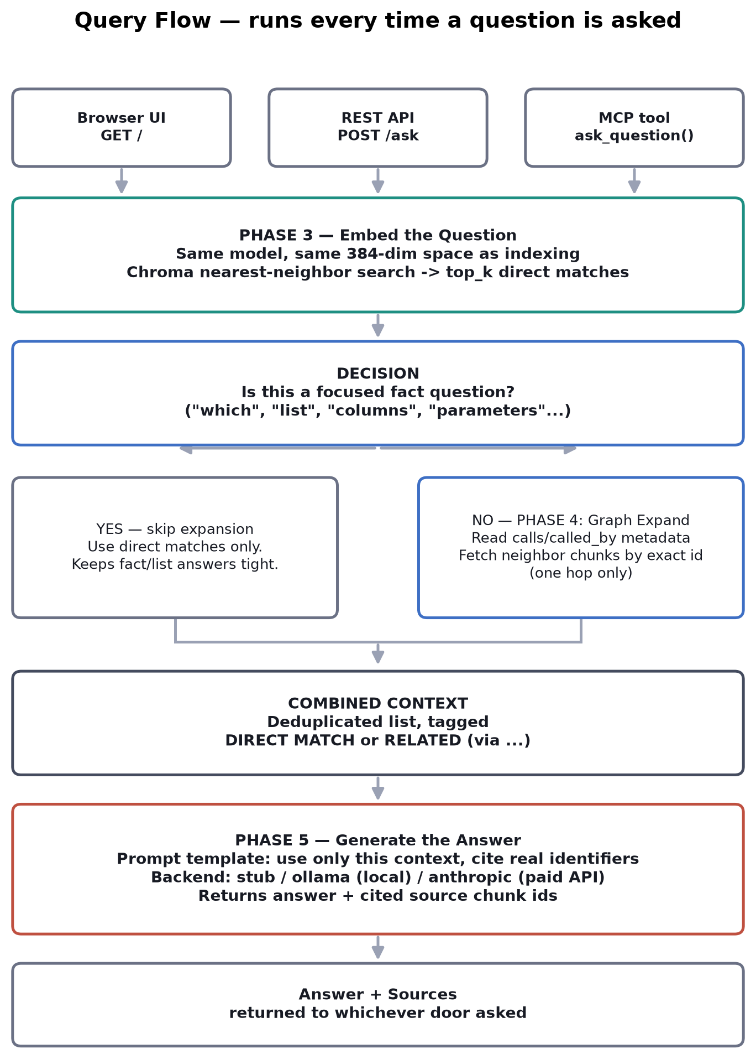

3. Key Concepts & Terminology (Glossary)
These are the exact terms used throughout the project's code and documentation — kept as-is, explained in simple language.
RAG (Retrieval-Augmented Generation) — A pattern where, instead of asking an AI model a question directly, you first RETRIEVE relevant information from your own data, then hand that information to the AI along with the question, so it answers using real facts instead of guessing.
AST (Abstract Syntax Tree) — The structured, tree-shaped representation of code that Python's own ast module produces when it reads a .py file. It knows exactly where every function starts and ends, unlike text-based tools like regex.
Chunk — One retrievable unit of code — in this project, always a whole function, a whole method, or a whole 'section' of module-level script code. Never a fixed-size slice of text.
CodeChunk — The actual data structure (a Python dataclass) used to represent one chunk: its id, name, qualified_name, file path, line numbers, source code, docstring, and its calls / called_by lists.
Qualified name — A function's full name including its class, if any — e.g. ModelTrainer.train instead of just train. Used to tell apart same-named methods on different classes.
Call graph — A map of which functions call which other functions across the whole repository — built in Phase 2. Stored as two lists per chunk: calls (what this function calls) and called_by (what calls this function).
Call resolution — The process of turning a raw called name (like the text "undersample") into an actual chunk id (like "data_utils.py::undersample") by looking it up in the repo's own functions. Anything that doesn't match a real chunk (like a pandas or built-in call) is dropped as noise.
Embedding — A list of numbers (a vector) that represents the MEANING of a piece of text. Similar meanings produce numerically similar vectors, even if the exact words are different.
Embedding provider — The pluggable component responsible for turning text into embeddings. This project's primary provider is sentence-transformers; its fallback is TF-IDF.
sentence-transformers / all-MiniLM-L6-v2 — The specific local AI model used to generate embeddings. Runs on CPU, free, produces a 384-number vector per piece of text, and needs one one-time internet download (~80MB) before it can run fully offline.
TF-IDF (Term Frequency – Inverse Document Frequency) — A much older, keyword-based way of turning text into vectors, used ONLY as an offline fallback if the sentence-transformers model can't be downloaded. It matches based on shared words, not true meaning.
Vector database / Chroma — A specialized local database (chromadb) built to store embeddings and quickly find the ones closest to a given query vector. This project stores each chunk's vector plus its source code and call-graph metadata together in one Chroma collection called code_chunks.
Upsert — "Update or insert." Chroma's upsert() call overwrites a chunk's entry if its id already exists, instead of creating a duplicate — this is what makes re-indexing after a code change safe to run repeatedly.
Semantic search — Finding chunks whose embeddings are numerically closest to the question's embedding — i.e., closest in MEANING, not in exact keyword overlap.
top_k — The number of direct semantic matches to retrieve for a question, before any graph expansion happens. Configurable per request (default is 3).
Graph-expanded retrieval / one-hop expansion — After finding the top_k direct matches, the retriever also looks up each match's calls and called_by list and pulls in those neighboring chunks too — but only one level deep (one hop), not further.
Direct match vs. graph neighbor — Two labels attached to every retrieved chunk: direct_match means it was found by semantic search itself; graph_neighbor means it was pulled in afterwards because it's connected in the call graph to a direct match.
Semantic module chunking — The technique (Phase 1) for splitting long, function-free module-level script code into several topic-coherent chunks, by embedding each top-level statement and cutting a new chunk whenever the running average meaning drifts too far from the current group.
SEMANTIC_SPLIT_THRESHOLD — The similarity cutoff (0.55) used in semantic module chunking — chosen by testing a range (0.50–0.80) against a real script and picking the value that produced the most sensible chunk boundaries.
SEMANTIC_MIN_GROUP_LINES — A floor of 8 lines that a chunk-in-progress must reach before it's allowed to be closed off — stops a single short statement from becoming its own tiny, low-context chunk.
Cosine similarity — A mathematical way of measuring how similar two vectors' DIRECTIONS are, regardless of their size. Used both to compare a question's embedding against stored chunks, and internally during semantic module chunking.
Answer provider — The pluggable component responsible for turning retrieved code context + a question into a final natural-language answer. Three options: StubProvider (no AI, just formats context), OllamaProvider (local, free LLM), AnthropicProvider (paid Claude API).
Prompt template — The fixed set of instructions given to the LLM every time, telling it to use only the provided context, prefer exact identifiers, stay concise, and not guess.
Citations / sources — The list of exact chunk ids that were used to produce an answer — returned alongside every answer so you can verify where the information came from.
Recall (primary_recall / neighbor_recall) — Evaluation metrics from Phase 6. primary_recall asks 'did the correct chunk show up at all?' neighbor_recall asks 'for flow questions, did the correct RELATED chunk also get pulled in by graph expansion?'
MCP (Model Context Protocol) — An open standard that lets AI agents (like Claude Desktop or Claude Code) call external tools directly. Phase 7 exposes this project's pipeline as three MCP tools instead of only a REST API.
Notebook cell parsing — Support for Jupyter notebooks (.ipynb): each Python code cell is extracted and parsed exactly like a small standalone .py file, with cell numbers baked into chunk ids (e.g. analysis.ipynb::cell_3::train_model).

4. Deep Dive: Phase 1 — AST Parser
File: phase1_ast_parser.py. Main class: RepoParser.
This phase walks every .py and .ipynb file in a repo folder and turns it into a flat list of CodeChunk objects. It never uses regex or fixed-length text splitting — it uses Python's own ast.parse() to get the language's real parse tree, so function boundaries are always exact, no matter how the code is formatted (multi-line signatures, decorators, nested functions all work correctly).

How a normal function becomes a chunk
- Walk the AST looking for every FunctionDef / AsyncFunctionDef node.
- If it's inside a ClassDef, record it as a method with a qualified_name like ModelTrainer.train.
- If it's not inside any class, record it as a plain function.
- Grab its exact start_line / end_line and slice the real source text between them — this guarantees the chunk is the WHOLE function, never a partial cut.
- Grab its docstring if it has one.
- Walk inside the function body and collect every ast.Call node it finds — both bare calls like foo() and attribute calls like self.foo() or df.groupby() — as its raw "calls" list (not yet resolved to real chunk ids; that happens in Phase 2).

What happens when a file has NO functions
Real-world files are not always full of neat functions. Streamlit apps, notebook-style scripts, and straight-line training scripts often run top to bottom with no def anywhere. This project does not skip those files — their top-level code becomes its own chunk(s), called module chunks:
- Short file, one topic: all the leftover top-level lines become ONE chunk, id'd file.py::__module__.
- Long file, several topics: the leftover code is split into several coherent parts using SEMANTIC MODULE CHUNKING (see below), id'd file.py::__module__::part1, part2, and so on.
- File with only imports (or truly empty): produces ZERO chunks for that file — there is genuinely nothing to index, and nothing is invented.

Semantic Module Chunking — the deep dive
This is one of the more advanced pieces of the project. The problem it solves: a function-free script that mixes several unrelated jobs (e.g. data cleaning, then feature engineering, then model training, then a totally separate customer-segmentation step) would otherwise become ONE giant, blurry chunk with one confused embedding covering five different ideas at once.
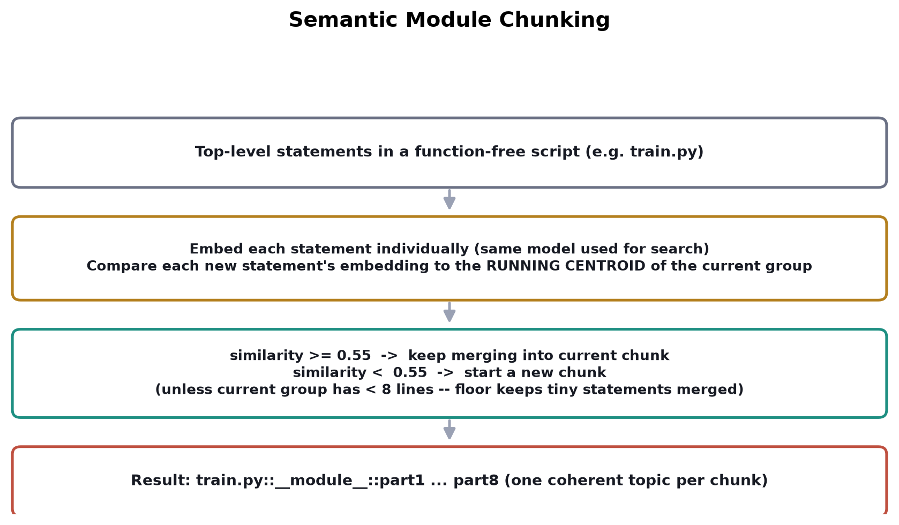
Step by step:
- Collect every top-level statement in the file (skipping def/class bodies and import lines) as a separate small unit, keeping its own line range and the calls found inside it.
- Embed each unit individually, using the exact same embedding model that is later used for search — no new model, no separate logic.
- Walk through the units in order. For each new unit, compare its embedding to the RUNNING CENTROID (average vector) of the group currently being built — not just to the previous single statement, because comparing to only one neighbor was noisy (a short one-line statement like model.fit(X, y) can look "dissimilar" purely from being short).
- If the similarity is ≥ 0.55 (SEMANTIC_SPLIT_THRESHOLD), OR the current group hasn't reached 8 lines yet (SEMANTIC_MIN_GROUP_LINES), keep merging into the current group.
- Otherwise, close the current group and start a new one — this is the moment a real topic change was detected.
- Each finished group becomes one chunk.
Real measured result on test_repo/train.py (a 147-line script with zero functions):
BEFORE: 1 chunk (train.py::__module__, lines 14-160, 147 lines, 5 unrelated topics blended)
AFTER: 8 chunks (train.py::__module__::part1 .. part8, 1-43 lines each)
part1 lines 14-22 setup (paths, load CSV, mkdir)
part2 lines 24-52 churn label cleanup + feature engineering
part3 lines 54-96 train/test column split + preprocessing pipeline
part4 lines 98-110 model pipeline definition
part5 lines 112-128 fit + save model
part6 lines 130-140 segmentation column prep
part7 lines 142-158 KMeans clustering + save
part8 lines 160-160 final print
The 0.55 threshold itself was not guessed — it was chosen by sweeping values from 0.50 to 0.80 against this real file and picking the value that produced the most sensible boundaries. This “measure, don't assume” approach repeats throughout the project (see the evaluation harness in Section 9).
Notebook (.ipynb) support:
- Each notebook is read as JSON; only cells where cell_type == "code" are processed.
- Each code cell is parsed exactly like a small standalone .py file, using the same function/module extraction logic.
- Notebook-only syntax such as %matplotlib inline, !pip install ..., and ?some_function is commented out first (while preserving line numbers) so the remaining real Python in the cell can still be parsed by ast.
- Chunk ids include the cell number, e.g. analysis.ipynb::cell_3::train_model.

5. Deep Dive: Phase 2 — Call Graph Builder
File: phase2_call_graph.py. Main class: CallGraphBuilder.
Phase 1 gave every chunk a list of RAW call names (plain text like "undersample", but also noise like "read_csv" from pandas). Phase 2's job is to turn those raw names into real, resolved links between chunks — this resolved graph is exactly what makes retrieval smarter than plain vector search.

How resolution works
- Build a name_index: a dictionary mapping each function's short name (e.g. "train") to a list of every chunk id that has that name — handling the case where two different classes both define a method with the same name.
- For every raw name a chunk calls, look it up in name_index.
- If there's no match, DROP it — it's a library call or a built-in, not something in this repo.
- If there IS a match, keep it as a resolved edge, replacing the raw text name with the real target chunk id.
- Once every chunk's calls list is resolved, build the REVERSE edge: called_by. If chunk A calls chunk B, then B's called_by list gets A added to it.

Known limitation — stated plainly in the project itself
This is NAME-BASED resolution, not true static analysis. If two different classes both have a method called train, a call written as self.train() could resolve ambiguously — the current code handles the common case (a unique name across the whole repo) and falls back to “first match” otherwise. A fully correct fix would require type inference (actually knowing what type self is at that point in the code), which is intentionally left out of scope for this project.
get_neighbors(chunk_id): a convenience method that returns everything a chunk calls PLUS everything that calls it — combined, this is exactly the “one-hop neighborhood” used later in Phase 4.

6. Deep Dive: Phase 3 — Embeddings + Storage
Files: phase3_embedding_providers.py (the embedding backends) and phase3_code_store.py (the CodeStore class, using Chroma).

The embedding providers
- EmbeddingProvider is an abstract interface with one method: embed(texts) -> list of vectors. Nothing else in the project needs to know which concrete backend is active.
- SentenceTransformerProvider (primary): loads the all-MiniLM-L6-v2 model locally, runs entirely on CPU, and turns text into a 384-number vector. Free, no API key, but needs one internet connection the very first time to download (~80MB); after that it's fully offline forever.
- TfidfProvider (fallback): uses scikit-learn's TfidfVectorizer, fully offline with zero downloads, but weaker — keyword-overlap based, not true deep semantic similarity. It only activates automatically if the sentence-transformers model fails to load.
- get_embedding_provider(): tries the primary backend first inside a try/except, and only falls back to TF-IDF if that raises an exception.

What text actually gets embedded
For every chunk, the exact text sent to the embedding model is:
f"{qualified_name}\n{docstring}\n{source}"
The docstring is placed first (right after the name) deliberately, because it's usually the clearest, most human-readable statement of what a function is FOR — giving it more influence on the resulting embedding than if it were buried after a long function body.

How storage works (CodeStore.index_chunks)
- A local, persistent Chroma client is created at a folder (default ./chroma_db) — one single collection is used, named "code_chunks".
- Every chunk's combined text is embedded in one batch call for efficiency.
- collection.upsert() is called with: ids (the chunk ids), embeddings (the vectors), documents (the RAW SOURCE CODE, unmodified — note this is slightly different text than what was embedded), and metadatas (file_path, qualified_name, docstring, start_line, end_line, and the calls/called_by lists joined into comma-separated strings, because Chroma metadata values must be plain scalars, not lists).
- Because it's an UPSERT (update-or-insert), re-running indexing after a code change is completely safe — Chroma overwrites existing ids instead of creating duplicates. This is what makes re-indexing a live repo practical.

How search works (CodeStore.query)
- The incoming question is embedded using the exact same provider and model as indexing — this is essential, because a question and a piece of code can only be compared if they live in the same numerical space.
- collection.query() is called with that single embedding and n_results=top_k.
- Chroma's internal nearest-neighbor index returns the top_k closest stored vectors, along with their ids, documents, and metadata — this is PLAIN semantic search, with no graph logic yet; that's entirely Phase 4's job.

7. Deep Dive: Phase 4 — Graph-Expanded Retrieval
File: phase4_retriever.py. Main class: GraphExpandedRetriever.
This is the phase that makes this project meaningfully different from a basic RAG demo. Plain semantic search finds chunks that SOUND related to a question, but the full answer often needs a function's neighbors too.

retrieve(question, top_k, force_expand) — step by step
- Run Phase 3's plain semantic search to get the top_k direct matches.
- Decide whether to expand the graph, using _should_expand_graph(): a simple keyword heuristic. If the question contains focused/fact-style words ("what are", "which", "list", "input", "variable", "feature", "column", "parameter"...), expansion is SKIPPED, so a fact-listing answer stays tight instead of getting diluted with tangential code. Otherwise (a “flow” style question like “where is X handled?”), expansion is turned ON.
- For every direct match, read its already-resolved calls and called_by metadata (stored back in Phase 3) and collect any neighbor chunk ids not already in the result set.
- Fetch those neighbor chunks from Chroma directly by id, using collection.get(ids=...) — this is a DIRECT LOOKUP, not a new similarity search, because the exact ids are already known from the metadata.
- Return one combined, deduplicated list. Every entry is tagged relation: "direct_match" or "graph_neighbor", and every graph_neighbor also carries matched_via, naming which direct match pulled it in.

Why only ONE hop, never two
Two-hop expansion was considered and deliberately rejected: it tends to pull in loosely related code that drowns out the actual answer. One hop is a conscious trade-off between completeness and noise, not an oversight — and it's exactly what Phase 6's evaluation harness was built to double-check (see Section 9).
force_expand: an override parameter used only by the evaluation harness, to force graph expansion strictly on or off regardless of the question's wording — letting the eval script run a clean A/B comparison on the same question set.

8. Deep Dive: Phase 5 — Answer Generation + API
Files: phase5_answer_providers.py (LLM backends) and phase5_api.py (the FastAPI app).

Answer providers — same pattern as embeddings
- AnswerProvider is an abstract interface with one method: generate(question, context) -> answer text.
- StubProvider: no AI call at all. Just formats the retrieved context into readable sections. Its whole purpose is to prove the retrieval half of the pipeline works BEFORE spending any time setting up a real LLM.
- OllamaProvider: fully local and free. Talks to a locally running Ollama server (default model llama3.2:3b) over HTTP at localhost:11434. Needs Ollama installed and a model pulled once, then works fully offline.
- AnthropicProvider: calls the real Claude API. Higher-quality answers, costs a small amount per query, needs the anthropic package and an ANTHROPIC_API_KEY environment variable.
- get_answer_provider(backend=...): the single switch. Changing this ONE line in phase5_api.py (and restarting the server — it's read once at startup, not per request) is the entire process for swapping which AI answers questions.

The shared prompt template
All three-ish backends that actually call an LLM share one fixed set of instructions:
- Use ONLY the provided code context — do not guess or use outside knowledge.
- Prefer exact identifiers: variable names, column names, function names, file ids.
- Ignore nearby code that is not required for the answer.
- If the question is a "what are / which / list / inputs / features / columns / parameters" question, answer only with bullets of the relevant names.
- Keep the answer concise: max 8 bullets or 120 words. If the context is missing the answer, say so in one short sentence instead of guessing.

FastAPI endpoints (phase5_api.py)
Endpoint | What it does
GET / | Serves the browser UI (index a repo, ask a question, pick top_k, see sources).
POST /index | Runs RepoParser -> CallGraphBuilder -> CodeStore.index_chunks() on a given repo_path.
POST /ask | Runs the full retrieve-then-generate flow, returns JSON: {question, answer, sources}.
POST /ask/plain | Same as /ask, but returns a plain-text formatted response for terminal use.

9. Deep Dive: Phase 6 & 6b — Evaluation Harness
Files: phase6_eval.py (retrieval quality) and phase6b_answer_eval.py (answer quality).
This is the part of the project that answers the question every RAG demo tends to dodge: “how do you actually know it works?” Instead of assuming graph expansion helps, the project measures it.

Why a separate eval_repo/ instead of test_repo/
test_repo/ (a real Streamlit churn-prediction app) turned out to be almost entirely module-level script code with almost no real function-to-function call graph — so it couldn't exercise graph expansion at all. eval_repo/ is a small, purpose-built fixture repo with a real, known call chain (data loading → class-imbalance handling → training → evaluation → inference → API), reproducing the project's own flagship example on purpose, so the evaluation is reproducible no matter what real project test_repo/ happens to contain.
It's indexed into an ISOLATED Chroma path (./chroma_db_eval), so running the eval never touches your real index.

Phase 6 — Retrieval evaluation
A fixed 21-question set (eval_questions.json), each tagged one of:
- flow — has a known “neighbor” chunk (a caller/callee) that one-hop expansion should surface.
- focused — a fact/list-style question where expansion should stay off.
- none — an out-of-scope question with no correct answer, logged qualitatively rather than scored.
It sweeps top_k and forces graph expansion on/off, measuring:
- primary_recall — did the directly-relevant chunk show up at all?
- neighbor_recall — for flow questions, did the related (graph-expanded) chunk ALSO show up? This is the metric that specifically tests whether Phase 4 is pulling its weight.
Measured result:
top_k | expand | primary_recall | neighbor_recall | n_primary | n_neighbor
--------------------------------------------------------------------------
3 | False | 80.0% | 50.0% | 20 | 12
3 | True | 90.0% | 83.3% | 20 | 12
1 | True | 80.0% | 83.3% | 20 | 12
5 | True | 100.0% | 100.0% | 20 | 12
At top_k=3, turning on one-hop graph expansion lifts neighbor_recall from 50% to 83.3% — a measured, quantified answer to “does Phase 4 actually help,” not just an assumption.

Phase 6b — Answer-quality evaluation
Phase 6 only proves the right CODE reaches the LLM's context. It says nothing about whether the LLM's final natural-language ANSWER is actually correct. Phase 6b closes that gap: it runs the same 20 questions through the REAL pipeline end to end (retrieval → real Ollama-generated answer, same as /ask), then checks whether the generated answer TEXT actually names the correct function(s) — a deterministic substring check against identifiers, not a second LLM-as-judge call.
answer_primary_recall: 75.0% (15/20)
answer_neighbor_recall: 58.3% (7/12)
Compared against the retrieval-level numbers (90.0% / 83.3% at top_k=3), there is a real, measured drop between “the right context was retrieved” and “the final answer actually said it.” The most likely cause called out directly by the project: the prompt template's own instruction to “ignore nearby code that is not required for the answer” appears to sometimes suppress the small local model from mentioning a correctly retrieved neighbor chunk, even when it's sitting right there in context. This is the project's most important honest finding: good retrieval does NOT automatically mean a good final answer — they are separate failure points and need separate measurement.

10. Deep Dive: Phase 7 — MCP Server
File: phase7_mcp_server.py, using FastMCP.
MCP (Model Context Protocol) is an open standard that lets AI agents — Claude Desktop, Claude Code, or any custom agent — call external tools directly, as first-class actions, instead of only through a REST API a human has to script against. Phase 7 exposes this project's EXACT SAME pipeline (Phases 1–5, completely unmodified) as three MCP tools.
Tool | Purpose
index_repo(repo_path) | Parse, build the call graph, embed, and store a repo.
search_code(question, top_k) | Raw graph-expanded retrieval, no LLM step — returns source directly so the calling agent can reason over it itself.
ask_question(question, top_k) | Retrieval + LLM-generated answer with citations — same as /ask.

This file adds NO new retrieval or answer logic — it is only a thin adapter wiring the same RepoParser → CallGraphBuilder → CodeStore → GraphExpandedRetriever pipeline into MCP tool functions. This is only possible as a small, additive file because the earlier phases were cleanly layered from the start.

11. Important Design Decisions & Trade-offs
Whole-function chunking instead of fixed-size text splitting — Guarantees a chunk is always semantically complete — never cuts a function in half — at the cost of chunks having uneven sizes.
Provider-agnostic embeddings and LLMs — Both are hidden behind a small abstract interface (embed() / generate()), so switching from a free local model to a paid API is a one-line change with zero impact on the rest of the pipeline.
Name-based call resolution, not full static analysis — Much simpler to implement, works correctly for the common case (unique function names across a repo), but can resolve ambiguously if two classes share a method name — a known, explicitly stated trade-off.
One-hop graph expansion only — Chosen after considering two-hop expansion and finding it pulls in too much unrelated code. A deliberate precision-vs-completeness trade-off, not an oversight.
Heuristic-based expand/skip decision — A simple keyword check decides whether a question is “focused” (skip expansion) or “flow-style” (expand) — lightweight and effective, though not a learned classifier.
Upsert-based re-indexing — Re-running /index on a changed repo is always safe because Chroma overwrites existing chunk ids rather than duplicating them.
Separate eval_repo/ fixture for evaluation — test_repo/ (a real app) didn't actually exercise the call graph, so a small purpose-built repo with a known call chain was created specifically to make the evaluation meaningful and reproducible.
Measuring retrieval AND answer quality separately (Phase 6 vs 6b) — Proved that good retrieval (90% recall) does not automatically translate into a good final answer (75% answer recall) — the two need to be tracked as separate failure points.
Flat file structure, no Python packaging — All phases import each other directly (from phase1_ast_parser import ...) and live in one folder — intentionally simple, appropriate for a project of this size.

12. Known Limitations
- Python only. The parser uses Python's ast module, which cannot parse C++, Java, or JS. Adding another language means writing a separate Tree-sitter-based parser for it; everything downstream (call graph, storage, retrieval, API) stays the same.
- Notebook support is code-cell based only. Markdown cells, outputs, images, and non-Python cell magics are not indexed as knowledge sources.
- Call resolution is name-based, not true static analysis, as covered in Section 5 — same-named methods on different classes can resolve ambiguously.
- One-hop graph expansion only — two hops tends to pull in loosely-related code and drown out the actual answer.
- Module-level code is captured as one or more __module__ chunks per file, split by topic — fine for typical scripts, though a very large script with many mixed concerns would still benefit from even smarter splitting.
- TF-IDF fallback (used only if sentence-transformers can't load) is keyword-based, not semantic — it works for queries sharing vocabulary with the code/docstrings, but is weaker for paraphrased questions.

13. Interview Questions & Answers
40 likely interview questions about this project, grouped by topic, with concise, confident answers using the project's own terminology.

A. Concept & Motivation Questions
Q: What problem does this project solve?
A: It lets a developer ask natural-language questions about a codebase and get an answer
grounded in the actual code, with citations, instead of manually searching files or asking
an LLM that has no real knowledge of this specific repo and might hallucinate an answer.
Q: What is RAG, and why use it here instead of just asking an LLM directly?
A: RAG stands for Retrieval-Augmented Generation: retrieve relevant information from your own
data first, then hand it to the LLM alongside the question. Without it, an LLM has no
knowledge of a private codebase and would have to guess or hallucinate an answer.
Q: Why not just chunk every file into fixed-size text blocks like most basic RAG demos?
A: Fixed-size chunking cuts functions in half mid-logic and loses structure, and retrieval
then returns an isolated snippet with no context about what calls it or what it calls.
This project instead chunks by whole function/method using Python's ast module, which
guarantees semantically complete chunks every time.
Q: What makes this project's retrieval smarter than plain vector search?
A: Graph-expanded retrieval (Phase 4): after finding the top_k direct semantic matches, it also
looks up each match's resolved calls/called_by relationships and pulls in those one-hop
neighbor chunks, so the LLM sees a function together with its immediate caller or callee.

B. Parsing & Chunking (Phase 1)
Q: Why use Python's ast module instead of regex to parse code?
A: Regex-based splitting breaks on nested functions, decorators, and multi-line signatures.
ast.parse() gives Python's own real parse tree, producing exact function/class boundaries
regardless of formatting style.
Q: What is a CodeChunk, exactly?
A: A dataclass representing one retrievable unit: its id, name, qualified_name, file_path,
start/end line numbers, full source text, docstring, and its calls / called_by lists
(the second one filled in later by Phase 2).
Q: How does the parser handle a file that has no functions at all, like a straight-line script?
A: It still indexes it. All leftover top-level statements become one or more "module" chunks
(id'd file.py::__module__), instead of being skipped. If the file is long and mixes several
unrelated topics, semantic module chunking splits it into multiple focused parts
(file.py::__module__::part1, part2, ...) instead of one blurry chunk.
Q: Explain semantic module chunking in detail.
A: Each top-level statement in module-level code is embedded individually using the same model
used for search. Statements are grouped in order by comparing each new statement's embedding
to the RUNNING CENTROID (average vector) of the current group, not just the previous single
statement, because single-neighbor comparison was noisy for short statements. If similarity
is at least 0.55, or the current group hasn't reached 8 lines yet, it merges into the
current group; otherwise, it starts a new chunk. On a real 147-line function-free training
script, this turned one blurry chunk into 8 focused, topic-coherent chunks.
Q: Why compare against a running centroid instead of just the previous statement?
A: Comparing only to the immediately previous statement was noisy: a short one-line statement
like model.fit(X, y) can look artificially dissimilar to its neighbors purely because it's
short, even though it clearly belongs to the same logical section. Averaging the whole
current group smooths that out.
Q: Why is the similarity threshold 0.55, specifically?
A: It wasn't guessed. Values from 0.50 to 0.80 were swept against a real script, and 0.55 was
the value that produced the most sensible chunk boundaries — the same measure-don't-assume
approach used in the project's evaluation harness.
Q: How are Jupyter notebooks handled?
A: Each .ipynb file is read as JSON; only code cells are processed. Notebook-only syntax like
%magic commands, !shell commands, and ?help queries are commented out first (preserving line
numbers) so the remaining real Python can still be parsed with ast. Each cell is parsed like
its own small file, and chunk ids include the cell number, e.g. analysis.ipynb::cell_3::train_model.

C. Call Graph (Phase 2)
Q: How does the call graph get built?
A: Every chunk's raw called names (plain text, from Phase 1) are looked up against an index of
every function name in the repo. A match becomes a resolved edge; no match (a library call
or built-in) is dropped as noise. The reverse edge, called_by, is then built from those
resolved calls.
Q: What is the main limitation of this call graph, and how would you fix it properly?
A: It's name-based resolution, not true static analysis. If two different classes both define
a method called train, self.train() could resolve ambiguously; the current code falls back
to "first match." A correct fix needs type inference — actually knowing the type of self
at that call site — which is intentionally out of scope here.
Q: How does the system avoid polluting the call graph with pandas/numpy/builtin calls?
A: Every raw call name is checked against a name_index built only from the repo's own parsed
functions. Anything that doesn't match — like pd.read_csv or len() — has no entry in
that index and is simply dropped.

D. Embeddings & Storage (Phase 3)
Q: What embedding model is used, and why?
A: sentence-transformers' all-MiniLM-L6-v2, chosen because it's local, free, runs on CPU, and
only needs one one-time ~80MB download before working fully offline forever after. It
produces a 384-number vector per piece of text.
Q: What happens if sentence-transformers can't be downloaded?
A: The system automatically falls back to a TF-IDF provider (scikit-learn), which is fully
offline with zero downloads, but is keyword-overlap based rather than truly semantic —
weaker for paraphrased questions.
Q: What exact text gets embedded for each chunk, and why that specific combination?
A: qualified_name + docstring + source, in that order. The docstring is placed right after the
name deliberately, because it's usually the clearest human statement of intent, giving it
more influence on the resulting embedding than if it were buried after a long function body.
Q: Why store data in Chroma instead of a plain list or a SQL database?
A: Chroma is a vector database purpose-built to store embeddings and quickly find the ones
closest to a query embedding, using an internal nearest-neighbor index — something a plain
list or standard SQL database isn't optimized to do.
Q: What is upsert, and why does it matter here?
A: Upsert means update-or-insert: if a chunk id already exists in the collection, its entry is
overwritten instead of duplicated. This makes re-indexing a repo after a code change
completely safe to run repeatedly, which is what enables practical re-indexing of a live
project.
Q: Where does the call graph information actually live once it's stored?
A: Inside each chunk's Chroma METADATA, as calls and called_by fields — joined into
comma-separated strings because Chroma metadata values must be plain scalars, not lists.
This is what lets Phase 4 do graph expansion without re-parsing anything.

E. Retrieval (Phase 4)
Q: Walk me through what happens, step by step, when someone asks a question.
A: The question is embedded with the same model used for indexing. Chroma returns the top_k
closest chunks by semantic similarity (direct matches). A keyword heuristic decides whether
to expand the graph. If expansion is on, each direct match's calls/called_by metadata is
read, and those neighbor chunks are fetched from Chroma by exact id (a direct lookup, not a
new search). Everything is combined into one deduplicated, labeled list and handed to the
LLM along with the question.
Q: Why does the retriever decide to sometimes skip graph expansion?
A: A simple keyword heuristic (_should_expand_graph) detects "focused" fact/list-style
questions — containing words like which, list, columns, or parameters — and skips
expansion for those, so the answer stays tight instead of getting diluted with tangential
code. Flow-style questions (like "where is X handled?") get expansion turned on.
Q: Why is expansion limited to one hop instead of two or more?
A: Two-hop expansion was tried conceptually and rejected — it tends to pull in loosely
related code that drowns out the real answer. One hop is a deliberate trade-off between
completeness and noise, and it's exactly what the evaluation harness (Phase 6) measures and
confirms is worthwhile.
Q: What's the difference between a "direct match" and a "graph neighbor" in the results?
A: A direct_match was found by semantic search itself, based on similarity to the question. A
graph_neighbor was pulled in afterwards because it's connected in the call graph to a
direct match — it also carries a matched_via field naming which direct match caused it to
be included.
Q: Is fetching graph neighbors another semantic search?
A: No — it's a direct lookup by exact chunk id (collection.get(ids=...)), because the
neighbor ids are already known from the direct match's stored metadata. Only the very first
step (finding the direct matches) is an actual similarity search.

F. Answer Generation & API (Phase 5)
Q: How do you switch between different LLM backends?
A: Change a single line in phase5_api.py: get_answer_provider(backend="stub" / "ollama" /
"anthropic"), then restart the server, since the backend is read once at startup, not per
request.
Q: What does the StubProvider do, and why include it at all?
A: It doesn't call any LLM — it just formats the retrieved context into readable sections.
It exists so the whole retrieval pipeline can be verified end-to-end before spending any
time setting up a real LLM like Ollama or Claude.
Q: What instructions does the prompt template give the LLM?
A: Use only the provided context and don't guess; prefer exact identifiers like function and
column names; ignore nearby code not needed for the answer; answer list-style questions with
bullets only; and keep the whole answer to at most 8 bullets or 120 words.
Q: What API endpoints does the FastAPI app expose?
A: GET / for the browser UI, POST /index to parse and store a repo, POST /ask to get a JSON
answer with sources, and POST /ask/plain for a plain-text formatted version for terminal
use.

G. Evaluation (Phase 6 / 6b)
Q: How do you know graph expansion (Phase 4) actually helps, instead of just assuming it?
A: Phase 6 measures it directly: at top_k=3, one-hop expansion lifts neighbor_recall from 50%
to 83.3% on a 21-question fixed eval set run against a purpose-built fixture repo. That's a
quantified answer, not an assumption.
Q: What is the difference between primary_recall and neighbor_recall?
A: primary_recall asks whether the directly-relevant chunk showed up at all in the results.
neighbor_recall asks, for flow-type questions, whether the related caller/callee chunk was
ALSO pulled in — specifically testing whether graph expansion is doing useful work.
Q: Why build a separate eval_repo/ instead of evaluating against test_repo/?
A: test_repo/ (a real Streamlit churn app) turned out to be almost entirely module-level script
code with barely any real function-to-function call graph, so it couldn't exercise graph
expansion at all. eval_repo/ was purpose-built with a known call chain to make the
evaluation both meaningful and reproducible.
Q: What does Phase 6b measure that Phase 6 doesn't?
A: Phase 6 only proves the right CODE reached the LLM's context (retrieval quality). Phase 6b
checks whether the LLM's final natural-language ANSWER actually names the correct function,
using a deterministic substring check — not a second LLM-as-judge call — so it's
reproducible and free.
Q: What was the most interesting finding from Phase 6b?
A: That good retrieval does not automatically produce a good final answer: retrieval-level
recall was 90%/83.3%, but the final answer text only actually named the right function
75%/58.3% of the time. The likely cause is the prompt's own instruction to "ignore nearby
code not required for the answer," which may suppress the model from mentioning a correctly
retrieved neighbor chunk.

H. MCP Server (Phase 7)
Q: What is MCP, and why expose the project through it?
A: MCP (Model Context Protocol) is an open standard letting AI agents like Claude Desktop or
Claude Code call external tools directly as first-class actions. Exposing this project
through MCP lets any MCP-compatible agent index a repo and ask questions about it as tool
calls, instead of only through a REST API a human has to script against.
Q: Why is search_code kept separate from ask_question as two different MCP tools?
A: search_code returns raw graph-expanded retrieval results with no LLM step, letting a calling
agent (like Claude Code itself) read and reason over the actual code directly. ask_question
additionally runs the LLM step and returns a finished natural-language answer with
citations. Keeping them separate serves two different kinds of callers.
Q: Did building the MCP server require changing the earlier phases?
A: No — it's an additive ~100-line file that wires the exact same
RepoParser -> CallGraphBuilder -> CodeStore -> GraphExpandedRetriever pipeline into MCP tool
functions. This was only possible because Phases 1-5 were already cleanly layered.

I. Design, Trade-offs & Extension Questions
Q: What are this project's known limitations?
A: Python-only parsing (ast-based, so no C++/Java/JS support without a separate Tree-sitter
parser); name-based (not type-inferred) call resolution; one-hop-only graph expansion;
module-level chunking that, while now semantically split, still isn't infinitely granular;
and a TF-IDF fallback that is keyword-based rather than truly semantic.
Q: How would you extend this project to support another programming language?
A: Write a separate Tree-sitter-based parser for that language producing the same CodeChunk
shape (id, name, source, docstring, calls). Everything downstream — call graph
resolution, storage, retrieval, and the API — stays exactly the same, since they only
depend on that shared chunk structure, not on Python specifically.
Q: If you had more time, what would you improve first?
A: Likely the answer-quality gap Phase 6b surfaced — revisiting the prompt template's
"ignore irrelevant nearby code" instruction, since it appears to sometimes suppress mention
of correctly-retrieved graph-expanded neighbors even when they're relevant.
Q: Why keep all files flat (no Python package structure)?
A: The project is intentionally simple in scope — one folder, direct flat imports like
"from phase1_ast_parser import RepoParser" — appropriate for its size, and it keeps the
phase-by-phase learning structure easy to follow.

End of document.

