**FILE SHARING IN MULTICLOUD PALTFORMS**

**Create Resource Group in Azure.**

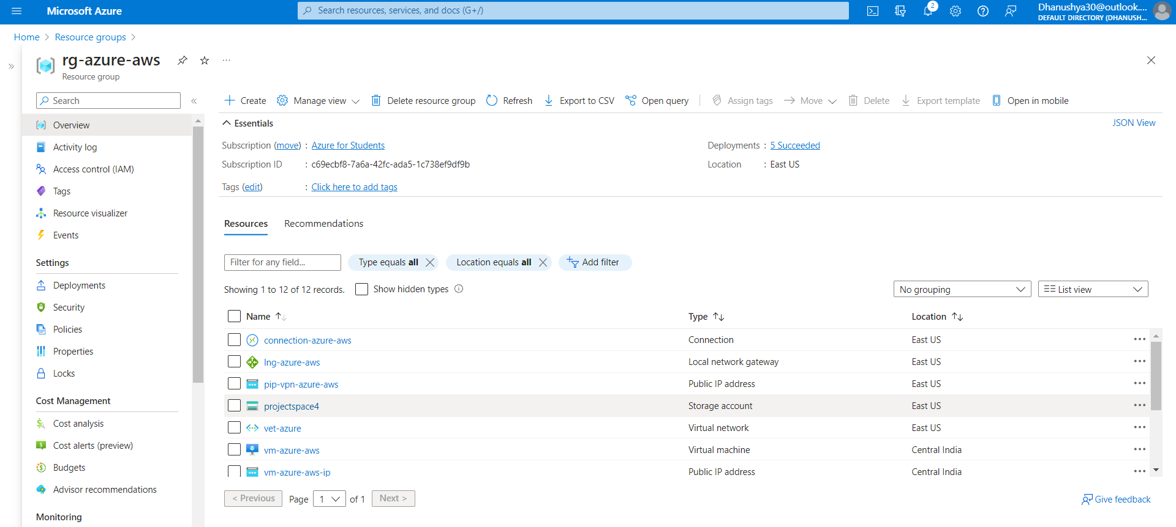

**create virtual network**

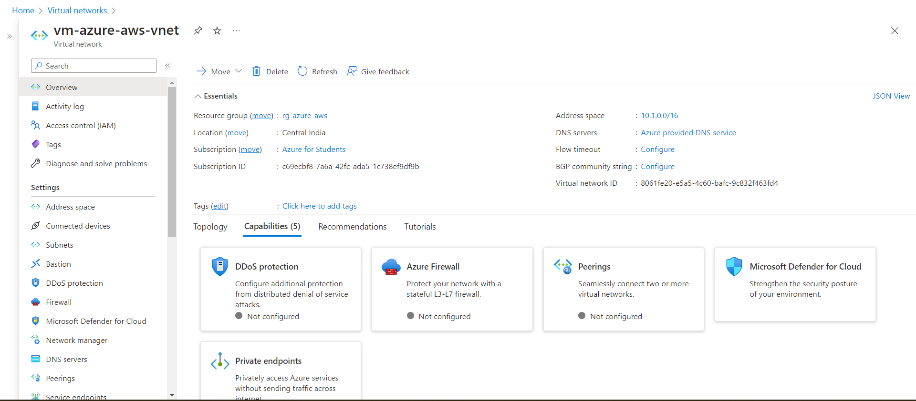

**create the vpn gateway**

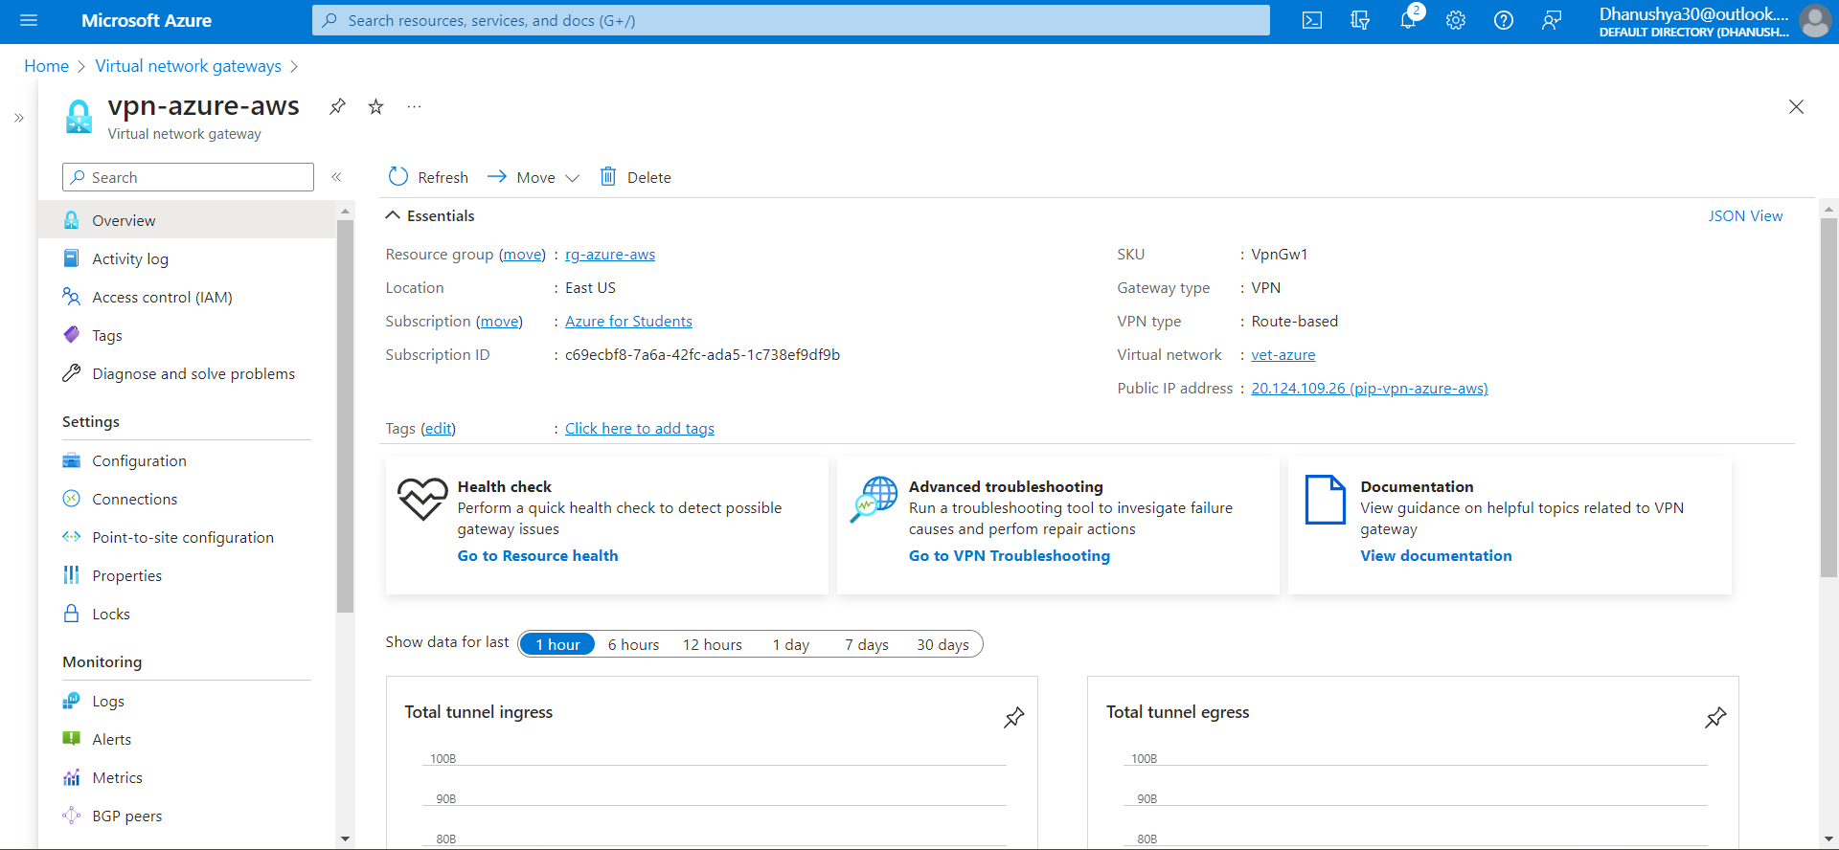

**create the virtual private cloud (VPC) in aws**

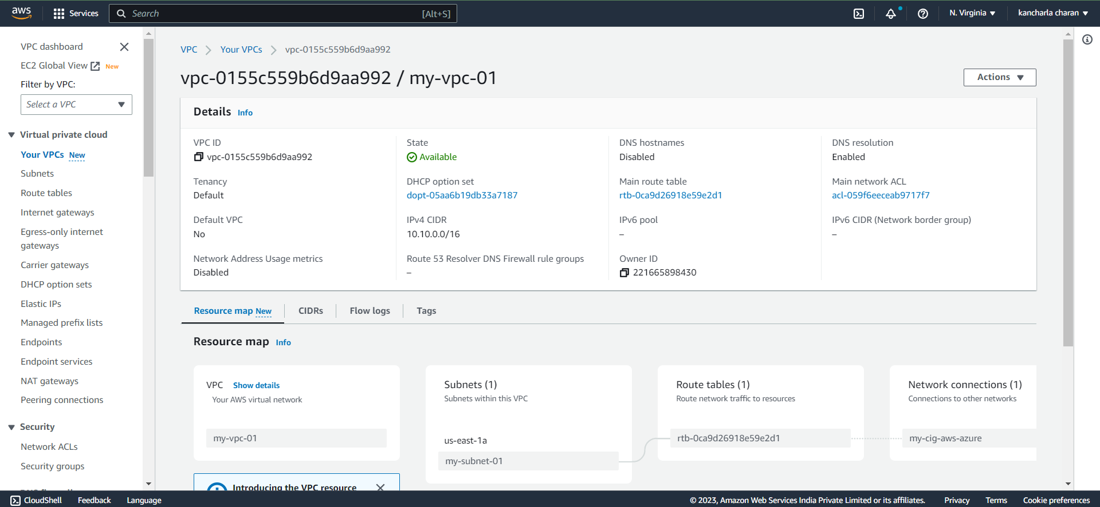

**create a subnet inside the vpc (virtual network)**

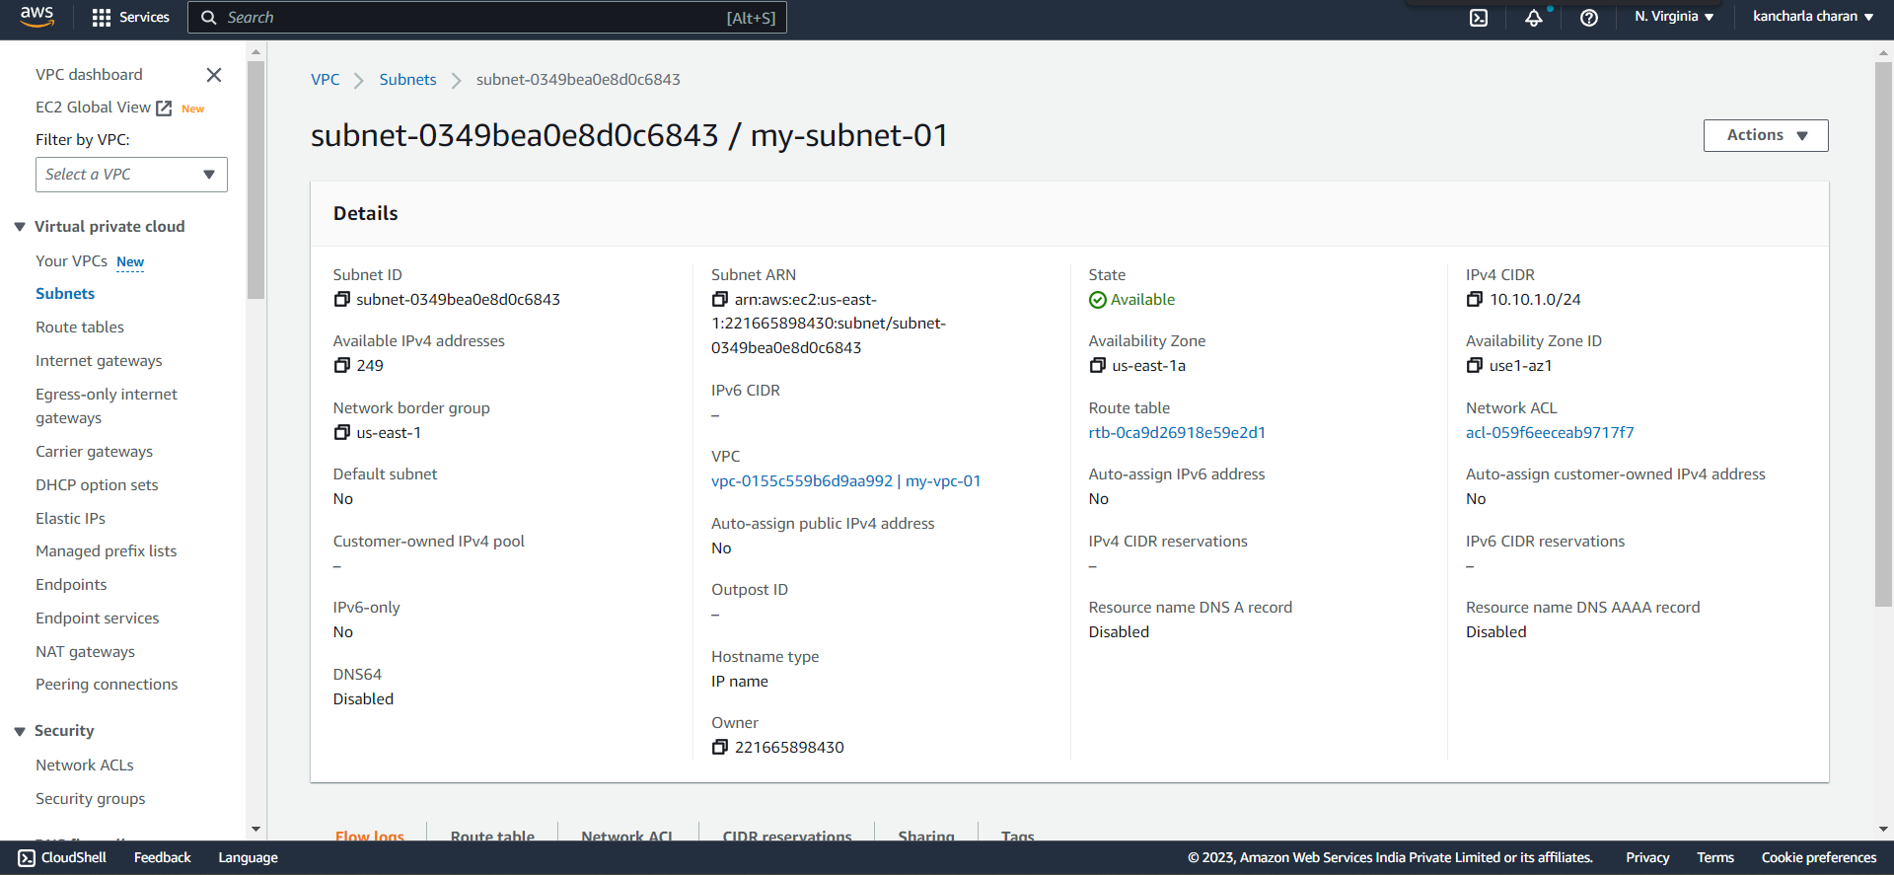

**create a customer gateway pointing to the public ip address of azure vpn gateway**

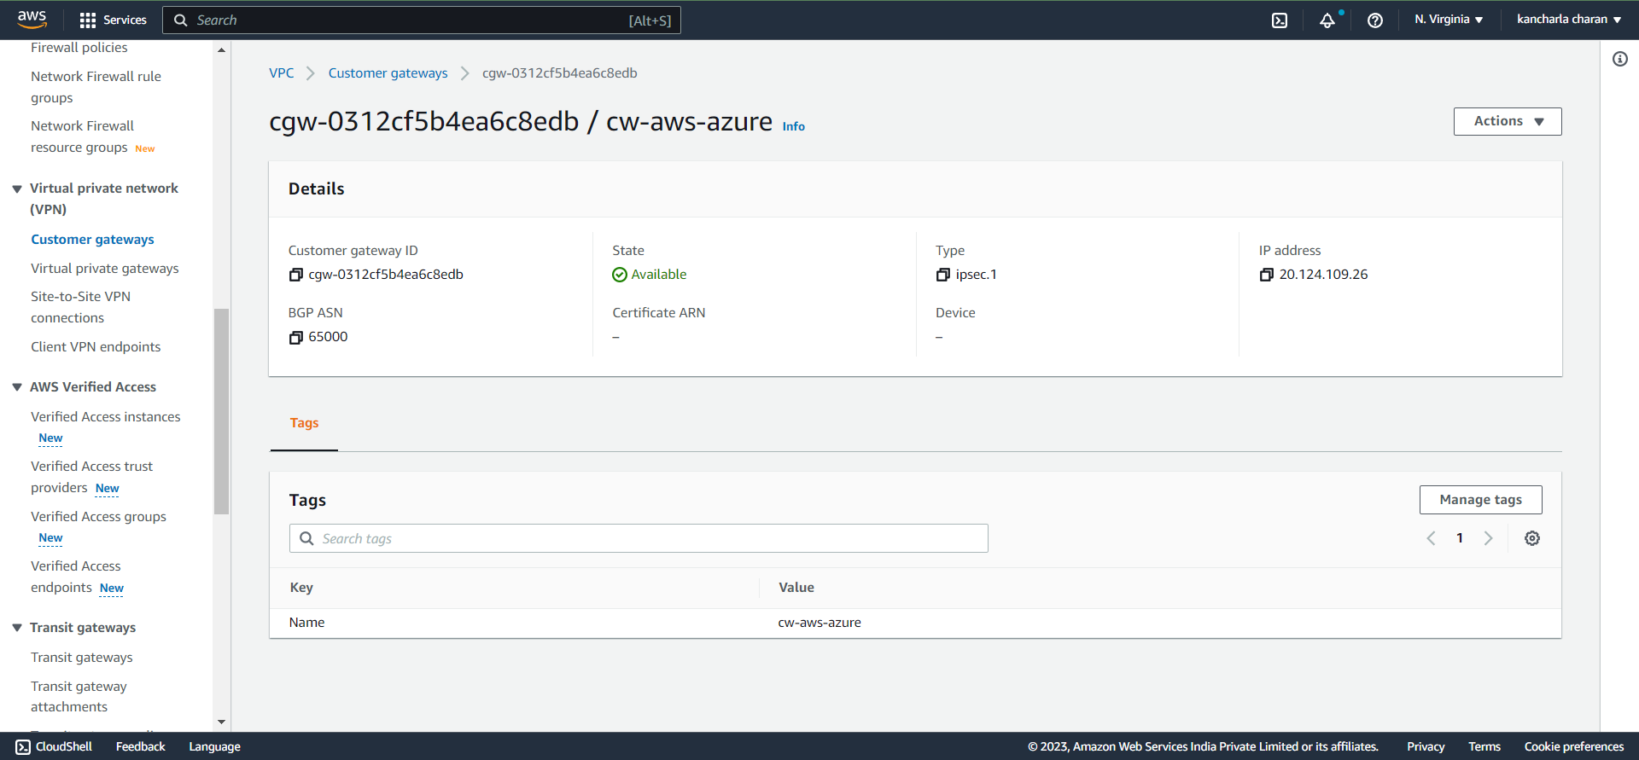

**create the virtual private gateway the attach to the vpc.**

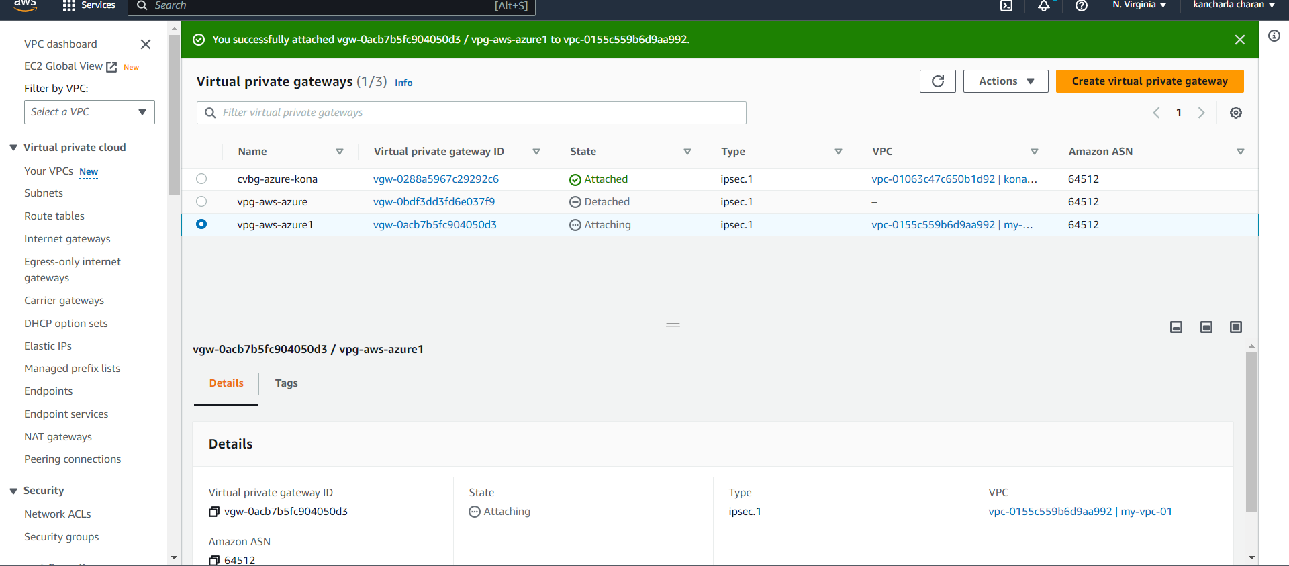

**create a site-to-site vpn connection**

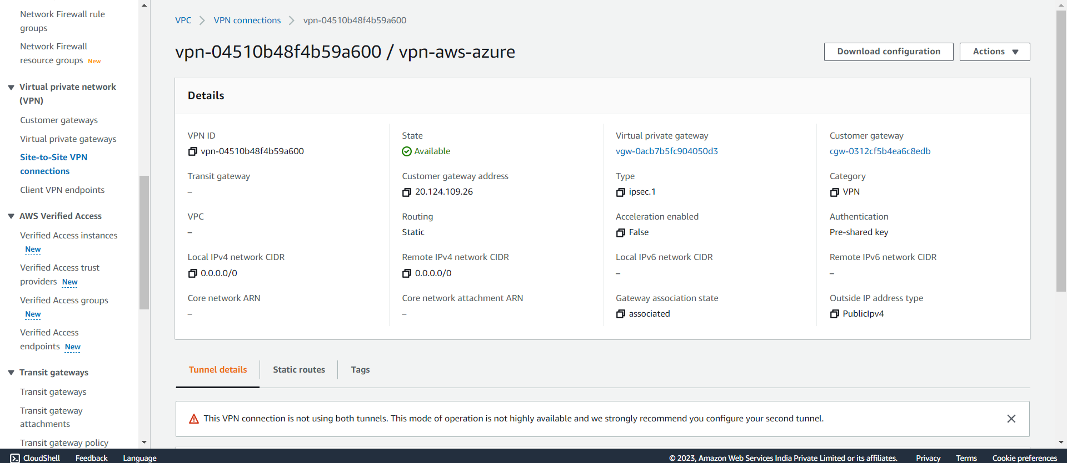

**Download the configcreate a resource group on Azure to delpoy the resource on thaturation file.**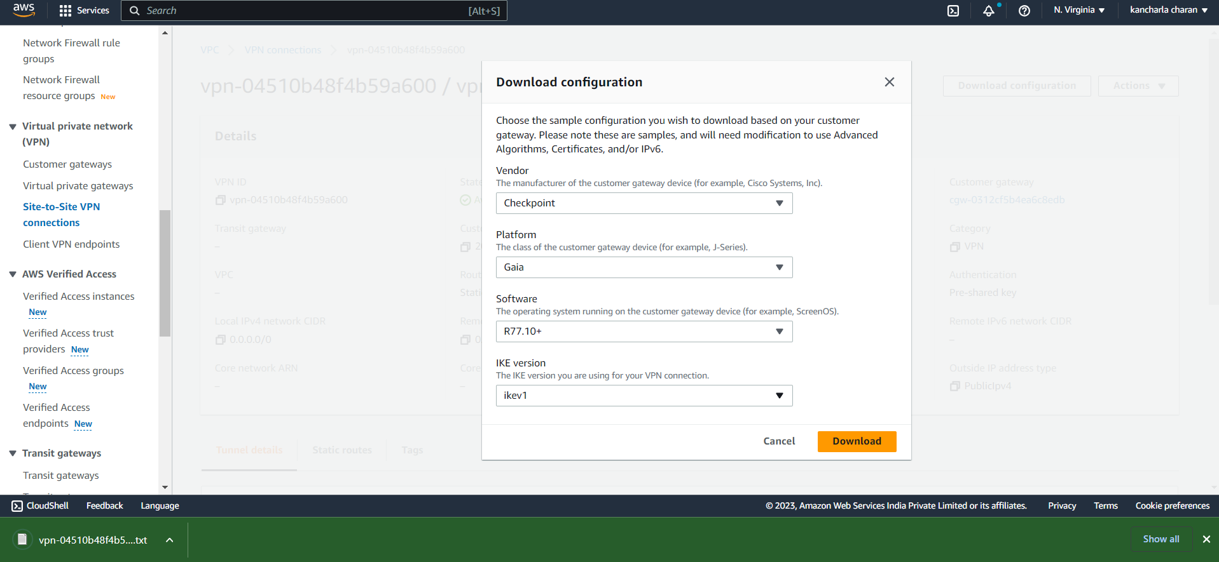

**Connecting Azure and Aws**

**Create the local network gateway in azure.**

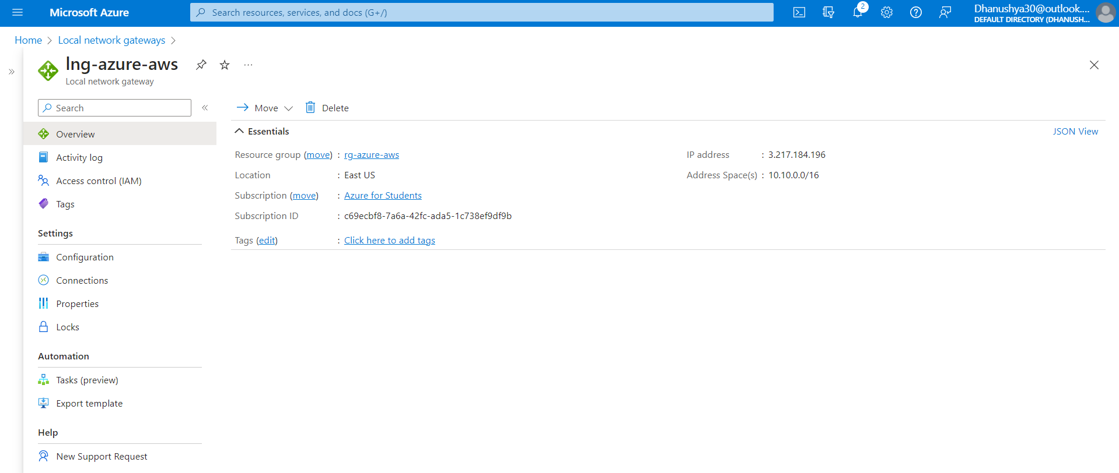

**Create the connection on the virtual network gateway in azure.**

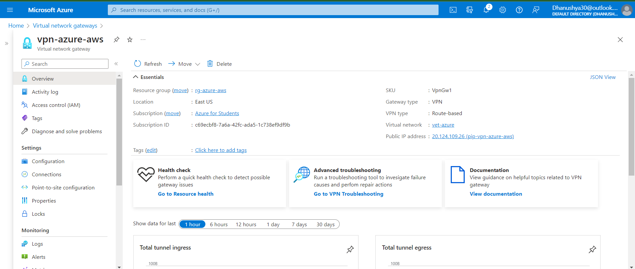

**Create internet gateway and attach it to in AWS.**

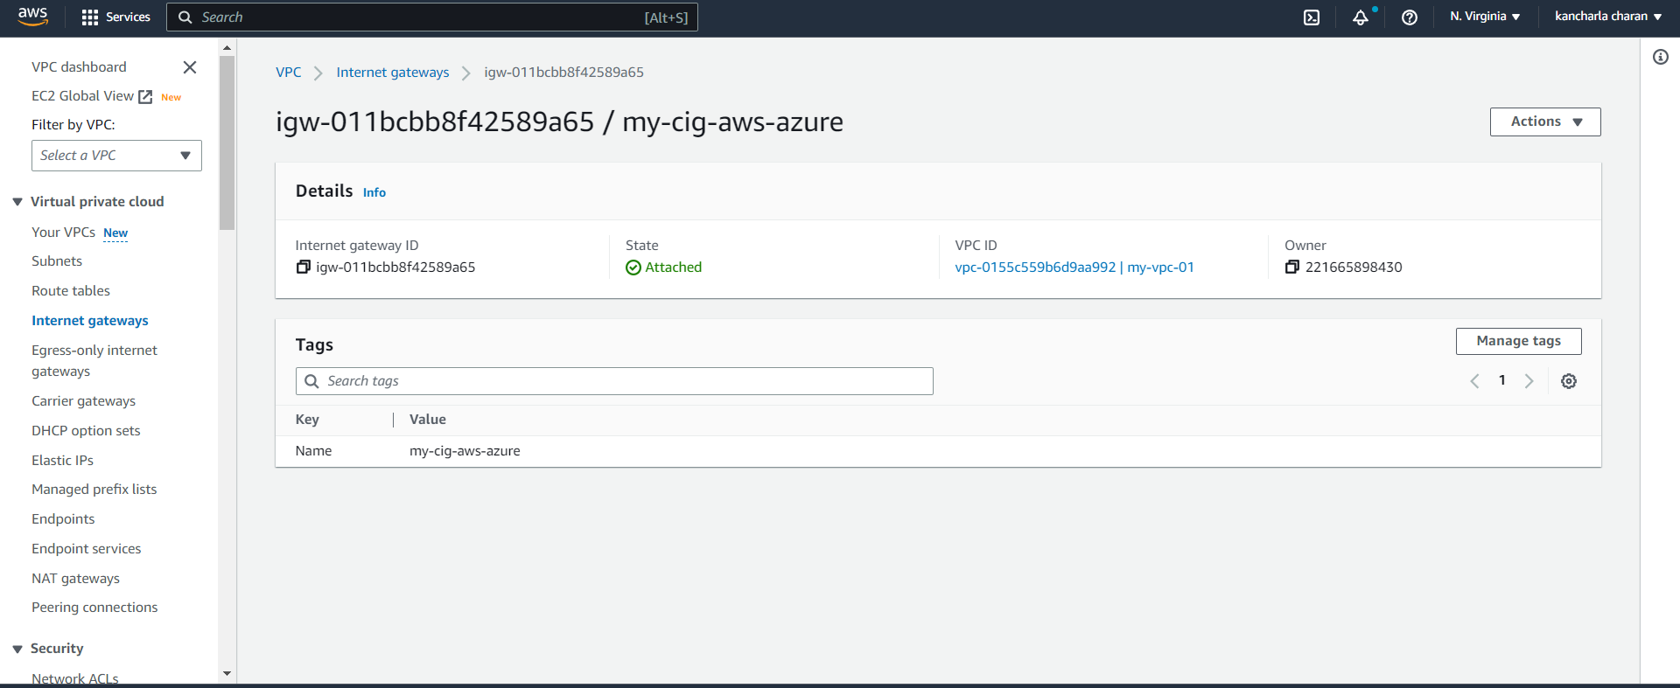

**Now let’s edit the route table associated with our vpc.**

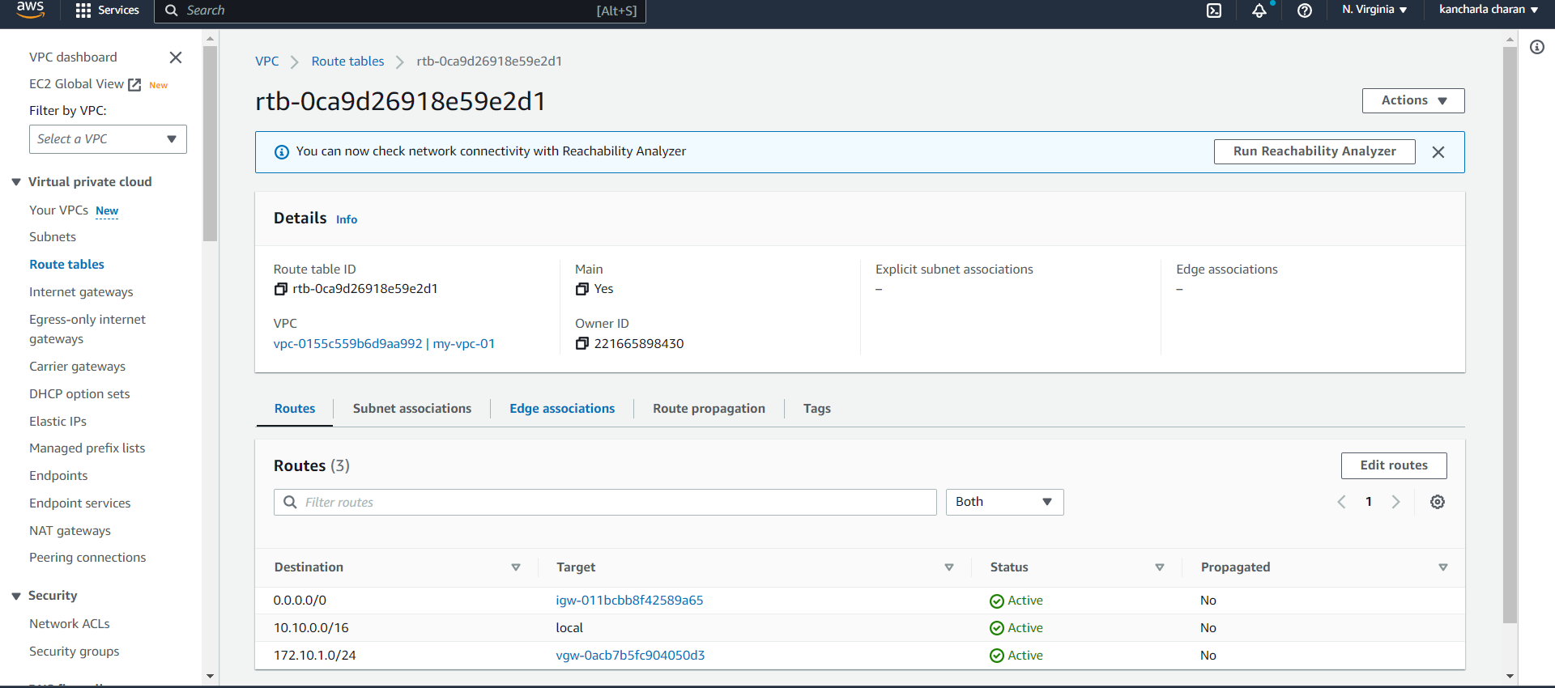

**Create vm in both Azure and Aws and test the connection.**

**AWS vm Instance**

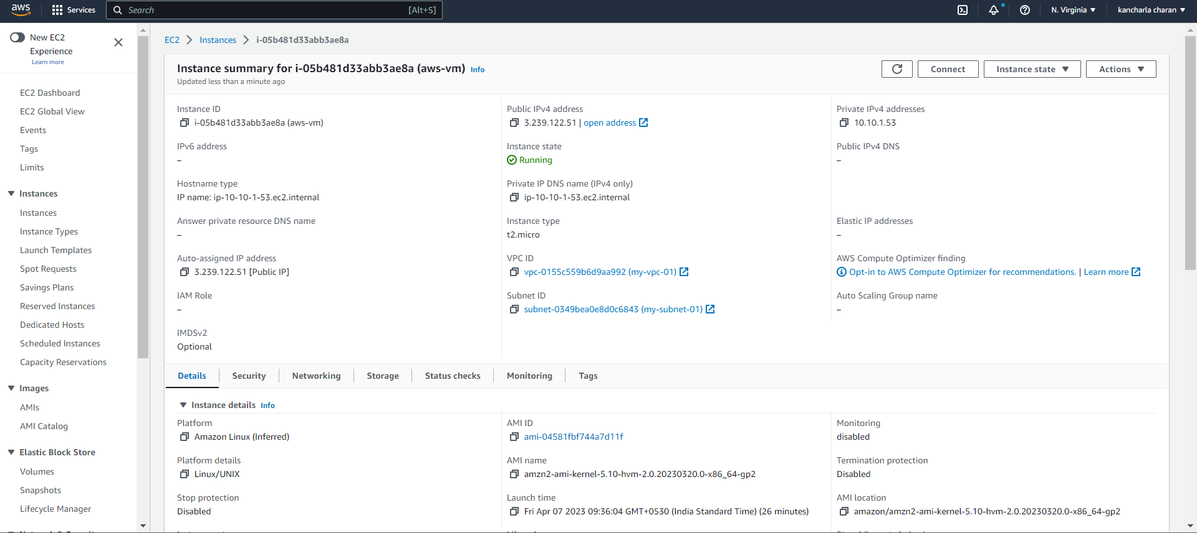

**Azure Virtual Machine**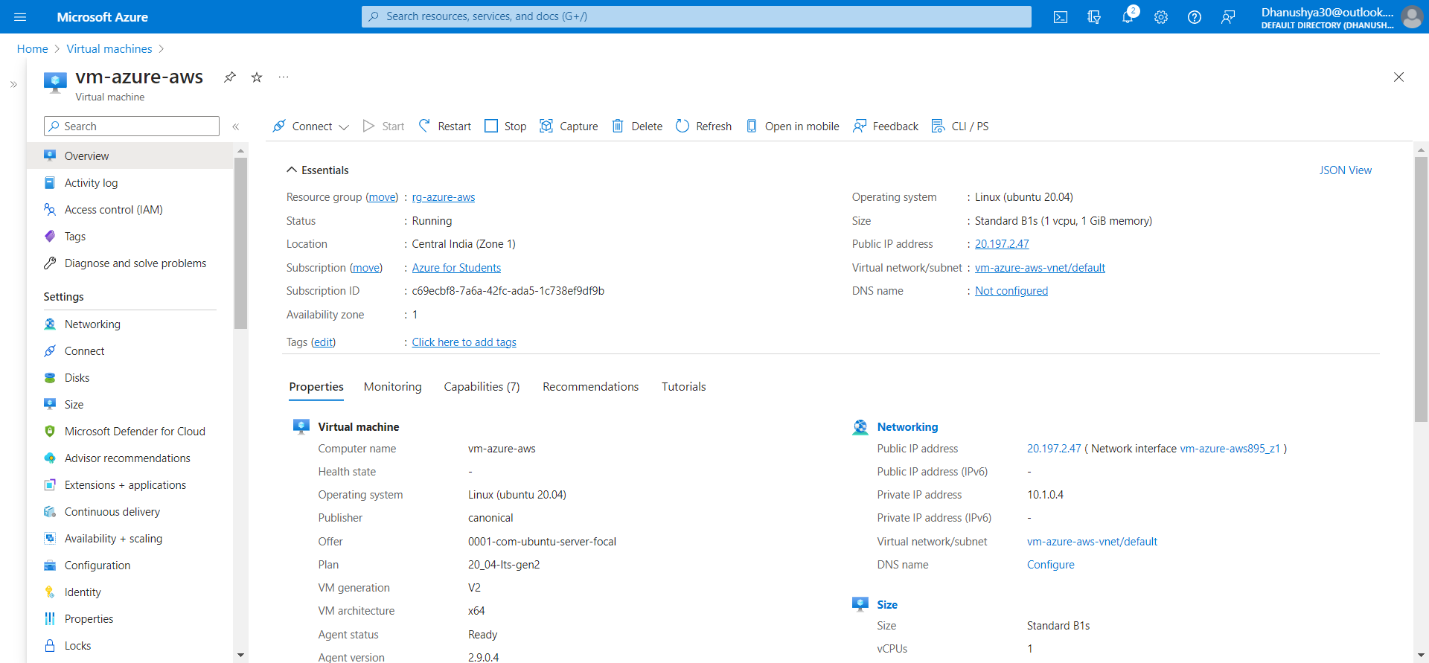

**Create the EFS file system in AWS.**

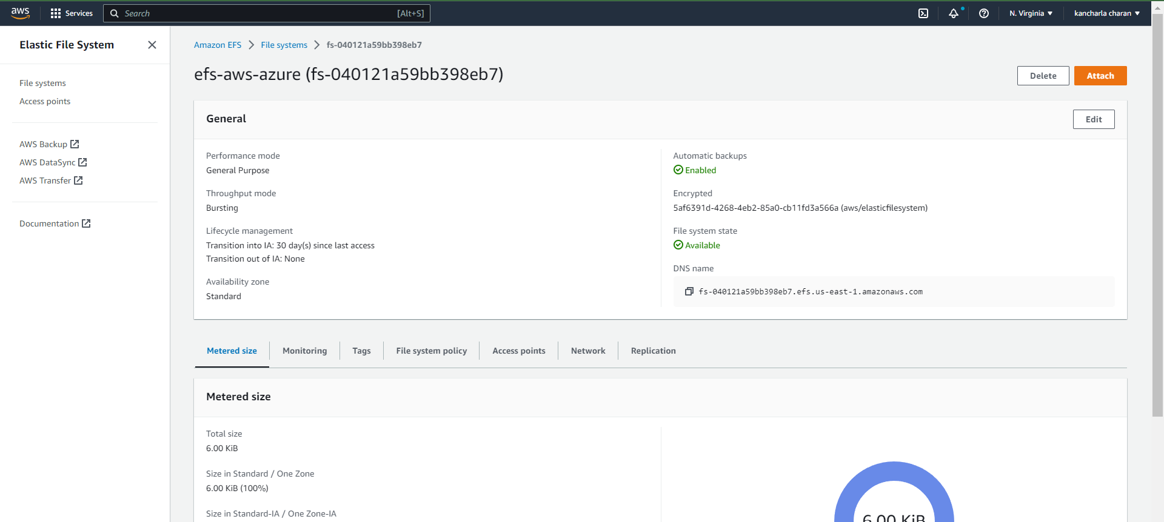

**Create the Storage Account in Azure.**

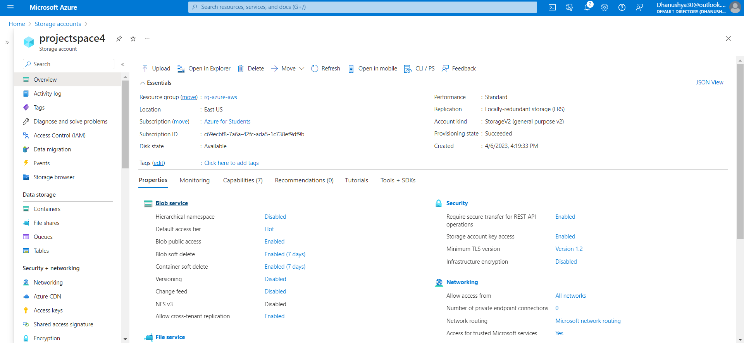

**Create Files Share account in storage account.**

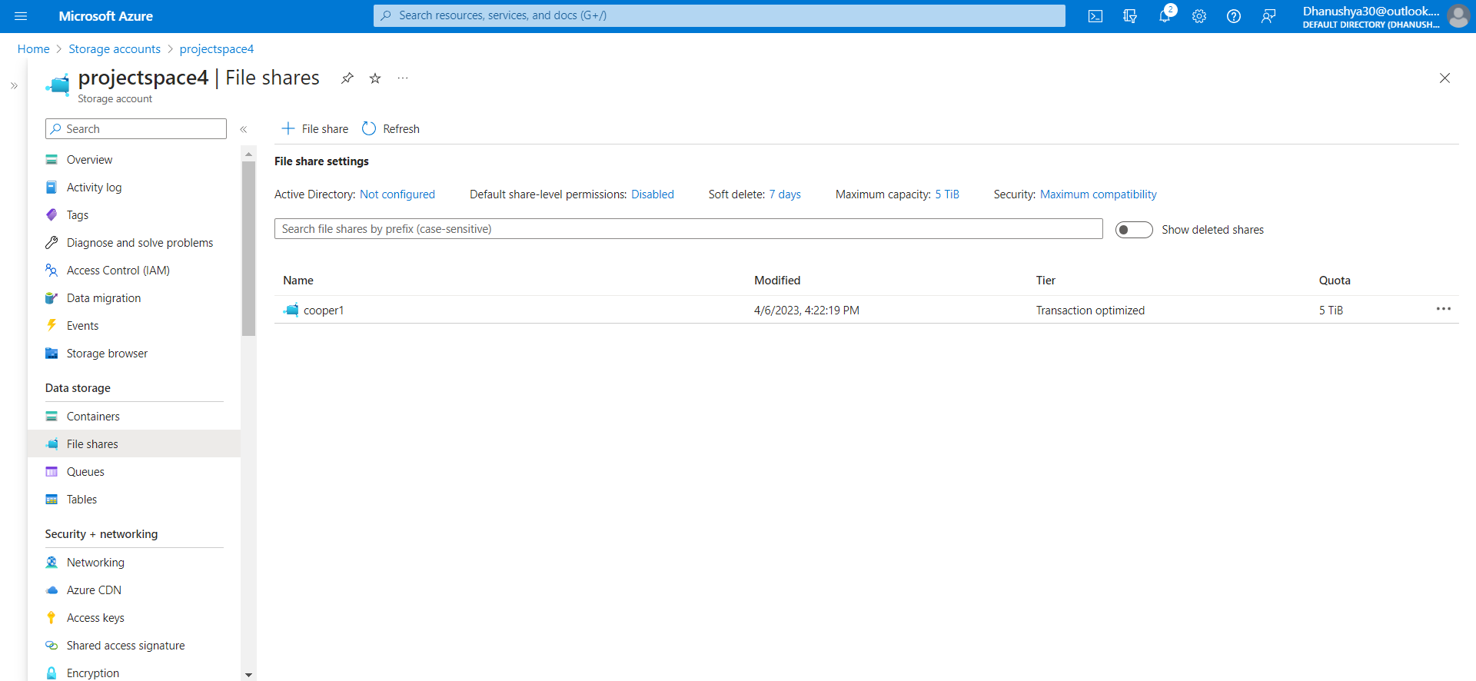

**Upload the Files into the File shares Floder.**

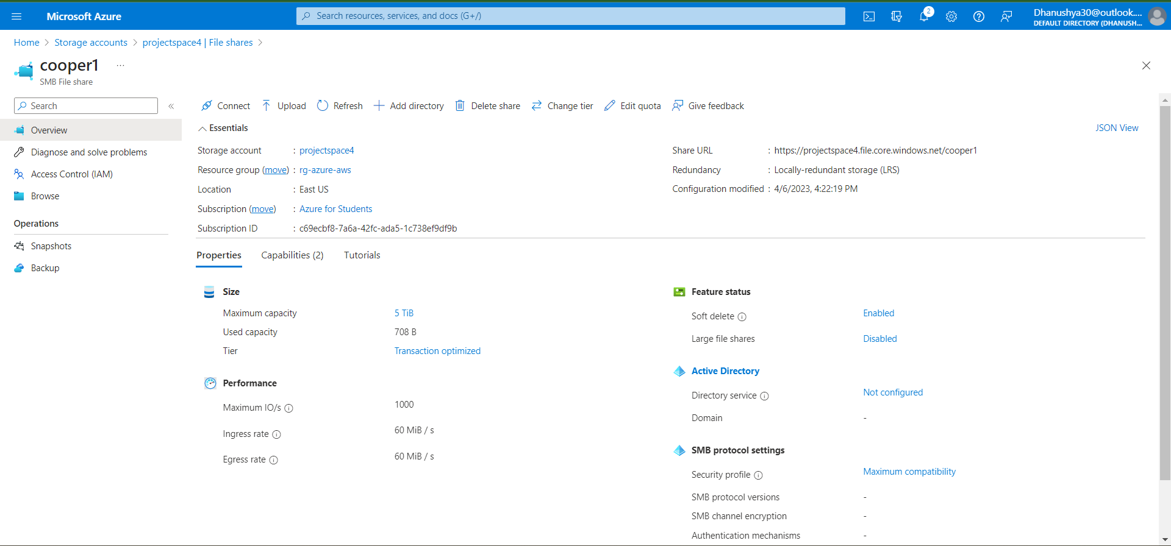

**Vpc Peer-To-Peer in between Two Instances.**

**Azure to Aws peering**

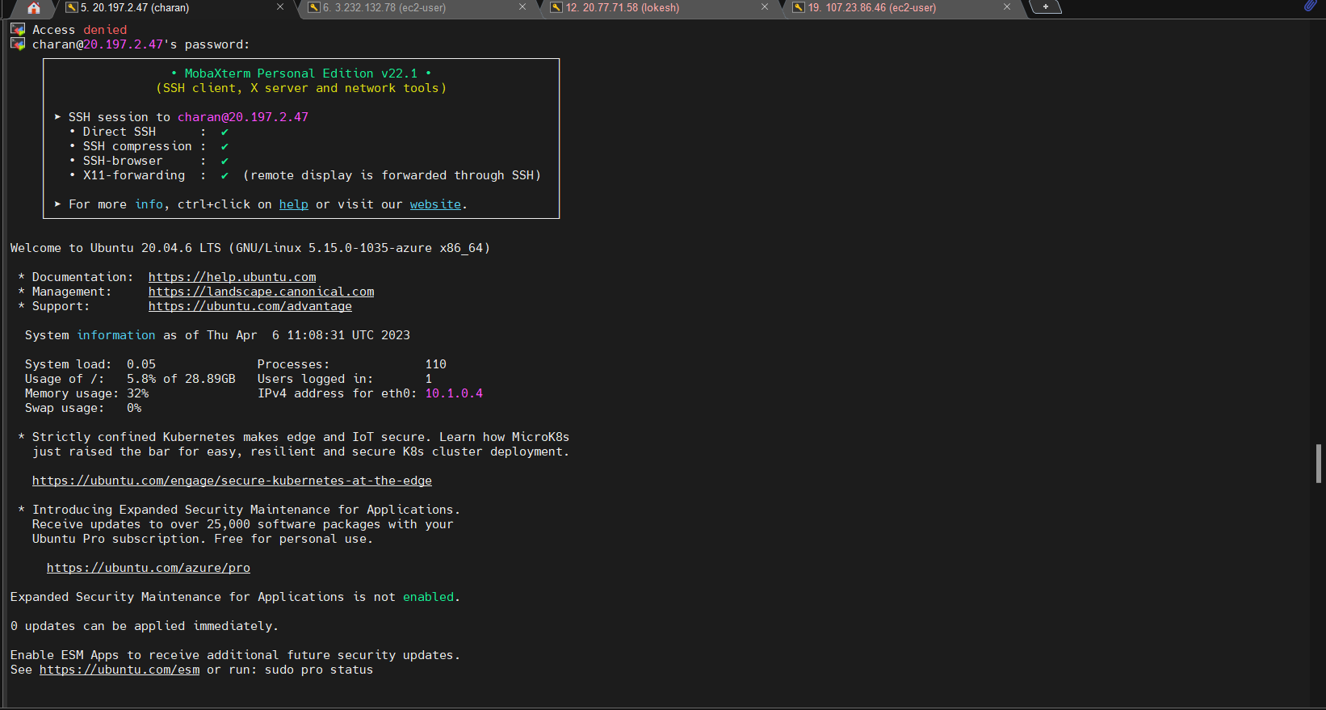

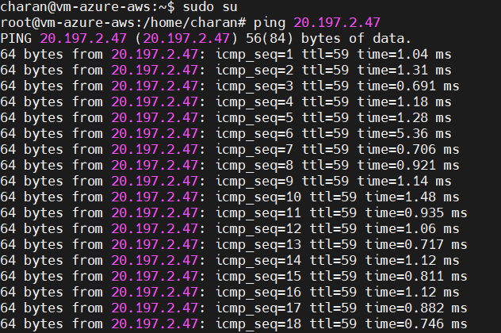

**Move to Mount point created.**



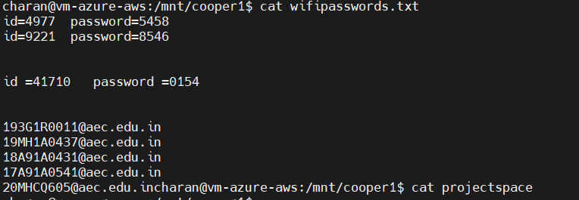

**Aws to Azure peering**

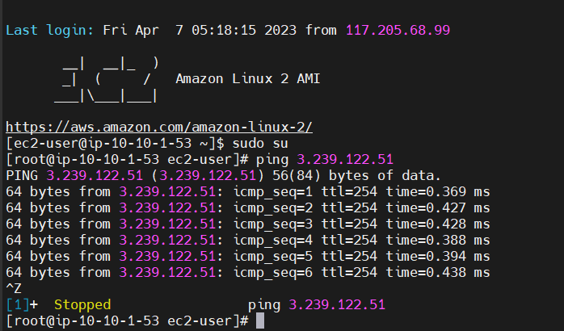

**Install the CIFS Packages in Aws Instance.**



**Copy the Mount Point from Azure Paste in Aws Console.**

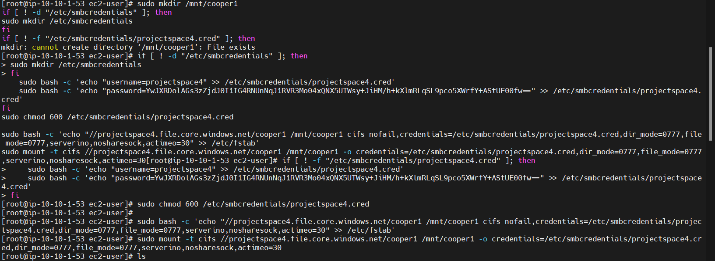

**Create the Mount Directory in Aws.**

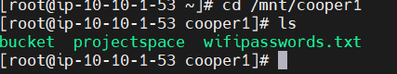

**Open Mount point in Aws Console.**

