Name: Yash Yadav Date:10 June
Reg No:24BCY10247

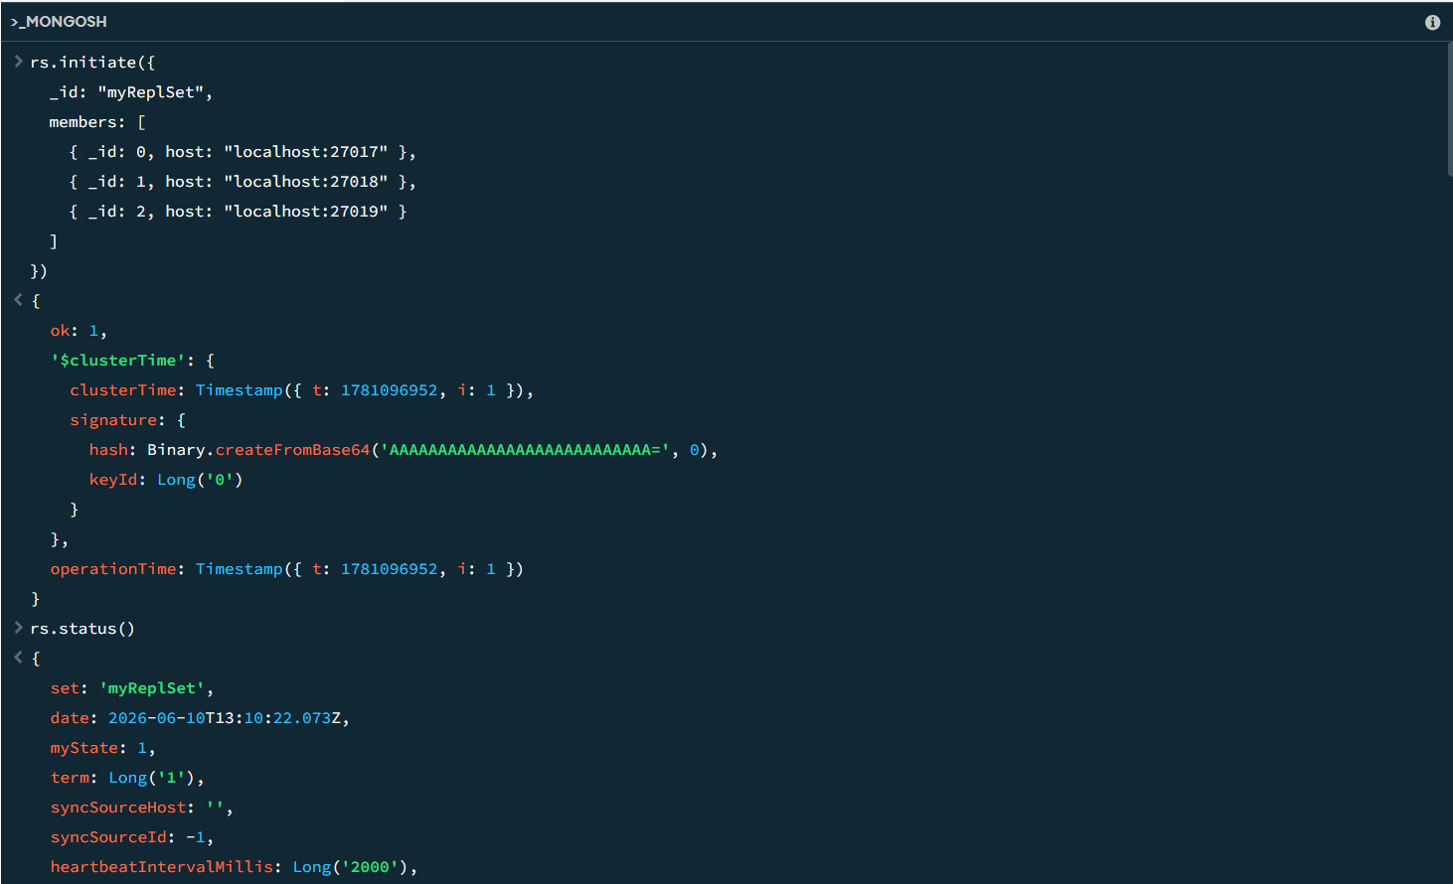



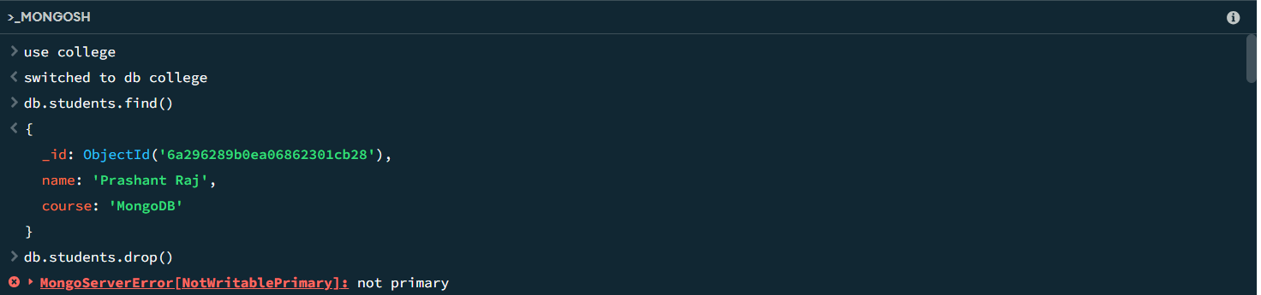

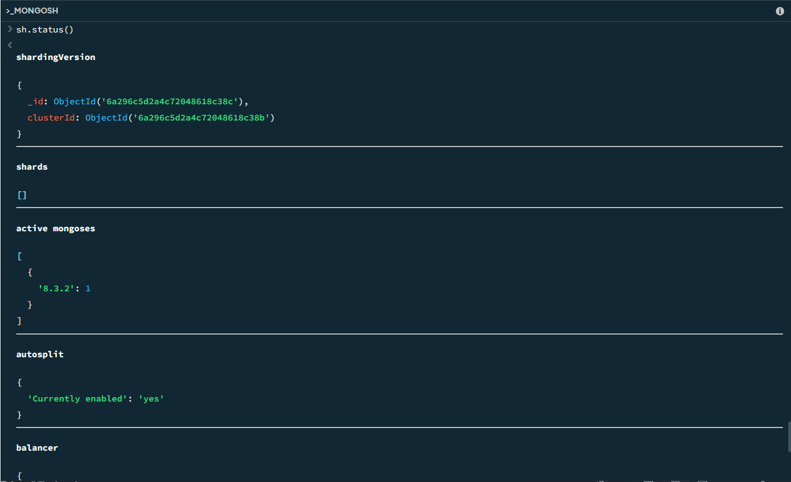

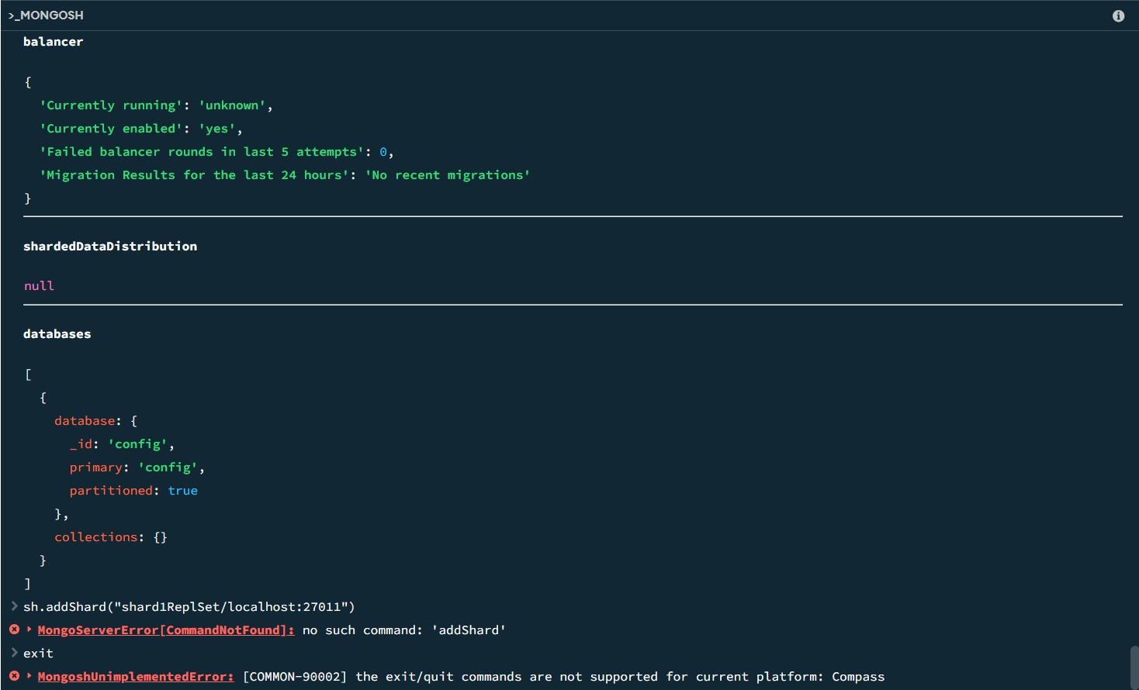

Submitted by: Yash Yadav(24BCY10247)

