🎓
Smart Classroom
Learning Management System
━━━━━━━━━━━━━━━━━━━━━━━━━━━━━━━━━━━━━━━━
Complete Project Documentation
Prepared by
Yaswanth Munagoti
Django · Python · SQLite · Bootstrap 5 · Gemini AI
June 2026

Table of Contents
Right-click and select "Update Field" to generate Table of Contents
💡 TIP: To generate the Table of Contents in Word: Right-click the text above → select "Update Field" → choose "Update entire table".

1. Project Overview
Smart Classroom is a comprehensive web-based Learning Management System (LMS) built with Django that connects administrators, teachers, and students in a digital classroom environment. The platform provides end-to-end academic management including course creation, assignments, quizzes, online coding tests, attendance tracking, AI-powered tutoring, real-time chat, certificates, and analytics — all within a single, unified web application.
The system is designed to replicate and enhance the traditional classroom experience by providing digital tools for every aspect of teaching and learning. It supports 3 user roles (Admin, Teacher, Student), 3 approval workflows, and features an anti-cheat exam system for secure online assessments.

Key Highlights
• 12 Django Applications working together as a cohesive system
• 24 Database Models with 29 foreign key and 3 many-to-many relationships
• 105+ URL Endpoints covering all CRUD operations and API endpoints
• 50+ HTML Templates with responsive Bootstrap 5 design
• 3 User Roles (Admin, Teacher, Student) with granular permissions
• 3 Approval Workflows for user registration, course creation, and enrollment
• AI Integration via Google Gemini for per-course AI tutoring
• Anti-Cheat Exam System with fullscreen lock, tab detection, and auto-submit
• 4 Assessment Types: Assignments, Quizzes, Coding Tests, Projects
• Real-time Chat with direct messages and per-course group chat
• Data Export in CSV, Excel, and PDF formats
• Light/Dark Mode with CSS variable-based theme toggle

Feature Summary
# | Feature | Description
1 | User Management | 3 roles (Admin, Teacher, Student) with approval workflows
2 | Department & Course Mgmt | Departments → Courses with unique codes, approval system
3 | Enrollment System | Students request enrollment → Teacher/Admin approves
4 | Assignments | Create, submit (file/GitHub), grade with marks & feedback
5 | Quizzes | MCQ-based quizzes with auto-scoring, time limits, date windows
6 | Online Coding Tests | In-browser coding IDE with sample/hidden test cases, auto-evaluation
7 | Attendance | Teacher marks or student self-marks (with deadlines)
8 | Study Materials | Upload PDF, DOC, PPT, ZIP, PY files for download
9 | Recorded Classes | Video uploads (file or URL) with streaming player
10 | Team Projects | Project submissions with GitHub links, ZIP uploads, grading
11 | Chat System | 1-on-1 direct messages + per-course group chat (AJAX real-time)
12 | AI Tutor | Per-course AI chatbot powered by Google Gemini
13 | Virtual Sessions | Schedule online meeting links with auto-attendance
14 | Certificates | Issue badges (Completion, Excellence, Topper, Participation)
15 | Reports & Leaderboard | Report cards, grade exports (CSV/Excel), rankings
16 | Notification System | In-app notifications for all key events
17 | Admin Panel | Custom admin dashboard for managing everything
18 | Light/Dark Mode | CSS variable-based theme toggle

2. Technology Stack & Requirements
The Smart Classroom LMS is built using a modern Python web development stack. Django serves as the core web framework providing the MVC architecture, ORM, authentication, and templating engine. The frontend uses Bootstrap 5 for responsive design with custom CSS for theming.

Software Dependencies
Technology | Purpose | Version
Python | Backend programming language | 3.10+
Django | Web framework (MVT architecture) | ≥4.2, <5.0
SQLite3 | Database (built into Django/Python) | Built-in
Pillow | Image processing (profile pics, banners) | ≥9.0
WhiteNoise | Static file serving in production | ≥6.0
Gunicorn | Production WSGI server | ≥20.0
WeasyPrint | PDF generation for certificates/reports | ≥59.0
openpyxl | Excel export for marks/reports | ≥3.1
Google Generative AI | Gemini AI integration (AI Tutor) | Latest
Bootstrap 5 | Frontend CSS framework (via CDN) | 5.x
Chart.js | Dashboard analytics charts | Latest
Font Awesome | Icon library for UI elements | 6.x

requirements.txt
Django>=4.2,<5.0
Pillow>=9.0
whitenoise>=6.0
gunicorn>=20.0
WeasyPrint>=59.0
openpyxl>=3.1

Key Configuration (settings.py)
Setting | Value
Database | SQLite3 (db.sqlite3)
User Model | users.CustomUser (extends AbstractUser)
Time Zone | Asia/Kolkata
Login Redirect | /users/dashboard/
Logout Redirect | /users/login/
Media Root | BASE_DIR / "media"
Static Root | BASE_DIR / "staticfiles"
CSRF Origins | localhost, ngrok tunnels

Django Applications (12 Apps)
The project is organized into 12 Django applications, each responsible for a specific domain:
App Name | Purpose | Key Models
users | Authentication, profiles, admin panel, notifications | CustomUser, Notification
courses | Departments, courses, enrollment, virtual sessions, AI tutor | Department, Course, Enrollment, VirtualSession, AITutorMessage
assignments | Assignment creation, submission, grading | Assignment, Submission
quiz | MCQ quizzes with auto-scoring | Quiz, Question, Choice, QuizAttempt, StudentAnswer
tests | Online coding tests with test cases | Test, CodingQuestion, TestCase, StudentResponse
attendance | Attendance sessions and records | AttendanceSession, AttendanceRecord
materials | Study material file uploads | Material
recorded_classes | Video recordings for courses | RecordedClass
projects | Team project submissions | Project
chat | Direct messages and group chat | DirectMessage, GroupMessage
certificates | Digital badges and certificates | Certificate
reports | Report cards and grade analytics | ReportCard

3. System Architecture
The Smart Classroom LMS follows Django's Model-View-Template (MVT) architectural pattern. The system is designed as a monolithic Django application with 12 tightly integrated apps. Each app encapsulates its own models, views, URLs, and templates, while sharing the common user authentication and course enrollment infrastructure.

Architecture Diagram
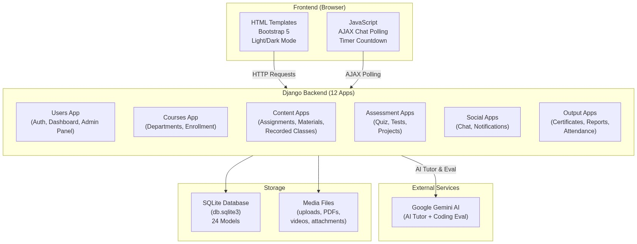
Figure 1: Smart Classroom System Architecture

Request Lifecycle
Every HTTP request follows a well-defined pipeline through the Django framework:
Browser → HTTP Request → Django URL Router → View Function
↓
Permission Check (Role + Enrollment + Assignment)
↓
Database Query (ORM)
↓
[Optional] Gemini AI Call
↓
Template Rendering → HTML Response → Browser

The middleware stack includes security middleware, session management, CSRF protection, authentication middleware, and a custom **AccountStatusMiddleware** that intercepts requests from unapproved users and redirects them to an approval status page.

Project Directory Structure
smart_classroom/ # Project root
├── smart_classroom/ # Django project settings
│ ├── settings.py # Configuration (DB, apps, middleware)
│ ├── urls.py # Root URL configuration
│ └── wsgi.py # WSGI entry point
├── users/ # User authentication & admin panel
├── courses/ # Department, course, enrollment, AI tutor
├── assignments/ # Assignment CRUD & grading
├── quiz/ # MCQ quiz system
├── tests/ # Online coding test engine
├── attendance/ # Attendance tracking
├── materials/ # Study material uploads
├── recorded_classes/ # Video recording management
├── projects/ # Team project submissions
├── chat/ # Direct & group messaging
├── certificates/ # Digital badges & certificates
├── reports/ # Report cards & analytics
├── templates/ # Shared base templates
├── static/ # CSS, JS, images
├── media/ # User-uploaded files
├── images/ # Documentation diagrams
├── db.sqlite3 # SQLite database
├── manage.py # Django management script
├── requirements.txt # Python dependencies
├── setup.py # Automated setup script
└── test_suite.py # Comprehensive test suite

4. User Roles & Permissions
The system implements a 3-tier role-based access control (RBAC) model. Each user is assigned exactly one role at registration, which determines their dashboard, navigation menu, and permitted actions throughout the platform.

Role Descriptions
**👑 Admin** — The superuser with full system control. Admins manage departments, approve teacher/student registrations, approve courses, and have access to the Django admin panel. Admin accounts are auto-approved upon creation.
**🧑‍🏫 Teacher** — Course instructors who create and manage academic content. Teachers can create courses (subject to admin approval), manage assignments, quizzes, coding tests, attendance, materials, recorded classes, and grade student submissions. Teacher accounts require admin approval before activation.
**🎓 Student** — Learners who enroll in courses and complete academic activities. Students can browse departments, request enrollment, submit assignments, take quizzes/tests, view materials, chat with peers/teachers, and access AI tutoring. Student accounts require admin approval before activation.

Role Comparison Matrix
Feature | Admin | Teacher | Student
Account Status | Auto-active | Needs approval | Needs approval
Dashboard | Admin panel | Course overview + charts | Learning overview + charts
Departments | Create / Edit / List | View only | View only
Courses | Create / Edit / Approve | Create (needs approval) | View & enroll
Enrollment | Approve / Reject | Approve / Reject (own) | Request enrollment
Assignments | — | Create / Edit / Grade | View / Submit
Quizzes | — | Create / Edit / Add Qs | Take quiz (once)
Online Tests | — | Create / Edit / Add Qs | Take test (once)
Attendance | — | Create session / Mark | Self-mark (if allowed)
Materials | — | Upload / Delete | Download
Recorded Classes | — | Upload / Edit / Delete | View / Watch
Projects | — | Grade | Submit / Delete own
Chat (DM) | Chat with anyone | Chat with anyone | Chat with teachers & peers
Group Chat | — | Course group chat | Course group chat
AI Tutor | — | Access per course | Access per course
Certificates | — | Issue to students | View / Download own
Reports | — | View all / Edit / Export | View own report card
Leaderboard | View | View | View
Notifications | Receive | Receive | Receive
Admin Panel | ✅ Full access | ❌ | ❌

5. Approval Workflows
The system implements 3 approval workflows to maintain quality control and ensure only authorized users access the platform. Each workflow follows a request → review → approve/reject pattern with in-app notifications at each stage.

Workflow 1: User Registration Approval
When a new teacher or student registers, their account is created with `approval_status = pending`. They are redirected to an approval status page and cannot access the dashboard until an Admin approves their account. The custom `AccountStatusMiddleware` enforces this restriction on every request.
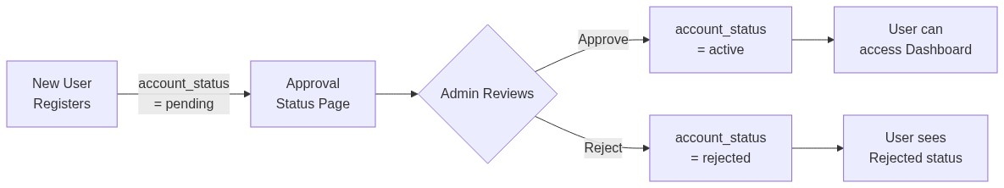
Figure 2: User Registration Approval Workflow

Workflow 2: Course Creation Approval
When a teacher creates a new course, it is saved with `approval_status = pending`. The course is invisible to students until an Admin approves it. The system auto-generates a unique course code (e.g., CS-ML2026) and batch identifier. Admin-created courses are auto-approved.
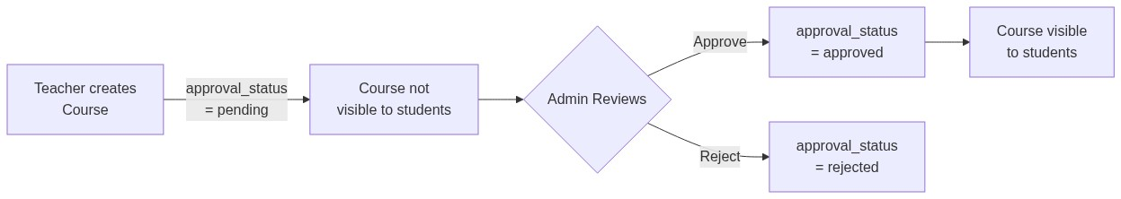
Figure 3: Course Creation Approval Workflow

Workflow 3: Student Enrollment Approval
When a student requests enrollment in a course, an `Enrollment` record is created with `status = pending`. The course teacher receives a notification and can approve or reject the request. Approved students get full access to all course content. The system supports soft-delete for un-enrollment (preserving student data) and seamless re-enrollment.
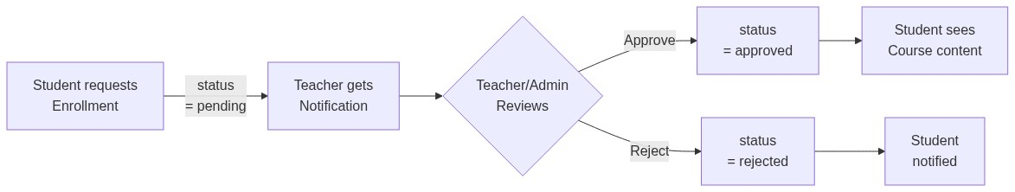
Figure 4: Student Enrollment Approval Workflow

6. Complete Database Schema
The Smart Classroom database consists of 24 models distributed across 12 Django apps. The schema is designed around two central entities: **CustomUser** (referenced by 17 FKs and 3 M2M relationships) and **Course** (referenced by 15 FKs). Together, these form the backbone connecting all modules of the LMS.

6.1 Complete Database Schema (ERD)
The following diagram shows the complete entity-relationship diagram for all 24 models and 29 relationships in the system:
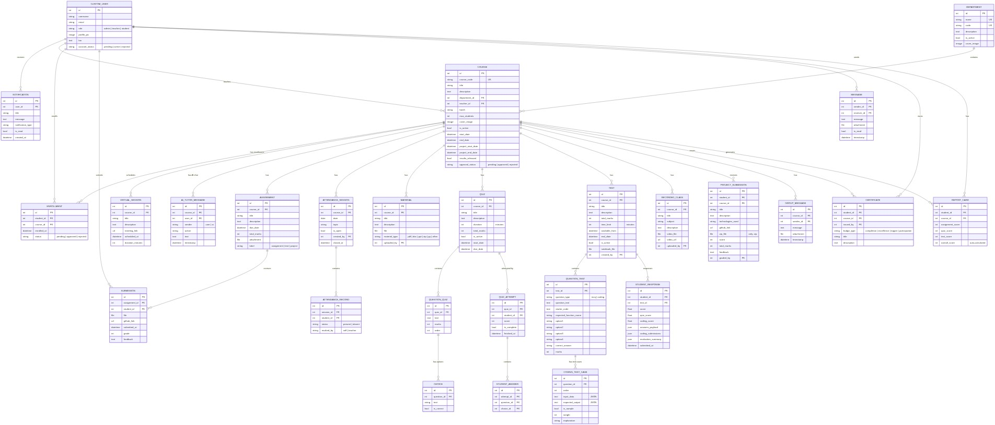
Figure 5: Complete Database Schema — Entity Relationship Diagram

6.2 Entity Relationship Diagrams (By Module)
To ensure readability, the 24-model schema has been partitioned into 7 logical modules:

Module 1: User Profiles & Direct Messages
Manages registration status, authentication roles, in-app notifications, and direct messaging between users.
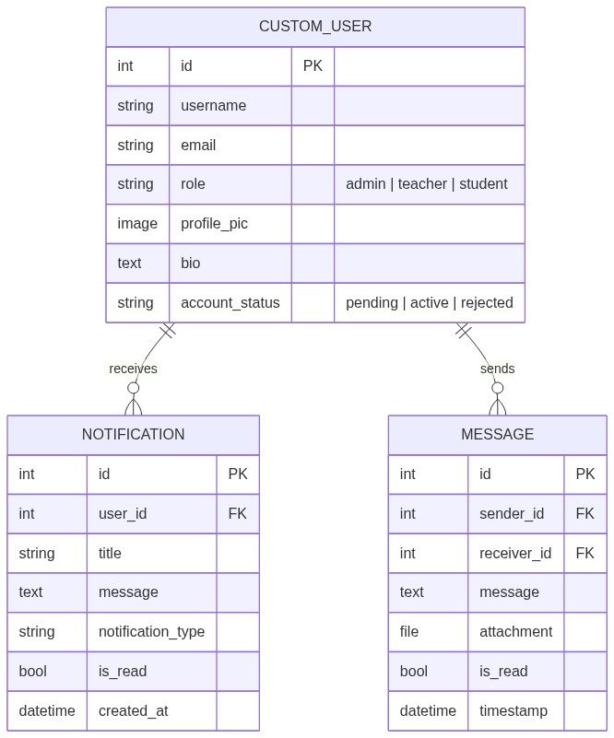
Figure 6: Module 1: User Profiles & Direct Messages — ERD

Module 2: Course & Enrollment Structure
Handles departments, courses, student enrollment requests, virtual live sessions, per-course group chats, and AI Tutor conversation logs.
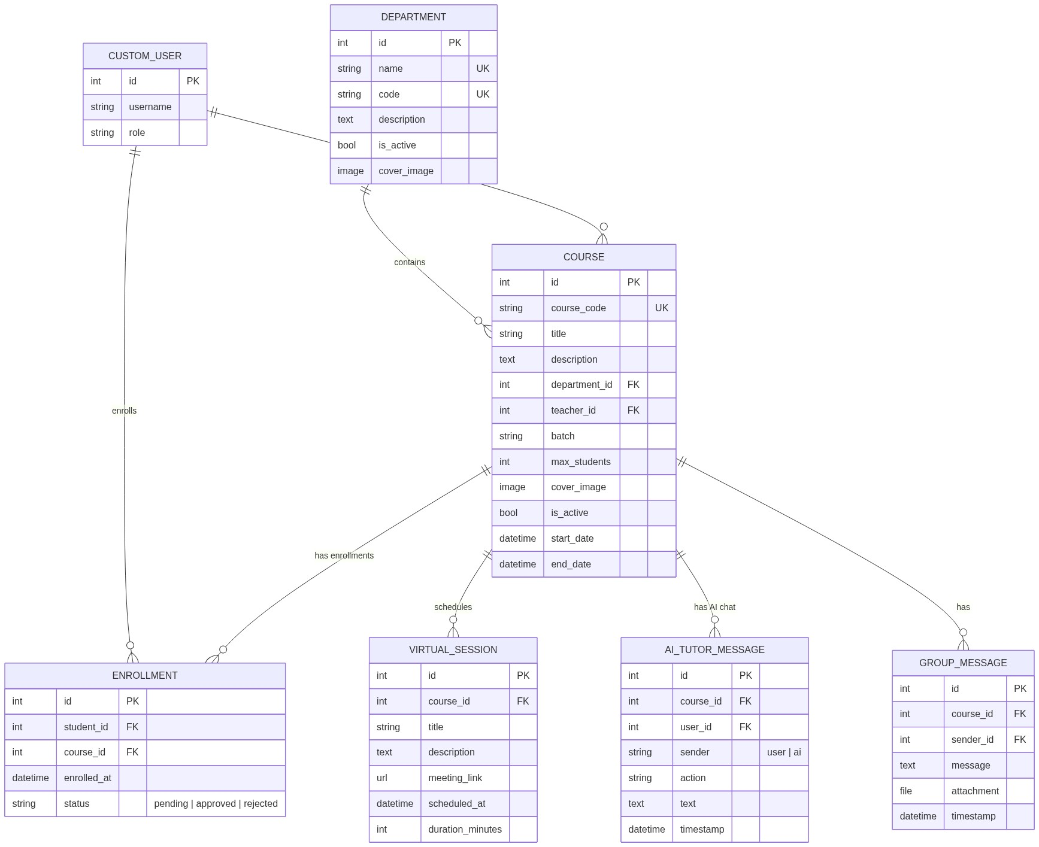
Figure 7: Module 2: Course & Enrollment Structure — ERD

Module 3: Study Materials & Recorded Classes
Stores uploaded files (PDFs, PPTs, code files) and recorded video links/files for course materials.
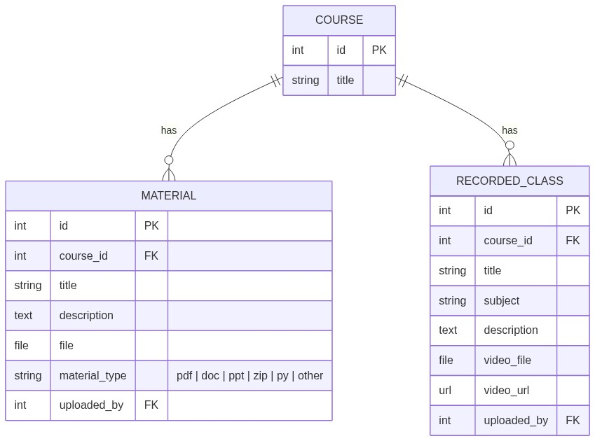
Figure 8: Module 3: Study Materials & Recorded Classes — ERD

Module 4: Assignments & Project Management
Organizes standard assignments (with grade + feedback) and capstone team project submissions.
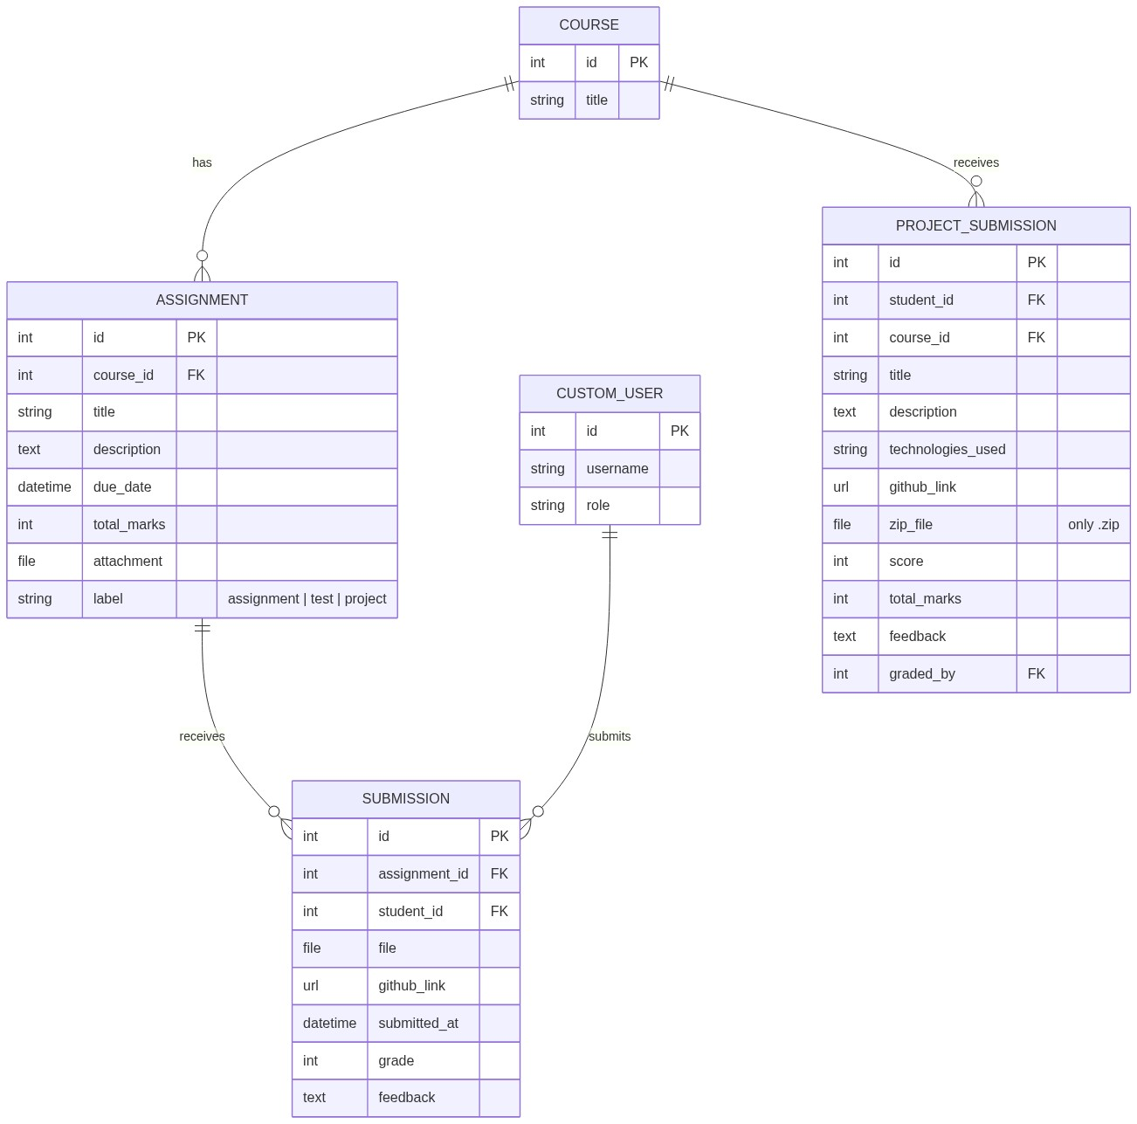
Figure 9: Module 4: Assignments & Project Management — ERD

Module 5: Quiz Assessment System
Represents MCQ-based quizzes, questions, options (choices), attempts, and student answers.
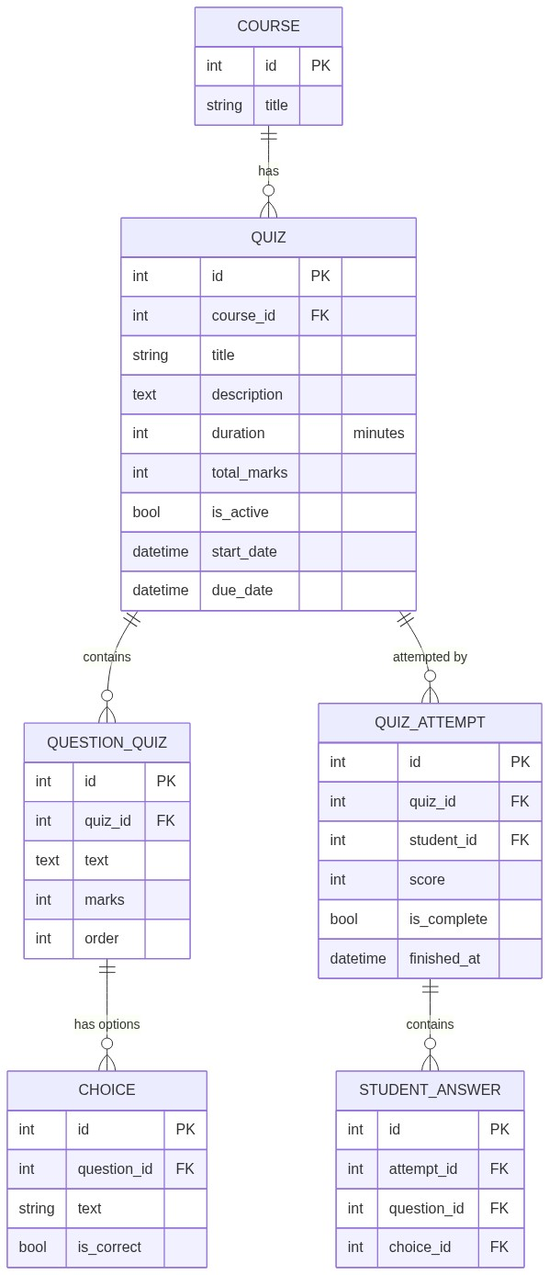
Figure 10: Module 5: Quiz Assessment System — ERD

Module 6: Online Coding Tests
Details the coding exam engine, including questions, test cases (sample/hidden), and execution evaluation scores.
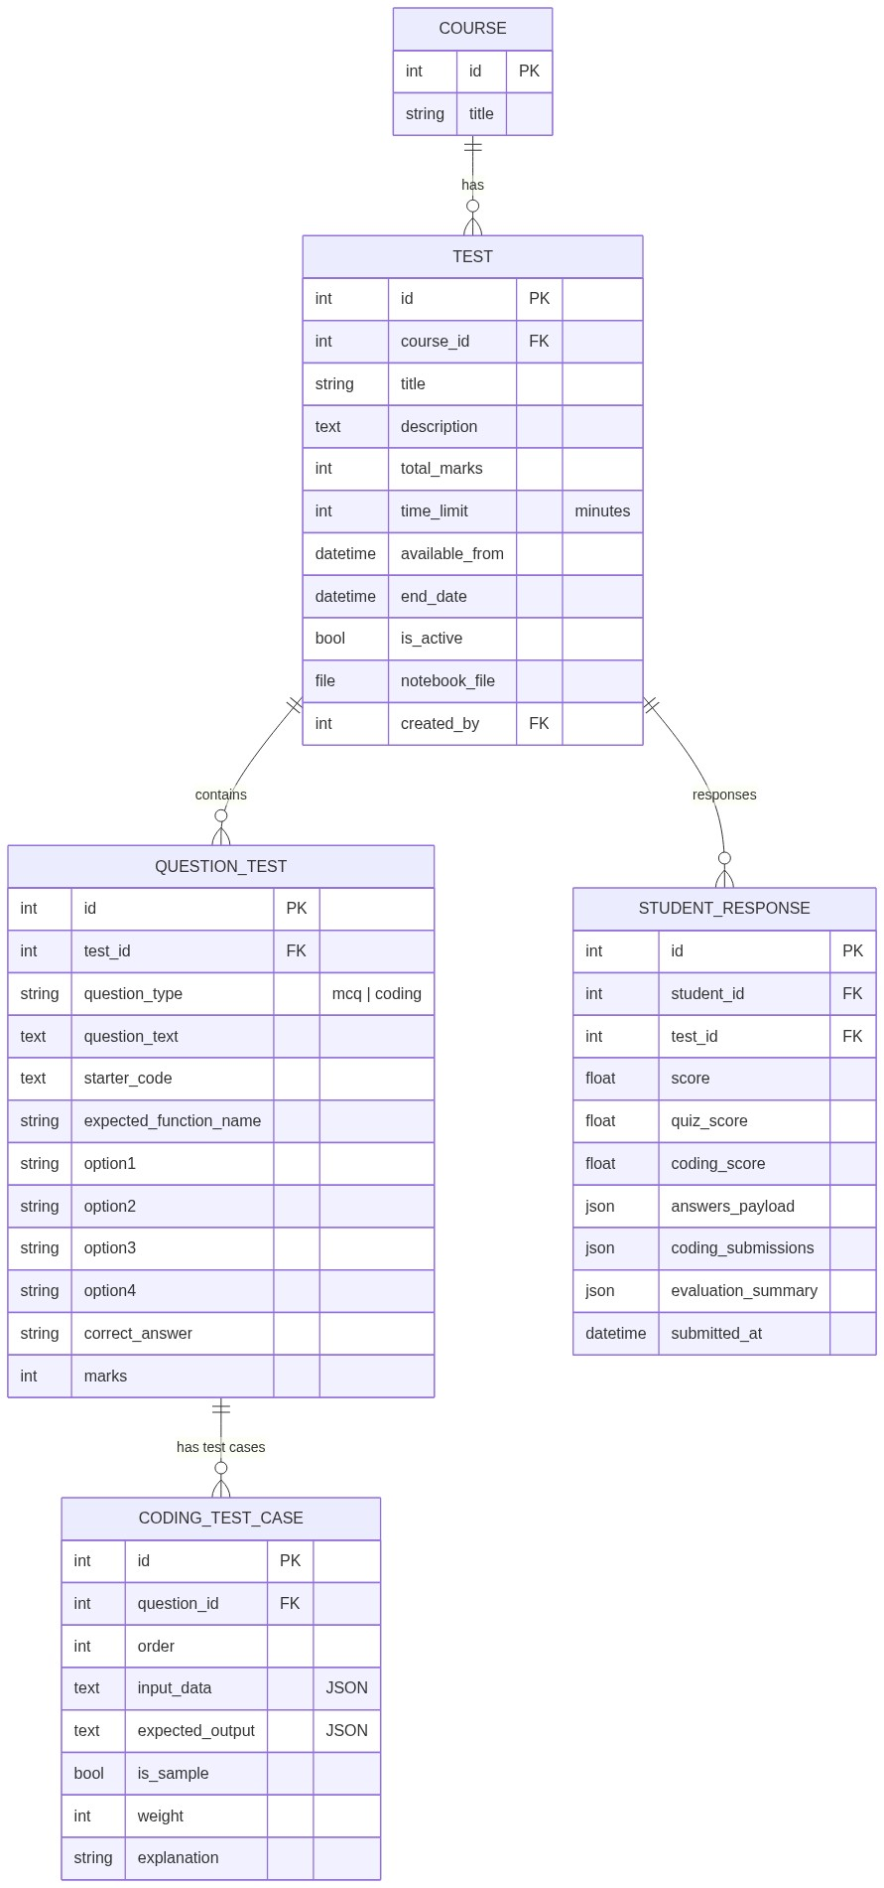
Figure 11: Module 6: Online Coding Tests — ERD

Module 7: Attendance, Grading & Certificates
Manages student attendance tracking, issued completion/excellence badges, and aggregated report cards.
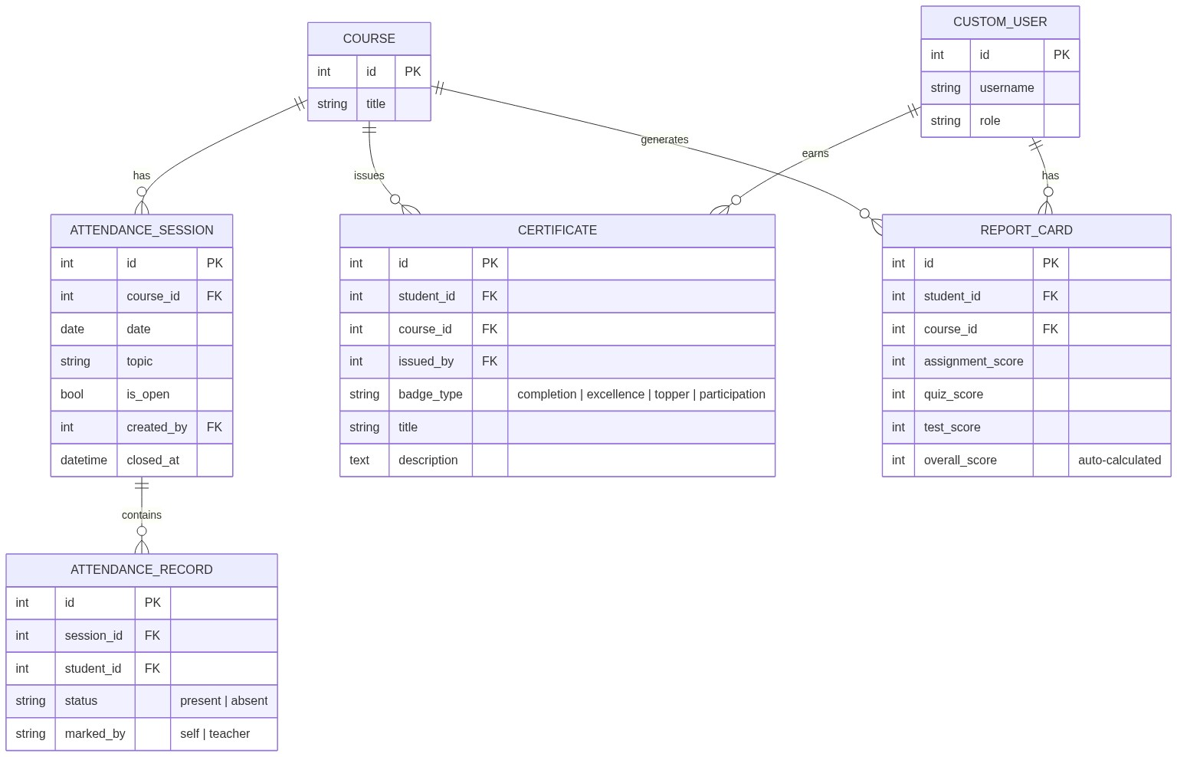
Figure 12: Module 7: Attendance, Grading & Certificates — ERD

6.3 Unique Constraints
The following unique constraints enforce data integrity across the database, preventing duplicate records in critical relationships:
Model | Constraint | Purpose
Enrollment | (student, course) | One enrollment per student per course
Submission | (assignment, student) | One submission per assignment
AttendanceSession | (course, date) | One session per day per course
AttendanceRecord | (session, student) | One record per student per session
QuizAttempt | (quiz, student) | One attempt per student per quiz
StudentAnswer | (attempt, question) | One answer per question
StudentResponse | (student, test) | One response per test
Certificate | (student, course, badge_type) | One badge type per student per course
ReportCard | (student, course) | One report per student per course

6.4 Summary Statistics
Metric | Count
Total Django Apps | 12
Total Database Models | 24
Foreign Key Relationships | 29
Many-to-Many Relationships | 3
Central Model | Course (referenced by 15 FKs)
User Model | CustomUser (referenced by 17 FKs + 3 M2M)

7. Application Flows — Screen by Screen
This section documents the complete user journey through every major feature of the platform. Each flow diagram shows the step-by-step interaction between the user and the system.

Flow 1: Registration → Approval → Dashboard
New users register by selecting their role (Teacher/Student), filling in profile details, and submitting the form. The system creates an account with pending status. Once an Admin approves, the user is redirected to their role-specific dashboard on next login.
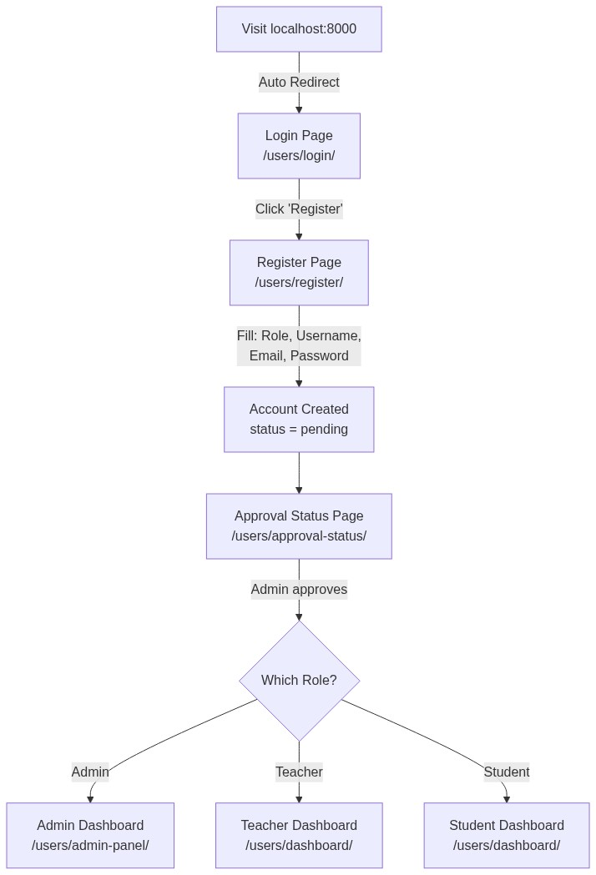
Figure 13: Registration → Approval → Dashboard Flow

Flow 2: Teacher Dashboard — Data Overview
The teacher dashboard provides a comprehensive overview of all teaching activities:
Dashboard Section | Data Displayed
My Courses | All courses taught with student/assignment/quiz/pending counts
Total Students | Sum of enrolled students across all courses
Total Assignments | Count of all assignments created
Total Quizzes | Count of all quizzes created
Pending vs Graded | Submission breakdown (assignments + projects)
Attendance Rate | Overall present/absent percentages
Course Status | Active / Inactive / Results Released counts
Pending Reviews | Top 5 ungraded submissions requiring action
Charts | Student counts, assignment counts, submission breakdown, attendance (JSON-powered Chart.js)

Flow 3: Student Dashboard — Data Overview
The student dashboard focuses on learning progress and upcoming tasks:
Dashboard Section | Data Displayed
Enrolled Courses | Courses with approved enrollment
Pending Work | Unsubmitted assignments + unattempted quizzes + tests + projects
Overall Performance | Average % across all graded work
Attendance % | Overall attendance rate across all courses
Student Rank | Ranking among all students (leaderboard position)
Upcoming Items | Next 4 deadlines (assignments, quizzes, tests, projects)
Charts | Weekly activity (7-day), course performance, workload breakdown

Flow 4: Course Creation → Enrollment
Teachers create courses by filling a form with title, description, department, dates, and cover image. After admin approval, students can browse departments, find the course, and request enrollment. The teacher gets a notification and approves/rejects the request.
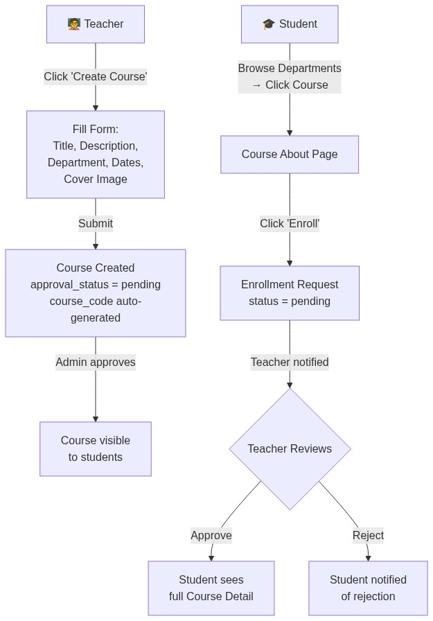
Figure 14: Course Creation → Enrollment Flow

Flow 5: Assignment Lifecycle
Teachers create assignments with title, description, deadline, total marks, and optional file attachments. Students submit work (file upload or GitHub link) before the deadline. The teacher grades each submission with marks and feedback. Students receive notification of their grades.
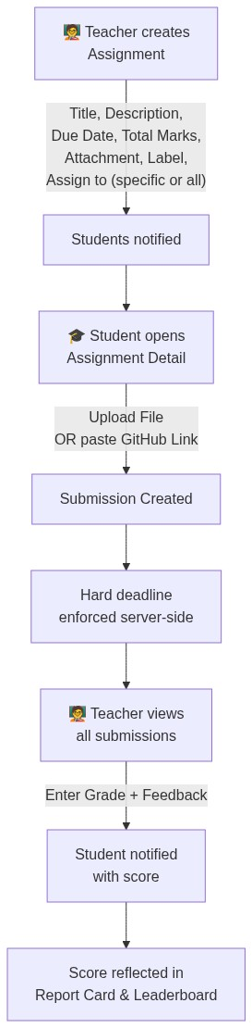
Figure 15: Assignment Lifecycle Flow

Flow 6: Quiz Lifecycle
Teachers create MCQ quizzes with configurable time limits, start/end dates, and question sets. Each question has multiple choices with one correct answer. Students take the quiz once within the allowed window. Scoring is automatic based on correct answers.
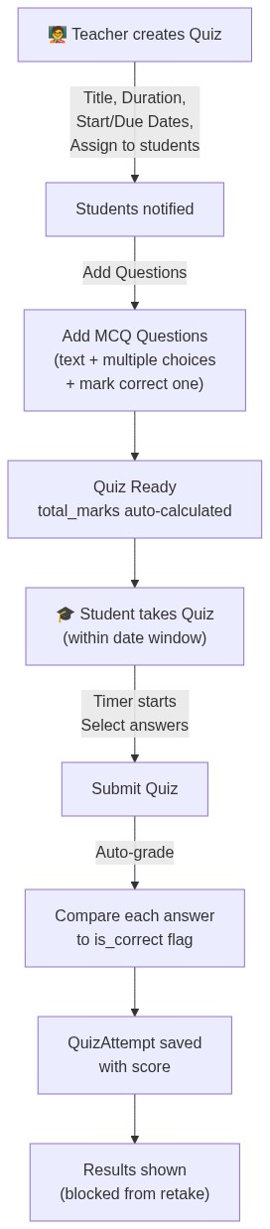
Figure 16: Quiz Lifecycle Flow

Flow 7: Online Coding Test (Unique Feature)
This is a standout feature of the LMS — an in-browser coding IDE where students write and submit code solutions. Teachers define coding questions with sample test cases (visible to students) and hidden test cases (for evaluation). The system runs student code against all test cases server-side and assigns a weighted score based on passed test cases.
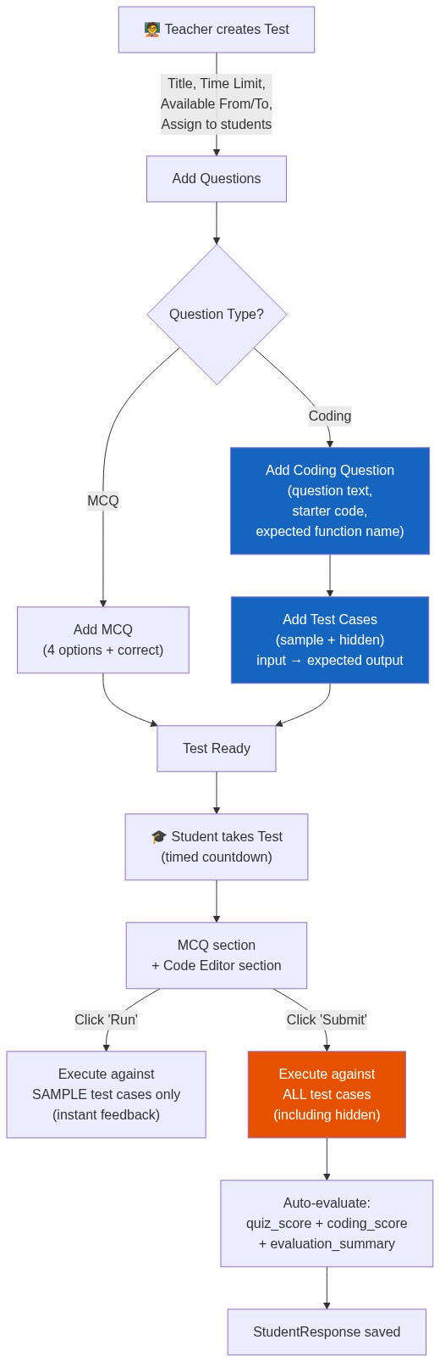
Figure 17: Online Coding Test Flow

Flow 8: Attendance Flow
Teachers create attendance sessions for specific dates. They can mark attendance manually or enable student self-marking within a configurable time window. Attendance records are tracked per student per session with unique constraints preventing duplicates.
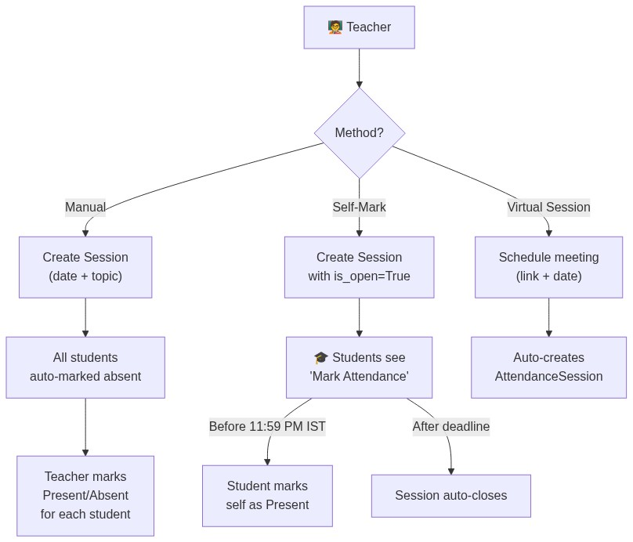
Figure 18: Attendance Tracking Flow

Flow 9: Chat System
The chat system supports two modes: direct messages (1-on-1) and course group chat. Messages are sent and received via AJAX polling for real-time feel. The system includes emoji picker, file upload support, and proper access control.
Figure 19: Chat System Flow
📝 NOTE: Access Control: Students can only DM teachers of their enrolled courses, peer students in the same courses, and admins. Teachers and admins can DM anyone.

Flow 10: Certificate Issuance
At the end of a course, teachers can issue digital badges/certificates to students. Four badge types are available: Completion, Excellence, Topper, and Participation. Each certificate is downloadable as a PDF and includes a unique verification. When a certificate is issued, a corresponding digital badge appears on the student's profile.
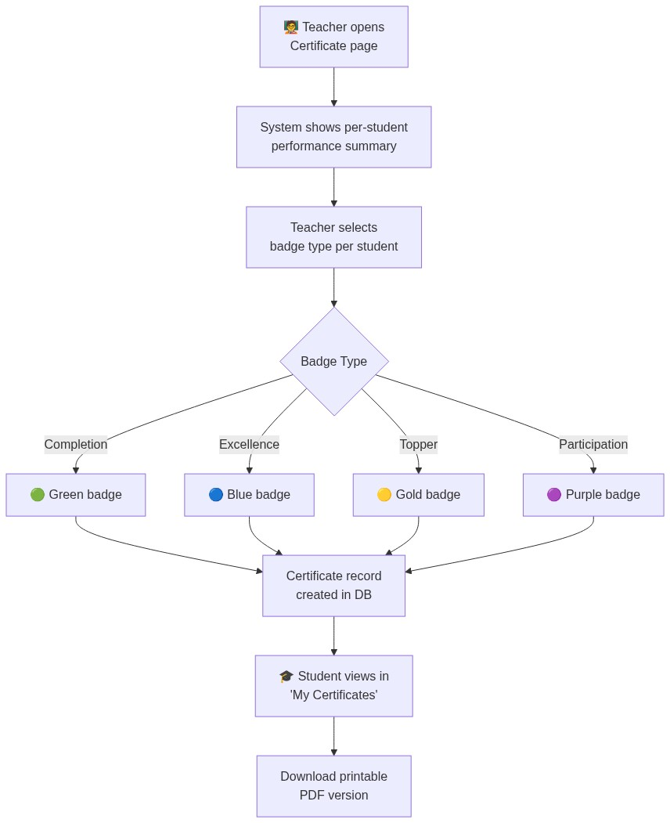
Figure 20: Certificate Issuance Flow

Flow 11: Reports & Grading
Teachers can generate report cards that aggregate scores across assignments, quizzes, coding tests, and projects for each student. Reports can be exported as Excel spreadsheets with color-coded formatting and weekly data breakdown.
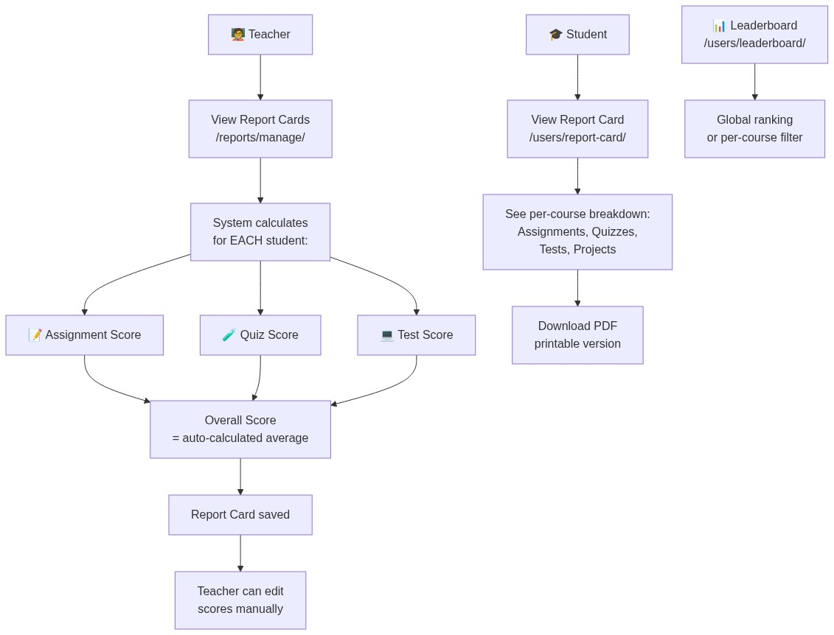
Figure 21: Reports & Grading Flow

Flow 12: Data Export
The system supports exporting data in three formats: CSV (simple tabular data), Excel (color-coded with multiple sheets and weekly analysis), and PDF (for certificates and report cards). Teachers can download comprehensive grade reports from the course detail page.
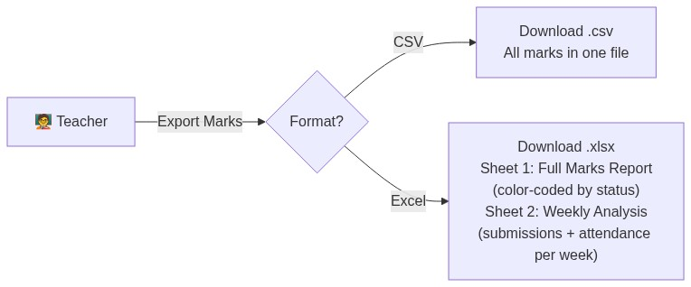
Figure 22: Data Export Flow

8. Step-by-Step: How to Create a Course (Example)
This section walks through a complete course lifecycle from creation to completion, demonstrating how the system works in practice.

Scenario
📝 NOTE: Teacher "Dr. Sharma" wants to create a course called "Machine Learning Fundamentals" under the Computer Science department and invite students.

Step 1: Login as Teacher
1. Open browser → Go to http://localhost:8000
2. Redirected to /users/login/
3. Enter credentials: teacher1 / pass123
4. Click Login → Redirected to Teacher Dashboard

Step 2: Create the Course
1. Click "Create Course" on the dashboard
2. Navigate to /courses/create/
3. Fill in the form:
Field | Example Value
Title | Machine Learning Fundamentals
Description | Learn the basics of ML including regression, classification, clustering, and neural networks.
Department | Computer Science
Max Students | 50
Start Date | 2026-06-15
End Date | 2026-09-15
Project Start | 2026-08-01
Project End | 2026-09-10
Cover Image | Upload a banner image

4. Click Submit
⚠️ IMPORTANT: The course is created with approval_status = pending. An Admin must approve it before students can see it. The system auto-generates a unique course_code (e.g., CS-ML2026) and batch identifier.

Step 3: Admin Approves the Course
1. Admin logs in → Goes to Admin Panel → Courses
2. Sees the pending course → Clicks Approve
3. Course is now visible to students

Step 4: Students Enroll
1. Student logs in → Browses Departments → Clicks Computer Science
2. Sees "Machine Learning Fundamentals" in the course list
3. Clicks the course → Sees the About page
4. Clicks "Enroll" → Enrollment request created (status = pending)
5. Teacher gets notification: "Student X requested enrollment"
6. Teacher clicks Approve → Student now has full access

Step 5: Add Content to the Course
After enrollment, the teacher adds content from the Course Detail page:
Action | What Teacher Does | What Students See
Create Assignment | Title: "Linear Regression", Due: June 25, Marks: 100 | Assignment appears in dashboard "Pending"
Upload Material | Upload "ML_Notes.pdf" (type: pdf) | Material available for download
Create Quiz | Title: "ML Basics Quiz", Duration: 30 min, Add 10 MCQs | Quiz appears in dashboard "Upcoming"
Create Coding Test | Title: "Implement KNN", Time: 60 min, Add test cases | Test appears in course detail
Upload Recording | Upload lecture video or paste YouTube URL | Recording available in course
Schedule Session | Set meeting link + date/time | Session listed, auto-attendance
Open AI Tutor | Available immediately per course | Students can chat with AI

Step 6: Student Submits Assignment
1. Student opens Assignment Detail → Clicks Submit
2. Uploads a .py file OR pastes a GitHub link
3. System enforces hard deadline (server-side check)
4. Submission saved with timestamp

Step 7: Teacher Grades
1. Teacher opens Assignment Detail → Sees all submissions
2. For each student, enters Grade: 85 (out of 100)
3. Enters Feedback: "Good implementation, but missing edge case handling."
4. Clicks Save → Student gets notification: "Your assignment scored 85/100"

Step 8: End of Course
Action | Result
Generate Report Cards | Score summary per student (assignments + quizzes + tests)
Export to Excel | Color-coded spreadsheet with all marks + weekly analysis
Issue Certificates | Select badge type per student (Completion/Excellence/Topper)
Release Results | Toggle results_released → students can see all scores

9. AI Integration
Smart Classroom integrates artificial intelligence in three key areas: an AI-powered tutoring chatbot with dynamic RAG context retrieval, an automated coding test evaluation engine, and a teacher assistant for AI-assisted assignment grading. Both RAG and grading features connect directly to Google's Gemini API using Python's built-in urllib libraries (zero dependencies), ensuring absolute lightweight operation and a safe local fallback to prevent server errors.

AI Tutor (Per-Course Chatbot with RAG)
Each course has a dedicated AI Tutor powered by Google Gemini. Students and teachers can chat with the AI about course-specific topics. To make the bot specialized for each course, the system implements a custom Retrieval-Augmented Generation (RAG) engine. When a user asks a question, the RAG engine searches uploaded materials (PDFs and text files) for the course, chunks the text, ranks them by term similarity matching, and appends the top matching sections to the Gemini prompt.
Property | Detail
Model | Google Gemini (direct API integration via urllib.request)
URL | /courses/<course_pk>/ai-tutor/
RAG Engine | Extracts text from PDF/code/text materials, chunks content, scores and retrieves top matches based on query terms.
Caching | Parsed text documents are cached in-memory with file modification time keys to speed up subsequent queries.
Persistence | Full conversation saved per user per course in the database (AITutorMessage model)
Fallback | If Gemini API is blocked or key is missing, automatically runs in Local Fallback Mode showing simulated replies.
Access | Only enrolled students and course teachers can access

AI Assignment Grading Assistant
When grading student assignment submissions, teachers can leverage the AI Grading Assistant. By clicking the "Generate AI Suggestion" button, an AJAX request triggers the server to read the student's submission text or code and pass it along with the assignment parameters to Gemini. The AI returns a recommended score and a structured feedback draft in Markdown, which the teacher can edit and approve.
Property | Detail
Model | Google Gemini (MIME response type restricted to JSON)
URL | /assignments/submission/<submission_pk>/ai-grade/
API Fallback | Catches request blocks/network failures to return mock grading and comments based on assignment tags with zero downtime.
Teacher Control | AI suggestions are only loaded into the scoring form inputs; nothing is saved until the teacher clicks "Save Grade".

Coding Test Evaluation Engine
The online coding test system includes an automated evaluation engine that runs student-submitted code against predefined test cases on the server side.
Property | Detail
Function | evaluate_coding_question() in tests app
Process | Takes student code → runs against hidden test cases → compares output
Scoring | Weighted test cases, partial credit possible based on cases passed
Security | Server-side execution only; code never runs in the browser
Languages | Python (primary), extensible to other languages

Anti-Cheat Exam System
The platform implements a comprehensive anti-cheat system for quizzes and coding tests to maintain exam integrity. This was one of the most critical features developed, addressing multiple security vulnerabilities:
Feature | Implementation
Fullscreen Lock | Exam auto-enters fullscreen on start; exit triggers warning
Tab Switch Detection | visibilitychange event listener detects tab switches
Window Blur Detection | blur event detects focus loss (half-screen, alt-tab, etc.)
Warning Counter | 2 warnings displayed with overlay before action
Auto-Submit | On 3rd violation, form is automatically submitted with saved answers
UI Lockdown | Sidebar, navbar, and footer hidden during exam (body.exam-active CSS class)
Pre-Exam Instructions | Rules overlay shown before exam starts with "I Agree" button
Browser X Detection | document.fullscreenElement === null check catches all exit methods

10. Admin Panel
The Admin Panel (`/users/admin-panel/`) provides a complete management interface for system administrators. It is a custom-built dashboard (separate from Django's built-in admin) designed specifically for the Smart Classroom's workflow needs.
Section | Capabilities
Dashboard | Total counts: departments, courses, teachers, students, pending approvals
Site Admin | Django-admin-style model browser with live counts for all 12 apps
Departments | Create, edit, list departments with course counts
Teachers | Create, approve/reject/deactivate, list with status filter, and bulk approval checkboxes
Students | Create, approve/reject, enroll in courses, list with status filter, and bulk approval checkboxes
Courses | Create (auto-approved), edit, approve/reject teacher-created courses

The admin panel uses a clean card-based layout with count badges showing pending items that require attention. All approval actions send automatic notifications to the affected users.

11. Security Features
Security is a core concern in the Smart Classroom LMS. The system implements multiple layers of protection covering authentication, authorization, data integrity, and exam security.

Authentication & Authorization
• Custom User Model (CustomUser) extending Django's AbstractUser with role field, account approval status, and unique student ID
• Unique Auto-Generated Student ID — student accounts automatically receive a sequential identifier STU-YYYYXX on registration (e.g. STU-202601) to uniquely identify learners across academic years
• AccountStatusMiddleware — intercepts every request; redirects unapproved users to approval page
• @login_required decorator on all views requiring authentication
• Role-based access control — views check user.role before allowing actions
• Enrollment verification — course content views verify student enrollment before granting access
• CSRF protection — Django's built-in CSRF middleware on all POST forms

Content Access Control
• Recorded classes — enrollment check prevents unauthorized video access (Critical fix #12)
• Assignment submissions — server-side deadline enforcement prevents late submissions
• Quiz/Test attempts — unique constraints prevent multiple attempts per student
• Chat access — students can only message teachers/peers in enrolled courses

Data Integrity
• Soft-delete enrollment — is_active=False instead of deletion, preserving all student data
• Unique constraints on 9 critical model relationships (see Section 6.3)
• Server-side validation — all forms validated on the server, not just client-side
• Password validators — Django's 4 built-in password validators enforced

Exam Security (Anti-Cheat)
The anti-cheat system (detailed in Section 9) prevents students from cheating during online quizzes and coding tests. It combines fullscreen enforcement, tab/window monitoring, and automatic submission on violation threshold.

12. Setup & Installation
The project includes an automated setup script (`setup.py`) that handles the complete installation process including virtual environment creation, dependency installation, database migration, sample data creation, and server startup.

Quick Setup (Automated)
# Navigate to project directory
cd "c:\Data Science and Gen Ai projects\smart_classroom"

# Run automated setup (creates venv, installs deps, migrates, seeds data, starts server)
python setup.py

Manual Setup (Step-by-Step)
# 1. Navigate to project
cd "c:\Data Science and Gen Ai projects\smart_classroom"

# 2. Create & activate virtual environment
python -m venv .venv
.venv\Scripts\activate # Windows
# source .venv/bin/activate # Linux/Mac

# 3. Install dependencies
pip install -r requirements.txt

# 4. Run database migrations
python manage.py migrate

# 5. Create sample data (teachers, students, courses, etc.)
python setup.py

# 6. Start the development server
python manage.py runserver

# 7. Open browser → http://localhost:8000

Default Test Accounts
After running the setup, the following test accounts are available:

Teachers
Username | Password | Role
teacher1 | pass123 | Teacher
teacher2 | pass123 | Teacher

Students
Username | Password | Role
student1 | pass123 | Student
student2 | pass123 | Student
student3 | pass123 | Student
student4 | pass123 | Student
student5 | pass123 | Student

Pre-Created Demo Data
Data Type | Count | Details
Courses | 3 | Python Programming, Web Development, Data Science
Assignments | 2 per course | With file attachments
Quizzes | 1 per course | With MCQ questions
Materials | 2 per course | Document + link types
Recorded Classes | 1 per course | Video files
Projects | 1 per course | With descriptions and deadlines
Certificates | Generated | For enrolled students
Report Cards | Generated | With aggregated scores

13. Complete URL Reference Map
The Smart Classroom LMS exposes 105+ URL endpoints organized across 12 Django apps. This reference map documents every accessible URL in the system.

Users (11 URLs)
URL | Description
/users/register/ | Registration page (select role, fill profile)
/users/login/ | Login page (username + password)
/users/logout/ | Logout (redirects to login)
/users/dashboard/ | Role-based dashboard (different per role)
/users/profile/ | Edit profile (name, bio, picture)
/users/change-password/ | Change password form
/users/leaderboard/ | Global/course leaderboard rankings
/users/report-card/ | Student report card view
/users/report-card/download/ | Download report card as PDF
/users/approval-status/ | Pending approval status page
/users/notifications/ | Notification inbox

Admin Panel (16 URLs)
URL | Description
/users/admin-panel/ | Admin dashboard
/users/admin-panel/site-admin/ | Django model browser
/users/admin-panel/departments/ | Department list
/users/admin-panel/departments/create/ | Create department
/users/admin-panel/departments/<pk>/edit/ | Edit department
/users/admin-panel/teachers/ | Teacher list
/users/admin-panel/teachers/create/ | Create teacher
/users/admin-panel/teachers/<pk>/approve/ | Approve teacher
/users/admin-panel/teachers/<pk>/reject/ | Reject teacher
/users/admin-panel/teachers/<pk>/deactivate/ | Deactivate teacher
/users/admin-panel/students/ | Student list
/users/admin-panel/students/create/ | Create student
/users/admin-panel/students/<pk>/approve/ | Approve student
/users/admin-panel/students/<pk>/reject/ | Reject student
/users/admin-panel/students/<pk>/enroll/ | Enroll student in course
/users/admin-panel/courses/ | Course management list

Courses (14 URLs)
URL | Description
/courses/ | Department list (course browser)
/courses/create/ | Create new course
/courses/department/<dept_pk>/ | Courses in department
/courses/<pk>/ | Course detail page
/courses/<pk>/about/ | Course about/info page
/courses/<pk>/edit/ | Edit course details
/courses/<pk>/delete/ | Delete course
/courses/<pk>/enroll/ | Request enrollment
/courses/<pk>/unenroll/ | Cancel/withdraw enrollment
/courses/enrollment/<pk>/approve/ | Approve enrollment request
/courses/enrollment/<pk>/reject/ | Reject enrollment request
/courses/<id>/students/ | Get enrolled students (JSON API)
/courses/<pk>/sessions/create/ | Create virtual session
/courses/<pk>/ai-tutor/ | AI Tutor chatbot interface

Assignments (9 URLs)
URL | Description
/assignments/course/<course_pk>/create/ | Create assignment for course
/assignments/<pk>/ | Assignment detail page
/assignments/<pk>/edit/ | Edit assignment
/assignments/<pk>/submit/ | Submit assignment (file/GitHub)
/assignments/<pk>/delete/ | Delete assignment
/assignments/submission/<pk>/grade/ | Grade student submission
/assignments/submission/<pk>/delete/ | Delete submission
/assignments/course/<pk>/export/csv/ | Export marks as CSV
/assignments/course/<pk>/export/excel/ | Export marks as Excel

Attendance (5 URLs)
URL | Description
/attendance/course/<pk>/ | Attendance session list
/attendance/course/<pk>/create/ | Create attendance session
/attendance/session/<pk>/ | Take/mark attendance
/attendance/session/<pk>/mark/ | Student self-mark attendance
/attendance/course/<pk>/student/ | Student attendance view

Materials (3 URLs)
URL | Description
/materials/course/<pk>/upload/ | Upload study material
/materials/<pk>/download/ | Download material file
/materials/<pk>/delete/ | Delete material

Quizzes (10 URLs)
URL | Description
/quiz/course/<pk>/ | Quiz list for course
/quiz/course/<pk>/create/ | Create new quiz
/quiz/<pk>/edit/ | Edit quiz details
/quiz/<pk>/questions/ | Add/manage questions
/quiz/<pk>/attempt/ | Take quiz (student)
/quiz/result/<pk>/ | View quiz result
/quiz/<pk>/submissions/ | All quiz submissions (teacher)
/quiz/<pk>/students/ | Students who attempted
/quiz/<pk>/delete/ | Delete quiz
/quiz/question/<pk>/delete/ | Delete individual question

Online Tests (12 URLs)
URL | Description
/tests/ | Test list (all)
/tests/course/<pk>/ | Tests by course
/tests/create/ | Create test (no course)
/tests/course/<pk>/create/ | Create test for specific course
/tests/<id>/ | Test detail page
/tests/<id>/edit/ | Edit test
/tests/<id>/delete/ | Delete test
/tests/<id>/take/ | Take test (coding IDE)
/tests/<id>/question/add/ | Add coding question
/tests/question/<id>/cases/add/ | Add test cases to question
/tests/<id>/responses/ | All student responses
/tests/<id>/responses/<id>/ | Individual response detail

Projects (4 URLs)
URL | Description
/projects/ | Project list
/projects/submit/ | Submit project (GitHub/ZIP)
/projects/<pk>/ | Project detail + grading
/projects/<pk>/delete/ | Delete project

Chat (6 URLs)
URL | Description
/chat/ | Chat inbox (conversation list)
/chat/<user_id>/ | Direct message chat room
/chat/send/<user_id>/ | Send DM (AJAX POST)
/chat/fetch/<user_id>/ | Fetch new messages (AJAX GET)
/chat/group/<course_id>/ | Course group chat room
/chat/group/fetch/<course_id>/ | Fetch group messages (AJAX GET)

Certificates (6 URLs)
URL | Description
/certificates/course/<pk>/issue/ | Issue certificates to students
/certificates/my/ | My certificates list
/certificates/<pk>/view/ | View certificate details
/certificates/<pk>/exact/ | Detailed certificate view
/certificates/<pk>/download/ | Download certificate as PDF
/certificates/<pk>/exact/download/ | Download detailed PDF

Reports (4 URLs)
URL | Description
/reports/ | Reports home page
/reports/manage/ | Report management list (teacher)
/reports/<pk>/ | Individual report detail
/reports/<pk>/edit/ | Edit report card

Recorded Classes (5 URLs)
URL | Description
/recorded-classes/ | Recording list
/recorded-classes/upload/ | Upload new recording
/recorded-classes/<pk>/edit/ | Edit recording details
/recorded-classes/<pk>/delete/ | Delete recording
/recorded-classes/<pk>/ | Watch recording (video player)

URL Count Summary
Module | URL Count
Users | 11
Admin Panel | 16
Courses | 14
Assignments | 9
Attendance | 5
Materials | 3
Quizzes | 10
Online Tests | 12
Projects | 4
Chat | 6
Certificates | 6
Reports | 4
Recorded Classes | 5
TOTAL | 105+

14. Development History & Bug Fixes
During the development of Smart Classroom LMS, 37 issues were identified, diagnosed, and fixed across the entire application. This section documents every issue with its impact, priority, and the solution applied. All issues are now resolved.

Priority Distribution
Priority | Count | Description
🔴 Critical | 5 | Security breaches, core functionality broken
High | 10 | Major feature failures, data integrity issues
Medium | 15 | Feature gaps, UX problems, missing functionality
Low | 7 | Visual glitches, minor polish items

Complete Issue Summary
# | Issue | Module | Priority | Status
1 | Course cards uneven layout (single course) | Courses UI | Medium | ✅ Fixed
2 | Course description bullets not rendering | Courses UI | Medium | ✅ Fixed
3 | Button misalignment in course cards | Courses UI | Low | ✅ Fixed
4 | Long descriptions overlapping cards | Courses UI | Medium | ✅ Fixed
5 | Test time lock not working / uneven desc | Tests App | High | ✅ Fixed
6 | Teacher dashboard charts not displaying | Dashboard | High | ✅ Fixed
7 | Pending work false positives/negatives | Dashboard | High | ✅ Fixed
8 | Projects no deadline → wrong pending status | Projects | High | ✅ Fixed
9 | Chat missing emoji, file upload, poor UI | Chat App | Medium | ✅ Fixed
10 | Specific students misalignment in edit | Assignments | Medium | ✅ Fixed
11 | Course desc not rendering on confirm page | Courses | Low | ✅ Fixed
12 | Unauthorized recorded class access | Recorded Classes | 🔴 Critical | ✅ Fixed
13 | Re-enrollment no confirmation | Courses | Medium | ✅ Fixed
14 | Student data lost on un-enroll/re-enroll | Courses | High | ✅ Fixed
15 | Digital badges not created on cert issue | Certificates | Medium | ✅ Fixed
16 | Year label overlapping badge section | Profile UI | Low | ✅ Fixed
17 | Badge download not available | Profile | Low | ✅ Fixed
18 | Edit assignment error (specific students) | Assignments | 🔴 Critical | ✅ Fixed
19 | Teacher cannot upload recorded session | Recorded Classes | 🔴 Critical | ✅ Fixed
20 | Test creation "no students" error | Tests App | High | ✅ Fixed
21 | Teacher nav link overflow | UI / Navbar | Low | ✅ Fixed
22 | Teacher missing pending work section | Dashboard | Medium | ✅ Fixed
23 | Tests list page not scrollable | Tests UI | Medium | ✅ Fixed
24 | Excel download missing weekly data | Reports | Medium | ✅ Fixed
25 | Unwanted orphan files in project | Cleanup | Low | ✅ Fixed
26 | No automated setup script | DevOps | Medium | ✅ Fixed
27 | No scrollbars on list pages | UI/UX | Low | ✅ Fixed
28 | No comprehensive test suite | QA / Testing | High | ✅ Fixed
29 | 3 test cases failing in test suite | QA | High | ✅ Fixed
30 | No live demo link without deployment | Demo/DevOps | Medium | ✅ Advised
31 | Students switching tabs during exams | Security/Exam | 🔴 Critical | ✅ Fixed
32 | Auto-submit not triggering after warnings | Security/Exam | 🔴 Critical | ✅ Fixed
33 | Browser X button bypasses fullscreen | Security/Exam | High | ✅ Fixed
34 | Sidebar/navbar visible during exam | Security/Exam | High | ✅ Fixed
35 | Half-screen window blur not detected | Security/Exam | High | ✅ Fixed
36 | Exam instructions overlay wrong alignment | UI / Exam | Low | ✅ Fixed
37 | Test status stuck on "Active" after deadline | Tests App | Medium | ✅ Fixed

Critical Issues — Detailed Solutions

#12: Unauthorized Recorded Class Access
**Problem**: Students not enrolled in a course could access recorded class videos by navigating directly to the URL — a complete security bypass exposing content meant to be restricted.
**Solution**: Added `@login_required` + enrollment check in the RecordedClass view. The view now checks if `request.user` is enrolled in the course linked to the video and redirects to the course list with an error message if not enrolled. Teacher access is always permitted.

#18: Edit Assignment Error (Specific Students)
**Problem**: When a teacher selected "Specific Students" for an assignment and tried to save changes, a server 500 error occurred — core functionality broken.
**Solution**: The M2M (many-to-many) relationship for `specific_students` was not being properly set after the form save. Fixed with `form.save_m2m()` call in the edit view.

#19: Teacher Cannot Upload Recorded Session
**Problem**: Upload failed silently or threw an error — no recorded content management possible.
**Solution**: Fixed `MEDIA_ROOT`/`MEDIA_URL` settings, updated file upload view for large files, added `enctype="multipart/form-data"` to the upload form, and checked file size limits.

#31-32: Anti-Cheat System Failures
**Problem**: Students could freely switch tabs/windows during exams; the warning counter didn't trigger auto-submit after 2 warnings.
**Solution**: Implemented comprehensive anti-cheat: fullscreen lock with `visibilitychange` and `blur` event listeners, proper violation counter with `setTimeout` fallback for cooldown, and forced `form.submit()` on 3rd violation with answer auto-save via hidden fields.

Final System State
After all fixes, every module of the Smart Classroom LMS is fully functional:
Module | Status
User Authentication (Teacher/Student) | ✅ Working
Course Management | ✅ Working
Assignment Management | ✅ Working
Quiz System | ✅ Working
Tests System (with anti-cheat) | ✅ Working
Projects Tracking | ✅ Working
Recorded Classes (access-controlled) | ✅ Working
Chat / Messaging | ✅ Working
Attendance Tracking | ✅ Working
Certificates & Digital Badges | ✅ Working
Reports & Analytics (Excel download) | ✅ Working
Teacher Dashboard with Charts | ✅ Working
Student Dashboard with Pending Work | ✅ Working
Anti-Cheat Exam System | ✅ Working
Comprehensive Test Suite | ✅ Working
Automated Setup Script | ✅ Working

─────────────────────────────────────────────────────────────────────────────────────

Final Summary
Metric | Count
Django Apps | 12
Database Models | 24
URL Endpoints | 105+
Templates | 50+
User Roles | 3 (Admin, Teacher, Student)
Approval Workflows | 3 (User, Course, Enrollment)
AI Integration Points | 2 (AI Tutor, Coding Evaluation)
Export Formats | 3 (CSV, Excel, PDF)
Chat Types | 2 (DM + Group)
Assessment Types | 4 (Assignment, Quiz, Coding Test, Project)
Certificate Types | 4 (Completion, Excellence, Topper, Participation)
Bugs Fixed | 37 (5 Critical, 10 High, 15 Medium, 7 Low)

─────────────────────────────────────────────────────────────────────────────────────

Document prepared by: Yaswanth Munagoti
Project: Smart Classroom LMS
Last Updated: June 2026

