🎓 Smart Classroom — Complete Project Documentation
Prepared for: Project Demonstration Meeting
Date: June 14, 2026
Project Type: Web-Based Learning Management System (LMS)
Tech Stack: Django · Python · SQLite · Bootstrap 5 · Gemini AI · WebSockets
────────────────────────────────────────────────────────────────────────────────

📋 Table of Contents
1. Project Overview
2. Technology Requirements
3. System Architecture
4. User Roles & Permissions
5. Approval Workflows
6. Complete Database Schema
7. Application Flow — Screen by Screen
8. Step-by-Step: How to Create a Course (Example)
9. AI Integration
10. Admin Panel
11. Setup & Installation
12. Default Test Accounts
13. Complete URL Reference Map
────────────────────────────────────────────────────────────────────────────────

🎯 1. Project Overview
Smart Classroom is a comprehensive web-based Learning Management System (LMS) built with Django that connects admins, teachers, and students in a digital classroom environment. It includes 12 Django apps and 24 database models.

Feature Summary
# | Feature | Description
--- | --------- | -------------
1 | User Management | 3 roles (Admin, Teacher, Student) with approval workflows
2 | Department & Course Management | Departments → Courses with unique codes, approval system
3 | Enrollment System | Students request enrollment → Teacher/Admin approves
4 | Assignments | Create, submit (file/GitHub), grade with marks & feedback
5 | Quizzes | MCQ-based quizzes with auto-scoring, time limits, date windows
6 | Online Coding Tests | In-browser coding IDE with sample/hidden test cases, auto-evaluation
7 | Attendance | Teacher marks or student self-marks (with deadlines)
8 | Study Materials | Upload PDF, DOC, PPT, ZIP, PY files for download
9 | Recorded Classes | Video uploads (file or URL) with streaming player
10 | Team Projects | Project submissions with GitHub links, ZIP uploads, grading
11 | Chat System | 1-on-1 direct messages + per-course group chat (AJAX real-time)
12 | AI Tutor | Per-course AI chatbot powered by Google Gemini
13 | Virtual Sessions | Schedule online meeting links with auto-attendance
14 | Certificates | Issue badges (Completion, Excellence, Topper, Participation)
15 | Reports & Leaderboard | Report cards, grade exports (CSV/Excel), rankings
16 | Notification System | In-app notifications for all key events
17 | Admin Panel | Custom admin dashboard for managing everything
18 | Light/Dark Mode | CSS variable-based theme toggle

────────────────────────────────────────────────────────────────────────────────

🔧 2. Technology Requirements

Software Dependencies
Technology | Purpose | Version
----------- | --------- | ---------
Python | Backend programming language | 3.10+
Django | Web framework | ≥4.2, <5.0
SQLite3 | Database (built into Django) | —
Pillow | Image processing (profile pics, banners) | ≥9.0
WhiteNoise | Static file serving | ≥6.0
Gunicorn | Production WSGI server | ≥20.0
WeasyPrint | PDF generation for certificates/reports | ≥59.0
openpyxl | Excel export for marks/reports | ≥3.1
Google Generative AI | Gemini AI integration (AI Tutor) | Latest
Bootstrap 5 | Frontend CSS framework (via CDN) | 5.x

requirements.txt
Django>=4.2,<5.0
Pillow>=9.0
whitenoise>=6.0
gunicorn>=20.0
WeasyPrint>=59.0
openpyxl>=3.1

Key Configuration (settings.py)
Setting | Value
--------- | -------
Database | SQLite3 (db.sqlite3)
User Model | users.CustomUser
Time Zone | Asia/Kolkata
Login Redirect | /users/dashboard/
Logout Redirect | /users/login/
Media Root | BASE_DIR / 'media'

────────────────────────────────────────────────────────────────────────────────

🏗 3. System Architecture
📊 Diagram 1: Flow Chart
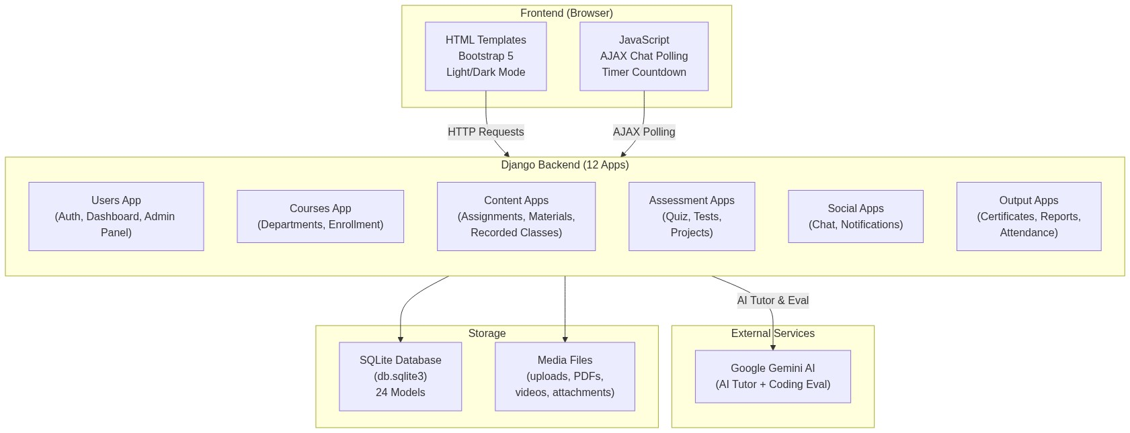

Request Lifecycle
Browser → HTTP Request → Django URL Router → View Function
↓
Permission Check (Role + Enrollment + Assignment)
↓
Database Query (ORM)
↓
[Optional] Gemini AI Call
↓
Template Rendering → HTML Response → Browser

────────────────────────────────────────────────────────────────────────────────

👥 4. User Roles & Permissions
The system has 3 roles with a hierarchical permission structure:

Role Comparison Matrix
Feature | 👑 Admin | 🧑‍🏫 Teacher | 🎓 Student
--------- | :-------: | :---------: | :---------:
Account | Auto-active | Needs approval | Needs approval
Dashboard | Admin panel | Course overview | Learning overview
Departments | Create/Edit/List | View only | View only
Courses | Create/Edit/Approve | Create (needs approval) | View & enroll
Enrollment | Approve/Reject | Approve/Reject (own courses) | Request enrollment
Assignments | — | Create/Edit/Delete/Grade | View/Submit
Quizzes | — | Create/Edit/Add Questions | Take quiz (once)
Online Tests | — | Create/Edit/Add Questions | Take test (once)
Attendance | — | Create session/Mark | Self-mark (if allowed)
Materials | — | Upload/Delete | Download
Recorded Classes | — | Upload/Edit/Delete | View/Watch
Projects | — | Grade | Submit/Delete own
Chat (DM) | Chat with anyone | Chat with anyone | Chat with teachers & peers
Group Chat | — | Course group chat | Course group chat
AI Tutor | — | Access per course | Access per course
Certificates | — | Issue to students | View/Download own
Reports | — | View all/Edit/Export | View own report card
Leaderboard | View | View | View
Notifications | Receive | Receive | Receive
Admin Panel | ✅ Full access | ❌ | ❌

────────────────────────────────────────────────────────────────────────────────

🔄 5. Approval Workflows
The system has 3 approval workflows to maintain quality control:

Workflow 1: User Registration Approval
📊 Diagram 2: Flow Chart
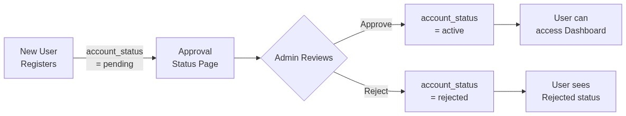

Workflow 2: Course Creation Approval
📊 Diagram 3: Flow Chart
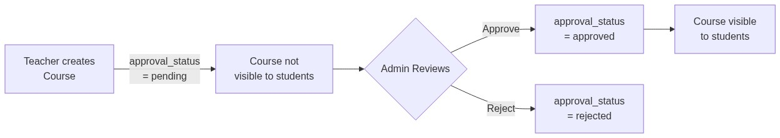

Workflow 3: Student Enrollment Approval
📊 Diagram 4: Flow Chart
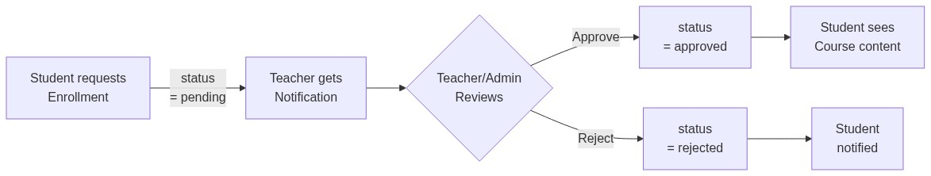
────────────────────────────────────────────────────────────────────────────────

🗄 6. Complete Database Schema

6.1 Entity Relationship Diagram (Partitioned by Module)
To ensure readability and clarity, the massive 24-model database schema has been divided into 7 logical modules.

6.1.1 Module 1: User Profiles & Direct Messages
Manages registration status, authentication roles, in-app notifications, and direct messaging between users.
📊 Diagram 5: Entity Relationship Diagram
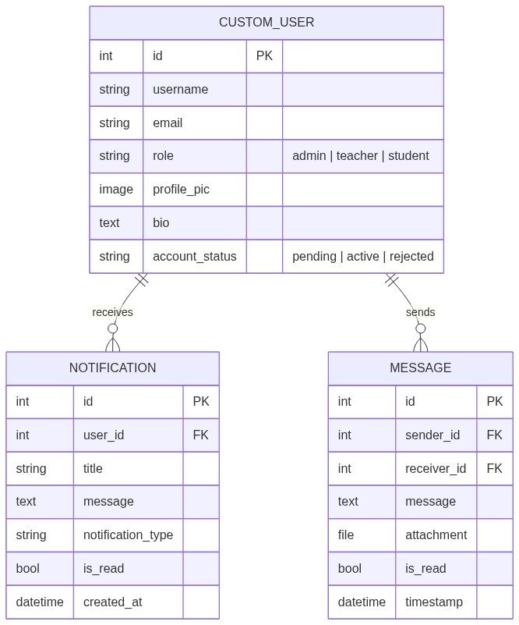

6.1.2 Module 2: Course & Enrollment Structure
Handles departments, courses, student enrollment requests, virtual live sessions, per-course group chats, and AI Tutor logs.
📊 Diagram 6: Entity Relationship Diagram
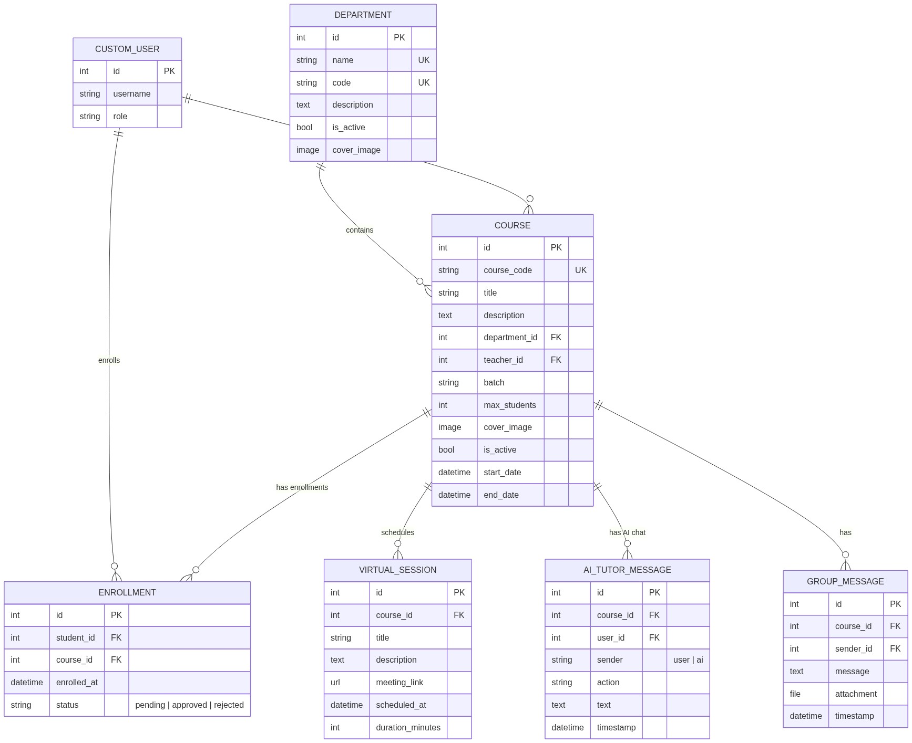

6.1.3 Module 3: Study Materials & Recorded Classes
Stores uploaded files (PDFs, PPTs, code files) and recorded video links/files for course materials.
📊 Diagram 7: Entity Relationship Diagram
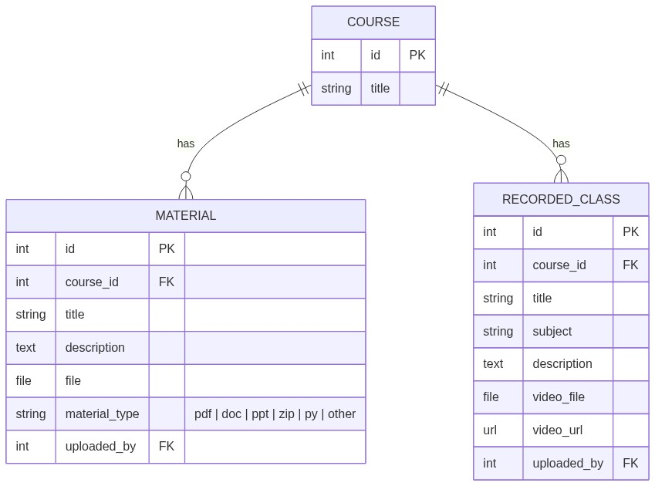

6.1.4 Module 4: Assignments & Project Management
Organizes standard assignments (with grade + feedback) and capstone team project submissions.
📊 Diagram 8: Entity Relationship Diagram
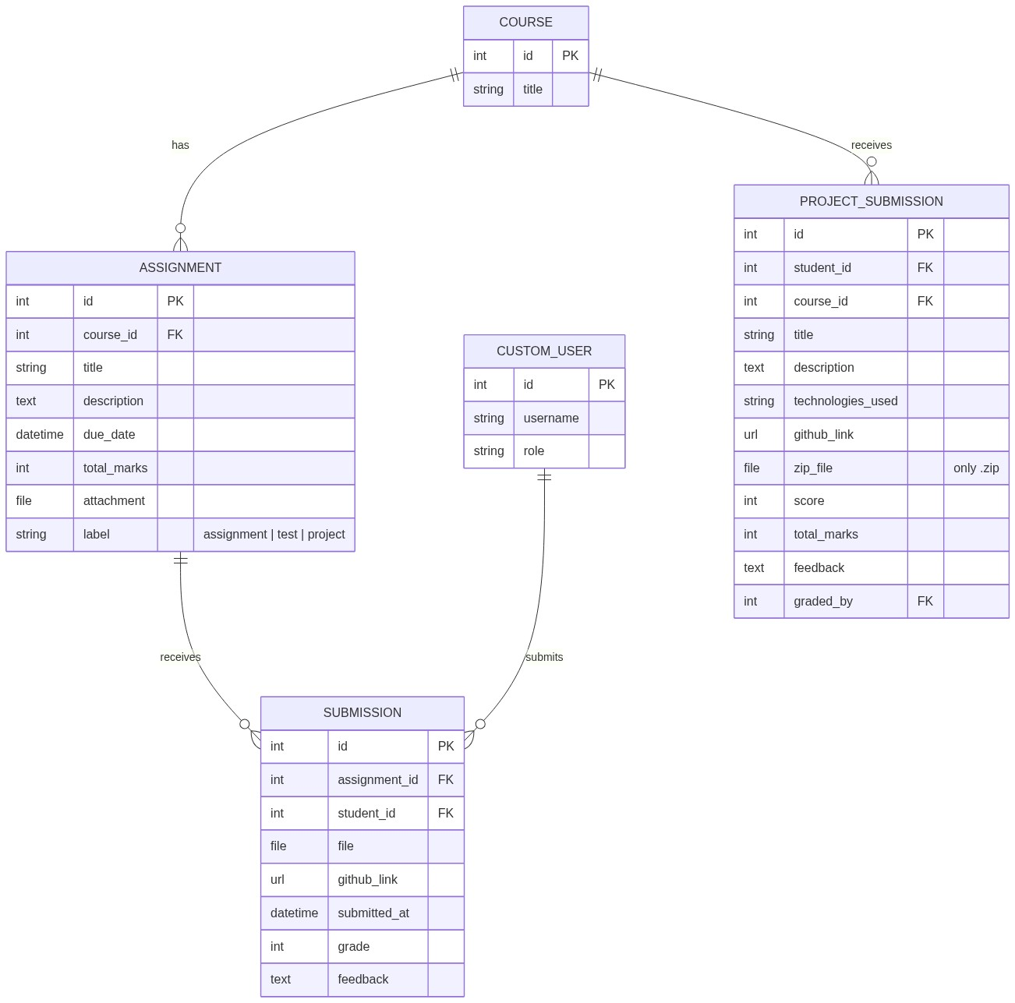

6.1.5 Module 5: Quiz Assessment System
Represents MCQ-based quizzes, questions, options (choices), attempts, and student answers.
📊 Diagram 9: Entity Relationship Diagram
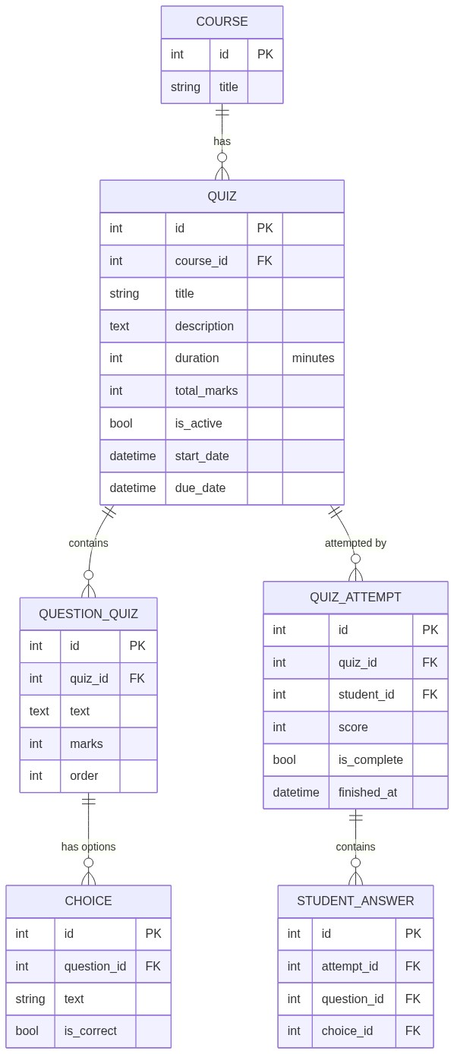

6.1.6 Module 6: Online Coding Tests
Details the coding exam engine, including questions, test cases (sample/hidden), and execution evaluation scores.
📊 Diagram 10: Entity Relationship Diagram
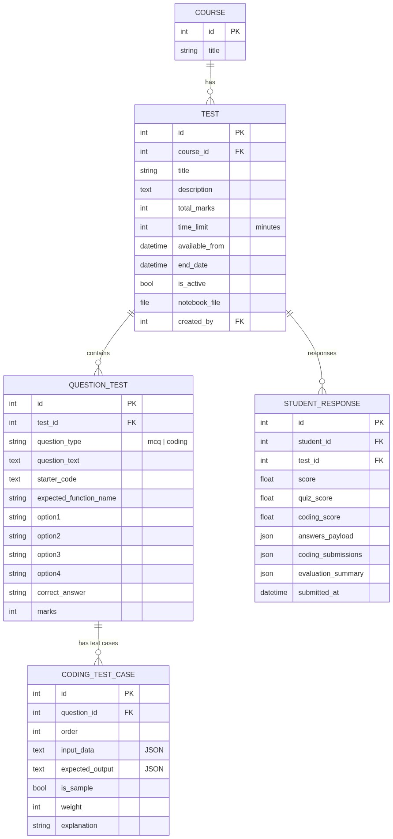

6.1.7 Module 7: Attendance, Grading & Certificates
Manages student attendance tracking, issued completion/excellence badges, and aggregated report cards.
📊 Diagram 11: Entity Relationship Diagram
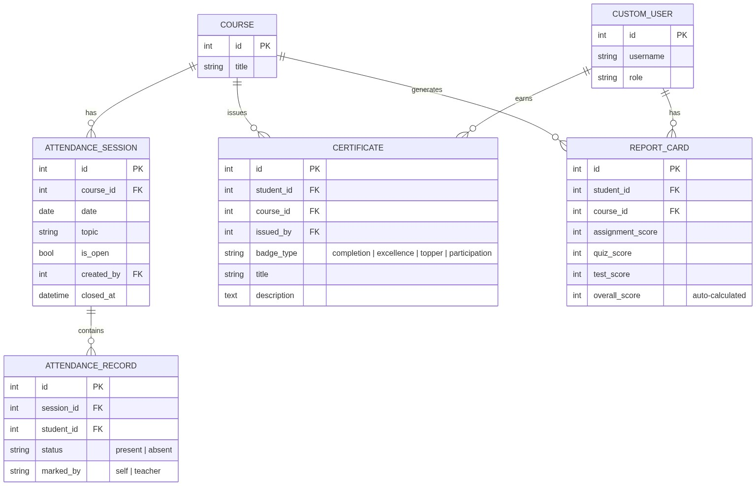

6.2 Unique Constraints
Model | Constraint | Purpose
------- | ----------- | ---------
Enrollment | (student, course) | One enrollment per student per course
Submission | (assignment, student) | One submission per assignment
AttendanceSession | (course, date) | One session per day per course
AttendanceRecord | (session, student) | One record per student per session
QuizAttempt | (quiz, student) | One attempt per student per quiz
StudentAnswer | (attempt, question) | One answer per question
StudentResponse | (student, test) | One response per test
Certificate | (student, course, badge_type) | One badge type per student per course
ReportCard | (student, course) | One report per student per course

6.3 Summary Statistics
Metric | Count
-------- | -------
Total Django Apps | 12
Total Database Models | 24
Foreign Key Relationships | 29
Many-to-Many Relationships | 3
Central Model | Course (referenced by 15 FKs)
User Model | CustomUser (referenced by 17 FKs + 3 M2M)

────────────────────────────────────────────────────────────────────────────────

🔄 7. Application Flow — Screen by Screen

Flow 1: Registration → Approval → Dashboard
📊 Diagram 12: Flow Chart
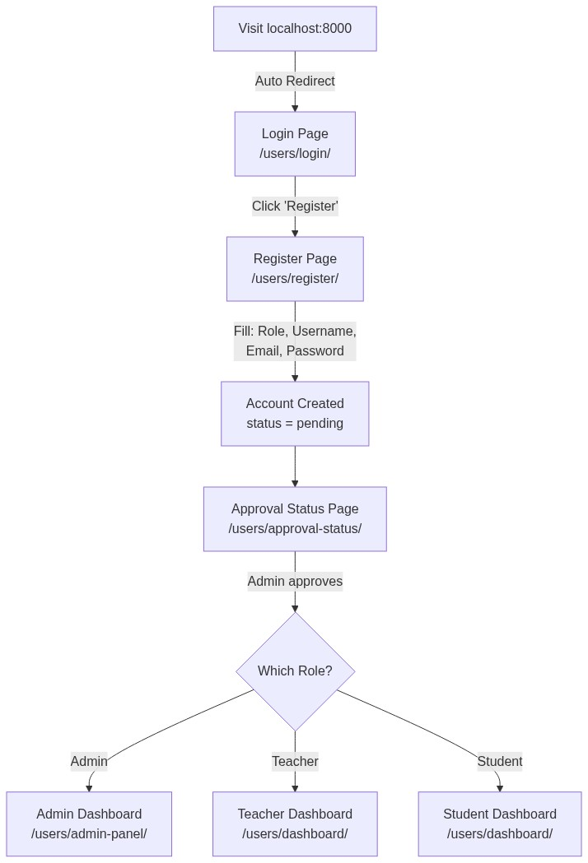

Flow 2: Teacher Dashboard — What You See
Dashboard Section | Data Displayed
------------------- | ---------------
My Courses | All courses taught with student/assignment/quiz/pending counts
Total Students | Sum across all courses
Total Assignments | All assignments created
Total Quizzes | All quizzes created
Pending vs Graded | Submission breakdown (assignments + projects)
Attendance Rate | Overall present/absent percentages
Course Status | Active / Inactive / Results Released counts
Pending Reviews | Top 5 ungraded submissions
Charts | Student counts, assignment counts, submission breakdown, attendance (JSON)

Flow 3: Student Dashboard — What You See
Dashboard Section | Data Displayed
------------------- | ---------------
Enrolled Courses | Courses with approved enrollment
Pending Work | Unsubmitted assignments + unattempted quizzes + tests + projects
Overall Performance | Average % across all graded work
Attendance % | Overall attendance across all courses
Student Rank | Ranking among all students
Upcoming Items | Next 4 deadlines (assignments, quizzes, tests, projects)
Charts | Weekly activity (7-day), course performance, workload breakdown

Flow 4: Course Creation → Enrollment
📊 Diagram 13: Flow Chart
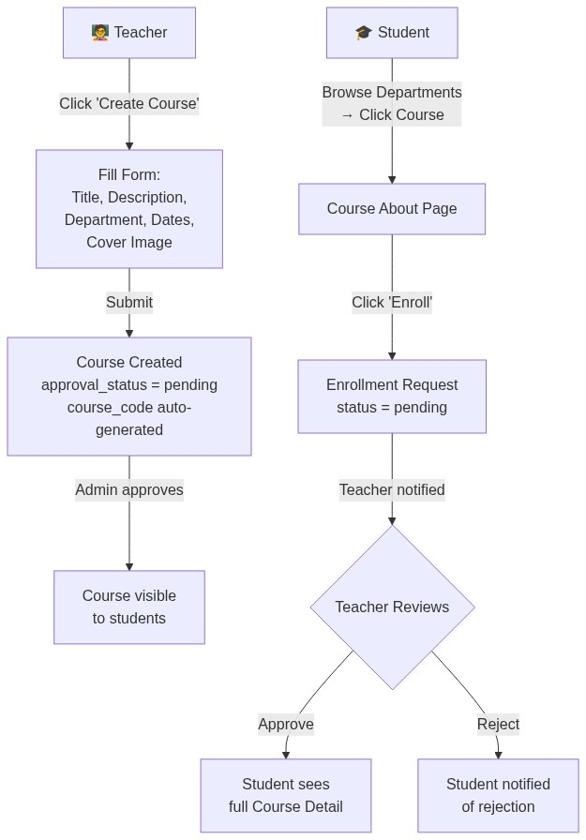

Flow 5: Assignment Lifecycle
📊 Diagram 14: Flow Chart
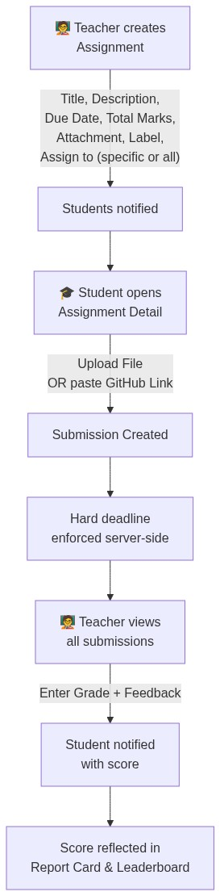

Flow 6: Quiz Lifecycle
📊 Diagram 15: Flow Chart
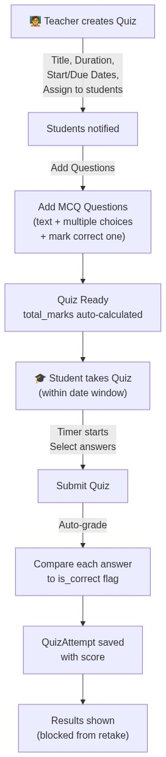

Flow 7: Online Coding Test (Unique Feature!)
📊 Diagram 16: Flow Chart
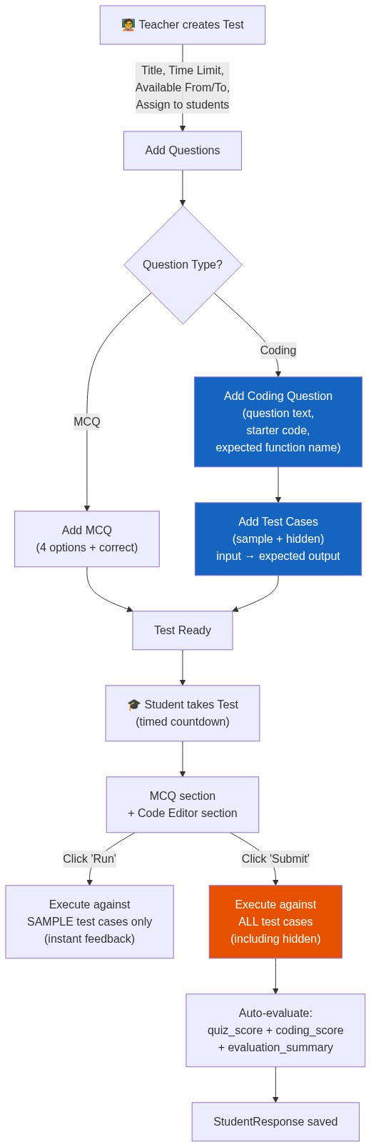

Flow 8: Attendance Flow
📊 Diagram 17: Flow Chart
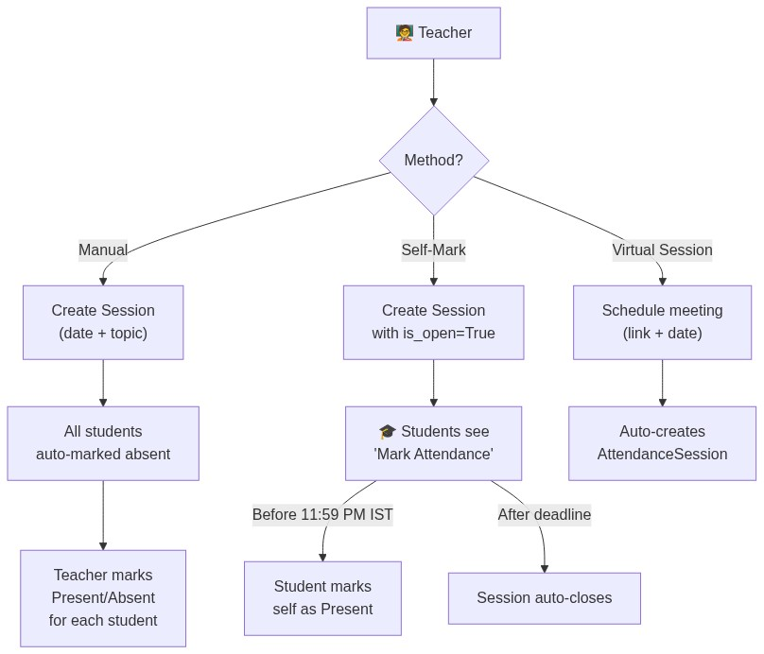

Flow 9: Chat System
📊 Diagram 18: Flow Chart
📝 NOTE: Access Control: Students can only DM teachers of their enrolled courses, peer students in same courses, and admins. Teachers and admins can DM anyone.

Flow 10: Certificate Issuance
📊 Diagram 19: Flow Chart
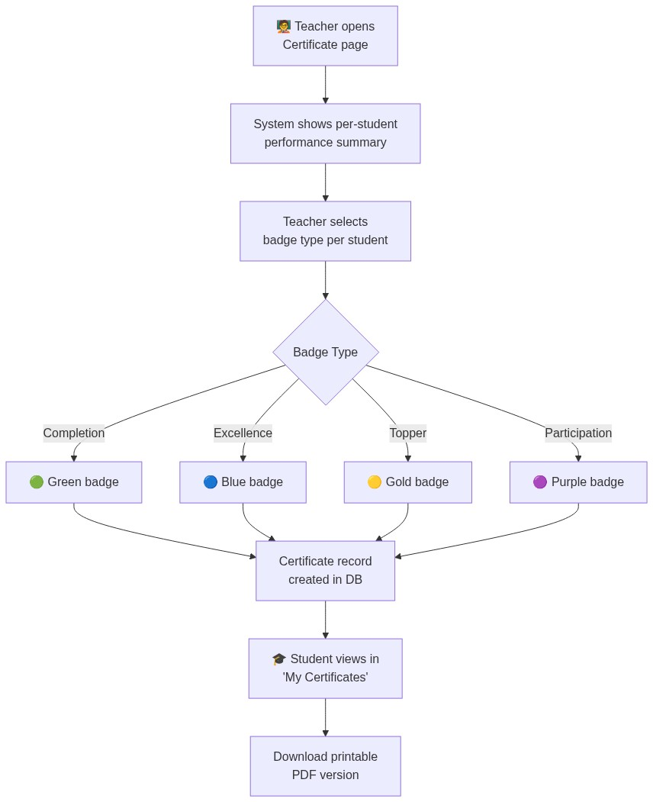

Flow 11: Reports & Grading
📊 Diagram 20: Flow Chart
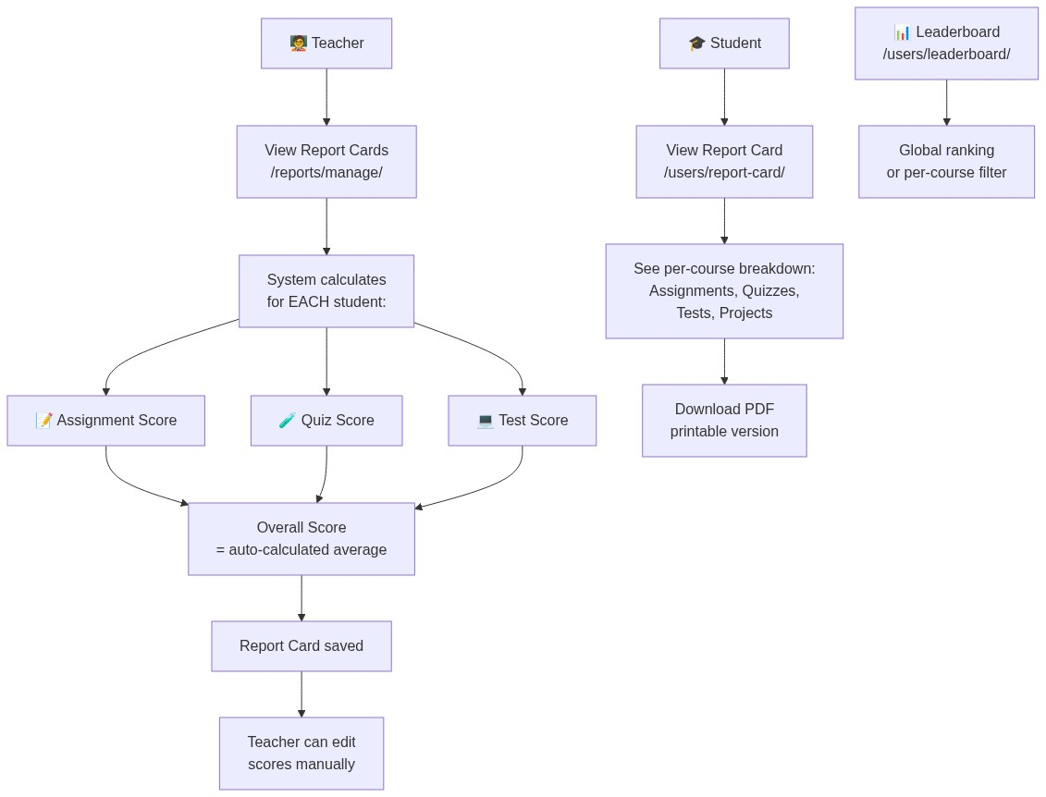

Flow 12: Data Export
📊 Diagram 21: Flow Chart
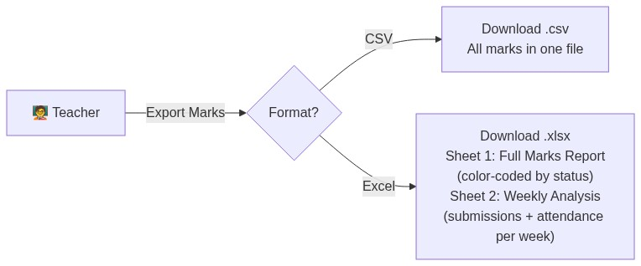
────────────────────────────────────────────────────────────────────────────────

📝 8. Step-by-Step: How to Create a Course (Example)

Scenario
Teacher "Dr. Sharma" wants to create a course called "Machine Learning Fundamentals" under the Computer Science department and invite students.
────────────────────────────────────────────────────────────────────────────────

Step 1: Login as Teacher
1. Open browser → Go to http://localhost:8000
2. Redirected to /users/login/
3. Enter credentials: teacher1 / pass123
4. Click Login → Redirected to Teacher Dashboard

Step 2: Create the Course
1. Click "Create Course" on the dashboard
2. Navigate to /courses/create/
3. Fill in the form:
Field | Example Value
------- | --------------
Title | Machine Learning Fundamentals
Description | Learn the basics of ML including regression, classification, clustering, and neural networks.
Department | Computer Science
Max Students | 50
Start Date | 2026-06-15
End Date | 2026-09-15
Project Start | 2026-08-01
Project End | 2026-09-10
Cover Image | Upload a banner image

4. Click Submit
⚠️ IMPORTANT: The course is created with approval_status = pending. An Admin must approve it before students can see it. The system auto-generates a unique course_code (e.g., CS-ML2026) and batch identifier.

Step 3: Admin Approves the Course
1. Admin logs in → Goes to Admin Panel → Courses
2. Sees the pending course → Clicks Approve
3. Course is now visible to students

Step 4: Students Enroll
1. Student logs in → Browses Departments → Clicks Computer Science
2. Sees "Machine Learning Fundamentals" in the course list
3. Clicks the course → Sees the About page
4. Clicks "Enroll" → Enrollment request created (status = pending)
5. Teacher gets notification: "Student X requested enrollment"
6. Teacher clicks Approve → Student now has full access

Step 5: Add Content to the Course
After enrollment, the teacher adds content from the Course Detail page:
Action | What Teacher Does | What Students See
-------- | ------------------- | -------------------
Create Assignment | Title: "Linear Regression", Due: June 25, Marks: 100, Attach PDF | Assignment appears in course + dashboard "Pending"
Upload Material | Upload "ML_Notes.pdf" (type: pdf) | Material available for download
Create Quiz | Title: "ML Basics Quiz", Duration: 30 min, Add 10 MCQs | Quiz appears in dashboard "Upcoming"
Create Coding Test | Title: "Implement KNN", Time: 60 min, Add coding question + test cases | Test appears in course detail
Upload Recording | Upload lecture video file or paste YouTube URL | Recording available in course
Schedule Virtual Session | Set meeting link + date/time | Session listed, auto-attendance created
Open AI Tutor | Available immediately per course | Students can chat with AI about course topics

Step 6: Student Submits Assignment
1. Student opens Assignment Detail → Clicks Submit
2. Uploads a .py file OR pastes a GitHub link
3. System enforces hard deadline (server-side check)
4. Submission saved with timestamp

Step 7: Teacher Grades
1. Teacher opens Assignment Detail → Sees all submissions
2. For each student, enters:
• Grade: 85 (out of 100)
• Feedback: "Good implementation, but missing edge case handling."
3. Clicks Save → Student gets notification: "Your assignment scored 85/100"

Step 8: End of Course
Action | Result
-------- | --------
Generate Report Cards | Score summary per student (assignments + quizzes + tests)
Export to Excel | Color-coded spreadsheet with all marks + weekly analysis
Issue Certificates | Select badge type per student (Completion/Excellence/Topper)
Release Results | Toggle results_released → students can see all scores

────────────────────────────────────────────────────────────────────────────────

🤖 9. AI Integration

AI Tutor (Per-Course Chatbot)
Property | Detail
---------- | --------
Model | Google Gemini (via google-generativeai library)
URL | /courses/<course_pk>/ai-tutor/
How it works | AJAX-based chat. Conversation history saved in AITutorMessage model. Supports different actions (general, topic-specific).
Persistence | Full conversation saved per user per course
Fallback | If API key missing, shows demo mode

Coding Test Evaluation Engine
Property | Detail
---------- | --------
Function | evaluate_coding_question() in tests app
Process | Takes student code → runs against hidden test cases → compares output
Scoring | Weighted test cases, partial credit possible
Security | Server-side execution only

────────────────────────────────────────────────────────────────────────────────

👑 10. Admin Panel
The Admin Panel (/users/admin-panel/) provides a complete management interface:
Section | Capabilities
--------- | -------------
Dashboard | Total counts (departments, courses, teachers, students, pending approvals)
Site Admin | Django-admin-style model browser with live counts for all 12 apps
Departments | Create, edit, list departments
Teachers | Create, approve/reject/deactivate, list with status filter
Students | Create, approve/reject, enroll in courses, list with status filter
Courses | Create (auto-approved), edit, approve/reject teacher-created courses

────────────────────────────────────────────────────────────────────────────────

⚙ 11. Setup & Installation
# 1. Navigate to project
cd "c:\Data Science and Gen Ai projects\smart_classroom"

# 2. Create & activate virtual environment
python -m venv .venv
.venv\Scripts\activate # Windows
# source .venv/bin/activate # Linux/Mac

# 3. Install dependencies
pip install -r requirements.txt

# 4. Run database migrations
python manage.py migrate

# 5. Create sample data (teachers, students, courses, etc.)
python setup.py

# 6. Start the development server
python manage.py runserver

# 7. Open browser → http://localhost:8000

────────────────────────────────────────────────────────────────────────────────

🔑 12. Default Test Accounts
After running python setup.py:

Teachers
Username | Password | Role
---------- | ---------- | ------
teacher1 | pass123 | Teacher
teacher2 | pass123 | Teacher

Students
Username | Password | Role
---------- | ---------- | ------
student1 | pass123 | Student
student2 | pass123 | Student
student3 | pass123 | Student
student4 | pass123 | Student
student5 | pass123 | Student

Pre-Created Data
Data Type | Count | Details
----------- | ------- | ---------
Courses | 3 | Python Programming, Web Development, Data Science
Assignments | 2 per course | With attachments
Quizzes | 1 per course | With MCQ questions
Materials | 2 per course | Document + link types
Recorded Classes | 1 per course | Video files
Projects | 1 per course | With descriptions
Certificates | Generated | For enrolled students
Report Cards | Generated | With scores

────────────────────────────────────────────────────────────────────────────────

🗺 13. Complete URL Reference Map

Users (11 URLs)
URL | Description
----- | -------------
/users/register/ | Registration page
/users/login/ | Login page
/users/logout/ | Logout
/users/dashboard/ | Role-based dashboard
/users/profile/ | Edit profile
/users/change-password/ | Change password
/users/leaderboard/ | Global/course leaderboard
/users/report-card/ | Student report card
/users/report-card/download/ | Download report PDF
/users/approval-status/ | Pending approval page
/users/notifications/ | Notification list

Admin Panel (16 URLs)
URL | Description
----- | -------------
/users/admin-panel/ | Admin dashboard
/users/admin-panel/site-admin/ | Model browser
/users/admin-panel/departments/ | Department list
/users/admin-panel/departments/create/ | Create department
/users/admin-panel/departments/<pk>/edit/ | Edit department
/users/admin-panel/teachers/ | Teacher list
/users/admin-panel/teachers/create/ | Create teacher
/users/admin-panel/teachers/<pk>/approve/ | Approve teacher
/users/admin-panel/teachers/<pk>/reject/ | Reject teacher
/users/admin-panel/teachers/<pk>/deactivate/ | Deactivate teacher
/users/admin-panel/students/ | Student list
/users/admin-panel/students/create/ | Create student
/users/admin-panel/students/<pk>/approve/ | Approve student
/users/admin-panel/students/<pk>/reject/ | Reject student
/users/admin-panel/students/<pk>/enroll/ | Enroll student
/users/admin-panel/courses/ | Course list

Courses (14 URLs)
URL | Description
----- | -------------
/courses/ | Department list (course browser)
/courses/create/ | Create course
/courses/department/<dept_pk>/ | Courses in department
/courses/<pk>/ | Course detail
/courses/<pk>/about/ | Course about page
/courses/<pk>/edit/ | Edit course
/courses/<pk>/delete/ | Delete course
/courses/<pk>/enroll/ | Request enrollment
/courses/<pk>/unenroll/ | Cancel enrollment
/courses/enrollment/<pk>/approve/ | Approve enrollment
/courses/enrollment/<pk>/reject/ | Reject enrollment
/courses/<id>/students/ | Get students (JSON API)
/courses/<pk>/sessions/create/ | Create virtual session
/courses/<pk>/ai-tutor/ | AI Tutor chatbot

Assignments (7 URLs)
URL | Description
----- | -------------
/assignments/course/<course_pk>/create/ | Create assignment
/assignments/<pk>/ | Assignment detail
/assignments/<pk>/edit/ | Edit assignment
/assignments/<pk>/submit/ | Submit assignment
/assignments/<pk>/delete/ | Delete assignment
/assignments/submission/<pk>/grade/ | Grade submission
/assignments/submission/<pk>/delete/ | Delete submission

Export (2 URLs)
URL | Description
----- | -------------
/assignments/course/<pk>/export/csv/ | Export marks as CSV
/assignments/course/<pk>/export/excel/ | Export marks as Excel

Attendance (5 URLs)
URL | Description
----- | -------------
/attendance/course/<pk>/ | Attendance list
/attendance/course/<pk>/create/ | Create session
/attendance/session/<pk>/ | Take attendance
/attendance/session/<pk>/mark/ | Self-mark attendance
/attendance/course/<pk>/student/ | Student attendance view

Materials (3 URLs)
URL | Description
----- | -------------
/materials/course/<pk>/upload/ | Upload material
/materials/<pk>/download/ | Download material
/materials/<pk>/delete/ | Delete material

Quizzes (10 URLs)
URL | Description
----- | -------------
/quiz/course/<pk>/ | Quiz list
/quiz/course/<pk>/create/ | Create quiz
/quiz/<pk>/edit/ | Edit quiz
/quiz/<pk>/questions/ | Add questions
/quiz/<pk>/attempt/ | Take quiz
/quiz/result/<pk>/ | View result
/quiz/<pk>/submissions/ | All submissions
/quiz/<pk>/students/ | Attempted students
/quiz/<pk>/delete/ | Delete quiz
/quiz/question/<pk>/delete/ | Delete question

Online Tests (12 URLs)
URL | Description
----- | -------------
/tests/ | Test list
/tests/course/<pk>/ | Tests by course
/tests/create/ | Create test (no course)
/tests/course/<pk>/create/ | Create test for course
/tests/<id>/ | Test detail
/tests/<id>/edit/ | Edit test
/tests/<id>/delete/ | Delete test
/tests/<id>/take/ | Take test (IDE)
/tests/<id>/question/add/ | Add question
/tests/question/<id>/cases/add/ | Add test cases
/tests/<id>/responses/ | All responses
/tests/<id>/responses/<id>/ | Response detail

Projects (4 URLs)
URL | Description
----- | -------------
/projects/ | Project list
/projects/submit/ | Submit project
/projects/<pk>/ | Project detail + grade
/projects/<pk>/delete/ | Delete project

Chat (6 URLs)
URL | Description
----- | -------------
/chat/ | Inbox
/chat/<user_id>/ | DM chat room
/chat/send/<user_id>/ | Send message
/chat/fetch/<user_id>/ | Fetch new messages (AJAX)
/chat/group/<course_id>/ | Group chat
/chat/group/fetch/<course_id>/ | Fetch group messages (AJAX)

Certificates (6 URLs)
URL | Description
----- | -------------
/certificates/course/<pk>/issue/ | Issue certificates
/certificates/my/ | My certificates
/certificates/<pk>/view/ | View certificate
/certificates/<pk>/exact/ | Detailed certificate
/certificates/<pk>/download/ | Download PDF
/certificates/<pk>/exact/download/ | Download detailed PDF

Reports (4 URLs)
URL | Description
----- | -------------
/reports/ | Reports home
/reports/manage/ | Report list (teacher)
/reports/<pk>/ | Report detail
/reports/<pk>/edit/ | Edit report

Recorded Classes (5 URLs)
URL | Description
----- | -------------
/recorded-classes/ | Class list
/recorded-classes/upload/ | Upload recording
/recorded-classes/<pk>/edit/ | Edit recording
/recorded-classes/<pk>/delete/ | Delete recording
/recorded-classes/<pk>/ | Watch recording

────────────────────────────────────────────────────────────────────────────────

📊 Final Summary
Metric | Count
-------- | -------
Django Apps | 12
Database Models | 24
URL Endpoints | 105+
Templates | 50+
User Roles | 3 (Admin, Teacher, Student)
Approval Workflows | 3 (User, Course, Enrollment)
AI Integration Points | 2 (AI Tutor, Coding Evaluation)
Export Formats | 3 (CSV, Excel, PDF)
Chat Types | 2 (DM + Group)
Assessment Types | 4 (Assignment, Quiz, Coding Test, Project)
Certificate Types | 4 (Completion, Excellence, Topper, Participation)

────────────────────────────────────────────────────────────────────────────────
Document prepared by: AI Assistant (Antigravity)
Project: Smart Classroom LMS
Last Updated: June 14, 2026

