ConfuseRay (dep-guard)
Date: July 13, 2026 | Author/Lead: YASH YADAV | Status: V1 Deployed
Project Links: https://github.com/yash-26-03/ConfuseRay

- Executive Overview:
  - Objective: I wanted a tool that could catch dependency confusion vulnerabilities before they ever make it into a production environment. Most existing solutions either focus on a single package ecosystem or require complex infrastructure to set up, so I decided to build something lightweight that works across npm, PyPI, and Maven all at once
  - The Challenge: Modern software supply chains rely on hundreds of third-party packages pulled from public registries. When organizations maintain private/internal packages alongside public dependencies, attackers can exploit a critical gap — publishing a malicious package on a public registry under the same name as an internal one. If the build system's resolver isn't explicitly scoped, it may silently pull the attacker's higher-versioned public package instead of the legitimate internal one. Existing CI/CD pipelines lacked automated, multi-ecosystem tooling to catch this class of supply-chain attack at the earliest possible stage
  - The Solution: ConfuseRay (also installable as dep-guard via pip install -e.) is a command-line scanner written in Python. It reads your project's dependency manifest files — package.json , requirements.txt, and pom.xml — checks every package name against live public registries, and flags any internal packages that also exist publicly. On top of that, it runs a typosquatting check to catch packages with names that are suspiciously close to your internal ones (think requests instead of requests).
The tool plugs directly into GitHub Actions and supports pre-commit hooks, so teams can catch these issues at the earliest possible stage — during development, not after deployment
  - Business Impact: Enables organizations to shift supply-chain security left by catching dependency confusion risks at commit/PR time rather than post-deployment.
- Technical Architecture:
Layer | Technology
Language | Python >= 3.8
HTTP Client | requests >= 2.28.0
Database (optional) | MongoDB via pymongo >= 4.0
CLI | Python's built-in argparse (subcommands: scan, init, dashboard)
Dashboard | Python's http.server — no external frameworks needed
Output Formats | Console (colored), JSON, Markdown, SARIF 2.1.0
CI/CD | GitHub Actions workflow + Git pre-commit hook
Testing | pytest — 9 test modules, 40+ test functions
Packaging | setuptools with a depguard console script entry point

-> The reason I went with only two runtime dependencies (requests and pymongo) was to keep the tool easy to install anywhere, including restricted environments.

- System Flow:

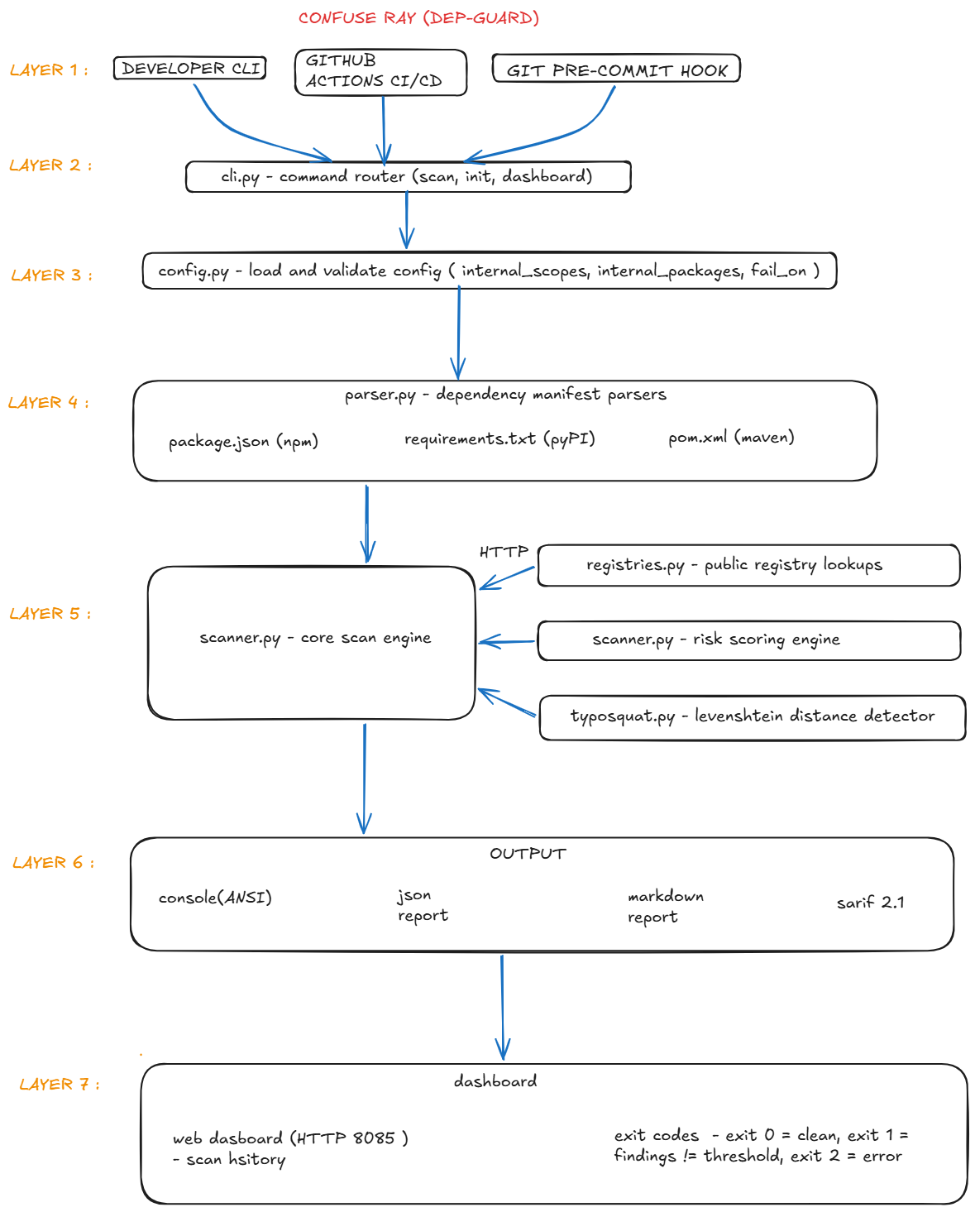
- Key Deliverables & Features:
- Multi-Ecosystem Scanning-> One of the trickier parts of this project was getting the parsers right for three very different file formats:
- package.json — I parse all four dependency categories: dependencies, devDependencies, peerDependencies, and optionalDependencies. Scoped packages (e.g., @company/utils) are handled properly too.
- requirements.txt — Handles extras like package[extra], strips inline comments, and deals with version specifiers correctly.
- pom.xml — This one was the most complex because Maven files often use ${property} placeholders. I added basic property interpolation so those packages don't get skipped.
All three can be scanned in a single command invocation, which makes it practical to drop into any existing pipeline.

- Risk Scoring -> Rather than just flagging everything as "bad," I built a weighted scoring system that assigns each finding a numeric risk score based on five factors: 1] Package belongs to an internal scope: +3 points, 2] Package name found on a public registry: +4 points
3] Public version is higher than your declared version: +5 points,
4] No registry scoping configuration found in the project: +2 points, 5] Typosquatting signal detected: +4 points.
Scores then map to severity levels: Critical — score ≥ 12, High — score
≥ 8, Medium — score ≥ 4, Low — score < 4.
This lets teams focus on what actually matters instead of drowning in noise

- Typosquatting Detection-> I implemented a Levenshtein edit-distance algorithm from scratch using dynamic programming. It compares every dependency name against your list of known internal packages and flags anything with an edit distance of 2 or less. So if someone published package, ConfuseRay will catch it.

- Built-in Dashboard-> Running depguard dashboard spins up a local web server on port 8085 with a simple HTML/JavaScript dashboard showing scan history and trend charts. It works with either filesystem-stored JSON reports or a MongoDB backend if you need longer-term tracking across many repos.

- CI/CD Integration-> The [--fail-on] flag lets you set a minimum severity threshold. The tool returns: 1] Exit code 0 — scan passed, nothing above your threshold, 2] Exit code 1 — findings found above the threshold (blocks the build), 3] Exit code 2 — something went wrong (scan error). I also included a ready-to-use GitHub Actions workflow file and a pre-commit hook, so adding this to an existing project is literally a copy-paste job.

- Implementation Highlights & Performance:
- Security Considerations-> A few things I made sure to get right on the security side:
1] When the tool checks for registry configuration, it looks for the relevant scoping files - pip.conf / .pypirc / pyproject.toml for PyPI, and .npmrc for npm, settings.xml for Maven. If those files are missing, the tool warns you because without them, your build system might not know where to look for internal packages, which is exactly the condition that makes confusion attacks possible.
2] The dashboard's file-serving code uses os.path.realpath() to validate all file paths before serving them, which prevents path traversal attacks.

- Performance-> For a typical project, scans finish in a matter of seconds. File discovery is O(n) across the project directory, and each package gets one HTTP lookup to the relevant registry with an 8-second timeout to avoid hanging on slow connections.
There's also an offline mode — you can point the tool at a local JSON cache of registry responses, which is useful for air-gapped environments or if you want to avoid hammering the registries during large batch scans.

- Testing-> I wrote 40+ unit tests across 9 modules covering everything from the parsers and scorer to the registry client and dashboard: test_config, test_parsers, test_scanner, test_reporter, test_scorer, test_typosquat, and test_dashboard.
Tests use pytest with parametrized cases where it made sense (especially for the parser and scorer logic). The GitHub Actions workflow also runs the full test suite on every push and pull request to main, and uploads generated reports as artifacts.
- Challenges & Strategic Roadmap:
- The Cross-Ecosystem Scoring Problem-> The hardest design challenge was figuring out how to score risk in a way that's meaningful across three ecosystems that work completely differently from each other. npm has scoped packages with @org/ prefixes, PyPI normalizes package names (so Maven uses My-Package and my_package are the same thing), and groupId:artifactId coordinates instead of just package names.
I spent a fair amount of time thinking about whether to build three separate scoring systems or one unified one. I went with a hybrid approach: the risk signals themselves (does this package exist publicly? is the public version higher?) are ecosystem-agnostic, but the parsing and name-normalization logic is ecosystem-specific. The registry client exposes a single lookup() method that returns a consistent response shape regardless of which registry it hit, so the scorer doesn't need to know or care about ecosystem differences.

- NextSteps (Phase2)-> There are two main things I want to tackle in the next phase: 1] More ecosystems -The tool currently covers npm, PyPI, and Maven, which handles most projects. But Go, Rust, and .NET are increasingly common and have the same vulnerability class. Adding support for go.sum, Cargo.toml, and .csproj / packages.config is the next logical step.

- Policy-as-code-> Right now the tool works great for a single repo, but larger organizations managing dozens of repos need something more centralized. I want to add support for a depguard-policy.yml file that defines org-wide rules - including per-package allowlists, blocklists, and exception workflows - so security teams can manage governance across all their repositories from one place instead of configuring each repo individually.

