EVALUATION EXPERIMENT

Circuit Diagram:

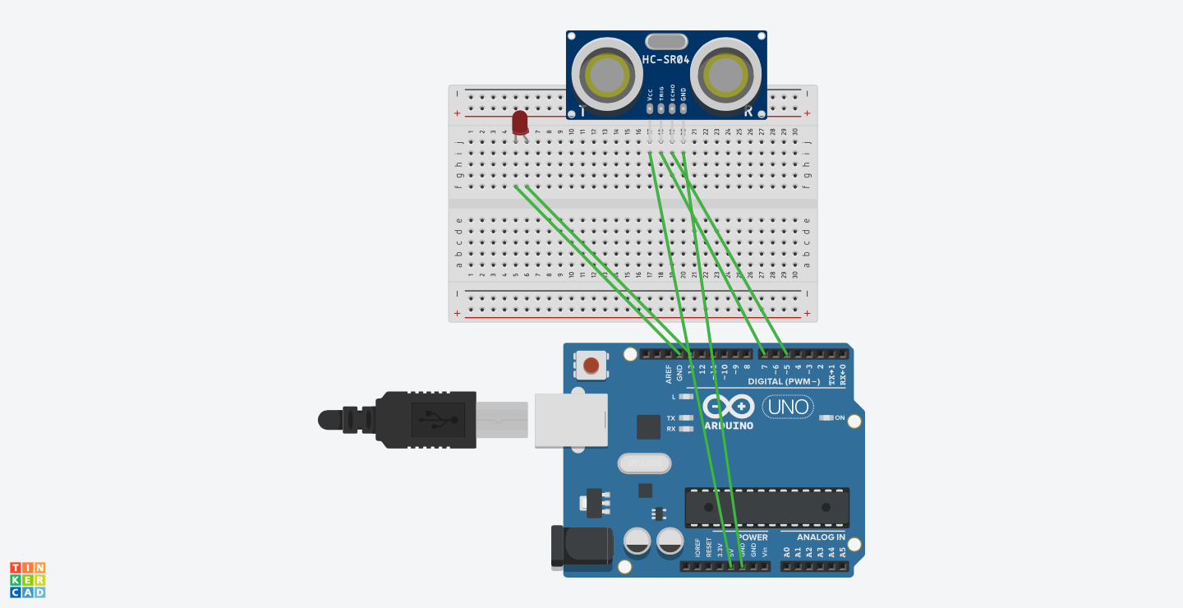

Theory:

Concepts Used:

LED

Arduino

Ultrasonic Distance Sensor

Code of Arduino

Usage:

This can be used in dancing stage or in game,whenever someone touches the tile.The ultrasonic sensor gives the reading that object is nearer to 10cm.

And the light starts blinking for 2ms.

Observations:

1.If we change the delay the light starts blinking slowly.

Precations:

1.Save the board and the sensor from getting damaged.

2.LED should be connected properly.