Session 2026-2027

Vision:Dream of where you want. | Mission: Means to achieve Vision

Program Educational Objectives of the program (PEO): (broad statements that describe the professional and career accomplishments)
PEO1 | Preparation | P: Preparation | Pep-CL abbreviation  pronounce as Pep-si-lL easy to recall
PEO2 | Core Competence | E: Environment (Learning Environment) | Pep-CL abbreviation  pronounce as Pep-si-lL easy to recall
PEO3 | Breadth | P: Professionalism | Pep-CL abbreviation  pronounce as Pep-si-lL easy to recall
PEO4 | Professionalism | C: Core Competence | Pep-CL abbreviation  pronounce as Pep-si-lL easy to recall
PEO5 | Learning Environment | L: Breadth (Learning in diverse areas) | Pep-CL abbreviation  pronounce as Pep-si-lL easy to recall

Program Outcomes (PO): (statements that describe what a student should be able to do and know by the end of a program)
Keywords of POs:
Engineering knowledge,Problem analysis, Design/development of solutions,Conduct Investigations of Complex Problems, Engineering Tool Usage, The Engineer and The World,Ethics, Individual and Collaborative Team work,Communication, Project Management and Finance, Life-Long Learning

PSO Keywords: Cutting edge technologies, Research

“I am an engineer, and I know how to apply engineering knowledge to investigate, analyse and design solutions to complex problems using tools for entire world following all ethics in a collaborative way with proper management skills throughout my life.” to contribute to the development of cutting-edge technologies and Research.

Integrity: I will adhere to the Laboratory Code of Conduct and ethics in its entirety.

Name and Signature of Student and Date
(Signature and Date in Handwritten)

Session | 2024-25 (ODD) |  | Course Name | Web Technology Lab
Semester | 3 |  | Course Code | 23CT1301
Roll No | 71 |  | Name of Student | Yash Mukesh Bhoyar
Practical Number |  | 6
Course Outcome |  | - Understand various internet technologies.  - Design the web pages using HTML and CSS.  - Implement the XML technology to store the data.  - Develop the interactive web pages using JavaScript.
Aim |  | JavaScript — Arrays, Objects & Higher-Order Functions.
Problem Definition |  | Develop a JavaScript program to model a shopping cart using an array of product objects. Each product should contain id, name, price, and quantity.
Theory  (100 words) |  | - Array  An array is a collection of multiple values stored in a single variable. JavaScript arrays can contain numbers, strings, objects, or other arrays.  Syntax:  let cart = [ ];  Example:  let products = ["Laptop", "Mouse", "Keyboard"];  Here, products is an array containing three elements.  - Object  An object stores data in the form of key-value pairs.  Syntax:  let product = {  id: 1,  name: "Laptop",  price: 50000  };  The object contains three properties:  - id → Product identification number  - name → Product name  - price → Product price  Array of Objects  An array can contain multiple objects. This is useful for representing real-world data such as products.  let cart = [  { id: 1, name: "Laptop", price: 50000, quantity: 1 },  { id: 2, name: "Mouse", price: 800, quantity: 2 }  ];  Each element of the array represents one product.  - push()  The push() method adds a new element to the end of an array.  Syntax:  array.push(element);  Example:  cart.push({  id: 3,  name: "Keyboard",  price: 1500,  quantity: 1  });  It adds the new product to the cart.  - filter()  The filter() method creates a new array containing only the elements that satisfy a specified condition.  Syntax:  array.filter(condition);  Example:  cart = cart.filter(product => product.id !== 2);  This removes the product whose ID is 2.  filter() is a higher-order function because it accepts a function as an argument.  - map()  The map() method creates a new array by applying a function to every element of the original array.  Syntax:  array.map(function);  Example:  cart.map(product => product.name);  It extracts only the product names.  For example:  ["Laptop", "Keyboard", "Headphones"]  - reduce()  The reduce() method processes all elements of an array and produces one final value.  Syntax:  array.reduce(function, initialValue);  Example:  cart.reduce(  (total, product) => total + product.price * product.quantity,  0  );  It calculates:  Total = price × quantity  for every product and adds all the values.  - Arrow Function  An arrow function provides a short way of writing functions.  Traditional function:  function(x) {  return x * 2;  }  Arrow function:  x => x * 2  In this experiment, arrow functions are used with map(), filter(), and reduce().  - Higher-Order Function  A higher-order function is a function that accepts another function as an argument or returns a function.  Common JavaScript higher-order array functions include:  map()  filter()  reduce()
Procedure and Execution  (100 Words) |  | Step for Implementation:  Step 1: Create the JavaScript file  Step 2: Create the shopping cart  Step 3: Implement the Add operation  Step 5: Implement product-name extraction  Step 6: Calculate the total price  Step 7: Add a new product  Step 8: Remove a product  Step 9: Display product names and total  Step 10: Execute the program
Code:
HTML:
<!DOCTYPE html>
<html>
<head>
<meta charset="UTF-8">
<title>Shopping Cart</title>
<link rel="stylesheet" href="style.css">
</head>
<body>
<h1>Shopping Cart</h1>
<section id="product-list"></section>
<aside id="cart">
<h2>Your Cart</h2>
<ul id="cart-list"></ul>
<p>Total: ₹<span id="total-price">0</span></p>
</aside>
<script src="script.js"></script>
</body>
</html>
CSS:
body {
font-family: Arial, sans-serif;
display: flex;
gap: 30px;
}
.product-card {
border: 1px solid #ccc;
padding: 10px;
margin-bottom: 10px;
}
Javascript:
const products = [
{ id: 1, name: "Notebook", price: 40 },
{ id: 2, name: "Pen", price: 10 },
{ id: 3, name: "Bag", price: 500 },
{ id: 4, name: "Water Bottle", price: 150 }
];

let cart = [];

const productList = document.getElementById("product-list");
const cartList = document.getElementById("cart-list");
const totalPriceEl = document.getElementById("total-price");

function displayProducts() {
productList.innerHTML = products
.map((product) => `
<div class="product-card">
${product.name} - ₹${product.price}
<button onclick="addToCart(${product.id})"> Add to Cart</button>
</div>`
)
.join("");
}

function addToCart(id) {
const item = products.find((p) => p.id === id);
cart.push(item);
displayCart();
}

function removeFromCart(id) {
cart = cart.filter((item) => item.id !== id);
displayCart();
}

function calculateTotal() {
return cart.reduce(
(sum, item) => sum + item.price, 0
);
}

function displayCart() {
cartList.innerHTML = cart
.map((item) => `
<li>
${item.name} - ₹${item.price}
<button onclick="removeFromCart(${item.id})"> ✖</button>
</li>`
)
.join("");

totalPriceEl.textContent = calculateTotal();
}

displayProducts();
Output:
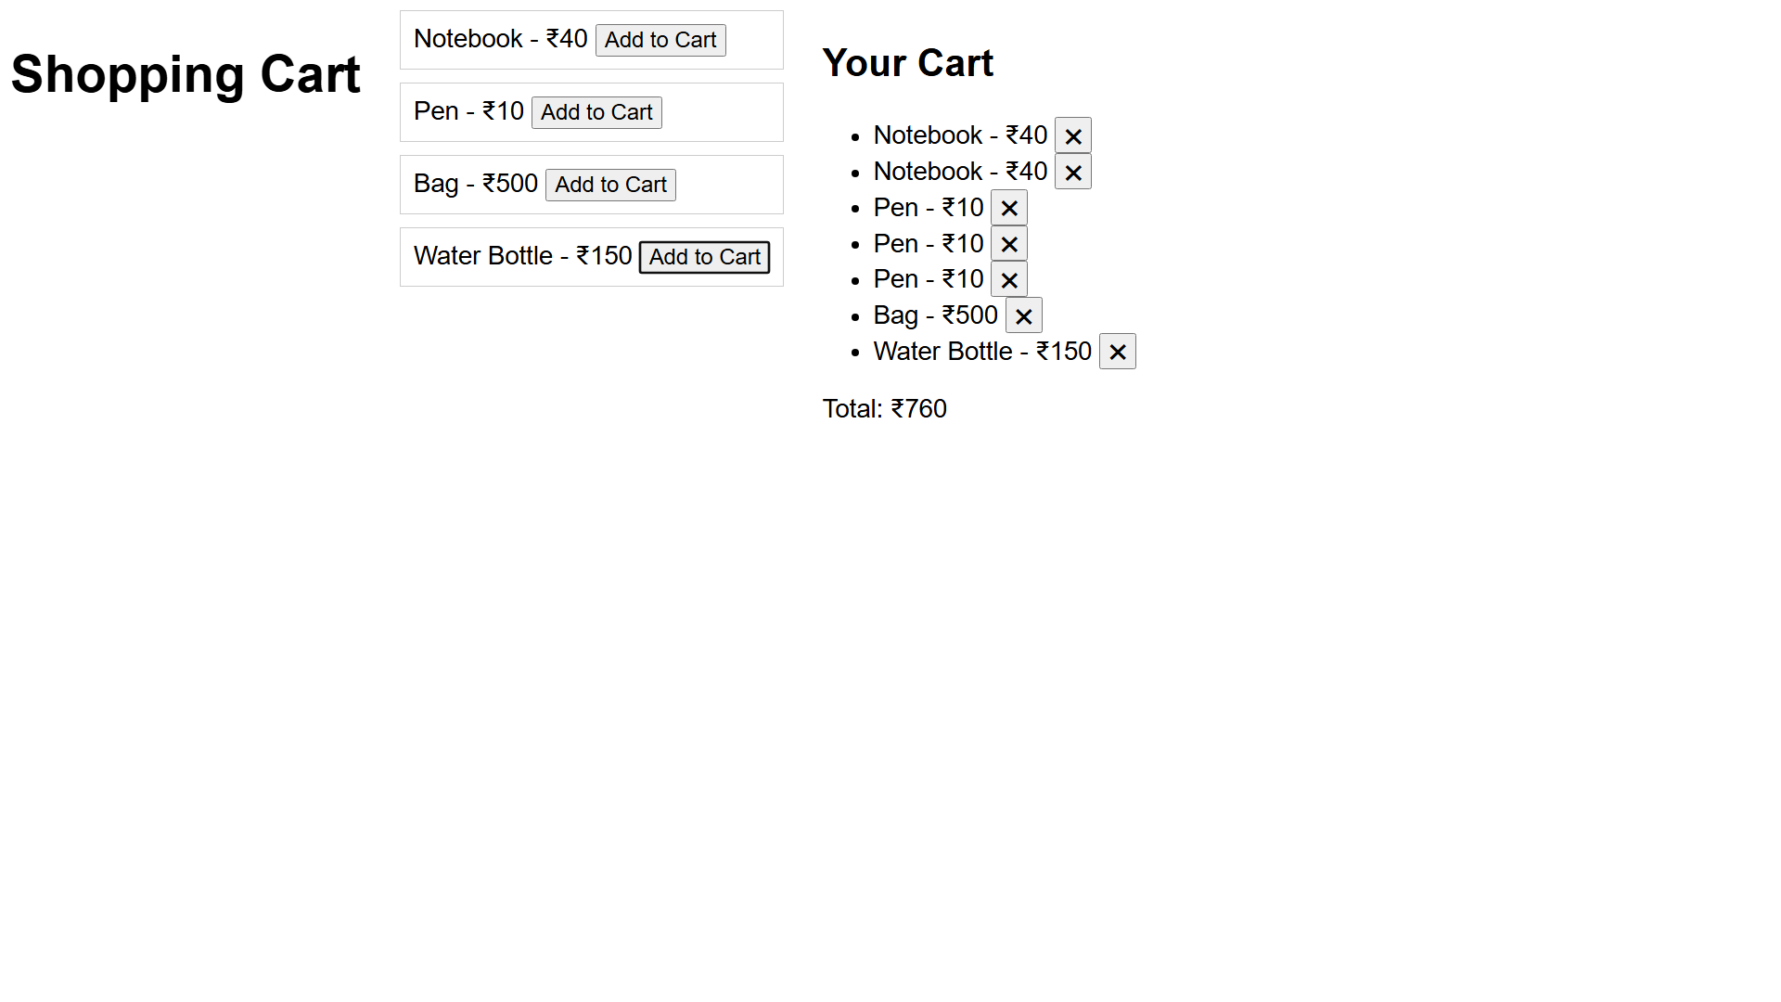
Output Analysis |  | The output displays a Shopping Cart interface showing product names and prices. It includes Add to Cart buttons, a list of selected products with remove buttons, and the yotal amount of the cart.
Link of student Github profile where lab assignment has been uploaded |  | https://github.com/yash-bhoyar/WTlab
Conclusion |  | The JavaScript program successfully models a shopping cart using an array of objects and demonstrates the use of push(), map(), filter(), and reduce() to add products, remove products, retrieve product names, and calculate the total price.
Plag Report (Similarity index < 12%)
Date |  | 29/09/26

