Session 2026-2027

Vision:Dream of where you want. | Mission: Means to achieve Vision

Program Educational Objectives of the program (PEO): (broad statements that describe the professional and career accomplishments)
PEO1 | Preparation | P: Preparation | Pep-CL abbreviation  pronounce as Pep-si-lL easy to recall
PEO2 | Core Competence | E: Environment (Learning Environment) | Pep-CL abbreviation  pronounce as Pep-si-lL easy to recall
PEO3 | Breadth | P: Professionalism | Pep-CL abbreviation  pronounce as Pep-si-lL easy to recall
PEO4 | Professionalism | C: Core Competence | Pep-CL abbreviation  pronounce as Pep-si-lL easy to recall
PEO5 | Learning Environment | L: Breadth (Learning in diverse areas) | Pep-CL abbreviation  pronounce as Pep-si-lL easy to recall

Program Outcomes (PO): (statements that describe what a student should be able to do and know by the end of a program)
Keywords of POs:
Engineering knowledge,Problem analysis, Design/development of solutions,Conduct Investigations of Complex Problems, Engineering Tool Usage, The Engineer and The World,Ethics, Individual and Collaborative Team work,Communication, Project Management and Finance, Life-Long Learning

PSO Keywords: Cutting edge technologies, Research

“I am an engineer, and I know how to apply engineering knowledge to investigate, analyse and design solutions to complex problems using tools for entire world following all ethics in a collaborative way with proper management skills throughout my life.” to contribute to the development of cutting-edge technologies and Research.

Integrity: I will adhere to the Laboratory Code of Conduct and ethics in its entirety.

Name and Signature of Student and Date
(Signature and Date in Handwritten)

Session | 2024-25 (ODD) |  | Course Name | Web Technology Lab
Semester | 3 |  | Course Code | 23CT1301
Roll No | 71 |  | Name of Student | Yash Mukesh Bhoyar
Practical Number |  | 4B
Course Outcome |  | - Understand various internet technologies.  - Design the web pages using HTML and CSS.  - Implement the XML technology to store the data.  - Develop the interactive web pages using JavaScript.
Aim |  | JavaScript — DOM Manipulation
Problem Definition |  | Build a To-Do List web app where users can add,  delete, and mark tasks as complete, using vanilla JavaScript DOM methods only.
Theory  (100 words) |  | The Document Object Model (DOM) represents an HTML webpage as a tree of elements. JavaScript can use the DOM to find, read, create, change, add, and remove HTML elements. Methods such as getElementById() are used to find elements, while .value reads the text entered by the user. createElement() creates new elements and textContent adds text to them. appendChild() adds elements to the webpage, while remove() deletes them. addEventListener() is used to respond to user actions such as button clicks. classList.toggle() adds or removes a CSS class. These methods are used together to create a dynamic To-Do List.
Procedure and Execution  (100 Words) |  | Step for Implementation:  - Open Visual Studio Code.  - Create a folder named TodoList.  - Create index.html, style.css, and script.js files.  - Create the basic HTML structure in index.html.  - Add a heading, task input box, Add Task button, and empty task list.  - Link the external CSS file and JavaScript file.  - Use getElementById() to access the required HTML elements.  - Use .value to read the task entered by the user.  - Use createElement() and textContent to create a new task.  - Use appendChild() to add the task to the list.  - Create Complete and Delete buttons using JavaScript.  - Use classList.toggle() to mark a task as complete and remove() to delete it.  - Clear the input box after adding a task.  - Save the files, open index.html in Chrome, and test the application.
Code:
Html:
<!DOCTYPE html>
<html>
<head>
<title>My To-Do List</title>
<style>
.completed {
text-decoration: line-through;
color: gray;
}
</style>
<link rel="stylesheet" href="style.css">
</head>
<body>
<h1>My To-Do List</h1>
<input type="text" id="taskInput"
placeholder="Enter a task">
<button id="addButton">Add Task</button>
<ul id="taskList"></ul>

<script src="script.js"></script>
</body>
</html>
Javascript:
let taskInput = document.getElementById("taskInput");
let addButton = document.getElementById("addButton");
let taskList = document.getElementById("taskList");

addButton.addEventListener("click", function() {

let task = taskInput.value;

if (task == "") {
alert("Please enter a task");
return;
}

let li = document.createElement("li");
li.textContent = task;

let completeButton = document.createElement("button");
completeButton.textContent = "Complete";
li.appendChild(completeButton);

completeButton.addEventListener("click", function() {
li.classList.toggle("completed");
});

let deleteButton = document.createElement("button");
deleteButton.textContent = "Delete";
li.appendChild(deleteButton);

deleteButton.addEventListener("click", function() {
li.remove();
});

taskList.appendChild(li);

taskInput.value = "";

});

CSS:
body {
font-family: Arial;
background-color: lightgray;
text-align: center;
}

h1 {
color: blue;
}

#taskInput {
width: 250px;
padding: 8px;
}

#addButton {
padding: 8px;
background-color: green;
color: white;
}

#taskList {
width: 400px;
margin: 20px auto;
text-align: left;
}

#taskList li {
background-color: white;
padding: 10px;
margin: 10px;
border: 1px solid black;
}

#taskList button {
margin-left: 10px;
}

.completed {
text-decoration: line-through;
color: gray;
}

Output:
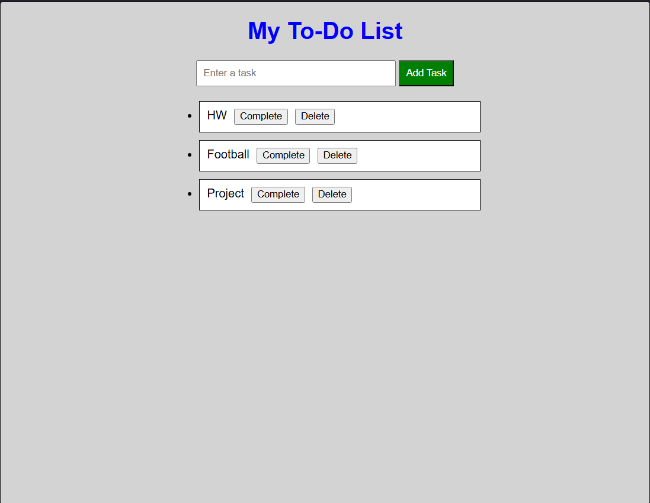
Output Analysis |  | The output displays a To-Do List containing a heading, input field, Add Task button, task list, Complete button, and Delete button. JavaScript DOM methods are used to dynamically add, complete, and delete tasks.
Link of student Github profile where lab assignment has been uploaded |  | https://github.com/yash-bhoyar/WTlab
Conclusion |  | Thus, the To-Do List was successfully created using JavaScript DOM manipulation methods to add, complete, and delete tasks.
Plag Report (Similarity index < 12%)
Date |  | 21/09/26

