Session 2026-2027

Vision:Dream of where you want. | Mission: Means to achieve Vision

Program Educational Objectives of the program (PEO): (broad statements that describe the professional and career accomplishments)
PEO1 | Preparation | P: Preparation | Pep-CL abbreviation  pronounce as Pep-si-lL easy to recall
PEO2 | Core Competence | E: Environment (Learning Environment) | Pep-CL abbreviation  pronounce as Pep-si-lL easy to recall
PEO3 | Breadth | P: Professionalism | Pep-CL abbreviation  pronounce as Pep-si-lL easy to recall
PEO4 | Professionalism | C: Core Competence | Pep-CL abbreviation  pronounce as Pep-si-lL easy to recall
PEO5 | Learning Environment | L: Breadth (Learning in diverse areas) | Pep-CL abbreviation  pronounce as Pep-si-lL easy to recall

Program Outcomes (PO): (statements that describe what a student should be able to do and know by the end of a program)
Keywords of POs:
Engineering knowledge,Problem analysis, Design/development of solutions,Conduct Investigations of Complex Problems, Engineering Tool Usage, The Engineer and The World,Ethics, Individual and Collaborative Team work,Communication, Project Management and Finance, Life-Long Learning

PSO Keywords: Cutting edge technologies, Research

“I am an engineer, and I know how to apply engineering knowledge to investigate, analyse and design solutions to complex problems using tools for entire world following all ethics in a collaborative way with proper management skills throughout my life.” to contribute to the development of cutting-edge technologies and Research.

Integrity: I will adhere to the Laboratory Code of Conduct and ethics in its entirety.

Name and Signature of Student and Date
(Signature and Date in Handwritten)

Session | 2024-25 (ODD) |  | Course Name | Web Technology Lab
Semester | 3 |  | Course Code | 23CT1301
Roll No | 71 |  | Name of Student | Yash Mukesh Bhoyar
Practical Number |  | 5
Course Outcome |  | - Understand various internet technologies.  - Design the web pages using HTML and CSS.  - Implement the XML technology to store the data.  - Develop the interactive web pages using JavaScript.
Aim |  | JavaScript — Events &amp; Interactivity
Problem Definition |  | Build ONE interactive app — a Calculator OR a short Quiz (pick  one) — that responds to clicks/key-presses and updates results dynamically, demonstrating event handling.
Theory  (100 words) |  | JavaScript events are actions that occur on a web page, such as mouse clicks and keyboard key presses. Event handling allows JavaScript to respond to these actions and perform specific operations. The addEventListener() method is used to attach an event to an HTML element. In the calculator, click events are used for number, operator, clear, and equals buttons. The keydown event is used to accept keyboard input. Functions such as addNumber(), setOperator(), calculate(), and clearDisplay() perform the required operations. Conditional statements using if and else if select the arithmetic operation, while Number() converts the input into numbers.
Procedure and Execution  (100 Words) |  | Step for Implementation:  - Open Visual Studio Code.  - Create a folder named Calculator.  - Create three files: index.html, style.css, and script.js.  - Create the calculator structure in the HTML file.  - Add a display box and buttons for numbers and arithmetic operators.  - Link the CSS and JavaScript files with the HTML file.  - Use getElementById() to access the calculator elements.  - Create functions for entering numbers, selecting operators, calculating results, and clearing the display.  - Use addEventListener() to handle button click events.  - Use keydown to handle keyboard input.  - Use if and else if statements for arithmetic operations.  - Save all files, open the HTML file in a browser, and test the calculator.
Code:
HTML:
<!DOCTYPE html>
<html>
<head>
<title>My Calculator</title>
<link rel="stylesheet" href="style.css">
</head>
<body>
<h1>My Calculator</h1>
<input type="text" id="display" readonly>

<div>
<button id="seven">7</button>
<button id="eight">8</button>
<button id="nine">9</button>
<button id="divide">/</button>
</div>

<div>
<button id="four">4</button>
<button id="five">5</button>
<button id="six">6</button>
<button id="multiply">*</button>
</div>

<div>
<button id="one">1</button>
<button id="two">2</button>
<button id="three">3</button>
<button id="subtract">-</button>
</div>

<div>
<button id="clear">C</button>
<button id="zero">0</button>
<button id="equals">=</button>
<button id="add">+</button>
</div>

<script src="script.js"></script>
</body>
</html>
Javascript:

let display = document.getElementById("display");

let operator = "";
let firstNumber = "";

function addNumber(number) {
display.value += number;
}

function setOperator(op) {
firstNumber = display.value;
operator = op;
display.value = "";
}

function calculate() {
let secondNumber = display.value;
let result;

if (operator == "+") {
result = Number(firstNumber) + Number(secondNumber);
}
else if (operator == "-") {
result = Number(firstNumber) - Number(secondNumber);
}
else if (operator == "*") {
result = Number(firstNumber) * Number(secondNumber);
}
else if (operator == "/") {
result = Number(firstNumber) / Number(secondNumber);
}

display.value = result;
}

function clearDisplay() {
display.value = "";
firstNumber = "";
operator = "";
}

document.getElementById("seven").addEventListener("click", function() {
addNumber("7");
});

document.getElementById("eight").addEventListener("click", function() {
addNumber("8");
});

document.getElementById("nine").addEventListener("click", function() {
addNumber("9");
});

document.getElementById("divide").addEventListener("click", function() {
setOperator("/");
});

document.getElementById("four").addEventListener("click", function() {
addNumber("4");
});

document.getElementById("five").addEventListener("click", function() {
addNumber("5");
});

document.getElementById("six").addEventListener("click", function() {
addNumber("6");
});

document.getElementById("multiply").addEventListener("click", function() {
setOperator("*");
});

document.getElementById("one").addEventListener("click", function() {
addNumber("1");
});

document.getElementById("two").addEventListener("click", function() {
addNumber("2");
});

document.getElementById("three").addEventListener("click", function() {
addNumber("3");
});

document.getElementById("subtract").addEventListener("click", function() {
setOperator("-");
});

document.getElementById("clear").addEventListener("click", function() {
clearDisplay();
});

document.getElementById("zero").addEventListener("click", function() {
addNumber("0");
});

document.getElementById("equals").addEventListener("click", function() {
calculate();
});

document.getElementById("add").addEventListener("click", function() {
setOperator("+");
});

document.addEventListener("keydown", function(event) {
console.log(event.key);
});

document.addEventListener("keydown", function(event) {
if (event.key >= "0" && event.key <= "9") {
addNumber(event.key);
}
if (event.key == "Enter") {
calculate();
}
if (event.key == "Escape") {
clearDisplay();
}
});

Output:
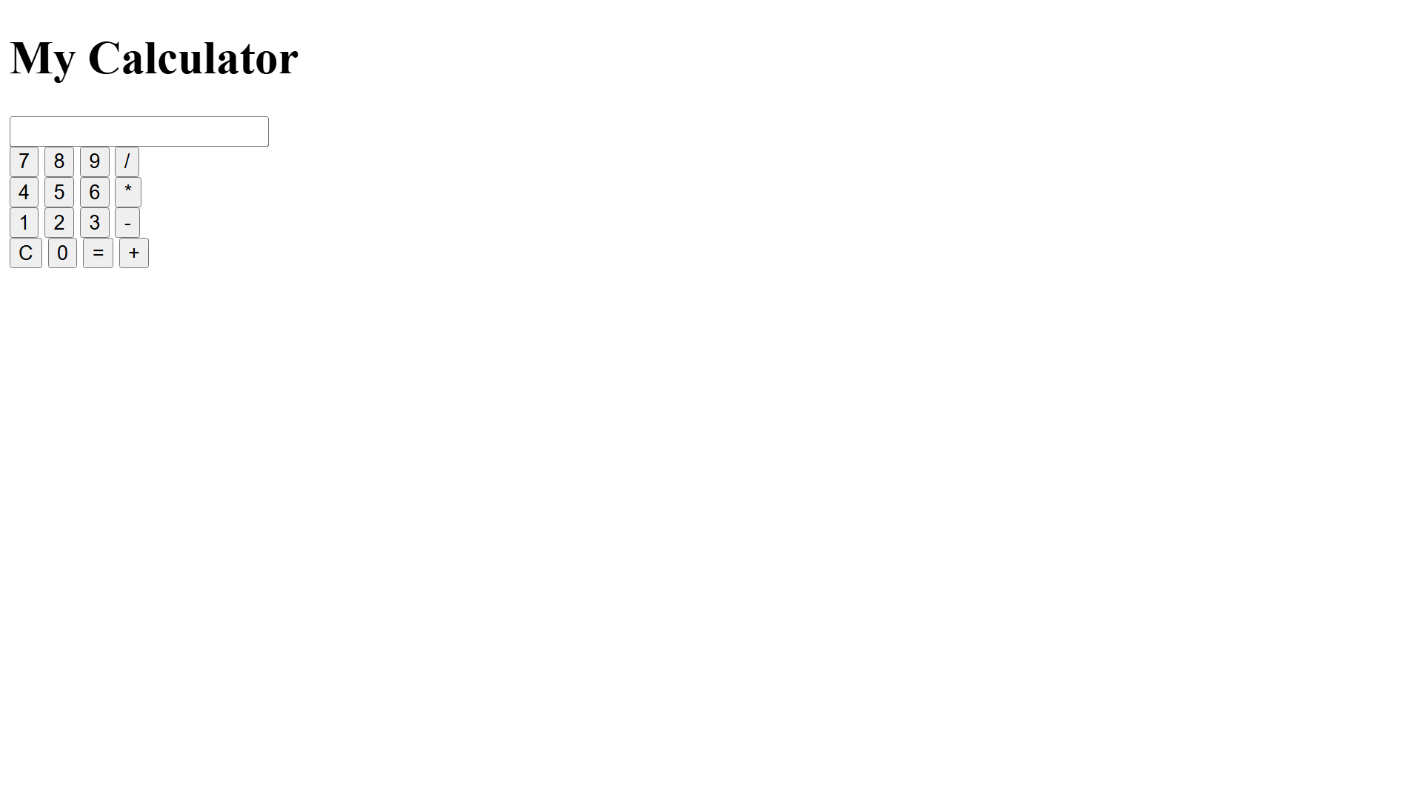
Output Analysis |  | The output displays an interactive calculator with a display box and buttons for numbers, arithmetic operators, Clear, and Equals. The calculator responds to button clicks and keyboard events and dynamically updates the displayed result.
Link of student Github profile where lab assignment has been uploaded |  | https://github.com/yash-bhoyar/WTlab
Conclusion |  | Thus, an interactive calculator was successfully developed using JavaScript events, functions, conditional statements, and DOM manipulation to perform arithmetic operations and update the display dynamically.
Plag Report (Similarity index < 12%)
Date |  | 22/09/26

