Session 2026-2027

Vision:Dream of where you want. | Mission: Means to achieve Vision

Program Educational Objectives of the program (PEO): (broad statements that describe the professional and career accomplishments)
PEO1 | Preparation | P: Preparation | Pep-CL abbreviation  pronounce as Pep-si-lL easy to recall
PEO2 | Core Competence | E: Environment (Learning Environment) | Pep-CL abbreviation  pronounce as Pep-si-lL easy to recall
PEO3 | Breadth | P: Professionalism | Pep-CL abbreviation  pronounce as Pep-si-lL easy to recall
PEO4 | Professionalism | C: Core Competence | Pep-CL abbreviation  pronounce as Pep-si-lL easy to recall
PEO5 | Learning Environment | L: Breadth (Learning in diverse areas) | Pep-CL abbreviation  pronounce as Pep-si-lL easy to recall

Program Outcomes (PO): (statements that describe what a student should be able to do and know by the end of a program)
Keywords of POs:
Engineering knowledge,Problem analysis, Design/development of solutions,Conduct Investigations of Complex Problems, Engineering Tool Usage, The Engineer and The World,Ethics, Individual and Collaborative Team work,Communication, Project Management and Finance, Life-Long Learning

PSO Keywords: Cutting edge technologies, Research

“I am an engineer, and I know how to apply engineering knowledge to investigate, analyse and design solutions to complex problems using tools for entire world following all ethics in a collaborative way with proper management skills throughout my life.” to contribute to the development of cutting-edge technologies and Research.

Integrity: I will adhere to the Laboratory Code of Conduct and ethics in its entirety.

Name and Signature of Student and Date
(Signature and Date in Handwritten)

Session | 2024-25 (ODD) |  | Course Name | Web Technology Lab
Semester | 3 |  | Course Code | 23CT1301
Roll No | 71 |  | Name of Student | Yash Mukesh Bhoyar
Practical Number |  | 4A
Course Outcome |  | - Understand various internet technologies.  - Design the web pages using HTML and CSS.  - Implement the XML technology to store the data.  - Develop the interactive web pages using JavaScript.
Aim |  | Introduction to JavaScript (Loop, Conditional Statement) and Form Validation.
Problem Definition |  | Build a registration form (name, email, password, phone  number) and write JavaScript to validate all fields on submit, displaying inline error messages.
Theory  (100 words) |  | JavaScript is a scripting language used to make web pages interactive and dynamic. It can be used to validate the data entered by a user before a form is submitted. Conditional statements such as if and else are used to check whether the entered values satisfy specific conditions. Loops are used to repeat a set of statements for multiple elements. In form validation, JavaScript checks fields such as name, email, password, and phone number and displays appropriate error messages when the entered data is invalid. The document object is used to access HTML elements and modify their content dynamically.
Procedure and Execution  - rds) |  | - Step for Implementation:  - Open a text editor such as VS Code or Notepad.  - Create a new HTML file and save it as registration.html.  - Create the basic HTML structure using <html>, <head>, and <body> tags.  - Create a registration form using <form>, <label>, and <input> tags.  - Add fields for Name, Email, Password, and Phone Number.  - Add <span> elements beside the fields to display error messages.  - Write JavaScript using the <script> tag.  - Use conditional statements to validate each field.  - Use a loop to process the form fields and clear previous error messages.  - Display inline error messages when invalid data is entered.  - Save the file and open it in a web browser.  - Test the form with valid and invalid inputs.
Code:
HTML:
<!DOCTYPE html>
<html>

<head>
<title>Registration Form</title>
<link rel="stylesheet" href="style.css">
</head>

<body>

<h1>Registration Form</h1>

<form onsubmit="return validateForm()">

<label>Name:</label>
<input type="text" id="name">
<span id="nameError"></span>
<br><br>

<label>Email:</label>
<input type="text" id="email">
<span id="emailError"></span>
<br><br>

<label>Password:</label>
<input type="password" id="password">
<span id="passwordError"></span>
<br><br>

<label>Phone Number:</label>
<input type="text" id="phone">
<span id="phoneError"></span>
<br><br>

<input type="submit" value="Submit">
<input type="reset" value="Reset">

</form>

<script src="script.js"></script>

</body>

</html>
CSS:
body {
font-family: Arial;
background-color: lightgray;
}

h1 {
text-align: center;
color: blue;
}

form {
width: 400px;
margin: auto;
background-color: white;
padding: 20px;
border: 1px solid black;
}

label {
color: blue;
font-weight: bold;
}

input {
padding: 5px;
}

span {
color: red;
}
Javascript:
function validateForm() {

var errors = ["nameError", "emailError", "passwordError", "phoneError"];

for (var i = 0; i < errors.length; i++) {
document.getElementById(errors[i]).innerHTML = "";
}

var name = document.getElementById("name").value;
var email = document.getElementById("email").value;
var password = document.getElementById("password").value;
var phone = document.getElementById("phone").value;

var valid = true;

if (name == "") {
document.getElementById("nameError").innerHTML = " Enter name";
valid = false;
}

if (email == "" || !email.includes("@")) {
document.getElementById("emailError").innerHTML = " Enter valid email";
valid = false;
}

if (password.length < 6) {
document.getElementById("passwordError").innerHTML = " Minimum 6 characters";
valid = false;
}

if (phone.length != 10 || isNaN(phone)) {
document.getElementById("phoneError").innerHTML = " Enter valid phone";
valid = false;
}

return valid;
}

 |  | Output: 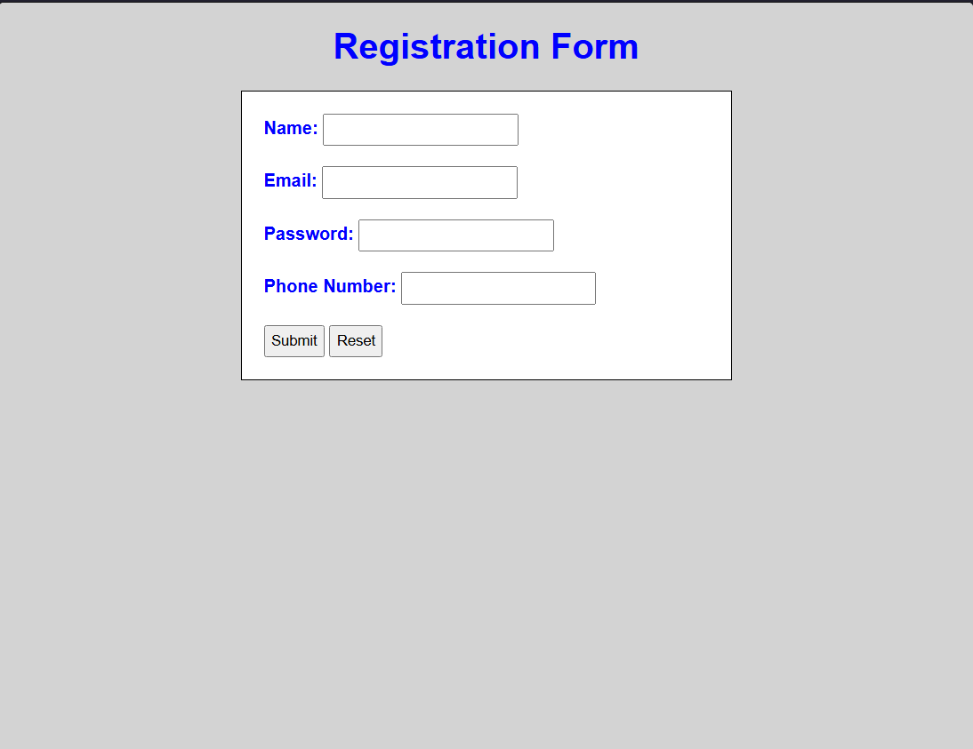
Output Analysis |  | The output displays a registration form containing Name, Email, Password, and Phone Number fields. JavaScript validates the entered values using conditional statements and a loop, and displays error messages beside the fields when invalid data is entered.
Link of student Github profile where lab assignment has been uploaded |  | https://github.com/yash-bhoyar/WTlab
Conclusion |  | Thus, JavaScript loops, conditional statements, and form validation were successfully implemented using separate HTML, CSS, and JavaScript files.
Plag Report (Similarity index < 12%)
Date |  | 21/09/26

