NYIT

**Fall 2021**

Homework No: 01

Title: Introduction

**Name:** Patade, Yash Arun

**Class ID#:** 11

**School ID#:** 1284979

**Course:** Java Networking

**Course ID:** CSCI 725

**Date:** 09/20/2021

Assignment Contents

1) Question: What is Thread? 4

Answer) 4

2) Question: Macro Assemble & Assembler. 5

• What sort of programs are Macro‐Assembler and Assembler? 5

3) Java Installation. 6

4) Making working directory c:\java\ 6

5) Downloading java compiler and API class libraries. 7

• Switching directory from default to our base directory ‘C:\java\’ 8

6) Checking where is the compiler c:\java\bin 9

7) Using GUI‐mouse and CLI‐keyboard shells. 10

• CLI cmd.exe Shell Work 10

• Start cmd.exe shell and change directory to ‘c:\java’ 11

• Change (cd) directory to default working directory c:\java\bin 11

• Default working directory or default package is c:\java\bin 12

• Check if java tools (*.exe) programs are present. 12

• Compiler javac.exe & interpreter JVM java.exe are present. 13

8) Using edit.exe or notepad.exe source text editing programs. 13

• Use edit.exe to type and save your files / save your programs. 13

• Saving the source code. 14

• Saving the source code text Boolean1.java in c:\java\bin directory. 15

• Placing “” quotes on the source file name string ”Boolean1.java” (Notepad may add txt sometimes) 15

• Verifying that source cade text file is saved as Boolean1.java 16

• Testing again if the source program has been saved. 16

• Testing the size of the source file ‘Boolean1.java’ 17

• Using type command to test if the saved text is exactly as needed. 17

• Checking all characters displayed on the console screen. 18

9) Java compiler javac.exe. 18

• Using java compiler javac.exe to compile source Boolean1.java 18

• No error text indicates perfect compilation. 19

11) Java Virtual Machine (JVM) java.exe program. 19

• Use JVM program java.exe to execute object Boolean1.class 19

12) Running/testing compiled Java program Boolean1.class. 20

• Running and testing executable object file Boolean1.class 20

13) Testing of File Presence. 20

• Checking if both source and object files are present. 20

• Confirmed, both source Boolean1.java and object Boolean1.class are ok. 21

14) Testing of Object File ASCII Character Content. 21

• Printing on the screen, the Java bytecode of Boolean1.class file. 21

• JVM object code Boolean1.class cannot be read as ASCII text. 21

References. 22

Questions from [Microsoft PowerPoint - ____725_01_Lecture_01_ProgramEx_.pptx (tfbor.com)](http://tfbor.com/02_725/01_Introduction/725_01_Lecture_00_ProgramExexution_.pdf)

# 1) Question: What is Thread?

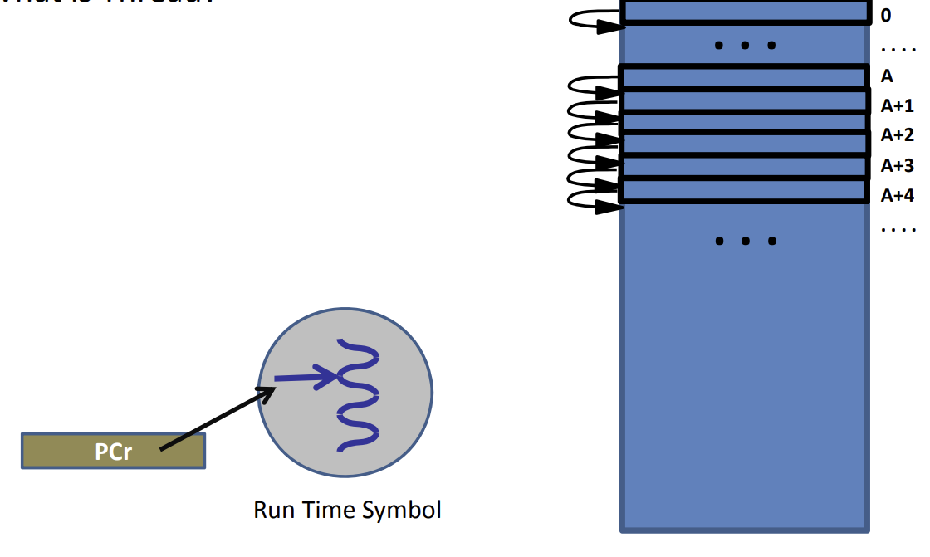

## Answer)

• Thread is made of the sequence of instructions in execution.

• Normal thread: In the normal execution instructions are executed in sequence going from lower to higher addresses.

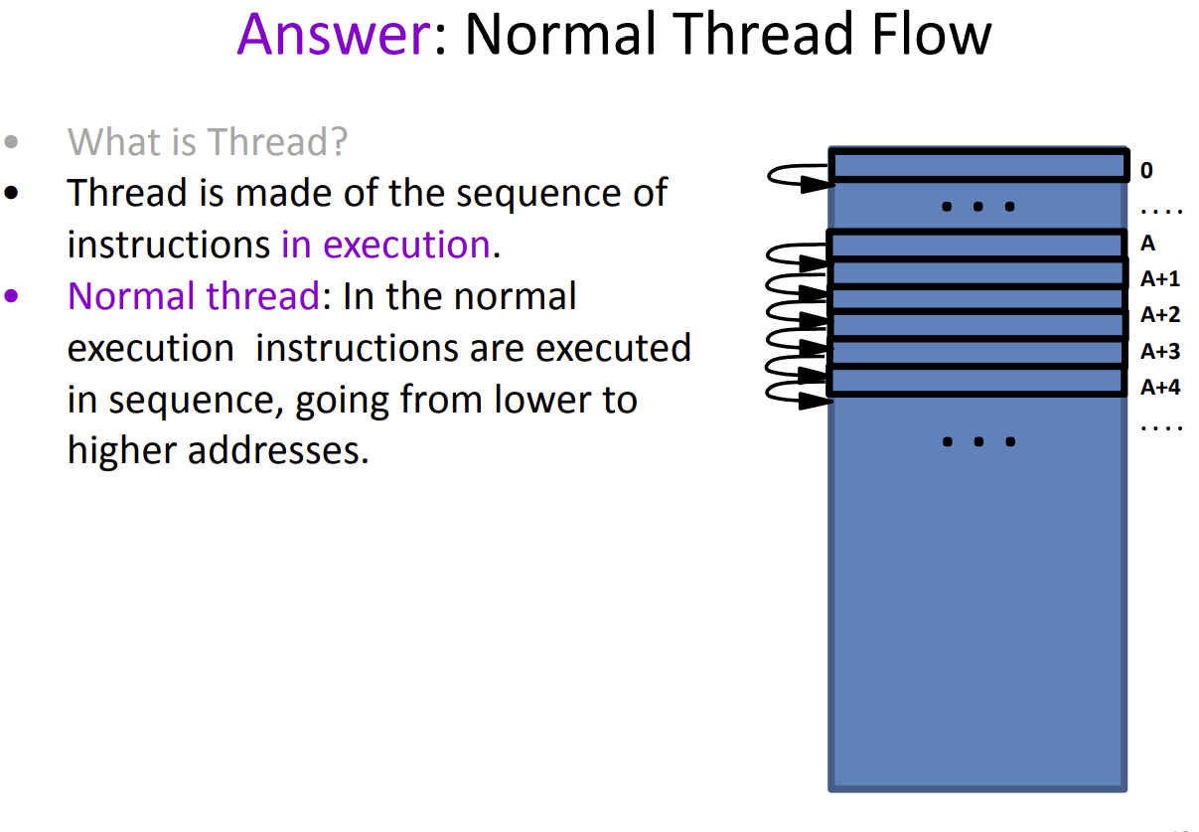

# 2) Question: Macro Assemble & Assembler.

## • What sort of programs are Macro‐Assembler and Assembler?

Answer)

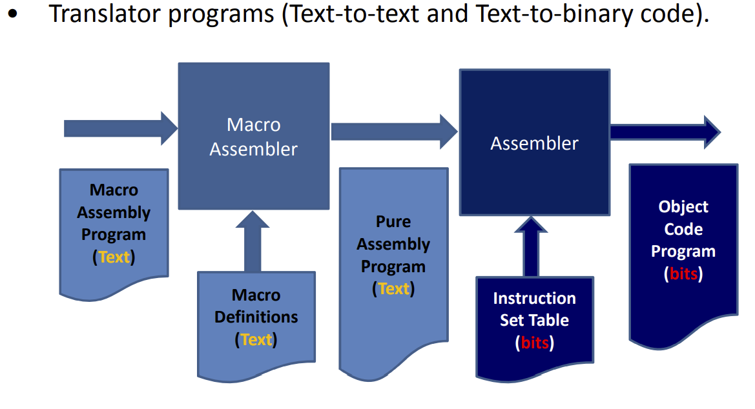

Question from [Microsoft PowerPoint - 725_01_Lecture_05_ExJavaInstall.pptx (tfbor.com)](http://tfbor.com/02_725/01_Introduction/725_01_Lecture_05_ExJavaInstall.pdf)

and [Microsoft PowerPoint - 735_10_Exercise_00_JavaInstall.pptx (tfbor.com)](http://tfbor.com/02_725/01_Introduction/735_01_Exercise_01_JavaInstall.pdf)

# 3) Java Installation.

Java is a set of computer software and specifications developed by James Gosling at Sun Microsystems.

# 4) Making working directory c:\java\

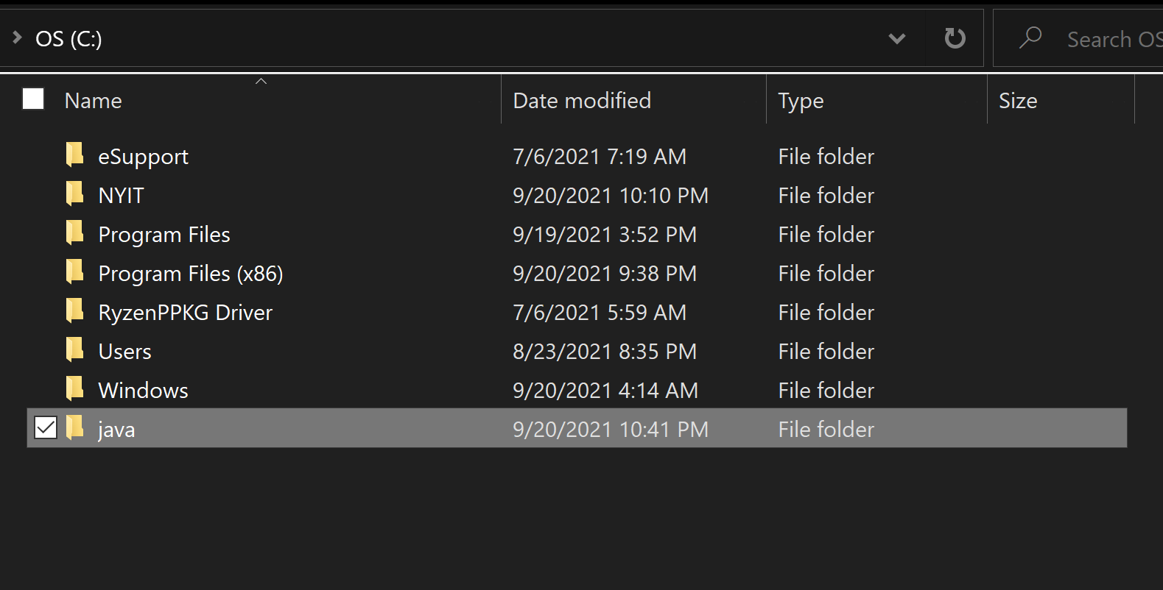

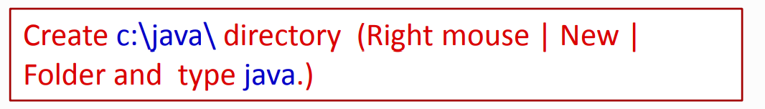

# 5) Downloading java compiler and API class libraries.

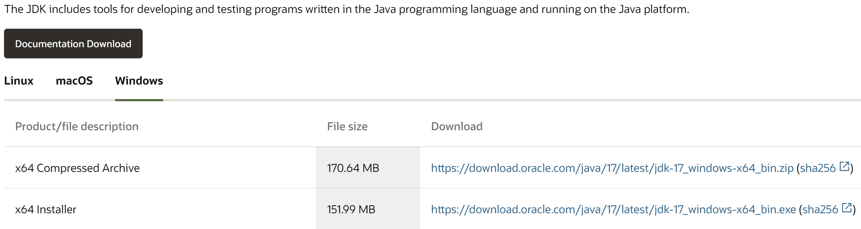

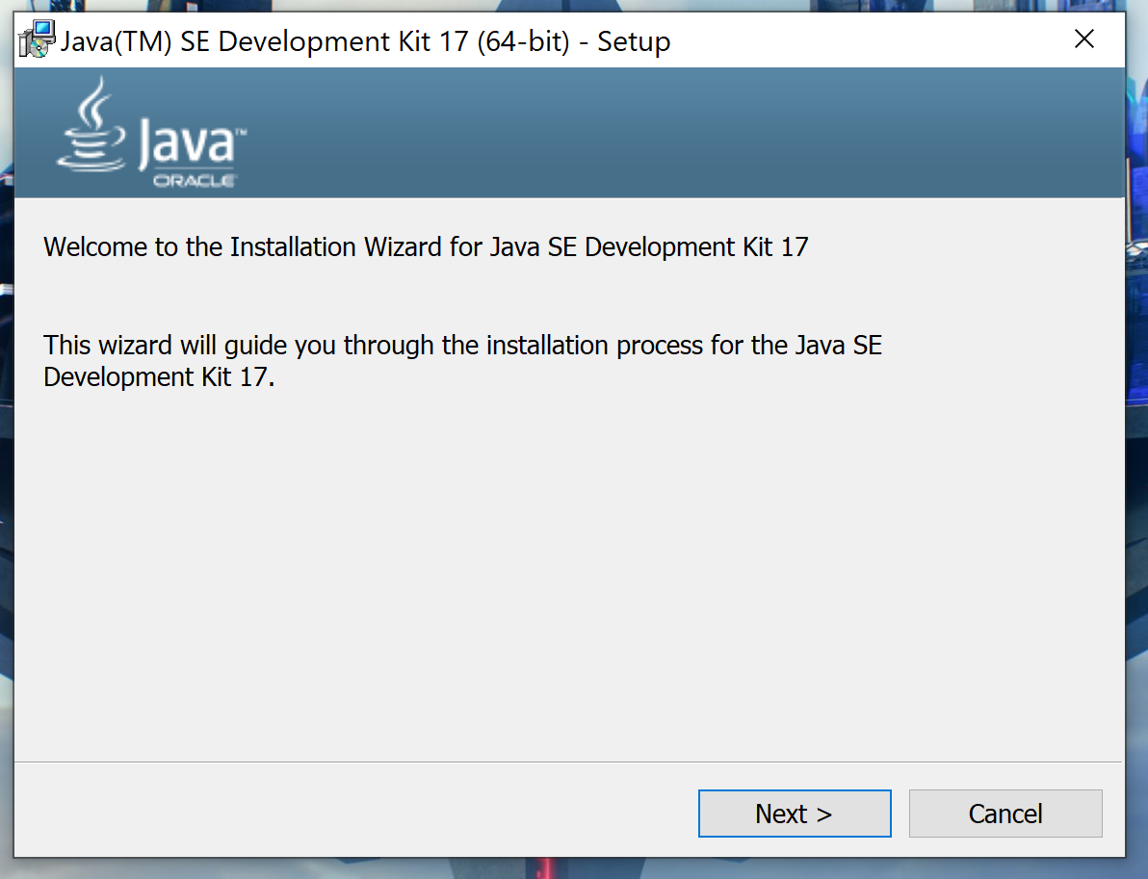

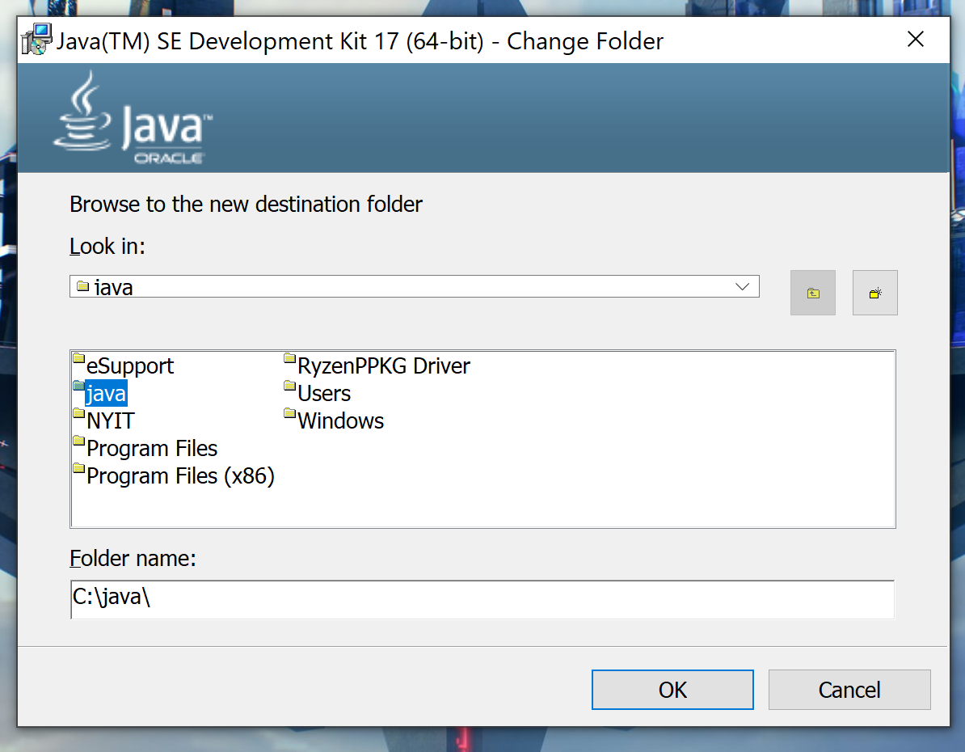

## • Switching directory from default to our base directory ‘C:\java\’

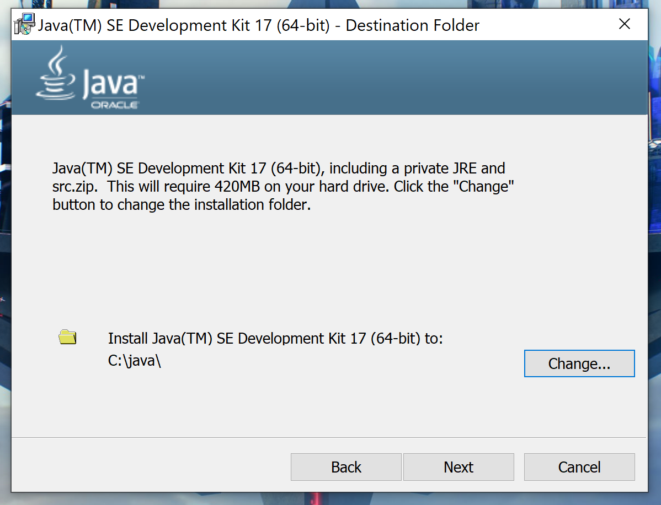

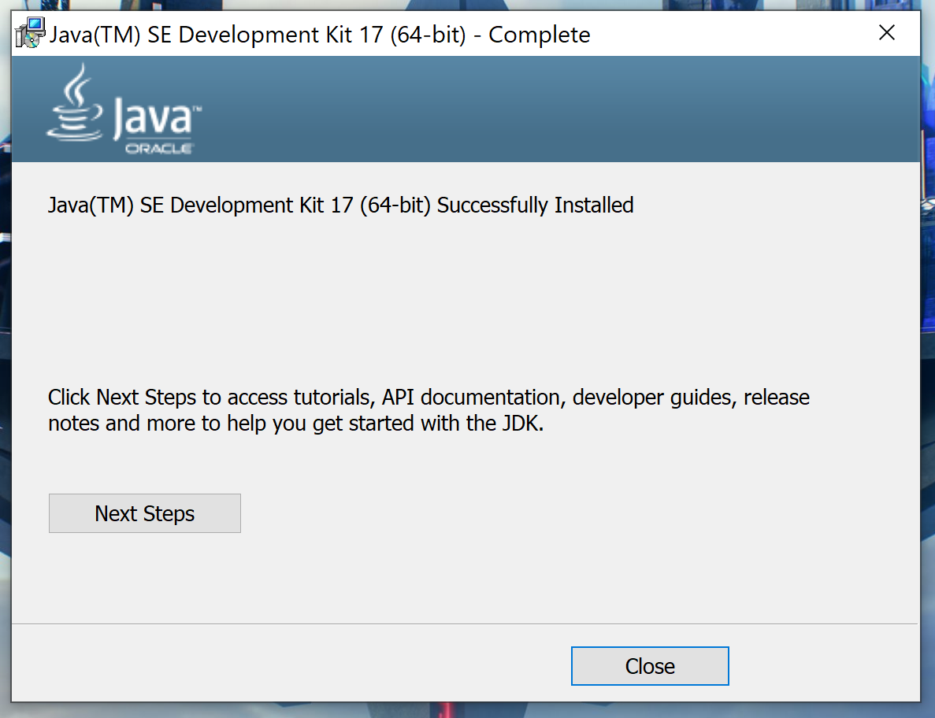

# 6) Checking where is the compiler c:\java\bin

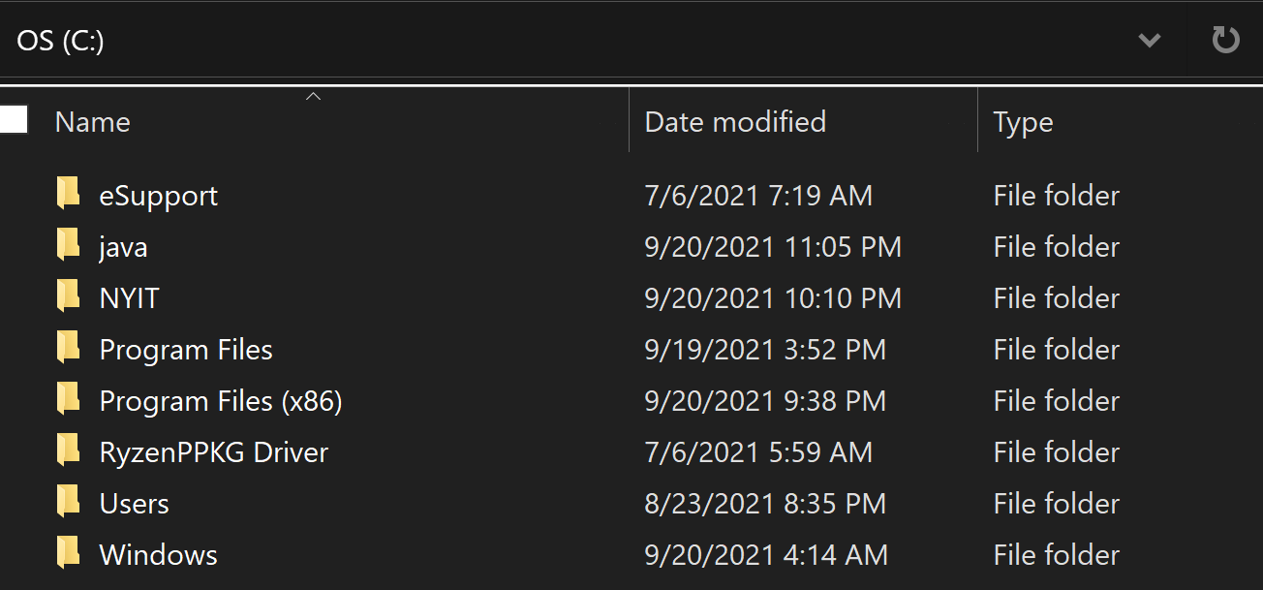

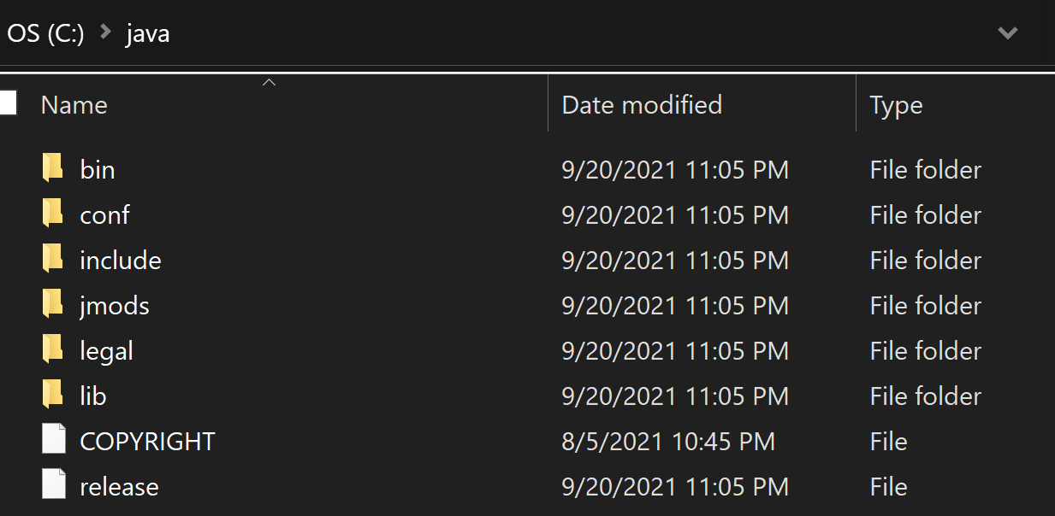

# 7) Using GUI‐mouse and CLI‐keyboard shells.

## CLI cmd.exe Shell Work

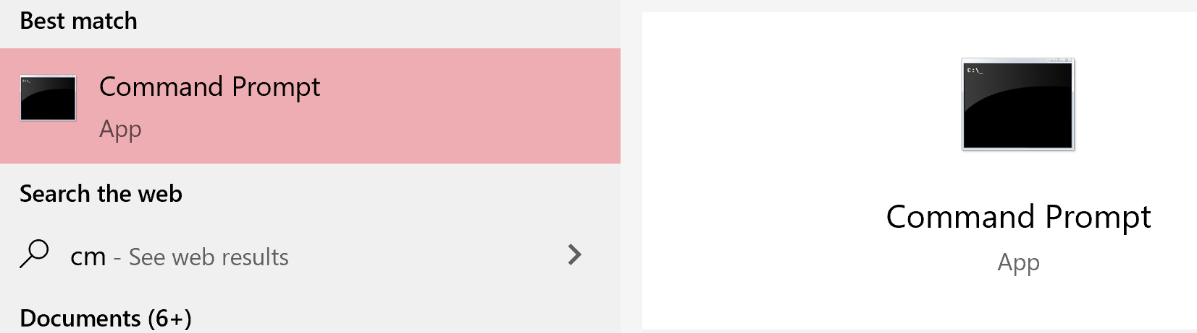

## Start cmd.exe shell and change directory to ‘c:\java’

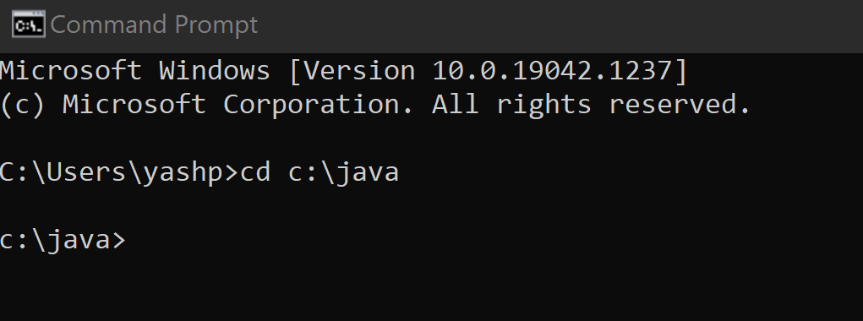

## Change (cd) directory to default working directory c:\java\bin

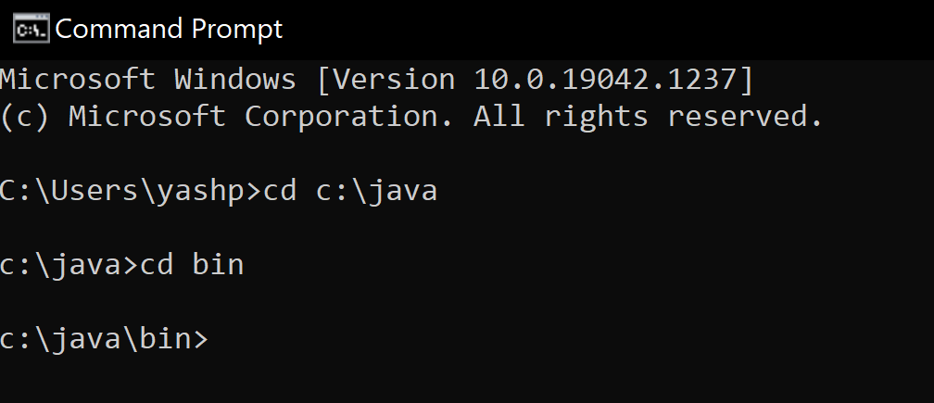

## Default working directory or default package is c:\java\bin



## Check if java tools (*.exe) programs are present.

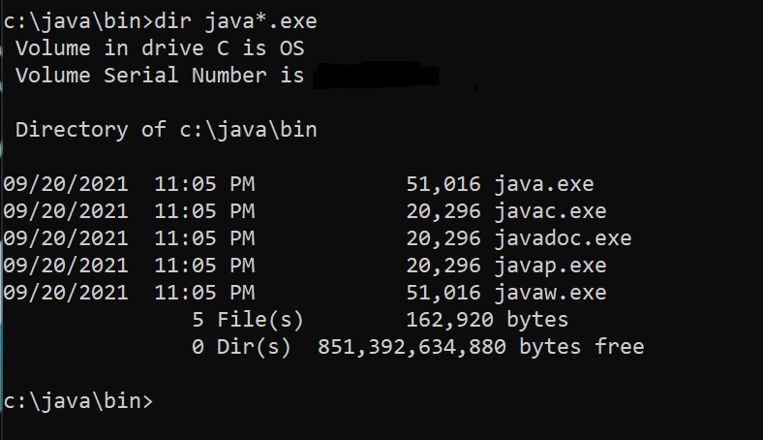

## Compiler javac.exe & interpreter JVM java.exe are present.



# 8) Using edit.exe or notepad.exe source text editing programs.

## Use edit.exe to type and save your files / save your programs.

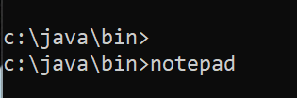

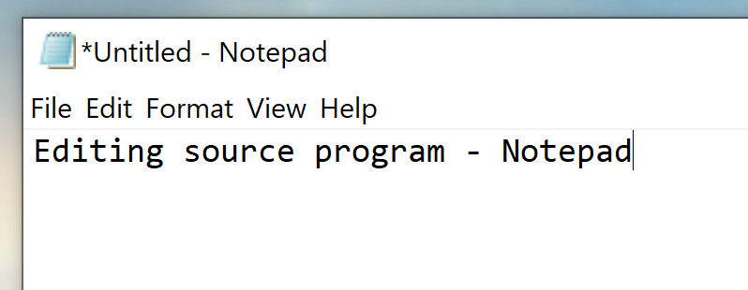

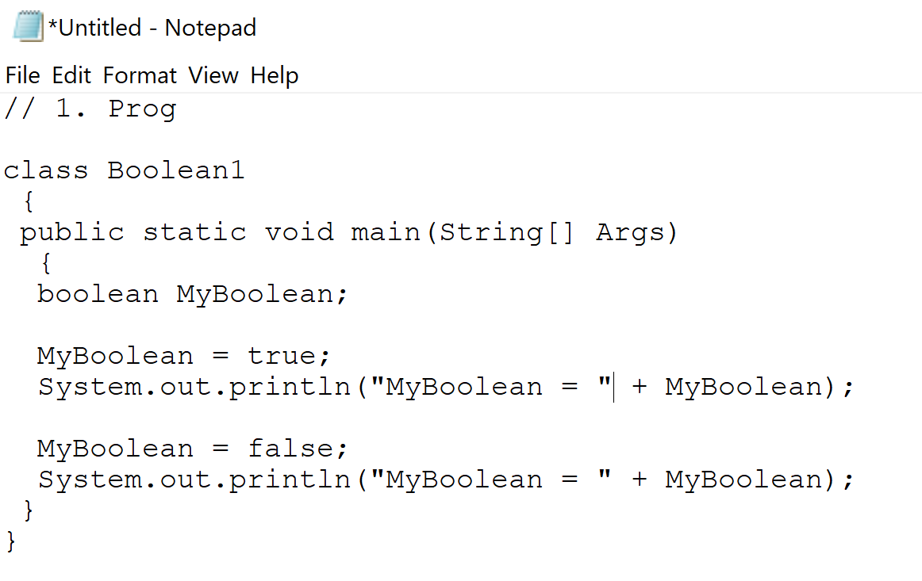

## Saving the source code.

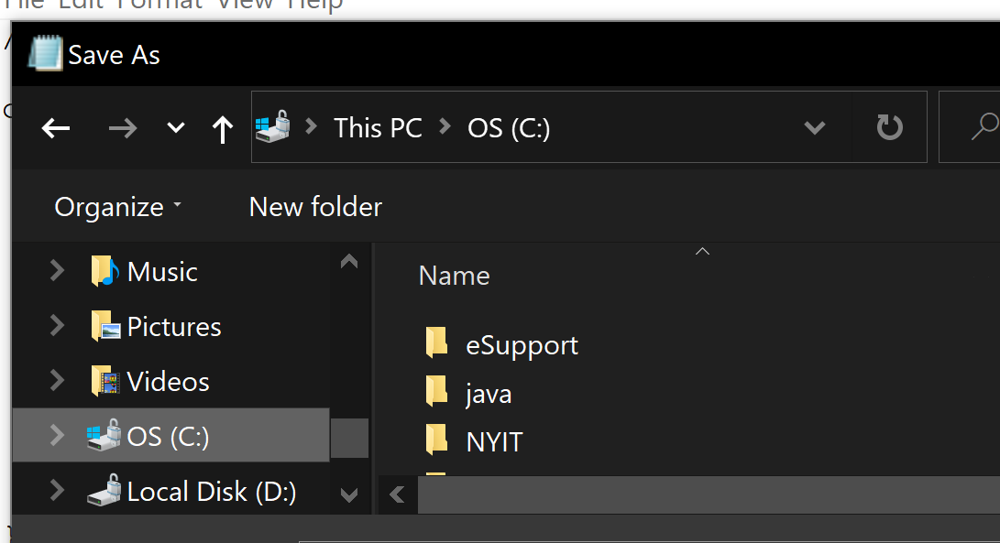

## Saving the source code text Boolean1.java in c:\java\bin directory.

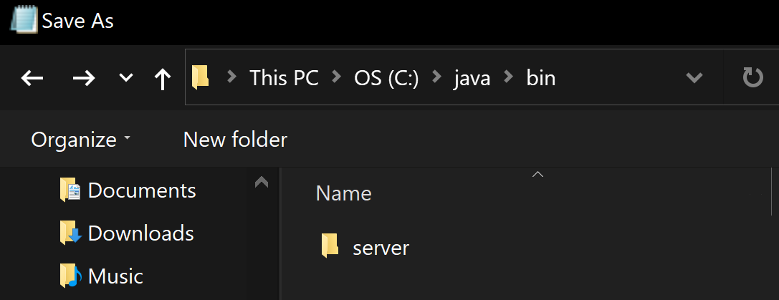

## Placing “” quotes on the source file name string ”Boolean1.java” (Notepad may add txt sometimes)

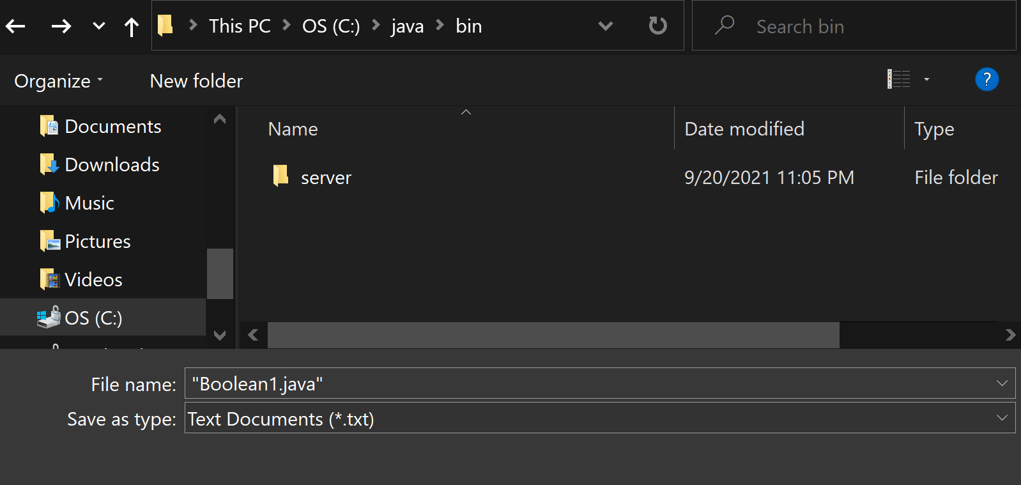

## Verifying that source cade text file is saved as Boolean1.java

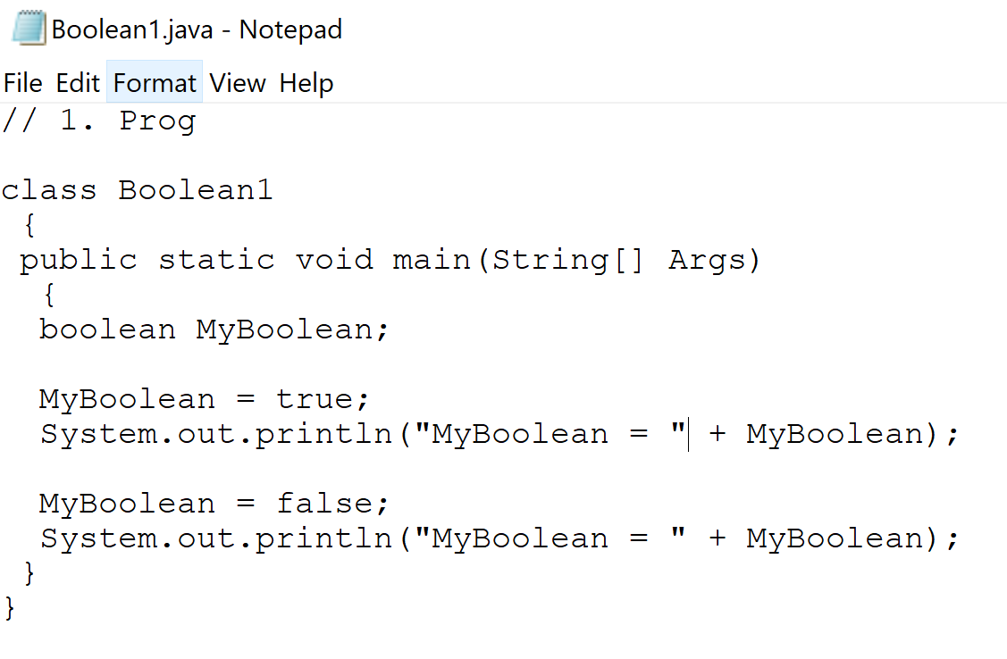

## Testing again if the source program has been saved.

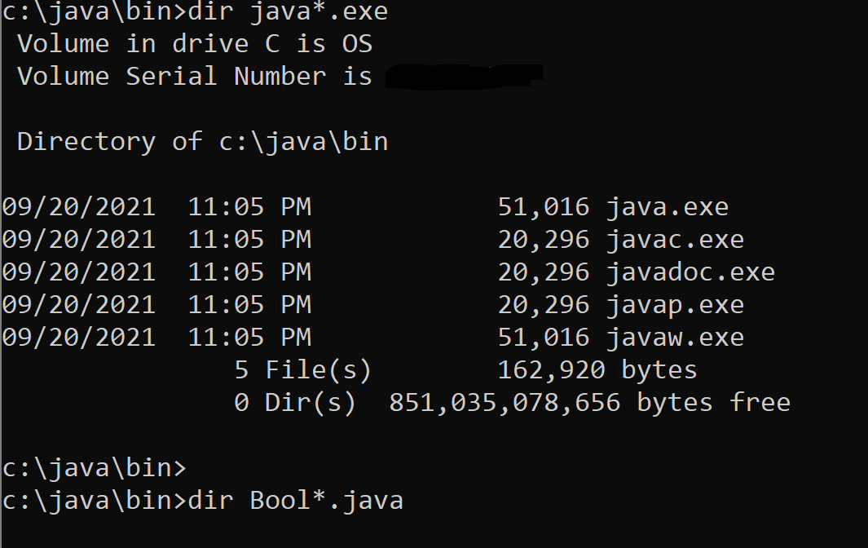

## Testing the size of the source file ‘Boolean1.java’

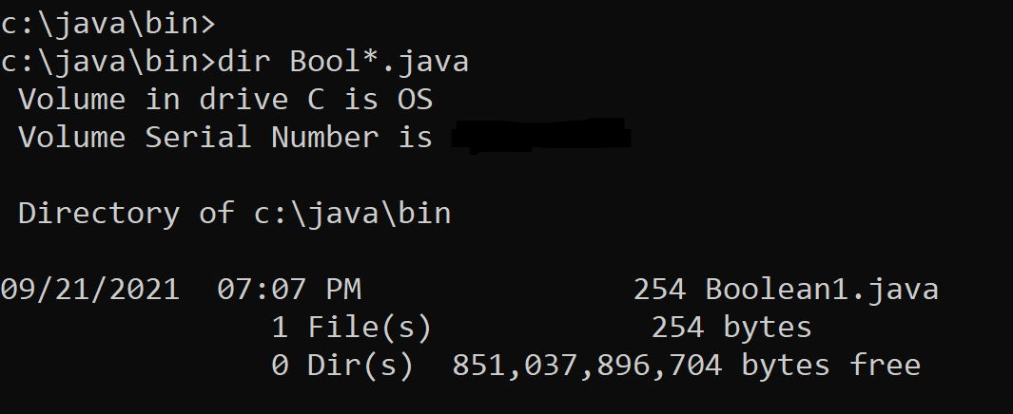

Here, the size of the source file is 254 characters (bytes).

## Using type command to test if the saved text is exactly as needed.

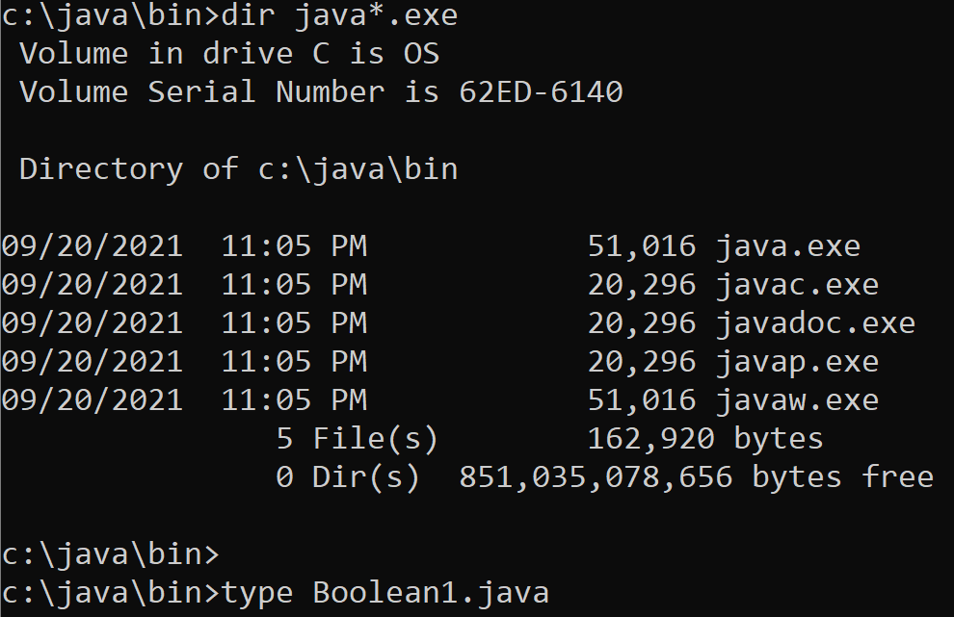

## Checking all characters displayed on the console screen.

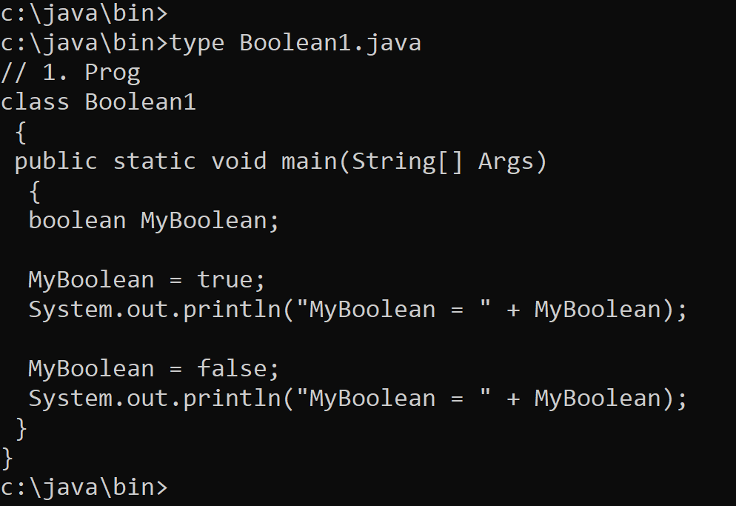

# 9) Java compiler javac.exe.

## Using java compiler javac.exe to compile source Boolean1.java

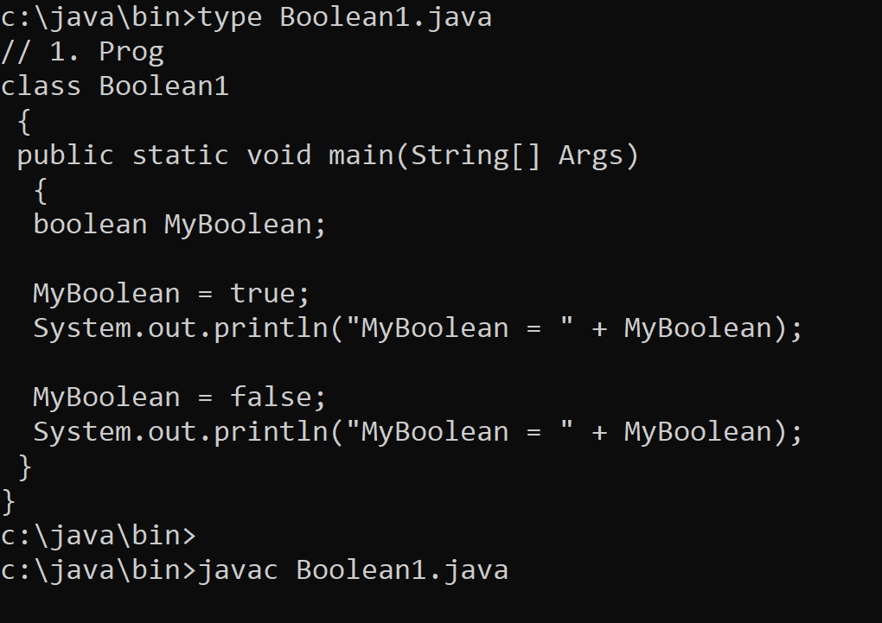

## No error text indicates perfect compilation.

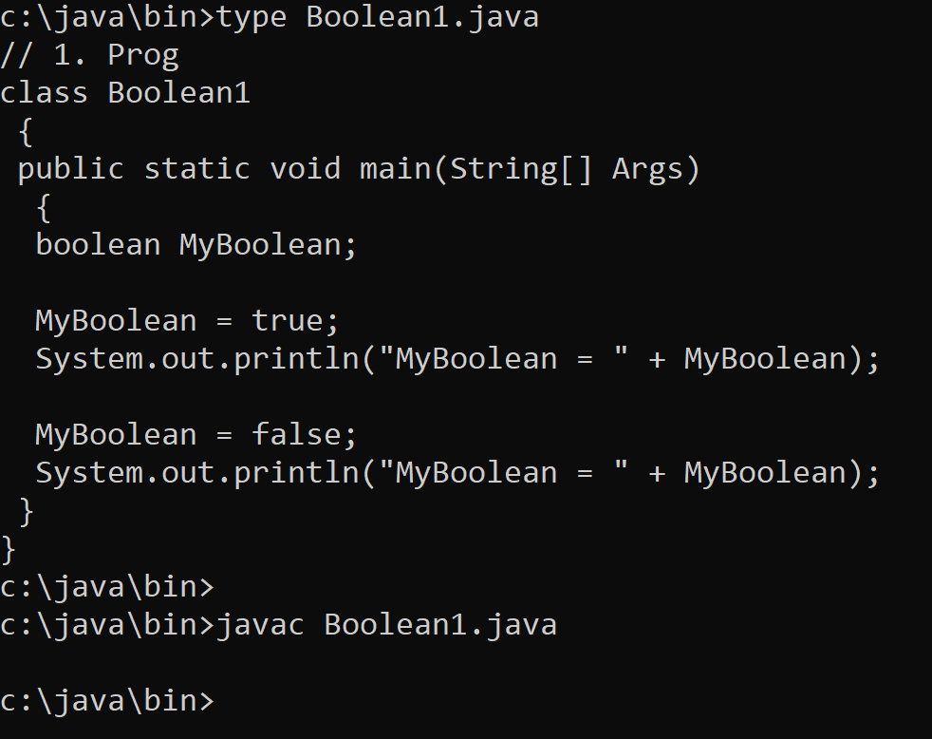

# 11) Java Virtual Machine (JVM) java.exe program.

## Use JVM program java.exe to execute object Boolean1.class

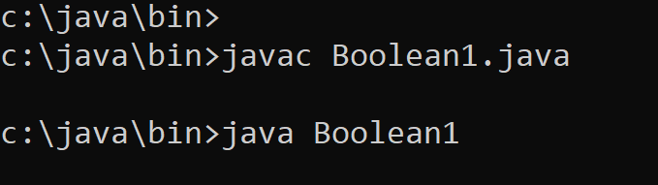

Just type java not java.exe and just Boolean1, not Boolean1.class

# 12) Running/testing compiled Java program Boolean1.class.

## Running and testing executable object file Boolean1.class

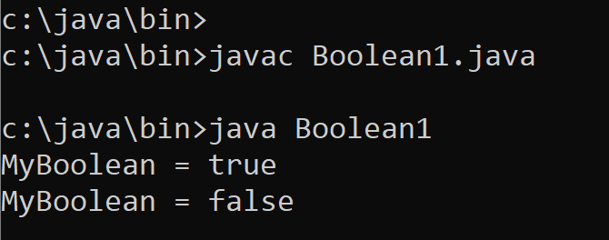

• JVM object file Boolean1.class (Java Byte‐code file) runs well, exactly as programmed.

• System.out.println() console output API function prints two boolean variables.

# 13) Testing of File Presence.

## Checking if both source and object files are present.

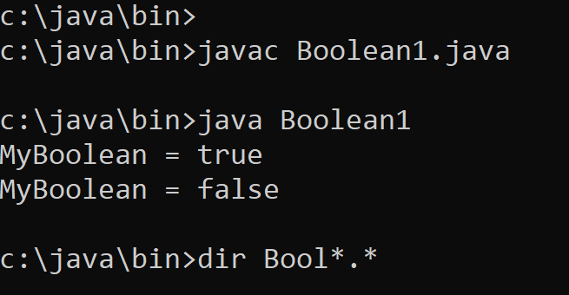

## • Confirmed, both source Boolean1.java and object Boolean1.class are ok.

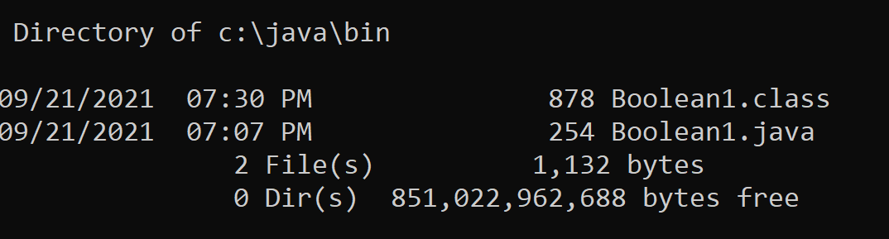

# 14) Testing of Object File ASCII Character Content.

## Printing on the screen, the Java bytecode of Boolean1.class file.

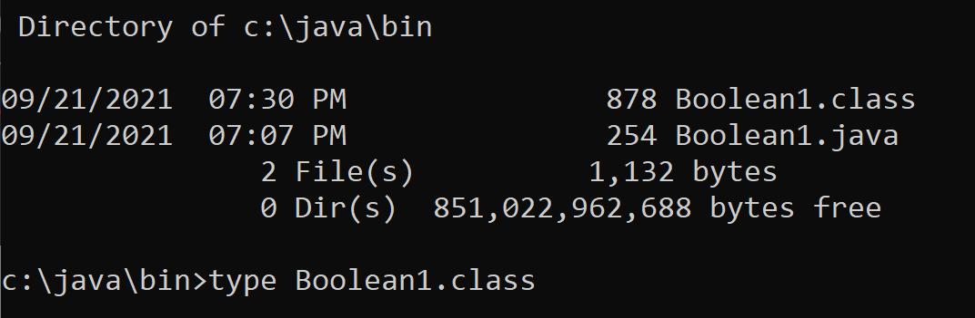

## JVM object code Boolean1.class cannot be read as ASCII text.

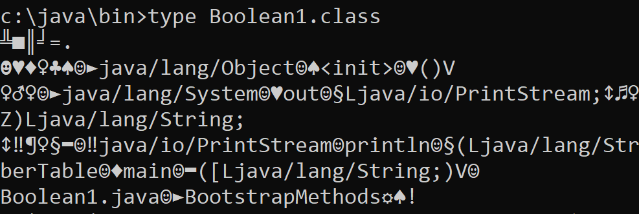

ASCII character decoder of the CLI shell cmd.exe shows unreadable text, not intended for human reader but aimed at the JVM interpreter/execution engine of bytecodes in Bollean1.class

# References.

[1] [Microsoft PowerPoint - ____725_01_Lecture_01_ProgramEx_.pptx (tfbor.com)](http://tfbor.com/02_725/01_Introduction/725_01_Lecture_00_ProgramExexution_.pdf)

[2] [tfbor.com/02_725/01_Introduction/725_01_Lecture_05_ExJavaInstall.pdf](http://tfbor.com/02_725/01_Introduction/725_01_Lecture_05_ExJavaInstall.pdf)

[3] [Microsoft PowerPoint - 725_01_Lecture_06_ExHmwk__v1______.pptx (tfbor.com)](http://tfbor.com/02_725/01_Introduction/725_01_Lecture_06_ExHmwk____.pdf)

[4] [Microsoft PowerPoint - 735_10_Exercise_00_JavaInstall.pptx (tfbor.com)](http://tfbor.com/02_725/01_Introduction/735_01_Exercise_01_JavaInstall.pdf)

[5] [Java Downloads | Oracle](https://www.oracle.com/java/technologies/downloads/)