NYIT

**Fall 2021**

Homework No: 04

Title: UML 2 Java

**Name:** Patade, Yash Arun

**Class ID#:**  11

**School ID#:** 1284979

**Course:** Java Networking

**Course ID:** CSCI 725

**Date:** 18/10/2021

Contents

1) Java 9 installation. 4

❖ UML to Java Mapping. 9

Mapping Representation: Notes. 9

- Each UML class may be assigned a note with the proposed PSM (Platform specific – Java partial or complete code ideas) 9

Visibility for Attributes and Operations. 10

- UML note symbol has a tab in the upper right corner. 10

Class Scope Attributes and Operations. 11

- UML model is Platform Independent Model or PIM and Java program is Platform Specific Model or PSM. 11

Example: Utility Class Stereotype. 11

- A grouping of global attributes and operations. 11

❖ Designing Relationships - Aggregation (OOA-OOD-OOP) 12

Composition – Strong Aggregation. 12

- Composition and Aggregation are the form of association between two objects, but there is a subtle difference. 12

Example: Composition. 12

- Example: Human class is a composition of body parts; Hand, Leg and Heart. 12

- When human object dies, all it's body part 12

Example: Composition. 13

- Another example of Composition is Car and it's part e.g. engines, wheels etc. Individual parts of the car cannot function when a car is destroyed. 13

- When you destroy Car Windshield is destroyed too. 13

Composition Property. 13

- When composed (Strongly aggregated) object moves all of its parts are moving too. 13

- Example: Body and organs. 13

- Example: Vehicle and parts 13

Aggregation. 14

- Aggregation or weak aggregation allows including object to exists without a container (without being part of the main object). 14

- Aggregation is denoted by an empty diamond, which shows their obvious difference in terms of strength of the relationship. 14

Example: Aggregation. 14

- Team and Player which is part of a Team, can exist without a team and can become part of other teams as well. 14

Example: Aggregation. 15

- Student in School class, when School closed, Student still exist and then can join another School or so. 15

Relationships. 15

- Relationship between classes differ in their strength, where composition represents strongest form of relationship and association being the most general (the weakest) form. 15

Example: Aggregation. 16

- Student class and Address (or Apartment) class. 16

Nested Classes. 17

Work from [Microsoft PowerPoint - 725_04_Lecture_00_JDK9_Install_.pptx (tfbor.com)](http://tfbor.com/02_725/04_UML2Java/725_04_Lecture_00_JDK9_Install_.pdf)

# 1) Java 9 installation.

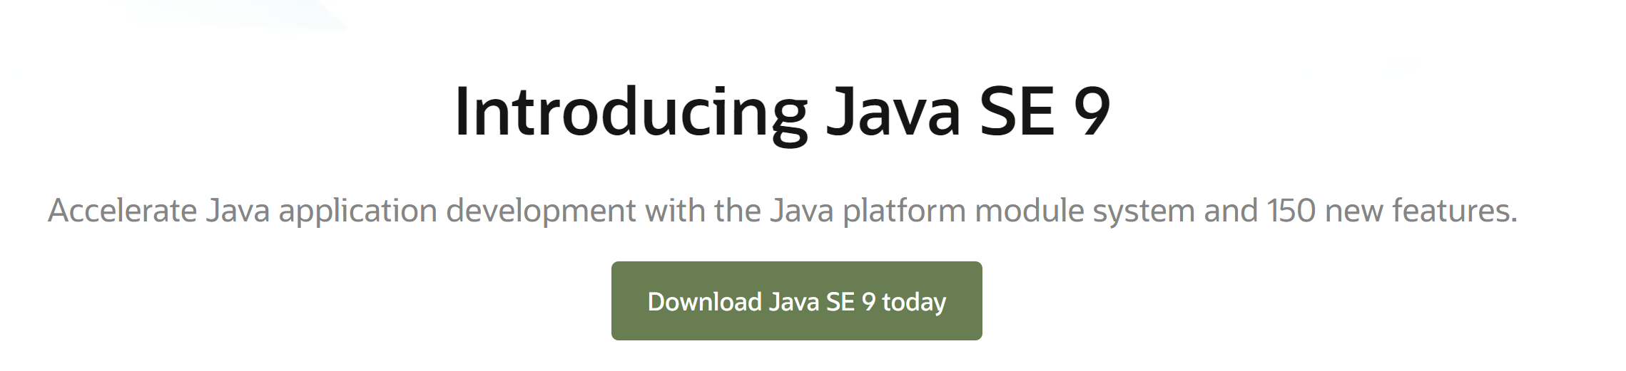

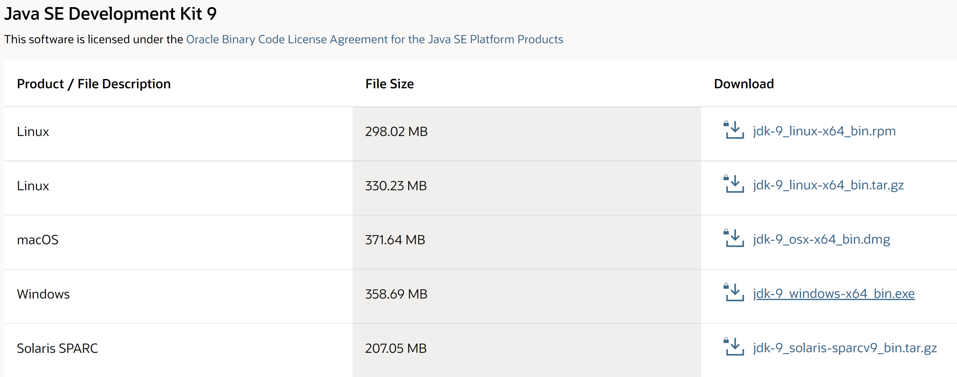

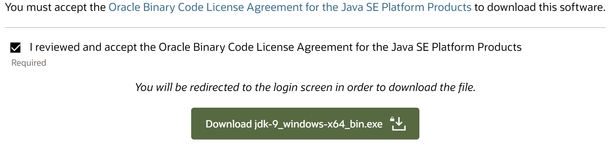









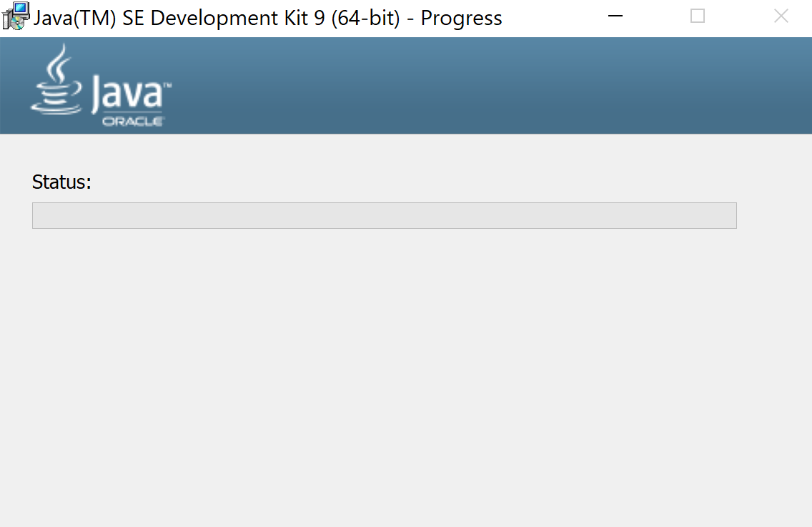



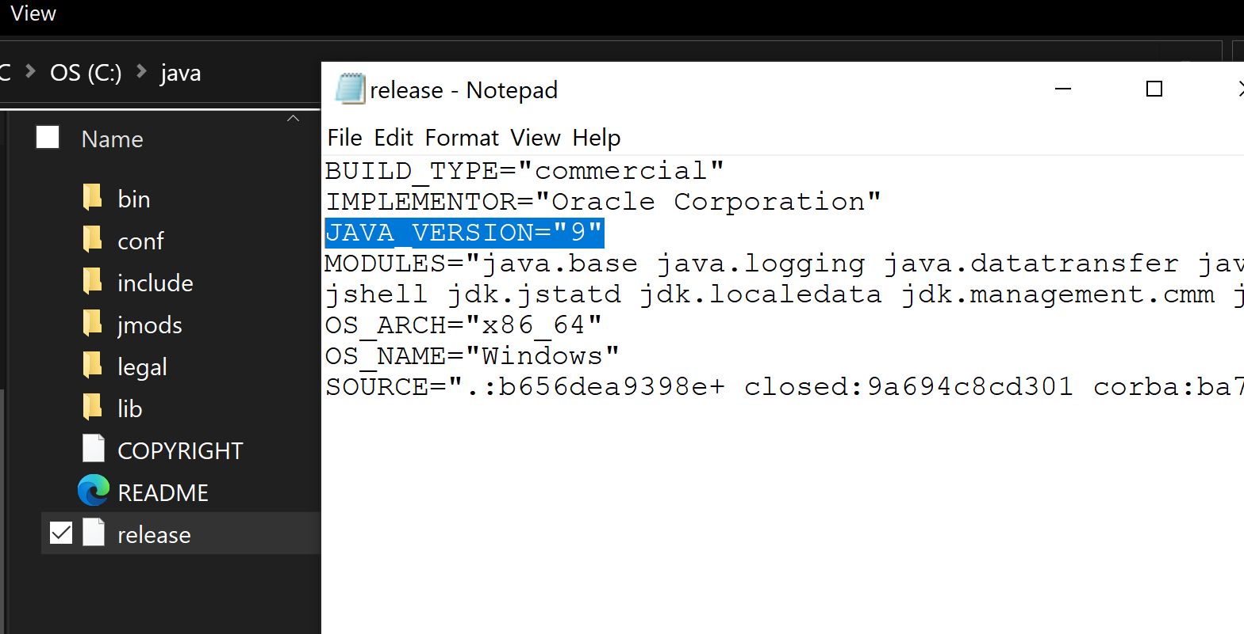

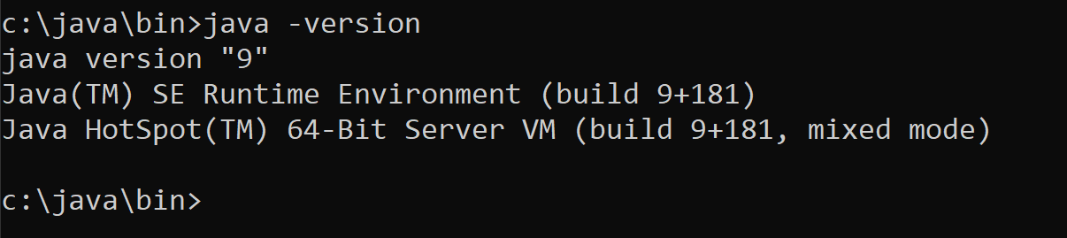

Work from [Microsoft PowerPoint - 725_04_Lecture_01_UMLtoJava_v1.pptx (tfbor.com)](http://tfbor.com/02_725/04_UML2Java/725_04_Lecture_01_UMLtoJava_v1.pdf)

# UML to Java Mapping.

# Mapping Representation: Notes.

## - Each UML class may be assigned a note with the proposed PSM (Platform specific – Java partial or complete code ideas)

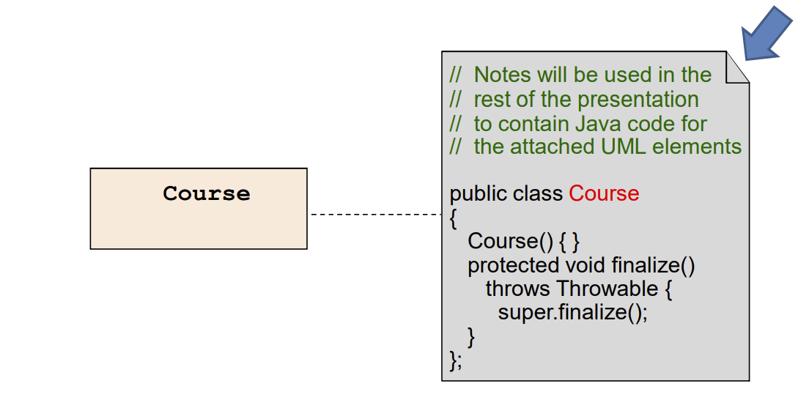

# Visibility for Attributes and Operations.

## - UML note symbol has a tab in the upper right corner.

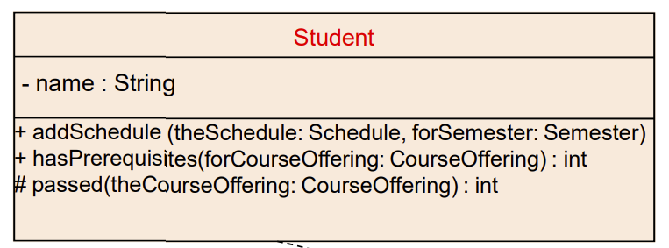

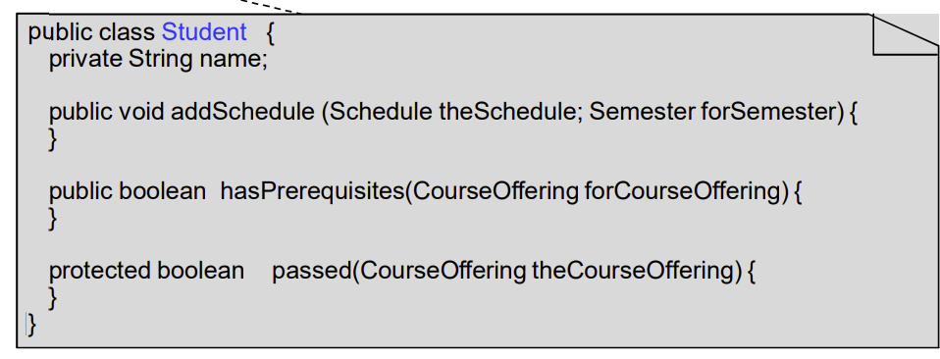

# Class Scope Attributes and Operations.

## - UML model is Platform Independent Model or PIM and Java program is Platform Specific Model or PSM.

- Two models are related via transformation or translation mechanism.

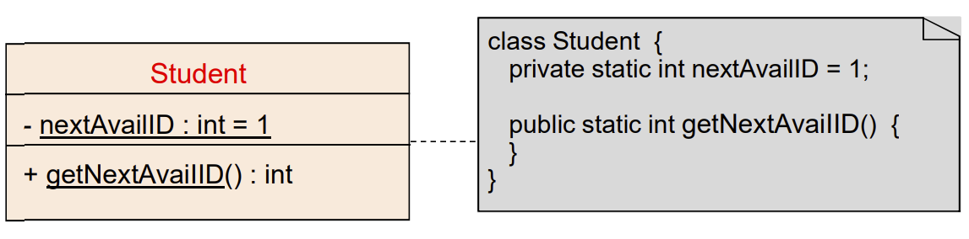

# Example: Utility Class Stereotype.

## - A grouping of global attributes and operations.

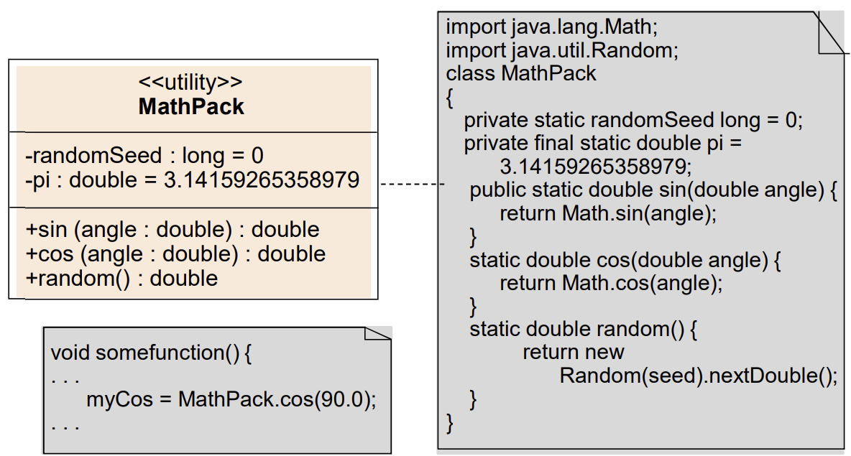

Work from [Microsoft PowerPoint - 725_04_Lecture_02_Aggregation_UML_Java_v1.pptx (tfbor.com)](http://tfbor.com/02_725/04_UML2Java/725_04_Lecture_02_Aggregation_UML_Java_.pdf)

# Designing Relationships - Aggregation (OOA-OOD-OOP)

# Composition – Strong Aggregation.

## - Composition and Aggregation are the form of association between two objects, but there is a subtle difference.

- With Composition, one class owns other class and other class cannot meaningfully exist, when its owner is destroyed.

– In UML notation, a composition is denoted by a filled diamond.

# Example: Composition.

## - Example: Human class is a composition of body parts; Hand, Leg and Heart.

### - When human object dies, all it's body part

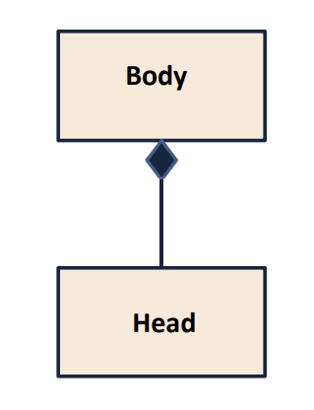

# Example: Composition.

## - Another example of Composition is Car and it's part e.g. engines, wheels etc. Individual parts of the car cannot function when a car is destroyed.

### - When you destroy Car Windshield is destroyed too.

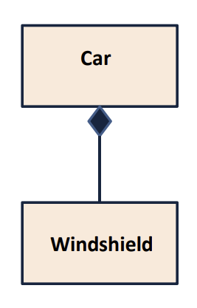

# Composition Property.

## - When composed (Strongly aggregated) object moves all of its parts are moving too.

### - Example: Body and organs.

### - Example: Vehicle and parts

# Aggregation.

## - Aggregation or weak aggregation allows including object to exists without a container (without being part of the main object).

### - Aggregation is denoted by an empty diamond, which shows their obvious difference in terms of strength of the relationship.

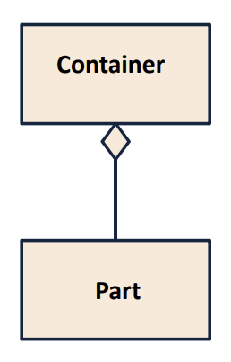

# Example: Aggregation.

## - Team and Player which is part of a Team, can exist without a team and can become part of other teams as well.

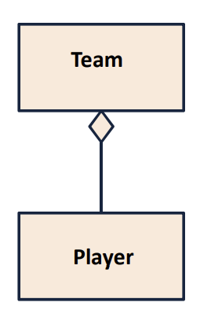

# Example: Aggregation.

## - Student in School class, when School closed, Student still exist and then can join another School or so.

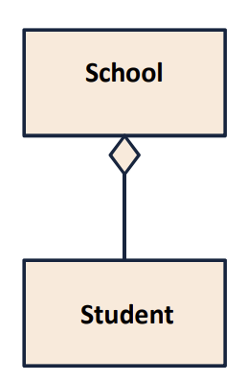

# Relationships.

## - Relationship between classes differ in their strength, where composition represents strongest form of relationship and association being the most general (the weakest) form.

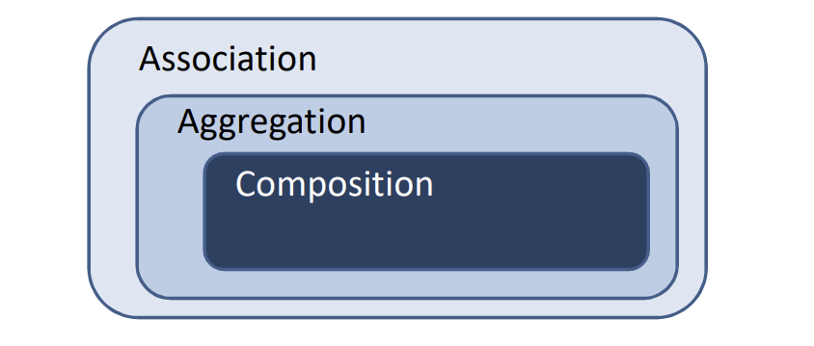

- Composition is stronger than Aggregation.

- Aggregation is a lighter form of Composition, where a sub-part object can meaningfully exist without main objects.

# Example: Aggregation.

## - Student class and Address (or Apartment) class.

- Every student has an address so the relationship between student and address is a Has-A relationship.

- But if you consider its vice versa then it would not make any sense as an Address doesn’t need to have a Student.

- Association may go both ways.

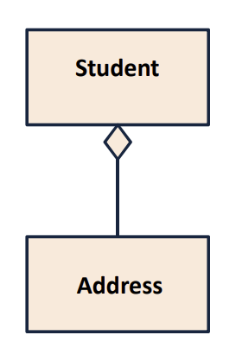

# Nested Classes.

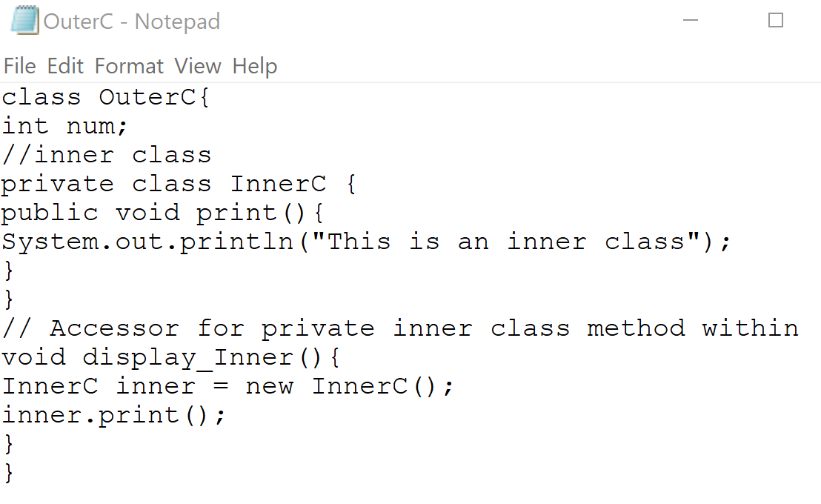

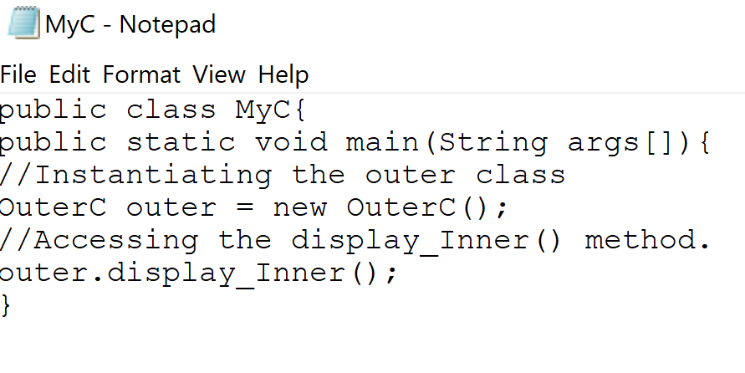

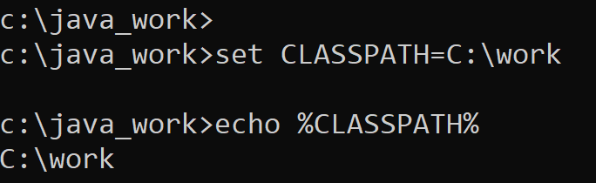

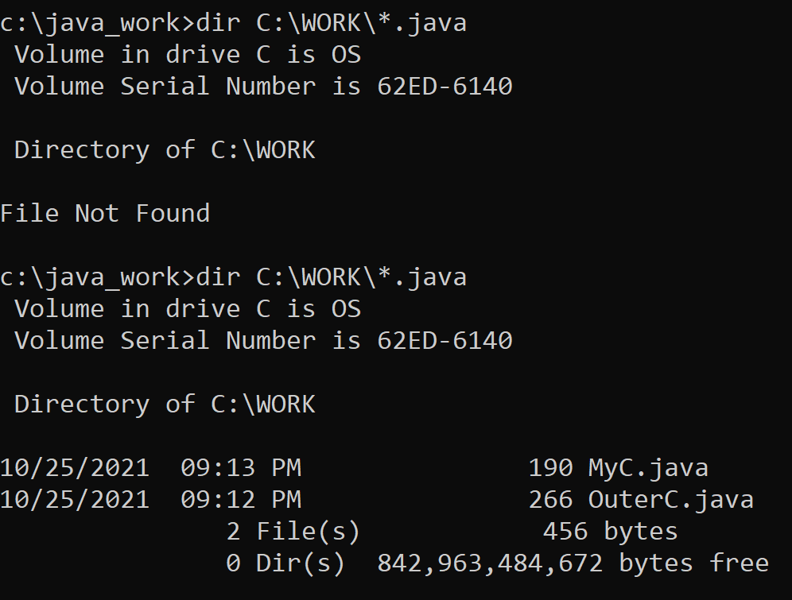

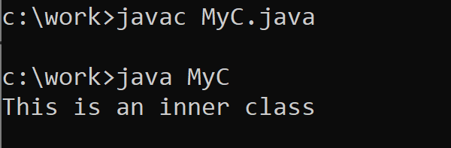

# References.

[1] [Microsoft PowerPoint - 725_04_Lecture_00_JDK9_Install_.pptx (tfbor.com)](http://tfbor.com/02_725/04_UML2Java/725_04_Lecture_00_JDK9_Install_.pdf)

[2] [Microsoft PowerPoint - 725_04_Lecture_01_UMLtoJava_v1.pptx (tfbor.com)](http://tfbor.com/02_725/04_UML2Java/725_04_Lecture_01_UMLtoJava_v1.pdf)

[3] [Microsoft PowerPoint - 725_04_Lecture_03_InnerClass_a_Java_.pptx (tfbor.com)](http://tfbor.com/02_725/04_UML2Java/725_04_Lecture_03_InnerClass_UML_Java_.pdf)