NYIT

**Fall 2021**

Homework No: 06

Title: Threads

**Name:** Patade, Yash Arun

**Class ID#:**  11

**School ID#:** 1284979

**Course:** Java Networking

**Course ID:** CSCI 725

**Date:** 2/11/2021

Contents

1) Homework Threads. 3

2) Question: Program at RT 19

- What does program become at Run Time (RT)? 19

3) Question: Thread and thread’s RTS. 20

- Why does each thread must have individual run time stack, RTST? 20

4) Class Wrapping homework codes. 20

1) File1.java 20

2) File2.java 21

3) File3.java 22

4) File4.java 23

5) File5.java 24

References 25

Work from <http://tfbor.com/02_725/06_a_MThreading_Polymorphism/725_06_Homework_ThrdsPrograms.doc>

# 1) Homework Threads.

1)

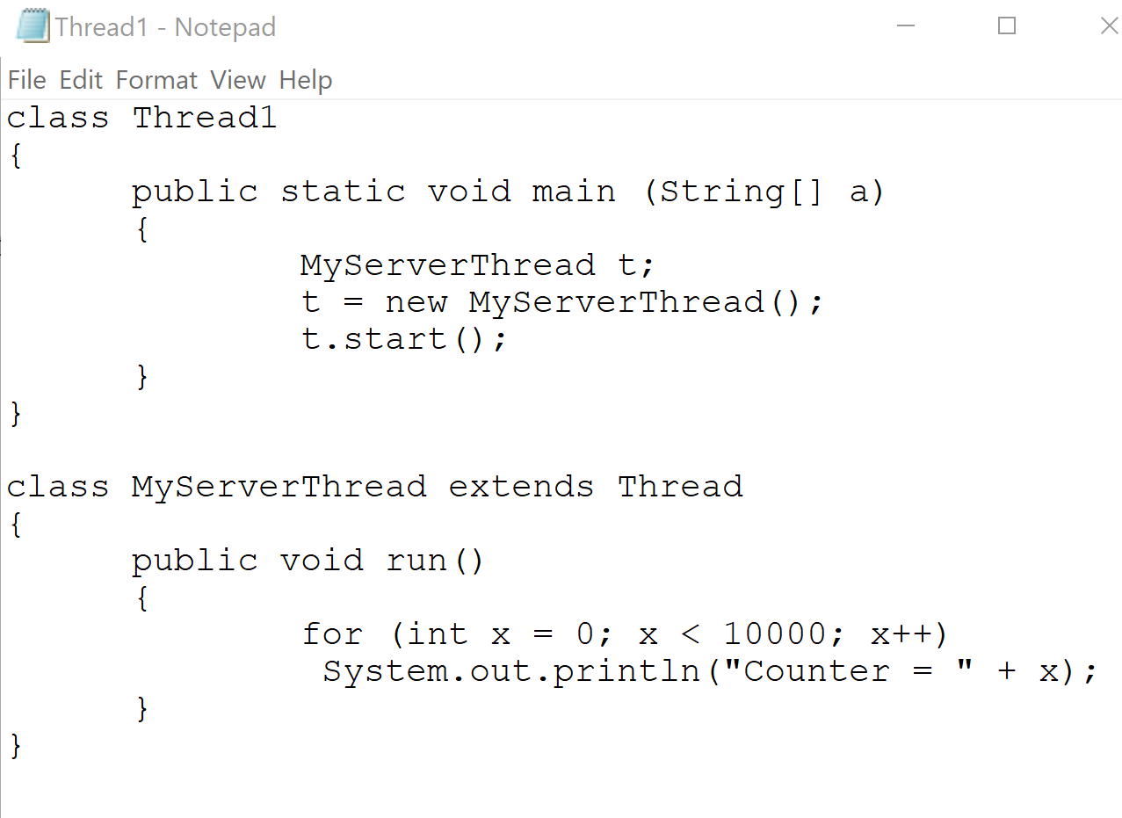

Result:

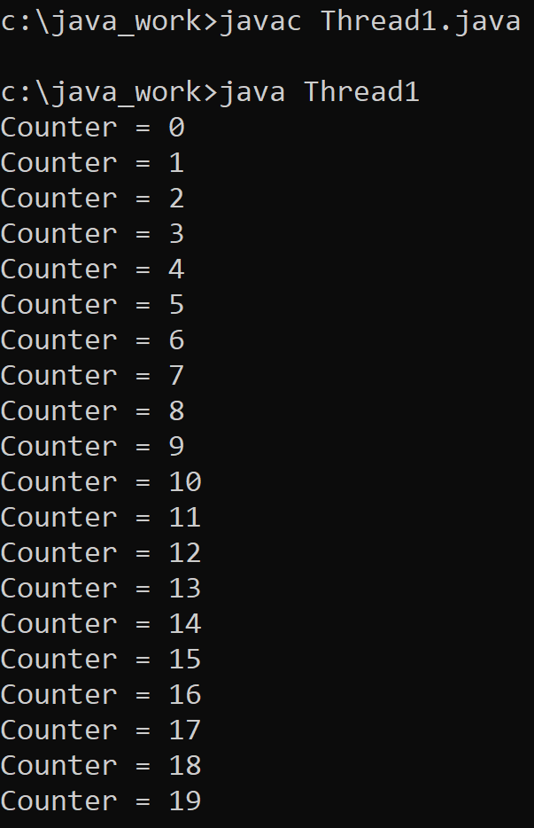

2)

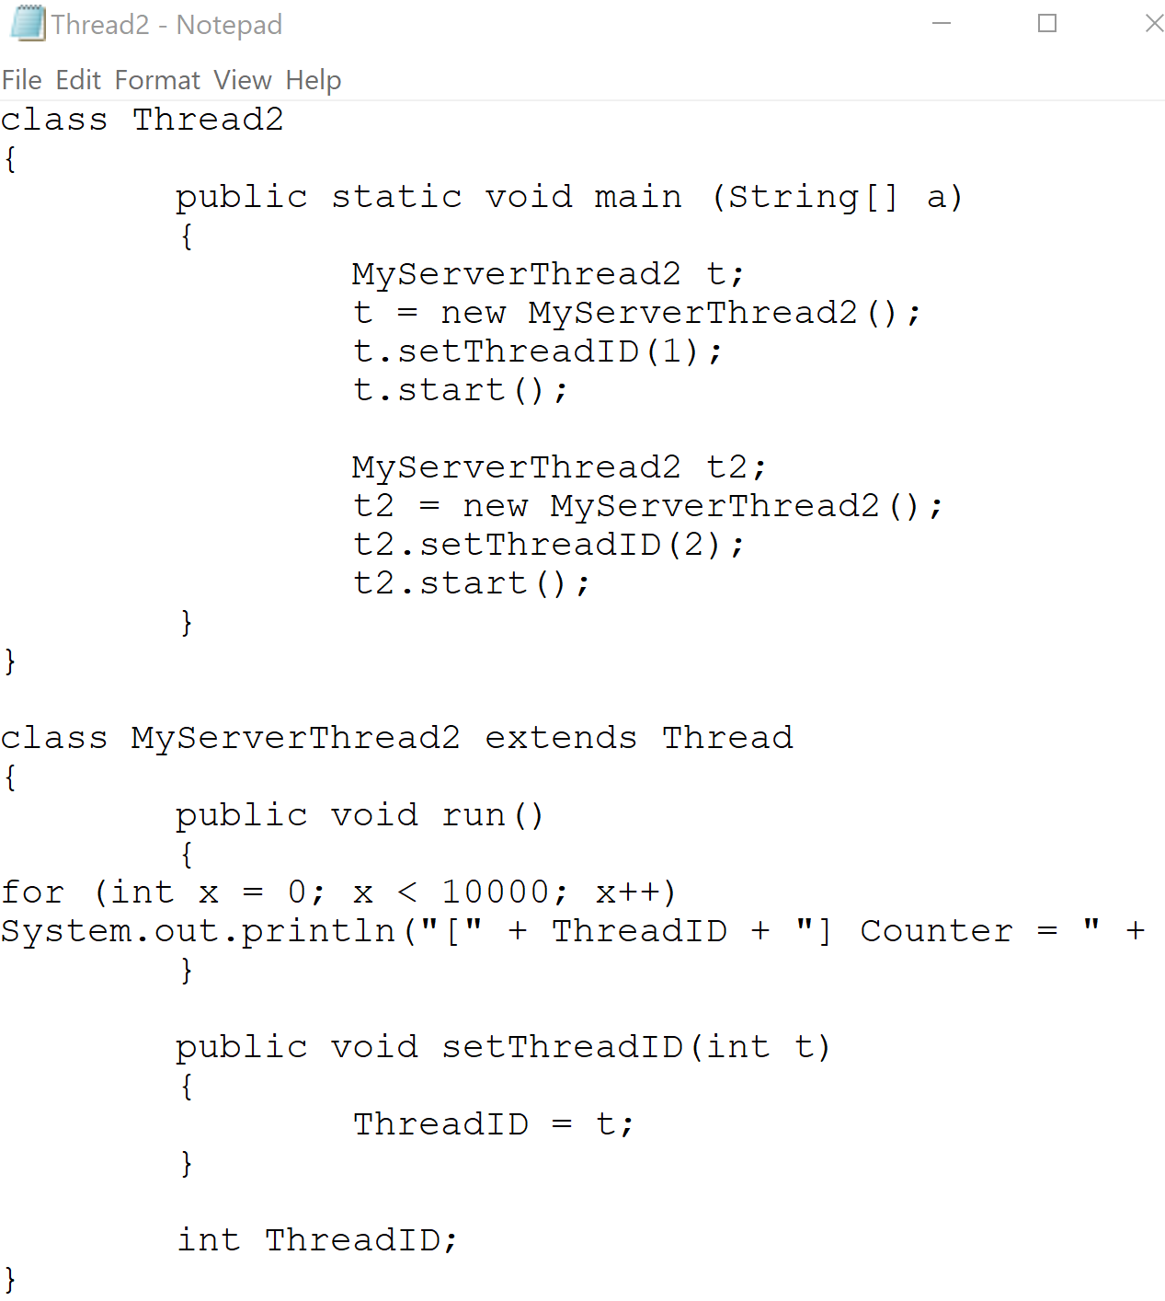

Result:

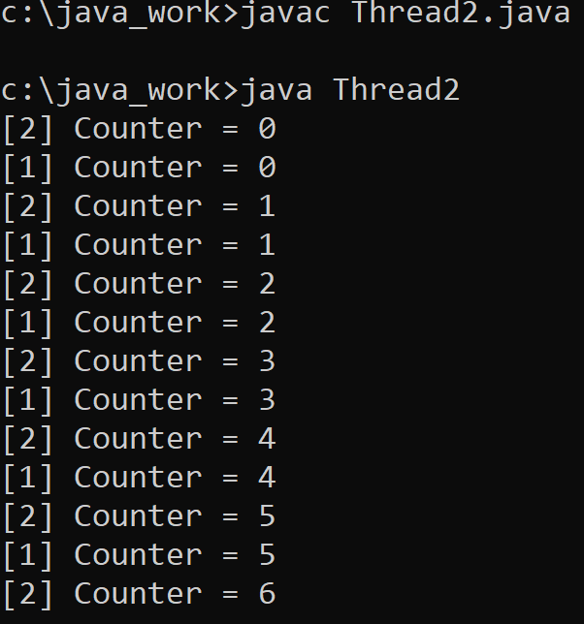

3)

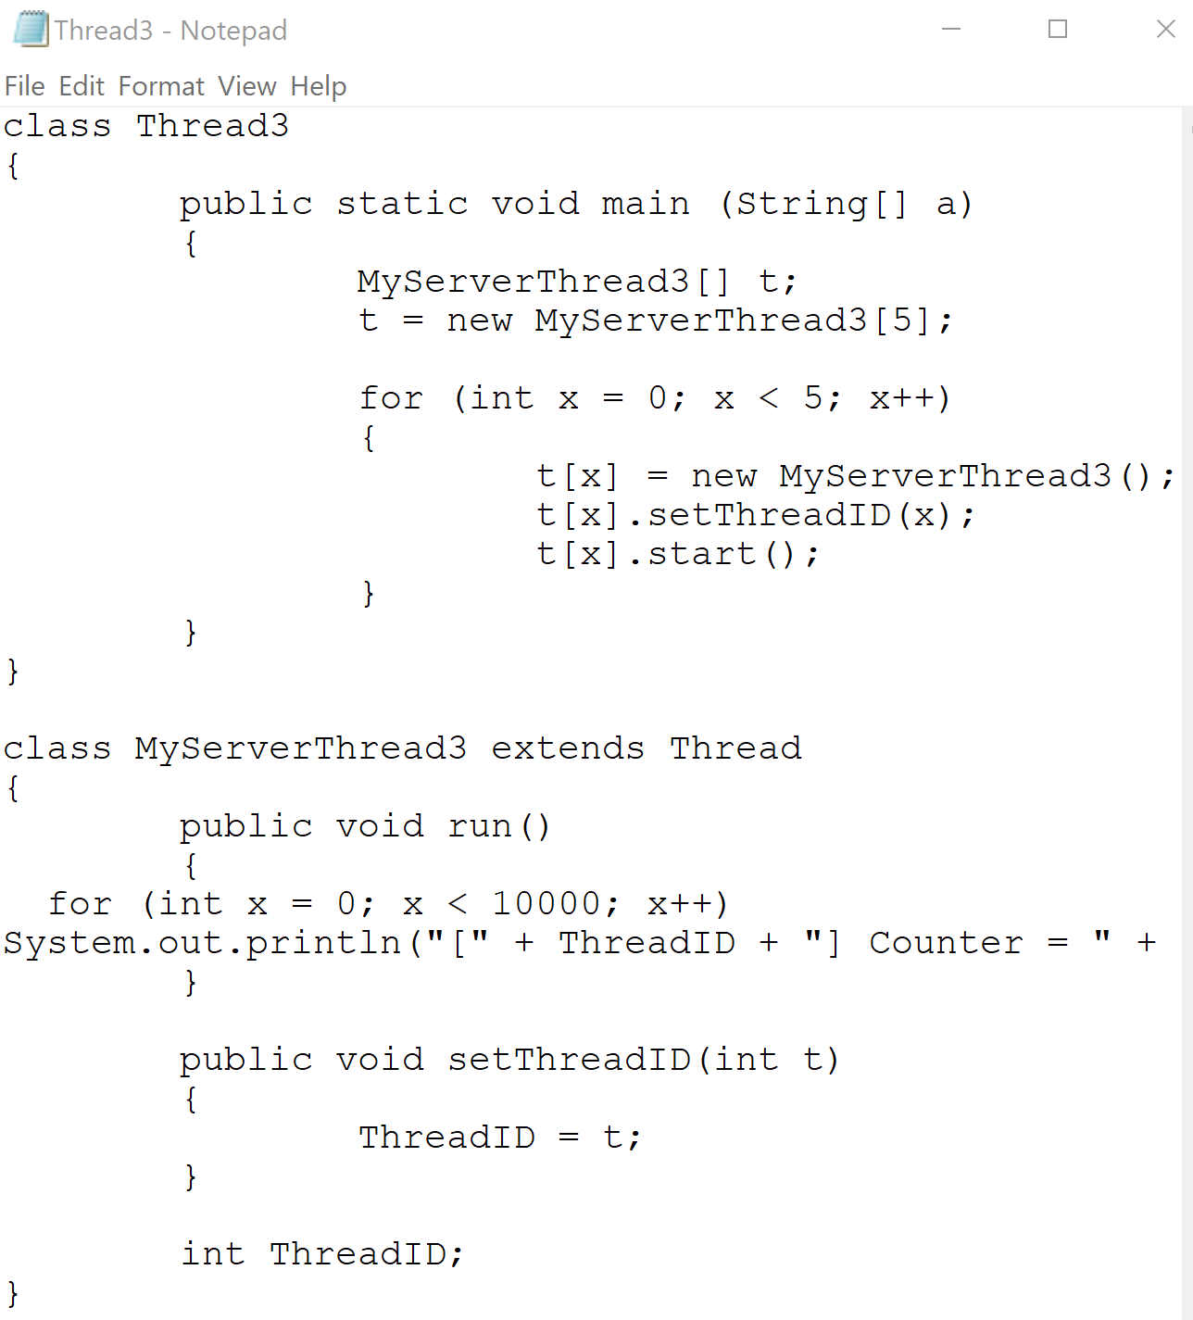

Result:

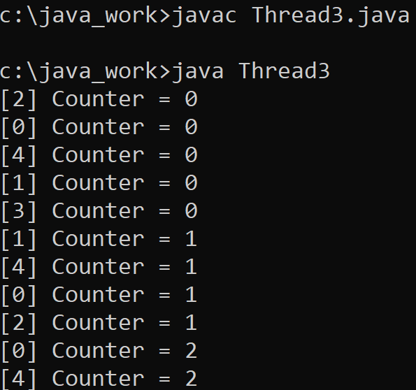

4)

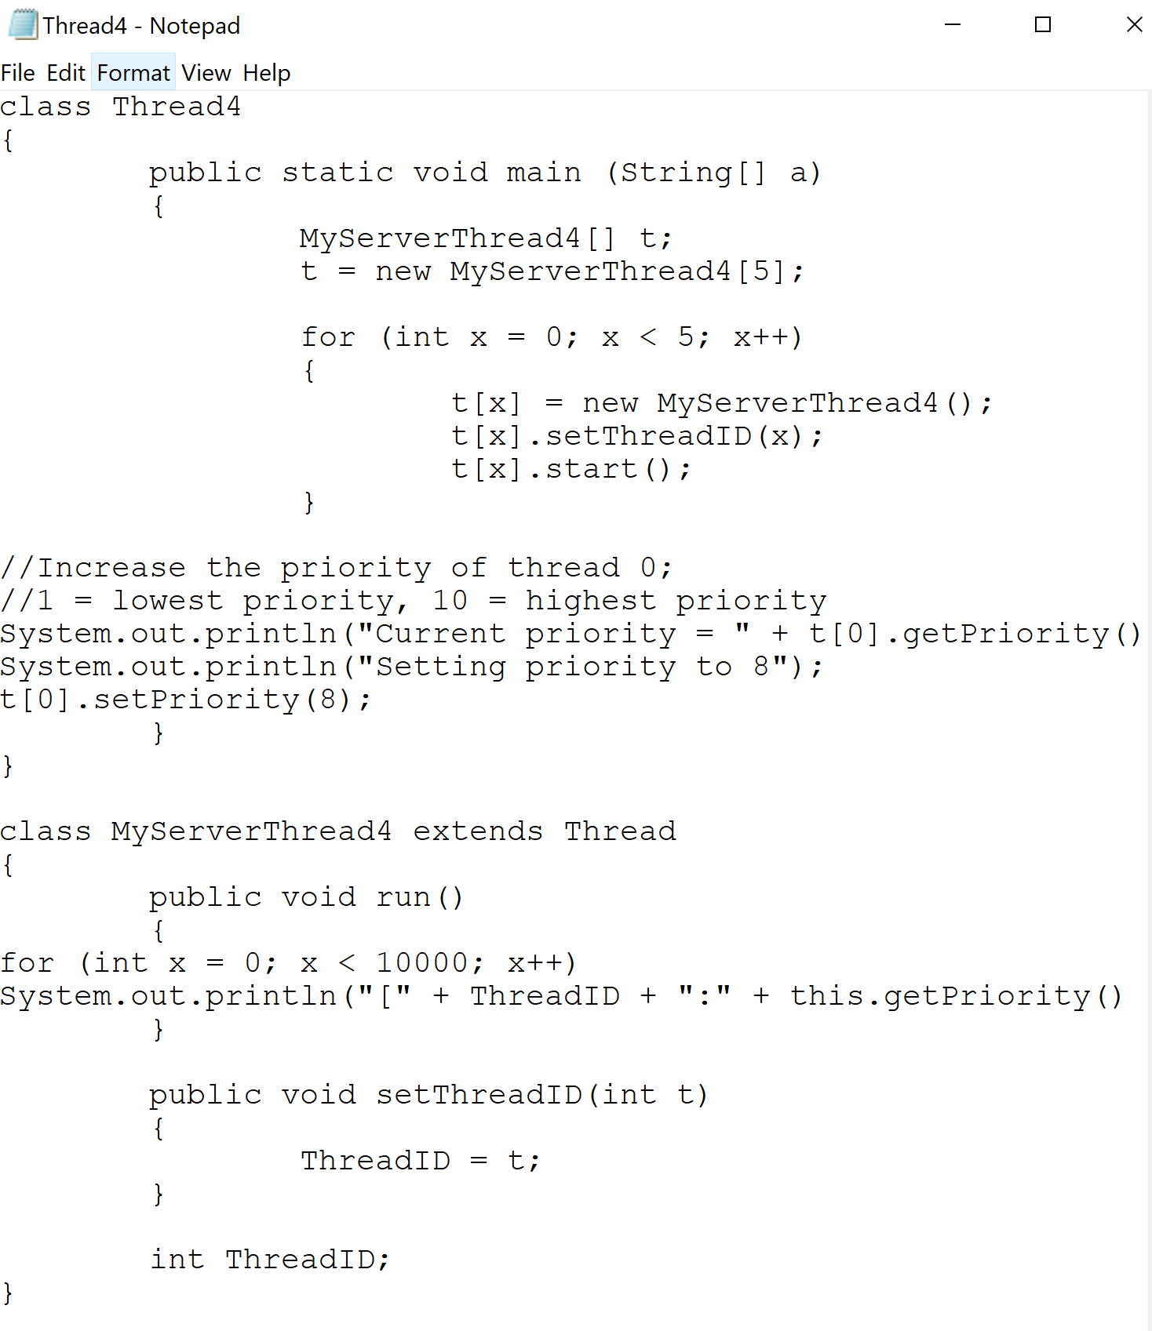

Result:

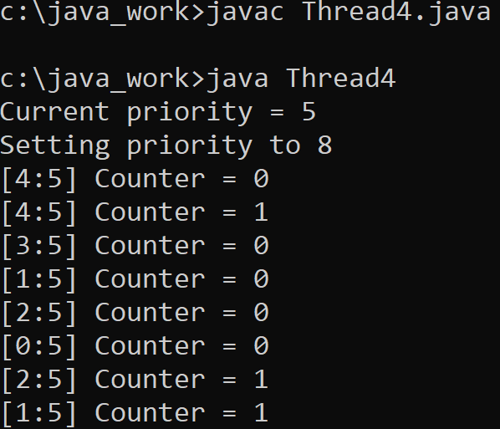

5)

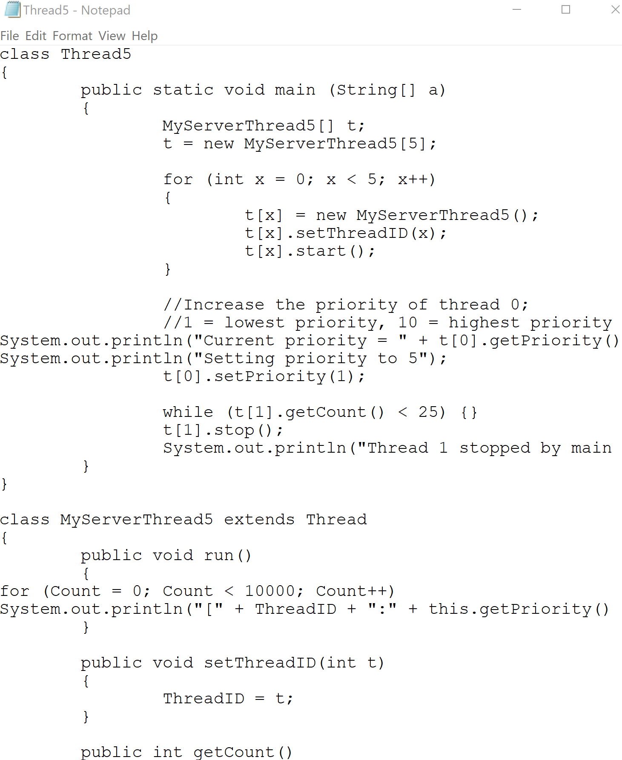

Result:

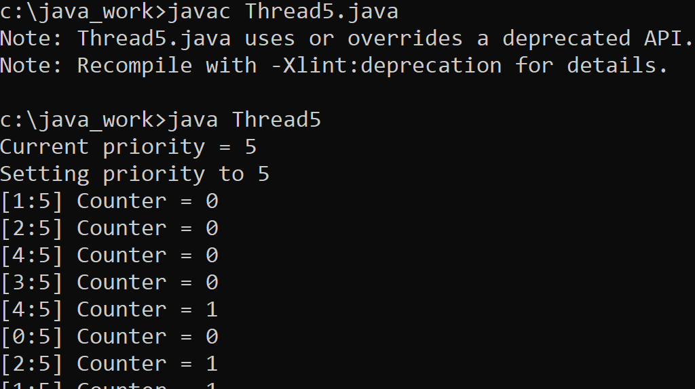

6)

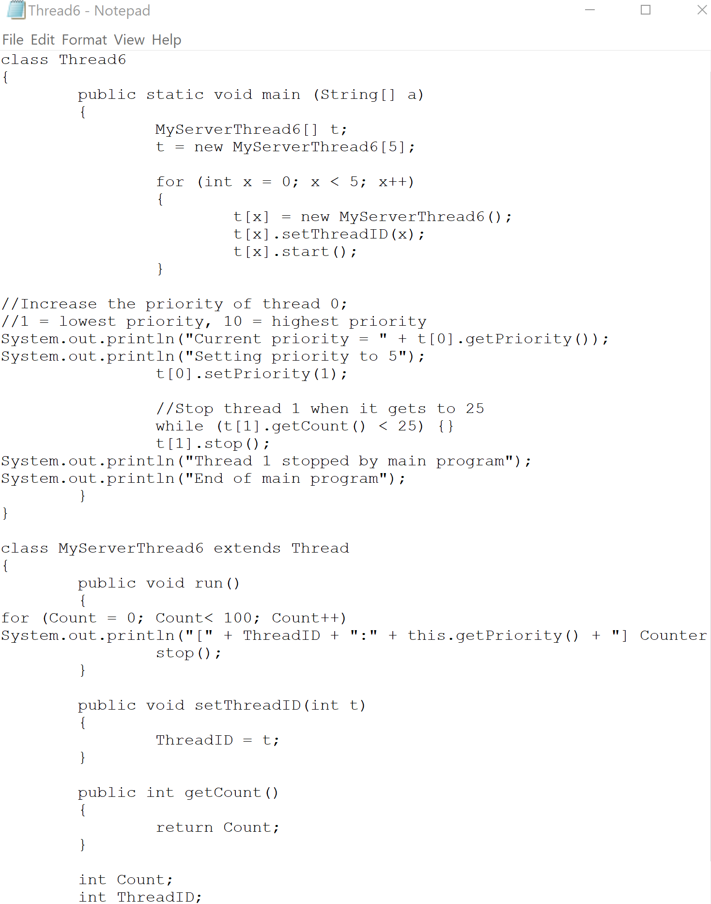

Result:

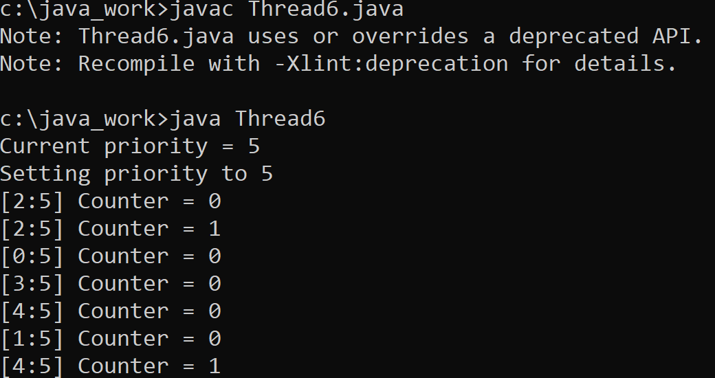

7)

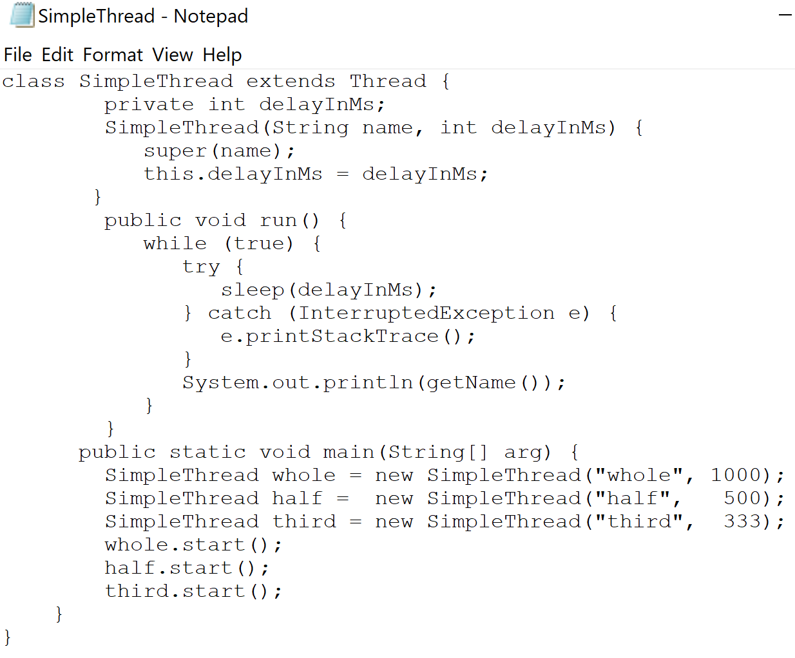

Result:

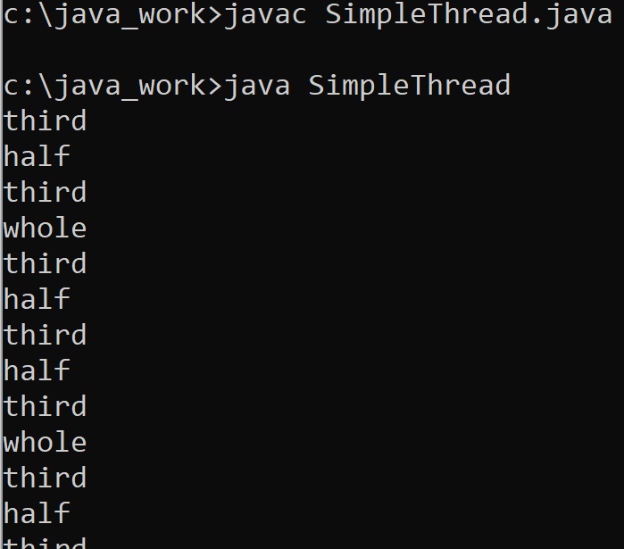

8)

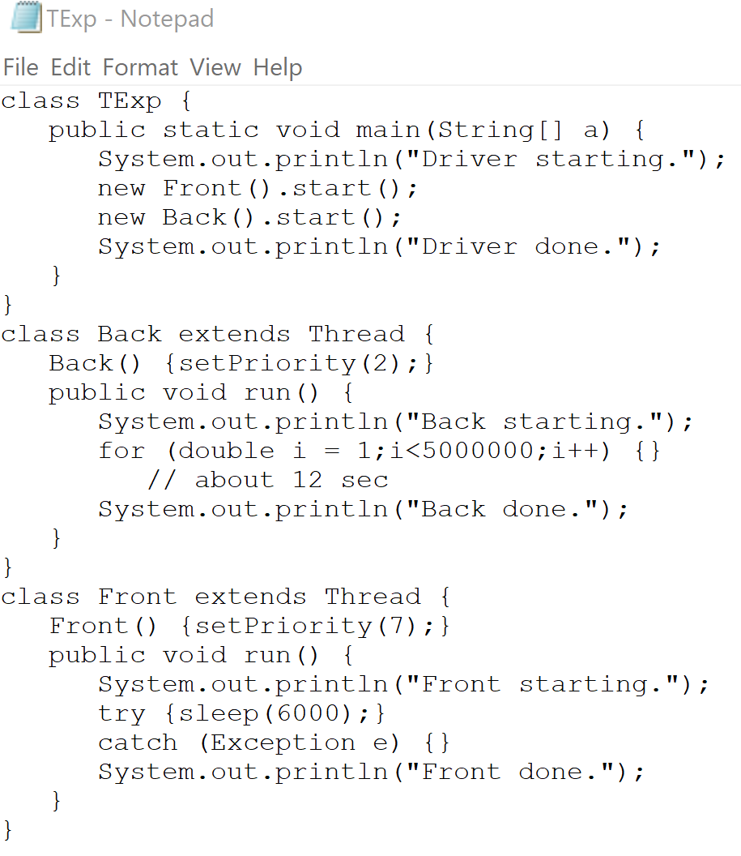

Result:

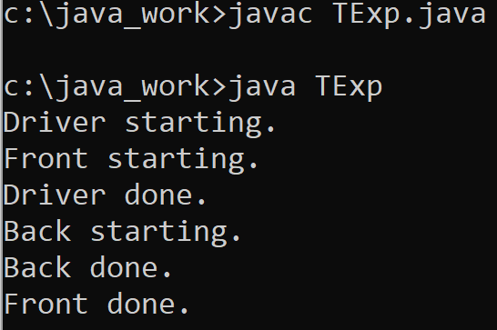

9)

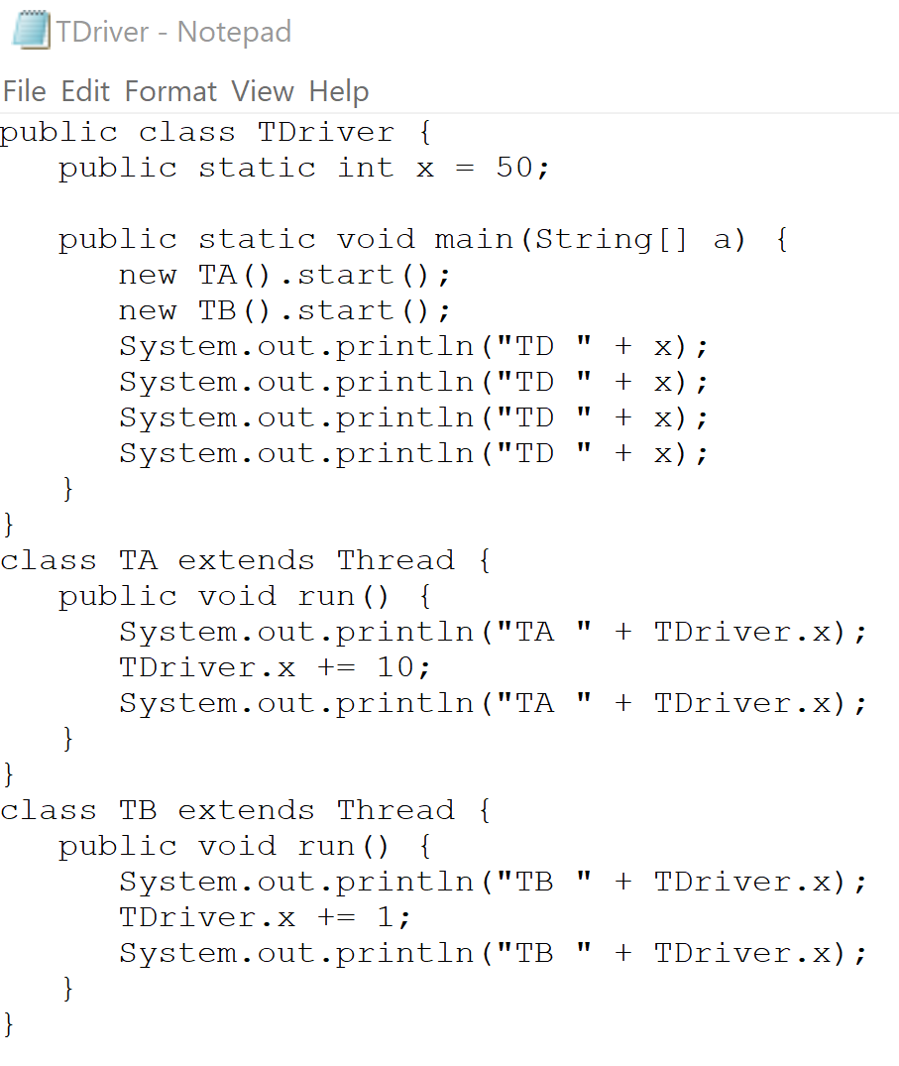

Result:

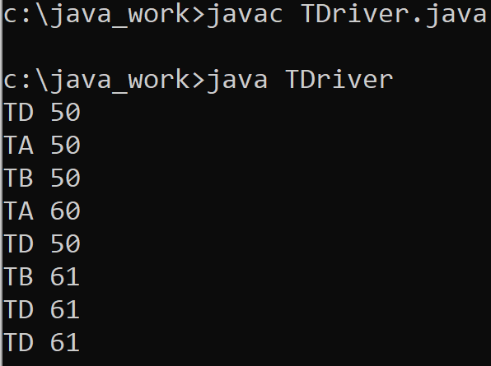

10)

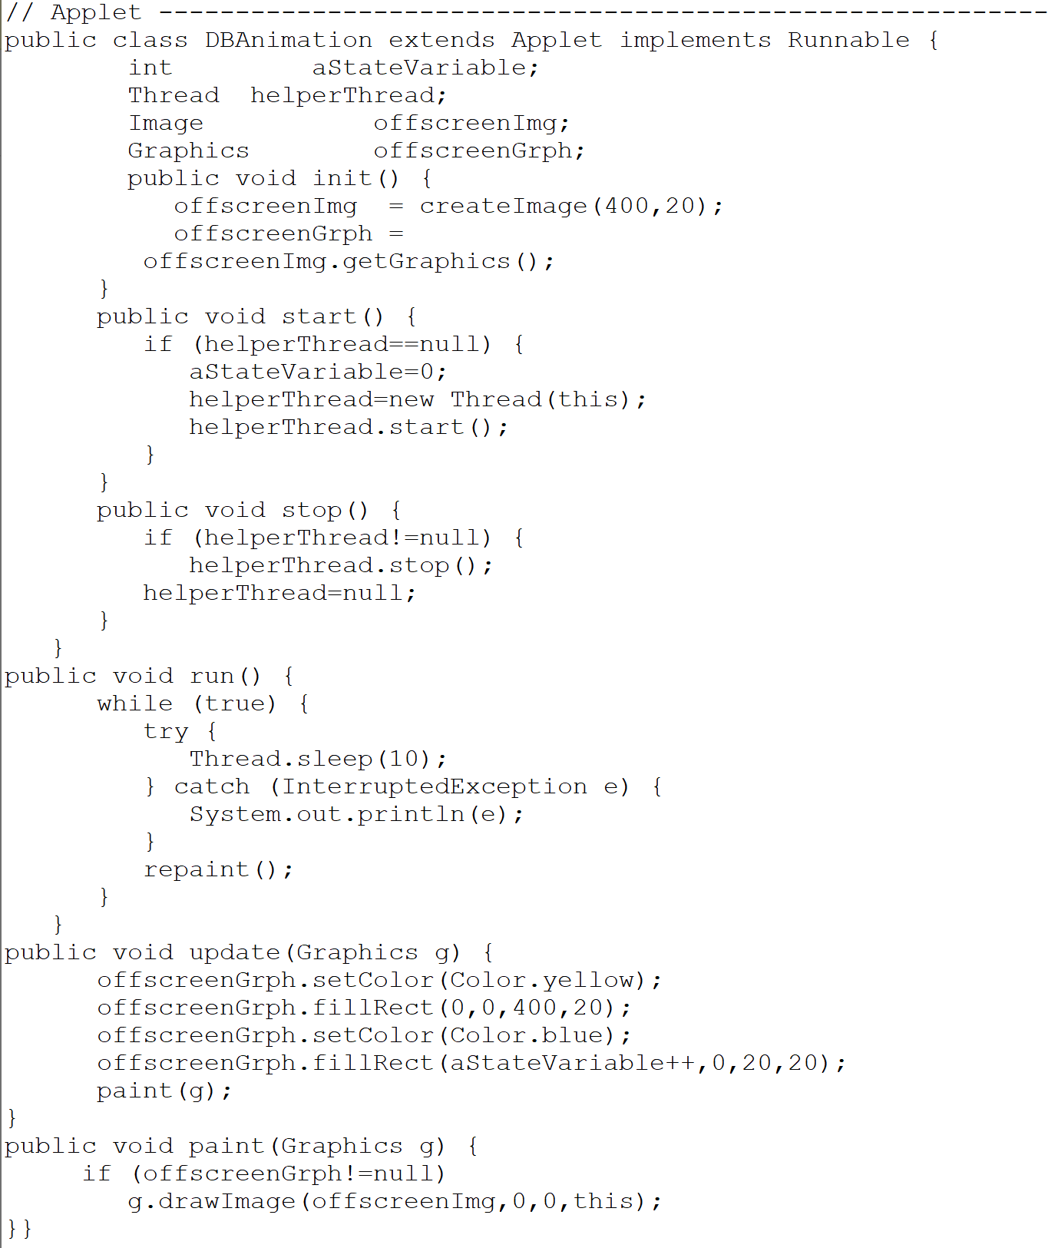

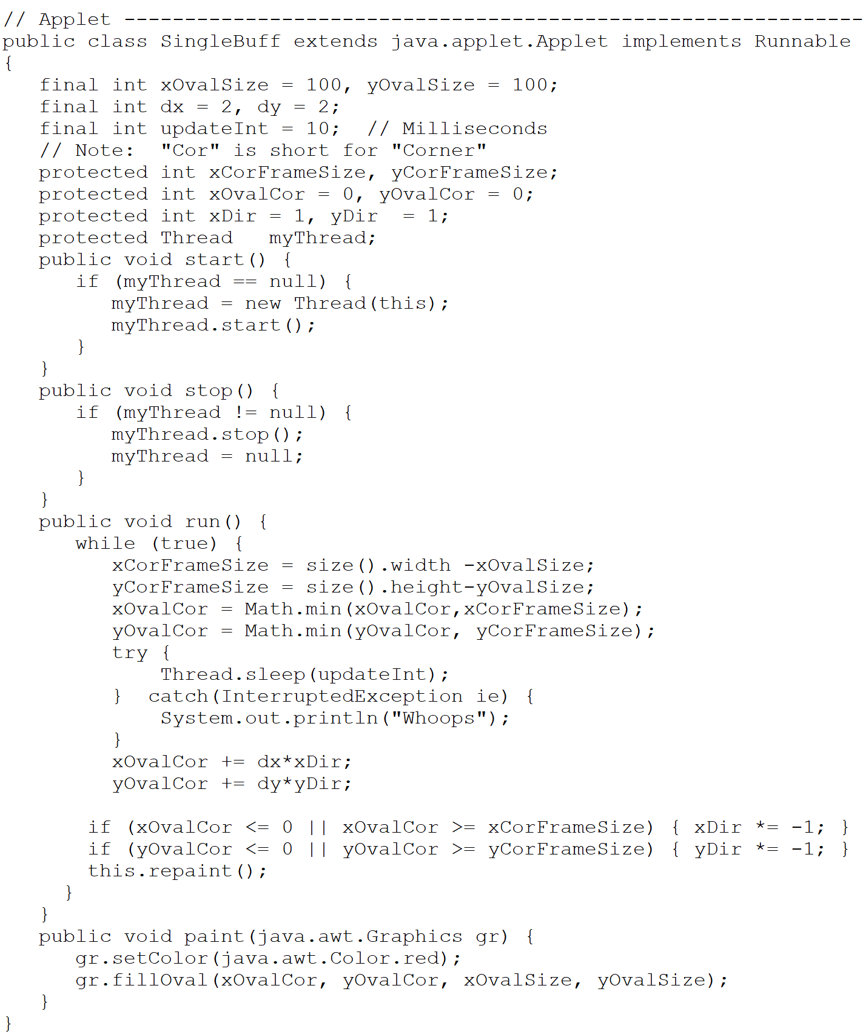

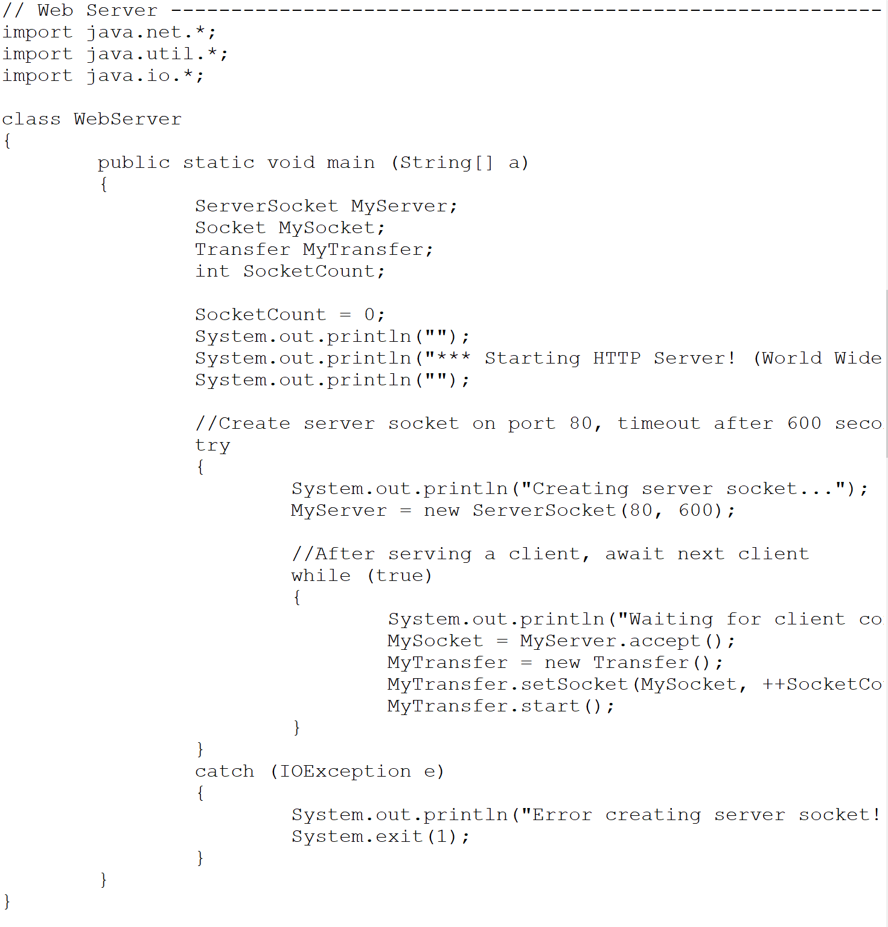

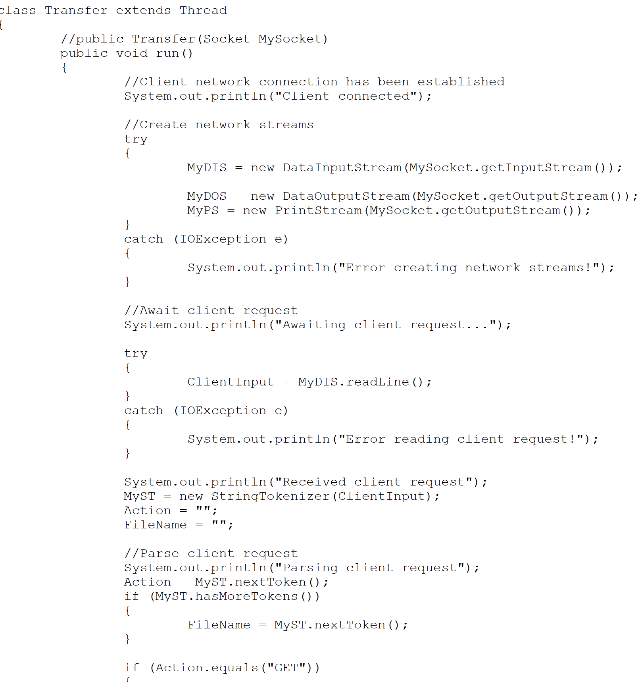

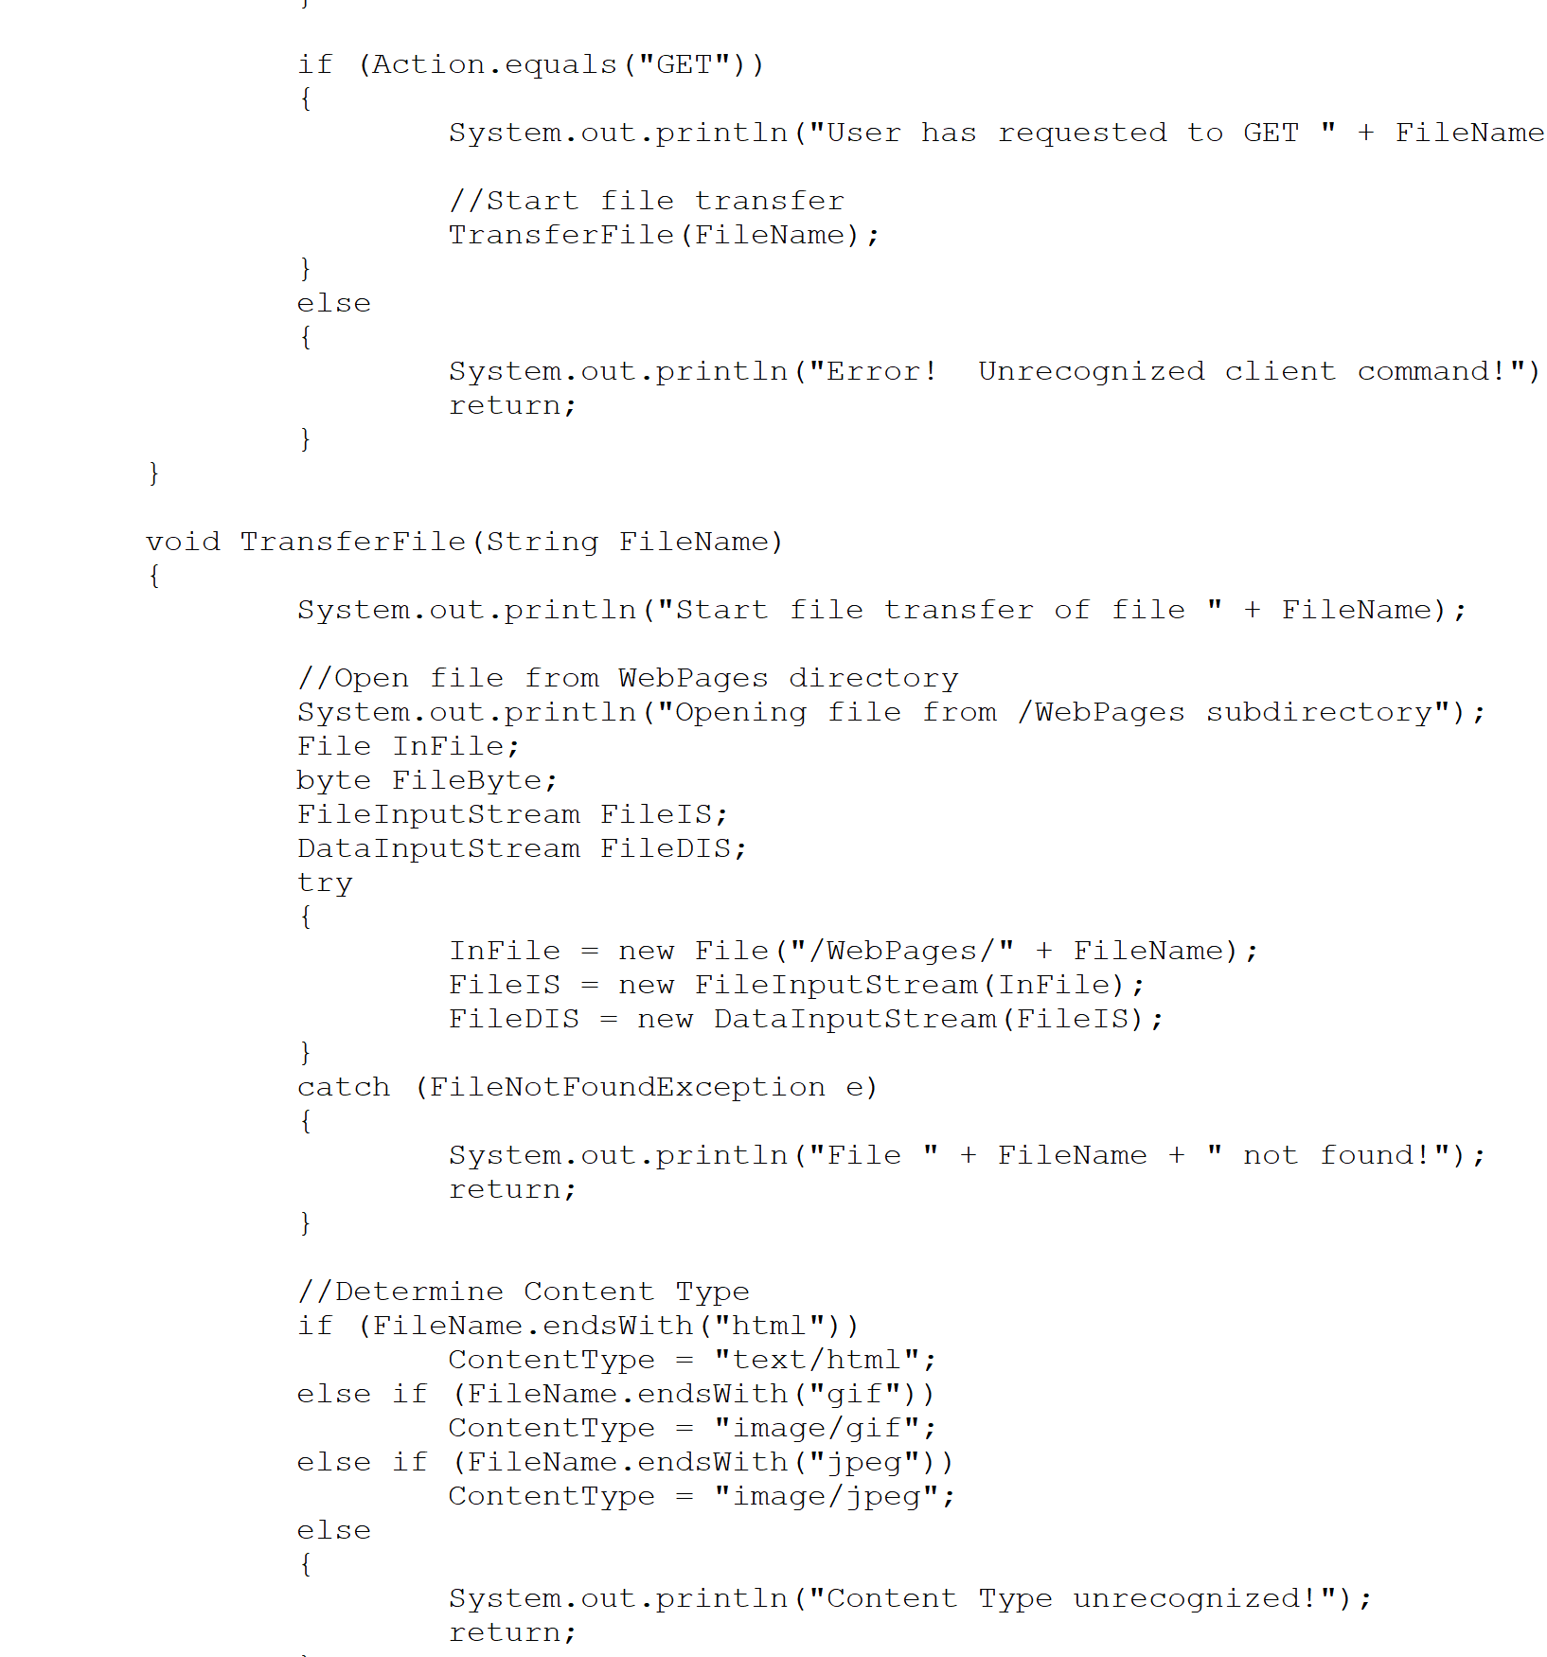

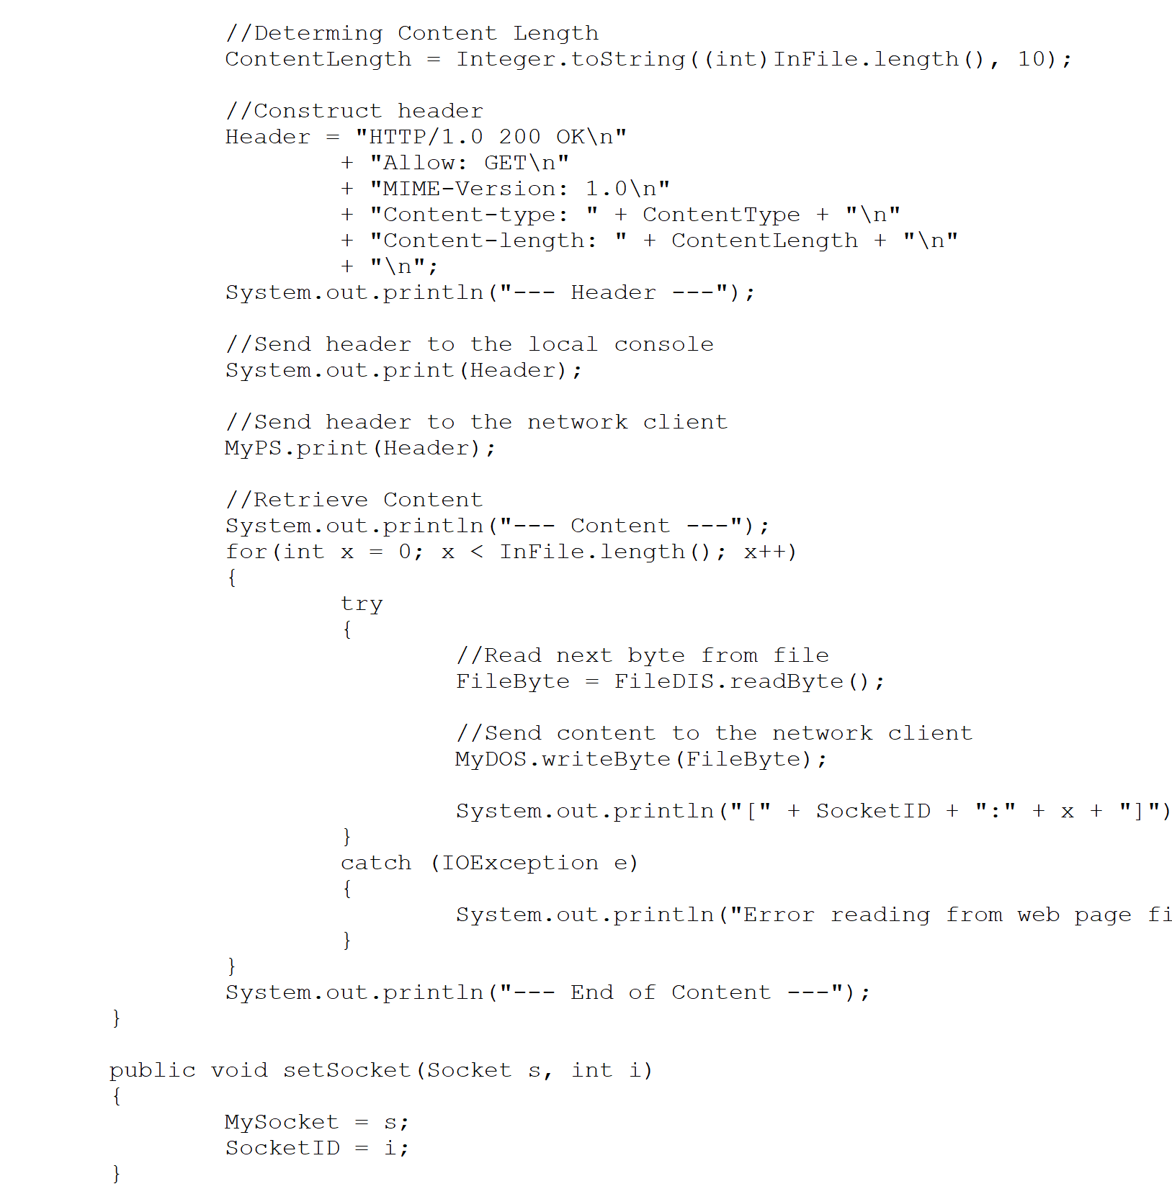

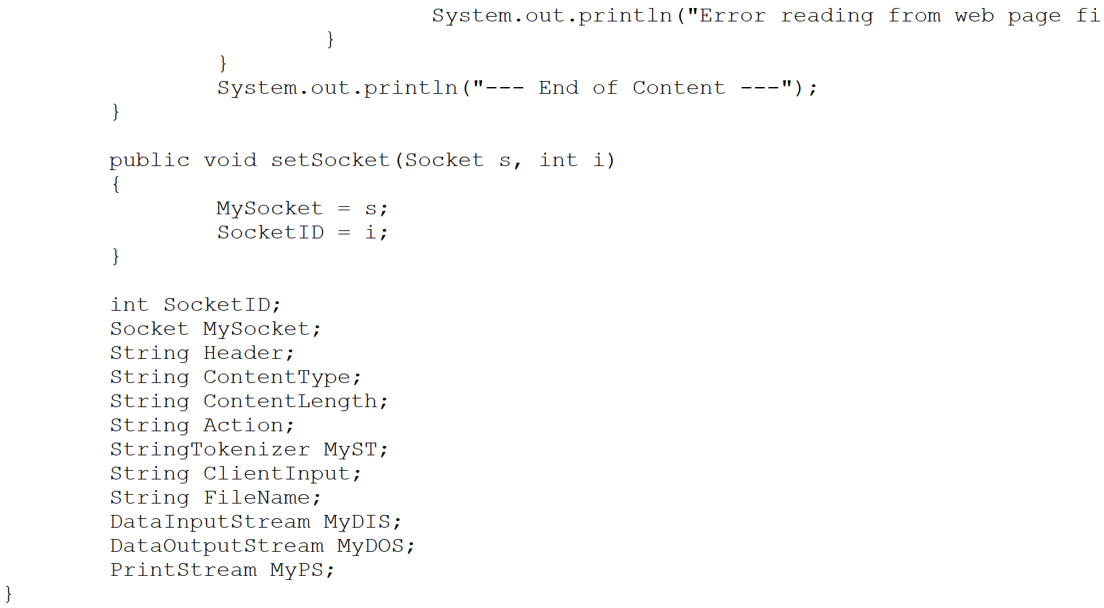

Result:

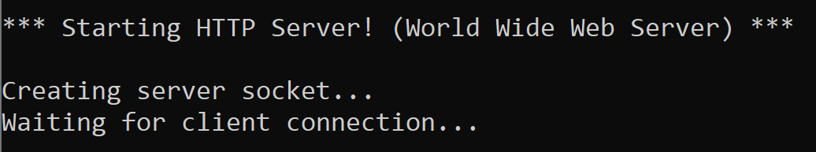

Work from [Microsoft PowerPoint - 725_07_Lect_01_Threads_shshsh.pptx (tfbor.com)](http://tfbor.com/02_725/06_a_MThreading_Polymorphism/725_06_Lecture_01_Threads_sh.pdf)

# 2) Question: Program at RT

## - What does program become at Run Time (RT)?

Answer) A computing process or simply a process.

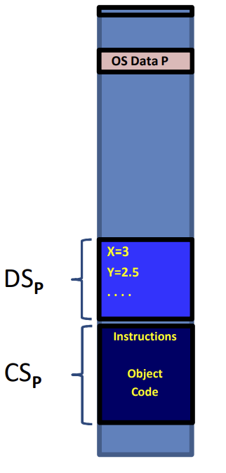

# 3) Question: Thread and thread’s RTS.

## - Why does each thread must have individual run time stack, RTST?

Answer)

• To be programmed as a modular program made up of functions (OOP methods).

• At run time, to call functions and return,

– Each call and return must be supported by an RTS which is used as a mail box between the thread’s internal functions.

# 4) Class Wrapping homework codes.

## File1.java

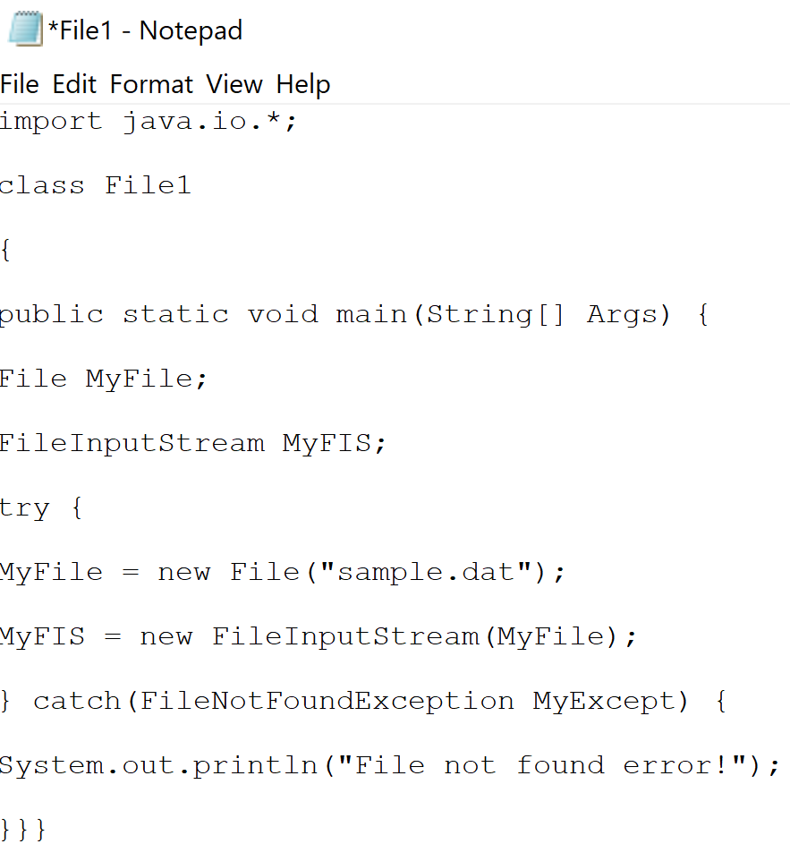

Result:

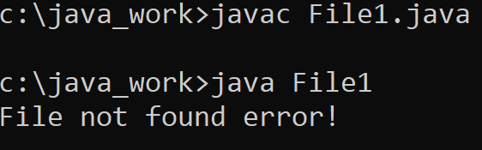

## 2) File2.java

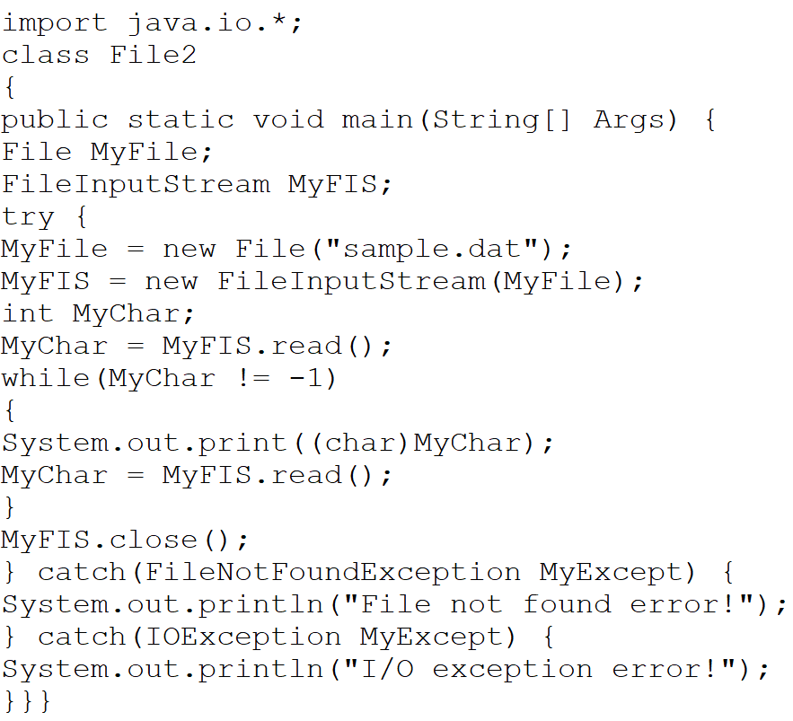

Result:

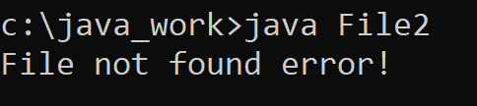

## 3) File3.java

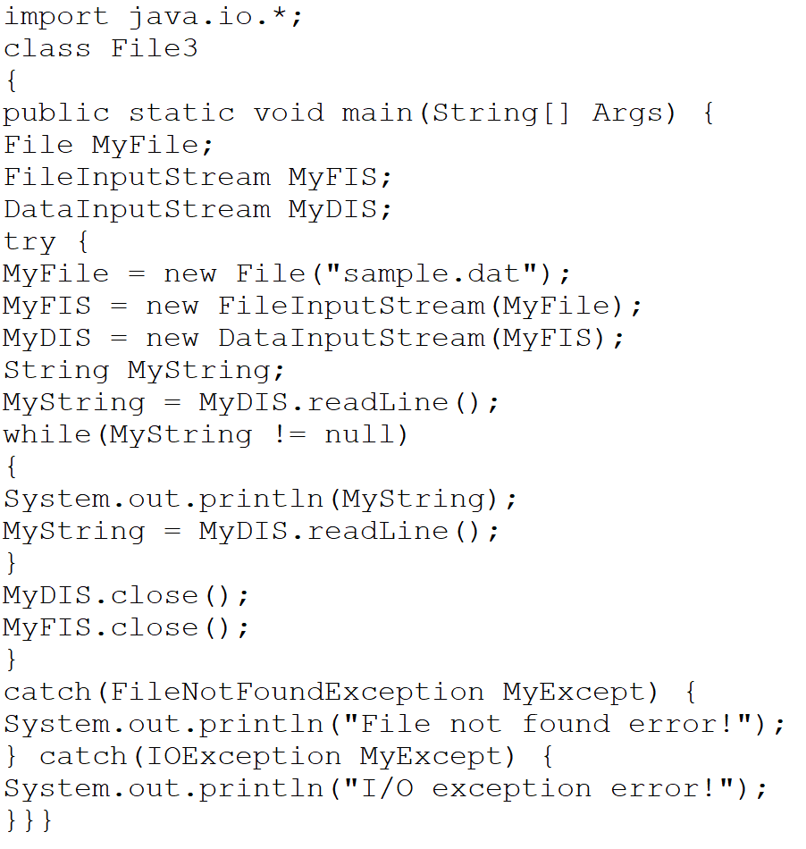

Result:

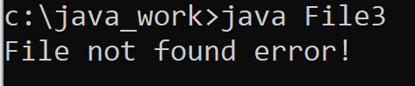

## 4) File4.java

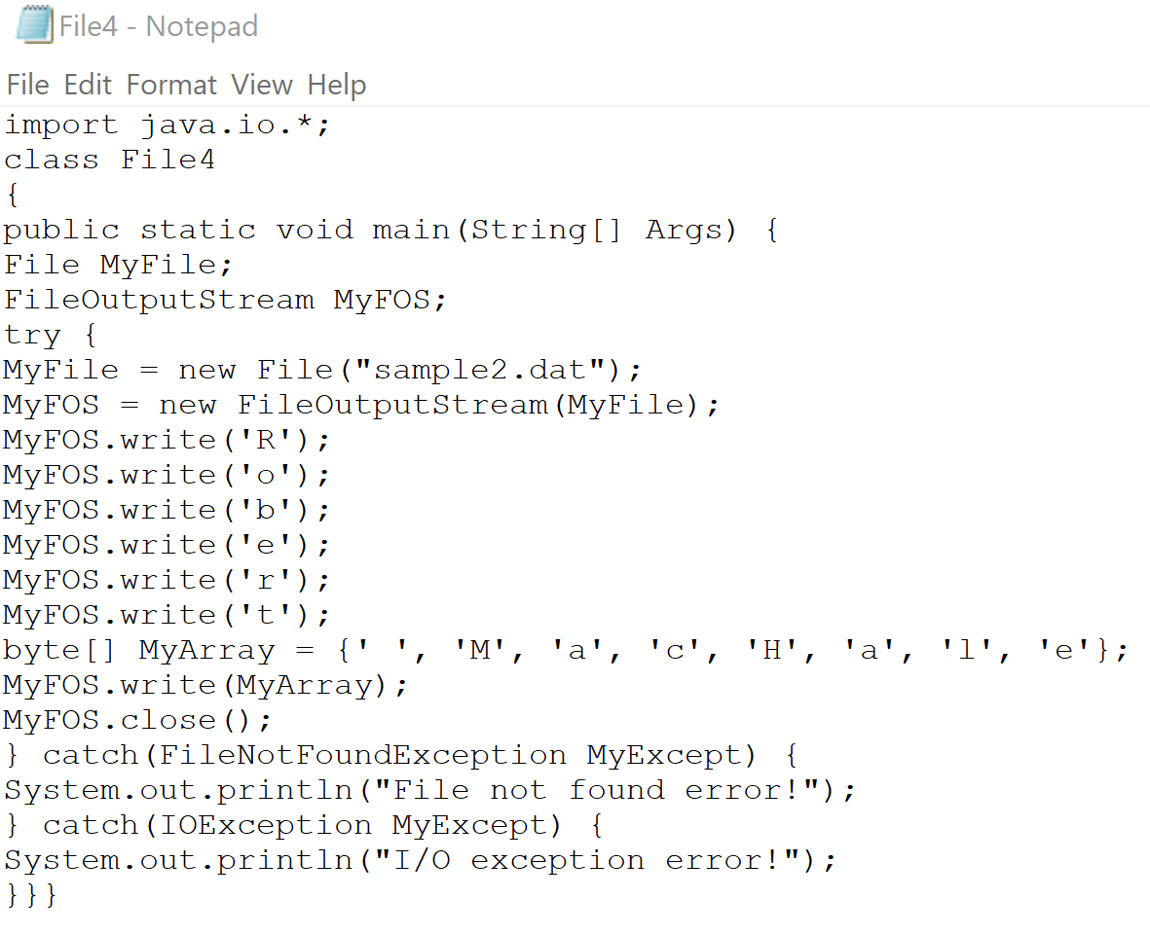

Result:

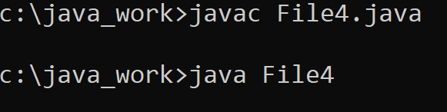

## 5) File5.java

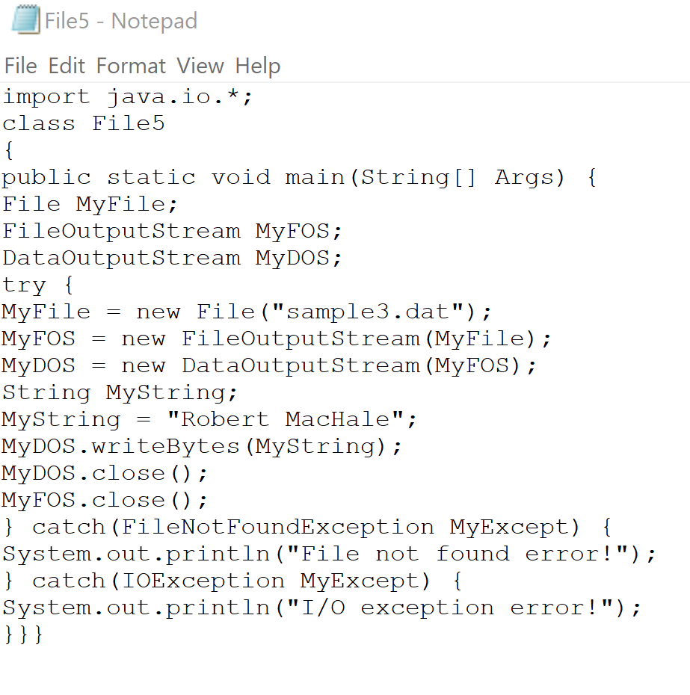

Result:

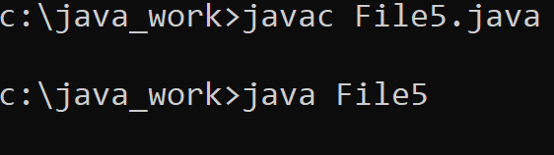

# References

[1] [Microsoft PowerPoint - 725_07_Lect_01_Threads_shshsh.pptx (tfbor.com)](http://tfbor.com/02_725/06_a_MThreading_Polymorphism/725_06_Lecture_01_Threads_sh.pdf)

[2] [725_06_Homework_01_FileIO.doc (live.com)](https://view.officeapps.live.com/op/view.aspx?src=http%3A%2F%2Ftfbor.com%2F02_725%2F06_b_IO_ClassWrapping_%2F725_06_Homework_01_FileIO.doc&wdOrigin=BROWSELINK)

[3] [Polymorphism (The Java™ Tutorials > Learning the Java Language > Interfaces and Inheritance) (oracle.com)](https://docs.oracle.com/javase/tutorial/java/IandI/polymorphism.html)