NYIT

**Fall 2021**

Homework No: 07

Title: IO Texts and Objects

**Name:** Patade, Yash Arun

**Class ID#:**  11

**School ID#:** 1284979

**Course:** Java Networking

**Course ID:** CSCI 725

**Date:** 10/11/2021

Assignment Contents

Work from: Microsoft PowerPoint - 725_07_Lecture_01_SystemIO_work.pptx (tfbor.com) 3

Example 1: 3

Example 2: 4

Work from: Microsoft PowerPoint - 725_07_Lecture_02_ObjectIO_sh.pptx (tfbor.com) 5

Example: Object Serialization. 5

Example: Serialize Demo. 6

References: 7

# Work from: [Microsoft PowerPoint - 725_07_Lecture_01_SystemIO_work.pptx (tfbor.com)](http://tfbor.com/02_725/07_a_IO_Text_/725_07_Lecture_01_SystemIO_.pdf)

# Example 1:

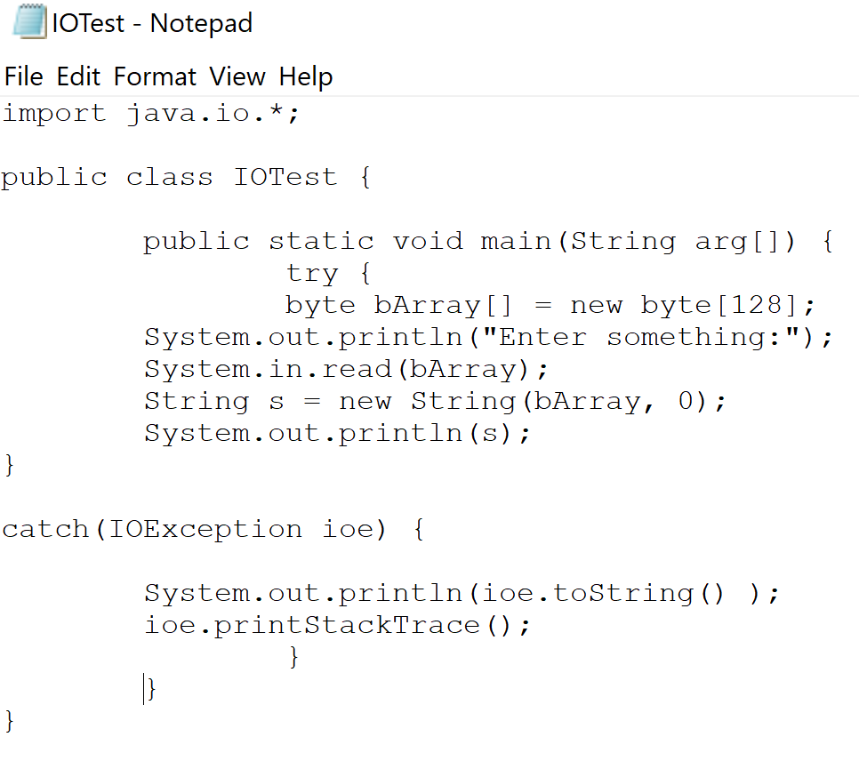

Result:

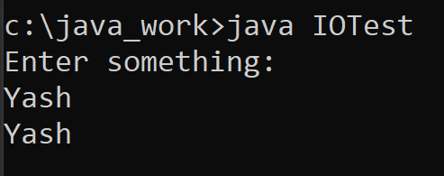

# Example 2:

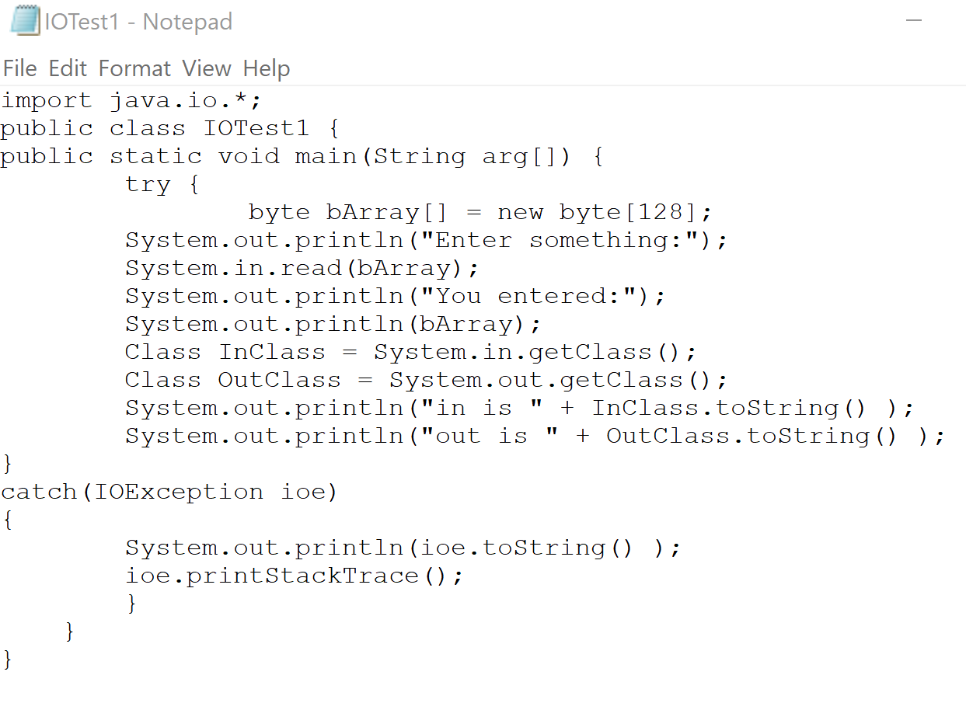

Result:

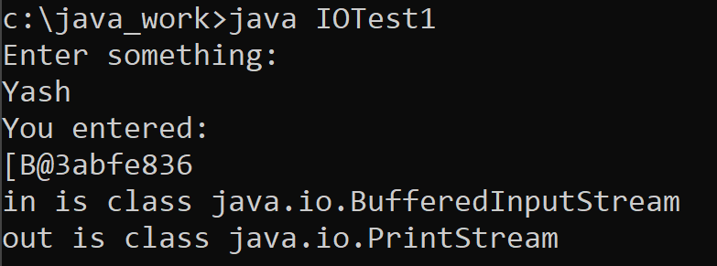

# Work from: [Microsoft PowerPoint - 725_07_Lecture_02_ObjectIO_sh.pptx (tfbor.com)](http://tfbor.com/02_725/07_b_IO_Objects/725_07_Lecture_02_ObjectIO_sh.pdf)

# Example: Object Serialization.

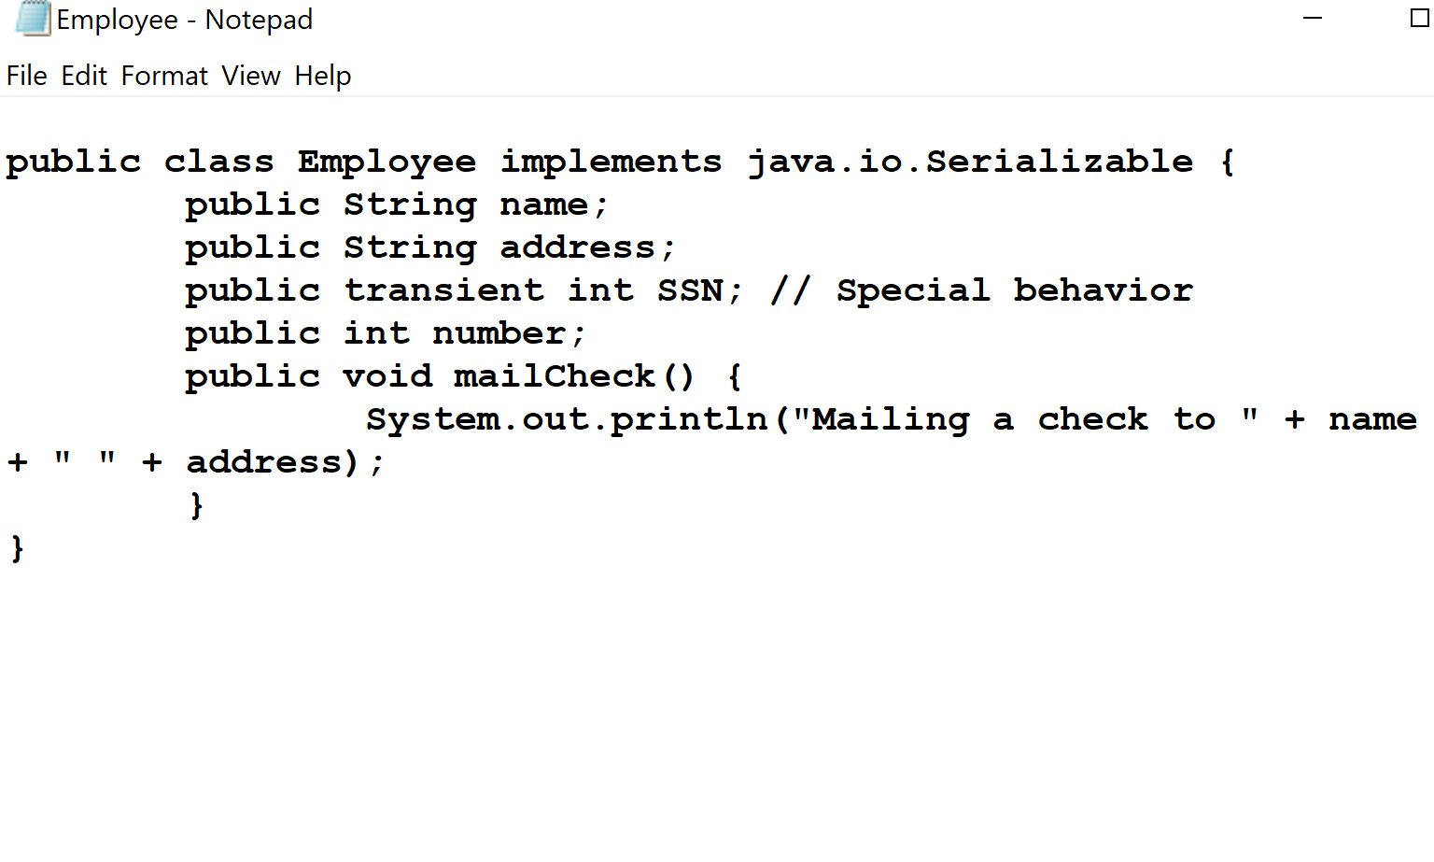

# Example: Serialize Demo.

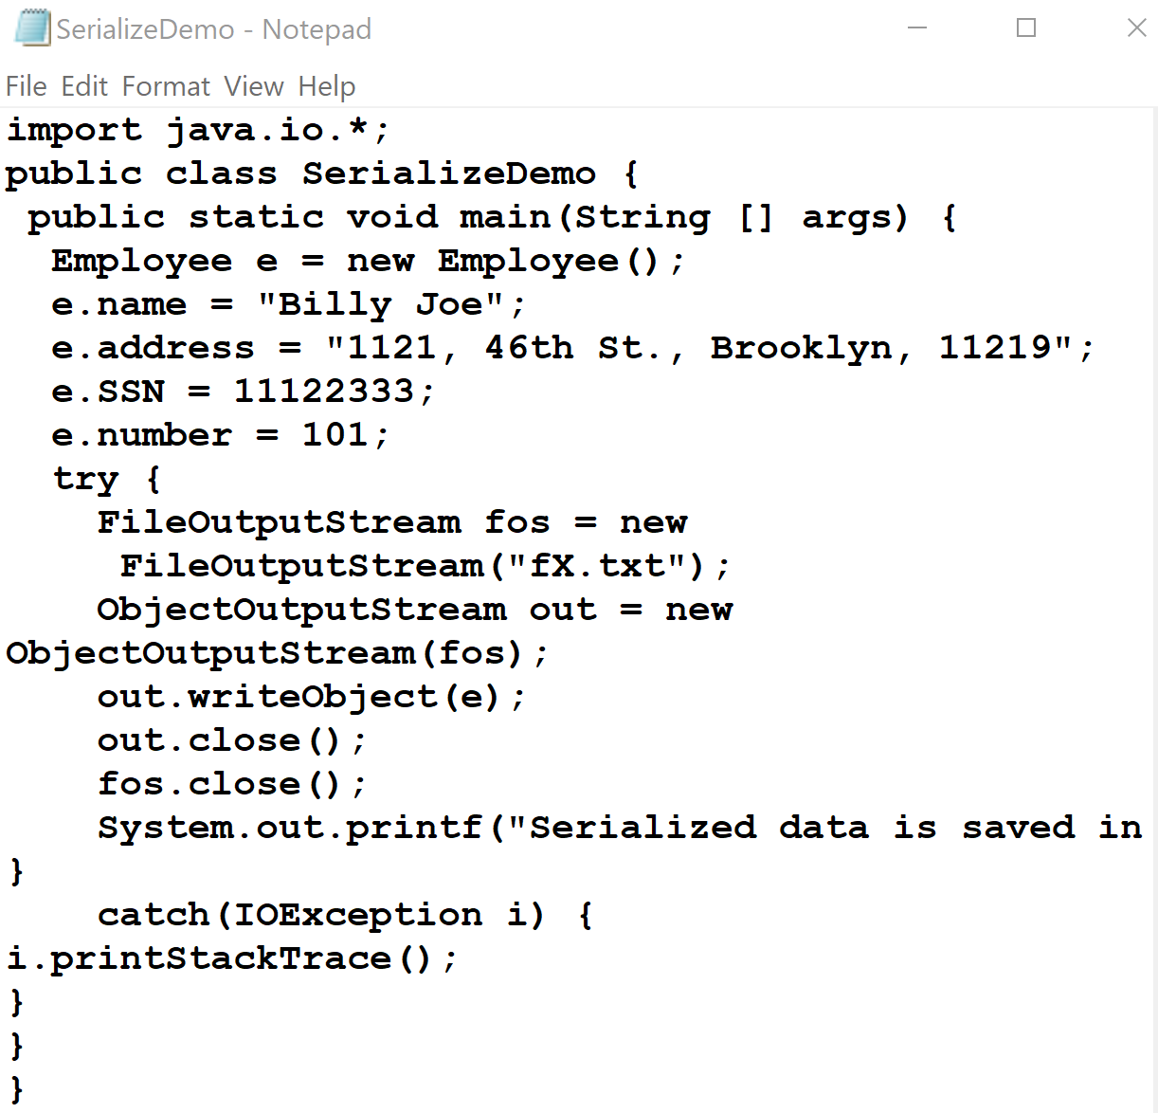

Result:

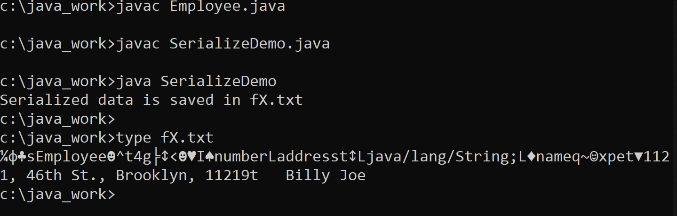

# References:

[1] [Microsoft PowerPoint - 725_07_Lecture_01_SystemIO_work.pptx (tfbor.com)](http://tfbor.com/02_725/07_a_IO_Text_/725_07_Lecture_01_SystemIO_.pdf)

[2] [Microsoft PowerPoint - 725_07_Lecture_02_ObjectIO_sh.pptx (tfbor.com)](http://tfbor.com/02_725/07_b_IO_Objects/725_07_Lecture_02_ObjectIO_sh.pdf)

[3] [Serialization and Deserialization in Java with Example - GeeksforGeeks](https://www.geeksforgeeks.org/serialization-in-java/)