NYIT

**Fall 2021**

Homework No: 08

Title: InetAddress and IO TCP/IP

**Name:** Patade, Yash Arun

**Class ID#:**  11

**School ID#:** 1284979

**Course:** Java Networking

**Course ID:** CSCI 725

**Date:** 14/11/2021

Assignment Contents

Work from: 725_08_Lecture_03_a_Sockets_sh.pptx (live.com) 4

1) TCP Client: 4

2) TCP Server: 4

Work from: 725_08_Lecture_04_b_NetContext_SA____.pptx (live.com) 5

Windows: %windir%\System32\drivers\etc\services 5

3) Port 25 = SMTP 5

4) Port 80 = HTTP 6

5) Port 110 = POP3 6

6) Port 1723 = PPTP 7

Work from: 725_08_Lecture_05_a_NetContext_SA____.pptx (live.com) 8

7) TCP/IP Configuration Parameters. 8

8) Basic TCP/IP Configuration Parameters. 8

9) Using arp command. 9

10) Local Router IP Number. 9

**ipconfig | findstr /i "Gateway"** 9

11) **/etc/services** file. 10

12) **/etc/protocol** file. 11

Work from: Client/server computing (tfbor.com) 12

13) Client Program. 12

14) Server Program. 13

15) What does IP address identify precisely? 14

16) InetAddressA Class. 14

17) DNSLookup Class. 15

Work from: Microsoft PowerPoint - 725_08_Lecture_02_OS_DNS_shsh______.pptx (tfbor.com) 16

18) What are the specific domain length naming restrictions? 16

19) What is the difference between the fully qualified name of a domain (FQDN) and the relative domain name (RDN)? 16

20) Name servers: 16

21) UDPClient.java Class. 17

22) UDPServer.java Class. 18

References 19

# Work from: [725_08_Lecture_03_a_Sockets_sh.pptx (live.com)](https://view.officeapps.live.com/op/view.aspx?src=http%3A%2F%2Ftfbor.com%2F02_725%2F08_c_IO_TCPip%2F725_08_Lecture_03_a_Sockets_sh.pptx&wdOrigin=BROWSELINK)

# 1) TCP Client:

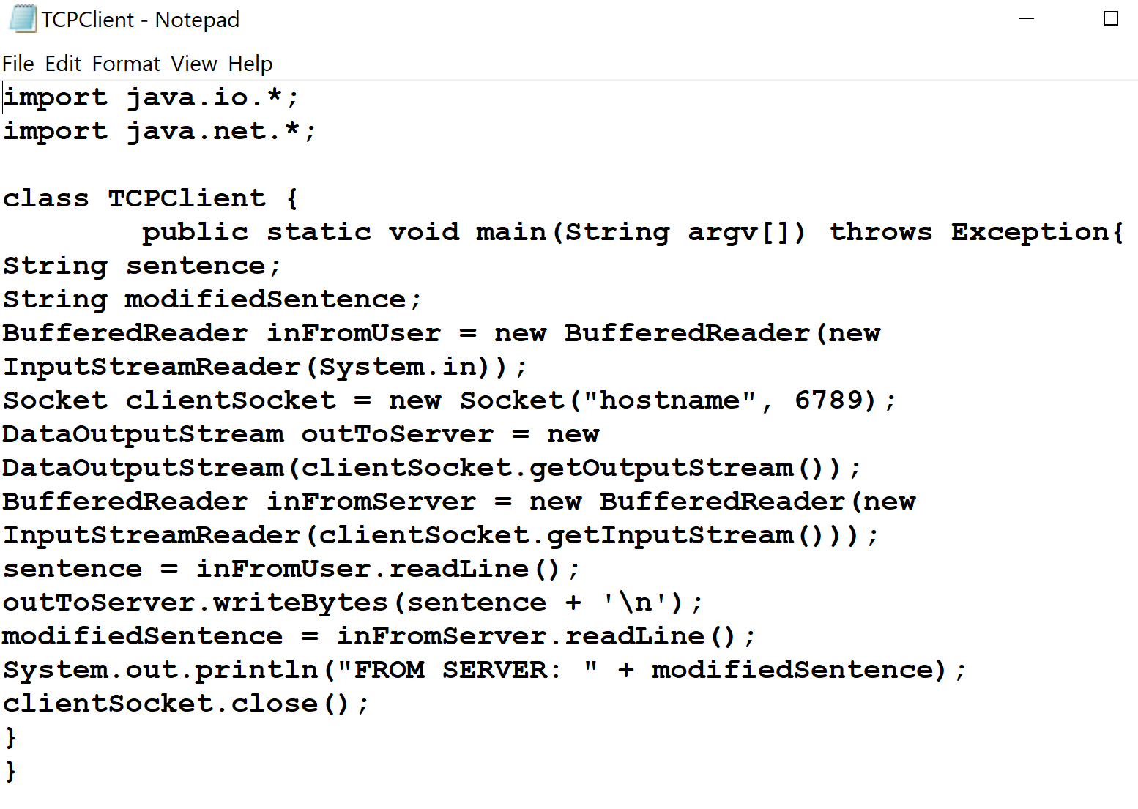

# 2) TCP Server:

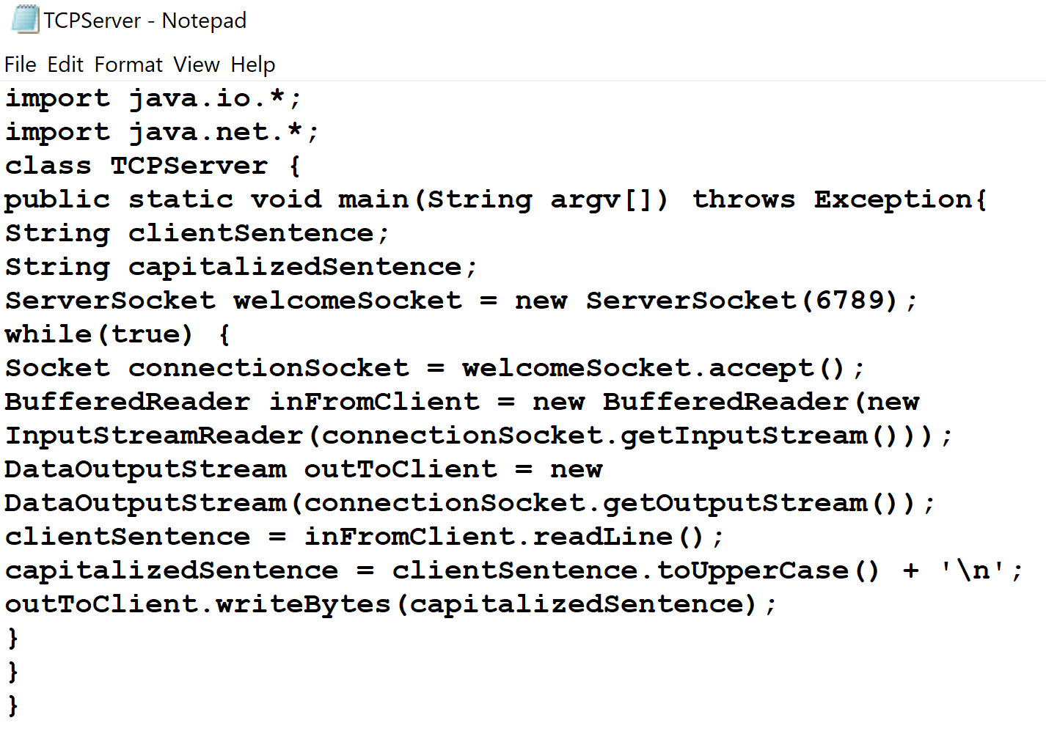

Result:

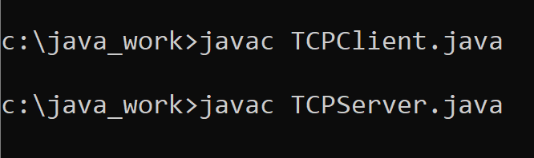

# Work from: [725_08_Lecture_04_b_NetContext_SA____.pptx (live.com)](https://view.officeapps.live.com/op/view.aspx?src=http%3A%2F%2Ftfbor.com%2F02_725%2F08_c_IO_TCPip%2F725_08_Lecture_04_b_NetContext_SA____.pptx&wdOrigin=BROWSELINK)

## Windows: %windir%\System32\drivers\etc\services

# 3) Port 25 = SMTP

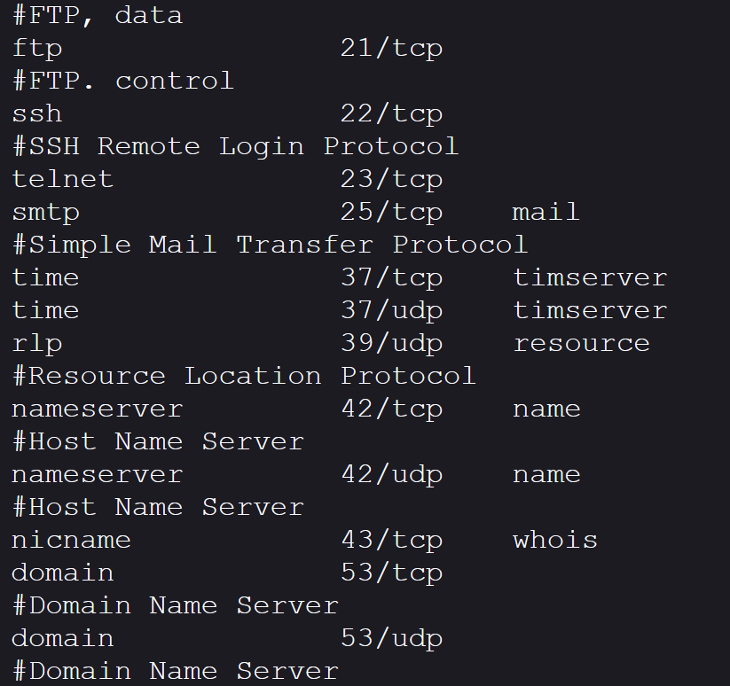

# 4) Port 80 = HTTP

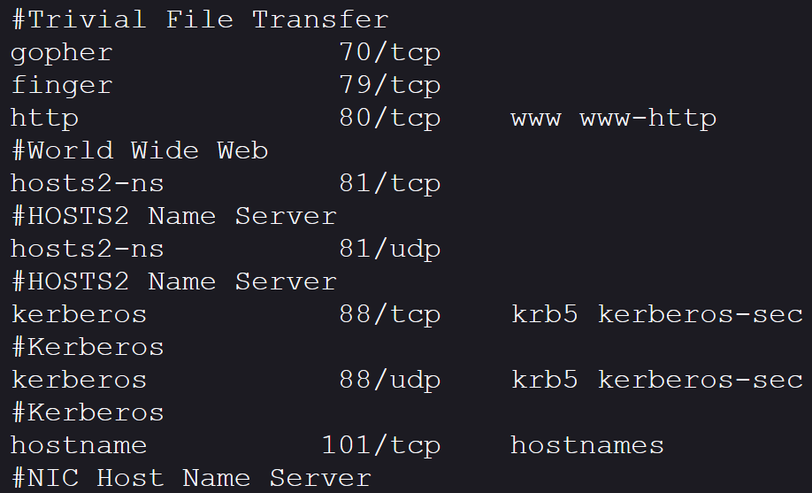

# 5) Port 110 = POP3

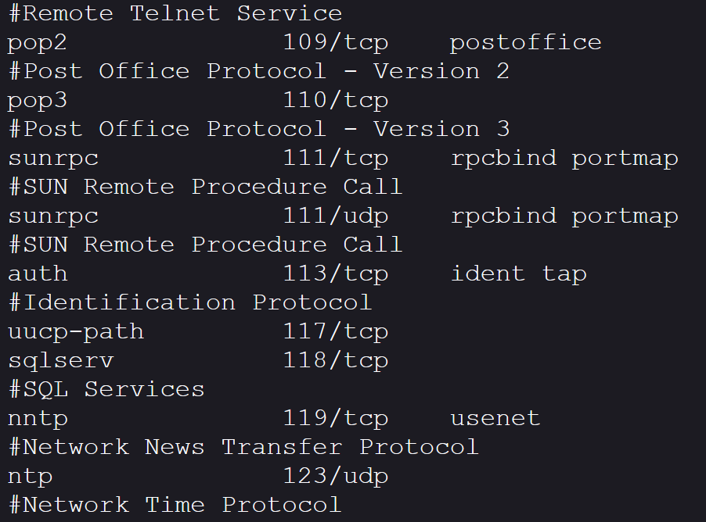

# 6) Port 1723 = PPTP

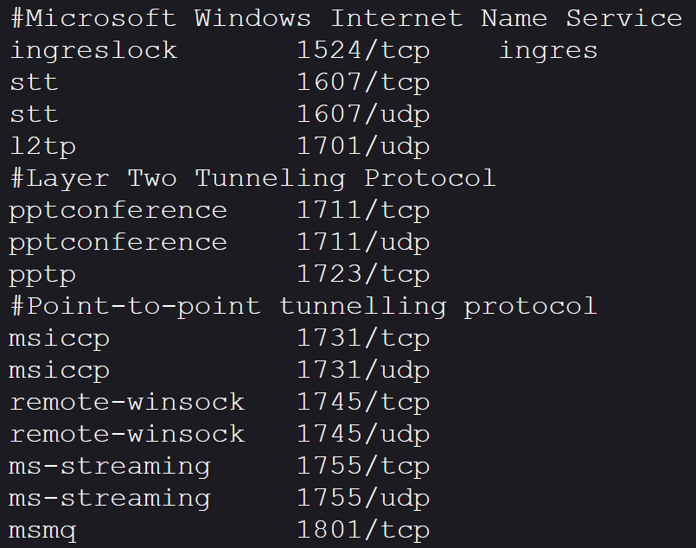

# Work from: [725_08_Lecture_05_a_NetContext_SA____.pptx (live.com)](https://view.officeapps.live.com/op/view.aspx?src=http%3A%2F%2Ftfbor.com%2F02_725%2F08_c_IO_TCPip%2F725_08_Lecture_05_a_NetContext_SA____.pptx&wdOrigin=BROWSELINK)

# 7) TCP/IP Configuration Parameters.

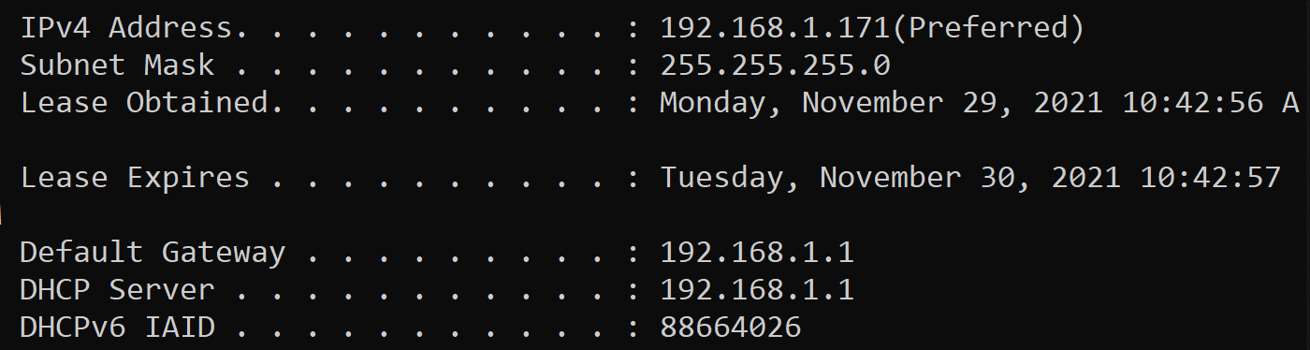

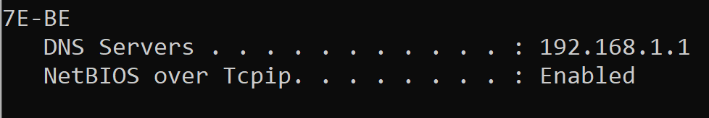

# 8) Basic TCP/IP Configuration Parameters.

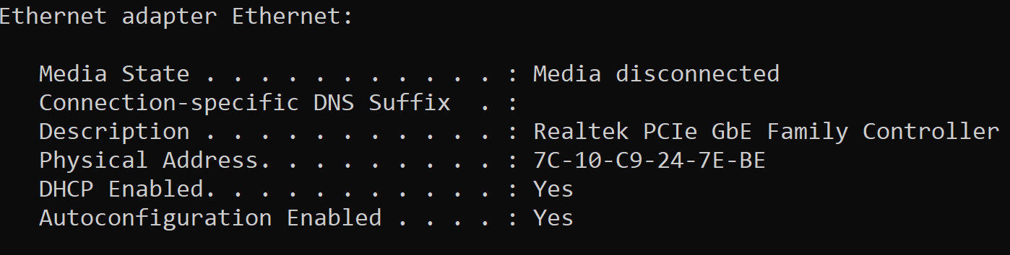

# 9) Using arp command.

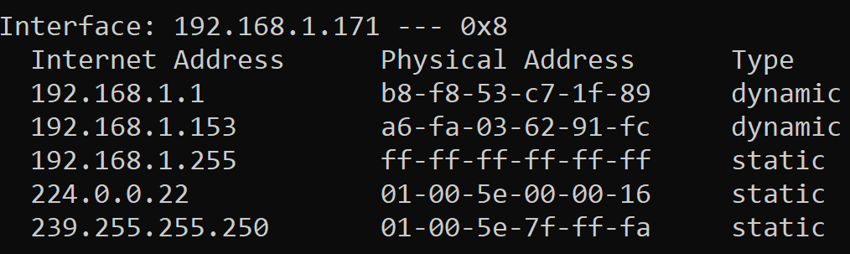

# 10) Local Router IP Number.

## **ipconfig | findstr /i "Gateway"**

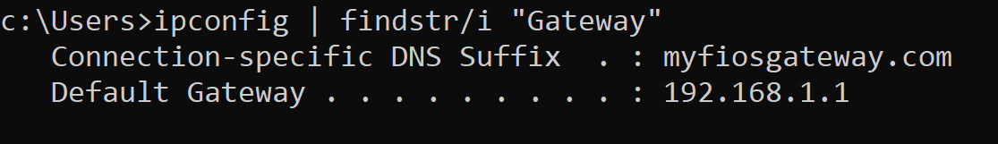

# 11) **/etc/services** file.

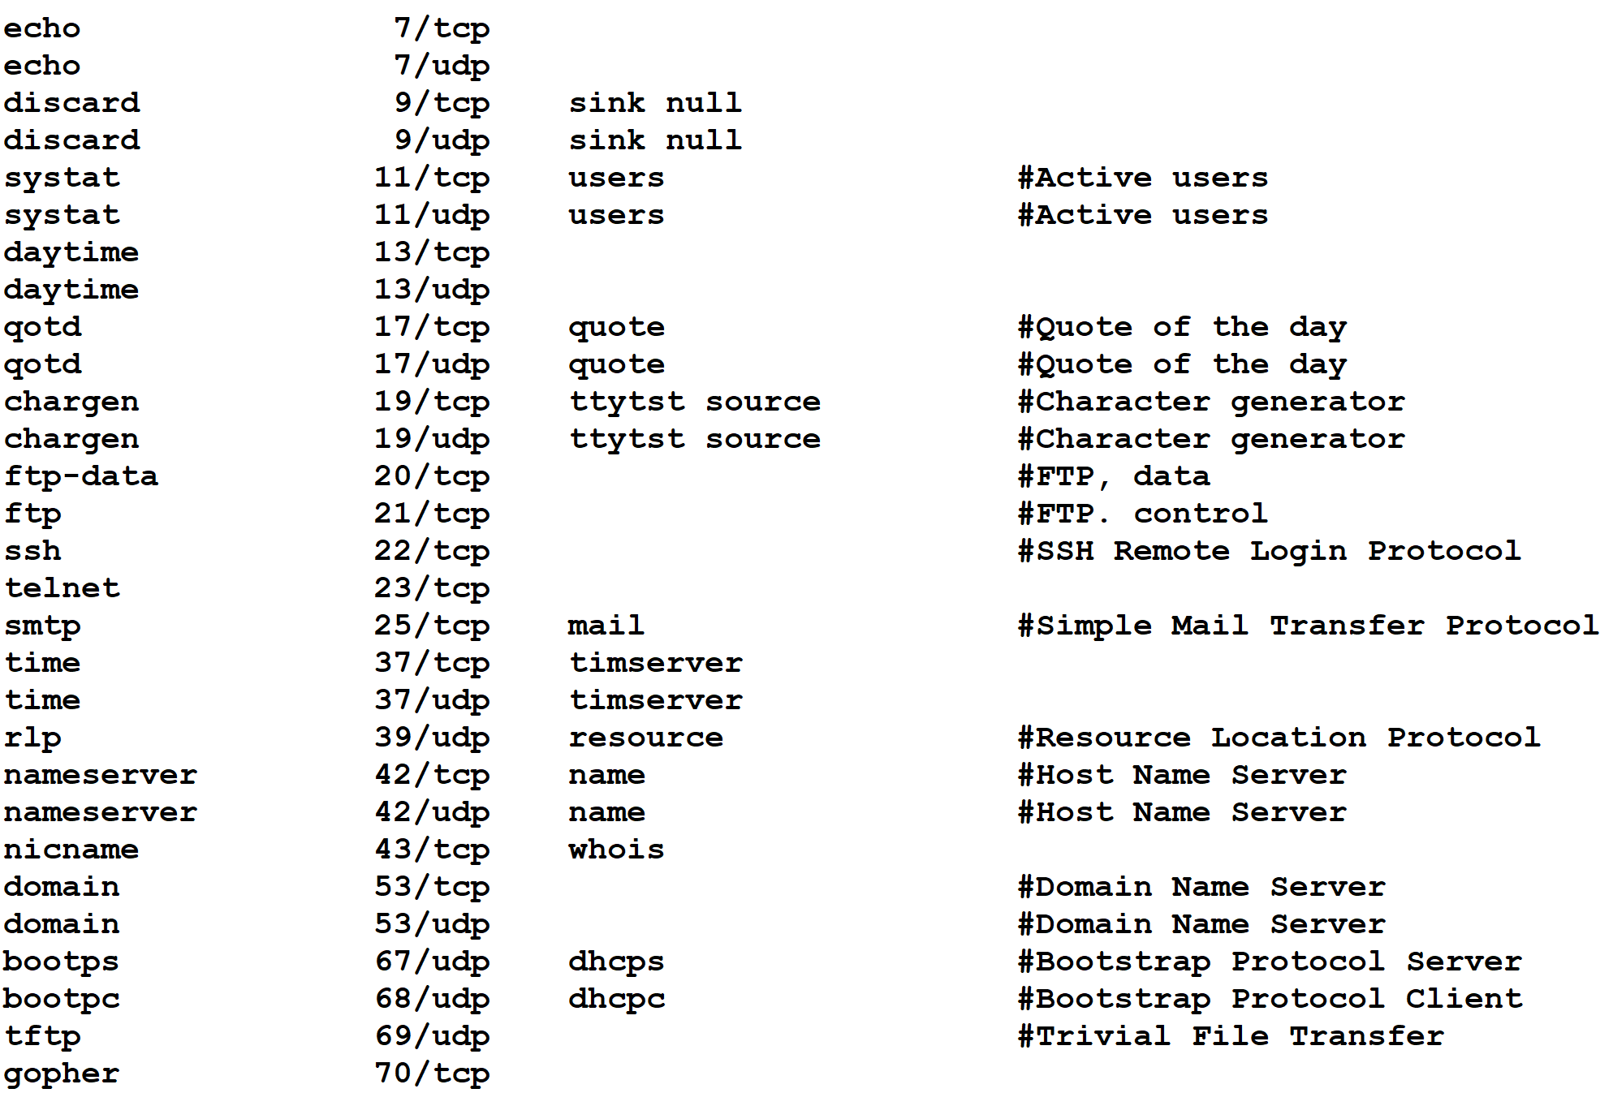

# 12) **/etc/protocol** file.

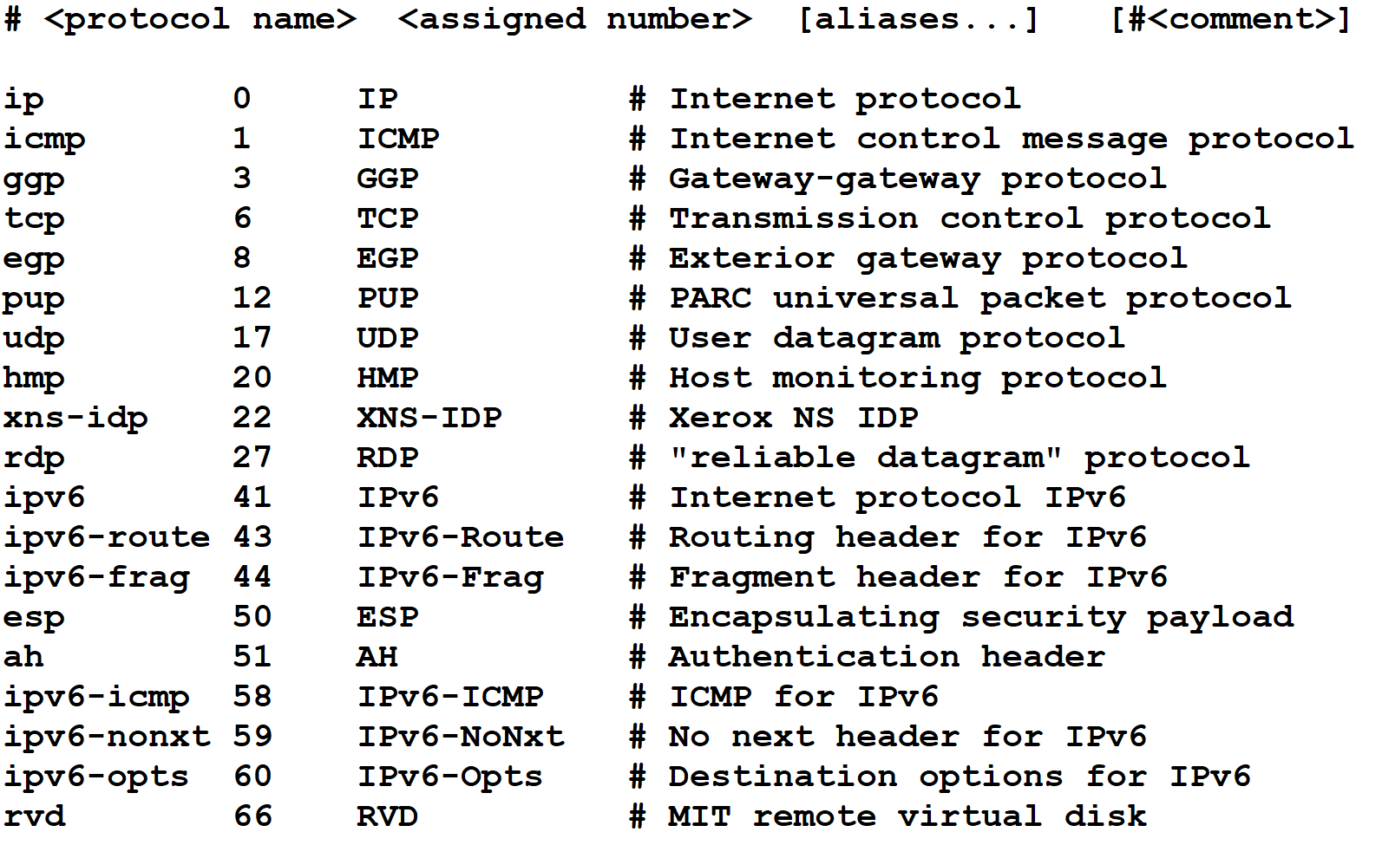

# Work from: [Client/server computing (tfbor.com)](http://tfbor.com/02_725/08_c_IO_TCPip/725_08_Text_02_Homework_ClientServer.pdf)

# 13) Client Program.

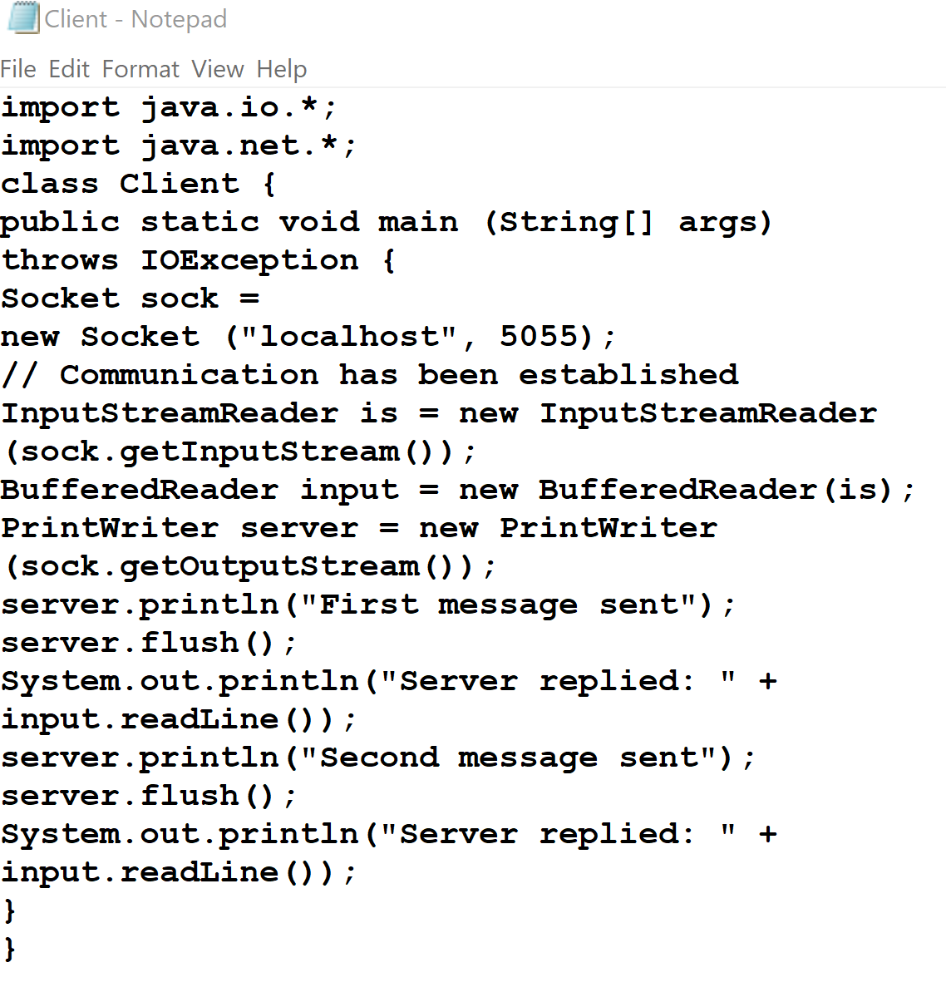

# 14) Server Program.

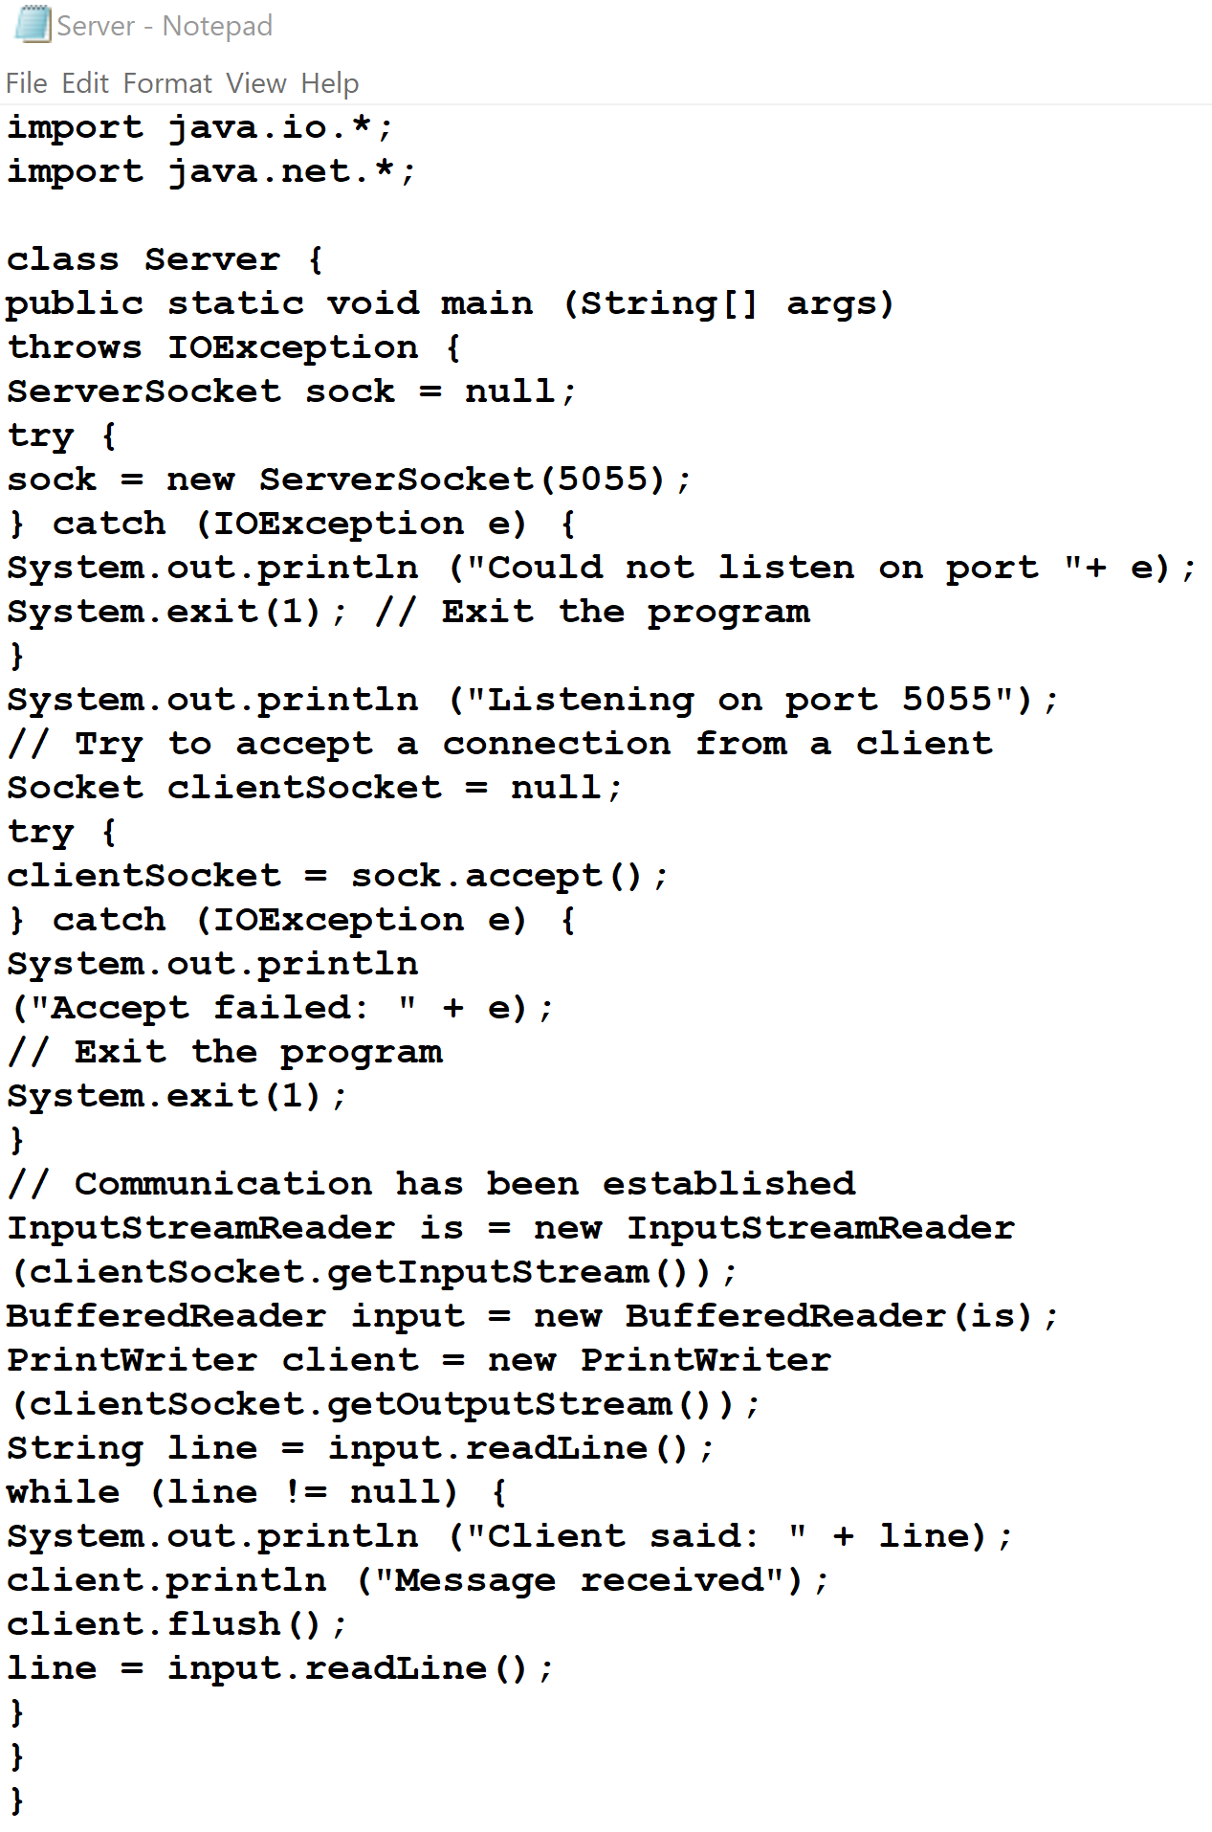

Result:

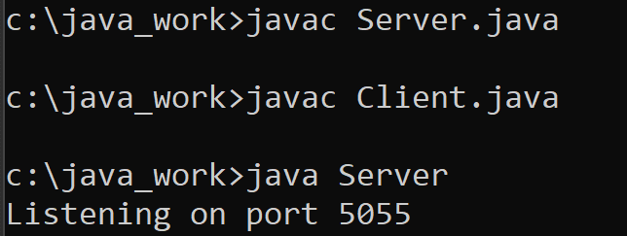

Work from: [Microsoft PowerPoint - 725_08_Lecture_02_InetAddress_Examples________.pptx (tfbor.com)](http://tfbor.com/02_725/08_InetAddress/725_08_Lecture_02_InetAddress_Examples________.pdf)

# 15) What does IP address identify precisely?

Ans) Operating system providing IP kernel service.

# 16) InetAddressA Class.

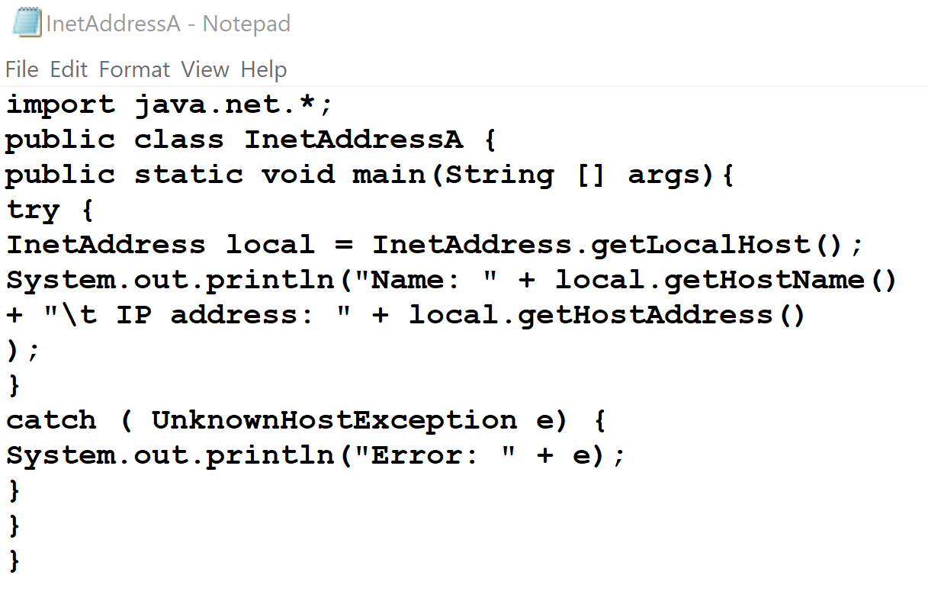

Result:

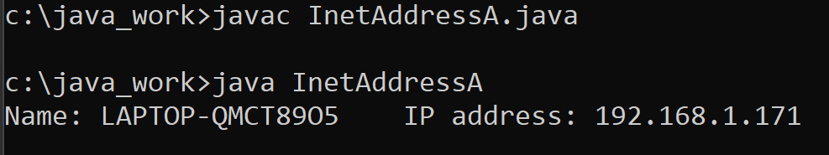

# 17) DNSLookup Class.

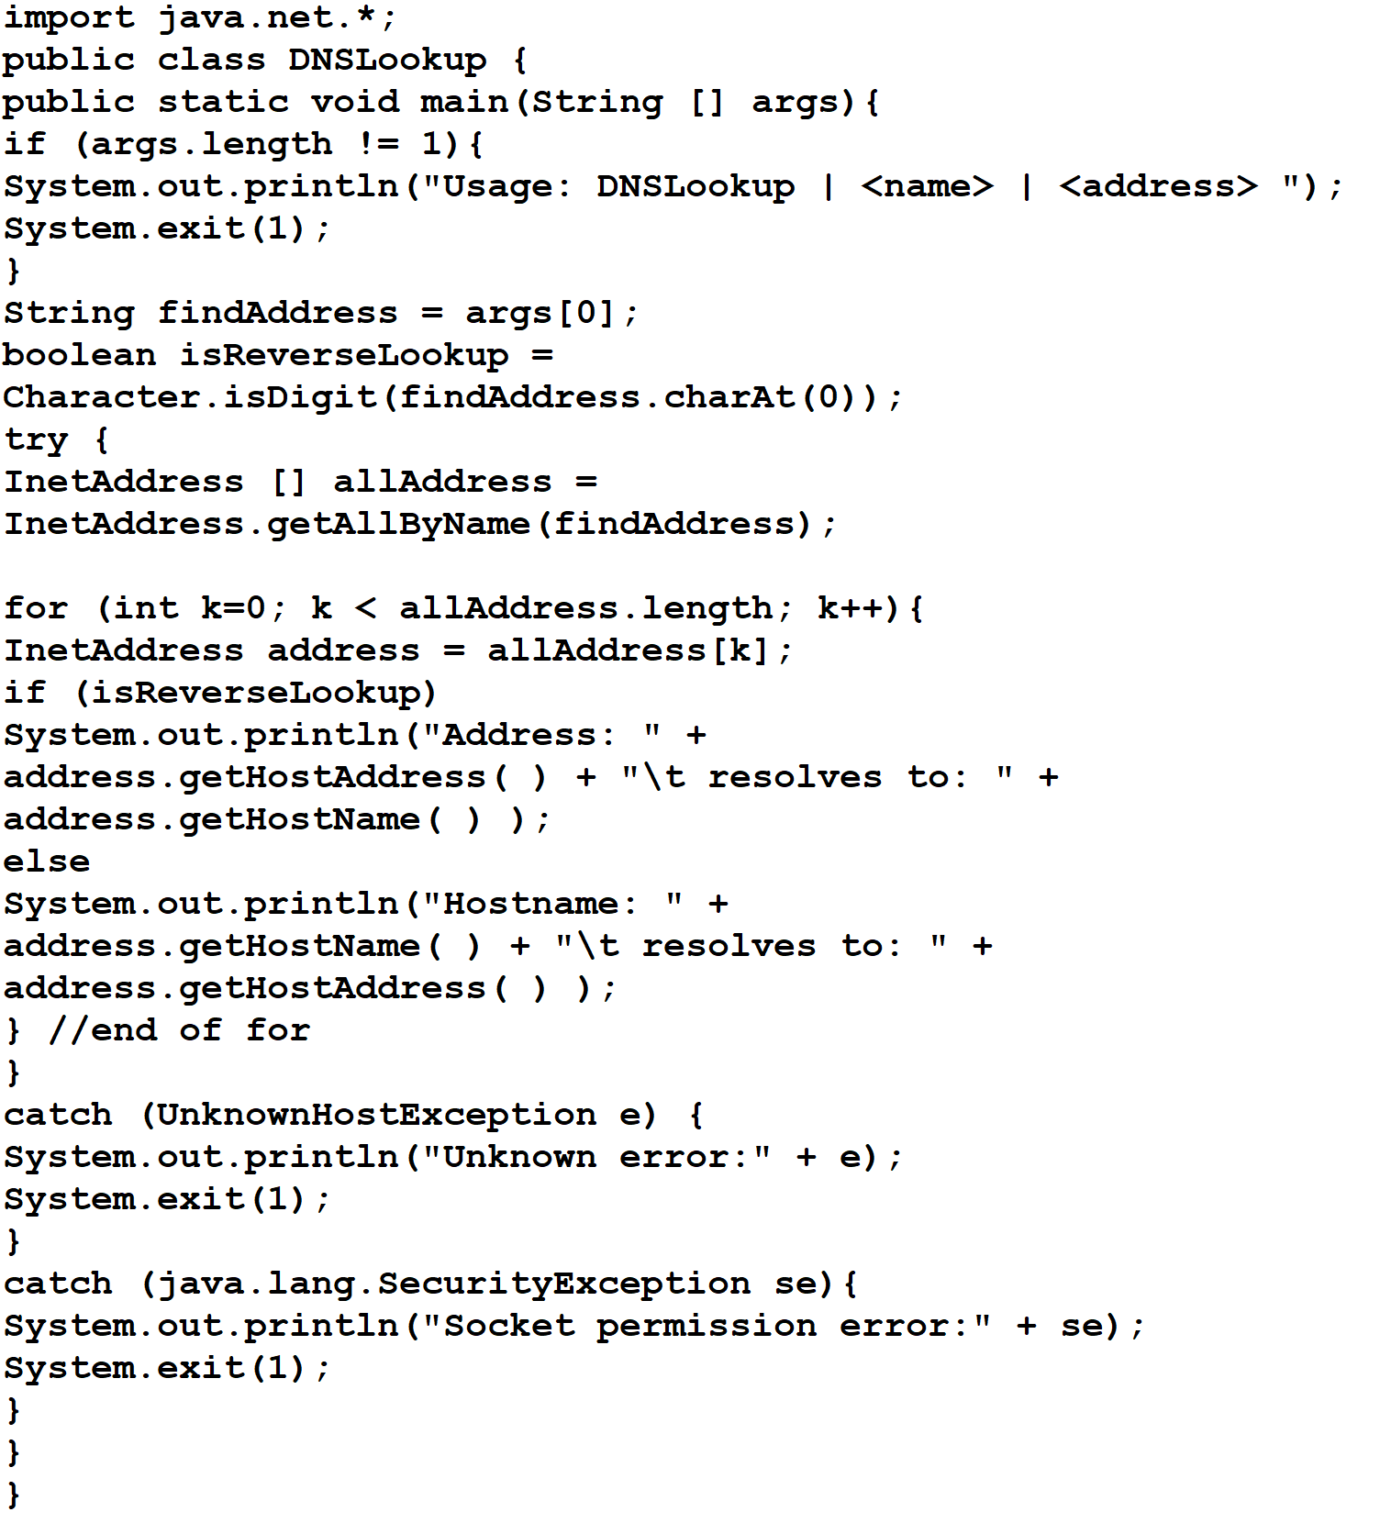

Result:

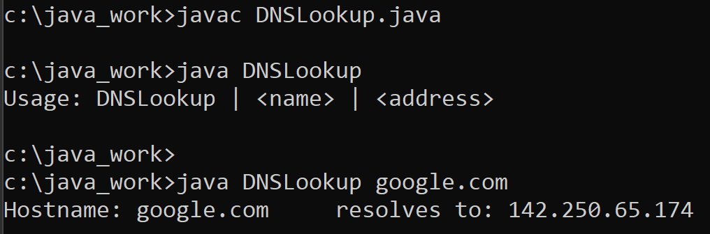

# Work from: [Microsoft PowerPoint - 725_08_Lecture_02_OS_DNS_shsh______.pptx (tfbor.com)](http://tfbor.com/02_725/08_InetAddress/725_08_Lecture_02_OS_DNS_.pdf)

# 18) What are the specific domain length naming restrictions?

Answer)

* There is a 255-character limit (including the dots) per FQDN.
* There is a 63 character limit per domain label.
* Names should only contain alphas, numerics, and the dash.

# 19) What is the difference between the fully qualified name of a domain (FQDN) and the relative domain name (RDN)?

Answer)

The fully qualified name of a domain is specified by appending all names from the leaf node up to the root of the name tree using a dot as the separator and including a trailing dot. Relative domain names do not end in a dot.

# 20) Name servers:

* Solve network reliability problems.
* Make applications distributed.
* **Enable faster programming and execution of distributed operations.**

Work from: [Microsoft PowerPoint - 725_08_Lecture_04_JavaUDP_v1_sh________.pptx (tfbor.com)](http://tfbor.com/02_725/08_InetAddress/725_08_Lecture_04_JavaUDP_v1________.pdf)

# 21) UDPClient.java Class.

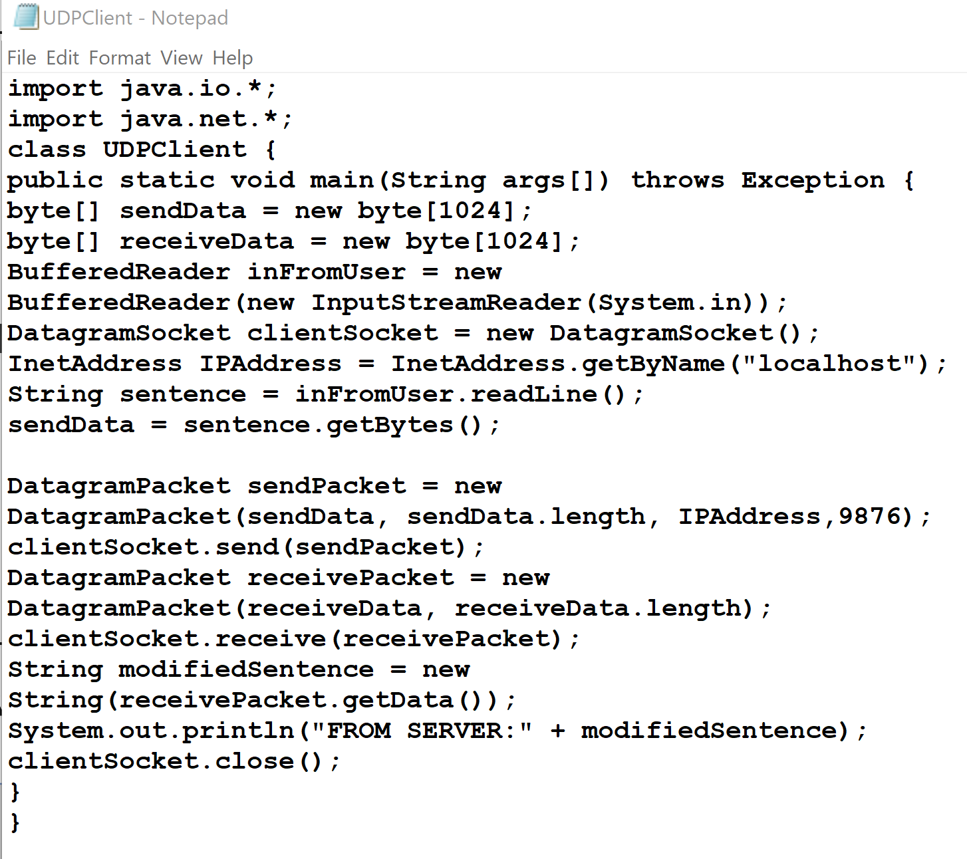

Result:

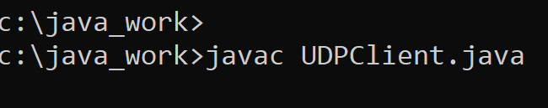

# 22) UDPServer.java Class.

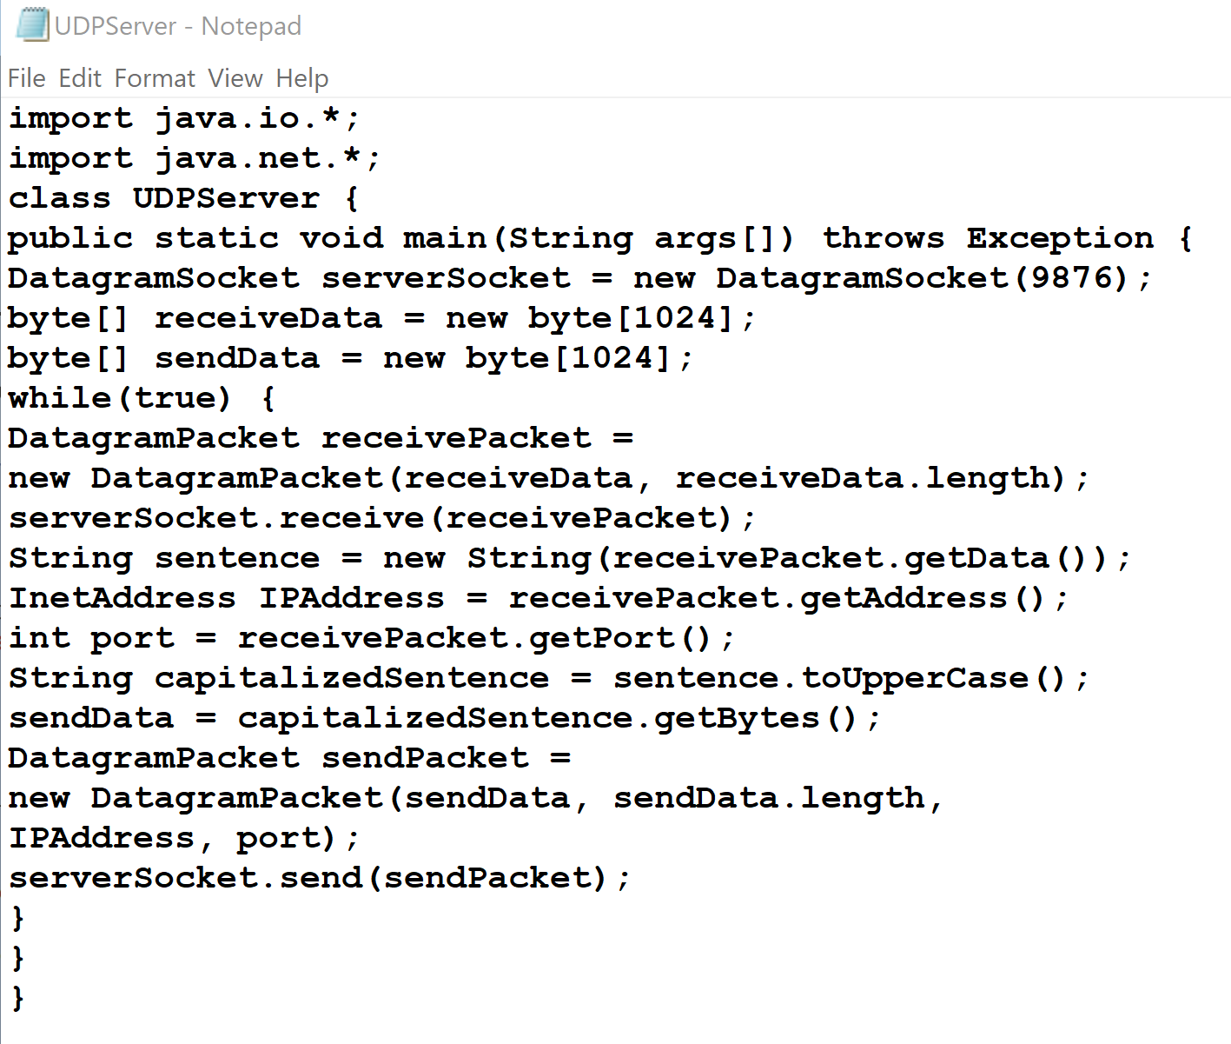

Result:

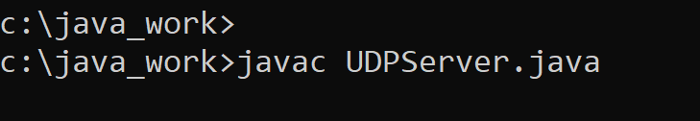

# References

[1] [Index of /02_725/08_InetAddress (tfbor.com)](http://tfbor.com/02_725/08_InetAddress/)

[2] [Index of /02_725/08_c_IO_TCPip (tfbor.com)](http://tfbor.com/02_725/08_c_IO_TCPip/)

[3] [InetAddress (Java Platform SE 7 ) (oracle.com)](https://docs.oracle.com/javase/7/docs/api/java/net/InetAddress.html)