NYIT

**Fall 2021**

Homework No: 09

Title: HTTP Web and TCP/IP Endpoints

**Name:** Patade, Yash Arun

**Class ID#:**  11

**School ID#:** 1284979

**Course:** Java Networking

**Course ID:** CSCI 725

**Date:** 18/11/2021

Assignment Contents

1) Question: HTTP Message Character Code. 3

• How many bits per character is used by the code specified in the HTTP header? : 3

2) HTTP Headers Keywords. 3

3) HTTP and HTML. 5

• What HTML tag is used to access directly HTTP? 5

Work from; Microsoft PowerPoint - 725_09_Lecture_02_OS_HTTPprotocol_Telnet_sh.pptx (tfbor.com) 6

4) Telnet Client on Windows. 6

5) MAC ID Number. 9

Work from: Microsoft PowerPoint - _725_10_Lect_00_URI_URL__.pptx (tfbor.com) 10

6) Question: URI vs URN vs URL. 10

• What is more general URI or URL? 10

• Can we say that URL IS-A URI? 10

7) What does a URI identify? 11

References. 12

Work from: [Microsoft PowerPoint - 725_09_Lecture_01_OS_HTTPprotocol_shsh.pptx (tfbor.com)](http://tfbor.com/02_725/09_HTTP_Web/725_09_Lecture_01_OS_HTTPprotocol_.pdf)

# 1) Question: HTTP Message Character Code.

## How many bits per character is used by the code specified in the HTTP header? :

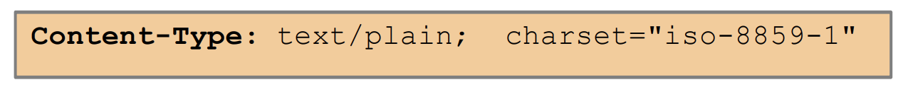

Answer)

International Standard Organization’s character iso-8859-1 is an 8b/char code.

─ ISO-8859-1 is the default character set used in most browsers.

─ The first 128 characters of ISO-8859-1 is the original ASCII character-set

─ The numbers from 0-9, the uppercase and lowercase English alphabet, and some special characters.

─ The higher part of ISO-8859-1 (codes from 160-255) contains the characters used in Western European countries and some commonly used special characters.

# 2) HTTP Headers Keywords.

|  |  |  |
| --- | --- | --- |
| Header | Type | Comment |
| Accept | Request | Define media types which are acceptable. Example Accept-Charset: character sets are acceptable. |
| Authorization | Request | Authentication credentials for HTTP authentication. |

|  |  |  |
| --- | --- | --- |
| Header | Type | Comment |
| From | Request | Email ID of request making user. |
| Referrer | Request | Web address of previous web page of a link. |
| If-modified-since | Request | Server sends back requested resource, if it has been modified after a given date. |
| User-agent | Request | User agent character string of the user agent. |
| Pragma | General | Affects the request-response chain. Pragma is applicable to the client requests. |
| Date | General | The date and time at which the message/request originated.  Date: Thurs, 27 July 2021 11:19:11 GMT |
| Content-length | Entity | Indicates the length of the content body. |
| Content-type | Entity | Indicates the media type of the content body. |
| Expires | Entity | Indicates the date and time after which the response is considered as expired/invalid. |
| Last-modified | Entity | Indicates the date and time when the response was last modified. |
| Location | Response | Alternate location of returned data. Also, foe the browser to redirect a URL. |

|  |  |  |
| --- | --- | --- |
| Header | Type | Comment |
| Server | Response | Indicates the software used by the origin server that managed requests. |
| Version | Response | Indicates the version of software |
| Status | Response | Issued in response to a clients’ request made to server. |
| WWW - authenticate | Response | Used to gain access to a particular resource. |

# 3) HTTP and HTML.

## What HTML tag is used to access directly HTTP?

Answer)

Anchor tag <A>.

Example: To enable user of the original rendered/displayed HTML page pageOld.html to just click and activate HTTP session with the HTTP server and download new resource pageNew.html on the Web server www in the DNS domain compX.xom it is enough to use in pageOld.html HTML code text:

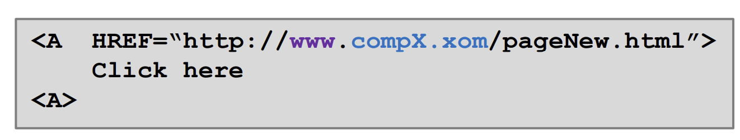

# Work from; [Microsoft PowerPoint - 725_09_Lecture_02_OS_HTTPprotocol_Telnet_sh.pptx (tfbor.com)](http://tfbor.com/02_725/09_HTTP_Web/725_09_Lecture_02_OS_HTTPprotocol_Telnet_.pdf)

# 4) Telnet Client on Windows.

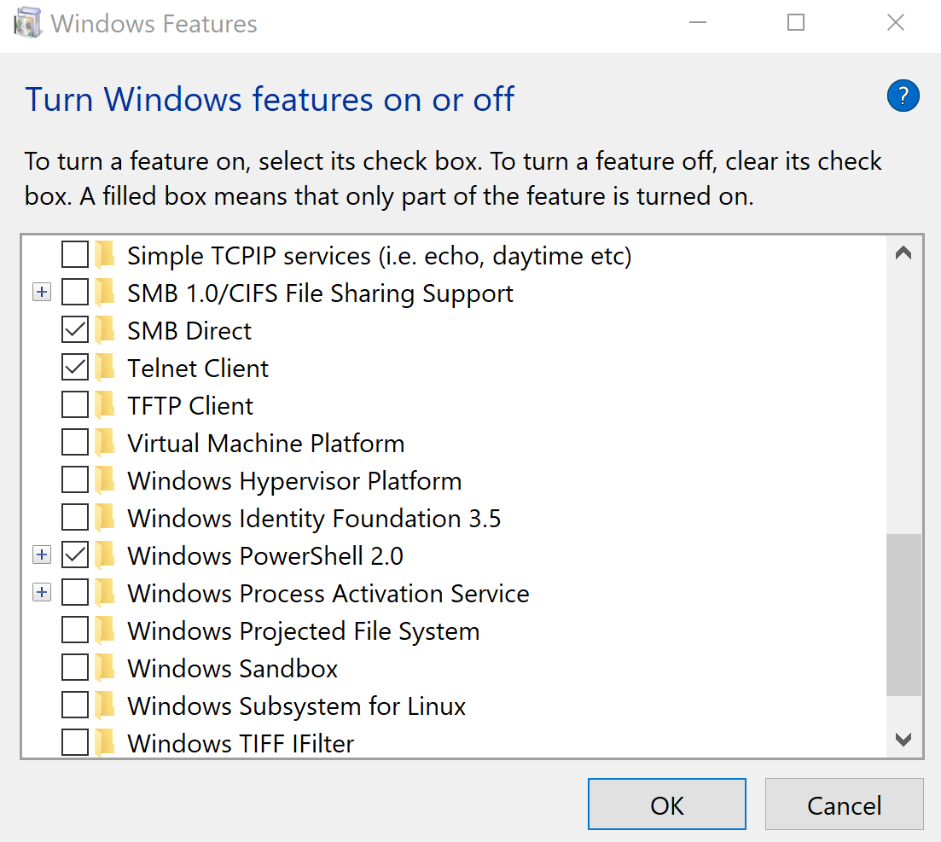

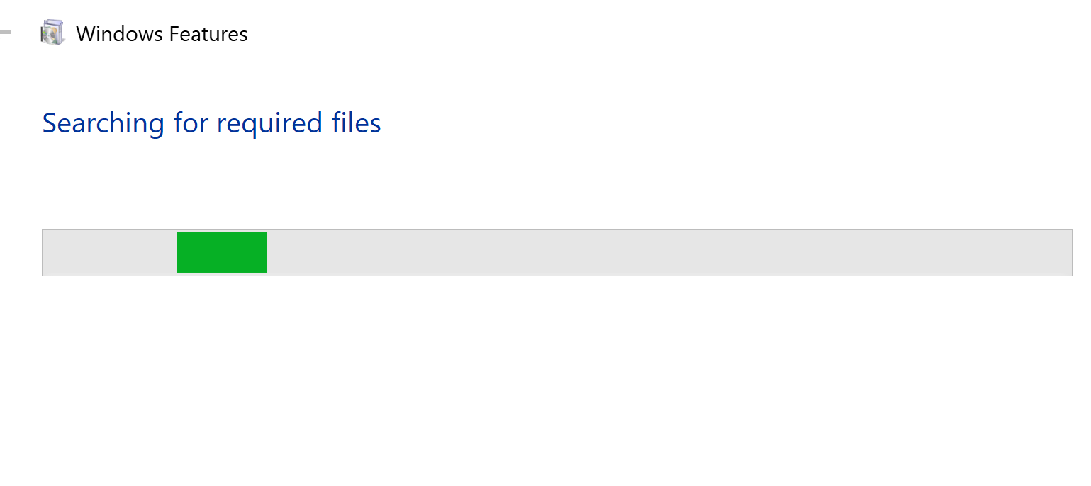

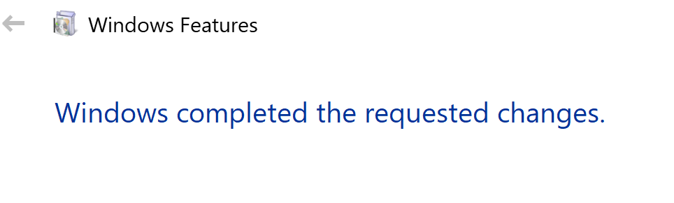

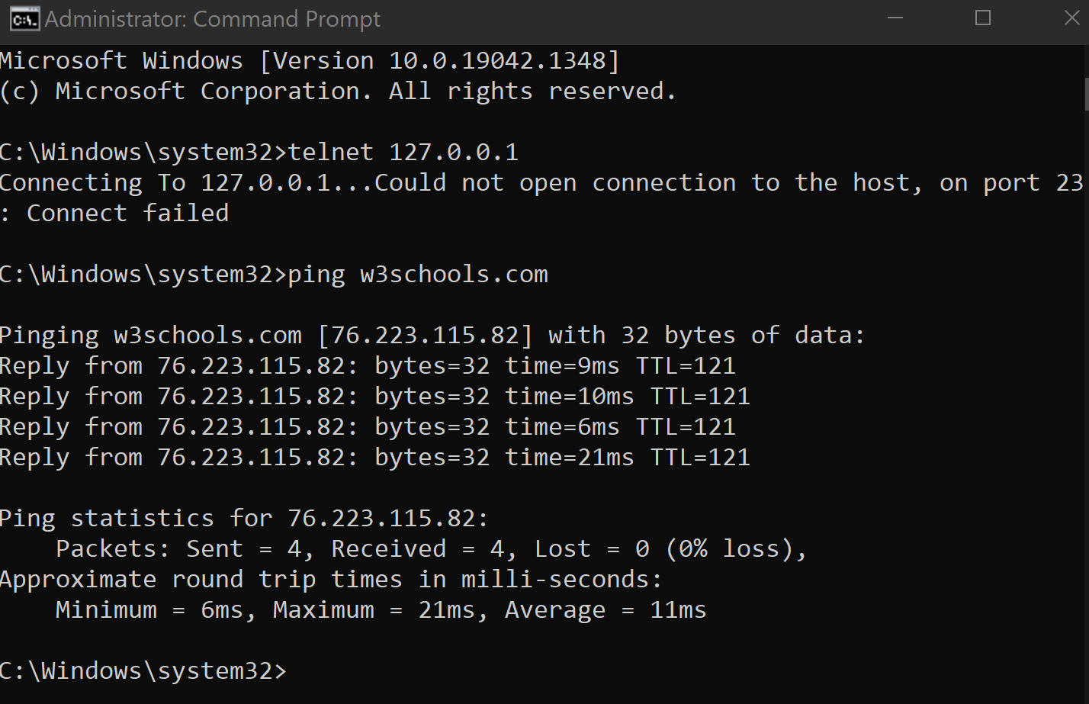

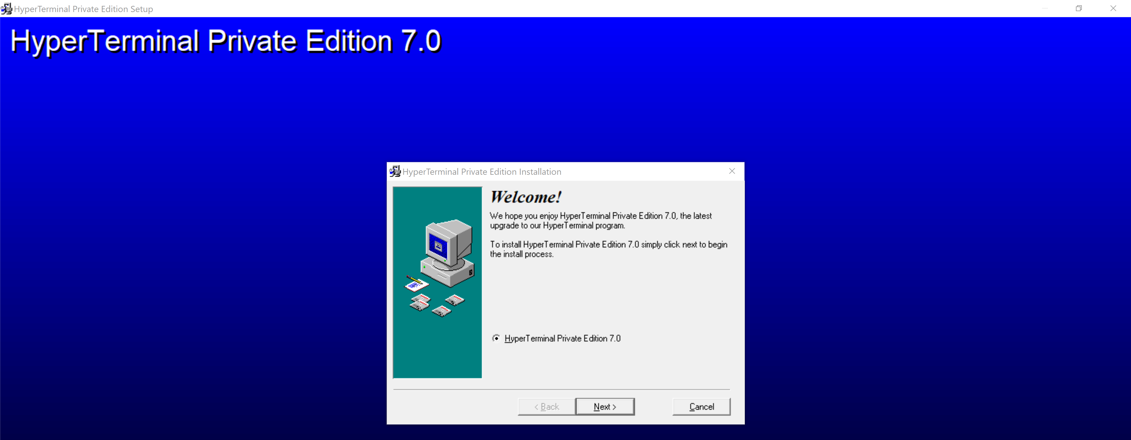

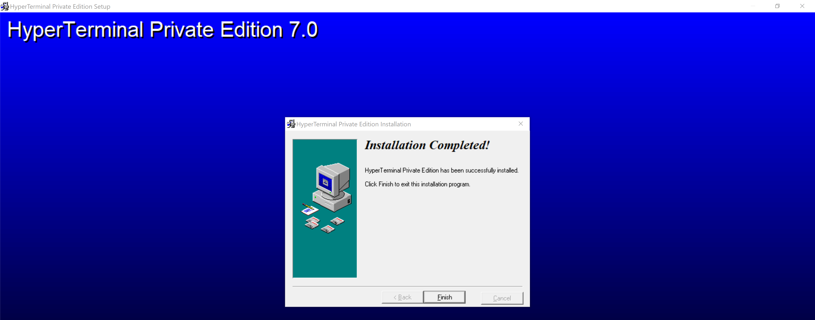

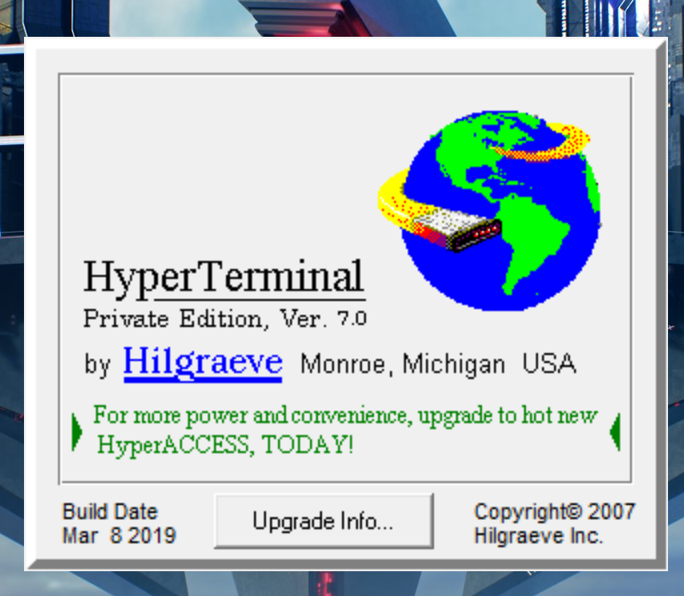

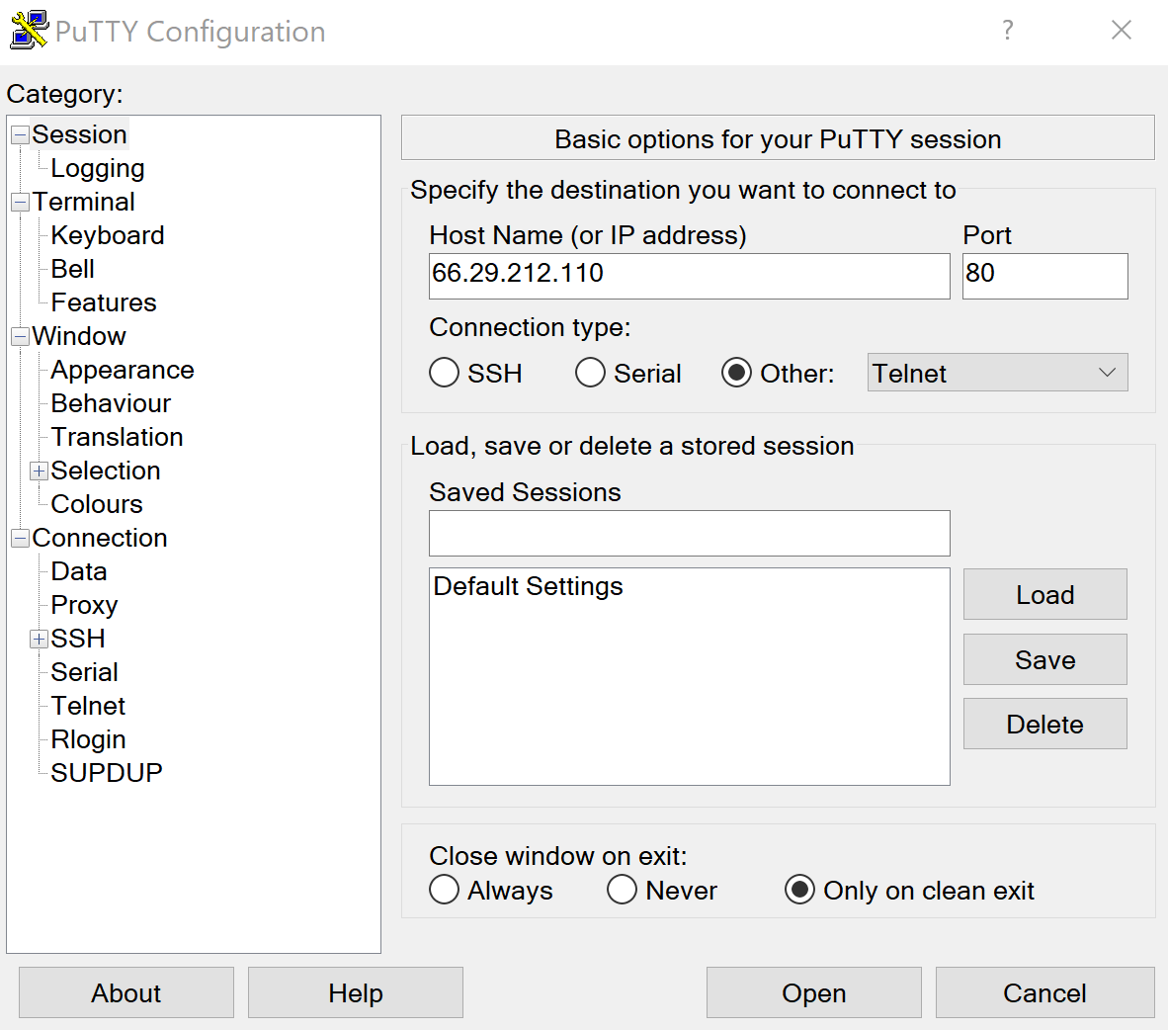

Work from: [Microsoft PowerPoint - _725_08_Lect_01_Networkcontext_SA_View____________.pptx (tfbor.com)](http://tfbor.com/02_725/09_TCPip_EndPoints/745_09_Lecture_01_SA.pdf)

# 5) MAC ID Number.

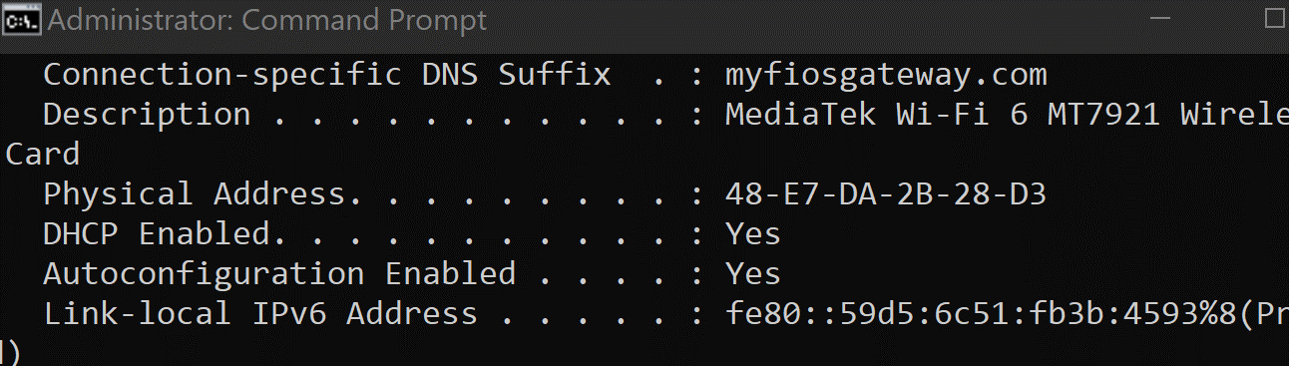

Company:

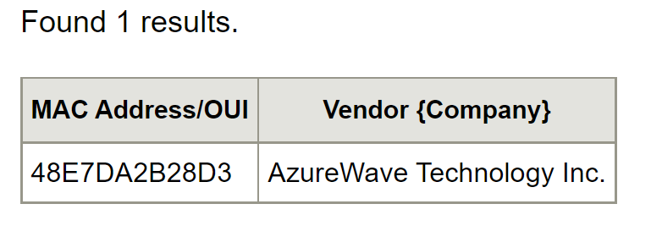

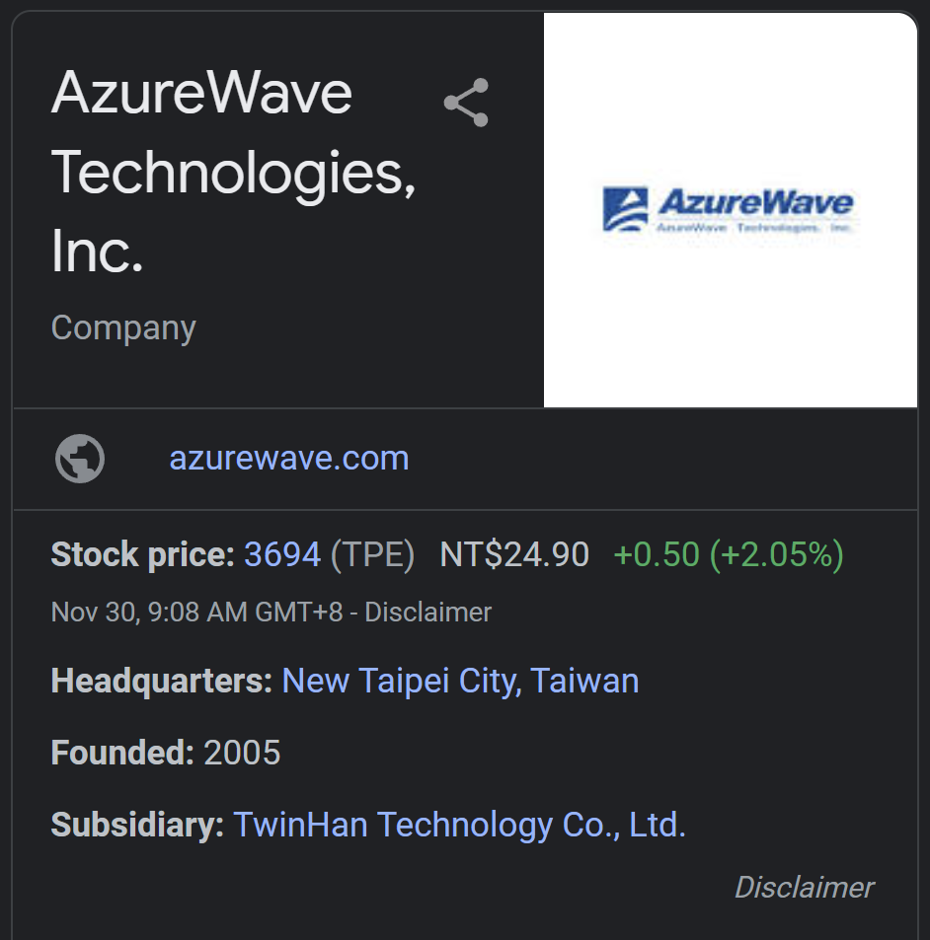

# Work from: [Microsoft PowerPoint - _725_10_Lect_00_URI_URL__.pptx (tfbor.com)](http://tfbor.com/02_725/09_TCPip_EndPoints/745_09_Lecture_03_URI_URL.pdf)

# 6) Question: URI vs URN vs URL.

## • What is more general URI or URL?

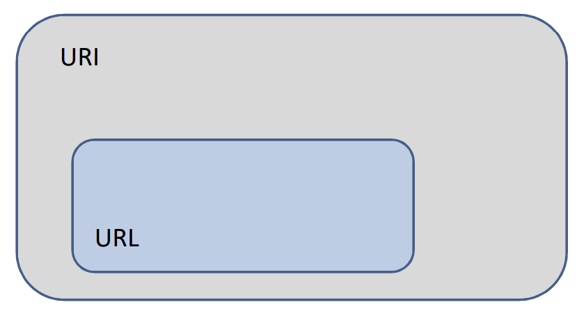

Answer)

URI is more general.

– URI applies to more cases than URL and covers URL which is more specific (Must have access method named).

## • Can we say that URL IS-A URI?

Answer)

Yes?

– It appears that URL inherits from URI with the resource access method as mandatory element present in the identifier.

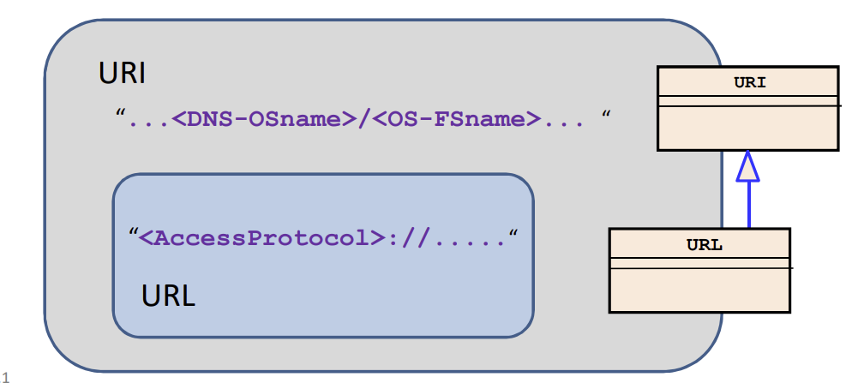

# 7) What does a URI identify?

• A URI identifies a Resource.

• A URI only comes into existence when it is bound to a Resource.

• A Resource is defined as anything that is identified by a URI.

• Resources only come into existence when a URI is bound to it.

• A URI cannot exist without a Resource.

• A Resource cannot exist without a URI.

# References.

[1] [Index of /02_725/09_TCPip_EndPoints (tfbor.com)](http://tfbor.com/02_725/09_TCPip_EndPoints/)

[2] [Index of /02_725/09_HTTP_Web (tfbor.com)](http://tfbor.com/02_725/09_HTTP_Web/)

[3] [MAC Address and OUI Lookup for 48E7DA2B28D3 - Find the Company that manufactured the network card. (aruljohn.com)](https://aruljohn.com/mac/48E7DA2B28D3)

[4] [HyperTerminal telnet software for Windows - Hilgraeve](https://www.hilgraeve.com/telnet-information/)