NYIT

**Fall 2021**

Homework No: 10

Title: App Distribution and Web Browser.

**Name:** Patade, Yash Arun

**Class ID#:**  11

**School ID#:** 1284979

**Course:** Java Networking

**Course ID:** CSCI 725

**Date:** 12/11/2021

Assignment Contents

1) Developing the server side. 3

2) Datagram Echo Server. 4

3) Developing the client side. 5

4) Web vs, Internet. 8

• What is the relationship between the web and the Internet? 8

5) Why is Web Popular? 9

6) First GUI Browser. 9

7) In-Line Java Script 3GL Code. 10

8) Input Visual Objects & User Generated Interrupts. 11

9) On-Click event. 12

# 1) Developing the server side.

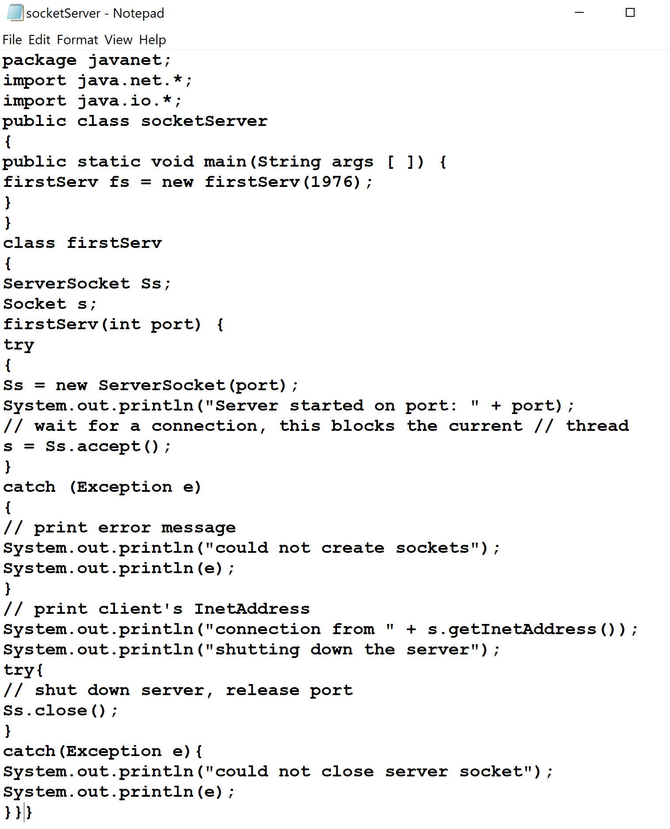

# 2) Datagram Echo Server.

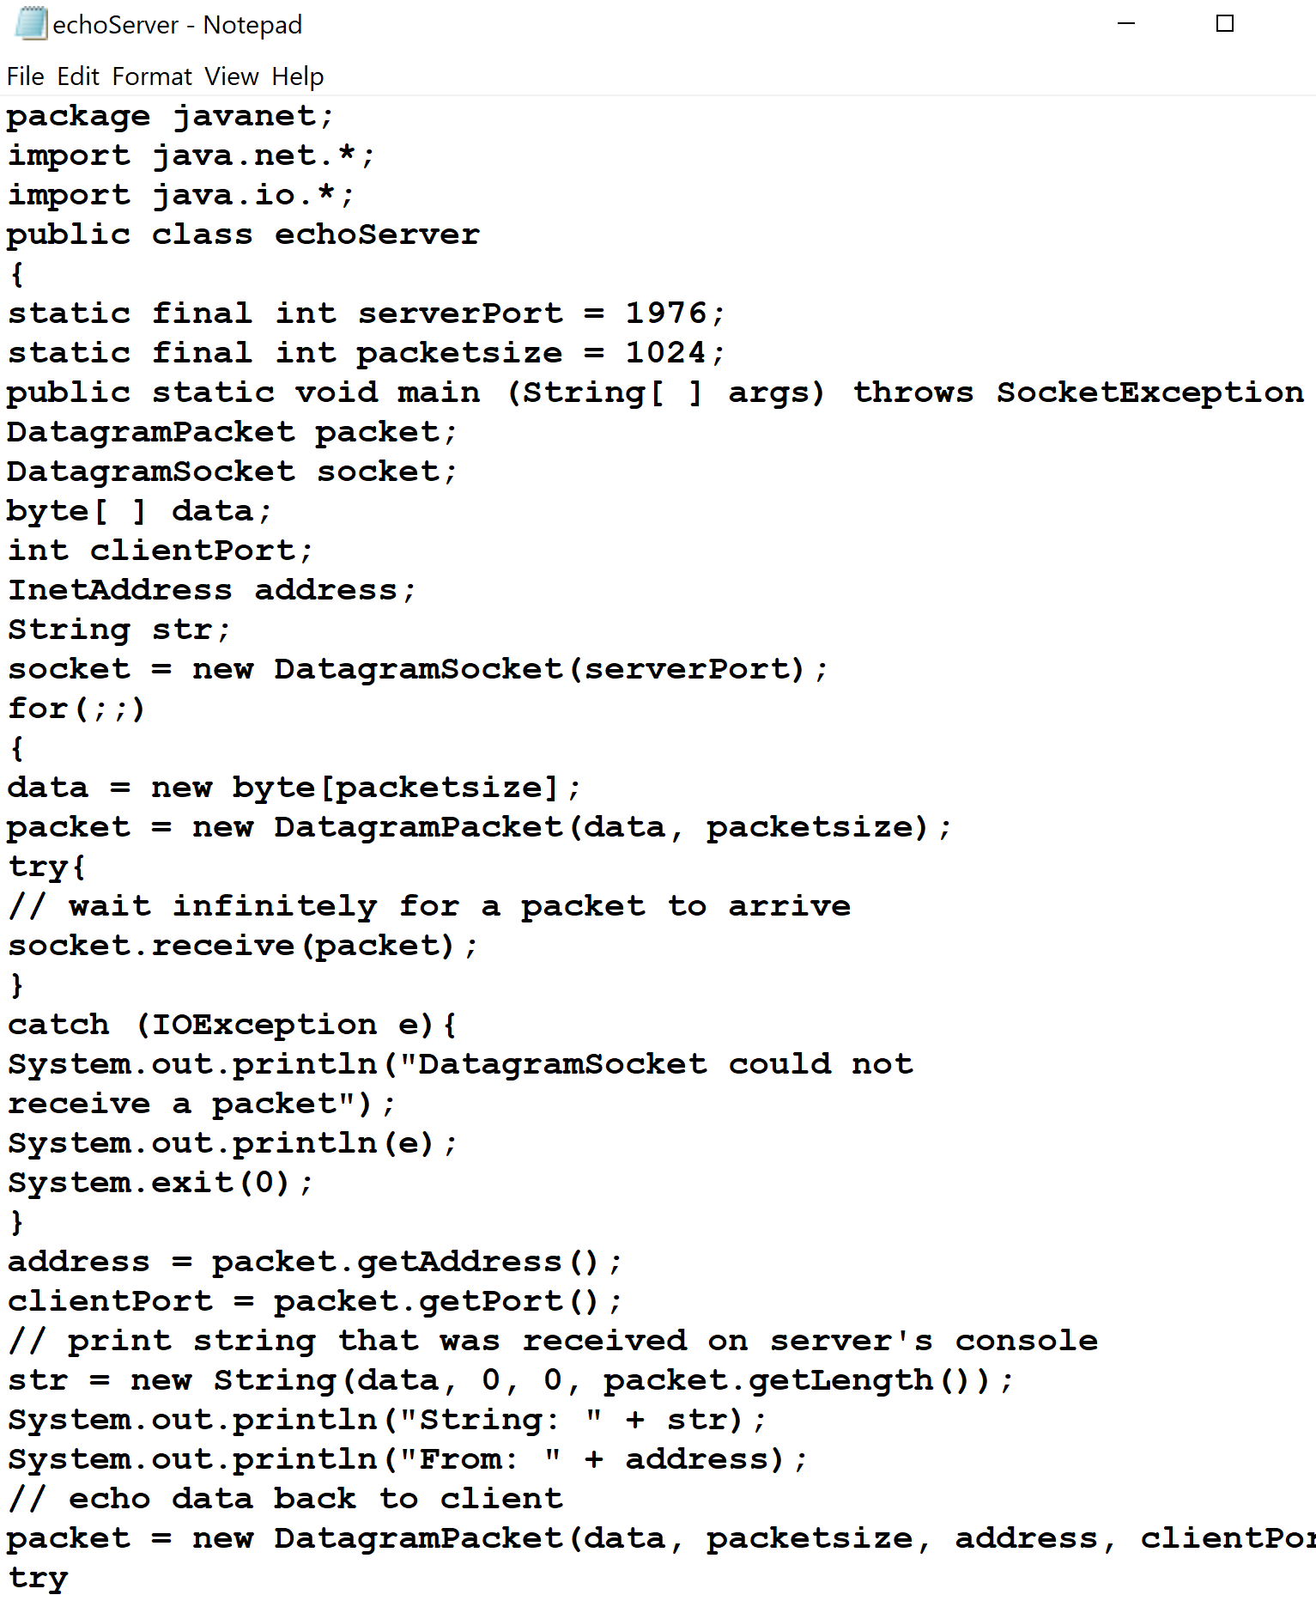

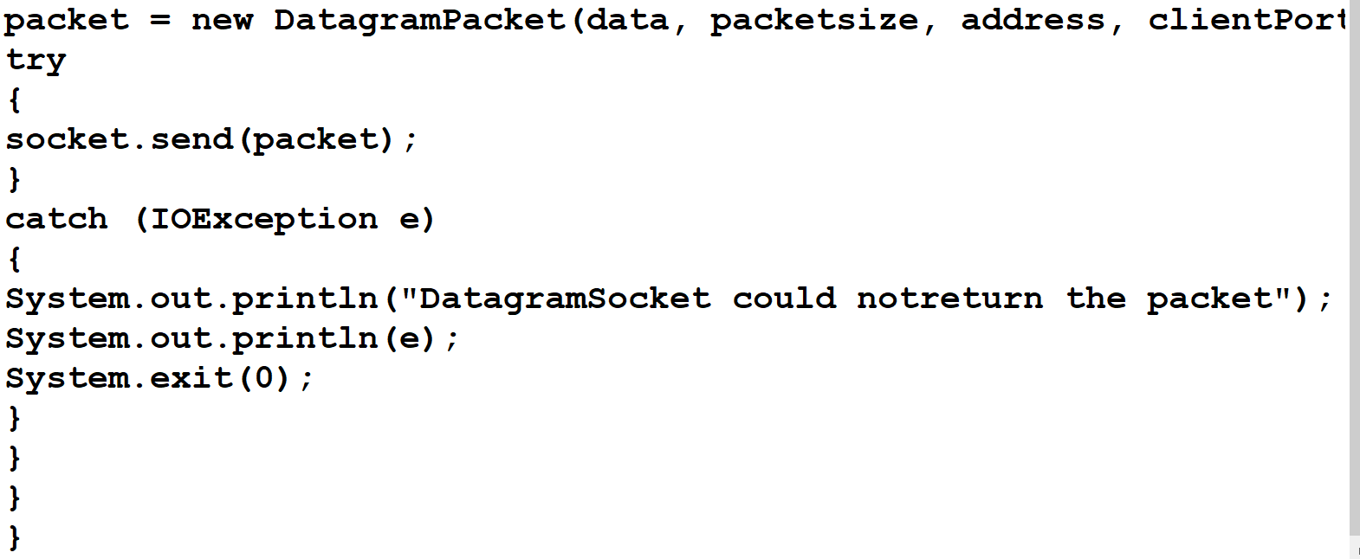

# 3) Developing the client side.

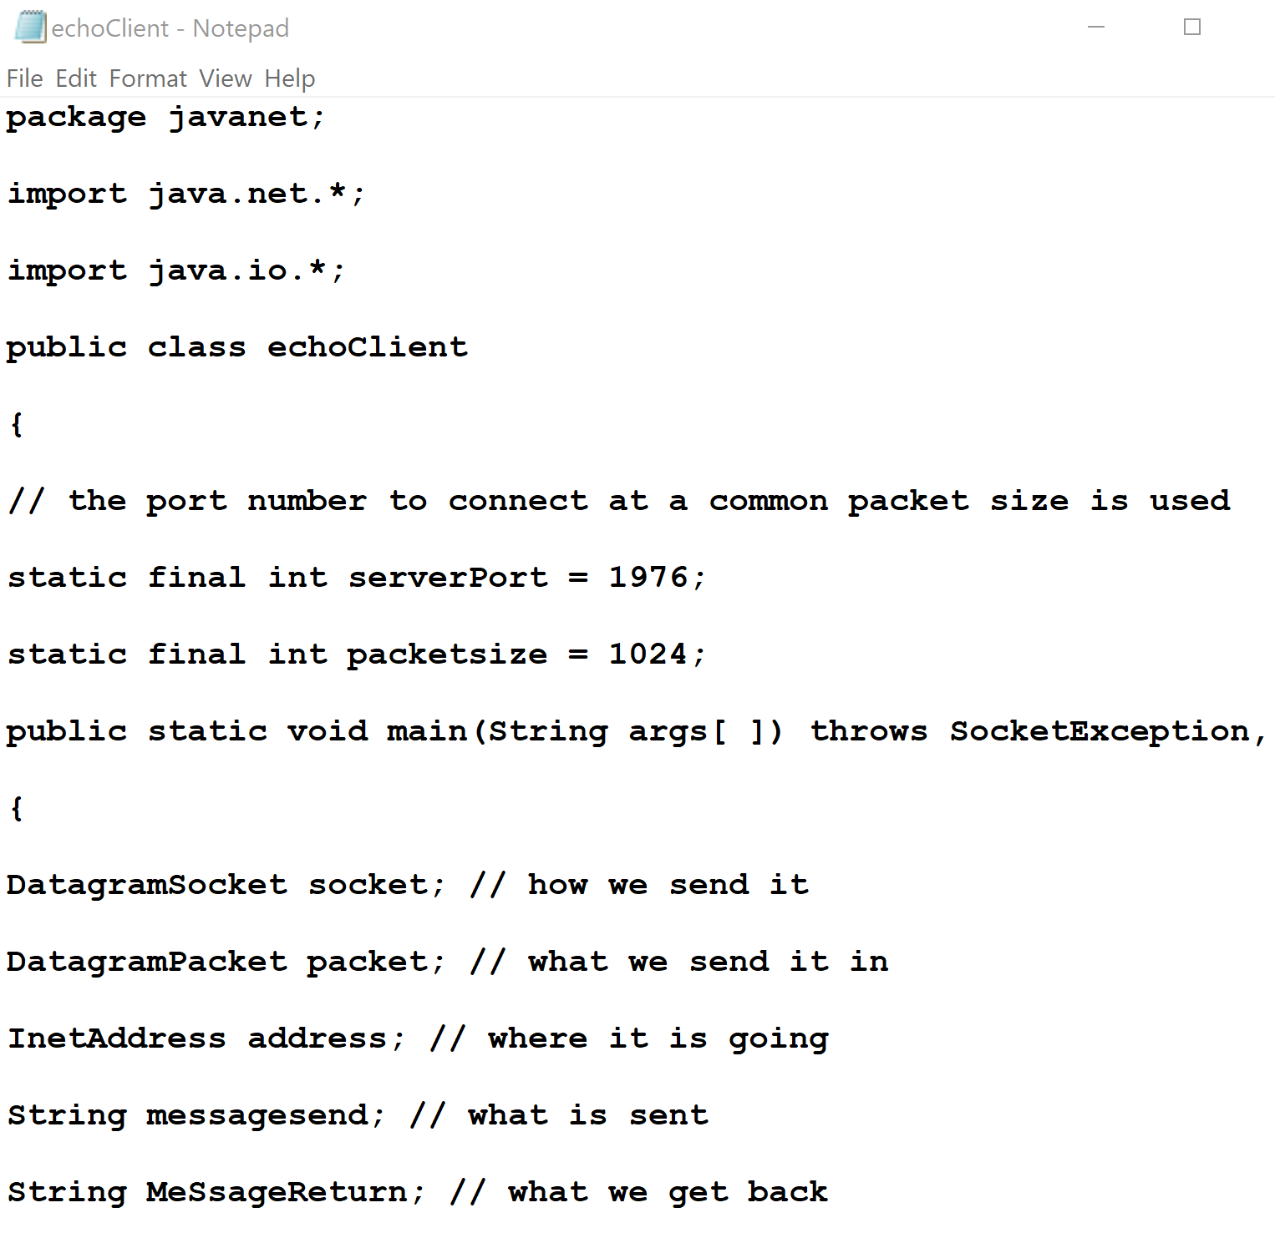

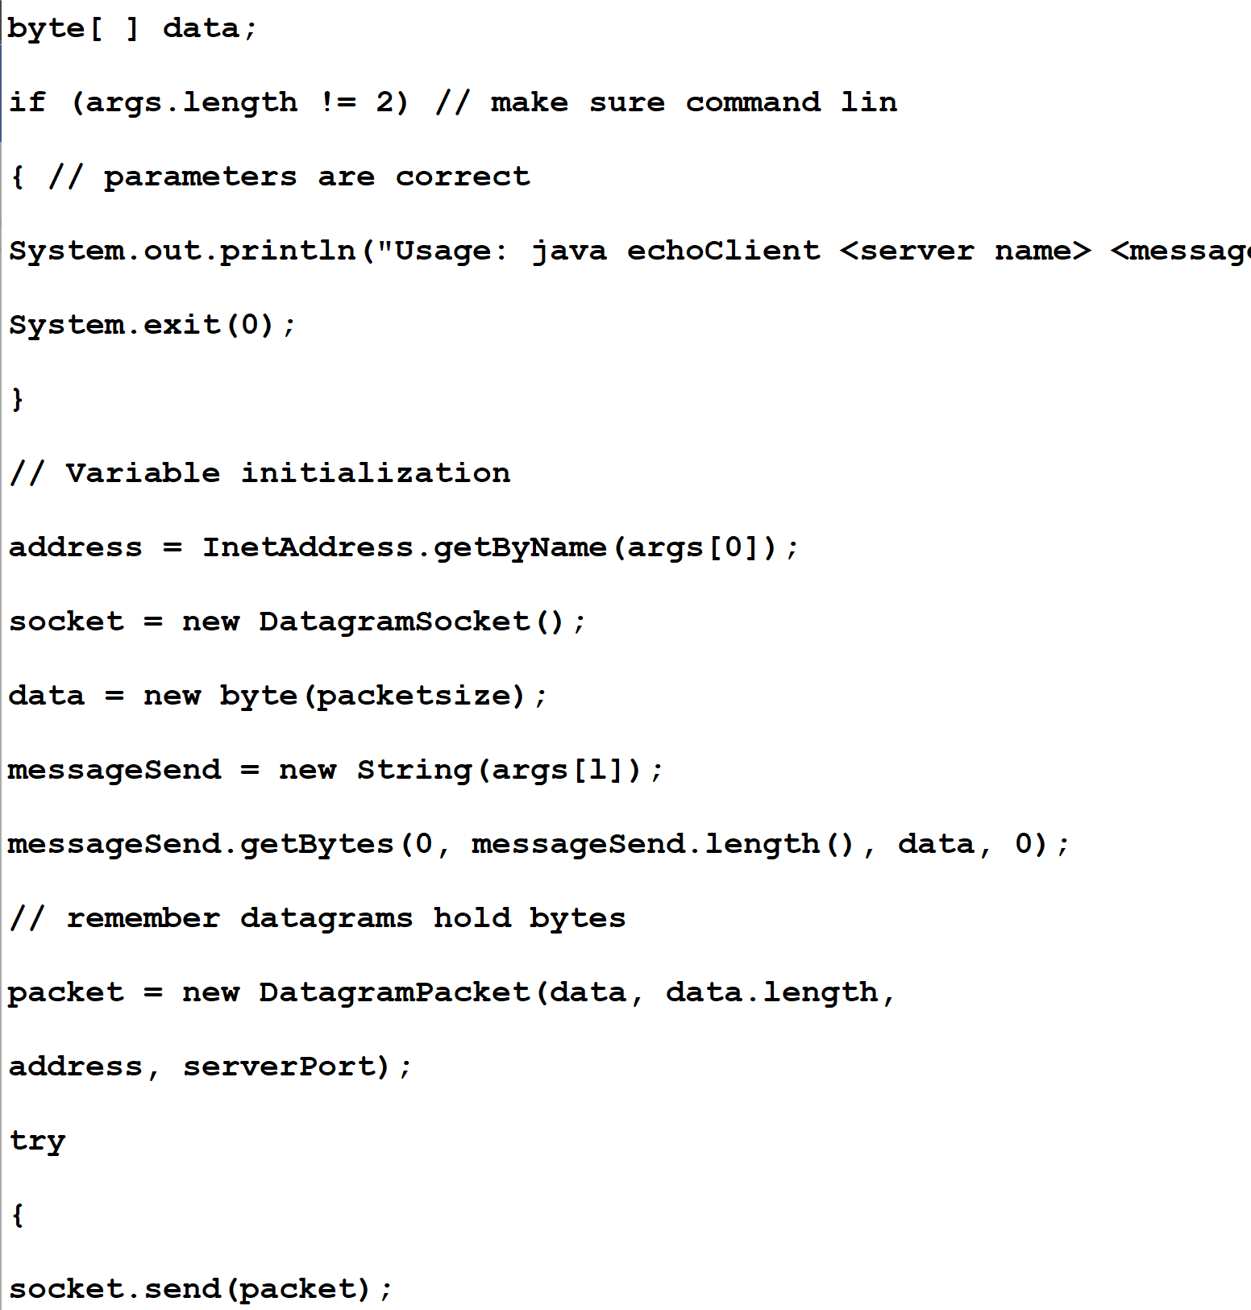

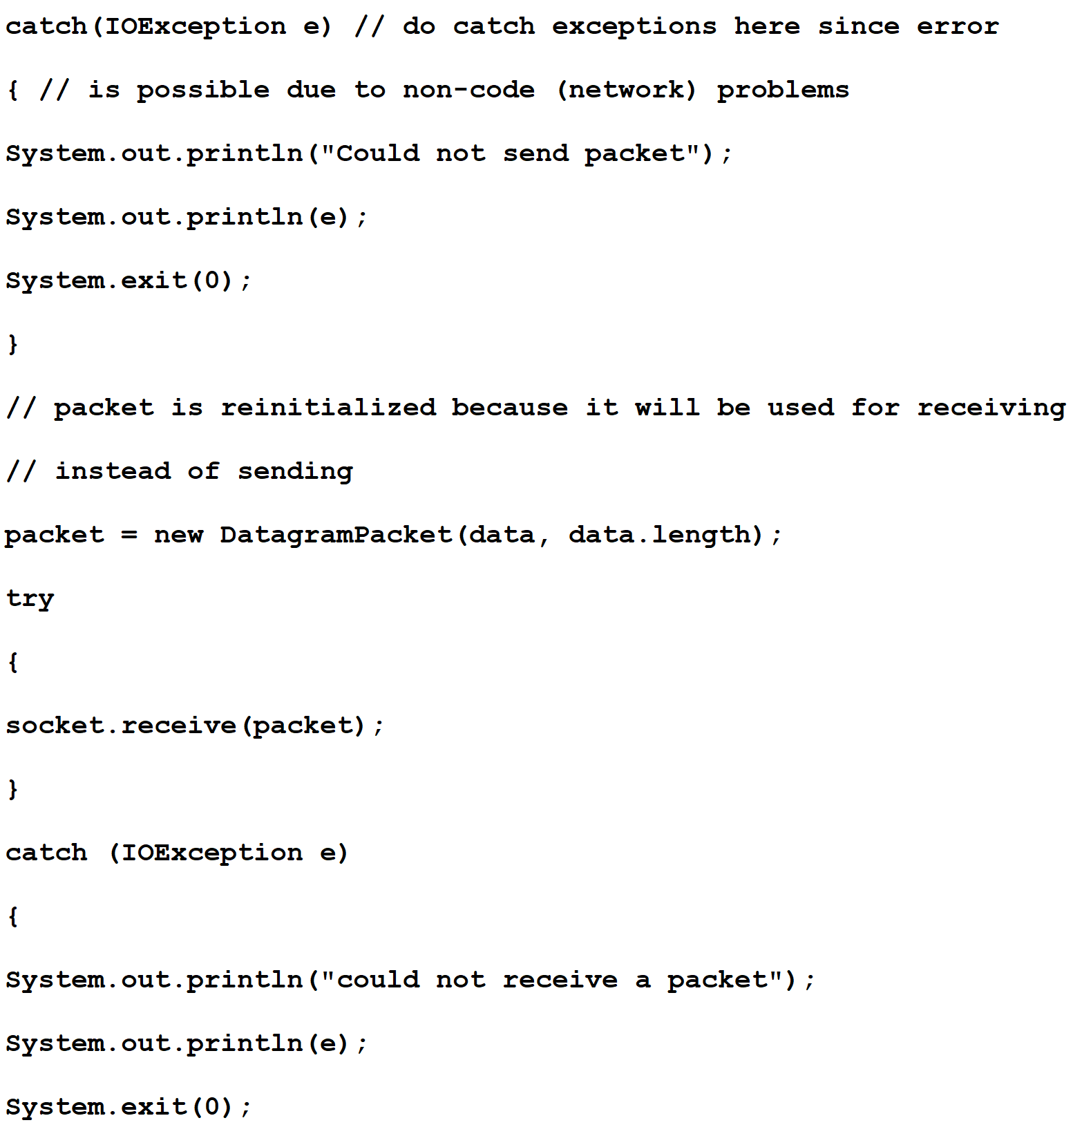

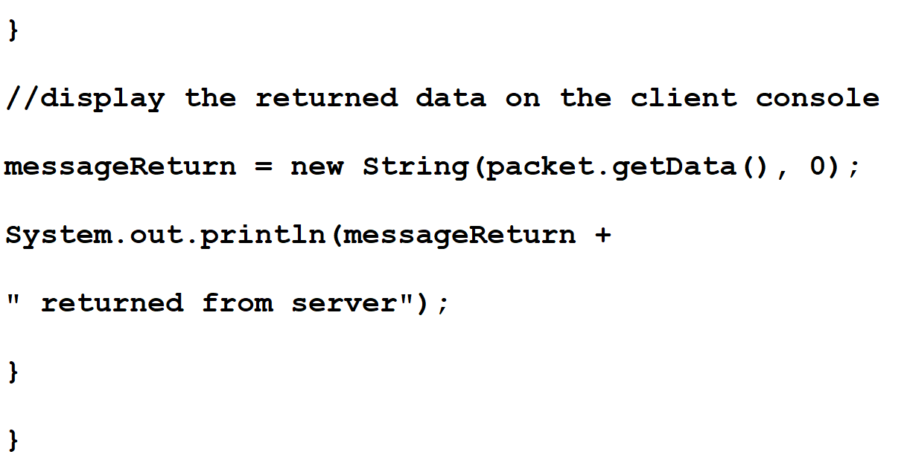

# 4) Web vs, Internet.

## • What is the relationship between the web and the Internet?

Answer)

The Internet contains physical components

– computers

– networks

– service

The Internet is a TCP/IP powered public network

– Contains physical components

• Host-Computers/nodes

• Networks/Network-devices

• Network services (e.g., DNS)

• The Web is a type of distributed application that may run in one host, on any network & the most preferably on Internet.

• Super pattern of dist app

– Uses HTTP as messaging protocol.

– Uses reusable framework programs:

• Web server, and

• Web browser.

# 5) Why is Web Popular?

Answer)

• The easiest to use distribute application of all

– Just a click on the hot spot creates connection, downloads remote resource-content, and renders it on the client UI device.

• Easy to navigate:

– Easy to address remote resource using URL/DNS-based mnemonic text address strings

– Read text in a nonlinear manner

• Reach largest audience

• Combines multiple types of data, multimedia:

– Character text, graphics, sound, video (MIME protocol)

• Easy to Publish or Post

# 6) First GUI Browser.

On April 22, 1993, a team from the University of Illinois Urbana champaign's National

Centre for Supercomputing Applications, led by 22‐year‐old C‐programmer Marc

Andreessen, released Mosaic GUI browser with the total  number of Web servers in the world fewer than 130.

# 7) In-Line Java Script 3GL Code.

Output:

# 8) Input Visual Objects & User Generated Interrupts.

Output:

# 9) On-Click event.

Output:

