REPORT

DATA STRUCTURES MINI PROJECT

TOPIC: QUINE MCCLUSKY METHOD

INDEX
Sr. No Topic Page no.
1 INTRODUCTION 2
2 ABSTRACT DATA TYPE 3
3 DATA STRUCTURES 5
4 FLOWCHART 8
5 METHODS 9
6 ALGORITHMS 12
7 PROGRAM 14
8 RESULT 40
9 CONCLUSION 48
10 ACKNOWLEDGEMENT 48

INTRODUCTION

Simplification of Boolean expression is a practical tool to optimize programing algorithms and circuits. Several techniques have been introduced to perform the minimization, including Boolean algebra (BA), Karnaugh Map (K-Map) and
Quine McCluskey. Minimization using Boolean Algebra requires high algebraic manipulation skills and will become more and more complicated when the number of terms increases. K-Map is a diagrammatic technique based on a special form of Venn diagram. It is easier to use than Boolean Algebra but usually it
is used to handle Boolean expression with no more than six variables. When the number of variables exceeds six, the
complexity of the map is exponentially enhanced and it
becomes more and more cumbersome. Functionally identical to
K-Map, Quine McCluskey method is more executable when dealing with larger number of variables and is easier to be mechanized and run on a computer. Although a number of programing codes implementing QM method are available online, not all of them are technically correct. Furthermore, it is found that some of them either didn’t take the Don’t-Care conditions into consideration or still had limitation of the number of variables. Here a Quine McCluskey simulation code based
on C language is introduced. Theoretically speaking, it has no limitation of the number of variables and has taken the Don’t-
Care conditions into account. In this article, we will introduce the procedure of Quine McCluskey method step by step. In each step we will explain how we implement it in the program.
At last we will attach the codes.

ABSTRACT

A Boolean function is a function that produces a Boolean value output by logical calculation of Boolean inputs. It plays key
roles in programing algorithms and design of circuits. Minimization of Boolean function is able to optimize the
algorithms and circuits. Quine-McCluskey (QM) method is one of the most powerful techniques to simplify Boolean expressions. Compared to other techniques, QM method is
more executable and can handle more variables. In addition, QM method is easier to be implemented in computer programs, which makes it an efficient technique. There are several
versions of QM simulation codes online, whereas some of them appear to have limitations of variables numbers or lack the consideration of Don’t-Care conditions. Here a QM simulation
code based on C programing is introduced. Theoretically it is able to handle any number of variables and has taken the Don’tCare conditions into account.
The running time of the Quine–McCluskey algorithm grows
exponentially with the number of variables. For a function of n variables the number of prime implicants can be as large as
3nln(n), e.g. for 32 variables there may be over 534 * 1012
prime implicants. Quine–McCluskey method is a tabular method that has an advantage over Karnaugh maps when a large number of inputs are present. With more inputs, pattern recognition in Karnaugh maps can be tedious or sometimes even impossible. The Quine–McCluskey method does not require pattern recognition.
The method involves two steps:
•Finding all prime implicants of the function.
•Use those prime implicants in a prime implicant chart to find the essential prime implicants of the function, as well as other prime implicants that are necessary to cover the function.
•Include the essential prime implicants in the minimal sum.
•After all the prime implicants are deleted from the prime- implicant table determine rows and determine columns,
and find the secondary essential prime implicants.
•Repeat steps 3 and 4 as many times as they are applicable until a minimal cover of the function is found.

In order to accurately use the Quine-McCluskey, the function needs to be given as a sum of minterms (if the Boolean function is not in minterm form, the minterm expansion can be found) to determine a minimum sum-of-products (SOP)
expression for a function. During the first step of the method, all prime implicants of a function are systematically formed by
combining minterms. These minterms are represented in a
binary notation and combined as follows: XY + XY’ = X (1.1)
where X is represented by a product of literals and Y is a single
variable of some sort. If two variables differ in exactly one variable, the two minterms will combine together.
To find all prime implicants, all possible pairs of minterms
should be compared and combined whenever possible. Sorting binary minterms into groups according to the number of 1’s in
each term, reduces the required number of comparisons one
must complete.
The main advantage of this method is that it can be implemented in any software in an algorithmic fashion but the disavantage of this method is that the computational complexity still remains high.
Data Structures:

Why use an Array?
Arrays a kind of data structure that can store a fixed-size sequential collection of elements of the same type. An array is
used to store a collection of data, but it is often more useful to
think of an array as a collection of variables of the same type.

Instead of declaring individual variables, such as number0, number1, ..., and number99, you declare one array variable such as numbers and use numbers[0], numbers[1], and ..., numbers[99] to represent individual variables. A specific element in an array is accessed by an index.
All arrays consist of contiguous memory locations. The lowest address corresponds to the first element and the highest address to the last element.

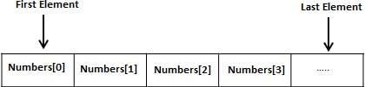

WHY USE LINKED LIST :

1. Linked lists allow insertion and removal of nodes at any point in the list, and allow doing so with a constant number of operations by keeping the link previous to the link being added or removed in memory during list traversal.
2. Linked list need not have continuous memory because in linked list elements are linked to each other by address of the
next node.
Difference between array and linked list

Array Linked list
Array is a collection of elements of similar data type.

Array supports Random Access, which means elements can be accessed directly using their index.

In an array, elements are stored in contiguous memory location or consecutive manner in the memory. Memory is allocated as soon as the array is declared,
at compile time. Size of the array must be specified at time of array decalaration.
Linked List is an ordered collection of elements of same type, which are connected to each other using pointers. Linked List
supports Sequential Access, which means to access
any element/node in a linked list, we have to sequentially
traverse the complete linked list, upto that element.
In a linked list, new elements can be stored anywhere in the memory.

Memory is allocated at runtime, as and when a new node is added.
Size of a Linked list is variable. It grows at runtime, as more nodes are added to it.

Difference between static and dynamic memory allocation

Static Dynamic
In this case, variables get allocated permanently.

Allocation is done before program execution.
It uses the data structure called stack for implementing static allocation.
In this case, variables get allocated only if your program unit gets active
Allocation is done during program execution
It uses the data structure called heap for implementing dynamic allocation
Less efficient More efficient
There is no memory reusability
There is memory reusability and memory can be freed when not required

Flowchart

prmImps

int pterm int count FTerm* pbnry prmImps* next
List

node* elem int ones list* next

FTerm

Binary* lsb
FTerm* next
Node

minGrp* trm1 binary* lsb int flag node* next

Binary

char bit binary* next
MinGrp

int term minGrp* next

Methods:

Structures Used:
~> binary
~~~ char bit, binary* next
It is a linked list to store the binary equivalent of a number.

~> minGrp
~~~ int term, minGrp* next
It is a linked list to store the corresponding Min-terms of a group.

~> node
~~~ minGrp* trm1, binary* lsb, int flag, node* next
This is the basic representation of a Group of minterms. It is the list of all the groups which belong to the same list.
=> trm1 is a pointer which points to the list of minterms of that
group.
=> lsb is a pointer which points to the binary equivalent of that group.
=> flag tells us if the group is further grouped. If not, then it becomes a Prime Implicant, which is essential in the final parts of the algorithm.

~> list
~~~ node* elem, int ones, list* next
This represents the grouping based on the number of 1's present in the binary equivalent of any of the Nodes.
=> elem is the pointer to all the groups which belong to this list.
=> ones is a variable to store the no. of 1's present in the above nodes.

~> FTerm
~~~ binary* lsb, FTerm* next
This represents a list of binary equivalents grouped together. It is used when we group the Prime Implicants and when we
finally the Essential Prime Implicants which finally help us finding the final Boolean Expression.

~> prmImps
~~~ int pterm, int count, FTerm* pbnry, prmImps* next
This represents the list for all the Prime Implicants corresponding to all the Min-Terms entered. It stores all the
binary equivalents of which the Min-Terms is
=> pterm is the Min-term whose equivalents we need to store.
=> count is a counter for number of equivalents it stores.
=> pbnry is a pointer to the list of equivalents.

Global Variables Used:
int bits => To store number of variables for which we will be creating an Expression.

int lstp => To store the maximum no. of Min-Terms present in any group. It is used for aligment in the final Tabular Display.

node* flagb => It is a temporary node which is used for comparing two binary equivalents.

Functions Used:
//To Declare nodes for each of the respective Structures
binary* createBit(char)
minGrp* createGrp(int)
node* createNode(minGrp*, binary*)
list* createList(int) prmImps* createImp(int) FTerm* createFTerm(binary*)

//To link nodes to each of the respective Lists
binary* addBit(binary*, char)
minGrp* addTerm(minGrp*, minGrp*)
node* addNode(node*, node*)
list* addList(int)
prmImps* addImps(prmImps*, int) FTerm* addFTerm(FTerm*, FTerm*)
void addElem(list*, node*, int)

//Special Functions
int putBits(node*)
int ifXs(binary*, binary*)
int isIn(int, minGrp*)
int size(minGrp*)
node* cmpBinary(node*, node*)

//To Initialise each node binary* getBinary(int) node* getPrime(list*[])
void getImps(node*, prmImps*)
binary* getBTerm(binary*) FTerm* getFTerm(prmImps*)

//To Display each of the different nodes
void getLine()
void getSpace()
void dispList(list*)
void dispNode(node*)
void dispTerm(minGrp*)
void dispBnry(binary*)
void dispFTerm(FTerm*)

Algorithms
int putBits(node*) =>
Makes the number of bits in the binary equivalent of each node equal, which is equal to ‘bits’ (no. of variables).

int ifXs(binary*, binary*) =>
Checks if the X’s, if present are at the same position in both the equivalents. This is used in comparing groups of alternate lists.

int isIn(int, minGrp*) =>
Check if the given int value is present in the given minGrp list.

int size(minGrp*) =>
Returns the size of the minGrp list.

node* cmpBinary(node*, node*) =>
Compares the binary equivalent of the given nodes.
If they can be grouped, then a new node whose equivalent has an additional ‘X’ is returned.
If they cannot be grouped, ‘NULL’ is returned.
If the two nodes sent have the same equivalent, then a pre- defined node ‘flagb’ is returned.

binary* getBinary(int) =>
Returns the Binary equivalent of the receives integer.

node* getPrime(list*[]) =>
Returns a list containing the Prime Implicants of the total calculation.

void getImps(node*, prmImps*) =>
Returns the Essential Prime Implicants of the final calculation.

binary* getBTerm(binary*) =>
Returns the final term which contains the character variable instead of ones, zeroes and X’s.

FTerm* getFTerm(prmImps*) =>
Returns the final expression containing the all the Essential Prime Implicants and makes sure that all the min-terms have been included, or else adds another Prime Implicant to create the final expression.

void main() =>

1. Initialises ‘flagb’ as a random pointer.
2. Initialises ‘bits’ based on the User’s input.
3. Declaration and Initialisation of temporary pointers, and ‘step’ Array.
4. Create a limit for receiving min-terms given by pow(2,
bits).
5. Choose the user input for Minterm or Maxterms.
6. Based on the user input, initialise the min-terms as 0 or 1 for each Maxterm and Minterm respectively.
7. Input Don’t Care terms from the user.
8. Initialise the first List of the first Step.
9. Begin comparing and grouping. Based on the QM algorithm, go on creating the table until we group all of the terms.
10. Get Prime Implicants.
11. Get Essential Prime Implicants.
12. Get the final Expression List.
13. Call display functions in their respective sequence to display the final table.

Program:

#include<stdio.h>
#include<math.h>
#include<stdlib.h>
#include<string.h>

typedef struct binary
{
char bit;
struct binary* next;
}binary;
typedef struct minGrp
{
int term;
struct minGrp* next;
}minGrp;
typedef struct node
{
minGrp* trm1;
binary* lsb;
int flag;
struct node* next;
}node;
typedef struct list
{

}list;
node* elem;
int ones;
struct list* next;
typedef struct FTerm
{
binary* lsb;
struct FTerm* next;
}FTerm;
typedef struct prmImps
{
int pterm; int count; FTerm* pbnry;
struct prmImps* next;
}prmImps;
int bits, lstp;
node* flagb;

//
binary* createBit(char);
minGrp* createGrp(int);
node* createNode(minGrp*, binary*);
list* createList(int);
prmImps* createImp(int); FTerm* createFTerm(binary*);
//
binary* addBit(binary*, char);
minGrp* addTerm(minGrp*, minGrp*);
node* addNode(node*, node*);
list* addList(int);
prmImps* addImps(prmImps*, int); FTerm* addFTerm(FTerm*, FTerm*);
void addElem(list*, node*, int);
//
int putBits(node*);
int ifXs(binary*, binary*);
int isIn(int, minGrp*);
int size(minGrp*);
node* cmpBinary(node*, node*);
//
binary* getBinary(int);
node* getPrime(list*[]);
void getImps(node*, prmImps*); binary* getBTerm(binary*); FTerm* getFTerm(prmImps*);
//
void getLine(); void getSpace(); void dispList(list*);
void dispNode(node*);
void dispTerm(minGrp*); void dispBnry(binary*); void dispFTerm(FTerm*);

void main()
{
int i, j, ch, l;
char s[2];
flagb = createNode(NULL, NULL); printf("Enter no. of Variables =>"); scanf("%i", &bits);
binary* tbit;
minGrp* tterm; node* tnode; node* nd1, *nd2; node* cmp;
list* step[bits]; list* grp1, *grp2; node* prime;
prmImps* final=NULL; FTerm* root;

for(i=0;i<=bits;i++)
{
step[i] = addList(i); tbit = createBit(i); tterm = createGrp(i);
}
l = pow(2,bits);
int mTerm[l];

printf("Enter 1 for MinTerms and 0 for MaxTerms
=>");
scanf("%i", &ch); strcpy(s, (ch)? "in":"ax"); for(i=0;i<l;i++)
{
mTerm[i] = (ch)? 0:1;
}

printf("Enter M%sTerms:\n", s);
do
{
scanf("%i", &i);
if(i<0 || i>=l)
{
break;
}
mTerm[i] = ch;
}while(1);

printf("Enter don't care terms:\n");
do
{
scanf("%i", &i);
if(i<0 || i>=pow(2, bits))
{
break;
}
mTerm[i] = 0;
tterm = createGrp(i);
tbit = getBinary(i);
tnode = createNode(tterm, tbit);
addElem(step[0], tnode, putBits(tnode));
}while(1);

for(i=0;i<l;i++)
{
if(mTerm[i])
{
tterm = createGrp(i);
tbit = getBinary(i);
tnode = createNode(tterm, tbit); addElem(step[0], tnode, putBits(tnode)); final = addImps(final, i);
}
}

printf("\n");
for(i=0;i<bits;i++)
{
grp1 = step[i];
grp2 = grp1->next;
for(j=0;j<=bits-i;j++)
{
if(grp1==NULL || grp2==NULL)
{
continue;
}
nd1 = grp1->elem;
while(nd1!=NULL)
{
nd2 = grp2->elem;
while(nd2!=NULL)
{
cmp = cmpBinary(nd1, nd2);
if(cmp!=NULL)
{

grp1->ones);
addElem(step[i+1], cmp,

}
nd2 = nd2->next;
}
nd1 = nd1->next;
}
grp1 = grp2;
grp2 = grp2->next;
}
}

prime = getPrime(step); getImps(prime, final); root = getFTerm(final);

for(i=0;i<=bits;i++)
{
printf("+--------------+\n"); printf("| Step %i: |\n", i); dispList(step[i]);
getLine();
printf("\n");
}
printf("The Prime Implicants are:\n");
getLine();
printf("| List : "); dispNode(prime); getLine();
printf("The Final Terms are:\n");
dispFTerm(root);
printf("\n\n");
}

binary* createBit(char ch)
{
binary* ptr = (binary*)malloc(sizeof(binary));
ptr->bit = ch;
ptr->next = NULL;
return ptr;
}

minGrp* createGrp(int n)
{
minGrp* ptr = (minGrp*)malloc(sizeof(minGrp));
ptr->term = n;
ptr->next = NULL;
return ptr;
}

node* createNode(minGrp* ptr1, binary* ptr2)
{
node* ptr = (node*)malloc(sizeof(node));
ptr->trm1 = ptr1;
ptr->lsb = ptr2;
ptr->flag = 0;
return ptr;
}

list* createList(int o)
{
list* ptr = (list*)malloc(sizeof(list));
ptr->elem = NULL;
ptr->ones = o;
return ptr;
}

prmImps* createImps(int n)
{
prmImps* ptr = (prmImps*)malloc(sizeof(prmImps));
ptr->pterm = n;
ptr->count = 0;
ptr->pbnry = NULL;
return ptr;
}

FTerm* createFTerm(binary* bnry)
{
FTerm* ptr = (FTerm*)malloc(sizeof(FTerm));
ptr->lsb = bnry;
ptr->next = NULL;
return ptr;
}

binary* addBit(binary* lsb, char ch)
{
binary* ptr = createBit(ch);
binary* tmp=lsb;

if(lsb==NULL)
{

}
else
{
lsb = ptr;

while(tmp->next!=NULL)
{
tmp = tmp->next;
}
tmp->next = ptr;
}

return lsb;
}

minGrp* addTerm(minGrp* grp, minGrp* ptr)
{
minGrp* trm, *tmp;
while(ptr!=NULL)
{
trm = createGrp(ptr->term);
if(grp==NULL)
{

}
else
{
grp = trm;

tmp = grp;
while(tmp->next!=NULL)
{
tmp = tmp->next;
}
tmp->next = trm;
}
ptr = ptr->next;
}
return grp;
}

node* addNode(node* elem, node* ptr)
{
node* tmp=elem; int k=1; if(elem==NULL)
{

}
else
{
elem = ptr;

while(tmp->next!=NULL)
{
if(cmpBinary(tmp, ptr)==flagb)
{
k=0;
break;
}
tmp = tmp->next;
}
if(cmpBinary(tmp, ptr)==flagb)
{

}
if(k)
{
k=0;
tmp->next = ptr;
}
}

return elem;
}

list* addList(int stp)
{
list* root = NULL; list* tmp = NULL; int i;

for(i=bits-stp;i>=0;i--)
{
tmp = createList(i); tmp->next = root; root = tmp;
}

return root;
}

prmImps* addImps(prmImps* root, int n)
{
prmImps* ptr = createImps(n);
prmImps* tmp=root;

if(root==NULL)
{

}
else
root = ptr;
{
while(tmp->next!=NULL)
{
tmp = tmp->next;
}
tmp->next = ptr;
}

return root;
}

FTerm* addFTerm(FTerm* root, FTerm* ptr)
{
FTerm* tmp = root; node* tmp1, *tmp2; int flag = 1;

if(tmp==NULL)
{

}
else
{
root = ptr;

while(tmp->next!=NULL)
{
tmp1 = createNode(NULL, tmp->lsb); tmp2 = createNode(NULL, ptr->lsb); if(cmpBinary(tmp1, tmp2)==flagb)
{
flag=0;
break;
}
tmp = tmp->next;
}

tmp1 = createNode(NULL, tmp->lsb); tmp2 = createNode(NULL, ptr->lsb); if(cmpBinary(tmp1, tmp2)==flagb)
{
flag=0;
}
if(flag)
{
tmp->next = ptr;
}
}

return root;
}

void addElem(list* root, node* ptr, int o)
{
while(root->ones!=o)
{
root = root->next;
}

root->elem = addNode(root->elem, ptr);
}

int putBits(node* nd)
{
binary* ptr = nd->lsb;
binary* tmp = ptr;
int k=0, i, l=0;
while(tmp!=NULL)
{
if(tmp->bit=='1')
k++;
tmp = tmp->next;
l++;
}

l = bits-l;
for(i=0;i<l;i++)
{
tmp = createBit('0');
tmp->next = ptr;
ptr = tmp;
}
nd->lsb = ptr;
return k;
}

int ifXs(binary* ptr1, binary* ptr2)
{
int i;
int flag = 1;

for(i=0;i<bits;i++)
{
if((ptr1->bit=='X'&& ptr2->bit!='X') || (ptr1-
>bit!='X'&& ptr2->bit=='X'))
{
flag = 0;
break;
}
ptr1 = ptr1->next;
ptr2 = ptr2->next;
}
}

int isIn(int n, minGrp* grp)
{
int flag=0;
while(grp!=NULL)
{
if(grp->term == n)
{
flag=1;
break;
}
grp = grp->next;
}

return flag;
}

int size(minGrp* ptr)
{
int k=0;

while(ptr!=NULL)
{
k++;
ptr = ptr->next;
}
return k;
}

node* cmpBinary(node* nd1, node* nd2)
{
node* cmp = NULL;
binary* ptr1 = nd1->lsb; binary* ptr2 = nd2->lsb; binary* res = NULL; minGrp* grp = NULL; binary* tmp;
int i, k=0;
char bit;

if(!ifXs(ptr1, ptr2))
{
return NULL;
}

for(i=0;i<bits;i++)
{
if(ptr1->bit==ptr2->bit)
{

}
else
{

}
bit = ptr1->bit;

bit = 'X';
k++;
res = addBit(res, bit);
ptr1 = ptr1->next;
ptr2 = ptr2->next;
}
if(k==0)
{
return flagb;
}
else if(k==1)
{

}
else
{

}
}
grp = addTerm(grp, nd1->trm1); grp = addTerm(grp, nd2->trm1); cmp = createNode(grp, res);
nd1->flag=1; nd2->flag=1; return cmp;

return NULL;

binary* getBinary(int n)
{
binary* ptr = NULL; binary* lsb = NULL; if(n==0)
{
ptr = createBit('0');
ptr->next = lsb;
lsb = ptr;
}
while(n>0)
{
ptr = createBit(n%2+'0');
ptr->next = lsb;
lsb = ptr;
n /= 2;
}
return ptr;
}

node* getPrime(list* step[])
{
list* lst;
node* nde, *tmp; minGrp* trm; binary* bnr;
list* prime;
node* root = NULL;
int l = bits+1, i;

for(i=0;i<l;i++)
{
lst = step[i];
while(lst!=NULL)
{
nde = lst->elem;
while(nde!=NULL)
{
if(!nde->flag)
{

nde->lsb);
tmp = createNode(nde->trm1,

root = addNode(root, tmp);
lstp = size(tmp->trm1);
}
nde = nde->next;
}
lst = lst->next;
}
}

return root;
}

void getImps(node* nde, prmImps* final)
{
FTerm* tmp;
node* prime;

while(final!=NULL)
{
prime = nde;
while(prime!=NULL)
{
if(isIn(final->pterm, prime->trm1))
{

tmp);
final->count++;
tmp = createFTerm(prime->lsb);
final->pbnry = addFTerm(final->pbnry,

}
prime = prime->next;
}
final = final->next;
}
}

binary* getBTerm(binary* ptr)
{
binary* bterm = NULL;
char vars[bits];
char bt;
int i, k=0;

for(i=0;i<bits;i++)
{
vars[i] = (65+i);
}

i=0;
while(ptr!=NULL)
{
bt = ptr->bit;
if(bt=='1')
{
bterm = addBit(bterm, vars[i]);
}
else if(bt=='0')
{

}
else
{

}
i++;
bterm = addBit(bterm, vars[i]);
bterm = addBit(bterm, '\'');

k++;
ptr = ptr->next;
}
if(k==bits)
{
bterm = addBit(bterm, '1');
}

return bterm;
}

FTerm* getFTerm(prmImps* final)
{
FTerm* fTerm = NULL; FTerm* bnry, *tmp; binary* eqvlnt;
prmImps* root = final, *del;
node* nd1, *nd2;
int flag;
while(root!=NULL)
{
if(root->count==1)
{
eqvlnt = root->pbnry->lsb; tmp = createFTerm(eqvlnt); fTerm = addFTerm(fTerm, tmp);
}

root = root->next;
}
root = final;
while(root!=NULL)
{
flag=0;
bnry = root->pbnry;
while(bnry!=NULL)
{
nd1 = createNode(NULL, bnry->lsb);
tmp = fTerm;
while(tmp!=NULL)
{
nd2 = createNode(NULL, tmp->lsb);
if(cmpBinary(nd1, nd2)==flagb)
{
if(root==final)
{
del = root;
final = root->next; root = final; free(del);
flag=1;
break;
}
}
tmp = tmp->next;
}
if(flag)
{
break;
}
bnry = bnry->next;
}
if(!flag)
{
eqvlnt = root->pbnry->lsb; tmp = createFTerm(eqvlnt); fTerm = addFTerm(fTerm, tmp); del = root;
final = root->next;
root = final;
free(del);
}
}
tmp = fTerm;
while(tmp!=NULL)
{
tmp->lsb = getBTerm(tmp->lsb);
tmp = tmp->next;
}

return fTerm;
}

void getLine()
{
int i, l = 10 + lstp*4; printf("+--------------+"); for(i=0;i<l;i++)
{
printf("-");
}
printf("+");
for(i=0;i<bits+2;i++)
{
printf("-");
}
printf("+\n");
}

void dispList(list* tmp)
{
while(tmp!=NULL)
{
getLine();
printf("| List %i ", tmp->ones);
dispNode(tmp->elem);
tmp = tmp->next;
}
}

void getSpace(int l)
{
if(l==1)
{

}
else
{

}
int i;
l = 3 + lstp*2;

l = lstp-l;
l = 5 + l*2;
for(i=0;i<l;i++)
{
printf("");
}
}

void dispNode(node* tmp)
{
int flag=0; int i, l; if(tmp==NULL)
{
printf(" |"); getSpace(1); printf(" - "); getSpace(1); printf("| "); for(i=0;i<bits;i++)
{
printf("~");
}
printf(" |\n");
}
while(tmp!=NULL)
{
if(flag)
{
printf("| ");
}
flag=1; printf(" |"); getSpace(size(tmp->trm1)); dispTerm(tmp->trm1); getSpace(size(tmp->trm1)); printf("| ");
dispBnry(tmp->lsb);
printf(" |\n");
tmp = tmp->next;
}
}

void dispTerm(minGrp* tmp)
{
int i;
while(tmp!=NULL)
{
i = tmp->term;
if(i<10)
{
printf("");
}
printf("%i ", tmp->term);
tmp = tmp->next;
}
}

void dispBnry(binary* tmp)
{
while(tmp!=NULL)
{
printf("%c", tmp->bit);
tmp = tmp->next;
}
}

void dispFTerm(FTerm* root)
{
if(root==NULL)
{
printf("0");
}
while(root!=NULL)
{
dispBnry(root->lsb); root = root->next; if(root!=NULL)
{
printf(" + ");
}
}
}
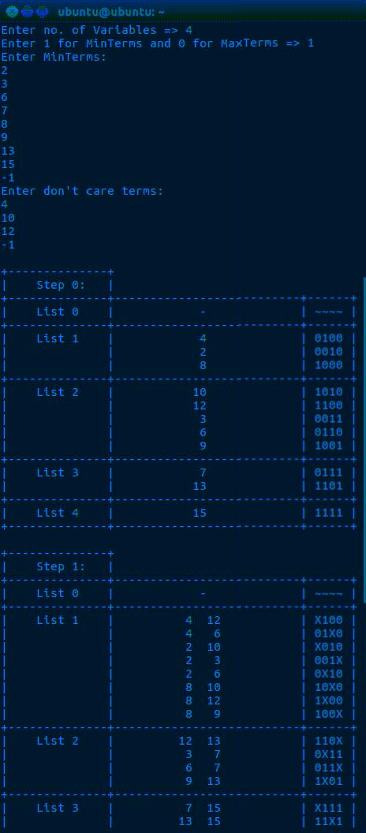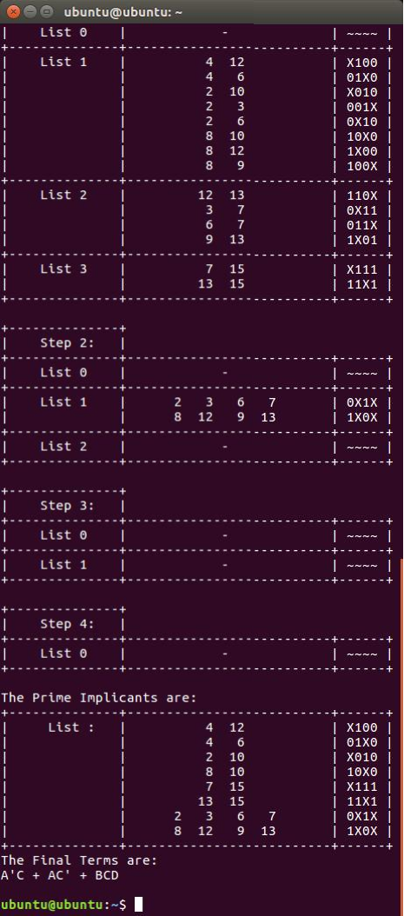

Result

CASE 1 ~> (MIN-TERMS WITH DON’T CARE)

CASE 2 ~> (ONLY MIN-TERMS)

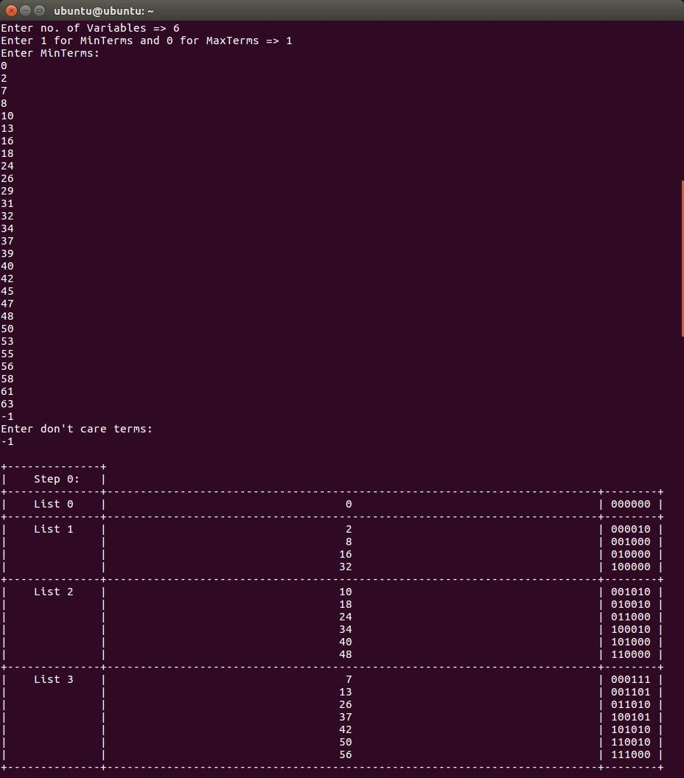

41

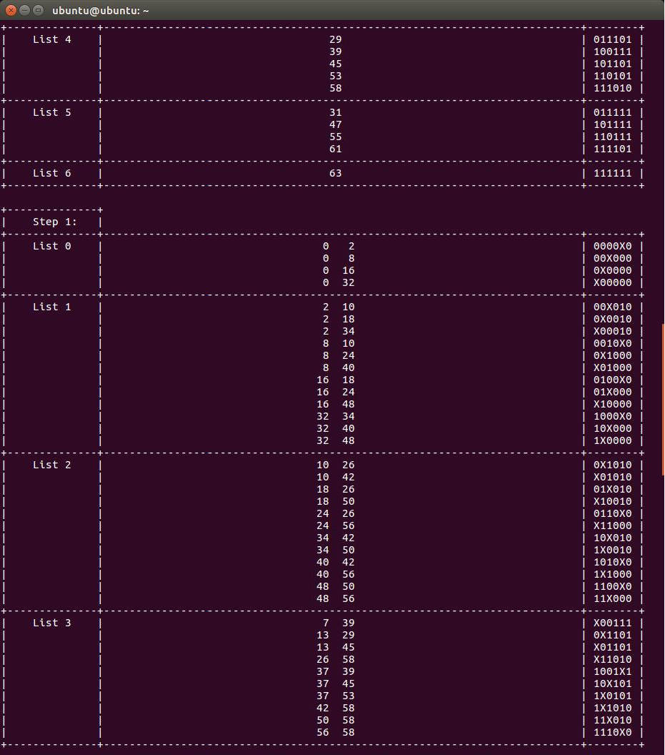

42

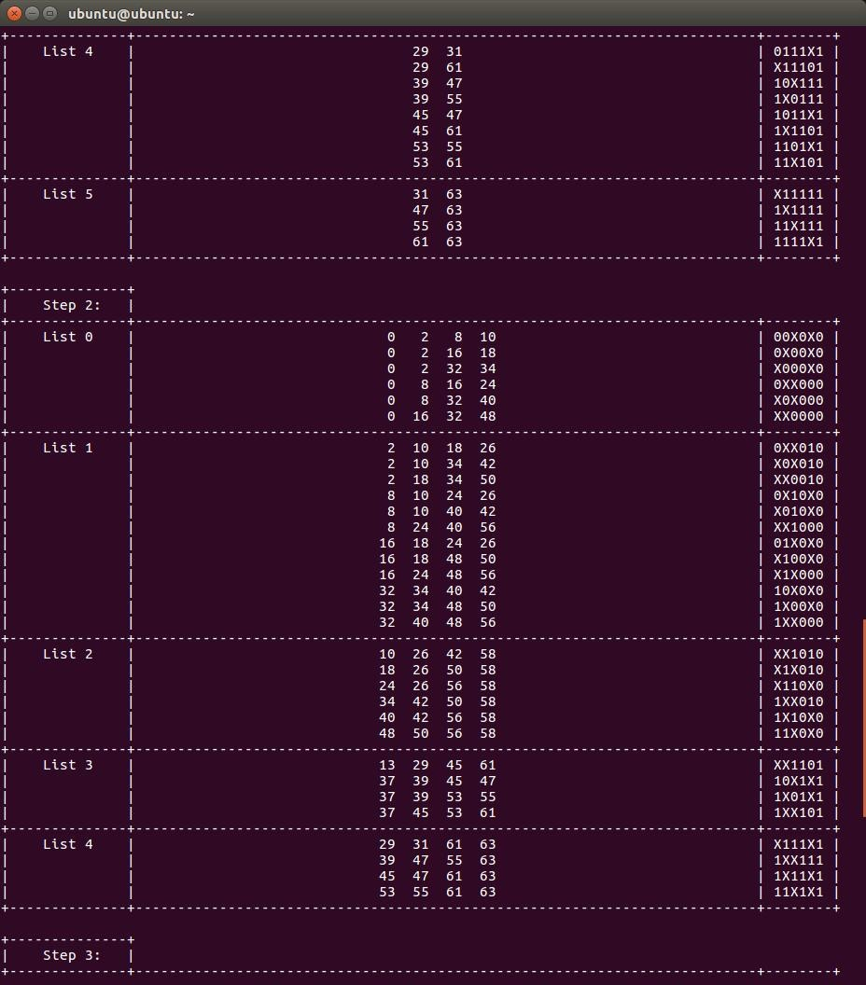

43

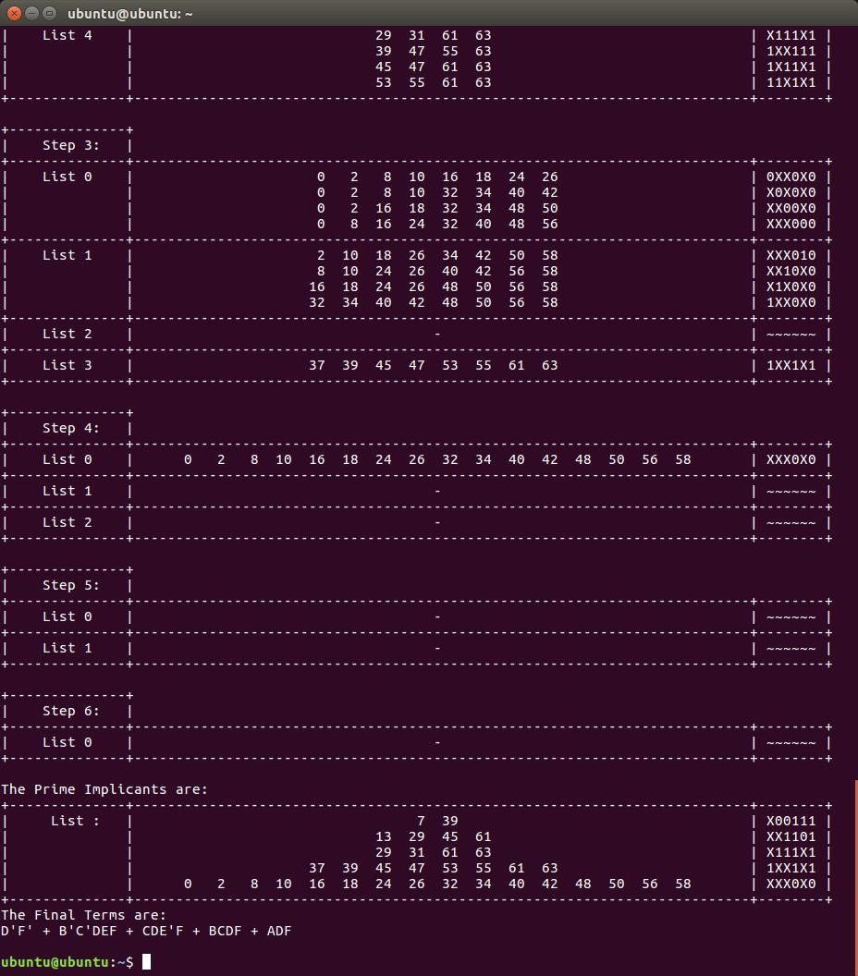

44
CASE 3 ~> (ONLY MIN-TERMS)

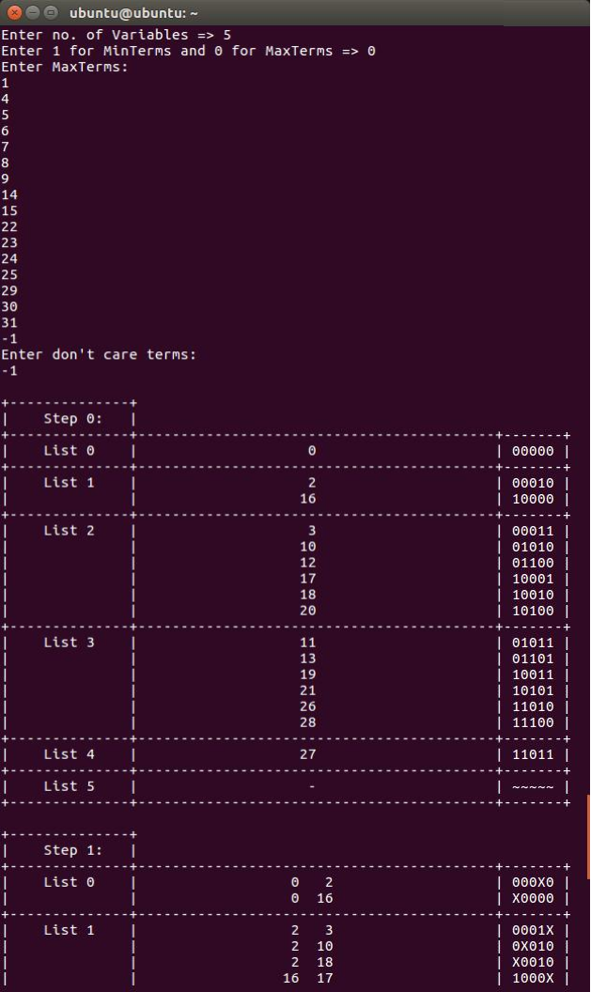

45

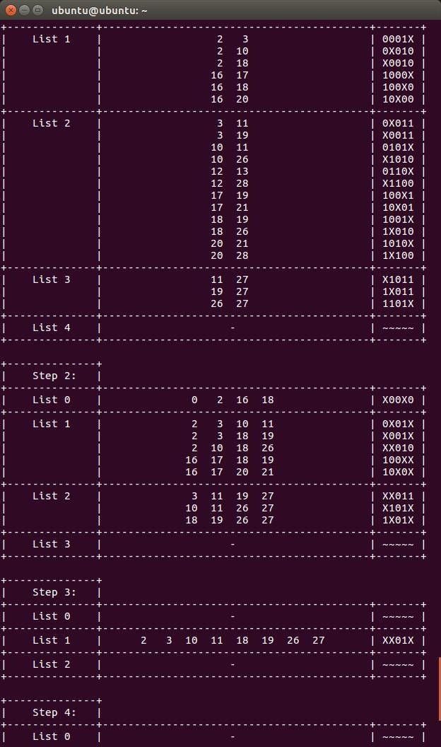

46

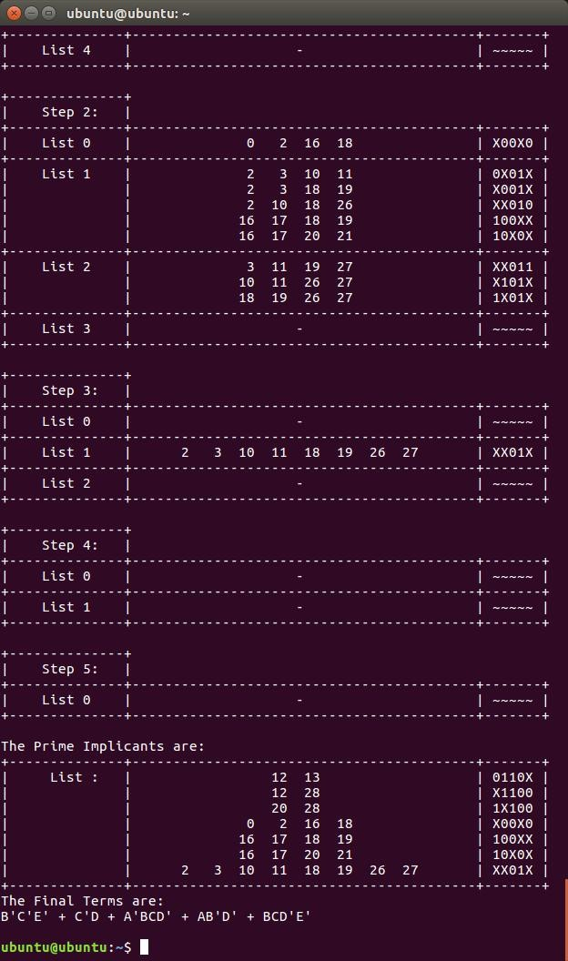

47

Conclusion

The aim of this article is to introduce a QM simulation code based on C program that is able to deal with any number of variables and takes the Don’t-Care condition into consideration, which is not easy to obtain online. Each step of QM method is illustrated in parallel with the corresponding data structure and algorithm used in the program to make it easier to understand. This program is also considered as a good example for practicing program implementation of methods.

Acknowledgment
We, the students of Se-Comp, DBIT would like to Thank Imran
Sir for giving this opportunity to create something out of our curriculum. We would also like to Thank Ditty Ma’am for
teaching us exceptionally and motivating us into doing this
project.

48

