**DATA PIPELINE ASSIGNMENT REPORT**

**Objective**:

To create a data pipeline that extracts data using Python, stores it in cloud storage, and integrates with Snowflake for further processing.

**GitHub Repository:** [Data/Data_Session2 at main · yash-cginfinity-225/Data](https://github.com/yash-cginfinity-225/Data/tree/main/Data_Session2)

**Assignment Tasks:**

1. **Part 1:**

* Use python to extract data in JSON or CSV format using an API request.

CODE:

* Deploy the extraction script on cloud platform.

CODE:

TEST RUN:

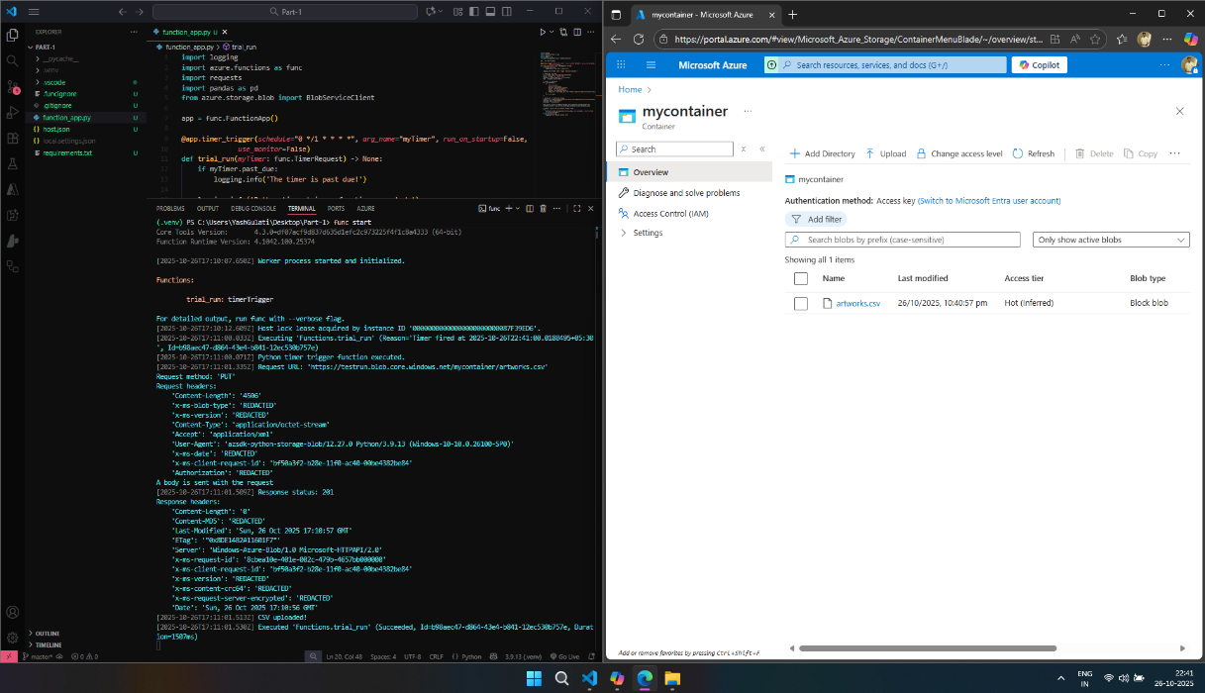

RESULT:

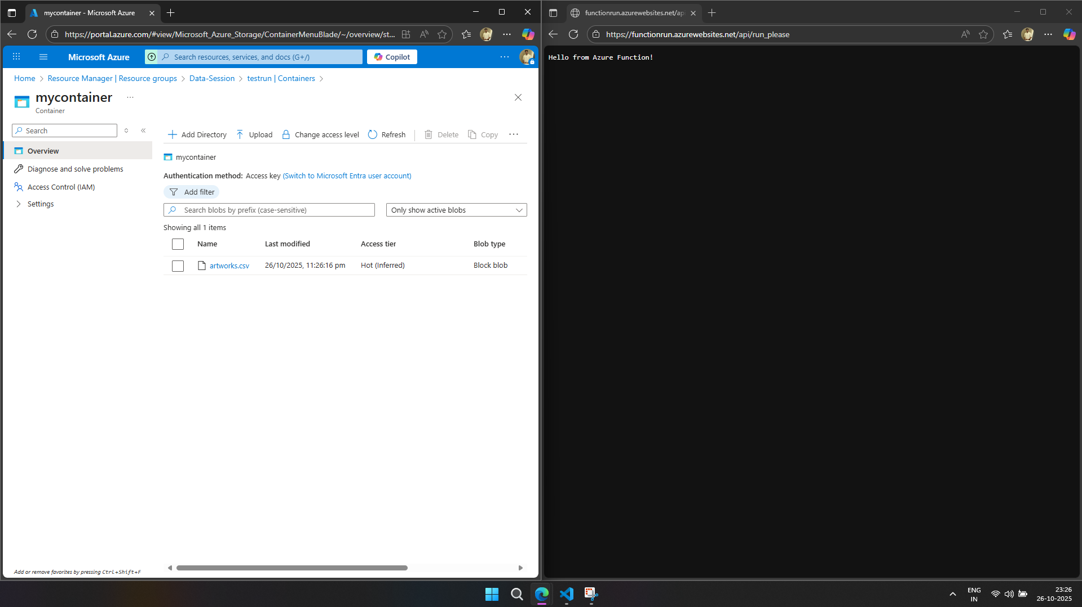

1. **Part 2:**

* Use python to extract data in JSON or CSV format using an API request.

CODE:

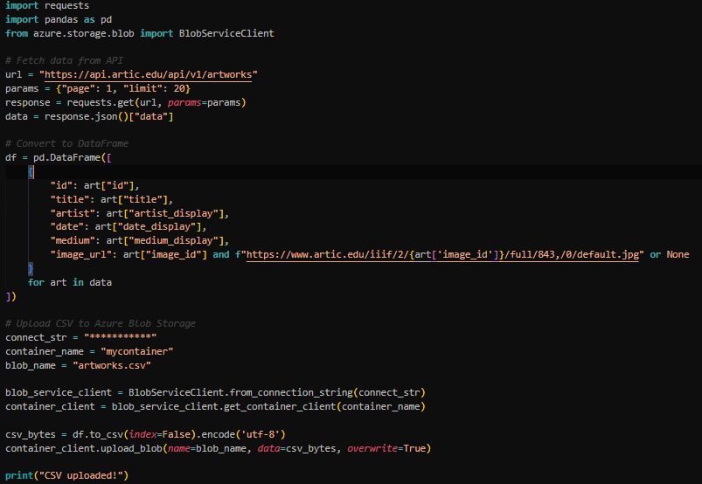

RESULT:

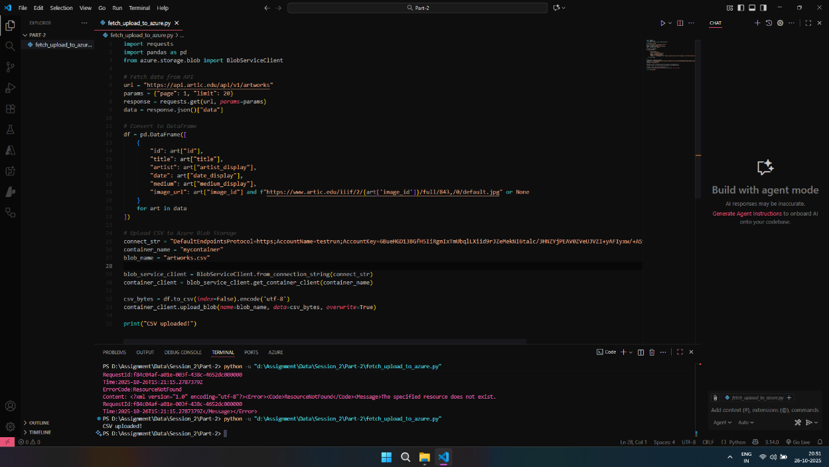

1. **Part 3:**

* Create a table for Raw Data.

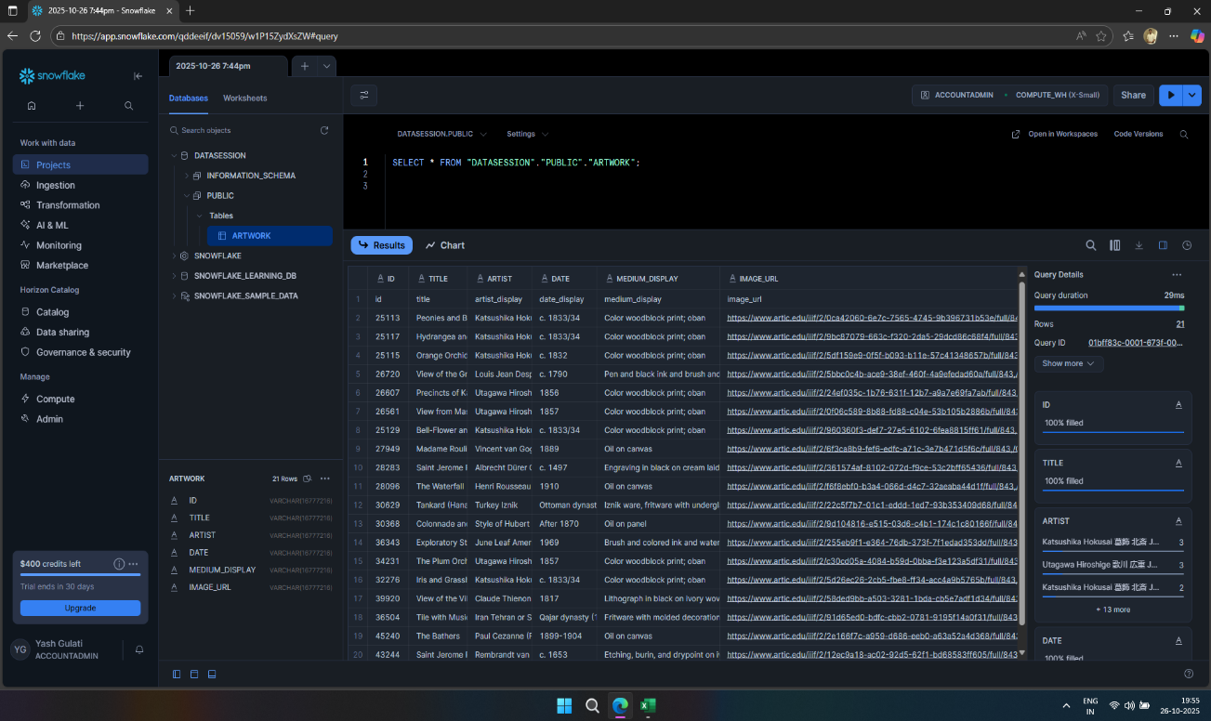

* Create a table for Transformed Data.

