**DATA PIPELINE ASSIGNMENT -2 (DUAL UPLOAD)**

**GITHUB URL:**

[**https://github.com/yash-cginfinity-225/Data_Pipeline_Dual_Upload.git**](https://github.com/yash-cginfinity-225/Data_Pipeline_Dual_Upload.git)

**API:**

* This Azure Function scrapes laptop data from [webscraper.io](https://webscraper.io/test-sites/e-commerce/static/computers/laptops?page=1) and fetches artwork details from the [Art Institute of Chicago API](https://api.artic.edu/api/v1/artworks).
* It processes two pages of laptop listings using BeautifulSoup, extracting titles, prices, and descriptions.
* Simultaneously, it retrieves 20 artworks with metadata like artist, date, and image URL.
* Both datasets are converted into CSV format using pandas and uploaded to Azure Blob Storage in a container named *mycontainer*.
* The function ensures container existence, handles errors gracefully, and logs progress throughout.
* Triggered via HTTP, it completes by returning a success message once both CSVs are uploaded.

**Screenshots:**

**Code Deployed on Azure:**

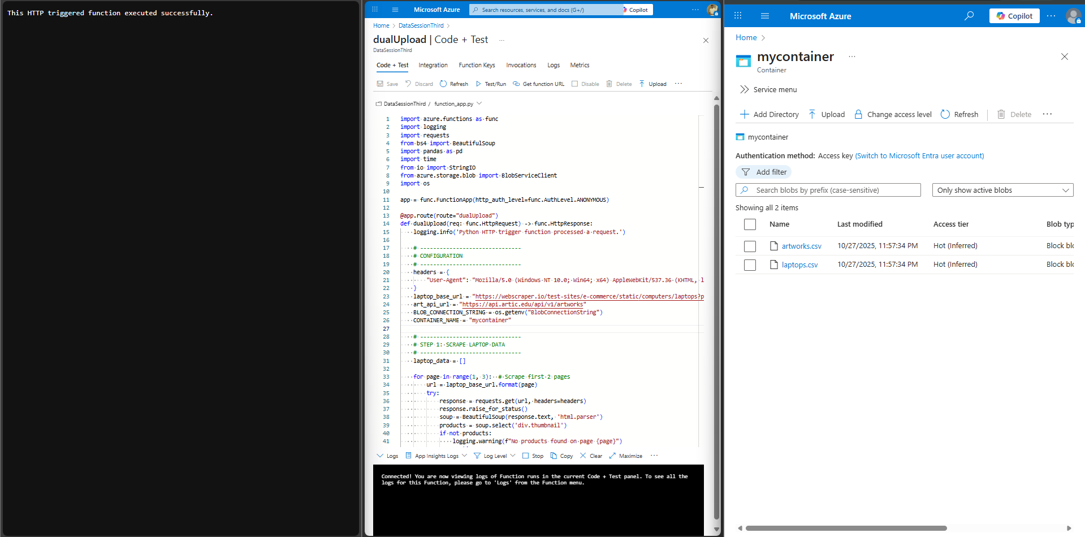

**View Created on Snowflake:**

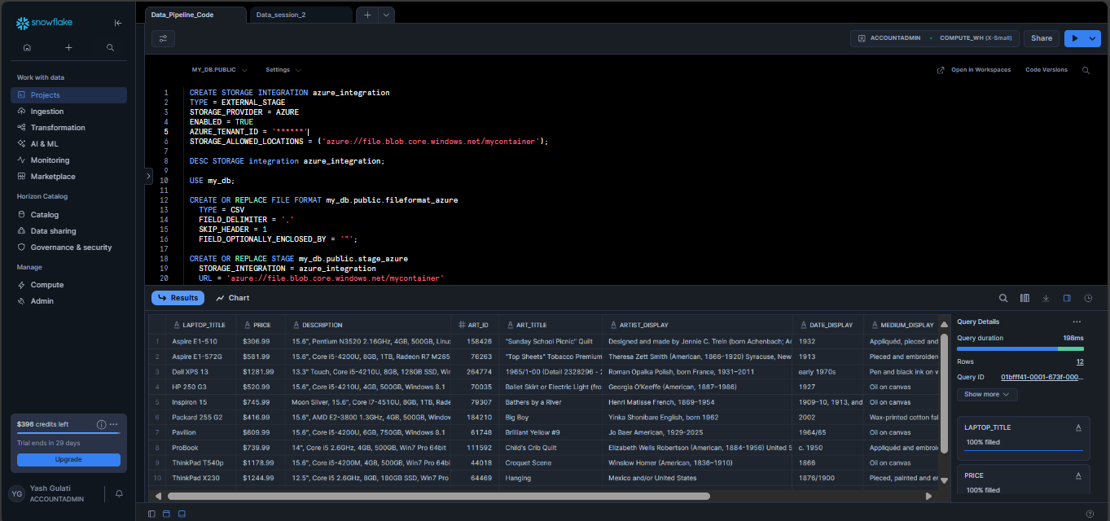

**The Python Script and SQL script are attached in the mail.**