**Question-11 Write a PHP program for student registration.**

**Code-**

**HTML CODE-**

<!DOCTYPE html>

<html lang="en">

<head>

<meta charset="UTF-8">

<meta http-equiv="X-UA-Compatible" content="IE=edge">

<meta name="viewport" content="width=for, initial-scale=1.0">

<title>Document</title>

</head>

<body>

<center>

<h2>Student Registration Form</h2>

<form action="testing.php" method="post">

<label>Name:</label><input type="text" name="name"><br>

<label>Email:</label><input type="email" name="email"><br>

<label>Age:</label><input type="text" name="age"><br>

<label>Address:</label><input type="text" name="address"><br>

<button type="submit" name="submit">Sumbit</button>

</form>

</center>

</body>

</html>

**PHP CODE-**

<?php

$server = "localhost";

$username = "root";

$password = "";

$dbname = "insert";

$conn = mysqli_connect($server, $username, $password, $dbname) ;

if(isset($_POST['submit']))

{

if(!empty($_POST['name']) && !empty($_POST['email']) && !empty($_POST['age']) && !empty($_POST['address']))

{

$name = $_POST['name'];

$email = $_POST['email'];

$age = $_POST['age'];

$address = $_POST['address'];

$query = "insert into form (name,email,age,address) values('$name', '$email', '$age', '$address')" ;

$run = mysqli_query($conn,$query) or die(mysqli_error());

if($run)

{

echo "submit success";

}

else{

echo"no";

}

}

else

{

echo "all required";

}

}

?>

**OUTPUT-**

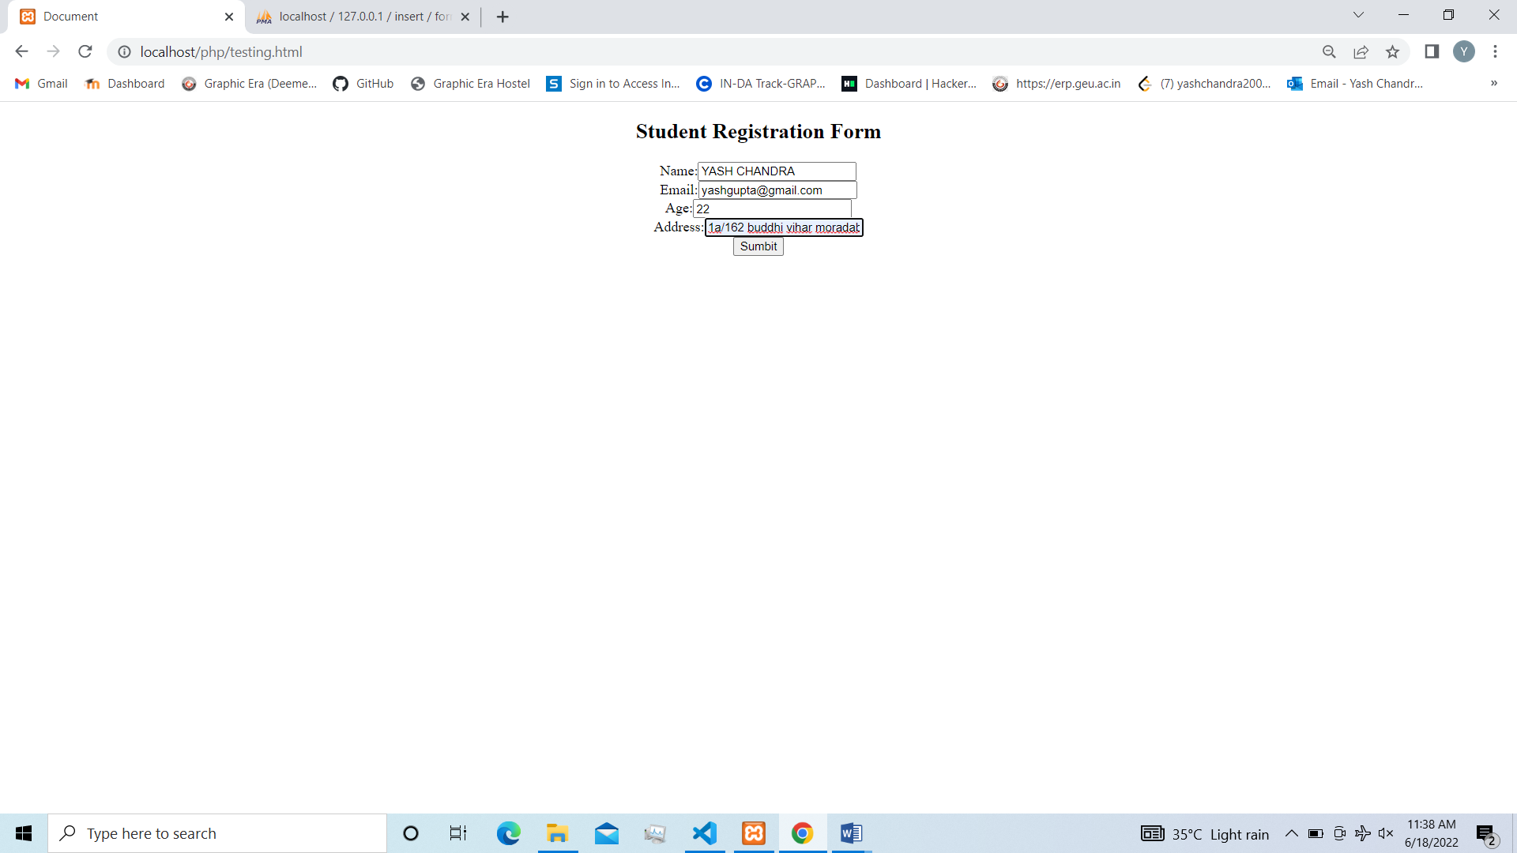

**After Submit-**

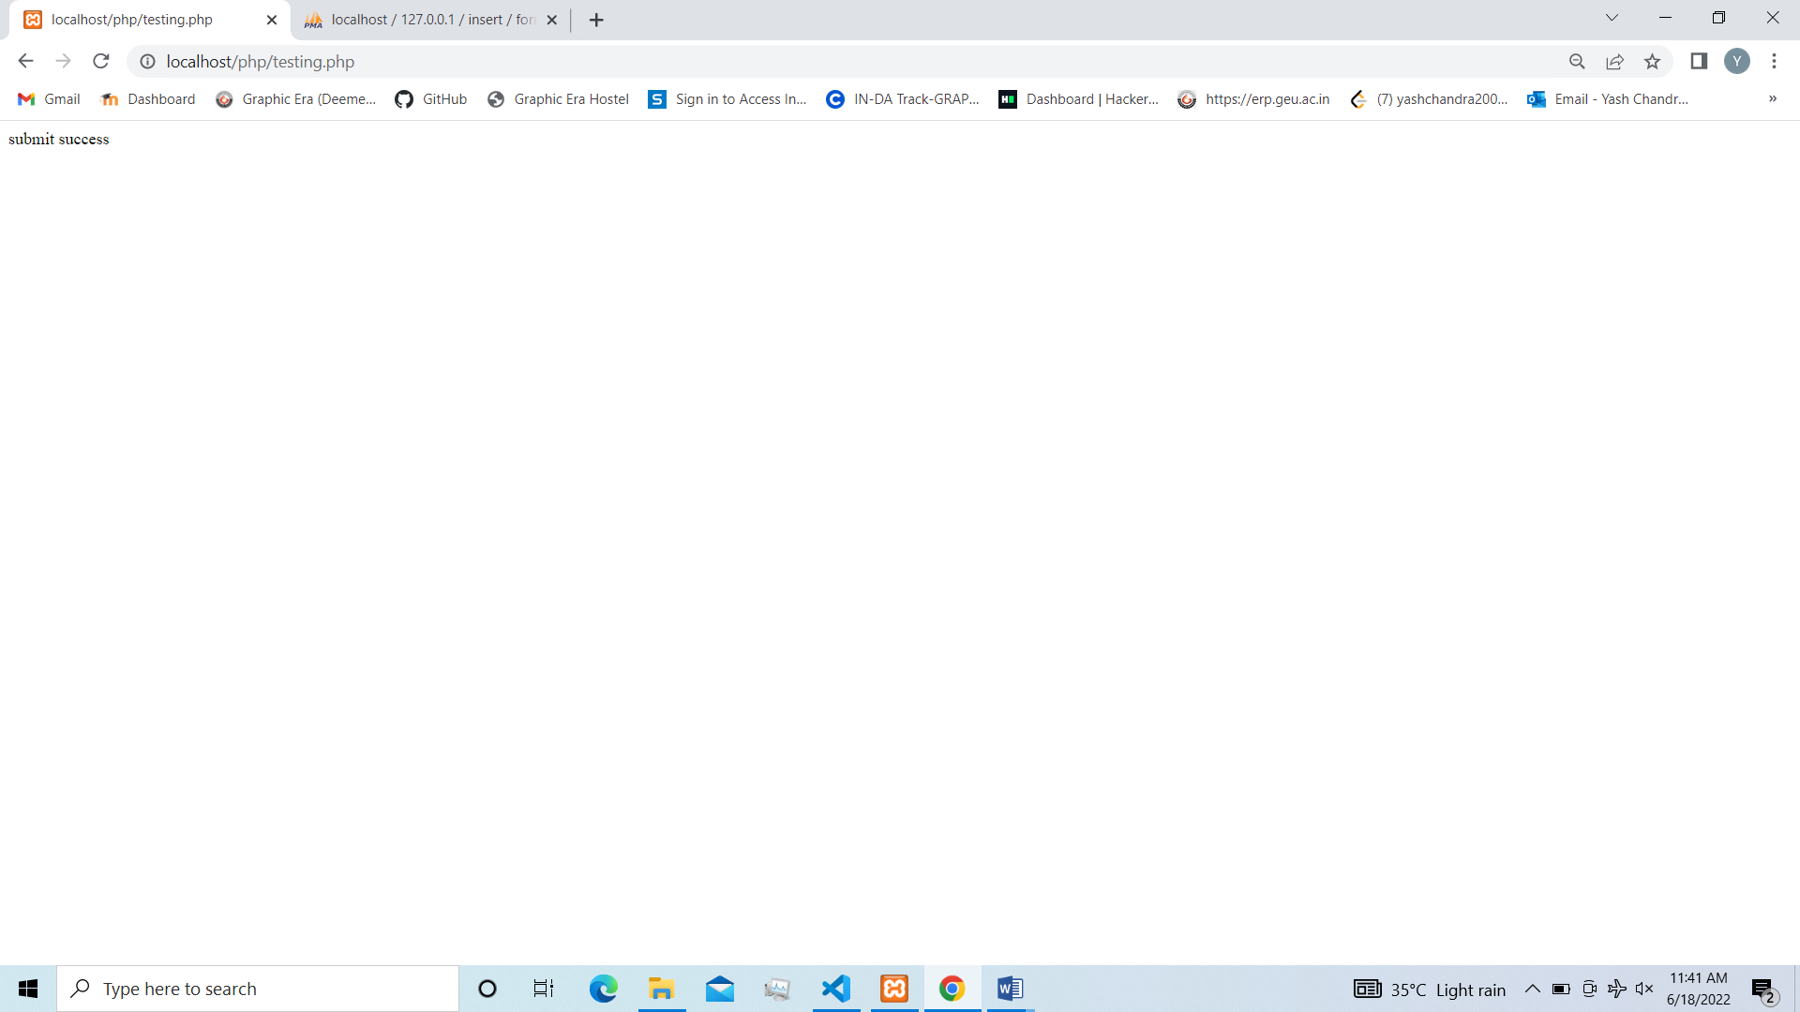

**Database Record-**

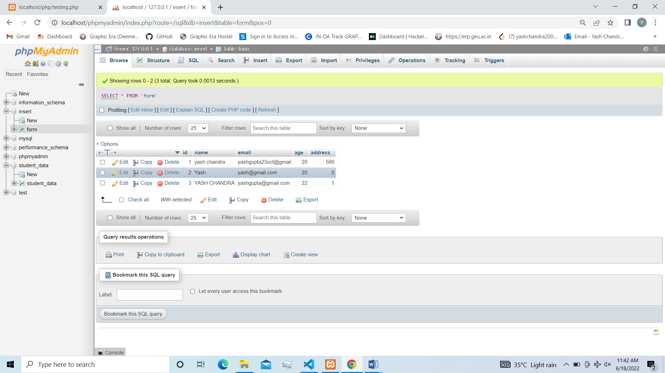

**Question-12 Write a PHP program to open a text file in ‘W’ Mode and inserting the text into a file and then read the text from file**

**Code-**

**PHP CODE –**

<?php

$myfile = fopen("newfile1.txt", "w") or die("Unable to open file!");

$txt = "Yash\n";

fwrite($myfile, $txt);

$txt = "Chandra \n";

fwrite($myfile, $txt);

fclose($myfile);

$myfile = fopen("newfile1.txt", "r") or die("Unable to open file!");

echo fread($myfile,filesize("newfile1.txt"));

fclose($myfile);

?>

**Output-**

**1. On Webpage-**

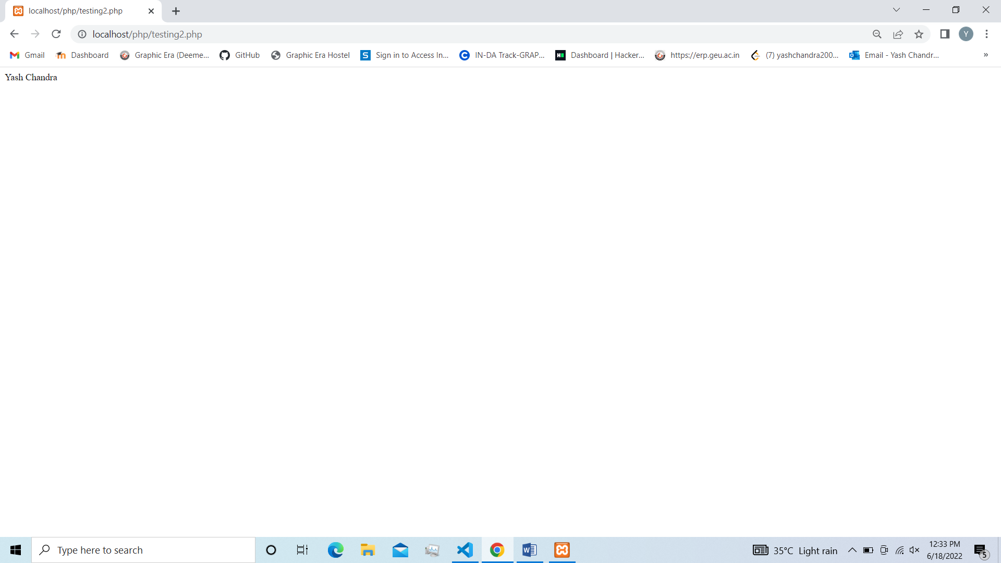

**2. Text file view-**

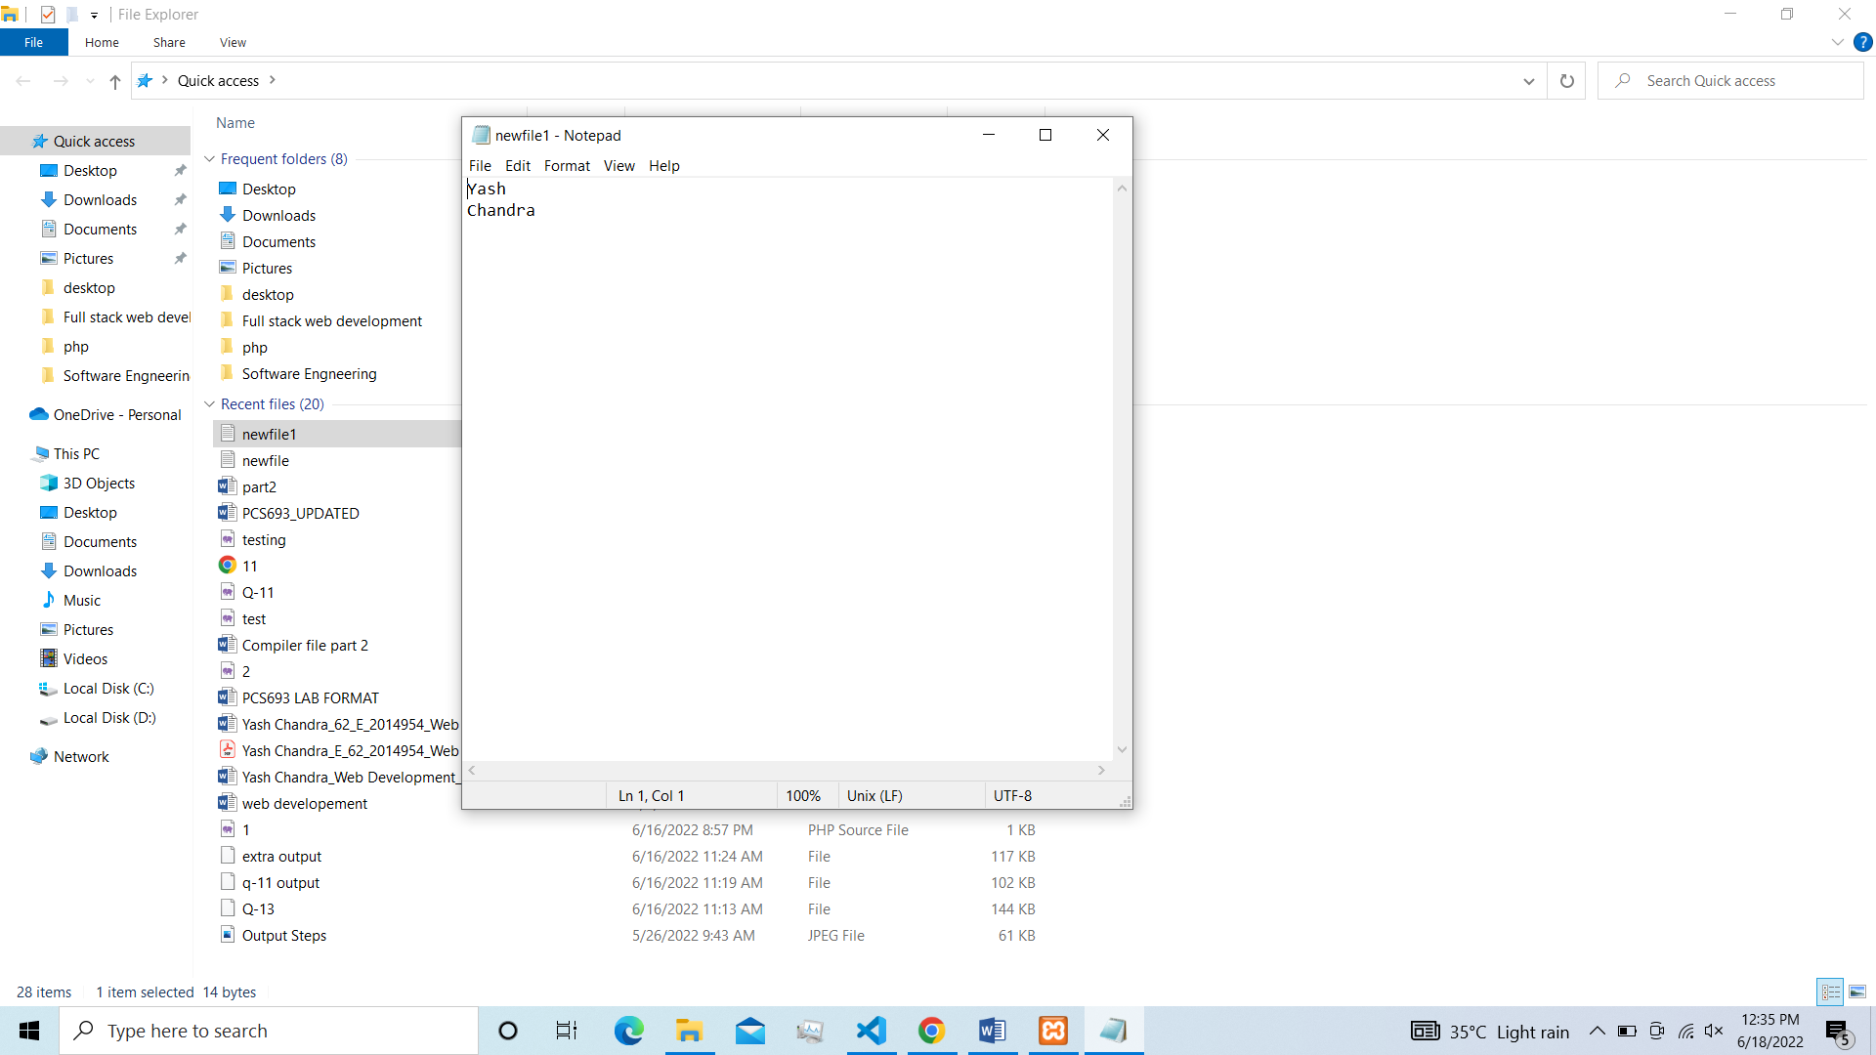

**Question-13 Write a PHP program to implement include and require.**

**Code-**

**Using Require-**

**File name- yash.php**

<?php

echo "I am Yash Chandra Be Happy and Spread Love here using require";

?>

**File name- Testing3.php**

<html>

<body>

<h1>Welcome to my home page!</h1>

<p>Some text.</p>

<p>Some more text.</p>

<?php require 'yash.php';?>

</body>

</html>

**File name- yash.php**

<?php

echo "I am Yash Chandra Be Happy and Spread Love here using include";

?>

**File name- testing3.php**

<html>

<body>

<h1>Welcome to my home page!</h1>

<p>Some text.</p>

<p>Some more text.</p>

<?php include 'yash.php';?>

</body>

</html>

**Output-**

**1. Using require**

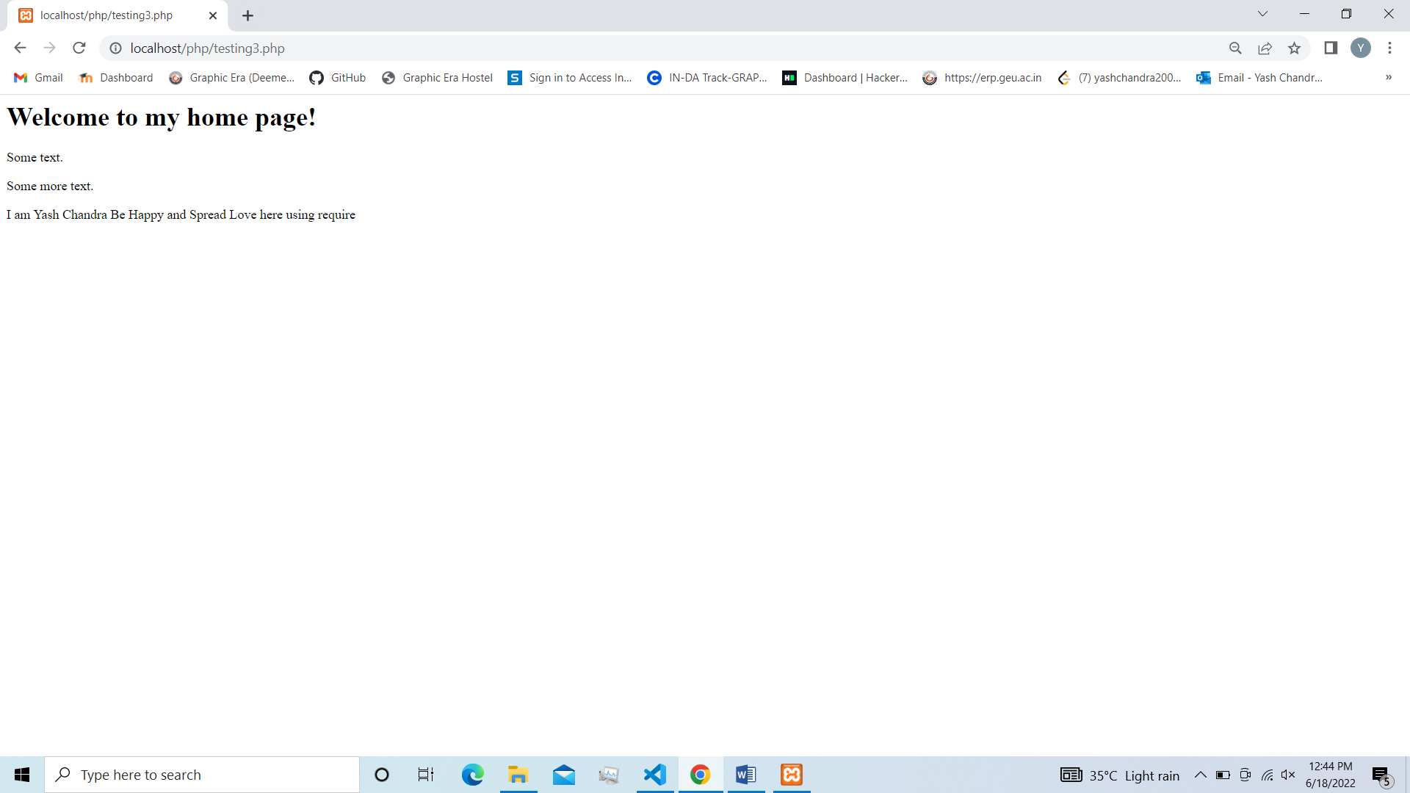

**2. Using include-**

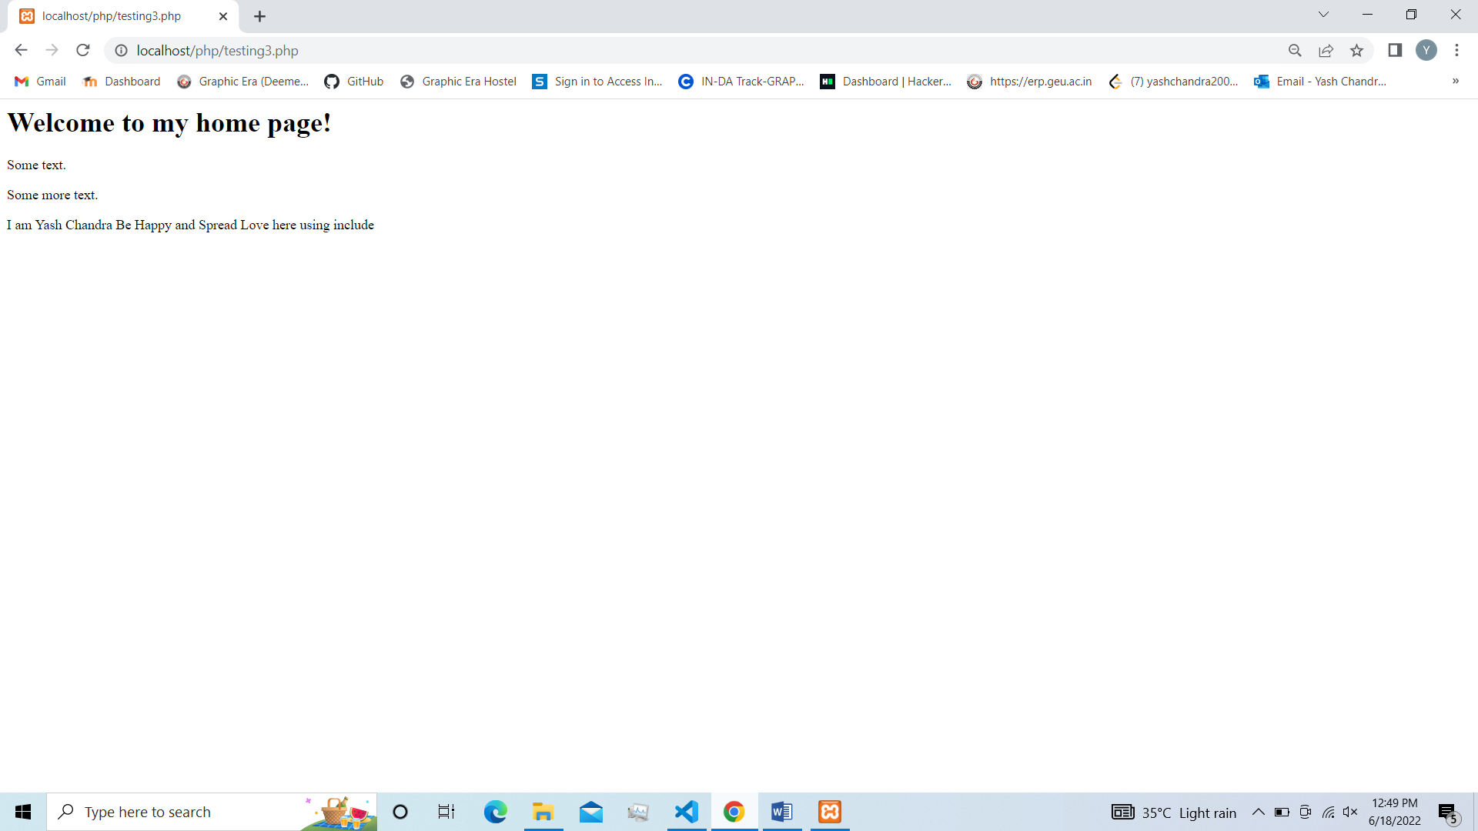

**Question-14** **Write a PHP program to connect a database and check the connection is successful or not.**

**Code-**

<?php

$server = "localhost";

$username = "root";

$password = "";

$con = mysqli_connect($server, $username, $password);

if(!$con)

{

die("Connection to this database failed due to ".mysqli_connect_error());

}

echo "Success Connecting to the db";

?>

**Output-**

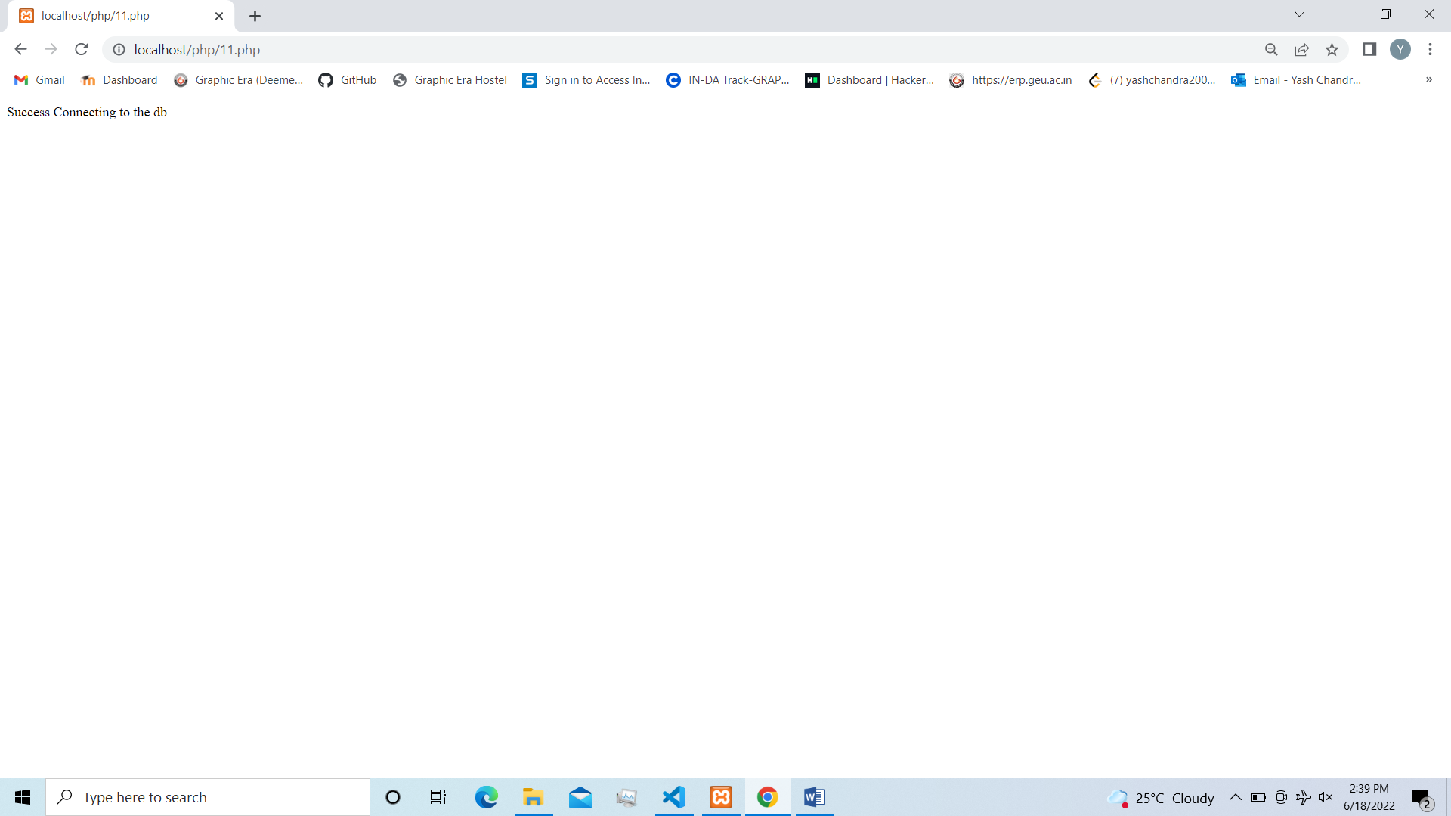

**Question-15** **Write a PHP program to create, insert, update, delete data in database using SQL queries.**

**Code-**

**File Name- action_form.php**

<!DOCTYPE html>

<html>

<head>

<base href="http://localhost/PHP/PCS%20693%20(Web%20Development%20Lab)/Assignment%209/Question%202/" />

<script>

function check() {

if (document.getElementsByName('action_dropdown')[0].value == '') {

alert('Please select an option !')

return false;

}

return true;

}

</script>

<style>

form {

border: 2px black solid;

padding: 15px;

background-color: lemonchiffon;

margin: auto;

width: 60%;

}

body { background-color: rgb(241, 216, 208); }

</style>

</head>

<?php

if (isset($_POST["submit"])) {

$action = $_POST["action_dropdown"];

switch($action) {

case "insert": header("Location: insert.php");

break;

case "view": header("Location: view.php");

break;

case "update": header("Location: update.php");

break;

case "delete": header("Location: delete.php");

break;

}

}

?>

<body>

<form method="post" action="action_form.php" target="output" onsubmit="return check()">

<legend><b><big> Employee Database </big></b></legend>

<table cellpadding="6">

<tr>

<td> Select an action </td>

<td>

<select name="action_dropdown">

<option value="" selected> select... </option>

<option value="insert"> Insert Record </option>

<option value="view"> View Data </option>

<option value="update"> Update Record </option>

<option value="delete"> Delete Record </option>

</select>

</td>

</tr>

<tr> <td> <input type="submit" name="submit" /> </td> </tr>

</table>

</form>

</body>

</html>

**File Name- delete.php**

<!DOCTYPE html>

<html>

<head>

<script src="validationscript.js"> </script>

<base href="http://localhost/PHP/PCS%20693%20(Web%20Development%20Lab)/Assignment%209/Question%202/" />

<style>

fieldset {

display: inline;

background-color: rgb(239, 253, 218);

}

body { background-color: rgb(220, 255, 253); }

form { margin: auto; width: 35%; }

</style>

</head>

<?php

$servername = "localhost";

$username = "root";

$password = "";

$dbname = "mysql";

# Establishing connection

$conn = mysqli_connect($servername, $username, $password, $dbname);

if (!$conn) {

die("Error connecting to the server: ".mysqli_connect_error());

}

$msg = "<br><br>";

if (isset($_POST["submit"])) {

$code = $_POST["ecode"];

# Check if any record exists with code as inputted by user

$check = "select * from EMP where CODE = '$code'";

$result = mysqli_query($conn, $check);

if (mysqli_num_rows($result) == 0) { # No record found

$msg .= ">> NO RECORD EXISTS WITH CODE AS '$code' !";

}

else { # Record exists

# Delete query

$query = "delete from EMP where CODE = '$code'";

if (mysqli_query($conn, $query)) {

$msg .= ">> RECORD DELETED SUCCESSFULLY !";

}

else {

$msg .= ">> ERROR DELETING THE RECORD: " . mysqli_error($conn);

}

}

}

# Terminating the connection

mysqli_close($conn);

?>

<body>

<form method="post" action="delete.php" autocomplete="off" onsubmit="return validate()">

<fieldset>

<legend><b><big> Delete Record </big></b></legend>

<table cellpadding="6">

<tr>

<td> Code </td>

<td> <input type="text" name="ecode" size="25" placeholder="Employee Code" autofocus required /> </td>

</tr>

<tr> <td> <input type="submit" name="submit" /> </td> </tr>

</table>

</fieldset>

<?php echo $msg ?>

</form>

</body>

</html>

**File name- insert.php**

<!DOCTYPE html>

<html>

<head>

<script src="validationscript.js"> </script>

<base href="http://localhost/PHP/PCS%20693%20(Web%20Development%20Lab)/Assignment%209/Question%202/" />

<style>

fieldset {

display: inline;

background-color: rgb(239, 253, 218);

}

body { background-color: rgb(220, 255, 253); }

form { margin: auto; width: 35%; }

</style>

</head>

<?php

$servername = "localhost";

$username = "root";

$password = "";

$dbname = "mysql";

# Establishing connection

$conn = mysqli_connect($servername, $username, $password, $dbname);

if (!$conn) {

die(">> ERROR CONNECTING TO THE SERVER: ".mysqli_connect_error());

}

$msg = "<br><br>";

if (isset($_POST["submit"])) {

$name = $_POST["ename"];

$code = $_POST["ecode"];

$desig = $_POST["edesig"];

$sal = $_POST["esal"];

# Insert query

$query = "insert into EMP values('$name', '$code', '$desig', '$sal')";

if (mysqli_query($conn, $query)) {

$msg .= ">> RECORD INSERTED SUCCESSFULLY !";

}

else {

$msg .= ">> ERROR INSERTING THE RECORD: ".mysqli_error();

}

}

# Terminating the connection

mysqli_close($conn);

?>

<body>

<form method="post" action="insert.php" autocomplete="off" onsubmit="return validate()">

<fieldset>

<legend><b><big> Insert Record </big></b></legend>

<table cellpadding="6">

<tr>

<td> Name </td>

<td> <input type="text" name="ename" size="25" placeholder="Employee Name" autofocus required /> </td>

</tr>

<tr>

<td> Code </td>

<td> <input type="text" name="ecode" size="25" placeholder="Employee Code" required /> </td>

</tr>

<tr>

<td> Designation </td>

<td> <input type="text" name="edesig" size="25" placeholder="Employee Designation" required /> </td>

</tr>

<tr>

<td> Salary </td>

<td> <input type="text" name="esal" size="25" placeholder="Employee Salary" required /> </td>

</tr>

<tr> <td> <input type="submit" name="submit" /> </td> </tr>

</table>

</fieldset>

<?php echo $msg ?>

</form>

</body>

</html>

**File name- message.html**

<!DOCTYPE html>

<html>

<body bgcolor="#b5dcb3">

<h2> Content will be displayed here. </h2>

<p> Select an option on the left to get started. </p>

</body>

</html>

**File name- question.html**

<!DOCTYPE html>

<html>

<head>

<title> Question 2 </title>

</head>

<frameset cols="30%, *" noresize="noresize" border="5">

<frame name="form" src="action_form.php">

<frame name="output" src="message.html">

</frameset>

</html>

**File Name- update.php**

<!DOCTYPE html>

<html>

<head>

<script src="validationscript.js"> </script>

<base href="http://localhost/PHP/PCS%20693%20(Web%20Development%20Lab)/Assignment%209/Question%202/" />

<style>

fieldset {

display: inline;

background-color: rgb(239, 253, 218);

}

body { background-color: rgb(220, 255, 253); }

form { margin: auto; width: 35%; }

</style>

</head>

<?php

$servername = "localhost";

$username = "root";

$password = "";

$dbname = "mysql";

# Establishing connection

$conn = mysqli_connect($servername, $username, $password, $dbname);

if (!$conn) {

die(">> ERROR CONNECTING TO THE SERVER: ".mysqli_connect_error());

}

$msg = "<br><br>";

if (isset($_POST["submit"])) {

$code = $_POST["ecode"];

$sal = $_POST["esal"];

# Check if any record exists with code as inputted by user

$check = "select * from EMP where CODE = '$code'";

$result = mysqli_query($conn, $check);

if (mysqli_num_rows($result) == 0) { # No record found

$msg .= ">> NO RECORD EXISTS WITH CODE AS '$code' !";

}

else { # Record exists

# Update query

$query = "update EMP set SALARY = '$sal' where CODE = '$code'";

if (mysqli_query($conn, $query)) {

$msg .= ">> RECORD UPDATED SUCCESSFULLY !";

}

else {

$msg .= "ERROR UPDATING THE RECORD: " . mysqli_error($conn);

}

}

}

# Terminating the connection

mysqli_close($conn);

?>

<body>

<form method="post" action="update.php" autocomplete="off" onsubmit="return validate()">

<fieldset>

<legend><b><big> Update Record </big></b></legend>

<table cellpadding="6">

<tr>

<td> Code </td>

<td> <input type="text" name="ecode" size="25" placeholder="Employee Code" autofocus required /> </td>

</tr>

<tr>

<td> New Salary </td>

<td> <input type="text" name="esal" size="25" placeholder="Employee Salary" required /> </td>

</tr>

<tr> <td> <input type="submit" name="submit" /> </td> </tr>

</table>

</fieldset>

<?php echo $msg ?>

</form>

</body>

</html>

**File Name- validationscripit.js**

function normal(elem) {

elem.style.border = "";

elem.style.backgroundColor = "";

}

function validate() {

var name = document.getElementsByName('ename')[0];

var code = document.getElementsByName('ecode')[0];

var desig = document.getElementsByName('edesig')[0];

var sal = document.getElementsByName('esal')[0];

var error_fields = [];

var msg = "Enter a valid: \n";

if (typeof name !== "undefined") {

const name_re = /^[A-Z][a-z]+([\s][A-Z][a-z]+)*$/;

if (!name_re.test(name.value)) {

msg += "> Name\n";

error_fields.push(name);

}

else { normal(name); }

}

if (typeof code !== "undefined") {

const code_re = /^[\d]+$/;

if (!code_re.test(code.value)) {

msg += "> Code\n";

error_fields.push(code);

}

else { normal(code); }

}

if (typeof desig !== "undefined") {

const desig_re = /^[A-Z][A-Za-z]+([\s][A-z][a-z]+)*$/;

if (!desig_re.test(desig.value)) {

msg += "> Designation\n";

error_fields.push(desig);

}

else { normal(desig); }

}

if (typeof sal !== "undefined") {

const sal_re = /^[\d]+$/;

if (!sal_re.test(sal.value)) {

msg += "> Salary\n";

error_fields.push(sal);

}

else { normal(sal); }

}

if (error_fields.length > 0) {

for (ef of error_fields) {

ef.style.border = "solid red 2px";

ef.style.backgroundColor = "rgb(255, 212, 212)"

}

alert(msg);

error_fields[0].focus();

return false;

}

return true;

}

**File Name- view.php**

<!DOCTYPE html>

<html>

<head>

<style>

table {

background-color: rgb(239, 253, 218);

margin: auto; width: 35%;

}

body { background-color: rgb(220, 255, 253); }

</style>

</head>

<body>

<?php

$servername = "localhost";

$username = "root";

$password = "";

$dbname = "mysql";

# Establishing connection

$conn = mysqli_connect($servername, $username, $password, $dbname);

if (!$conn) {

die("Error connecting to the server: ".mysqli_connect_error());

}

# Select query

$query = "select * from EMP";

$result = mysqli_query($conn, $query);

if (mysqli_num_rows($result) > 0) {

echo "<table border='1' cellpadding='5'>";

echo "<caption style='padding: 5px;'> EMPLOYEES' DATA </caption>";

echo "<tr>";

echo "<th> Code </th>";

echo "<th> Name </th>";

echo "<th> Designation </th>";

echo "<th> Fee </th>";

echo "</tr>";

while ($row = mysqli_fetch_array($result)) {

$n = $row[0]; $c = $row[1]; $d = $row[2]; $s = $row[3];

echo "<tr>";

echo "<td> $c </td>";

echo "<td> $n </td>";

echo "<td> $d </td>";

echo "<td> $s </td>";

echo "</tr>";

}

echo "</table>";

# Freeing memory of result set

mysqli_free_result($result);

}

else { # No record found

echo "<br><br>>> NO MATCHING RECORDS FOUND !";

}

# Terminating the connection

mysqli_close($conn);

?>

</body>

</html>

**Output-**

**1.Main page**



**2. Insert Record**



**3.View data**

**4.Update Record**

**5.Delete Record**

**Question-16 Write a JQUERY program to display JSON data.**

**Code-**

**File Name- details.json**

[

{ "Username": "user-1", "Noofquestions": "150", "TotalScore": "100", "Articles": "30" },

{ "Username": "user-2", "Noofquestions": "100", "TotalScore": "75", "Articles": "30" },

{ "Username": "user-3", "Noofquestions": "200", "TotalScore": "50", "Articles": "10" },

{ "Username": "user-4", "Noofquestions": "50", "TotalScore": "5", "Articles": "2" },

{ "Username": "user-5", "Noofquestions": "0", "TotalScore": "0", "Articles": "1" }

]

**File Name- testing4.php**

<html lang="en">

<head>

<meta charset="UTF-8">

<title></title>

<!-- INCLUDING JQUERY-->

<script src=

"https://code.jquery.com/jquery-3.5.1.js">

</script>

<!-- CSS FOR STYLING THE PAGE -->

<style>

table {

margin: 0 auto;

font-size: large;

border: 1px solid black;

}

h1 {

text-align: center;

color: #006600;

font-size: xx-large;

font-family: 'Gill Sans',

'Gill Sans MT', ' Calibri',

'Trebuchet MS', 'sans-serif';

}

td {

background-color: #E4F5D4;

border: 1px solid black;

}

th,td {

font-weight: bold;

border: 1px solid black;

padding: 10px;

text-align: center;

}

td {

font-weight: lighter;

}

</style>

</head>

<body>

<section>

<h1>Yash Chandra</h1>

<!-- TABLE CONSTRUCTION-->

<table id='table'>

<!-- HEADING FORMATION -->

<tr>

<th>UserHandle</th>

<th>Practice Problems</th>

<th>Coding Score</th>

<th>Articles</th>

</tr>

<script>

$(document).ready(function () {

// FETCHING DATA FROM JSON FILE

$.getJSON("details.json",

function (data) {

var student = '';

// ITERATING THROUGH OBJECTS

$.each(data, function (key, value) {

//CONSTRUCTION OF ROWS HAVING

// DATA FROM JSON OBJECT

student += '<tr>';

student += '<td>' +

value.UserName + '</td>';

student += '<td>' +

value.NoOfProblems + '</td>';

student += '<td>' +

value.TotalScore + '</td>';

student += '<td>' +

value.Articles + '</td>';

student += '</tr>';

});

//INSERTING ROWS INTO TABLE

$('#table').append(student);

});

});

</script>

</section>

</body>

</html>

**Output-**

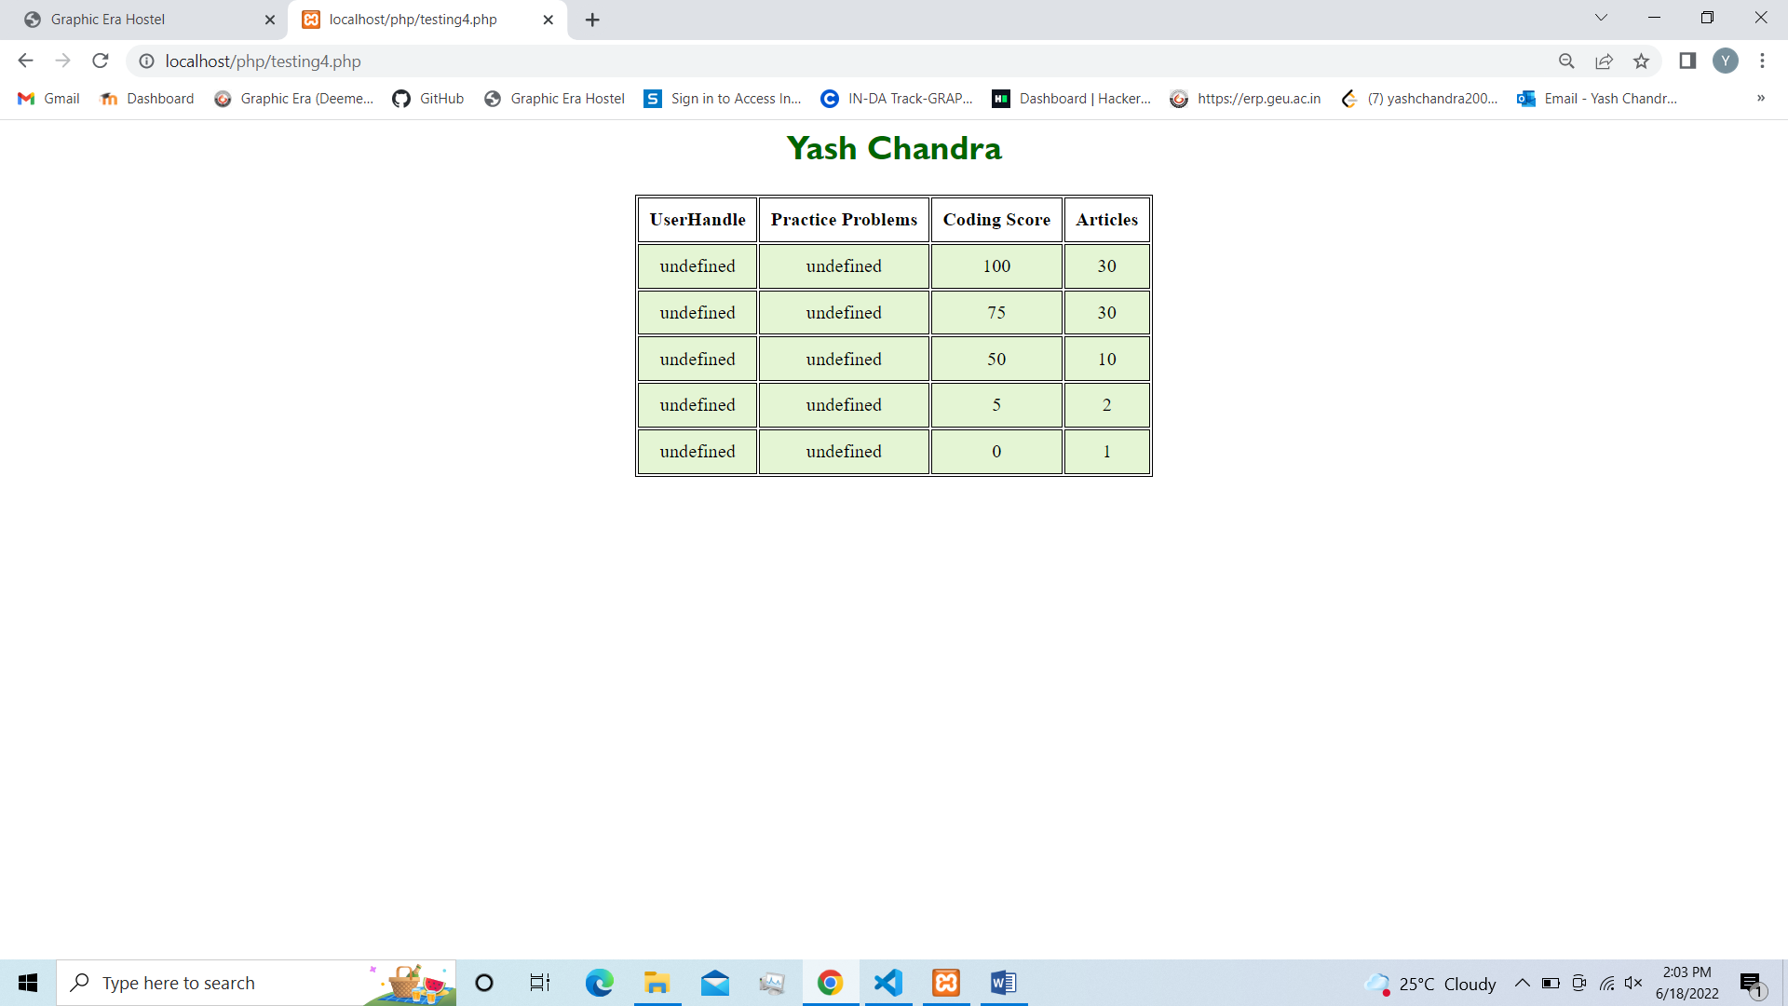

**Index**

|  |  |  |  |
| --- | --- | --- | --- |
| **S.No** | **Program** | **Date** | **Sign.** |
| 1 | Create a Simple Admission Form for University Admission. | 11/03/22 |  |
| 2 | Write a Simple HTML Script to make timetable. | 11/03/22 |  |
| 3 | Write a Program in HTML to implement a frame. | 25/03/22 |  |
| 4 | Write a Program in HTML to implement a table. | 25/03/22 |  |
| 5 | Write a JS function to check weather an ‘input’ is an integer or not. | 01/04/22 |  |
| 6 | Write a JS function to move a circle from top to bottom with 50px. | 01/04/22 |  |
| 7 | Write a JS Program to draw a smiley using  {moveto() function}. | 01/04/22 |  |
| 8 | Write a JS Program to calculate the volume of cube using form. | 01/04/22 |  |
| 9 | Write a JS for loop that iterate from 0 to 100 and check  the number is perfect square or not and display a message in console. | 08/04/22 |  |
| 10 | Write a JS function to check whether a given value is an valid password & mail-id not. | 08/04/22 |  |
| 11 | Write a PHP program for student registration. | 06/05/22 |  |
| 12 | W Write a PHP program to open a text file in ‘W’ Mode and inserting the text into a file and then read the text from file. | 06/05/22 |  |
| 13 | Write a PHP program to implement include and require. | 06/05/22 |  |
| 14 | Write a PHP program to connect a database and check the connection is successful or not. | 13/05/22 |  |
| 15 | Write a PHP program to create, insert, update, delete data in database using SQL queries. | 13/05/22 |  |
| 16 | Write a JQUERY program to display JSON data. | 13/05/22 |  |