TASK-6 solve this problem

1. Extract in year, month,day and use in sales data

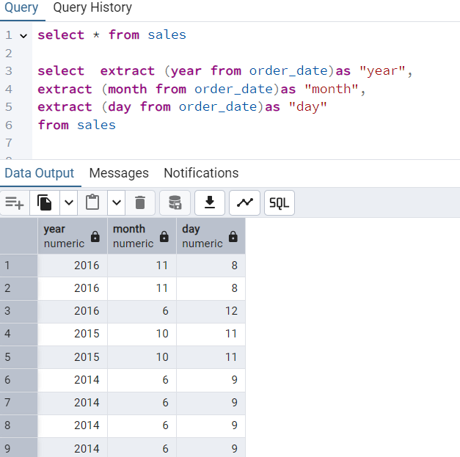

1. Group by using

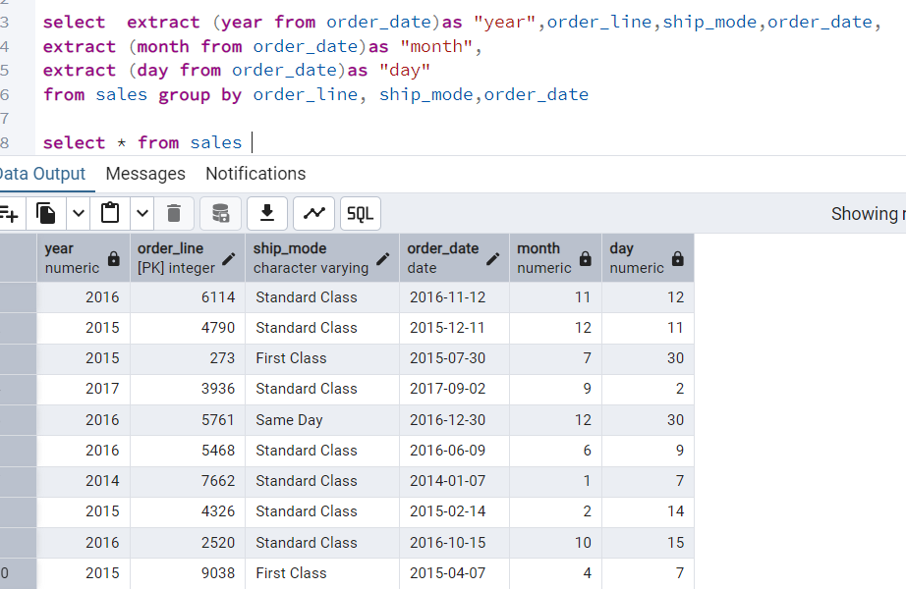

1. Using sum of profit and calculate

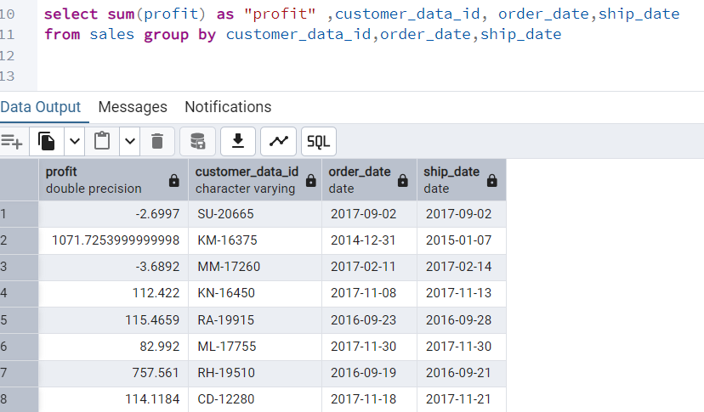

4)using order by 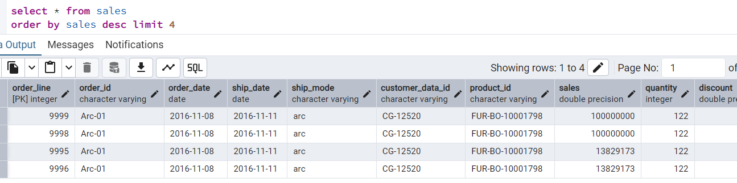

1. Using count of row and column
2. 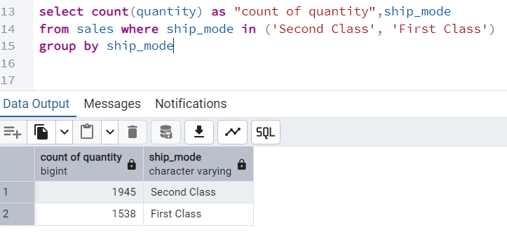

Find a stock on date most order this company

1. 