| **Experiment No.7** |
| --- |
| Aim: To implement Booth’s algorithm using c-programming |
| Name: Yash Rane |
| Roll no: 47 |
| Date of Performance: |
| Date of Submission: |

**Aim:**  To implement Booth’s algorithm using c-programming.

**Objective -**

1. To understand the working of Booths algorithm.
2. To understand how to implement Booth’s algorithm using c-programming.

**Theory:**

Booth’s algorithm is a multiplication algorithm that multiplies two signed binary numbers in 2’s complement notation. Booth used desk calculators that were faster at shifting than adding and created the algorithm to increase their speed.

The algorithm works as per the following conditions :

1. If Qn and Q -1  are same i.e. 00 or 11 perform arithmetic shift by 1 bit.
2. If Qn Q -1 = 10 do A= A - B and perform arithmetic shift by 1 bit.
3. If Qn Q  -1 = 01 do A= A + B and perform arithmetic shift by 1 bit.

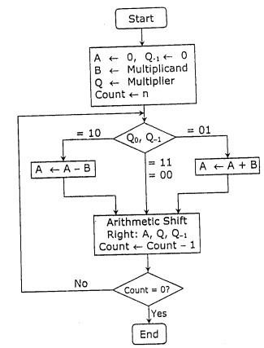

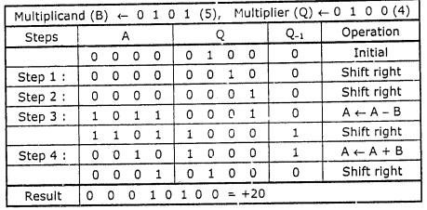

**Program:**  #include <stdio.h> #include <math.h>

int a = 0,b = 0, c = 0, a1 = 0, b1 = 0, com[5] = { 1, 0, 0, 0, 0}; int anum[5] = {0}, anumcp[5] = {0}, bnum[5] = {0}; int acomp[5] = {0}, bcomp[5] = {0}, pro[5] = {0}, res[5] = {0};

void binary(){ a1 = fabs(a); b1 = fabs(b); int r, r2, i, temp; for (i = 0; i < 5; i++){ r = a1 % 2; a1 = a1 / 2; r2 = b1 % 2; b1 = b1 / 2; anum[i] = r; anumcp[i] = r; bnum[i] = r2; if(r2

== 0){ bcomp[i] = 1;

} if(r == 0){ acomp[i] =1;

}

}

//part for two's complementing

c = 0; for ( i = 0; i < 5; i++){ res[i] = com[i]+ bcomp[i] + c; if(res[i] >= 2){ c = 1;

} else

c = 0;

res[i] = res[i] % 2;

} for (i = 4; i >= 0; i--){

bcomp[i] = res[i];

}

//in case of negative inputs if (a < 0){

c = 0; for (i = 4; i >= 0; i--){

res[i] = 0; } for ( i = 0; i < 5; i++){ res[i] =

com[i] + acomp[i] + c; if

(res[i] >= 2){ c = 1;

} else

c = 0;

res[i] = res[i]%2; } for (i = 4; i >= 0; i--){ anum[i] = res[i]; anumcp[i] = res[i];

}

} if(b < 0){

for (i = 0; i < 5; i++){ temp = bnum[i]; bnum[i] = bcomp[i]; bcomp[i] = temp;

}

}

} void add(int num[]){ int i; c = 0; for ( i = 0; i < 5; i++){ res[i] = pro[i] + num[i] + c; if (res[i]

>= 2){ c = 1; } else{

c = 0; } res[i] = res[i]%2;

} for (i = 4; i >= 0; i--){ pro[i] = res[i]; printf("%d",pro[i]);

} printf(":"); for (i = 4; i >= 0; i--){ printf("%d", anumcp[i]);

}

} void arshift(){//for arithmetic shift right int temp = pro[4], temp2 = pro[0], i; for (i = 1; i < 5 ; i++){//shift the MSB of product

pro[i-1] = pro[i];

}

pro[4] = temp; for (i = 1; i < 5 ; i++){//shift the LSB of product

anumcp[i-1] = anumcp[i];

}

anumcp[4] = temp2; printf("\nARSHIFT: ");//display together for (i = 4; i

>= 0; i--){ printf("%d",pro[i]);

} printf(":"); for(i =

4; i >= 0; i--){ printf("%d", anumcp[i]);

}

}

void main(){

int i, q = 0;

printf("\t\tBOOTH'S MULTIPLICATION ALGORITHM"); printf("\nEnter two numbers to multiply:

"); printf("\nBoth must be less than 16");

//simulating for two numbers each below 16 do{ printf("\nEnter A: "); scanf("%d",&a); printf("Enter B: "); scanf("%d", &b); }while(a >=16 || b >=16);

printf("\nExpected product = %d", a * b); binary(); printf("\n\nBinary Equivalents are: "); printf("\nA = "); for (i = 4; i >= 0; i--){

printf("%d", anum[i]);

} printf("\nB = "); for

(i = 4; i >= 0; i--){ printf("%d", bnum[i]);

} printf("\nB'+ 1 = ");

for (i = 4; i >= 0; i--){

printf("%d", bcomp[i]);

} printf("\n\n"); for (i = 0;i < 5; i++){ if

(anum[i] == q){//just shift for 00 or 11 printf("\n--

>"); arshift(); q = anum[i];

}

else if(anum[i] == 1 && q == 0){//subtract and shift for 10

printf("\n-->"); printf("\nSUB B: "); add(bcomp);//add two's complement to implement subtraction arshift(); q = anum[i];

} else{//add ans shift for 01 printf("\n-->");

printf("\nADD B: "); add(bnum);

arshift(); q

= anum[i];

}

}

printf("\nProduct is = ");

for (i = 4; i >= 0; i--){ printf("%d", pro[i]);

}

for (i = 4; i >= 0; i--){ printf("%d", anumcp[i]);

}

}

**Output:**

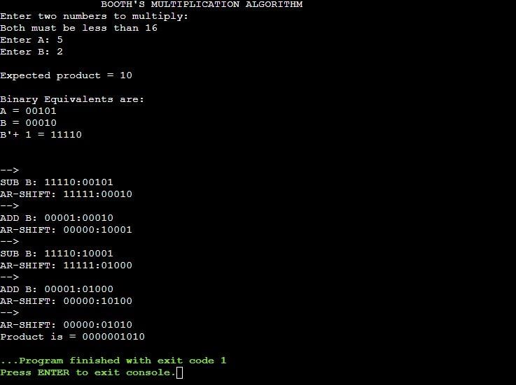

**Conclusion -**

Implementing Booth's algorithm in C provides an efficient method for multiplying binary numbers using signed integers. This algorithm reduces the complexity of multiplication by transforming the problem into a series of shifts and adds, leveraging the properties of binary arithmetic. By coding Booth's algorithm, you can effectively handle signed multiplication operations, which is particularly useful in low-level programming and digital systems design. The algorithm's systematic approach ensures that multiplication operations are performed accurately and efficiently, even when dealing with negative numbers.