

SCHOOL OF ENGINEERING AND TECHNOLOGY

Department of Computer Science and Engineering

Jain Global Campus, KanakapuraTaluk - 562112  
Ramanagara District, Karnataka, India

**2018-2019**

A Mini-Project Report on

“HOTEL BOOKING WEBSITE”

Submitted in partial fulfilment for the course

DATABASE MANAGEMENT SYSTEM LAB as part of the degree of

Bachelor of Technology

in

COMPUTER SCIENCE AND ENGINEERING

Submitted by

YASH KUMAR JAIN

16BTTCS003

Under the guidance of

**Dr G Komarasamy**

Associate Professor

Department of Computer Science and Engineering

School of Engineering & Technology

Jain University



School of Engineering & Technology

Department of Computer Science and Engineering

Jain Global campus

KanakapuraTaluk - 562112  
Ramanagara District

Karnataka, India

CERTIFICATE

This is to certify that the project work titled **“HOTEL BOOKING WEBSITE”** is carried out by **Yash Kumar Jain (16BTTCS003),**a bonafide students of 5th Semester Computer Science and Engineering, Bachelor of Technology at the School of Engineering & Technology, Jain University, Bangalore in partial fulfillment for the requirements of Computer Graphics and Visualization Laboratory (16CIC505L) during the year **2018‑2019**.

|  |  |  |
| --- | --- | --- |
| **Dr. G Komarasamy** |  | **Dr.Rajesh.S. L** |
| Assistant Professor  Dept. of CSE,  School of Engineering & Technology,  Jain University  Date: |  | H.O.D, CSE  School of Engineering & Technology,  Jain University  Date: |

DECLARATION

I **Yash Kumar jain (16BTTCS003)** is the student of fifth semester B.Tech in **Computer Science & Engineering**, at School of Engineering & Technology, **Jain** **University**. I hereby declare that the mini-project titled <**“Hotel Booking Website”>** has been carried out by us and submitted in the partial fulfilment for the course **16CIC503 – INTRODUCTION TO WEB TECHNOLOGY LAB**  as part of our degree in **Bachelor of Technology in Computer Science & Engineering** during the academic year **2018‑2019**.

|  |  |
| --- | --- |
|  |  |
| **Name1:Yash Kumar Jain**  **USN:16BTTCS003**  **Place:Bangalore**  **Date:** |  |
|  |  |
|  |  |
|  |  |
|  |  |

**ACKNOWLEDGEMENT**

*It is a great pleasure for us to acknowledge the assistance and support of a large number of individuals who have been responsible for the successful completion of this project work.*

*First, we take this opportunity to express our sincere gratitude to School of Engineering & Technology, Jain University for providing us with a great opportunity to pursue our Bachelor’s Degree in this institution.*

*In particular we would like to thank* ***Dr. Hariprasad.S.A****,* ***Director****,* ***School of Engineering & Technology****,* ***Jain University*** *for his constant encouragement and expert advice.*

*It is a matter of immense pleasure to express our sincere thanks to* ***Dr. Rajesh.S.L. Head of the department****,* ***Computer Science and Engineering****,* ***Jain University,*** *for providing right academic guidance that made our task possible.*

*We would like to thank our guides* ***Dr. G Komarasamy****,****Assistant Professor****,* ***Dept. of Computer Science and Engineering****,* ***Jain University****, for sparing their valuable time to extend help in every step of our project work, which paved the way for smooth progress and fruitful culmination of the project.*

*We are also grateful to our family and friends who provided us with every requirement throughout the course.*

*We would like to thank one and all who directly or indirectly helped us in completing the Project work successfully.*

**SYNOPSIS**

1. **PROJECT TITLE**
2. **ABSTRACT**
3. **INTRODUCTION**
4. **OBJECTIVES**
5. **METHODOLOGY**
6. **PROPOSED SYSTEM**
7. **PROGRAM**
8. **OUTPUT**
9. **INNOVATION AND CONTRIBUTION TO THE PROJECT**

**Student Signature**

**Name: Yash Kumar Jain**

**USN No: 16BTTCS003**

**SYNOPSIS**

**ABSTRACT**

Serai hotel and resort is a website designed primarily used for knowing and viewing about the information of Serai resort and room availability. This system will allow hotels and resorts to increase scope of business by reducing the labor cost involved. The system also allows to quickly and easily book the rooms and services with just few clicks. Hotel employees then use these registrations made by customer to book their rooms and services.

**INTRODUCTION**

Majestic hotel and resort website is generally an establishment where the public may obtain rooms or resort services. The word hotel is derived from the French **Hôtel**  . A **Resort** ([North American English](https://en.wikipedia.org/wiki/North_American_English)) is a self-contained commercial establishment that tries to provide most of a vacationer's wants, such as food, drink, [lodging](https://en.wikipedia.org/wiki/Lodging), [sports](https://en.wikipedia.org/wiki/Sport), [entertainment](https://en.wikipedia.org/wiki/Entertainment), and [shopping](https://en.wikipedia.org/wiki/Shopping), on the premises. This website compresis of room gallery, booking rooms, resort services, spa services etc. It takes the visitors breath away. It has luxurious and spacious rooms with inhouse spa and wide swimming pool. To spend your time in fun and joy indoor game room is provided where the atmosphere of the room just take away in the world of fun. Through this website you can contact the management of majestic hotel and resort. you will get mesmerised from the beach view from your balcony. Experience the beautiful interiors of hotel in every room.

**OBJECTIVES**

The objectives involving in this project are

* To make room booking online.
* User can view the services of an resort .
* User can get to know about spa and can see the spa gallery.
* To provide the customer with Quality services at competitive price.
* Overall a Best and Enjoyable atmosphere.

**METHODOLOGY**

Open website

Home page

Explore

Type of room

Make reservation

**Proposed System**

|  |  |
| --- | --- |
| **Hardware Requirements** | * Laptop * AMD Pentium Processor * 4GB RAM |
| **Software Requirements** | * Windows 32/64 bit operating System |
| **Platform** | * Windows 32/64 bit operating System |
| **Programming Language/Tools** | * HTML, Javascript, CSS |

|  |
| --- |
|  |
|  |
|  |
|  |
|  |
| **PROGRAM:**  <!DOCTYPE html>  <html>  <head>  <meta charset="utf-8">  <title> Serai hotel and resort</title>  <script type="text/javascript" src="https://ajax.googleapis.com/ajax/libs/jquery/3.2.1/jquery.min.js"></script>  <script type="text/javascript" src="dist/slick.js"></script>  <script type="text/javascript" src="dist/jquery.scrollUp.js"></script>  <link rel="stylesheet" type="text/css" href="css/main.css">  <link rel="stylesheet" type="text/css" href="css/slick.css">  <!-- <link rel="stylesheet" type="text/css" href="css/slick-theme.css">-->  <script type="text/javascript" src="dist/demo.js"></script>  <link href="https://fonts.googleapis.com/css?family=Open+Sans" rel="stylesheet">  </head>  <body >  <header class="tm-header">  <img class="tm-logo" src="images/yash1.jpg" alt="Majestic Hotel">  <nav class="tm-nav" >  <div>  <ul>  <li class="tm-list"><a href="index.html">Home</a></li>  <li class="tm-list"><a href="explore.html">Explore </a></li>  <li class="tm-list"><a href="rooms.html">Rooms</a></li>  <li class="tm-list"><a href="bb.html">Booking</a></li>  <li><a href="contact.html">Contact</a></li>  </ul>  </div>  </nav>  </header>  <section class="tm-imgslider">  <div class="slider single">  <div><div class="tm-slider"><img class="tm-sliderimage" src="images/main_slider11.png" alt="Majestic Hotel">  <div class="tm-slidertext">  <p class="bold"> Expierence</p>  <p class="simple">The Beauty and ambience </p>  <p class="simple">All in one place </p></div>  </div></div>  <div><div class="tm-slider"><img class="tm-sliderimage" src="images/main_slider12.png" alt="Majestic Hotel">  <div class="tm-slidertext">  <p class="bold"> Expierence</p>  <p class="simple">The tranquility </p>  <p class="simple">in hotel spa and swimming pool </p></div>  </div></div>  <div><div class="tm-slider"><img class="tm-sliderimage" src="images/main_slider13.png" alt="Majestic Hotel">  <div class="tm-slidertext">  <p class="bold"> Expierence</p>  <p class="simple">The luxorious interiors </p>  <p class="simple">in every hotel room </p></div>  </div></div>  <div><div class="tm-slider"><img class="tm-sliderimage" src="images/main_slider14.png" alt="Majestic Hotel">  <div class="tm-slidertext">  <p class="bold"> Expirence</p>  <p class="simple">The mesmerizing beach view </p>  <p class="simple">from your room's balcony</p></div>  </div></div>  </div>  <img src="images/back.png" class="left">  <img src="images/next.png" class="right">  </section>  <section class="slider room flex">  <div class="tm-rooms">  <img src="images/luxury.png">  <a href="rooms.html"> <p class="s">Luxury Suite</p> </a>  </div>  <div class="tm-rooms">  <img src="images/delux.png">  <a href="rooms.html"> <p class="s">Delux Suite</p></a>  </div>  <div class="tm-rooms">  <img src="images/premier.png">  <a href="rooms.html"> <p>Premier Suite</p></a>  </div>  <div class="tm-rooms">  <img src="images/luxuryroom.png">  <a href="rooms.html"> <p class="s">Luxury Room</p> </a>  </div>  <div class="tm-rooms">  <img src="images/deluxroom.png">  <a href="rooms.html"> <p>Delux Room</p></a>  </div>  <div class="tm-rooms">  <img src="images/premiumroom.png">  <a href="rooms.html"> <p>Premier Room</p></a>  </div>  </section>  <section class="tm-servicesection">  <div class="tm-service">  <img class="tm-serimage" src="images/bell.png">  <div>  <p class="b">Room Service</p>  <p> Enjoy your stay with excellent and timely room service </p> </div>  </div>  <div class="tm-service">  <img class="tm-serimage" src="images/coffee.png">  <div>  <p class="b">Free Breakfast</p>  <p> Enjoy Free breakfast every morning</p> </div>  </div>  </section>  <section class="tm-servicesection">  <div class="tm-service">  <img class="tm-serimage" src="images/car-front.png">  <div>  <p class="b">Free Parking</p>  <p> No need to pay any extra charges to park your vehicle </p> </div>  </div>  <div class="tm-service">  <img class="tm-serimage" src="images/spa.png">  <div>  <p class="b">Free Spa</p>  <p> Relax at the inhouse Spa once every day of your stay </p> </div>  </div>  </section>  <section class="tm-reviewsection">  <div class="tm-review ">  <div class="slider review">  <div class="tm-revcon">  <p class="b"> Reviews</p>  <div class="tm-stars">  <img src="images/star.png">  <img src="images/star.png">  <img src="images/star.png">  <img src="images/star.png">  <img src="images/star.png">  </div>  <div class="tm-rev">  <p> Great hotel, I am recommending it to everyone. Wished i had stayed few more days there.</p> <br/>  <p> Rachel Green Tripster</p> </div>  </div>  <div class="tm-revcon">  <p class="b"> Reviews</p>  <div class="tm-stars">  <img src="images/star.png">  <img src="images/star.png">  <img src="images/star.png">  <img src="images/star.png">  <img src="images/star.png">  </div>  <div class="tm-rev">  <p> Nice hotel, I had a wonderful expeirence and there are plenty of amenities. </p> <br/>  <p> Ross Geller Visitor</p> </div>  </div>  <div class="tm-revcon">  <p class="b"> Reviews</p>  <div class="tm-stars">  <img src="images/star.png">  <img src="images/star.png">  <img src="images/star.png">  <img src="images/star.png">  <img src="images/star.png">  </div>  <div class="tm-rev">  <p> Great hotel, Great food enough said. </p> <br/>  <p> Joey Tribiani </p> </div>  </div>  <div class="tm-revcon">  <p class="b"> Reviews</p>  <div class="tm-stars">  <img src="images/star.png">  <img src="images/star.png">  <img src="images/star.png">  <img src="images/star.png">  <img src="images/star.png">  </div>  <div class="tm-rev">  <p> Very nice hotel enjoyed the spa and as a masseuse I recommend it. </p> <br/>  <p> Pheobe Buffay Traveller</p> </div>  </div>  <div class="tm-revcon">  <p class="b"> Reviews</p>  <div class="tm-stars">  <img src="images/star.png">  <img src="images/star.png">  <img src="images/star.png">  <img src="images/star.png">  <img src="images/star.png">  </div>  <div class="tm-rev">  <p> Nice, calm and clean just the way I like it. </p> <br/>  <p> Monica Geller Tripster</p> </div>  </div>  <div class="tm-revcon">  <p class="b"> Reviews</p>  <div class="tm-stars">  <img src="images/star.png">  <img src="images/star.png">  <img src="images/star.png">  <img src="images/star.png">  <img src="images/star.png">  </div>  <div class="tm-rev">  <p> Knock knock whose there ? ... a satisfied customer. </p> <br/>  <p> Chandler Bing Visitor</p> </div>  </div>  </div>  </div>  </section>  <section class="tm-makeres">  <div class="tm-res">  <div class="tm-resbutton">  <a href="bb.html"> <p>Make Reservation</p></a>  </div>  </div>  </section>  <footer class="tm-footer">  <div class="tm-us">  <p class="bold">About Us</p>  <p>We are a part of chain of luxury hotels  which extends all over the world. We  provide a luxorious stay with various value  added and free services which will make  you visit us over and over again.</p>  </div>  <div class="tm-address">  <p class="bold">Address</p>  <p>muthaihalli, chickmaglore,karnataka  Phone : (+91) 9482681621  Email : jyash237@gmail.com</p>  </div>  <br/>  <div class="tm-media">  <a href="#"> <img src="images/fb.png"></a>  <a href="#"> <img src="images/G.png"> </a>  <a href="#"> <img src="images/twittr.png"> </a>  <a href="#"> <img src="images/insta.png"> </a>  </div>  <!-- <a href="#top"> <img class="tm-up" src="images/up.png"> </a>-->  </footer>  </body>  </html>  <!DOCTYPE html>  <html>  <head>  <meta charset="utf-8">  <title> Serai hotel and resort</title>  <link rel="stylesheet" type="text/css" href="css/main.css">  <link href="https://fonts.googleapis.com/css?family=Open+Sans" rel="stylesheet">  <script type="text/javascript" src="https://ajax.googleapis.com/ajax/libs/jquery/3.2.1/jquery.min.js"></script>  <script type="text/javascript" src="dist/jquery.scrollUp.js"></script>  <script type="text/javascript" src="dist/demo.js"></script>  </head>    <body>  <header class="tm-header">  <img class="tm-logo" src="images/yash1.jpg" alt="Majestic Hotel">  <nav class="tm-nav">  <div>  <ul>  <li class="tm-list"><a href="index.html">Home</a></li>  <li class="tm-list"><a href="explore.html">Explore</a></li>  <li class="tm-list"><a href="rooms.html">Rooms</a></li>  <li class="tm-list"><a href="bb.html">Booking</a></li>  <li><a href="contact.html">Contact</a></li>  </ul>  </div>  </nav>  </header>  <section class="tm-main">  <p>Explore</p>  </section>  <section class="tm-expsection">  <div class="tm-exp1">  <p> Luxorious and Spacious Rooms</p>  <img src="images/luxorius.png">  </div>  </section>  <section class="tm-expsection">  <div class="tm-exp2">  <p> Inhouse Spa</p>  <img src="images/spahouse.png" >  </div>  </section>  <section class="tm-expsection">  <div class="tm-exp1">  <p> Swimming Pools</p>  <img src="images/swimming.png">  </div>  </section>  <section class="tm-expsection">  <div class="tm-exp2">  <p> Indoor Game Room</p>  <img src="images/play.png" >  </div>  </section>  <section class="tm-makeres">  <div class="tm-res">  <div class="tm-resbutton">  <a href="bb.html"> <p>Make Reservation</p></a>  </div>  </div>  </section>  <footer class="tm-footer">  <div class="tm-us">  <p class="bold">About Us</p>  <p>We are a part of chain of luxury hotels  which extends all over the world. We  provide a luxorious stay with various value  added and free services which will make  you visit us over and over again.</p>  </div>  <div class="tm-address">  <p class="bold">Address</p>  <p>muthaihalli,chickmaglore,karnataka  Phone : (+91)9482681621  Email : jyash237@gmail.com</p>  </div>  <br/>  <div class="tm-media">  <a href="#"> <img src="images/fb.png"></a>  <a href="#"> <img src="images/G.png"> </a>  <a href="#"> <img src="images/twittr.png"> </a>  <a href="#"> <img src="images/insta.png"> </a>  </div>  <!-- <a href="#"> <img class="tm-up" src="images/up.png"> </a>-->  </footer>  </body>  </html>  <!DOCTYPE html>  <html>  <head>  <meta charset="utf-8">  <title> Serai hotel and resort</title>  <link rel="stylesheet" type="text/css" href="css/main.css">  <link href="https://fonts.googleapis.com/css?family=Open+Sans" rel="stylesheet">  <script type="text/javascript" src="https://ajax.googleapis.com/ajax/libs/jquery/3.2.1/jquery.min.js"></script>  <script type="text/javascript" src="dist/jquery.scrollUp.js"></script>  <script type="text/javascript" src="dist/demo.js"></script>  </head>  <body>  <header class="tm-header">  <img class="tm-logo" src="images/yash1.jpg" alt="Majestic Hotel">  <nav class="tm-nav">  <div>  <ul>  <li class="tm-list"><a href="index.html">Home</a></li>  <li class="tm-list"><a href="explore.html">Explore</a></li>  <li class="tm-list"><a href="rooms.html">Rooms</a></li>  <li class="tm-list"><a href="bb.html">Booking</a></li>  <li><a href="contact.html">Contact</a></li>  </ul>  </div>  </nav>  </header>  <section class="tm-main">  <p>Rooms</p>  </sec>  <section class="tm-roomsection">  <div class="tm-room1">  <div class="tm-trans"> <div><p>2 Bed</p><p>Complimentary liquor</p><p>Free Wifi</p> </div>  <div><p>Only for</p><p class="bold">$ 1999.99</p> </div></div>  <img class="tm-roomimage" src="images/luxury.png">  <p class="s">Luxury Suite</p>  </div>  <div class="tm-room1">  <div class="tm-trans"> <div><p>2 Bed</p><p>Luxorious interior</p><p>Free Wifi</p> </div>  <div><p>Only for</p><p class="bold">$ 1599.99</p> </div></div>  <img class="tm-roomimage" src="images/delux.png">  <p>Delux Suite</p>  </div>  <div class="tm-room1">  <div class="tm-trans"> <div><p>2 Bed</p><p>Scenic View</p><p>Free Wifi</p> </div>  <div><p>Only for</p><p class="bold">$ 1299.99</p> </div></div>  <img class="tm-roomimage" src="images/premier.png">  <p>Premier Suite</p>  </div>  </section>  <br/>  <section class="tm-roomsection">  <div class="tm-room1">    <div class="tm-trans"> <div><p>2 Bed</p><p>Free wifi</p><p>Fresh towels</p> </div>  <div><p>Only for</p><p class="bold">$ 999.99</p> </div></div>  <img class="tm-roomimage" src="images/luxuryroom.png">  <p class="s">Luxury Room</p>  </div>  <div class="tm-room1">  <div class="tm-trans"> <div><p>2 Bed</p><p>Fresh towels</p><p>Less costly</p> </div>  <div><p>Only for</p><p class="bold">$ 599.99</p> </div>  <img class="tm-roomimage" src="images/deluxroom.png">  <p>Delux Room</p>  </div>  <div class="tm-room1">    <div class="tm-trans"> <div><p>1 Bed</p><p>Fresh towels</p><p>Less costly</p> </div>  <div><p>Only for</p><p class="bold">$ 399.99</p> </div></div>  <img class="tm-roomimage" src="images/premiumroom.png">  <p>Premier Room</p>  </div>  </section>  </br>  <section class="tm-makeres">  <div class="tm-res">  <div class="tm-resbutton">  <a href="bb.html"> <p>Make Reservation</p></a>  </div>  </div>  </section>  <footer class="tm-footer">  <div class="tm-us">  <p class="bold">About Us</p>  <p>We are a part of chain of luxury hotels  which extends all over the world. We  provide a luxorious stay with various value  added and free services which will make  you visit us over and over again.</p>  </div>  <div class="tm-address">  <p class="bold">Address</p>  <p>muthaihalli,chickmaglore,karnataka  Phone : (+91)9482681621  Email : jyash237@gmail.com</p>  </div>  <br/>  <div class="tm-media">  <a href="#"> <img src="images/fb.png"></a>  <a href="#"> <img src="images/G.png"> </a>  <a href="#"> <img src="images/twittr.png"> </a>  <a href="#"> <img src="images/insta.png"> </a>  </div>  <!-- <a href="#"> <img class="tm-up" src="images/up.png"> </a>-->  </footer>  </body>  </html>    <!DOCTYPE html>  <html>  <head>  <meta charset="utf-8">  <title> Serai hotel and resort</title>  <link rel="stylesheet" type="text/css" href="css/main.css">  <link href="https://fonts.googleapis.com/css?family=Open+Sans" rel="stylesheet">  <script type="text/javascript" src="https://ajax.googleapis.com/ajax/libs/jquery/3.2.1/jquery.min.js"></script>  <script type="text/javascript" src="dist/jquery.scrollUp.js"></script>  <script type="text/javascript" src="dist/demo.js"></script>  </head>  <body>  <header class="tm-header">  <img class="tm-logo" src="images/yash1.jpg" alt="Majestic Hotel">  <nav class="tm-nav">  <div>  <ul>  <li class="tm-list"><a href="index.html">Home</a></li>  <li class="tm-list"><a href="explore.html">Explore</a></li>  <li class="tm-list"><a href="rooms.html">Rooms</a></li>  <li class="tm-list"><a href="bb.html">Booking</a></li>  <li><a href="contact.html">Contact</a></li>  </ul>  </div>  </nav>  </header>  <section class="tm-main">  <p>Rooms</p>  </section>  <section class="tm-roomsection">  <div class="tm-room1">  <div class="tm-trans"> <div><p>2 Bed</p><p>Complimentary liquor</p><p>Free Wifi</p> </div>  <div><p>Only for</p><p class="bold">$ 1999.99</p> </div></div>  <img class="tm-roomimage" src="images/luxury.png">  <p class="s">Luxury Suite</p>  </div>  <div class="tm-room1">  <div class="tm-trans"> <div><p>2 Bed</p><p>Luxorious interior</p><p>Free Wifi</p> </div>  <div><p>Only for</p><p class="bold">$ 1599.99</p> </div></div>  <img class="tm-roomimage" src="images/delux.png">  <p>Delux Suite</p>  </div>  <div class="tm-room1">  <div class="tm-trans"> <div><p>2 Bed</p><p>Scenic View</p><p>Free Wifi</p> </div>  <div><p>Only for</p><p class="bold">$ 1299.99</p> </div></div>  <img class="tm-roomimage" src="images/premier.png">  <p>Premier Suite</p>  </div>  </section>  <br/>  <section class="tm-roomsection">  <div class="tm-room1">  <div class="tm-trans"> <div><p>2 Bed</p><p>Free wifi</p><p>Fresh towels</p> </div>  <div><p>Only for</p><p class="bold">$ 999.99</p> </div></div>  <img class="tm-roomimage" src="images/luxuryroom.png">  <p class="s">Luxury Room</p>  </div>  <div class="tm-room1">  <div class="tm-trans"> <div><p>2 Bed</p><p>Fresh towels</p><p>Less costly</p> </div>  <div><p>Only for</p><p class="bold">$ 599.99</p> </div></div>  <img class="tm-roomimage" src="images/deluxroom.png">  <p>Delux Room</p>  </div>  <div class="tm-room1">  <div class="tm-trans"> <div><p>1 Bed</p><p>Fresh towels</p><p>Less costly</p> </div>    <div><p>Only for</p><p class="bold">$ 399.99</p> </div></div>  <img class="tm-roomimage" src="images/premiumroom.png">  <p>Premier Room</p>  </div>  </section>  <br/>  <section class="tm-makeres">  <div class="tm-res">  <div class="tm-resbutton">  <a href="bb.html"> <p>Make Reservation</p></a>  </div>  </div>  </section>  <footer class="tm-footer">  <div class="tm-us">  <p class="bold">About Us</p>  <p>We are a part of chain of luxury hotels  which extends all over the world. We  provide a luxorious stay with various value  added and free services which will make  you visit us over and over again.</p>  </div>  <div class="tm-address">  <p class="bold">Address</p>  <p>muthaihalli,chickmaglore,karnataka  Phone : (+91)9482681621  Email : jyash237@gmail.com</p>  </div>  <br/>  <div class="tm-media">  <a href="#"> <img src="images/fb.png"></a>  <a href="#"> <img src="images/G.png"> </a>  <a href="#"> <img src="images/twittr.png"> </a>  <a href="#"> <img src="images/insta.png"> </a>  </div>  <!-- <a href="#"> <img class="tm-up" src="images/up.png"> </a>-->  </footer>  </body>  </html>    <!DOCTYPE html>  <html>  <head>  <meta charset="utf-8">  <title> Serai hotel and resort</title>  <script type="text/javascript" src="https://ajax.googleapis.com/ajax/libs/jquery/3.2.1/jquery.min.js"></script>  <script type="text/javascript" src="dist/pickmeup.min.js"></script>  <script type="text/javascript" src="dist/handleCounter.js"></script>  <link rel="stylesheet" type="text/css" href="css/pickmeup.css">  <link rel="stylesheet" type="text/css" href="css/handle-counter.min.css">  <link rel="stylesheet" type="text/css" href="css/main.css">  <link href="https://fonts.googleapis.com/css?family=Open+Sans" rel="stylesheet">  <script type="text/javascript" src="dist/jquery.scrollUp.js"></script>  <script type="text/javascript" src="dist/demo.js"></script>  </head>  <body>  <header class="tm-header">  <img class="tm-logo" src="images/yash1.jpg" alt="Majestic Hotel">  <nav class="tm-nav">  <div>  <ul>  <li class="tm-list"><a href="index.html">Home</a></li>  <li class="tm-list"><a href="explore.html">Explore</a></li>  <li class="tm-list"><a href="rooms.html">Rooms</a></li>  <li class="tm-list"><a href="bb.html">Booking</a></li>  <li><a href="contact.html">Contact</a></li>  </ul>  </div>  </nav>  </header>  <section class="tm-main">  <p>Booking</p>  </section>  <section class="tm-booking">  <form>  <div class="tm-form1">  <input type="text" name="name" placeholder="Name">  <input type="email" name="email" placeholder="E-mail">  <label for="rooms" id="inlinelable">Rooms</label>  <select name="Rooms" id="rooms">  <option value="luxurys">Luxury Suite</option>  <option value="deluxs">Delux Suite</option>  <option value="premiers">Premier Suite</option>  <option value="Luxuryr">Luxury Room</option>  <option value="deluxs">Delux Room</option>  <option value="premierr">Premier Room</option>  </select>  <div class="tm-num1" id="handleCounter1">  <label for="number1" >Number of Rooms</label><br/>  <button type="button" class="counter-minus btn btn-primary">- </button>  <input type="text" name="number1" id="number1" value="1">  <button type="button" class="counter-plus btn btn-primary">+ </button>  </div>  <div class="tm-num2" id="handleCounter2">  <label for="number2">Number of Guests</label><br/>  <button type="button" class="counter-minus btn btn-primary">-</button>  <input type="text" name="number2" id="number2" value="1">  <button type="button" class="counter-plus btn btn-primary">+</button>  </div>  </div>  <div class="vertical-line"> </div>  <div class="tm-form2">  <div class="tm-cl">  <label for="date1" class="arrival">Visiting Dates from Arrival to Departure</label>  <input type="text" name="date1" class="range" readonly="readonly">  <input type="submit" id="sub" value="Proceed">  </div>  </div>  </form>  </section>  <footer class="tm-footer">  <div class="tm-us">  <p class="bold">About Us</p>  <p>We are a part of chain of luxury hotels  which extends all over the world. We  provide a luxorious stay with various value  added and free services which will make  you visit us over and over again.</p>  </div>  <div class="tm-address">  <p class="bold">Address</p>  <p>  Phone : (+91)9482681621  Email : jyash237@gmail.com</p>  </div>  <br/>  <div class="tm-media">  <a href="#"> <img src="images/fb.png"></a>  <a href="#"> <img src="images/G.png"> </a>  <a href="#"> <img src="images/twittr.png"> </a>  <a href="#"> <img src="images/insta.png"> </a>    </div>  <!-- <a href="#"> <img class="tm-up" src="images/up.png"> </a>-->  </footer>  </body>  </html> |

**OUTPUT:**

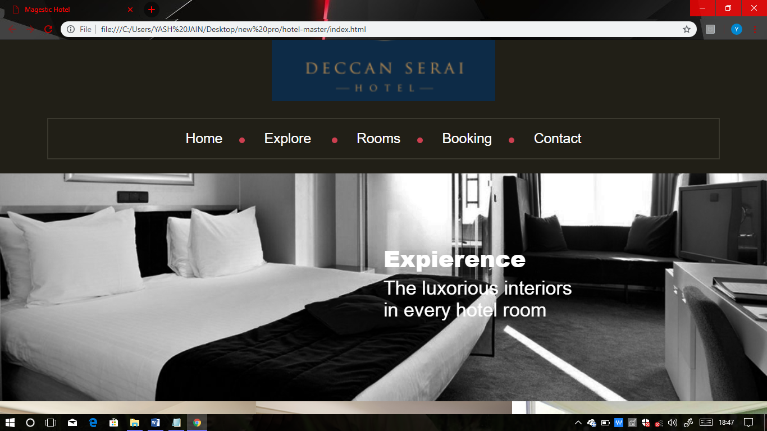

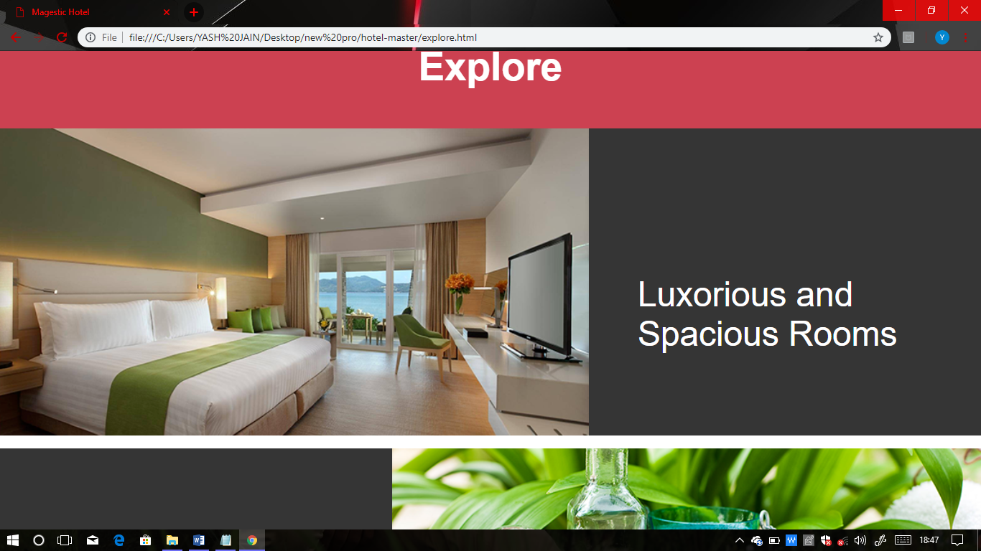

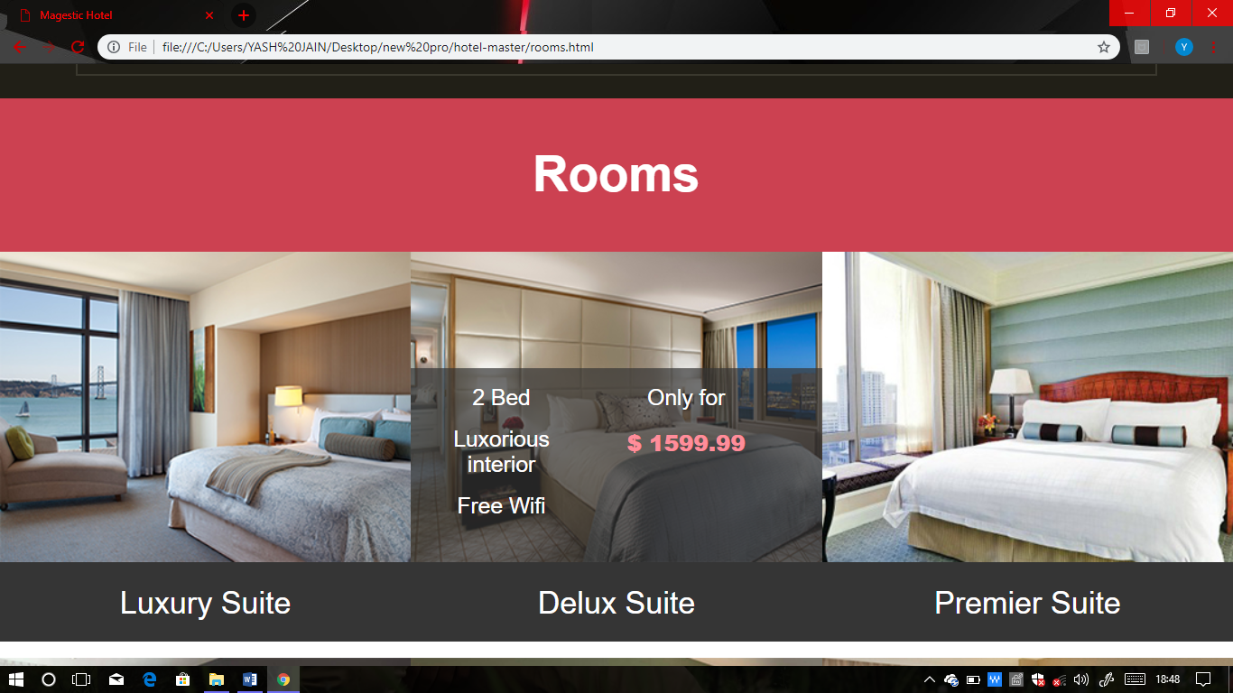

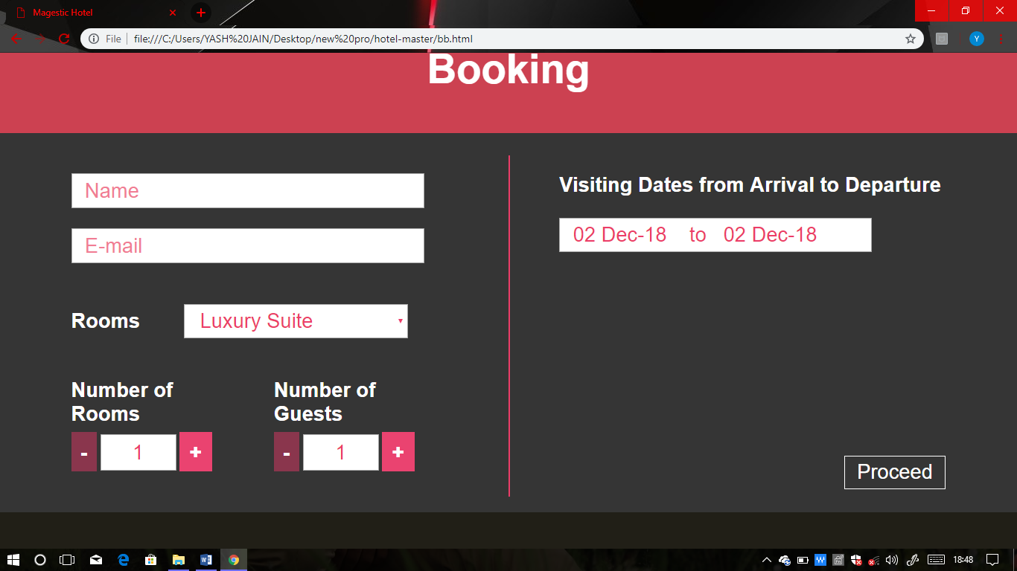

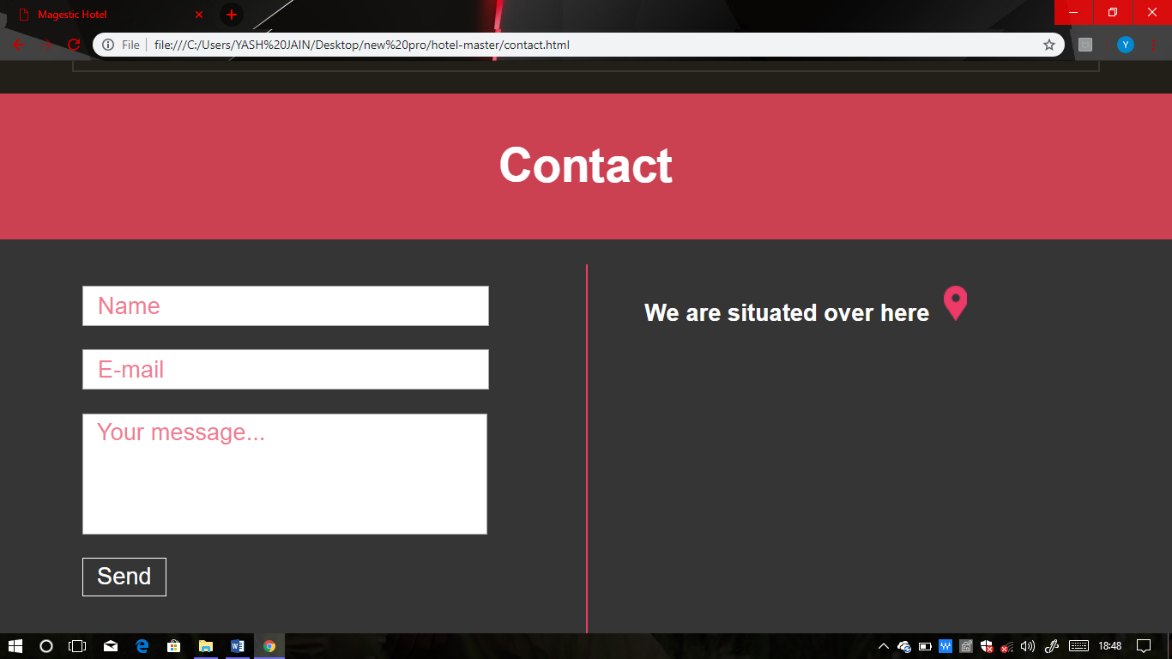

**INNOVATION AND CONTRIBUTION TO THE PROJECT**

This project proposed online booking in resort and hotel.

The outcome of the project helps in viewing the rooms ,knowing the services and customer can make any inquiry regarding availability of rooms, cafeteria and its services.

**COST ESTIMATION**

|  |  |  |  |
| --- | --- | --- | --- |
| **Sl. No.** | **Particulars** | **Quantity** | **Cost in Rs.** |
| 1 | Computer System with AMD Pentium Processor, 4GB RAM | 1 | 3000 |
| 2 | Windows7,64 bit operating System License | 1 | 15,000 |
|  | | | **18,000** |

**REFERENCES**

* G. Eason, B. Noble, and I.N. Sneddon, “On certain integrals of Lipschitz-Hankel type involving products of Bessel functions,” Phil. Trans. Roy. Soc. London, vol. A247, pp. 529-551, April 1955.
* Priddle, A. 2014. Detroit Auto Show: 2015 C-Class will be first car to be made in Mercedes’ Alabama plant. Detroit Free Press, 12 January 2014. Accessed on 13 January 2014. Retrieved from http://www.freep.com/article/20140112/BUSINESS03/301120152

**Student Signature**