**CSS:-**

1. **CSS Box model :-**
2. A box is an element containing images, texts etc. The dimensions of the box can be set using width, height, padding and margin properties. Various sides of the box can be customized individually using top, bottom, left, right with the property name. For example “**margin-bottom:20px”.** By default width and height is set for the content inside the box.

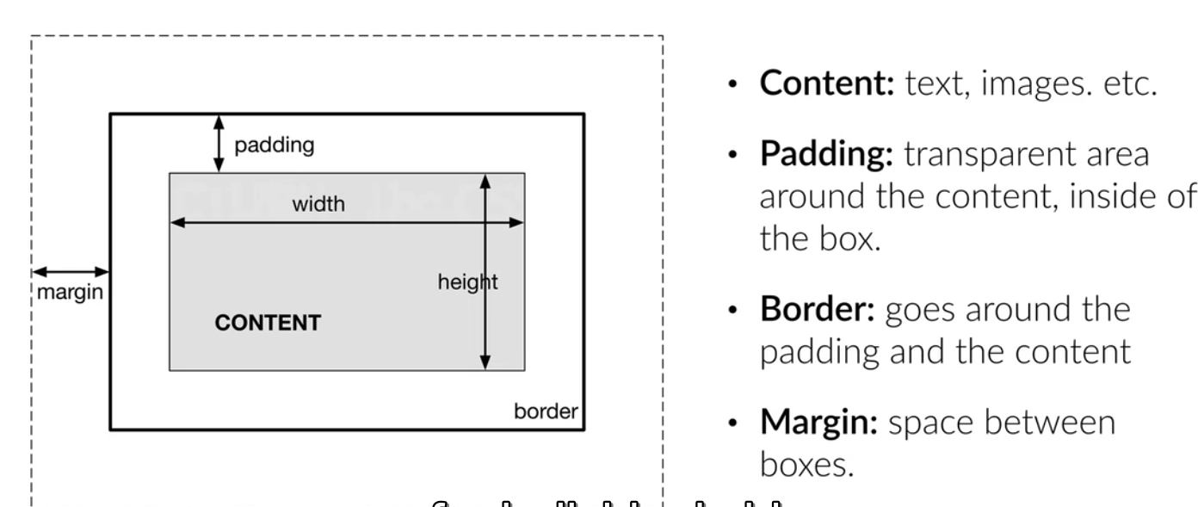

1. The width and height can be made to set for the entire box using “**box-sizing:border-box’”**property.

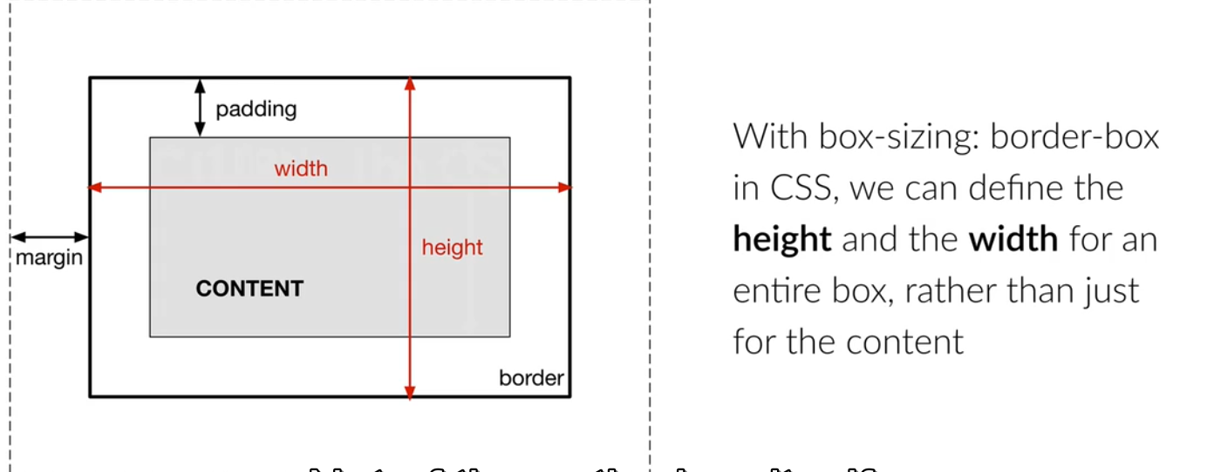

1. Width can also be specified in perecentage. For example “**width:75%; “.**
2. **Positioning of Elements:-**

There are five different position values:

* static
* relative
* fixed
* absolute
* sticky

Elements are then positioned using the top, bottom, left, and right properties. However, these properties will not work unless the position property is set first. They also work differently depending on the position value.

a) **Relative:-** An element with position: relative; is positioned relative to its normal position.Setting the top, right, bottom, and left properties of a relatively-positioned element will cause it to be adjusted away from its normal position. Other content will not be adjusted to fit into any gap left by the element.

b) **Fixed:-** An element with position: fixed; is positioned relative to the viewport, which means it always stays in the same place even if the page is scrolled. The top, right, bottom, and left properties are used to position the element. A fixed element does not leave a gap in the page where it would normally have been located.

c) **Absolute:-** An element with position: absolute; is positioned relative to the nearest positioned ancestor (instead of positioned relative to the viewport, like fixed).However; if an absolute positioned element has no positioned ancestors, it uses the document body, and moves along with page scrolling.

d) **Sticky:-** An element with position: sticky; is positioned based on the user's scroll position.A sticky element toggles between relative and fixed, depending on the scroll position. It is positioned relative until a given offset position is met in the viewport - then it "sticks" in place (like position:fixed).