# **Medlife Pharmacy**

## 

Medlife Pharmacy is a system that stores data related to medication use processes within pharmacies in an orderly and systematic manner.

**Mission Statement**

The main aim of this project is to develop the system such that the pharmaceutical store can effectively manage its behemoth data and stay ahead of the curve.

**Mission Objective**

* To develop a system that deals with the day to day requirement of any pharmacy.
* To ensure safety, accuracy, and efficiency within the pharmaceutical store.
* To provide competitive advantage to the pharmacy.

## 

## **ER Schema:**

## **Entities, Attributes, and Primary Keys**

Company (**cmpName**, cmpPhone, cmpAddress)

Drug (**drgBarcode** ,drgName, drgType, drgDose, drgCode, drgCostPrice, drgSellPrice, drgProductionDate, drgExpirationDate, drgQuantity, drgProfit)

Inventory(**invId** , invType, invAddress)

Bill (**bilId** , bilType, bilPrice, bilDate)

Customer(**cstId**, cstName, cstPhone, cstDOB)

Employee(**empId**, empName, empPhone, empAddress, empPassword, empType)

-HourlyEmployee (empHourlyRate)

-FullTimeEmployee (empSalary, empStockAmount, empPaidLeave)

-ContractEmployee (empContractDuration, empContractAmount)

## **Relationships, Attributes, Degrees, Participating Entities and Constraints:**

Produce: binary relationship

1 Company to 1 or more Drugs

1 Drug to 1 Company

Purchase: binary relationship

1 Inventory to 1 or more Drugs

1 Drug to 0 or more Inventory

Sale: binary relationship

1 Drug to 0 or more Bills

1 Bill to 1 or more Drugs

Receive: binary relationship

1 Customer to 1 or more Bills

1 Bill to 1 Customer

Assists: binary relationship

1 Customer to 0 or 1 Employee

1 Employee to 0 or more Customers

## **Business Processes**

Medlife would like to design a conceptual database to help them store, manage and retrieve data in the most optimum way. Medlife purchases drugs from Drug-making companies and sells them to customers, therefore acting as a middleman to bridge the gap between the two. The business descriptions of Medlife include:

* Each company is described by a unique company Name, company phone number, and company address.
* Each drug is described by a unique drug barcode, drug name, drug type, drug dose, drug code, drug cost price, drug sell price, drug production date, drug expiration date, drug quantity, and company id of the drug.
* Each company produces one or many drugs and one drug is produced by only one company because they try to maximize profit by patenting the drugs.
* Each inventory is described by a unique inventory identifier, barcode of the drug that the inventory contains, inventory type, inventory price, inventory quantity, and inventory data.
* Each inventory contains information about one or more drugs, so basically tells us about the availability in terms of quantity, price, etc. of the drugs.
* Each drug can be a part of multiple inventories as Medlife may buy the same drug multiple times from the manufacturing company.
* Each bill is described by a unique combination of drug barcode and customer id, bill identifier, bill type, bill price, bill quantity, bill date, and an employee identifier that made the sale.
* Each customer is described by a unique customer identifier, customer name, customer phone, and customer date of birth.
* Each customer can receive one or more bills depending on the drugs that he/she buys and the date of purchase, and each bill can only be received by one customer.
* Each employee is described by a unique employee identifier, employee name, employee phone number, employee address, employee salary, and employee password.
* Each customer can either be assisted by an employee or he/she can choose the self-checkout option and not require employee assistance.
* Each employee has to assist multiple customers if they avoid using the self-checkout option.

ER Diagram:

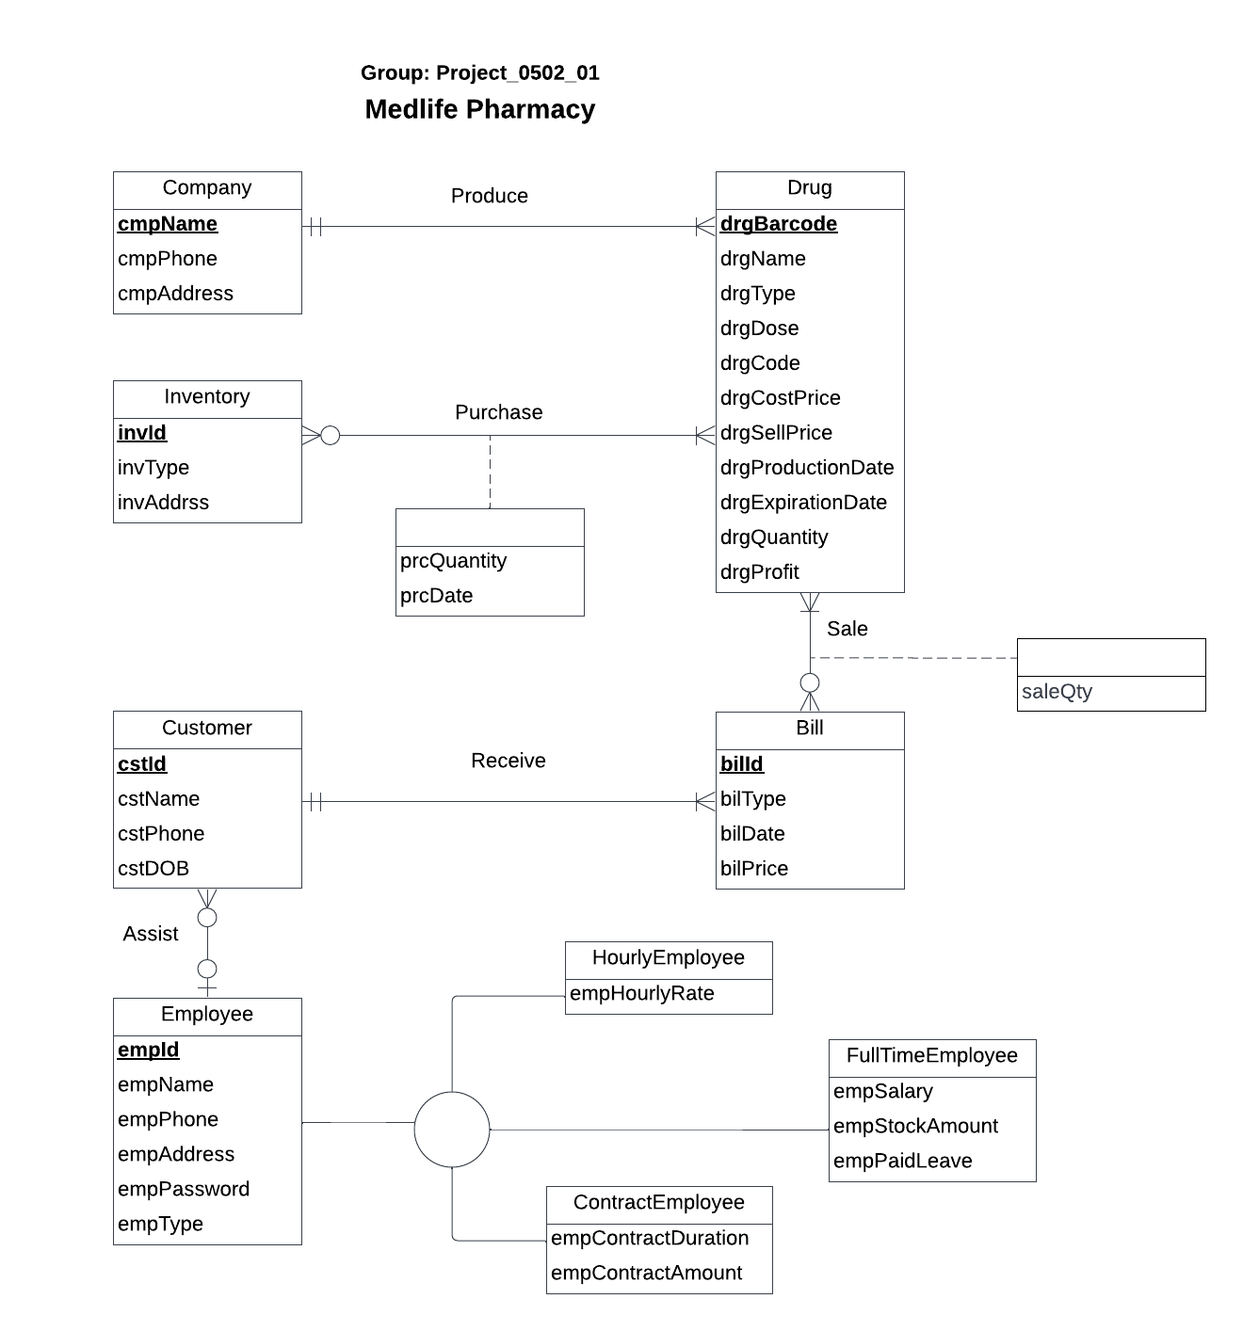

**Relations:**

Company (**cmpName**, cmpPhone, cmpAddress)

Drug (**drgBarcode** ,drgName, drgType, drgDose, drgCode, drgCostPrice, drgSellPrice, drgProductionDate, drgExpirationDate, drgQuantity, drgProfit, *cmpName*)

Inventory(**invId**, invType, invAddress)

Bill (**bilId** , bilType, bilPrice, bilDate, *cstId*)

Customer (**cstId**, cstName, cstPhone, cstDOB, *empId*)

Employee (**empId**, empName, empPhone, empAddress, empPassword, empType)

HourlyEmployee (***empId***, empHourlyRate)

FullTimeEmployee (***empId***, empSalary, empStockAmount, empPaidLeave)

ContractEmployee (***empId***, empContractDuration, empContractAmount)

Purchase (***invId***, ***drgBarcode* ,** prcQuantity, prcDate)

Sale (***drgBarcode***, ***bilId* ,**saleQty)

**Functional dependencies:**

cmpName → cmpPhone, cmpAddress

drgBarcode → drgName, drgType, drgDose, drgCode, drgCostPrice, drgSellPrice, drgProductionDate, drgExpirationDate, drgQuantity, drgProfit, cmpName

invId → invType, invAddress

bilId → bilType, bilPrice, bilDate, cstId

cstId → cstName, cstPhone, cstDOB, empId

empId → empName, empPhone, empAddress, empPassword, empType

empId → empHourlyRate

empId → empSalary, empStockAmount, empPaidLeave

empId → empContractDuration, empContractAmount

invId, drgBarcode → prcQuantity, prcDate

drgBarcode, bilId → saleQty

**Referential Integrity:**

| **Relation** | **Foreign Key** | **Base Relation** | **Primary Key** | **Business Rule** | **Constraint: ON DELETE** | **Business Rule** | **Constraint: ON UPDATE** |
| --- | --- | --- | --- | --- | --- | --- | --- |
| Produce | cmpName | Company | cmpName | R1 | NO ACTION | R2 | CASCADE |
| Produce | drgBarcode | Drug | drgBarcode | R3 | NO ACTION | R4 | CASCADE |
| Purchase | invId | Inventory | invId | R5 | SET NULL | R6 | CASCADE |
| Purchase | drgBarcode | Drug | drgBarcode | R7 | NO ACTION | R8 | CASCADE |
| Sale | drgBarcode | Drug | drugBarcode | R9 | SET NULL | R10 | CASCADE |
| Sale | bilId | Bill | bilId | R11 | CASCADE | R12 | CASCADE |
| Assist | cstId | Customer | cstId | R13 | NO ACTION | R14 | NO ACTION |
| Assist | empId | Employee | empId | R15 | NO ACTION | R16 | NO ACTION |
| Customer | cstId | Bill | bilId | R17 | NO ACTION | R18 | NO ACTION |

**Business Rules:**

R1: When a company that produces drugs shuts down then the company id should not be deleted.

R2: When the information about the company that produces drugs is updated then the corresponding company information should be updated accordingly.

R3: When the company stops producing the drug then the information related to the drug should not be deleted.

R4: When the information about the drug that is produced by a company is updated then the corresponding drug information of that company should be updated accordingly.

R5: When we stop buying the drug for our inventory the information related to the inventory of that drug should be set null.

R6: When the information about the inventory that is purchased by us is updated then the corresponding inventory information should be updated accordingly.

R7: When we stop purchasing the drug for our inventory the information related to the drug for that inventory should be set null.

R8: When the information about the inventory that is purchased by us is updated then the corresponding inventory information should be updated accordingly.

R9: When a drug sold to the customer is deleted from the database then the information related to the drug should be set to null.

R10: When the information related to the drug that’s been sold to the customer is updated then the corresponding information related to the drug should be updated accordingly.

R11: When a bill related to a drug is deleted from the database then the corresponding sale information should be deleted.

R12: When the bill information about a drug is updated then the corresponding bill information should be updated in the database.

R13: When the information about a customer assisted by an employee is deleted then the corresponding employee information should not be deleted.

R14: When the information about a customer assisted by an employee is updated then the corresponding employee information should not be updated.

R15: When the information about the employee that assisted a customer is deleted the corresponding customer information should not be deleted.

R16: When the information about the employee that assisted a customer is deleted the corresponding customer information should not be updated.

R17: When the bill that’s generated for a customer is deleted then the customer information should not be deleted.

R18: When the bill that’s generated for a customer is updated then the customer information should be updated accordingly.

**Sample Data for the relations:**

Company ('Fizer', 2404848894, '6210 Belcrest Road, Hyattsville 20782')

Drug (11290890, 'Advil', 'Prescription' , 2 , '2d00', 23.4, 29.9, '11/07/2022'. '11/09/2023', 12, 6.5, ‘Fizer’)

Inventory (‘B12456’, 'Warehouse', '3240 Fawn Circle, PA 204567')

Bill ('I6789', 'Self checkout', 12.45, 12, '04/08/2022', 7890)

Customer (‘7890’, 'Modi', 9033033666, '08/19/1999')

Employee (‘700’, 'Rohit', 2405678895, '4330 Heart Break road, College park 20742', ‘#Rtu78ER’, ‘Hourly’)

HourlyEmployee (‘700’, 23.12)

FullTimeEmployee (‘7001’, 23456.90, 34532.00, 25)

ContractEmployee (‘7002’, 15, 89098)

Produce ('Fizer', 11290890)

Purchase ('B12456', 11290890, 10, '11/02/2022')

Sale (11290890 , 'I6789', 25)