**Mohr’s Circle Testing**

**Yash Meshram | Shreyas Sonawane | Manish Alriya | Rwik Rana**

This is a sample testing file that contains the steps taken to check the functionality and correctness of the Mohr’s Circle App. This file contains examples taken from each of the 4 subparts of Mohr’s Circle i.e 2-D Mohr’s Circle (Stress and Strain), 3-D Mohr’s Circle (Stress and Strain). The remaining test cases have been well documented in the same folder under the filename Mohr_Test_Cases.pdf.

**For 2-D (Stress)**

**Given:**

$σ$ x = 34.3 $τ$ xy = 83.9

$σ$ y = 74 θ = 54.6

**Calculating principal stress:**

This is the rendered form of the equation. You can not edit this directly. Right click will give you the option to save the image, and in most browsers you can drag the image onto your desktop or another program.

This is the rendered form of the equation. You can not edit this directly. Right click will give you the option to save the image, and in most browsers you can drag the image onto your desktop or another program.

The roots of the above equation will be the principal stress ($σ$ 1, $σ$ 2)

| $σ$ 1 = 140.366 |
| --- |

| 2 = -32.066 |
| --- |

**Calculating Rotated Stress:**

|  |
| --- |

|  |
| --- |

|  |
| --- |

**Calculating centre and radius of mohr circle:**

Centre:

|  |
| --- |

Radius/:

|  |
| --- |

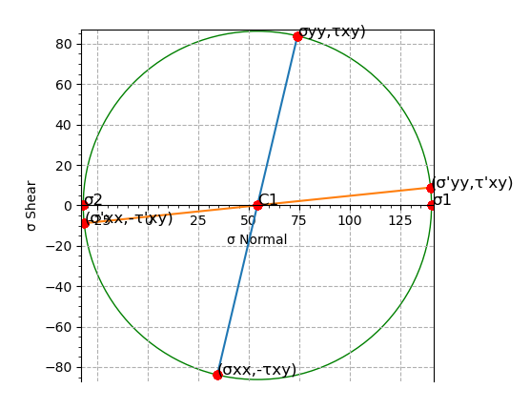

**For 3-D (Stress)**

**Given:**

$σ$ xx = 77.6 $σ$ xy = 50.8 α = 74o

yy = 26.8 yz = 35.4 β = 61o

zz = 33.7 zx = 14.4 y = 34o

**Calculating Principal stress:**

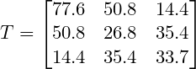

$T - (l)I = 0$

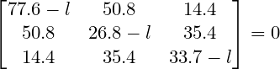

$l^{3} - I1 × l^{2} + I2 × l - I3 = 0$

Where

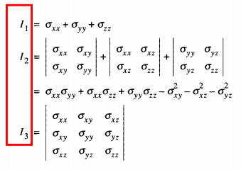

$I1 = 77.6 + 26.8 + 33.7$

$I2 = 77.6×26.8 + 77.6×33.7 + 26.8×33.7 - 50.8^{2} - 14.4^{2} - 35.4^{2}$

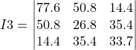

$I1 = 138.1$

$I2 = 1556.8$

$I3 = -67893.2$

Thus, the equation will be

$l^{3} - 138.1 × l^{2} + 1556.8× l + 67893.2 = 0$

The root of the above cubic equation will be the principal stress

|  |
| --- |

|  |
| --- |

|  |
| --- |

**Calculating Normal stress($σNN$) and Shear stress()**

|  |
| --- |

|  |
| --- |

**Calculating Centres and Radius:**

$C1 : (\frac{σ1 + σ3}{2}, 0) ≡ (\frac{120.50581 - 16.51675}{2}, 0) ≡ (51.9945, 0)$

$C2 : (\frac{σ2 + σ3}{2}, 0) ≡ (\frac{34.11094 - 16.51675}{2}, 0) ≡ (8.797, 0)$

$C3 : (\frac{σ1 + σ2}{2}, 0) ≡ (\frac{120.50581 + 34.11094}{2}, 0) ≡ (77.3083, 0)$

$R1 = \frac{σ1 - σ3}{2} = \frac{120.50581 + 16.51675}{2} = 68.51128$

$R2 = \frac{σ2 - σ3}{2} = \frac{34.11094 + 16.51675}{2} = 25.3138$

$R3 = \frac{σ1 - σ2}{2} = \frac{120.50581 - 34.11094}{2} = 43.1974$

$τmax = R1 = 68.51128$

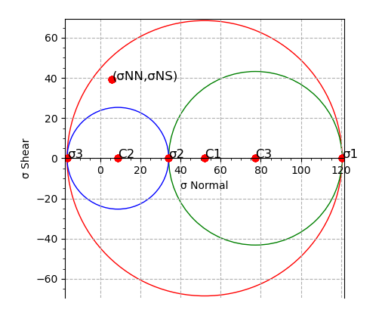

**For 2-D (Strain)**

**Given:**

$ε$ x = 34.3 $γ$ xy = 83.9

$ε$ y = 74 θ = 54.6

**Calculating Principal strain:**

This is the rendered form of the equation. You can not edit this directly. Right click will give you the option to save the image, and in most browsers you can drag the image onto your desktop or another program.

This is the rendered form of the equation. You can not edit this directly. Right click will give you the option to save the image, and in most browsers you can drag the image onto your desktop or another program.

The roots of the above equation will be the principal stress ($ε$ 1, $ε$ 2)

| $ε$ 1 = 100.559 |
| --- |

| 2 = 7.741 |
| --- |

**Calculating Rotated Strain:**

|  |
| --- |

|  |
| --- |

|  |
| --- |

**Calculating centre and radius of mohr circle:**

Centre:

|  |
| --- |

Radius/:

|  |
| --- |

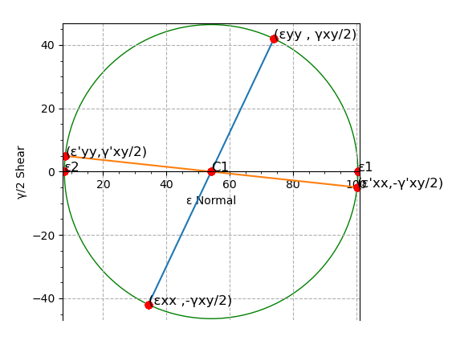

**For 3-D (Strain)**

**Given:**

$ε$ xx = 77.6 $γ$ xy = 50.8 α = 74o

yy = 26.8 yz = 35.4 β = 61o

zz = 33.7 zx = 14.4 y = 34o

**Calculating Principal stress:**

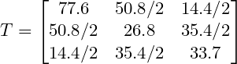

$T - (l)I = 0$

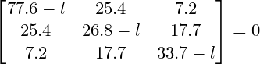

$l^{3} - I1 × l^{2} + I2 × l - I3 = 0$

Using the same formula as used in 3-D (Stress)

$I1 = 77.6 + 26.8 + 33.7$

$I2 = 77.6×26.8 + 77.6×33.7 + 26.8×33.7 - 25.4^{2} - 7.2^{2} - 17.7^{2}$

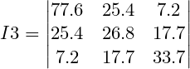

$I1 = 138.1$

$I2 = 4587.67$

$I3 = 29116.66$

Thus, the equation will be

$l^{3} - 138.1 × l^{2} + 4587.67× l - 29116.66 = 0$

The root of the above cubic equation will be the principal stress

|  |
| --- |

|  |
| --- |

|  |
| --- |

**Calculating Normal stress() and Shear stress()**

|  |
| --- |

|  |
| --- |

**Calculating Centres and Radius:**

