**Name-YASH MUNDHE**

**SEC- C**

**ROLL NO. -48**

**Aim**:- Study and Installation of Weka AI tool

Requirements: Java Development Kit (JDK) installed (version 8 or above)

**Theory**:

**WEKA (Waikato Environment for Knowledge Analysis)** is a popular open-source machine learning software developed at the University of Waikato in New Zealand. It provides tools for:

* Data preprocessing
* Classification
* Regression
* Clustering
* Association rule mining
* Data visualization

WEKA is written in Java and includes a GUI (Graphical User Interface) for easy interaction. It supports various standard machine learning algorithms and data mining techniques and allows users to build, evaluate, and compare models efficiently.

WEKA works primarily with .arff (Attribute-Relation File Format) and also supports .csv and .xrff.

Procedure:

**1. Install Java (if not already installed):**

* Go to <https://www.oracle.com/java/technologies/javase/javase-jdk8-downloads.html>
* Download and install JDK 8 or later.
* Set JAVA_HOME environment variable (if needed).

**2. Download WEKA:**

* Visit the official WEKA website: https://www.cs.waikato.ac.nz/ml/weka/
* Navigate to the Downloads section.
* Choose the appropriate version for your OS (Windows/Linux/macOS).
* Download the installer or executable .jar file.

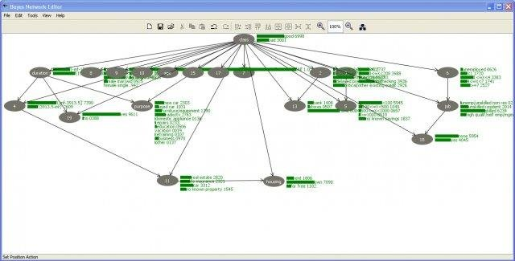

**3. Install or Run WEKA:**

* **Windows:** Run the .exe installer and follow the instructions.
* **Linux/macOS:** Use the .jar file:
* Once installed, launch the WEKA GUI Chooser.

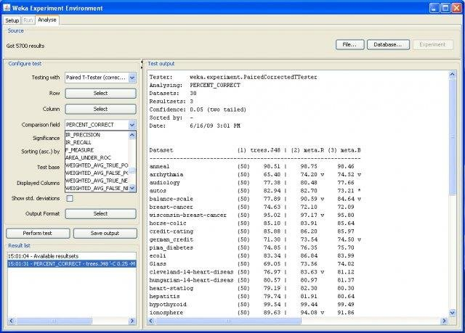

**4. Explore the Interface:**

* Open the "Explorer" interface.
* Load a sample dataset (e.g., iris.arff) from the data/ folder.
* Browse through the "Preprocess", "Classify", "Cluster", "Associate", and "Visualize" tabs.

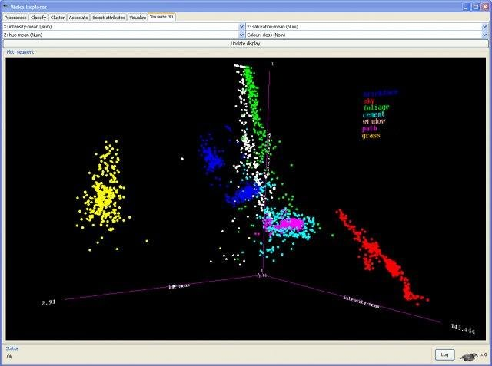

**Conclusion**:WEKA was successfully installed and launched. The tool provides a comprehensive environment for data mining and machine learning experiments using a simple GUI. Sample datasets were loaded and analyzed using built-in classifiers and visualizations.