**Compiler Design Lab**

**Practical-3**

**Name: Yash Patni**

**Roll: 71**

**Batch: A4**

**Aim:** (A) Write a program to find FIRST for any grammar. All the following rules of FIRST must be implemented.

(B) Calculate Follow for the given grammar and Construct the LL (1) parsing table using the FIRST and FOLLOW.

**Code:**

import sys

from tabulate import tabulate

terminals = ['a', 'b', 'c', 'p']

non_terminals = ['S', 'A', 'B', 'C']

starting_symbol = 'S'

productions = ["S->ABC/C", "A->a/bB/#", "B->p/#", "C->c"]

productions_dict = {nT: [] for nT in non_terminals}

for production in productions:

    nonterm_to_prod = production.split("->")

    alternatives = nonterm_to_prod[1].split("/")

    for alternative in alternatives:

        productions_dict[nonterm_to_prod[0]].append(alternative)

LL1_table = {}

conflicts = False

def first(string):

    first_ = set()

    if string in non_terminals:

        alternatives = productions_dict[string]

        for alternative in alternatives:

            first_2 = first(alternative)

            first_ |= first_2

    elif string in terminals:

        first_ = {string}

    elif string == '' or string == '#':

        first_ = {'#'}

    else:

        first_2 = first(string[0])

        if '#' in first_2:

            i = 1

            while '#' in first_2:

                first_ |= (first_2 - {'#'})

                if string[i:] in terminals:

                    first_ |= {string[i:]}

                    break

                elif string[i:] == '':

                    first_ |= {'#'}

                    break

                first_2 = first(string[i:])

                first_ |= (first_2 - {'#'})

                i += 1

        else:

            first_ |= first_2

    return first_

def follow(nT):

    follow_ = set()

    prods = productions_dict.items()

    if nT == starting_symbol:

        follow_ |= {'$'}

    for nt, rhs in prods:

        for alt in rhs:

            for char in alt:

                if char == nT:

                    following_str = alt[alt.index(char) + 1:]

                    if following_str == '':

                        if nt == nT:

                            continue

                        else:

                            follow_ |= follow(nt)

                    else:

                        follow_2 = first(following_str)

                        if '#' in follow_2:

                            follow_ |= (follow_2 - {'#'})

                            follow_ |= follow(nt)

                        else:

                            follow_ |= follow_2

    return follow_

FIRST = {non_terminal: set() for non_terminal in non_terminals}

FOLLOW = {non_terminal: set() for non_terminal in non_terminals}

for non_terminal in non_terminals:

    FIRST[non_terminal] |= first(non_terminal)

FOLLOW[starting_symbol] |= {'$'}

for non_terminal in non_terminals:

    FOLLOW[non_terminal] |= follow(non_terminal)

print("{: ^20}{: ^20}{: ^20}".format('Non Terminals', 'First', 'Follow'))

for non_terminal in non_terminals:

    print("{: ^20}{: ^20}{: ^20}".format(non_terminal, str(FIRST[non_terminal]), str(FOLLOW[non_terminal])))

for non_terminal, alternatives in productions_dict.items():

    for alternative in alternatives:

        first_set_alt = first(alternative)

        for terminal in first_set_alt - {'#'}:

            if (terminal, non_terminal) not in LL1_table:

                LL1_table[(terminal, non_terminal)] = [alternative]

            else:

                LL1_table[(terminal, non_terminal)].append(alternative)

                if len(LL1_table[(terminal, non_terminal)]) > 1:

                    conflicts = True

                    print(f"Conflict at ({terminal}, {non_terminal})")

        if '#' in first_set_alt or '' in first_set_alt:  # If epsilon is in FIRST(α)

            for terminal in FOLLOW[non_terminal]:

                if (terminal, non_terminal) not in LL1_table:

                    LL1_table[(terminal, non_terminal)] = [alternative]

                else:

                    LL1_table[(terminal, non_terminal)].append(alternative)

                    if len(LL1_table[(terminal, non_terminal)]) > 1:

                        conflicts = True

                        print(f"Conflict at ({terminal}, {non_terminal})")

# Displaying the LL(1) parsing table with terminals as row headers and non-terminals as column headers

table_data = []

for terminal in terminals:

    row = [terminal] + [', '.join(LL1_table.get((terminal, non_terminal), [])) for non_terminal in non_terminals]

    table_data.append(row)

print(tabulate(table_data, headers=['Terminals'] + non_terminals, tablefmt='grid'))

if conflicts:

    print("Conflicts found.")

else:

    print("No conflicts found.")

**Output:**

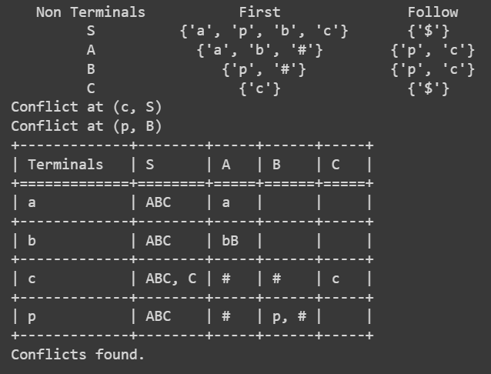

**Conclusion:** In this practical we successfully implemented program to calculate first and follow for the given production. Also constructed the LL(1) parsing table.