**Compiler Design Lab**

**Practical-4**

**Name: Yash Patni**

**Roll: 71**

**Batch: A4**

**Aim:** (A) Write a program to validate a string using the parsing table generated in

practical 3. Consider valid &amp; invalid string &amp; print the stack &amp; buffer input tracing.

Input: LL (1) parsing table

Implementation: String parsing rules using stack

Output: Each step-in string parsing and whether the input string is valid or invalid.

**Code:**

from tabulate import tabulate

terminals = ['a', 'b', 'c', 'p']

non_terminals = ['S', 'A', 'B', 'C']

starting_symbol = 'S'

productions_dict = {

    'S': ['A', 'BC'],

    'A': ['a', 'b'],

    'B': ['p', '#'],

    'C': ['c']

}

LL1_table = {}

conflicts = False

def first(string):

    first_ = set()

    if string in non_terminals:

        alternatives = productions_dict[string]

        for alternative in alternatives:

            first_2 = first(alternative)

            first_ |= first_2

    elif string in terminals:

        first_ = {string}

    elif string == '' or string == '#':

        first_ = {'#'}

    else:

        first_2 = first(string[0])

        if '#' in first_2:

            i = 1

            while '#' in first_2:

                first_ |= (first_2 - {'#'})

                if string[i:] in terminals:

                    first_ |= {string[i:]}

                    break

                elif string[i:] == '':

                    first_ |= {'#'}

                    break

                first_2 = first(string[i:])

                first_ |= (first_2 - {'#'})

                i += 1

        else:

            first_ |= first_2

    return first_

def follow(nT):

    follow_ = set()

    prods = productions_dict.items()

    if nT == starting_symbol:

        follow_ |= {'$'}

    for nt, rhs in prods:

        for alt in rhs:

            for char in alt:

                if char == nT:

                    following_str = alt[alt.index(char) + 1:]

                    if following_str == '':

                        if nt == nT:

                            continue

                        else:

                            follow_ |= follow(nt)

                    else:

                        follow_2 = first(following_str)

                        if '#' in follow_2:

                            follow_ |= (follow_2 - {'#'})

                            follow_ |= follow(nt)

                        else:

                            follow_ |= follow_2

    return follow_

FIRST = {non_terminal: set() for non_terminal in non_terminals}

FOLLOW = {non_terminal: set() for non_terminal in non_terminals}

for non_terminal in non_terminals:

    FIRST[non_terminal] |= first(non_terminal)

FOLLOW[starting_symbol] |= {'$'}

for non_terminal in non_terminals:

    FOLLOW[non_terminal] |= follow(non_terminal)

for non_terminal, alternatives in productions_dict.items():

    for alternative in alternatives:

        first_set_alt = first(alternative)

        for terminal in first_set_alt - {'#'}:

            if (non_terminal, terminal) not in LL1_table:

                LL1_table[(non_terminal, terminal)] = alternative

            else:

                print(f"Conflict at ({non_terminal}, {terminal})")

                conflicts = True

        if '#' in first_set_alt or '' in first_set_alt:  # If epsilon is in FIRST(α)

            for terminal in FOLLOW[non_terminal]:

                if (non_terminal, terminal) not in LL1_table:

                    LL1_table[(non_terminal, terminal)] = alternative

                else:

                    print(f"Conflict at ({non_terminal}, {terminal})")

                    conflicts = True

if not conflicts:

    print("No conflicts found.")

# Parsing function

def parse_input(input_str):

    stack = [starting_symbol]

    buffer = list(input_str)

    stack_trace = []

    buffer_trace = [buffer[:]]

    action_trace = []

    accepted = False

    while stack:

        top_of_stack = stack[-1]

        if top_of_stack in terminals:

            if top_of_stack == buffer[0]:

                stack.pop()

                buffer.pop(0)

                action_trace.append(f"Matched {top_of_stack}")

            else:

                break

        elif top_of_stack in non_terminals:

            key = (top_of_stack, buffer[0])

            if key in LL1_table:

                production = LL1_table[key]

                stack.pop()

                if production != '#':

                    action_trace.append(f"Applied {top_of_stack} -> {production}")

                    stack.extend(reversed(production))

            else:

                break

        else:

            break

        stack_trace.append(''.join(stack))

        buffer_trace.append(buffer[:])

        if not stack and not buffer:

            accepted = True

    return accepted, stack_trace, buffer_trace, action_trace

# Validate strings

def validate_string(input_str):

    print("Parsing input string:", input_str)

    accepted, stack_trace, buffer_trace, action_trace = parse_input(input_str)

    if accepted:

        print("String Accepted.")

    else:

        print("String Rejected.")

    trace_data = list(zip(stack_trace, buffer_trace, action_trace))

    print(tabulate(trace_data, headers=['Stack Trace', 'Buffer Trace', 'Action Trace'], tablefmt='grid'))

# Test with some strings

validate_string("pc")

validate_string("abbc")

**Output:**

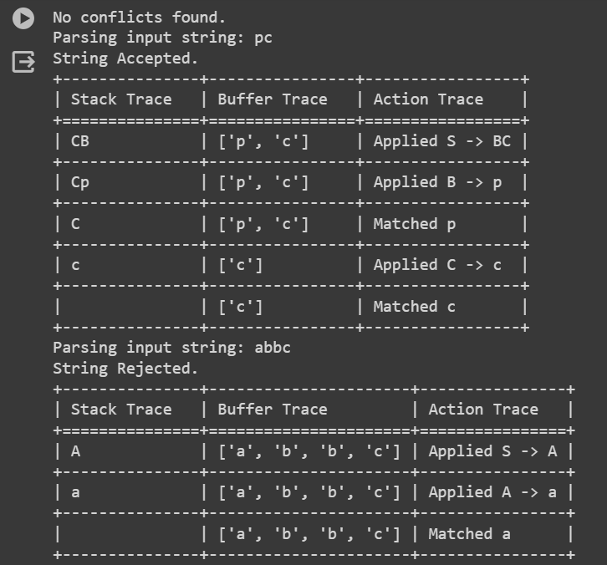

**Aim:** (B) Use Virtual Lab on LL1 parser to validate the string and verify your string validation using simulation.

**Output:**

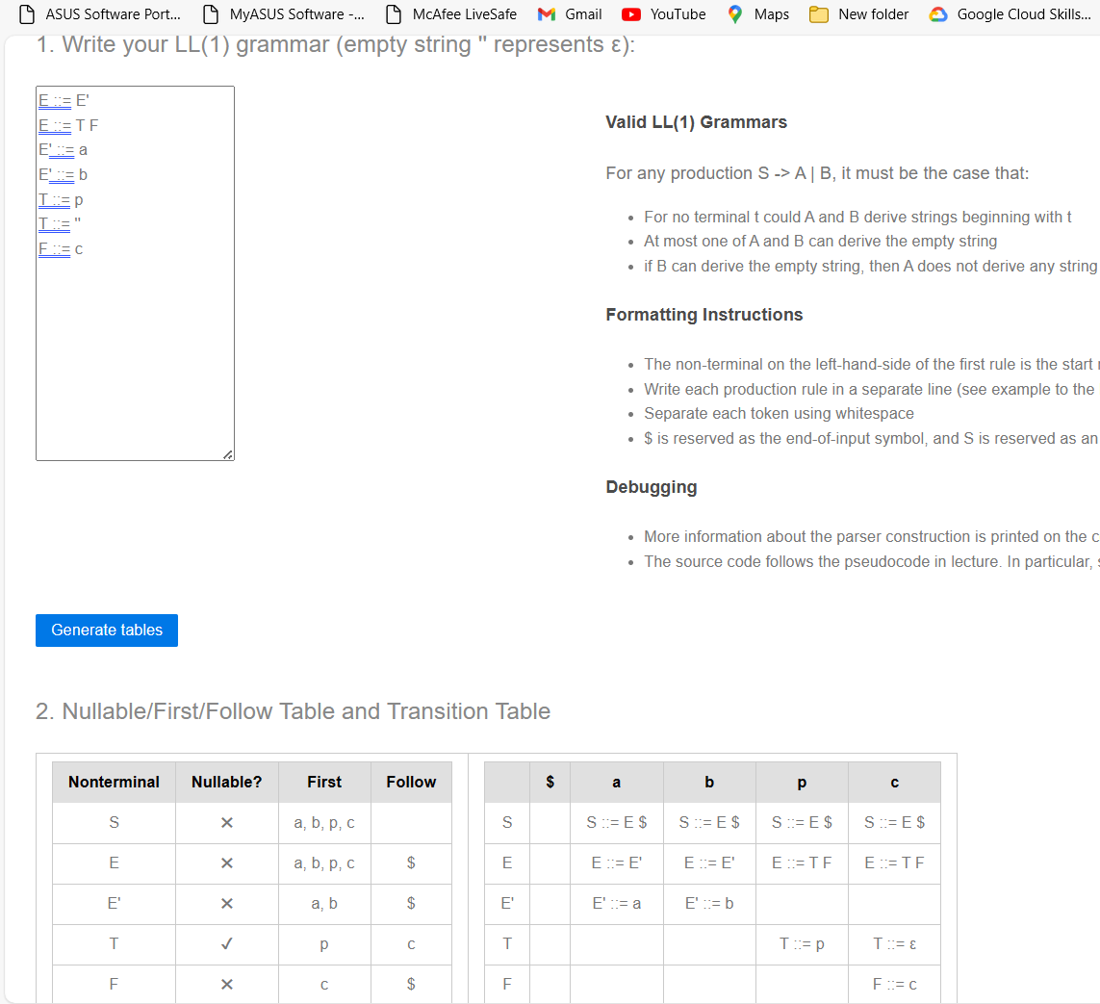

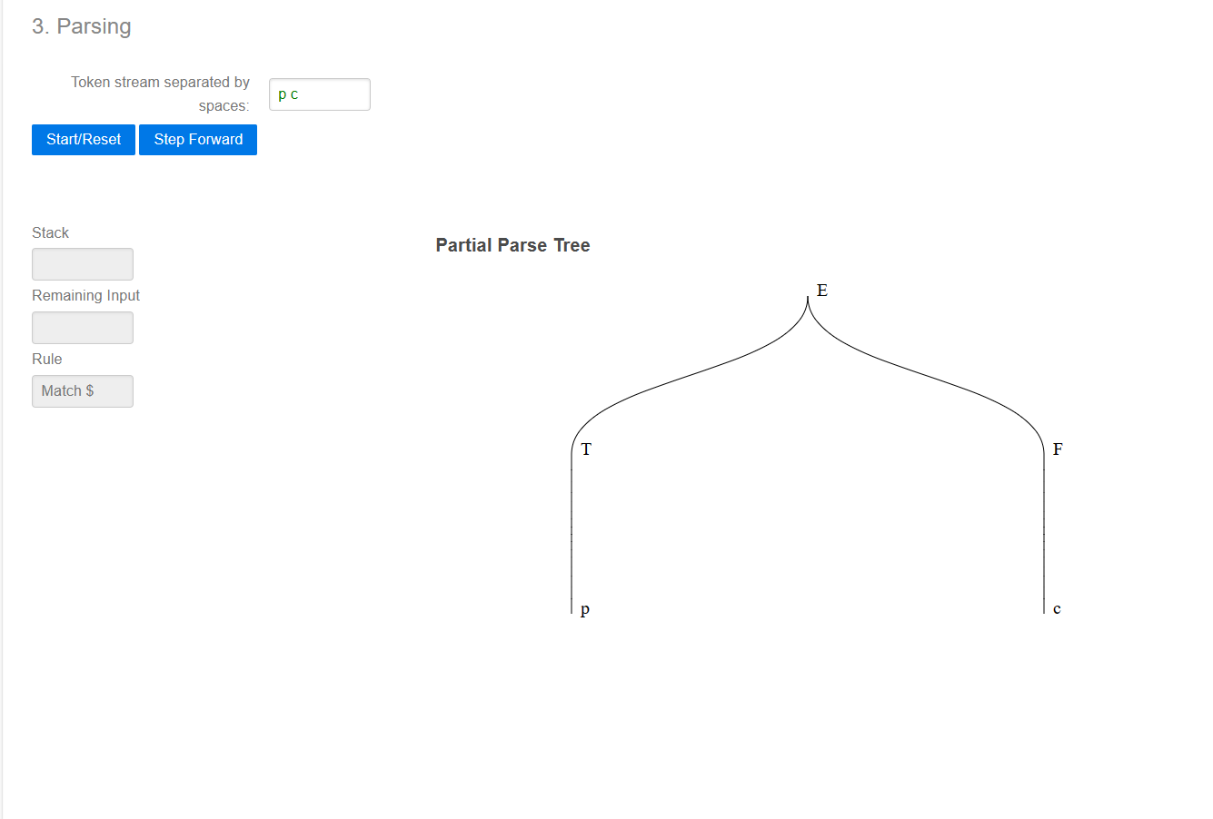

**Conclusion:** In this practical we successfully implemented program to validate string using parsing table. Also used virtual lab simulation to verify and validate the same string.